MBA – Master of Business Administration in Marketing
Module: International Marketing (LCMB7006)

Name - Shirinbanu Saiyed
Student ID - 2242206
University Name - University of Wales Trinity Saint David
Lecturer Name – Tushara Balendran
Year - 2023-24



Table of Contents

1.0 Introduction 4
2.0 Compare and contrast situational analysis models in UK and USA 4
3.0 Marketing Strategies 11
3.1 STP 11
3.1.1 U.K 11
3.1.2 USA 11
3.2 7 P’s 13
3.3 Market Entry Methods 14
3.1.1 UK 14
3.1.2 USA 14
3.4 Directional Development strategies 16
3.4.1 UK 16
3.4.2 USA 16
4.0 Discussion of the similarities and differences across as wide a range of variables of business of the brand Nike 17
4.1 UK 17
4.2 USA 18
5.0 Strategies and organizational approaches used to the discussed factors by Brand Nike 19
5.1 UK 19
5.2 USA 20
6.0 Recommendations 21
6.1 Recommendations for UK 21
6.2 Recommendations for the US 21
7.0 Conclusion 22
Reference List 23

1.0 Introduction
The comparison of the marketing context of the brand Nike in the countries of UK and USA is evaluated. The comparison would be done with respect to the situation of the business in the countries of the UK and USA. The marketing strategies that are applicable in both countries are discussed. The context of culture, human, political situation, structure of the market and the economic condition are to be discussed. The recommendations for the application of the best marketing practices based on the above factors is provided.

2.0 Compare and contrast situational analysis models in UK and USA

PESTLE Analysis of UK
A strategic technique for analyzing the external macro environmental elements influencing a business is PESTLE analysis. Political, Economic, Social, Technological, Legal, and Environmental issues are what it stands for. This model helps evaluate how these factors affect Nike's foreign marketing tactics in the context of the company's activities in the UK.
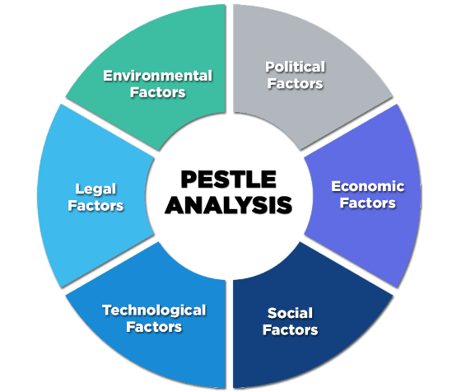
Figure 1: PESTLE analysis
(Source: Enterslice.com, 2023)

Political:
UK: There is the presence of government regulations related to the athletic footwear industry, such as product, labeling, safety and advertising. Changes in the regulations would be affecting the manufacturing as well as marketing strategy of Nike in the UK.
USA: The country of the United States is promoting and advocating democracy. The country is having a stable political environment, technological upgradation, advanced infrastructure, which is making it a good destination for foreign direct investment.
Economic:
UK: The economic conditions such as the disposable income of the people of the UK is high for which there is a high chance for them to spend on non-essential items like athletic footwear. However, a lot of fluctuation is taking place in the exchange rate of the UK which is affecting the pricing strategies and cost of raw materials (Chen, 2021).
USA: The United States has a strong manufacturing sector which assists the production of goods including the footwear products. However, the economic condition of the country has been affected because of the global lock down due to the coronavirus pandemic (Nica, Chiriță and Ionescu, 2021).
Social:
UK: Shifts in preferences and consumer lifestyles are taking place for health and fitness which is affecting the demand for athletic footwear. The industry of operation of Nike in the UK is also influenced by the fashion trends of the people of the country.
USA: There is a high level of awareness related to Fitness and healthy footwear in the society of the United States. Moreover, fashion trends are also playing a significant role in the preferences of the consumers of the US.
Technological:
UK: Advancements are taking place in the manufacturing processes as well as materials in the footwear industry of the UK. The growth of online retail for athletic footwear products is also taking place (Nica, Chiriță and Ionescu, 2021).
USA: There is advancement of manufacturing processes, materials as well as wearable technologies. The online retail sector of the country is also strong and easy to frequently influence the consumers' purchasing behavior.
Environmental:
UK: There is high awareness of environmental issues such as the sustainability of the raw materials used in the manufacturing of the footwear product.
USA: The level of consciousness of the consumers towards environmental sustainability of business operations is high. This is pressurizing the companies to adopt sustainable practices in the sourcing and manufacturing operations (Savitha and Roopa, 2023).
Legal:
UK: The country is having strict labor practices such as their working conditions and wages, which leaves an impact on the manufacturing processes as well as ethical sourcing by the athletic footwear brand Nike.
USA: The companies operating in the country are needed to consider the legal aspects such as trademarks, the protection of intellectual property, while branding and designing the product.
Although Nike has a number of advantages in the UK market, it must continue to be alert and flexible, particularly in light of future legislative and economic developments. Nike is able to make well-informed judgments and customize its marketing strategy to the unique circumstances of the UK market by being aware of these PESTLE variables.

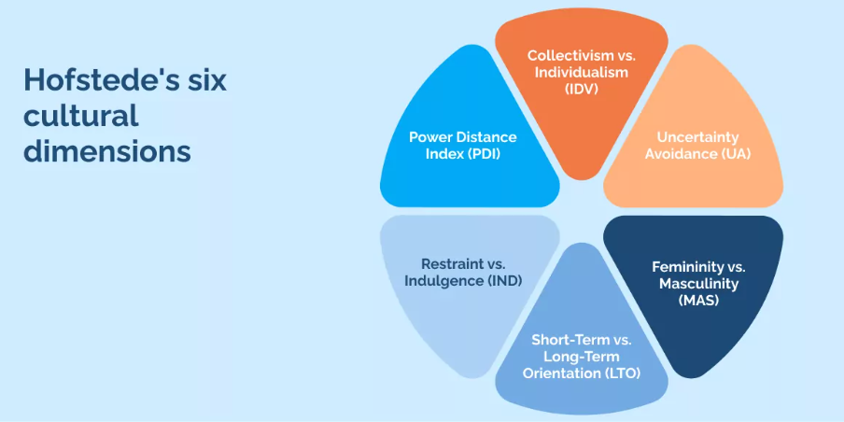
Figure 2: Hofstede model
(Source: Change.walkme.com, 2023)
For a sophisticated comprehension of the Hofstede model's application to the cultural component of PESTLE analysis, a deeper investigation of the model is necessary, particularly when contrasting two disparate nations like the UK and the United States. Examining the Hofstede model's six dimensions of culture Power Distance, Masculinity vs. Femininity, Individualism vs. Collectivism, Uncertainty Avoidance, Long-Term Orientation vs. Short-Term Normative Orientation, and Indulgence vs. Restraint offers insightful information about the cultural subtleties that can have a big impact on international marketing strategies. Because of its emphasis on relationships and overall agreeableness, UK may lean more local, whereas the US, for example, may fare better in the opportunity vs participation section due to its emphasis on personal opportunity and open doors.
Furthermore, comparing the Drawn Direction feature to the Transient Standardising Direction feature, it can be seen that the UK emphasizes long-term connections and customs, whereas the United States may be even more transiently organized. An organization like Nike may benefit from a customized marketing strategy when this thorough study is applied to their business. Nike is able to better communicate across cultural boundaries and connect with customers on a deeper level by tailoring its messaging to the unique cultural nuances of each country. For example, marketing strategies that emphasize individual accomplishments and personal expression may be more successful in the United States than those that emphasize tradition and long-term quality in the UK.
The Hofstede model is useful since it is generalizable and thorough, but there are certain disadvantages that should be considered as well. One such difficulty is the potential for oversimplifying the subtleties of cultural nuances and for reinforcing stereotypes about a culture. Notwithstanding these drawbacks, Nike has been able to effectively navigate a variety of markets and develop a globally recognizable brand image because of its skillful application of this approach.
Competitor Analysis
The top competitors of Nike in the market of UK are the following. Adidas is the major competitor in the segment of sports, fair and athletic footwear. Puma is also a significant competitor which is selling casual and athletic footwear and the companies we can also compete with are Nike are Reebok, Under Armour, Skechers, Essex, New balance, and Decathlon.
The competitors of the brand Nike in the market of the USA or Adidas, Under Armour, Reebok, Puma, New balance, ASICS, Vans and Converse.
Consumer Behaviour
The consumers of the UK footwear industry are trend conscious and their preferences for footwear changes with seasonal variations. The established brands are enjoying a high level of trust and recognition and the consumers give a preference to quality footwear. There has been a rise of online shopping of footwear and the consumers are highly influenced by the online reviews and ratings in the decision making process.
The consumers of the US, are trend conscious and are following fashion trends with respect to their footwear choices. The market is diverse for which the consumers prefer various styles on the basis of their age, region as well as cultural influence. The consumers are displaying loyalty towards the recognised brands. The affinity of the people of the US to purchase footwear via the e-commerce channel is high (Savitha and Roopa, 2023). The high awareness of sustainability as well as ethical practices for the US customers are making them prioritize brands who are operating in an eco-friendly manner.

Porter's five forces
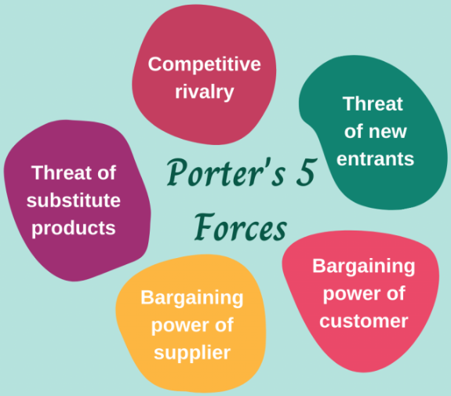
Figure 3: Porter Five Forces
(Source: Anscommerce.com, 2023)
Supplier power: The power of the supplier of Nike, in both the countries of UK and USA is low
Barrier to entry: The entry into the shoe production industry is not significantly difficult. However, the level of brand value that the company Nike has could not be developed by a new market in trends (Jiang 2019). Therefore the company experiences a moderate level of threat from new entrances in both the countries of the UK and USA.
Threat to substitution: The threat of substitution of the shoe products that are sold by the company, Nike is very low in both countries (Viana 2022).
Industry rivalry: There is the presence of significant level of rivalry in the market of operation of Nike, in both the countries of UK and the USA
Power of buyers: Since, the brand value of the company Nike is very high, the power which is exerted by the buyers in the market of the UK and USA is low (Saini et al., 2022).

SWOT analysis for US

Strengths: The brand equity of the company Nike is very strong. The company is having a low-cost manufacturing process which is the key part of the business strategy of the company. The application of innovative strategies were done for the purpose of conducting the marketing and the company adopted the strategy of engaging iconic celebrities for the endorsement of the products.
Weakness: The athletic shoe products of the brand Nike are facing controversies related to the labor practices. Moreover, the brand is also highly dependent on the US market. Another weakness of the brand is that it is having an unfavorable relationship with their retailers. Additionally, the revenue stream of the company is highly dependent on only the athletic footwear products (Kim, 2020).
Opportunities: The company Nike is investing in new markets and is also engaged in the practice of increasing the product range. The brand Nike is also tapping the key trends of the future in the athletic sportswear industry. The company is also taking the opportunity of new technologies and is also investing in sustainability. (Nica, Chiriță and Ionescu, 2021)
Threats: The company is facing the threat from counterfeit Nike products. The competition faced from other sports brands is also high. Moreover, the enforcement of the company in animal abuse scandals is also a significant threat.

SWOT analysis for UK
Strengths: Nike is striving to lay out a presence in the Unified Realm. The organization's exceptional swoosh seal and effective advertising techniques have set its position on the lookout (Fontaine 2020). Nike is at the front line of the sportswear industry on the grounds of its unrelenting obligation to development and headway. The firm sells various merchandise, including athletic apparel, footwear, and ornamentation, that are popular among purchasers.
Weaknesses: Nonetheless, Nike has several disadvantages in the UK market. Its products' high cost may restrict its market share, particularly when it faces competition from less expensive options (Fiorellini Bernardis 2019). Reputational hazards are associated with ethical issues, such as labor practice disputes. Furthermore, Nike's reliance on outside manufacturers exposes it to supply chain interruptions that may affect the availability of its products.
Opportunities: Nike has a lot of prospects in the UK, despite obstacles. The company has an opportunity to increase its online presence and attract more customers thanks to the expanding e-commerce trend (Chan 2023). Nike may grow its product lines in fitness and well-being-focused sectors to take advantage of the growing emphasis on health and wellbeing. Forming strategic alliances and working together, particularly with regional influencers and sports organizations, might lead to new business opportunities.
Threats: Nike faces challenges in the UK market that need to be carefully considered. Sustained efforts are necessary to retain and increase market share in the face of fierce competition from local and international sportswear companies (Heffron 2019). Risks come with economic downturns since they might cause consumers to spend less on luxuries like designer sportswear. Complying with changing legislation is essential for managing any obstacles, especially those pertaining to labor practices and sustainability. Furthermore, the danger to brand integrity posed by the widespread availability of fake Nike merchandise calls for the implementation of stringent trademark protection protocols.

Integration of SWOT analysis for both countries
An in-depth grasp of Nike's worldwide status is provided by the merging of SWOT studies for the US and the UK. Nike's competitive advantage is derived from its strong brand equity, creative marketing techniques, and celebrity partnerships. Nonetheless, issues still exist, including debates over labor standards and a strong reliance on the US market. Nike uses their swoosh symbol and creative marketing to try to make a big impression in the UK. However, there are drawbacks, such as high product costs and moral dilemmas. Prospects encompass worldwide market penetration, bolstering digital presence, and forming key partnerships. Risks include fierce rivalry, recessions, and the requirement for strict brand defense against knockoff goods. Nike's continued success on the international scene is ensured by careful consideration of these aspects.

3.0 Marketing Strategies

3.1 STP

3.1.1 U.K
Segmentation: The adoption of different criteria of segmentation is done for identifying the distinct groups of customers based on their preferences, needs and behavior in the market of the UK. The demographic segmentation of the market is done on the basis of age of the targeted populations like the young adults, teenagers or professionals. Demographic segmentation also involves tailoring the products based on the gender and also by providing different options for people with different income brackets. The geographical segmentation is done for tailoring the marketing efforts on the basis of the location of the consumers i.e whether they live in the rural or the urban region. The psychographic segmentation is done for being appealing to the consumers who are having a fitness oriented active lifestyle.
Targeting: The marketing messages are needed to be targeted to the individuals who are having an active lifestyle and are engaging regularly in physical activities. Moreover, the fashion conscious consumers also need to be targeted. The UK is popular for sports events. The country is also having athletic clubs who are also needed to be targeted with the marketing messages (Diantari and Jokhu, 2021).
Positioning: In order to position the product in the market of the UK, emphasis needs to be given on the act of highlighting the cutting-edge technologies as well as decisions that would be appealing to the fitness enthusiasts and athletes of the UK. Importance is given to the trend conscious customers of the UK. The British cultural values are needed to be reflected in the marketing campaigns.

3.1.2 USA
Segmentation: The segmentation of the market of the USA is being done on the basis of the variables of demographic segmentation, geographical segmentation, behavioral segmentation and psychographic segmentation. Unlike the UK, the population of the US is diverse, so the demographic segmentation is highly dependent on the factor of ethnicity and religious background (Hoffman, Gold and Curtin, 2019).
Targeting: In order to target the market of the USA, the creation of the products for meeting the specific sports needs such as soccer, basketball, learning and others is done. A wider strategy of targeting is needed to be done because of the presence of a diverse population in which specific attention is given to the sub urban, urban as well as rural market (Diantari and Jokhu, 2021).
Positioning: Since the market of the USA is highly conscious towards the environment, the positioning strategy of the product needs to communicate the commitment of Nike towards sustainability as well as ethical practices. The projection of a rich brand history is done for conveying credibility and authenticity. Strong emphasis is given on performance and innovation for catering to the diverse needs related to an active life for the consumers of America. The culture of America needs to be embraced in the marketing campaign of the brand Nike. Engagement with American celebrities and athletes need to be done for the enhancement of brand connection with the audience of the US (Hoffman, Gold and Curtin, 2019). Corporate social responsibilities need to be given emphasis for aligning with American values.
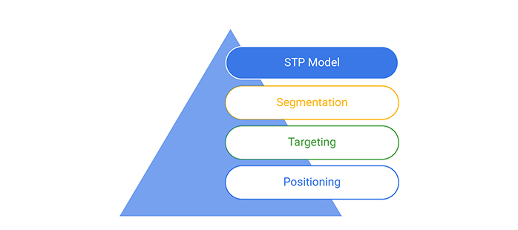
Figure 4: STP
(Source: Hoffman, Gold and Curtin, 2019)

3.2 7 P’s

Product: The consideration of the cultural preferences of the consumers of the UK and the USA is done. The products that are having high popularity in one country are different in the other country.
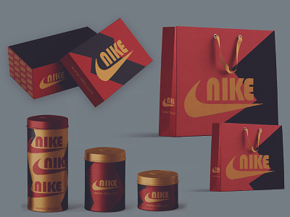
Figure 5: Packaging variety
(Source: Oliveira et al., 2021)
Price: This aspect is associated with the pricing and currency strategy. The difference of the values of currency of the UK and the US is affecting the pricing strategy of Nike in the country. The consideration of the value of US dollar is to be done for the development of the pricing strategy of Nike in the USA and the consideration of the value of the UK pound is done at the time of the development of the pricing strategy of the brand Nike in the USA (Oliveira et al., 2021). The consideration of the expectations of the consumers of the UK and USA, with respect to discounts, pricing as well as value perception is done. The adoption of psychological pricing strategy has been done by Nike in the market of UK and USA.
Promotion: The consideration of the cultural sensitivity of the consumers of the UK and the USA need to be done while framing the promotional strategies and marketing messages. The language, tone as well as the imagery utilized in the advertising campaigns are needed to be adjusted as per the cultural sensitivity of the consumers of the market of the UK and USA.
Place: Promoting to customers in the UK and the USA requires careful consideration of cultural sensitivity. In order to adapt advertising campaigns to the cultural quirks of every market, changes must be made to the language, tone, and images. The UK and the USA have different tastes and expectations when it comes to distribution and logistics. With so many different purchasing channels and distinct expectations for product availability, Nike's logistics and distribution network in the USA needs to be rather large. With benefits including local knowledge, lower financial risk, and quicker market penetration, franchising has been chosen as the market entrance approach. Loss of control and homogeneity are possible disadvantages. It takes strategic thinking to decide to franchise in these fast-paced marketplaces, weighing the pros and cons.
People: The consideration of the cultural differences of the people of the UK and the USA is done while marketing the products of the brand Nike. The different people aspects that are needed to be considered, should be with respect to both the employees and the customers. Cultural communication styles and nuances that are different for both of the countries would be affecting the approach of employee management as well as the customer service approach (Oliveira et al., 2021).
Physical Evidence: The understanding regarding the cultural expectations of the consumers of the UK and the USA is needed to be done. The physical evidence signifies the tangible elements that are supporting the product or services. This would be including the branding, packaging as well as overall perception related to sports footwear.
Process: The processes that are related to the regulatory and legal compliances are needed to be considered as they are different in the markets of the UK and USA. The brand is needed to adhere to the local regulations which is crucial for the brand to successfully operate in both of the markets.

3.3 Market Entry Methods

3.1.1 UK
The market entry method which is most preferable for entering the market of the UK are the following:
- Setting up flagship stores in the prime locations: The brand Nike is needed to establish flagship stores in all the prominent locations of the major cities of the UK for the purpose of letting the brand build a strong presence. These stores would be serving as showcases of the latest innovations in the products of the present.
- Collaborating with local athletes: The brand Nike is needed to collaborate with the popular athletes as well as sports teams of the UK for enhancing the brand image of Nike in the UK (Oliveira et al., 2021).
- Online retailing and customisation: The brand Nike is needed to leverage the growth of the trend of online shopping. The brand can enhance the e-commerce platform. It is operating in the UK by offering customized options for their products like limited edition, release of personalized designs for attracting as well as retaining the customers.
- Sponsorship and community engagement: In order to further develop the entry of the brand Nike in the market of the UK the company is needed to engage with the local communities with the help of sports sponsorship events, youth programmes and the sponsorship with the local teams for contributing to the brand loyalty of Nike. This would help the brand align with the market of the UK.
- Social responsibility and environmental initiatives: The marketplace of the UK is putting a strong emphasis on social responsibility and sustainability. Therefore the brand Nike is needed to highlight its commitment towards these values, by launching marketing campaigns as well as product initiatives that would be resonating with the consumer base of the UK.

3.1.2 USA
The market entry methods, which is preferable for entering the market of the USA are the following:
- Strategic partnership: In the adoption of the strategy of the advantage is of the development of partnership with the sports and retailers, speciality stores as well as department stores in the key regions of the US, the partnership would be helping the footwear brand to increase the market share. However, this would be having the involvement of collaboration or exclusive product launches for the creation of a unique experience of shopping (Xintong and Xin, 2021).
- Franchising: Since, the market of the USA is fast, the option of franchising would be an effective mode of entry. This would be allowing the brand to operate the stores under the guidance of a local operator who is having in-depth understanding of the market dynamics and preferences of the local consumers of the USA.
- E-commerce expansion: In order to expand the market of the branded Nike in the USA, consideration of the e-commerce space is needed to be done for aligning with the growing trend of online shopping in the country of USA. The online shopping expenses are needed to be enhanced and digital marketing strategies are needed to be leveraged for obtaining a broader reach to the audience.
The considerations that are needed to be made for both the markets are the following:
- Cultural sensitivity: There is the requirement of understanding and then respecting the cultural elements for both of the countries for successfully operating and expanding in the markets. Nike is needed to tailor the marketing message and also produce offerings for aligning with the local preferences of the UK and USA.
- Digital marketing: The company is needed to invest in digital marketing strategies in the countries of both the UK and USA. Influencer partnership, social media as well as online advertising would be powerful tools for reaching the target audiences (Xintong and Xin, 2021).
- Regulatory compliances: The company is needed to comply with the local standards and regulations of the respective countries of the USA and the UK. This would ensure that Nike products as well as business practices are adhering to the applicable laws of the footwear industry that are different in both of the countries.
- Market research: Total market research is needed to be conducted in the individual countries of the UK and the USA. The advantage is that this would be including the understanding regarding the preferences, consumer behavior as well as competitive landscapes for informing the strategic decision making.

3.4 Directional Development strategies
The directional development strategies signifies the expansion and growth approaches of the company for the purpose of the achievement of the objective of the development of an effective marketing strategy.

3.4.1 UK
- Localized marketing campaign: There is the requirement of the development of a marketing campaign which resonates with the values and culture of the British. Hence, engagement is to be done with the local events, partnerships and sponsorships for connecting with the community and in reinforcing the brand loyalty (Simha, 2020).
- Inclusive initiative and diversity: There is the requirement of promoting inclusivity and diversity in marketing as well as product offerings. This would involve collaboration with all the local designers and the diverse athletes of the local market for the purpose of the enhancement of the inclusiveness of the product lines of the brand Nike.
- Technological integration: The brand is needed to incorporate cutting-edge technologies within the retail spaces for the enhancement of in-store shopping experiences. This would include interactive displays, virtual try on’s, smart meters for engaging the customers.
- Grassroot initiatives and community engagement: There is the requirement of strengthening ties with the local community by the enhancement of investment in grass root programmes of sports. Initiatives such as supporting the local athletes as well as in engaging with the community development initiatives would be aligning with the emphasis of the brand on capturing the consumers of the UK.

3.4.2 USA
- Retail expansion: The company is needed to open flagship stores in all the cities for the enhancement of the visibility of the brand and also for the creation of an impressive brand experience. The opportunities in the emerging markets within USA are needed to be explored for the purpose of capturing the untapped consumer segments.
- E-commerce innovation: The company is needed to increase its investment in the technological advancements for the purpose of providing an enhanced online shopping experience. There is the requirement of the implementation of technology structures, virtual try on, augmented reality features, as well as personalized recommendations for the purpose of the enhancement of the journey of a digital customer.
- Sustainability focus: The company Nike is needed to enhance its commitment towards sustainability by the introduction of products as well as manufacturing practices that are eco-friendly. They are needed to communicate the efforts effectively for resonating with the environment conscious customers.
- Collaborations: The company is needed to influence the athletes and continue partnership with them along with celebrities for launching exclusive collaborations as well as limited edition releases (Simha, 2020). This strategy is needed to be adopted for the generation of excitement, creating an image of exclusivity and also for driving the consumer's demand.
- Expansion in the domain of health and wellness: There is the requirement of capitalizing on the growing interest of the consumers regarding the health and wellness-based products by the expansion of the product line in the domain of sports and fitness. This would be including the development of partnership with fitness apps and also the development of smart athletic wear by expanding into fitness and training services.
There are a number of common considerations that are needed to be made by the brand in both the markets that at the following:
- Digital transformation: The company is needed to continue investment in digital technologies as well as e-commerce platforms for adapting with the changing behavior of the consumers. The development of seamless off-line and online integration is to be done for the development of a holistic customer experience.
- The supply chain optimisation: The supply chain is to be optimized for sustainability and efficiency and the brand is needed to explore opportunities within the local manufacturing as well as sourcing for aligning with the global trends towards the development of a transparent and responsible supply chain.
- Continuous innovation: The company is needed to bring about continuous advancement and innovation in the product lines.

4.0 Discussion of the similarities and differences across as wide a range of variables of business of the brand Nike

4.1 UK
In the case of analyzing the brand Nike's activities in the UK market, a discussion of the brand's similarities and contrasts across a wide variety of characteristics provides intriguing insights (Fontaine, 2020). In the field of marketing, it is crucial to evaluate the implications of national differences and similarities, paying special attention to human aspects and cultural communities, and understanding how market structures, political and economic characteristics, and sociodemographic vary from one another. Subtle cultural differences are a big part of Nike's success in the UK. The British market likes a blend of modern and traditional styles. Nike has successfully merged its worldwide brand with regional tastes, realizing the value of cultural resonance.
For example, advertisements showcasing regional sports heroes and embracing British sports culture have been positively received by the UK public. Brexit and other economic measures have shaped the UK market's distinct features on the economic front. Nike has demonstrated its capacity to successfully handle information and extrapolate meaning from changeable economic landscapes by adjusting pricing strategies and supply chain management to navigate through economic uncertainty (Hébert-Losier et al., 20222). Nike has had to match its political tactics to the UK's regulatory framework. Adherence to labor laws and environmental restrictions has been essential, demonstrating a dedication to moral behavior. This is in line with the modern ethical standards needed for international marketing. Nike has acknowledged the varied client base in the UK based on sociodemographic factors, catering to different lifestyles and interests.
Nike has exhibited proficiency in developing tactics that align with the shifting socio-demographic environment of the United Kingdom by customizing products and marketing messaging for distinct segments (Firmansyah, 2019). Nike's skillful management of cultural, economic, political, and sociodemographic factors has contributed to its success in the UK market. The brand has demonstrated a thorough awareness of the many variables at play in the global marketplace by skillfully managing information, deriving meaning, and creating worldwide marketing strategies that are both morally and culturally appropriate.

4.2 USA
The Nike brand stands out as a success model in the field of worldwide marketing with its ubiquity and iconic position. Analyzing Nike's business factors in the US reveals both parallels and divergences in a variety of ways. Nike has successfully incorporated the American values of athletics, innovation, and independence into their culture. By supporting well-known players and teams, the brand has skillfully integrated itself into the fabric of American sports culture and developed a strong bond with the country's ardent sports fan base (Yan et al., 2022). But Nike's attitude to cultural groups goes beyond sports; it welcomes a variety of cultural components and uses partnerships and sponsorships to connect with a wide range of customers. Regarding the human element, Nike has led the way in recognizing and resolving social challenges.
A sophisticated awareness of the various human facets present in the American market is demonstrated by initiatives such as the support of social justice issues and campaigns aimed at empowering women (Adrian and Faiza, 2022). The fierce rivalry that characterizes American market structures necessitates strategic agility. In order to keep ahead of the competition, Nike has thrived in this area by consistently reinventing its goods and marketing techniques. Nike's target market's purchasing power is greatly influenced by economic factors, such as disposable income and consumer spending habits, which also shape the brand's pricing and promotional activities. Nike has skillfully handled political controversy by using moral principles as a guide when making decisions. The brand's commitment to environmental and social responsibility speaks to a modern ethical mindset that appeals to socially concerned American consumers. Nike's marketing methods cater to a wide range of age groups and demographics, demonstrating its capacity to adjust to the changing needs of the American populace.
Efficient information management is critical to developing a thorough foreign marketing plan for the US market. Nike's success comes from both comprehending marketing concepts and placing them in the context of the country's dynamic and diversified environment (Brandberg et al., 2020). This strategy execution fluency is a reflection of the brand's ability to skillfully combine marketing knowledge with a keen understanding of the social, cultural, and economic context of the United States.

5.0 Strategies and organizational approaches used to the discussed factors by Brand Nike

5.1 UK
Nike uses a strategic strategy to handle cultural quirks, human factors, and various market structures in the ever-changing UK market. Nike recognizes the value of cultural groups and designs its marketing campaigns to speak to the diverse range of British culture. This entails skillfully incorporating regional traditions, ideals, and inclinations into their marketing initiatives to establish a strong bond with the intended audience (Niskanen, 2019). A key component of Nike's UK market strategy is human factors. Nike's ability to comprehend the attitudes, habits, and goals of British consumers allows them to design campaigns that are not just aimed at promoting their products but also at fitting in with the social fabric.
Beyond simple product placement, this strategy cultivates a feeling of connection and affiliation with the brand. Nike's approach also takes politics and the economy into account. Resilience and relevance are ensured by adjusting to the political and economic climate of the United Kingdom. Furthermore, sociodemographic data is carefully examined in order to serve a variety of customer groups. Nike uses data analytics to gather insightful information through efficient information management, which informs innovative global marketing tactics. The business has proficiency in developing strategies by including moral issues in its designs.

5.2 USA
Nike has a strategy that combines many organizational approaches and strategies in order to navigate the complex U.S. market. Nike's cultural resonance with American consumers stems from its embrace of the country's ideals of athletics, innovation, and individuality. To inspire and resonate with the spirit of America, the marketing techniques emphasize the 'Just Do It' concept while leveraging cultural differences (Wells, 2019). In Nike's U.S. approach, human factors are crucial since the company teams up with athletes and celebrities to create strong emotional bonds. This strategy makes use of the public's obsession with sports and celebrity culture, which helps the brand succeed in a market where influencers and personal narratives are key factors.
Nike is also skilled at navigating American market systems, seeing the value of direct-to-consumer and e-commerce avenues. Dynamic pricing methods and strategic alliances are employed to handle the economic factor, therefore guaranteeing the brand's accessibility to a wide range of socio-economic groups. Nike strategically interacts with social and political concerns in order to support causes that the American people find appealing. Nike recognizes the variety of tastes and lifestyles that are common in the United States and caters its products to a wide range of age groups based on sociodemographic factors.

6.0 Recommendations

6.1 Recommendations for UK
Nike may provide strategic suggestions using the TOWS matrix in the context of international marketing, especially in the UK market. It is advisable to leverage Nike's assets in terms of global reach, innovation, and brand awareness in order to seize opportunities and counteract any threats (Jenkins and Huzinec, 2021).
Strength-Opportunity (SO) Strategy: Profit from the expanding health and wellness trend in the UK market by utilizing Nike's unique product line and strong brand image. Incorporate specialized sportswear and footwear that corresponds with the growing need for customers who prioritize exercise.
Strength-Threat (ST) Strategy: Reduce possible risks by making use of Nike's extensive worldwide reach and formidable marketing skills. Create targeted advertising campaigns that speak to the UK market, addressing issues like ethical sourcing and sustainability to dispel any unfavorable impressions.
Weakness-Opportunity (WO) Strategy: In order to overcome flaws like possible price sensitivity, introduce reasonably priced product lines made especially for the UK market. Work together with regional athletes and influencers to build brand recognition and connect with a wide range of customers.
Weakness-Threat (WT) Strategy: Invest in strategic alliances or acquisitions to proactively address vulnerabilities, such as local brand rivalry. This can mitigate any potential negative effects and help Nike gain a firmer footing in the UK market.

6.2 Recommendations for the US
Nike's TOWS analysis for the US market shows tactical suggestions that build on internal strengths to overcome opportunities, neutralize threats, and overcome weaknesses (Rasmussen et al., 2022).
Maximize Strengths to Exploit Opportunities (SO): Nike should develop technologically sophisticated and sustainable goods (O) to address the growing demand for eco-friendly and high-performance athletic gear, building on its strong brand image (S). Partnering with prominent sportsmen and influencers may improve brand affinity and market penetration.
Convert Weaknesses by Exploiting Opportunities (WO): Nike can offer mid-range or entry-level product lines (O) to attract cost-conscious consumers without sacrificing quality in order to address the issue of excessive product price (W). Incorporating consumer loyalty initiatives and bundle choices helps mitigate pricing apprehensions while cultivating brand allegiance.
Use Strengths to Counteract Threats (ST): Nike is in a good position to handle market saturation (T) by concentrating on specialized markets or launching exclusive product lines because of its strong worldwide presence and brand loyalty (S). Even in the face of market rivalry, consistent innovation and marketing initiatives may guarantee ongoing consumer interest.
Minimize Weaknesses to Defend Against Threats (WT): Reducing the effect of competition (T) entails fixing flaws such as possible supply chain vulnerabilities (W). Nike can manage uncertainties and interruptions in the global market by diversifying its sourcing alternatives and enhancing the robustness of its supply chain.

7.0 Conclusion
Hence, it can be concluded with the help of the above analysis of the market of the countries of the UK and the US that the brand Nike is needed to evaluate the preferences of the customers of both the countries for the purpose of designing the marketing strategies that would be most effective in both of the countries. The alignment of the marketing strategies is needed to be done as per the culture, political situation, economic situation and the behavior of the consumers of the countries. The consideration of all the factors are highly significant for aligning with the trends and culture of both the countries.

Reference List
Adrian, D. and Faiza, E., 2022. Women's Empowerment in Nike Advertisements: A Multimodal Analysis.
Anscommerce.com, 2023. Retrieved from https://www.anscommerce.com/blog/how-porters-five-forces-help-in-e-commerce-business-analysis/. Accessed on 13-12-2023.
Brandberg, O., Myrefelt Norlinger, M. and Ngo, K., 2020. Nike’s Dream Crazy campaign and how it influenced views and opinions towards the brand.
Chan, E.L., Wachs, F.L., Garcia, C., Cotter, B.T. and Muñoz, R., 2023. Recuperative wokeness: Nike and the commodification of potential for social change. Sociology of Sport Journal, 1(aop), pp.1-10.
Change.walkme.com, 2023. Retrieved from https://change.walkme.com/geert-hofstede-model/. Accessed on 13-12-2023.
Chen, J., 2021. Investigation and analysis of Anta’s product marketing strategy.
Diantari, N.P.E. and Jokhu, J.R., 2021. The Impact of Instagram as a Social Media Tool on Consumer Purchase Decision on Nike. Jurnal Ilmiah Manajemen Dan Bisnis, 7(1), pp.116-127.
Enterslice.com, 2023. Retrieved from https://enterslice.com/learning/pestle-analysis-a-mechanism-for-analysis-of-businesses/. Accessed on 13-12-2023.
Fiorellini Bernardis, A., 2019. Labor issues and workers’ rights within the global supply chain. How to manage the work environment. The Nike case.
Firmansyah, R.S., 2019. Revealing racial hegemony in Nike advertisement campaigns on Youtube: a systematic multimodal critical discourse analysis. Haluan Sastra Budaya, 3(2), pp.189-203.
Fontaine, S.P., 2020. Analyzing the Social Media Presence of Nike, Adidas, and New Balance Using Social Listening.
Fontaine, S.P., 2020. Analyzing the Social Media Presence of Nike, Adidas, and New Balance Using Social Listening.
Hébert-Losier, K., Finlayson, S.J., Driller, M.W., Dubois, B., Esculier, J.F. and Beaven, C.M., 2022. Metabolic and performance responses of male runners wearing 3 types of footwear: Nike Vaporfly 4%, Saucony Endorphin racing flats, and their own shoes. Journal of Sport and Health Science, 11(3), pp.275-284.
Heffron, E., 2019. Nike's Corporate Social Advocacy (CSA) Practices as Related to Strategic Issues Management (SIM) and Threats to Organizational Legitimacy.
Hoffman, A.N., Gold, N. and Curtin, C., 2019. Nike, Inc.: Late Arrival to the “Athleisure-wear” Trend. Rotterdam School of Management, Erasmus University.
Jenkins, E.S. and Huzinec, M., 2021. Memeability in an Attention Economy: On the Form of the Nike Kaepernick Meme. Southern Communication Journal, 86(4), pp.402-415.
Jiang, W., 2019. Sustainable development of supply chain in footwear industry–take Nike as the case. Asian Business Research, 4(3), p.86.
Kim, M., 2020. How Phil Knight made Nike a leader in the sport industry: Examining the success factors. Sport in Society, 23(9), pp.1512-1523.
Nica, I., Chiriță, N. and Ionescu, Ș., 2021. Using of KPIs and Dashboard in the analysis of Nike company's performance management. Theoretical & Applied Economics, 28(1).
Niskanen, H., 2019. Sustainability in the sporting goods industry: How Nike, Adidas and Puma have developed company sustainability.
Oliveira, M., Rodrigues, I., Lopes, J.M., Borges, A. and Oliveira, J., 2021. How Can Gamified Applications Drive Engagement and Brand Attitude? The Case of Nike Run Club Application. Administrative Sciences, pp.1-20.
Rasmussen, K., Dufur, M.J., Cope, M.R. and Pierce, H., 2021. Gender marginalization in sports participation through advertising: The case of Nike. International Journal of Environmental Research and Public Health, 18(15), p.7759.
Saini, M., Saravanan, D., Kutty, N.M. and Agrawal, R., 2022. Brand Influencing Customers Buying Behaviors: A Case Study on Nike. ECS Transactions, 107(1), p.5597.
Savitha, R. and Roopa, J., 2023. A Study on Effect of Content Marketing on Customer Engagement with Respect To NIKE. Journal of Survey in Fisheries Sciences, 10(4S), pp.1806-1816.
Simha, S., 2020, August. Study of Sensory Marketing Strategies in Retailing Business. In 3rd Asia Pacific Management Research Conference (APMRC 2019) (pp. 34-38). Atlantis Press.
Viana, A.L.D.V., 2022. Nike-s self-evident supremacy within rising competition. how to grow stronger in a post-endemic environment (Doctoral dissertation).
Wells, P., 2019. Just Do It, Impossible Is Nothing: Animation and Sports Commercials. Animation and Advertising, pp.179-193.
Xintong, W. and Xin, M., 2021. Study on Co-design of Fashion Brands and Their Marketing Strategies. In 5th International Conference on Education, Management and Social Science (EMSS 2021) (p. 276). Francis Academic Press.
Yan, C., Brown, C. and Greenleaf, A., 2022. Just Do It: Analysis of Nike’s Marketing Strategies and Growth Recommendations. Journal of Student Research, 11(4).

