DS 1 Template

My Screenshots/Photos
- Please add 4–6 screenshots or photos of your digital life.
- You can use your phone or laptop.
- For each screenshot, write one or two sentences explaining what it shows.

Screenshot/Photo 1
[Insert Photo/Screenshot below]
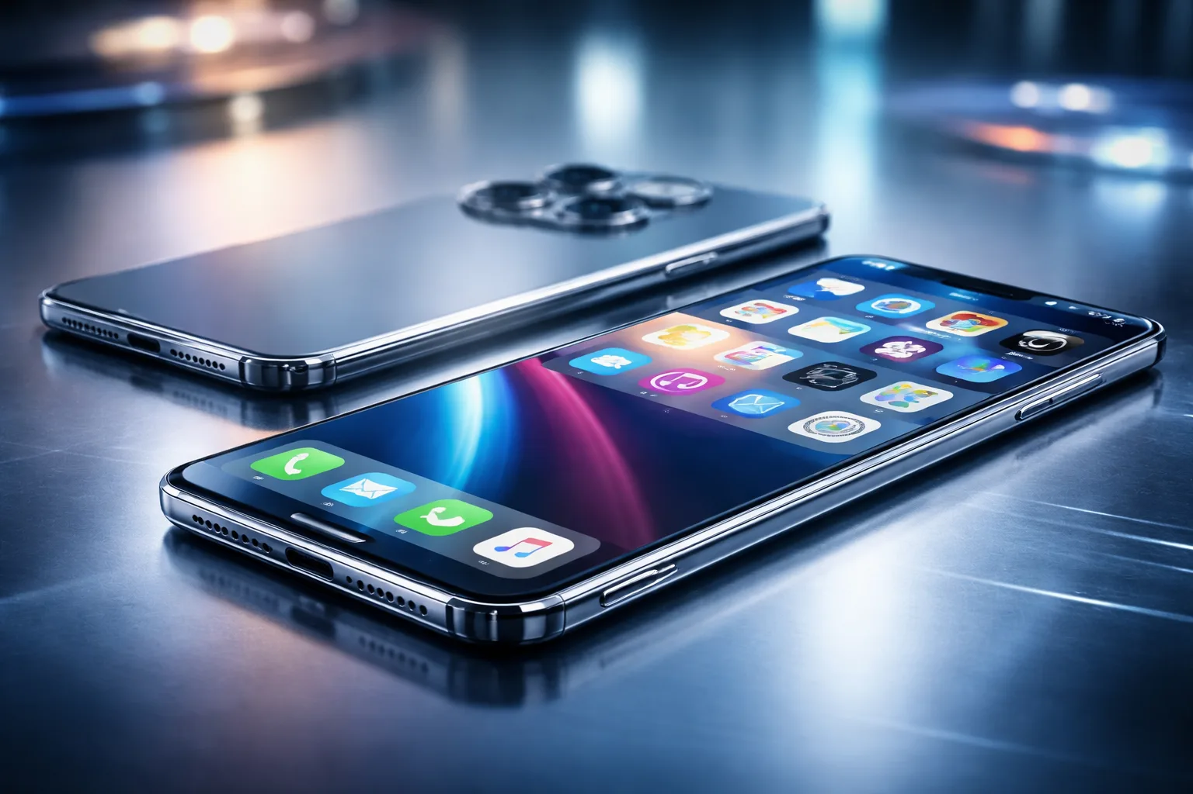
[Write what this shows of your digital life]
I use my iphone mostly for social media and phone calls.
I feel like im good on using social media platforms and how to utilise them and learn from them. And I would want to improve on knowing when to get off socials because once im on Instagram, snapchat, facebook. I find it hard to close the apps once Im deep into it.
And why do the skills matter because sometimes you can learn a lot more watching 1 video on youtube on how to make good coffee you can learn better and make it better in a 1 minute video short then reading and following a recipe

Screenshot/Photo 2
[Insert Photo/Screenshot below]

[Write what this shows of your digital life]

Screenshot/Photo 3
[Insert Photo/Screenshot below]
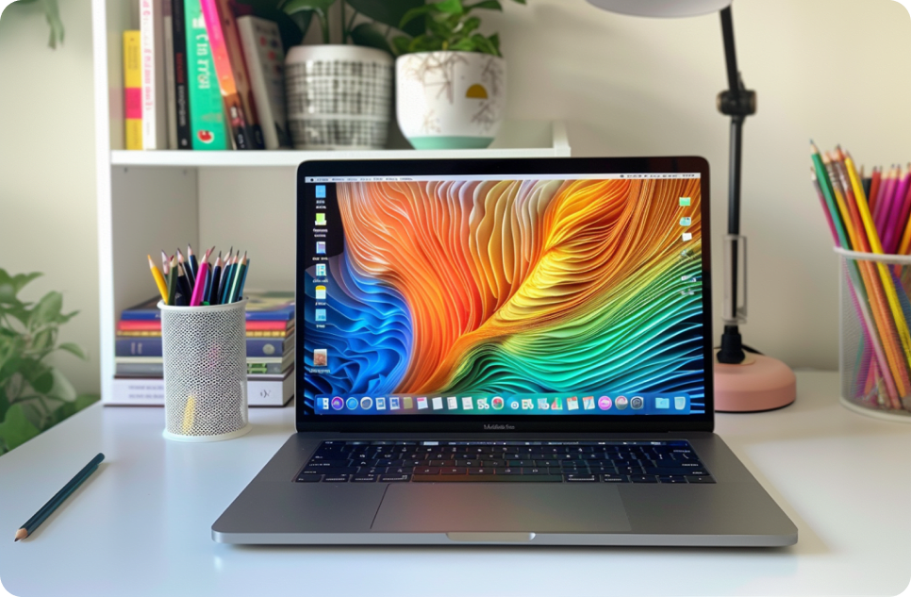
I use laptop mostly for buying and selling stuff like cars, games, bikes, etc.
I feel like im good at negotiations, I can talk down to a price where is fair on both sides and both parties can walk off happy
what I need to learn and get better with is patience and trust I find my self losing interest fast if the seller or buyer don’t respond on time and immediately call it a scam when 80% of the time is not
And these skills matter because learning to negotiate and sell helps a lot in the business world
[Write what this shows of your digital life]

Screenshot/Photo 4
[Insert Photo/Screenshot below]
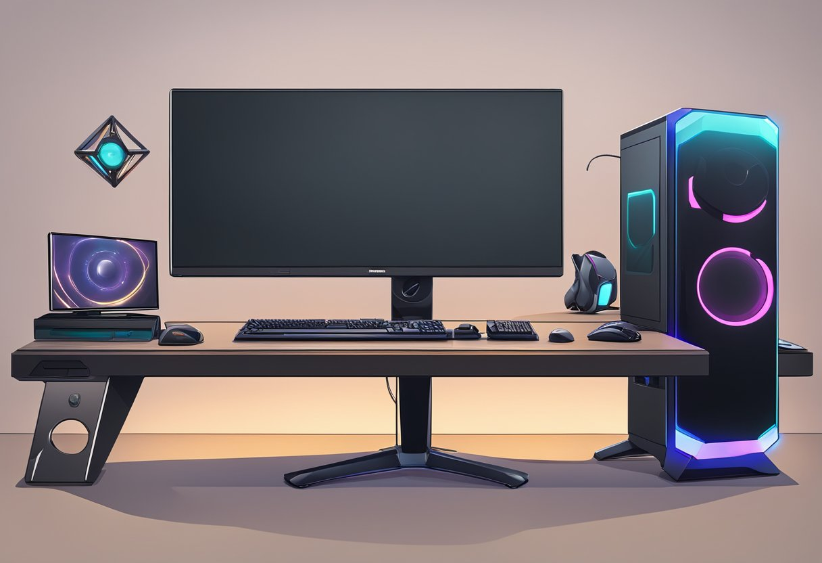
[Write what this shows of your digital life]
I use my pc for meetings, research and planning.
I feel like im good at researching the internet using my pc feels more free and less closed off I like the space I get at my desk
I want to improve on planning better since I lack in that area keeping to a schedule and following a plan
these skills matter because researching is one the most valuable assets in business

Screenshot/Photo 5
[Insert Photo/Screenshot below]
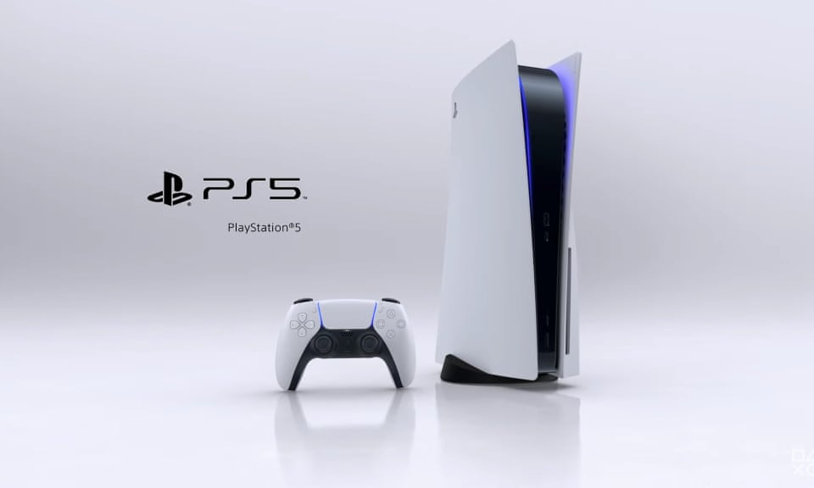
[Write what this shows of your digital life]
I play on my PS5 mostly car racing games
I feel like im good at escaping the real world and just relax clear my head and reset while being on my PS5
I would want to improve knowing when to get off on the game same issue as I have with social media once im too long on them its hard for me to stop
and these skills matter because knowing I can reset my brain and destress and start over with a clear mind the next day but getting on the game and just enjoy what im doing

Screenshot/Photo 6
[Insert Photo/Screenshot below]
[Write what this shows of your digital life]

My Short Reflection
- Write 5–8 simple sentences about your digital life.
- You can use the sentence starters below if helpful.
I use digital tools to use social media for my own enjoyment
I feel confident when I negotiate using my laptop
I want to improve my planning
I often use these tools to research and answer my questions
I sometimes feel nervous when doing my home work/assignments
I hope this module will help me improve my confidence and knowledge
digital skills are important for me because I learn a lot more them

Sentence starters
- I use digital tools to …
- I feel confident when I …
- I want to improve …
- I often use these tools: …
- I sometimes feel nervous about …
- I hope this module will help me …
- Digital skills are important for me because …
You can write more if you want.

Submission Checklist
Before you submit, please check:
​​​ ☒ I added 4–6 screenshots
☒ I wrote short sentences for each screenshot
☒ I wrote my short reflection
☒ My work is my own
☒ My file opens correctly
​​☒ My file opens correctly

