Student name: Mia Johnson
Student number: 2205387
Module: Independent Project
Module code: BMTP6015
Assignment Title: Portfolio of evidence and the live event
Lecture’s name: Scott James

ITT Portfolio of Evidence – Mia Johnson
Introduction: 1
Strategic Frameworks for Event Success: 2
October 24th Document: 3
Discussion of roles and what people would ideally like to do: 4
Ideas: 5
Exhibition Ideas: 5
On the Day of the event (11th February 2025): 7
Roles: 8
Companies I contacted and when: 9
The specific aims are as follows: 11
Event Budget and Cost Overview: 12
Risk Assessment: 13
Communication Plans: 15
Social Media: 15
Communication: 16
Essential Resources: 16
Summary of ITT Future You Event at Swansea Arena 17
Post-Event Evaluation: ITT Future You 2025 17
Conclusion 19
Reference list: 19

Introduction:
As the Exhibition Manager for the ITT Future You event, I was responsible for coordinating and managing the exhibition space to create a seamless, engaging experience for both exhibitors and attendees. My main tasks included overseeing the registration and allocation of exhibitor stands, coordinating coordination, and ensuring the smooth setup and dismantling of the event (Getz, 2012).
In collaboration with exhibitors, I ensured that their specific needs were met while optimising the exhibition layout to foster interaction between them and attendees. By effectively managing communication and adhering to timelines, as noted in the research of Morreale, Osborn, and Pearson (2000), I contributed to the creation of a well-organised and vibrant exhibition space that played a key role in the event’s overall success (Tzortzi, 2004).
The research of Deci and Ryan, (2012) states that individuals are more motivated and perform better when tasks align with their intrinsic interests and strengths. When a task supports a sense of competence and autonomy, there is a higher likelihood of engagement and success. This explains why people often choose tasks that match their interests and abilities rather than those that do not align with their motivations. From this research, the reason I was best suited to being one of the exhibition managers is I am well organised, adaptive and flexible as well as having excellent attention to detail.

The Role of Mind Mapping:
To visually organise key ideas and their relationships, I created a mind map. Mind maps are a powerful tool for brainstorming, problem-solving, and structuring information clearly and engagingly (Erdem, 2017). They help break down complex concepts into interconnected, simpler parts, boosting creativity and enhancing memory retention. By using a mind map, I was able to organise various aspects of the ITT Future You event, including exhibition concepts, potential contacts, and engagement strategies.
As noted by Buzan (2010), mind maps not only assist in organising ideas but also guide better planning and organisation, making information more accessible and easier to recall. Buzan (2024) further emphasizes that the purpose of a mind map is to identify crucial areas for success and visually structure the relationships among key concepts.

Strategic Frameworks for Event Success:
In creating the mind map, I integrated several strategic frameworks to ensure a thorough approach to the event's success. One of these frameworks is Stakeholder Theory, which I used to identify and categorize primary stakeholders—such as exhibitors, attendees, sponsors, and event staff. Understanding each group’s unique interests and influence, as discussed by Friedman and Miles (2002), helped me tailor communication strategies. For instance, exhibitors were primarily interested in networking opportunities and brand visibility, while attendees were focused on gaining informative and engaging experiences. This helped in aligning our efforts to meet the expectations of each stakeholder group (Perrier, 2015).
Additionally, I applied the Segmentation, Targeting, and Positioning (STP) Model to further refine our approach (Kotler, and Keller, 2016). According to Kalam (2020), segmentation allows for a better understanding of the audience, which I divided into students, industry professionals, and educators. By targeting each segment with specific messaging—such as career development insights for students and networking opportunities for professionals—I was able to position the event as a valuable platform for learning and industry connections. This targeted approach helped maximize engagement and satisfaction across diverse audience segments, as noted by Baxter and Smith (1993).
The integration of these theoretical frameworks into the mind map allowed for a structured, strategic approach to organising the ITT Future You event. By addressing stakeholder interests and employing targeted messaging, I was able to enhance both the attendee and exhibitor experience, ensuring the event’s overall success (Brown, and James, 2004).

October 24th Document:
On the 24th of October, our group gathered to brainstorm and compile a list of informal ideas for this year’s ITT Future You event, which we would present to Jacqui Jones, the Programme Manager for Tourism & Events. Jacqui, who has been a respected member of the University for over 30 years, brings a wealth of experience and expertise in organisng and hosting events. Throughout my university experience, she has been a consistent source of support, significantly contributing to both the academic and professional development of students. Her dedication to excellence continues to inspire and influence those around her.
This brainstorming session was an opportunity to explore different possibilities and share creative insights. By gathering diverse perspectives, we were able to ensure a comprehensive approach that considered various aspects of event planning and execution. The ideas and concepts for the ITT Future You event evolved through collaboration and teamwork, with Jacqui’s valuable input shaping our direction (Berridge, 2018).
These discussions were crucial in refining our approach, as each team member contributed their unique perspectives and feedback. This collaborative process reflects Social Learning Theory (Bandura, 1977), which emphasizes the importance of learning through social interactions. By engaging in dialogue and exchanging ideas, we were able to build on one another's viewpoints, resulting in new insights and innovative solutions. Bandura’s theory underscores how social context and communication influence learning, and in our case, these group interactions were essential in developing stronger event concepts (Bandura, 1986).

Discussion of roles and what people would ideally like to do:
I chose to work as the Exhibition Manager because it aligns perfectly with my strengths in organisation, strategic planning, and my passion for creating engaging experiences. Self-Determination Theory (Deci & Ryan, 1985) suggests that motivation thrives when tasks fulfil three basic needs: autonomy, competence, and relatedness. This role meets all of those needs for me.
First, it provides autonomy, as I have the freedom to make key decisions about exhibition layouts and coordination with vendors, which allows me to feel in control and creatively challenged. It also helps me build competence by utilizing my problem-solving skills and attention to detail. When the event runs smoothly, it boosts my confidence in my abilities. Finally, the role satisfies my need for relatedness, as it gives me the opportunity to work closely with exhibitors, my team, and attendees, fostering valuable connections along the way (Gammie & Cargill, 2002).
Choosing this role has enabled me to leverage my strengths while pursuing my interests. It has been a fulfilling opportunity for both personal and professional growth, all while contributing to my long-term career aspirations (Soria & Stubblefield, 2015).

Ideas:

Exhibition Ideas:
The organisations selected for the ITT Future You event were chosen based on their alignment with the event's core goals of networking, learning, and career development. Each organisation brings valuable industry expertise and insights that help enhance the event’s overall impact. By offering relevant resources and facilitating meaningful connections, they play a key role in ensuring the success of the event for both exhibitors and attendees (Ghasemi & Amyot, 2020).
In making these decisions, my process was guided by several key factors, including the event’s objectives, target audience, and available resources. For example, I carefully designed the exhibition layout to encourage attendee flow and maximize interaction (Tassiopoulos, 2010). Additionally, I took into account feedback from past events, which helped refine the layout and improve the overall experience (Stone, 1981). These decisions were made with the intent to create an engaging environment that directly aligns with the event’s goals, ensuring that all participants—whether exhibitors or attendees—benefit from a meaningful experience (Mair, 2013).

On the Day of the event (11th February 2025):
To ensure smooth communication among all team members during the event, I recommend arranging walkie talkies. Last year, we faced challenges in reaching organisers due to poor mobile service within the Arena. Having walkie talkies would enable us to stay in constant contact, address any issues quickly, and improve the overall efficiency of the event (Genç, 2017).
In addition to communication, we will be providing tea and coffee for both exhibitors and the college and school lectures throughout the event. Refreshments will be available in designated areas for exhibitors to network, as well as throughout the day to enjoy while engaging with others. This service aims to enhance the overall event experience by creating opportunities for informal interactions and fostering a positive atmosphere (Stokes, 2006).
To keep everything on track, regular meetings will be scheduled to monitor and assess the progress of the project. These meetings will allow all team members to share updates, address any challenges, and ensure milestones are being met on time. By holding consistent check-ins, we can identify potential issues early, make necessary adjustments, and keep the project on course to meet its goals and deadlines.

Roles:
Roles within the team were determined by assessing the project’s needs and the expertise of each team member (Smith & Johnson, 2020). We prioritized tasks that would directly impact the project’s success, assigning key responsibilities, such as project management first (Brown et al., 2019). Roles will then be distributed based on individual strengths and preferences, ensuring that each team member is matched with tasks they are best suited for (Williams, 2018). While input from the team will be considered, the project manager or team lead will make the final decisions to ensure alignment and maintain motivation across the team (Taylor, 2021).
After the meeting, I created an Excel spreadsheet to track 180 potential exhibitors and personally contacted 64. This organised approach streamlined the outreach process, allowing the team to efficiently follow up and secure participation, which contributed to the overall success of the event. As well as contacting 64 exhibitors I also picked up emails from other an example of this was Jacqui Jones she was unable to be in university due to personal issues I also helped contact the ones on her list and follow up with them too.
In my role as the Exhibition Manager, I have learned that building long-term relationships is crucial to the success of any event. Relationship Marketing Theory (Berry, 1983) emphasizes the importance of nurturing ongoing relationships with exhibitors, sponsors, and partners. By maintaining strong, personalized connections, we not only benefit the current event but also lay the foundation for continued support in future endeavours.
Moreover, Network Theory (Granovetter, 1973) underscores the significance of interconnected relationships within a network. In the context of event planning, these connections—whether with vendors, attendees, or other professionals—can be leveraged to share resources and opportunities, ultimately enhancing the event’s success. By applying both of these theories, I have seen firsthand how cultivating strategic relationships and networks can contribute to the growth and long-term success of events (Jago, and Deery, 2010).

Companies I contacted and when:
Student Accommodations in the area | Student roost, Seren, Old way centre, True student, Ty Nant, Crown Place. | These were contacted on the 6th of January and 3 confirmed as coming
Attractions in Swansea | Plantasia, Ninja Warrior, Bunkers, Swansea Museum, Oyster mouth castle, MiTours, VIP Wales, Zip world, the wave, Swansea grand, Revive wellness club, The Egypt centre, Glynn Vivian Art Gallery, Mission Gallery. | These were contacted from the 6th of January to the 22 January
Bristol attractions | Wake the tiger, We the Curious, Virgin balloons, Noah's ark, Bristol Zoo, Aerospace, Wookey hole, SS Great Britain, Tyntesfield, Bristol Old Vic, Bristol Hippodrome, the wave activity centre, Tobacco Factory Theatres, Thacher's, Cameron Balloons, Ashton Gate. | These were contacted from the 6th of January to the 22 January
Welsh attractions | Cardiff Bay water activity centre, Cardiff Museum, Cardiff Millennium Centre, Cardiff Blues, King Arthur Hotel, Bluestone, AU Vodka. | These were contacted from the 6th of January to the 24 January
Travel | National express, Jet Blue, P&O, Royal Carribean, Edwards Coaches, Camp America, Coastal Cottages, Air ambulance. | These were contacted from the 6th of January to the 22 January
Other | Level 256, Jack Murphie's, Peppermint, MIND, UWTSD PACE, Merlin, Bunac, Seren collections, Events Room, Seren Retreats, Longleat, Seren collection, Rockley. | These were contacted from the 6th of January to the 22 January

ITT Future You 2025 is a premier career and networking event tailored for students, graduates, and professionals in the travel and tourism industry. Hosted at Swansea Arena on February 11, 2025, this event offers attendees the opportunity to connect with industry leaders, explore career opportunities, and gain valuable insights into the latest trends in travel, tourism, and hospitality (Mair, and Thompson, 2009).
The event’s aims were developed through collaborative discussions within our team, where we identified several key objectives. These included ensuring a smooth event experience, actively engaging attendees, and fostering lasting relationships with exhibitors. Through the collective input of the group, each member brought their unique expertise to the table, which helped shape our goals. By aligning these objectives with the overall vision for the event, we created clear aims that reflect our shared priorities and set us up for success (Shone, and Parry, 2013).

The specific aims are as follows:
- Inspire and educate the next generation of travel and tourism professionals.
- Connect students with industry leaders, employers, and recruiters.
- Provide workshops, keynote speeches, and panel discussions on industry trends.
- Foster networking and mentorship opportunities.

The event goals were developed through group discussions, with each team member contributing their expertise. This collaborative approach led to clear, aligned objectives for the ITT Future You event (Kurtz, and Boone, 2013). Our key goals are as follows:
- Attract 450+ attendees, including students, academics, and industry professionals.
- Secure key sponsors and partners from the travel and tourism sector.
- Offer at least 15 industry-led talks and workshops.
- Provide real-time job and internship opportunities for attendees.

Event Budget and Cost Overview:

Expenses Category | Estimated Cost (£)
Swansea arena | Free
Entertainment | Free
Lunch for tutors | £600
Decorations | £100
Snacks for goodie bags | Castell Howell sponsorship £200

Stakeholders are vital to the success of ITT Future You 2025, providing financial support, industry expertise, and networking opportunities that enhance the event’s quality and credibility. Their contributions fund key elements, like snacks for attendees and volunteers, adding value to the event (Greenwood, 2001).
For example, Castell Howell sponsored £200 in gift cards for snacks, which will be included in the goodie bags, increasing participant engagement and enhancing the attendee experience. This support is crucial, as it not only helps fund the event but also creates a more enjoyable and memorable experience for everyone (Lee, 2016).
Exhibitors and sponsors contribute by highlighting their products, while event partners assist with coordination and promotion, ensuring the event is well-resourced and receives the attention it deserves (Solberg, and Preuss, 2015).
Building strong relationships with stakeholders, like Castell Howell, is essential for the event’s success. Their involvement is key to improving the overall experience and ensuring everything runs smoothly.

ADD FINISHED TIMELINE AFTER EVENT

A risk assessment is essential for event planning, ensuring the safety and smooth operation of ITT Future You 2025. It helps identify potential hazards, assess their impact, and implement measures to minimize risks for attendees, staff, and exhibitors. By addressing issues such as crowd management, technical failures, and emergency procedures, we can create a secure and organised environment (Kirk, 2019).
To cover all aspects, I conducted a comprehensive risk assessment on November 23rd, outlining key risks and the steps taken to mitigate them, ensuring a safe and successful event at Swansea Arena.

Risk Assessment:
Risk | Likelihood | Impact | Contingency plan
Weather | Medium | High | If it's raining, ensure wet floor signs and matts are out to soak up water.
Technical failures | Low | High | Arrange for backup equipment or on-site technicians. Test equipment the day before sound, lights, mics.
Health Emergency | Low | Medium | Have first-aid kits and trained staff are available.
Logistical problems | Low | Medium | Assign student ambassadors to guide groups and answer questions.
Cancellations or no shows | Low | Medium | Have standby performers, speakers, or vendors.
Transport Delays | Medium | High | Set up a holding area with refreshments and activities for early or delayed arrivals.
Confusion and overcrowding | Medium | Medium | Use clear signage and provide printed schedules/maps at registration.

To ensure the smooth operation of the event, specific roles and responsibilities were assigned to team members (Williams, 2022). Grace and I were responsible for contacting and communicating with both attendees and vendors, providing updates, instructions, and handling inquiries throughout the event. We also received valuable support from other team members, which made the process smoother.
In case of emergency situations or technical issues, a designated person was assigned to manage the response, addressing immediate needs such as equipment failures or safety concerns (Swansea Arena, 2025). However, in the event of a major emergency, Swansea Arena’s own regulations and protocols would take precedence (Mijović et al., 2019).
Additionally, a lead was appointed for the evacuation plan, ensuring the safe and orderly evacuation of attendees if necessary. Clear assignment of these responsibilities ensures the event remains well-organised and secure (Alsnih, and Stopher, 2004).
ADD IN WORD DOCUMENT NAMED MIDDLE CONCORSE

Communication Plans:
In the lead-up to the event, we prioritized clear communication with attendees from schools and colleges to ensure their questions were answered and they had the support they needed (Tulsky, 2005). Multiple emails were sent to provide updates and address any concerns, including a final email the day before the event with the schedule, venue directions, and other essential information.
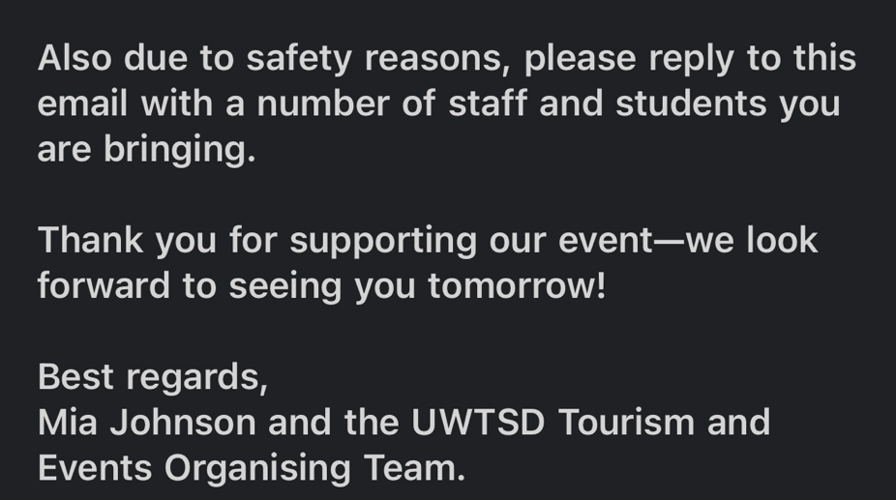
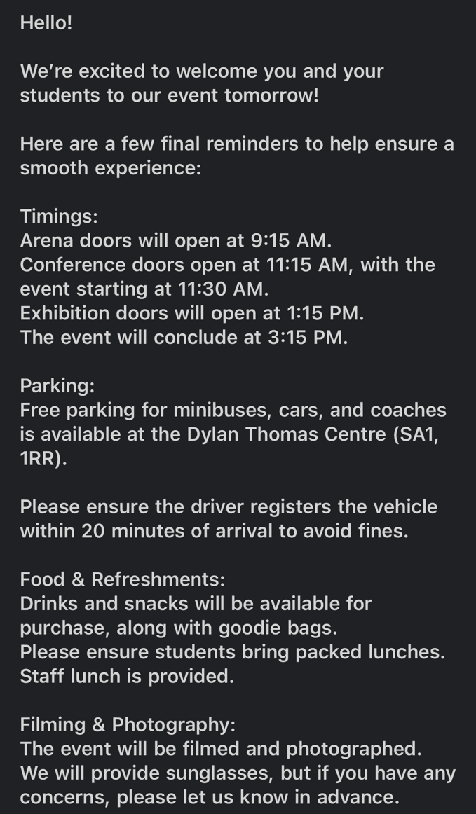

Social Media:
In addition to email communication, we created an Instagram page. We collectively decided that Instagram was the most effective platform to share information with the school and college students attending the event. This choice was made because it best suited our target demographic of 15 to 18-year-olds, allowing us to engage with them more successfully. Instagram’s popularity among this age group, along with its visual and interactive features, provided an ideal way to maximize reach, encourage engagement, and ensure the information was both accessible and appealing. The page was regularly updated with daily countdown posts starting 14 days before the event. Scott managed the page, keeping it active and engaging. Event signage at the venue also provided helpful information. This multi-channel approach ensured attendees felt supported and prepared, contributing to a smooth experience from start to finish.
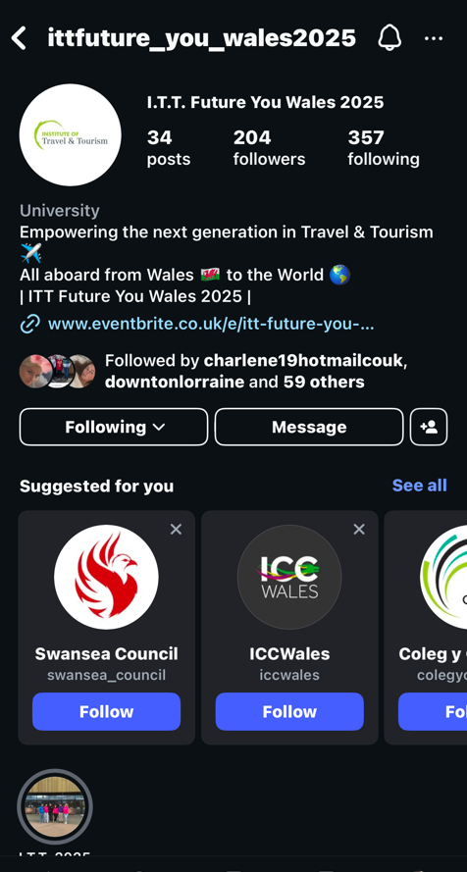
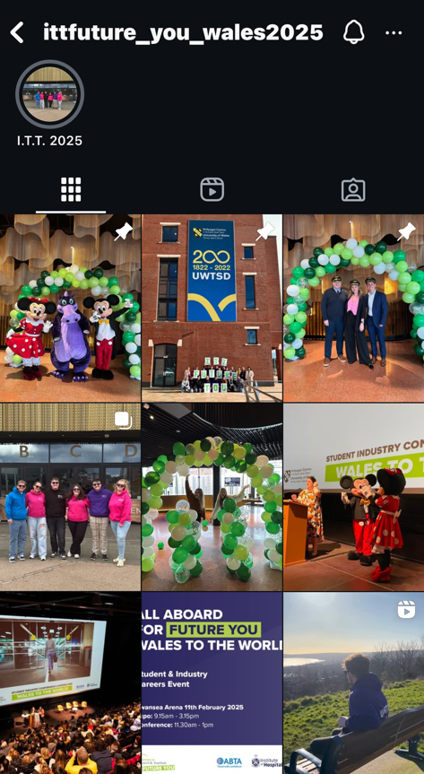
On the other hand, the most effective way to reach lecturers, exhibitors, and industry professionals was through email and LinkedIn. Unlike the younger demographic, these groups typically prefer more formal and direct methods of communication. Email allowed for clear, concise, and professional correspondence, while LinkedIn provided a platform for networking and industry-specific engagement. Using these channels ensured that information was delivered in a manner that aligned with their communication preferences, increasing the likelihood of meaningful interactions and responses.

Communication:
To ensure smooth communication and coordination, we created a dedicated WhatsApp group chat for volunteers and staff, including first, second, and third-year students. This allowed us to share updates, schedule changes, and last-minute instructions, ensuring everyone was on the same page. The group also served as a platform for staff to ask questions or clarify any uncertainties, enabling quick problem-solving and ensuring everyone felt supported throughout the event (Jago, and Deery, 2009).

Essential Resources:
To prioritize safety, first-aid kits were placed in accessible locations, with key staff informed of their exact whereabouts, following the arena’s safety protocols. Additionally, contact information for key vendors, contractors, and emergency services was readily available, allowing us to respond swiftly to any issues (Alsnih, and Stopher, 2004).
Several preparations were made to ensure the event ran smoothly. Printed maps, event schedules, and signage helped guide attendees and staff, minimizing confusion. After the set up the day before, Grace and I also created a color-coded map for both the staff assisting with the event and the exhibitors. This map not only indicated where each exhibitor was located but also served as a useful tool for networking, making it easier for attendees and participants to connect with relevant individuals and organisations. The color-coding system helped to quickly identify different areas, ensuring smooth navigation and a more organised experience for everyone involved. Backup IT equipment, such as laptops, microphones, and projectors, was prepared in case of technical issues. Contact information for campus health services was on hand for emergencies, ensuring the well-being of all involved.
A thorough review of the contingency plan was conducted to address new risks or changes, and a clear list of volunteer roles was printed in the staff room. A walkthrough or rehearsal was planned to familiarize staff with their tasks and the venue, ensuring everyone understood their responsibilities and contingency protocols in case of unexpected situations. These measures helped minimize risks, ensuring a smooth and successful event (Clark, 2010).

Summary of ITT Future You Event at Swansea Arena
The ITT Future You event, held on February 11th at Swansea Arena, aimed to inspire and connect the next generation of travel and tourism professionals. It provided students and young professionals with valuable networking opportunities, career insights, and industry knowledge, bridging the gap between education and industry.
The event featured over 50 exhibitors, including UWTSD courses, Oakwood, Yummy Jobs, and others. Attendees had the opportunity to explore various career paths and engage with industry experts. Notable speakers shared insights on emerging trends and offered practical advice to those entering the field.
With over 400 attendees registered on Eventbrite and an additional 200 on the day, the event attracted over 600 participants, making it the largest ITT Future You event held in Wales. The event received positive feedback for creating an inspiring and informative environment, successfully enhancing students' understanding of the industry and facilitating connections with potential employers.
Despite minor challenges during setup, effective communication and coordination ensured a smooth experience for all. Overall, the event made a significant impact by providing attendees with valuable insights and career opportunities while strengthening ties between educational institutions and industry leaders.

Post-Event Evaluation: ITT Future You 2025
The ITT Future You event, held on February 11th at Swansea Arena, aimed to provide students and emerging professionals in the travel and tourism sector with opportunities to network, gain career insights, and engage with industry leaders. The core objectives were to offer industry knowledge, connect education with employment, and provide a platform for exhibitors to interact with potential talent.
Event Success
The event was a major success, attracting over 600 attendees, with more than 400 individuals pre-registered on Eventbrite and an additional 200 walk-ins. This turnout made the Swansea Arena event the largest ITT Future You gathering held in Wales.
A substantial portion of attendees were students and young professionals.
Feedback
Feedback from attendees was overwhelmingly positive, particularly regarding the networking opportunities and interactions with industry professionals. Over 50 exhibitors, including UWTSD, Oakwood, and Yummy Jobs, offered a wide range of career opportunities. 90% of exhibitors reported high satisfaction, with a few mentioning lower foot traffic to the exhibition after the conference sessions concluded.
Venue
Swansea Arena was an ideal venue, providing ample space and easy access for attendees. Its layout facilitated smooth movement between exhibition and presentation areas, contributing to the event's success. The Arena’s close partnership with the University helped strengthen connections with local educational institutions and boosted event visibility.
Logistical Challenges
There were some logistical challenges, especially during registration. The high number of walk-in attendees led to congestion at the registration desks. Despite the successful use of Eventbrite for pre-registrations, the surge in walk-ins highlighted the need for a more efficient check-in system, such as QR codes or mobile check-ins, to streamline the process in future events. A more flexible crowd management plan would also help avoid congestion in high-traffic areas.
Marketing
The event’s promotion through social media, email, and University partnerships successfully attracted the target audience. To further enhance future events, expanding marketing efforts and incorporating personalized campaigns could help create more excitement and anticipation (Chadwick, and Thwaites, 2004).
Key Learnings
- Registration Process: Faster digital check-in options, like QR codes, and pre-event registration incentives could alleviate delays and improve attendee experience.
- Interactive Sessions: Attendees expressed interest in more interactive formats, such as workshops and Q&A panels, to offer tailored insights and hands-on learning.
- Venue Layout: As the event grows, adapting the venue layout to better accommodate larger crowds and improve flow in high-density areas would enhance the overall experience.
Conclusion
The ITT Future You event at Swansea Arena was a significant success, attracting over 600 attendees and offering valuable networking and career development opportunities. Despite some logistical challenges, the event achieved its objectives and solidified its role as a leading platform for travel and tourism career development. Moving forward, addressing logistical challenges, expanding marketing outreach, and enhancing interactive elements will further increase the event’s impact and success.

Reference list:
Alsnih, R. and Stopher, P.R., 2004. Review of procedures associated with devising emergency evacuation plans. Transportation Research Record, 1865(1), pp.89-97.
Bandura, A., 1986. Social foundations of thought and action: A social cognitive theory. Englewood Cliffs, NJ: Prentice-Hall.
Baxter, L.L. and Smith, P.J., 1993. Turbulent dispersion of particles: the STP model. Energy & Fuels, 7(6), pp.852-859.
Berridge, G., 2018. Events design and experience. London: Routledge.
Brown, A., Green, P. and Carter, S., 2019. Project Management Strategies: Optimising Team Performance. 2nd ed. Oxford: Oxford University Press.
Brown, S. and James, J., 2012. Event design and management: ritual sacrifice? In Festival and events management (pp. 53-64). Routledge.
Buzan, T., 2024. Mind map mastery: The complete guide to learning and using the most powerful thinking tool in the universe. Jaico Publishing House.
Chadwick, S. and Thwaites, D., 2004. Marketing and public relations for events. In: Event Management and Marketing: A Strategic Approach. Oxford: Butterworth-Heinemann, pp. 101-116.
Clark, P., 2010, October. Contingency planning and strategies. In 2010 Information Security Curriculum Development Conference (pp. 131-140).
Deci, E.L. and Ryan, R.M., 2012. Self-determination theory. Handbook of theories of social psychology, 1(20), pp.416-436.
Erdem, A., 2017. Mind maps as a lifelong learning tool. Universal Journal of Educational Research, 5(n12A), pp.1-7.
Friedman, A.L. and Miles, S., 2002. Developing stakeholder theory. Journal of Management Studies, 39(1), pp.1-21.
Gammie, E. and Cargill, E., 2002. Personal skills development in the accounting curriculum. Accounting Education, 11(1), pp.63-78.
Ghasemi, M. and Amyot, D., 2020. From event logs to goals: a systematic literature review of goal-oriented process mining. Requirements Engineering, 25(1), pp.67-93.
Genç, R., 2017. The importance of communication in sustainability & sustainable strategies. Procedia Manufacturing, 8, pp.511-516.
Getz, D., 2012. Event studies: Theory, research, and policy for planned events (2nd ed.). Routledge.
Greenwood, M., 2001. The Importance of stakeholders according to business leaders. Business & Society Review (00453609), 106(1).
Jago, L.K. and Deery, M., 2009. Event management and communication strategies. In: Event Management: An Integrated and Practical Approach. London: SAGE Publications, pp. 120-137.
Jago, L.K. and Deery, M., 2010. Events management: An introduction (2nd ed.). London: Routledge.
Kalam, K.K., 2020. Market segmentation, targeting and positioning strategy adaptation for the global business of Vodafone Telecommunication Company. International Journal of Research and Innovation in Social Science, 4(6), pp.427-430.
Kotler, P. and Keller, K.L., 2016. Marketing Management (15th ed.). Pearson Education.
Kirk, H., 2019. Prediction versus management models relevant to risk assessment: The importance of legal decision-making context. Clinical Forensic Psychology and Law, pp.347-359.
Lee, J., 2016. The role of sponsorship in event management: A case study approach. In: Event Management: Theory and Practice. Oxford: Goodfellow Publishers, pp. 103-118.
Mair, J., 2013. Conferences and conventions: A research perspective. Routledge.
Mair, J. and Thompson, K., 2009. The role of events in the development of professional networks. In: Events Management: An Integrated and Practical Approach. London: SAGE Publications, pp. 97-110.
Mijović, V., Tomašević, N., Janev, V., Stanojević, M. and Vraneš, S., 2019. Emergency management in critical infrastructures: A complex-event-processing paradigm. Journal of Systems Science and Systems Engineering, 28, pp.37-62.
Morreale, S.P., Osborn, M.M. and Pearson, J.C., 2000. Why communication is important: A rationale for the centrality of the study of communication. Journal of the Association for Communication Administration, 29(1), p.1.
Perrier, M., 2015. Networking and building relationships at events: A key success factor for professionals and organisations. In Conference and Event Management: A Guide for the Event Industry (pp. 225-240). Routledge.
Powell, D., 1996. Group communication. Communications of the ACM, 39(4), pp.50-53.
Shone, A. and Parry, B., 2013. Successful Event Management: A Practical Handbook (4th ed.). Andover: Cengage Learning.
Smith, D. and Johnson, R., 2020. Determining effective role allocation in project teams. Journal of Management Studies, 58(4), pp.1123-1135.
Solberg, H.A. and Preuss, H., 2015. The role of sponsors and partners in event marketing. In: Event Management and Sustainability: Theories, Practices, and Cases. Abingdon: Routledge, pp. 211-230.
Soria, K. and Stubblefield, R., 2015. Knowing me, knowing you: Building strengths awareness, belonging, and persistence in higher education. Journal of College Student Retention: Research, Theory & Practice, 17(3), pp.351-372.
Stone, V.L., 1981. Event, feedback, and analysis: Research media in the study of music events. Ethnomusicology, 25(2), pp.215-225.
Stokes, R., 2006. Network-based strategy making for events tourism. European Journal of Marketing, 40(5/6), pp.682-695.
Swansea Arena, 2025. Safety & security | Your visit | Swansea Arena. [online] Available at: https://www.swansea-arena.co.uk/visitors/your-visit-to-swansea-arena/safety-security [Accessed 17 Feb. 2025].
Tassiopoulos, D., 2010. Event management: A professional and developmental approach (2nd ed.). Cape Town: Juta and Company.
Taylor, K., 2021. Leadership and Decision Making in Project Management. London: Routledge.
Tzortzi, K., 2004. Building and exhibition layout: Sainsbury Wing compared with Castelvecchio. ARQ: Architectural Research Quarterly, 8(2), pp.128-140.
Tulsky, J.A., 2005. Beyond advance directives: importance of communication skills at the end of life. JAMA, 294(3), pp.359-365.
Williams, M., 2018. The role of strengths and preferences in team dynamics. International Journal of Organisational Psychology, 14(3), pp.215-227.
Williams, R.L., 2022. Smooth Operating and Other Social Acts. State University of New York Press.

