
ANALYSIS OF BUSINESS
IDEA AND
ENTREPRENEURSHIP MANAGEMENT
Module: Entrepreneur Code: LCBB5001
Lecturer: Dr Nishi Ramsurrun
Name: Simona Vitelaru
Student ID: 2133624
Table of Contents
Slide 3 - Introduction ................................................................................................................. 3
Slide 4 – Overview of your business idea .................................................................................. 3
Slide 5 – Management team plan ............................................................................................... 4
Slide 6 - Target market and marketing strategies ...................................................................... 4
Slide 7 – Competition and differentiation strategies.................................................................. 5
Slide 8 – Funding requirements and allocation.......................................................................... 5
Slide 9 – Conclusion .................................................................................................................. 6
Slide 10 – List of references ...................................................................................................... 7

Introduction
Strengths | Weakness
- Entrepreneurs have creativity skills along with innovative ideas. They are open to changes and introduce a good change management system.  - They are professionally strong and have a passion towards implementing a strong business plan. | - It has been observed that entrepreneurs often face stress due to minimum resources (Ayodeji, 2019).  - They often fail to perform time management due to  workplace stress. Their risk tolerance power is also less in comparison to other employees.
Opportunity | Threats
- Entrepreneurs have strong growth opportunities as they are exposed to technological growth in the market  (Tolstoy et al., 2021).  - The changing market conditions can build strong  globalisation opportunities for Entrepreneurs (Wang et al., 2021). | - Entrepreneurs often face strong market competition and compliance issues (Tolstoy et al., 2021).  - Sometimes the market condition can also impact professional growth and development (Tolstoy et al., 2021).
Overview of your business idea

- Establishing a retail clothing company in the UK market is the business concept. Businesses in the retail and commercial sectors are crucial to the nation's economy.
- This strategy aids in encouraging creativity and the capacity to adjust to the market's shifting circumstances (Tolstoy et al., 2021).
- With this business idea's assistance, the business environment will be advantageous to all parties involved. Strong industry knowledge is a prerequisite for entrepreneurship, and incorporating this business strategy will ultimately benefit all business owners and executives (Akram et al., 2021).
Management team plan
- Sales, marketing, and operations will make up the management group. The people that the departments of operations, sales, and marketing need to hire.
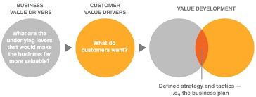
- They complement one another in their tasks and responsibilities to meet client expectations.
- The retail and commercial industries are significant to society. Retail and commercial businesses are impacted by elements like product sourcing and client service (Antwi, 2021).
- Retail and commercial business ideas assist customers as well as entrepreneurs.
Target market and marketing strategies
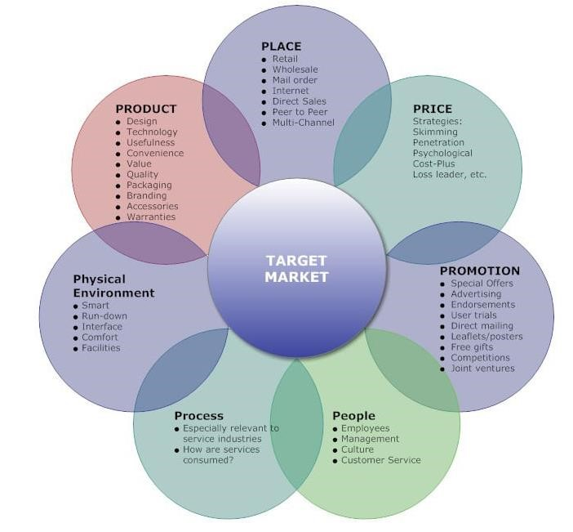
- The retail and commercial businesses often vary from each other. Hence there will be marketing strategies will be different. Some of the important marketing strategies are understanding and acknowledging the respective audience, and creating a better social media presence (Ayodeji, 2019).
- In this digital world, the market needs to prepare its websites so that it can attract more customers and represent its products on a global platform (Liao et al., 2020).
Competition and differentiation strategies
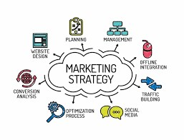
- The new product will be built on organic materials and eco-friendly features, while the competitors are the already-existing apparel companies.
- Aspiring entrepreneurs have a lot of responsibilities when it comes to implementing their retail and commercial business ideas. It is worth mentioning that the retail and commercial sectors are believed to constitute a significant portion of today's economy (Mostaghel et al., 2022). This sets their products apart from those of their competitors.
- An entrepreneur must study the participants to categories market breaches and create a distinctive marketing strategy. Market research is necessary to understand the target audience, their wants, preferences, and purchasing habits.
Funding requirements and allocation
- The required amount to launch the firm is between $2000 and $5000.
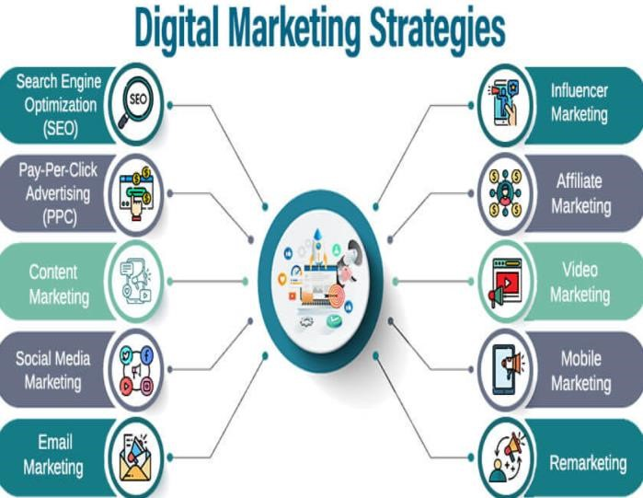
- The amount of funding a firm needs depends on a number of variables, including its location, size, and nature. Costs associated with inventories, marketing, software and technology developments, training, compliance, expansion, and professional services are a few of these variables (Mostaghel et al., 2022).
- In addition, a number of legal actions are connected to the finance needs. This money may come from a variety of sources, including loans, debts, savings, withdrawals from investments, partnerships, and joint ventures with other qualified parties (Ayodeji, 2019).

Conclusion
- I would like to thank all of you for listening to my pitch. It can be concluded that marketing strategies for retail and commercial businesses are essential.
- It is important to understand the audience and conduct market research to understand the business goals.

List of references
- Akram, U., Fülöp, M.T., Tiron-Tudor, A., Topor, D.I. and Căpușneanu, S., 2021. Impact of digitalization on customers’ wellbeing in the pandemic period: Challenges and opportunities for the retail industry. International Journal of Environmental Research and Public Health, 18(14), p.7533.[Available at:https://www.mdpi.com/1660-4601/18/14/7533]
- Antwi, S., 2021. "I just like this e-Retailer": Understanding online consumers' repurchase intention from relationship quality perspective. Journal of Retailing and Consumer Services, 61, p.102568.[Available
at:https://www.sciencedirect.com/science/article/abs/pii/S096969892100134X]
- Ayodeji, O.G. and Kumar, V., 2019. Social media analytics: a tool for the success of online retail industry. International
Journal of Services Operations and Informatics, 10(1), pp.79-95.[Available at:https://www.inderscienceonline.com/doi/abs/10.1504/IJSOI.2019.100630]
- Davis-Sramek, B., Ishfaq, R., Gibson, B.J. and Defee, C., 2020. Examining retail business model transformation: a longitudinal study of the transition to omnichannel order fulfillment. International Journal of Physical Distribution & Logistics Management, 50(5), pp.557-576.[Available at:https://www.emerald.com/insight/content/doi/10.1108/IJPDLM-02-2019-
0055/full/html

List of references(Contd.)
- Liao, S.H. and Yang, L.L., 2020. Mobile payment and online to offline retail business models. Journal of Retailing and Consumer Services, 57, p.102230.[Available at:https://www.sciencedirect.com/science/article/abs/pii/S0969698920307220]
- Mostaghel, R., Oghazi, P., Parida, V. and Sohrabpour, V., 2022. Digitalization driven retail business model innovation: Evaluation of past and avenues for future research trends. Journal of Business Research, 146, pp.134-145.[Available at:https://www.sciencedirect.com/science/article/pii/S0148296322003095]
- Tolstoy, D., Nordman, E.R., Hånell, S.M. and Özbek, N., 2021. The development of international e-commerce in retail SMEs: An effectuation perspective. Journal of World Business, 56(3), p.101165.[Available
at:https://www.sciencedirect.com/science/article/pii/S1090951620300936]
- Wang, C.N., Dang, T.T. and Nguyen, N.A.T., 2021. Outsourcing reverse logistics for e-commerce retailers: A two-stage fuzzy optimization approach. Axioms, 10(1), p.34.[Available at:https://www.mdpi.com/2075-1680/10/1/34]

