
Report for Academic Skills Assignment 2 2018- Reflective Report

Module name: Academic skills M4X01434
Project name: Ysgol Crug Glas Tuckshop
Name: Aniqa Niswat Anjum
Student number: 1702530

Table of Contents
- EXECUTIVE SUMMARY…………………………………………………………………………..1
- INTRODUCTION……………………………………………………………………………………2
2.1 REPORT remit……………………………………………………………………………………………..3
2.2 PROJET BACKGROUND ………………………………………………………………………………….4
2.3 models of reflection ………………………………………………………………………………5
2.4 masterclass session………………………………………………………………………………..6
2.5 influence of the masterclasses on the project ……………………………………7
2.6 INFLUENCE OF THE MASTERCLASSES ON PERSONAL learning………………………..8
2.7 conclusion ………………………………………………………………………………………………9
- REFERENCES ………………………………..……………………………………………………10

List of Figures

FIGURE 2-1 – Driscoll Three Staged ModeL
FIGURE 2-2- KOLB EXPERIMENTAL LEARNING MODEL

eXECUTIVE sUMMARY

This report reflects on how the masterclasses influenced my project, Ysgol Crug Glas tuckshop, and my personal learning and development. The group project is about raising awareness for Ysgol Crug Glas and help the children engage with the UWTSD staff and student during the tuckshop event. The school is located in Swansea, 5 minutes’ walk from the Business Campus, and it is specialised for disabled children and for those children with learning difficulties.
Bringing the children into the Business Campus for the tuck shop was a bit challenging since they are not used to such environment, however, we have successfully managed to introduce the kids into the campus and helped them engage with the staff and students.
The masterclasses were really beneficial for me and for my project, I have particularly liked how my presentation skills have developed after attending the masterclasses. I have seen the group getting more into the project after the guest speakers gave us their talks, the group worked harder to achieve the initial goal.
This report also contains some reflective models and how they helped me analyse the project to do better in future, the reflective models used in this report are Kolb’s and Driscoll reflective cycles.

Introduction

Report Remit

The purpose of this report is to enlighten the readers about the Ysgol Crug Glas Tuckshop Project, which was constructed by myself and 3 other pupils in the University of Wales Trinity Saint David. In the following pages, you will be gaining a better understanding of the school, the project itself, Kolb and Driscoll reflective cycles which are used to describe the experiences gained by the project. This report will also include a section that concentrates the primary themes of the masterclasses session that have had an impact on the project performance as well as my personal learning and development. The aim of this report is to give details and information about how the masterclasses influenced my project, helped me develop and learn new skills, and how I have utilised these skills within my project.

Brief background on my project
Ysgol Crug Glas is a “successful special school situated in Swansea. The school is part of the Pioneer Special Schools group looking at the new Successful Futures curriculum brought about by the Donaldson Report. According to the school’s website, (Ysgol Crug Glas, 2015) they are currently providing for 57 pupils aged between 3 and 19 years. All have profound and multiple, or severe and complex learning difficulties. Many have associated communication, behavioural and sensory difficulties, and a significant number have very specific healthcare requirements. Ysgol Crug Glas has a hydrotherapy pool, dark room, white room and soft play room as well as rebound therapy amenities. The facilities are also used by other schools' pupils throughout the City and County of Swansea. The school strongly believes that all the pupils are unique individuals, with the potential to develop and learn.” (YsgolCrugGlas, 2017)

Models of reflection
Critical thinking is not “a matter of accumulating information. Critical thinking skills can be used in exposing fallacies and bad reasoning, critical thinking can also play an important role in cooperative reasoning and constructive tasks. We can acquire knowledge by critical thinking (Wilson, 2009), improve our theories, and strengthen arguments. We can use critical thinking to enhance work processes and improve social institutions.”
Whilst there are multiple definitions for critical thinking, for the purpose of this report, the following working” definition will be used.
“As a means of focussing our attention back onto our own experience”
Cottrell (2011, p207)

There are many models an “organisation/ individual can use to analyse the progress or the development of a service, an event, a product; in this particular case is about a group project. The model I wish to use for analysing my project is Driscoll and Kolb. “Reflection enables us to draw on the past and present and direct ourselves into a better future. Terry Borton’s (1970) 3 stem questions: 'What?', 'So What?' and 'Now what?' was developed by John Driscoll in 1994, 2000 and 2007. Driscoll matched the 3 questions to the stages of an experiential learning cycle and added other questions that can be used to complete the cycle. (Mcclean, 2013) These three questions can help improve my thinking regarding my group project, so I have asked myself the three questions:
- What? – I have taken part of this project which aim was to help raise awareness for a school and its pupils. I have done this by bringing the school's tuckshop in my campus and helped the children engage with the university's staff and students. I also took part in a sponsored walk which raised money and awareness for the school. I have used my social network skills to share more awareness and get people involved. I and my group have created a blog page where we have shared various information about the project and some background details about the school. The blog was a good tool for communication, which was utilised to keep the public updated about all the events occurred.
- So, what? – During the project I have felt positivity, the work and progress I was doing were exemplary. After the project was completed, I am still feeling that all the tasks completed were all organised and I and the group achieved what we initially aimed.
- Now what? – From taking part in this project I have realised that this benefitted me and my group, we gained several skills which can be put into practice in any future activities. Some of the skills learnt are time management, team working and taking responsibility. Each member had a particular task to manage, we all collaborated together as a team to put the project in place and we have all have perceived that team working was the best way to complete the tasks quicker.
In the future, my group and I are planning to make more tuckshops to help raise money for the school. We are planning to do the tuckshop in the SA1 in an ampler location with more people, so the children can engage” with them.
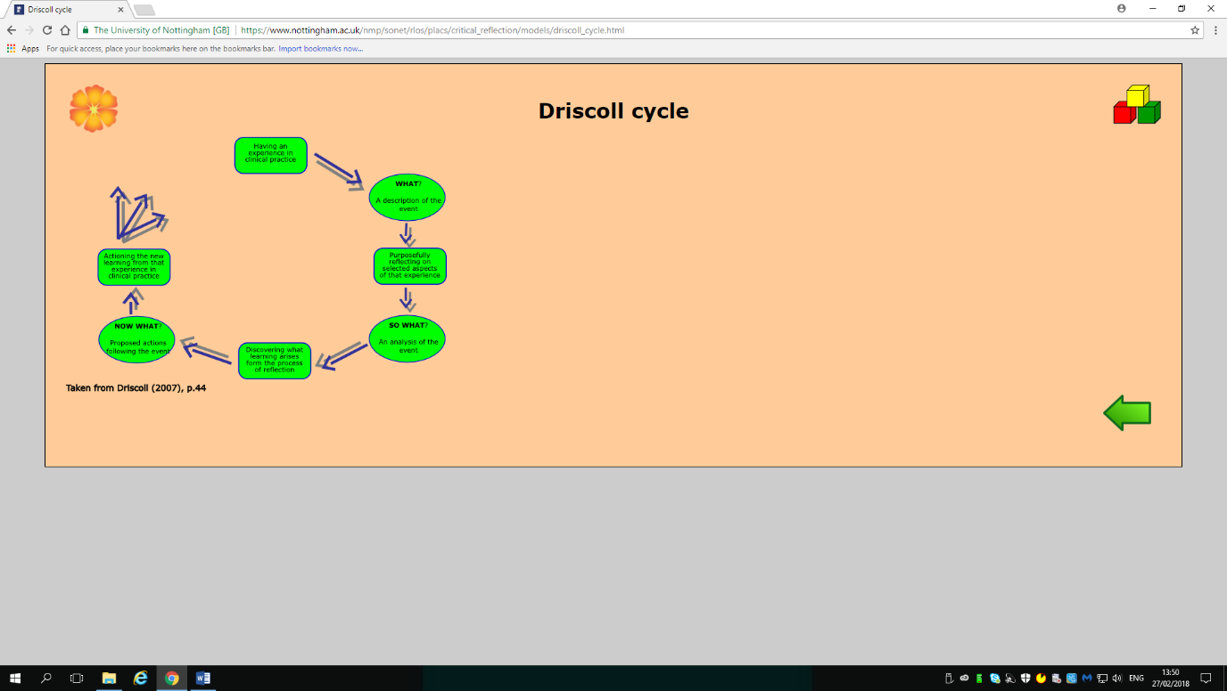

Figure 2-1 –Driscoll reflective cycle (Source: Driscoll, 2007), p.44

This is the model I have followed to analyse the aspects of my project, which helped me to evaluate the process of my project in details. This next model that I am going to describe is similar but with different questions. It is the experiential learning cycle published by David Kolb in 1984. “Kolb's experiential learning theory works on two levels: a four-stage cycle of learning and four separate learning styles. Much of Kolb’s theory is concerned with the learner’s internal cognitive processes. (McLeod, 2017)
“Kolb states that learning involves the acquisition of abstract concepts that can be applied flexibly in a range of situations. In Kolb’s theory, the impetus for the development of new concepts is provided” by new experiences.”
“Learning is the process whereby knowledge is created through the transformation of experience”
(Kolb, 1984, p. 38).
Experimental learning is a “process of constructing knowledge that involves a creative tension among the four learning modes that is responsive to contextual demands. This process is portrayed as idealised learning cycle where the learner touches all the bases: experiencing, reflecting, thinking and acting.”
Immediate on concrete experiences are the basis for observations and reflections (Fukami, 2009).
These reflections are assimilated and distilled into abstract concepts from which new implications for action can be drawn. These implications can be actively tested and serve as guides in creating new experiences (see Figure 2-2).

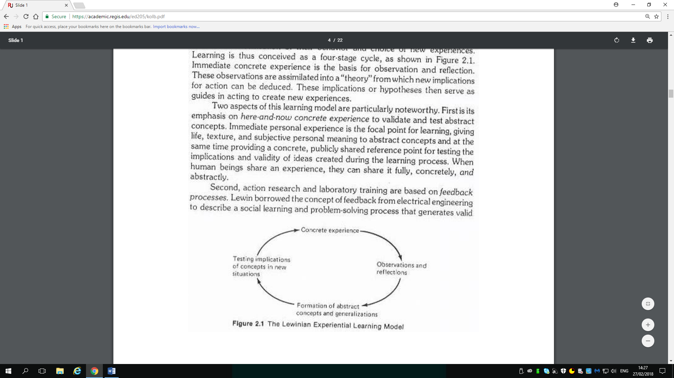

Figure 2-2- Kolb reflective cycle (Source: Kolb, 1984), p. 21

As stated in University of Leicester website (Mobbs, 2016) Experiential Learning Theory (ELT) provides a holistic model of the learning process “and is a multi-linear model of adult development. “The theory is called "Experiential learning" to accentuate the central role that experience plays in the learning process.”

For concrete experience, I have done a sponsored walk, which helped me raise money for the school, it was a remarkably long walk with my project group.
The second stage in the cycle is that of reflective observation, this is where I have thoroughly reflected on the experience, I and the group wrote a short report on what took place to help us reflect and get feedback from each other.
Abstract Conceptualisation is the process “of making sense of what has happened and involves interpreting the events and understanding the relationships between them.””
I and my project group done a variety of activities which helped Ysgol Crug Glas raise awareness; when we first brought the tuckshop in the business campus, many people did not know much about this school. We were surprised from seeing such a huge number of people turning up at the tuck shop and the fact that the children engaged with them well. We have realised what a major achievement we made by helping the school.
The final stage of the learning cycle is when the learner considers how they are going to put what they have learnt into practice, is where the learner is trying to plan how to test a model or theory or plan for a forthcoming experience. My project group and I have planned to make another tuck shop in the future, but with a bigger crowd. It is going to be challenging for the children, but teachers will be there too to help” them.

Masterclass Sessions
During the first semester I had the opportunity to attend masterclasses where I had few guest speakers, they came and talked through their work experience which gave me the knowledge and I have gained a few skills which I have used, not only for my project but also on my personal learning and development. All the guest speakers had powerful speeches and excellent presentations, however, after taking careful consideration I have felt that only two of these people have genuinely inspired me. Stifyn Parri, who is an entrepreneur and entertainer, (Parri, 2016) he is “also the Managing Director of Mr Producer. The company offers a wide range of creative services including developing creative concepts, “mentoring on presentation skills and confidence, event hosting, media training and creative” consultancy.”
In 2011 the company have expanded its business to become a nationwide acting agency (WalesOnline, 2011), this has been a massive achievement for Stifyn and a great opportunity for people thus augmented their confidence and presentation skills.
Parri had over 35 years of experience in the creative “industries, he is a presenter and a mentor; he set up Mr Producer back in 2001 and has produced live events such as the Opening Weekend of Wales Millennium Centre for BBC Wales, and the “Welcome 2 Wales Ryder Cup opening Concert” at the Millennium Stadium for SKY 1 and Sky Arts. Stifyn have created the Welsh Expat Social Welsh and Sexy Society (SWS) with events in New York, Spain, London and Russia. He also delivers workshops and private sessions expand confidence in performance and interview to all ages. He is not only a mentor but also a role model for” young entrepreneurs.
Another person that really motivated me was Kate from Gower Cottage Brownies. She started selling her Brownies in the local village shop in 2007 “where they rapidly became local’s and tourist’s favourite. Now Kate's multi-award-winning Brownies are sold all over the UK.” Kate was featured on ITV1's Countrywise Kitchen Team as their Baking, which was a big accomplishment for her. (GowerCottage, 2016)
Another businessman that has tremendously inspired me was Mark Power. Mark power have first built his very own restaurant, The Smoke Haus, back in 2012 in Swansea Wind Street.
As written on the website he has the whole idea of opening an American themed restaurant from a trip to the United States, which have convinced him to bring the American cuisine in Wales.
"On a soul-searching trip to New Orleans, we fell so deeply in love with the barbecue experience that we decided right there and then we were going to bottle it and bring it back to Wales." (Power, 2012)
Mark Power have seen that local people were enjoying his magical ingredients hence he decided to expand his business and build another Smoke Haus in the capital city, Cardiff. Later, the businessman has brought his idea in England and opened one in Bristol and Birmingham (Young, 2016). Mark Power is extremely proud of his achievement and his international growth.

Influence of Master classes on the Project
Stifyn Parri has done an excellent presentation of his career to the whole class. His enthusiasm, confidence and sense of humour have inspired my project group immensely. Everyone in the group could not build that confidence until Stifyn has shown us how easy it is to grow a little more faith in ourselves and that it will not harm anyone if we do so. My project group and I grew that confidence which helped us massively, we have assisted the children with their tuckshop among the teachers.
Kate, on the other hand, she has given us some great skills on self-reflection and self-reliance. She is only a successful entrepreneur because she has allowed downtime to reflect on the past and plan, Kate was also resourceful enough to depend on herself. I and my project group have done the same, even if we were working as a team we still did not depend on each other, we managed our own time and completed all the tasks on our own way. One particular thing that I and my group have liked about the Smoke Haus was the way they keep in touch with their customers. Mark Power and its team post some interesting articles on their blog to tell their customer what is happening in the Smoke Haus. My group and I have done the same, we made our own Blog for the school’s tuckshop to have better communication with people, to keep them updated and tell them more about us through pictures and posts. Blogging was also a creative way to advertise our project and tell people more about the Ysgol Crug Glas school. (Aniqa, 2017)

Influence of the master classes on personal learning & development
Stifyn Parry, Kate and Mark Power have had a massive influence on my personal learning and devolvement. All three were different and did different things in life to achieve what they have right now. All three have had an impact on my personal learning differently. Stifyn has massively encouraged me with presentation skill, he was extremely confident, and he knew how to handle situations. Thanks to his talk I have been able to grow my confidence a little more and I have stopped worrying while I gave presentations in front of a big number of people. “A bulk of research shows that when people are put in situations where they are expected to fail, their performance does plummet. Their head literally shuts down, and they end up confirming the expectations. When they're expected to win, their performance shoots back up. Same person, different expectations.” (Kaufman, 2011)
Kate showed me how simple things can lead you somewhere big in life. She started from zero and that made me believe anyone can achieve anything if their mind is set with that goal. I have learnt to stick with one thing and work hard to achieve it, not giving up until I am happy with the results. “Goal setting is the process of establishing an outcome to serve as the aim of one’s actions. In educational settings, the ultimate outcome is usually some form of learning as operationalized by the instructor or the students “. (Marzano & Pollock, 2001, p. 93)
Mark Power has demonstrated how enthusiasm can help you achieve big things in life. He has explained how he built Smoke Haus and where he got all these ideas from, this showed how confident he was. If one does not have confidence in themselves, they cannot achieve anything. “I still have those fears, undoubtedly. But now I know that I can beat them, that I can break through that wall of fear and come out on the other side. I’ve done it many times now, and that success will fuel further success.” (Babauta, 2007)

Conclusion

From the masterclasses, I have learnt many skills which helped my group project and help me grow as a person and gave me a trailer for the general aspects of life. I have realised everything is possible if you keep faith in yourself, reflecting on things you have done in the past to analyse the present can be truly beneficial. The reflective cycle of Kolb was extremely helpful, I will use it to reflect on future projects.

References

Aniqa, H. A. (2017). Y.C.G TUCKSHOP. Retrieved from Y.C.G TUCKSHOP: https://ysgolcrugglastuckshop.wordpress.com/
Babauta, L. (2007, December 9). 25 Killer Actions to Boost Your Self-Confidence. Retrieved from https://zenhabits.net/25-killer-actions-to-boost-your-self-confidence/
Cottrell, S. (2011). Critical Thinking Skills. New York: Palgrave Macmillan.
Driscoll, J. (2007). Practising Clinical Supervision. Brisbane: Elsevier.
Fukami, C. V. (2009). The SAGE Handbook of Management Learning, Education and Development. In C. V. Fukami, the SAGE Handbook of Management Learning, Education and Development (p. 44). London: SAGE publications.
Glas, Y. C. (2015). Swansea Edunet. Retrieved from Swansea Edunet: https://swansea-edunet.gov.uk/en/schools/crugglas/Pages/Default.aspx
GowerCottage. (2016). Gower Cottage Brownies. Retrieved from http://www.gowercottagebrownies.co.uk/
Kaufman, S. B. (2011, December 8). Confidence Matters Just as Much as Ability. Retrieved from https://www.psychologytoday.com/blog/beautiful-minds/201112/confidence-matters-just-much-ability
Kolb, D. A. (1984). Experiential Learning. New Jersey: Prentice Hall.
L, D. (2007). Experiential Learning (Kolb). Retrieved from Learning Theories: https://www.learning-theories.com/experiential-learning-kolb.html
Marzano, P. &. (2001). Classroom Instruction that Works: Alexandria: ASDC.
Mcclean, T. (2013). MODELS OF REFLECTION. Retrieved from the Institute gov: http://theinstitute.gov.gg/pluginfile.php/2086/mod_page/content/24/Reflective%20Writing%20Booklet.pdf
McLeod, S. (2017). Kolb- Learning styles. Retrieved from Simply Psychology: https://www.simplypsychology.org/learning-kolb.html
Mobbs, D. R. (2016). David Kolb. Retrieved from University Of Leicester: https://www2.le.ac.uk/departments/doctoralcollege/training/eresources/teaching/theories/kolb
Parri, S. (2016). Mr Producer. Retrieved from https://mrproducer.co.uk/homepage/
Power, M. (2012). WHERE WE'RE COMING FROM. Retrieved from the smoke haus: https://thesmokehaus.co.uk/about/
WalesOnline. (2011). Mr Producer expands its business. Retrieved from Wales Online: https://www.walesonline.co.uk/lifestyle/showbiz/mr-producer-expands-its-business-1855804
Wilson, M. (2009). Critical Thinking. Retrieved from University Of Sussex: http://www.sussex.ac.uk/skillshub/?id=277
Young, G. (2016). First look inside The Smoke Haus restaurant - where you can graffiti the toilets. Retrieved from Birmingham Live: https://www.birminghammail.co.uk/whats-on/food-drink-news/first-look-inside-smoke-haus-11403843
YsgolCrugGlas. (2017). Retrieved from https://www.swansea.gov.uk/article/4647/Ysgol-Crug-Glas

