Grand Hotel Budget Planner

Student Name: Silviu Alexandru Ciolan
Student ID: 2027368

Table of Contents

Introduction 3
Task 01 4
The budget planner (the cash flow forecast) based on the given information as well as the given template 4
Task 02 6
a) The importance of budgeting 6
b) Understanding of incremental budgeting, activity-based budgeting, value proposition and zero-based budgeting 8
c) The way how budgeting control can support sustainability 11
Conclusion 12
References 13

Introduction

The budget planner (the cash flow projection) based on the provided information and template has been included in the report. The significance of budgeting in the context of a business organisation has also been covered in this paper. The comprehension of the four main types of budgeting procedures was also covered in this paper. Finally, this research has provided further detail on how maintaining budgetary control might promote sustainability.

Task 01

The budget planner (the cash flow forecast) based on the given information as well as the given template
In preparing this budget, the activity-based budget method has been used. In this budgeting, all the required expenses for producing the revenue have been shown against the output or revenue.
The cash flow forecast
 | Apr | May | Jun | Jul | Aug | Sep | Oct | Nov | Dec | Jan | Feb | Mar | Total
 | £ | £ | £ | £ | £ | £ | £ | £ | £ | £ | £ | £ | £
Receipts :
Payment on business accounts | 185,000 | 166,000 | 185,000 | 140,000 | 142,000 | 149,000 | 156,500 | 166,900 | 174,000 | 149,000 | 150,900 | 150,800
Cash sales
Interest Received | 405 | 2,737 | 4,706 | 7,127 | 8,286 | 9,525 | 11,127 | 12,926 | 15,236 | 17,379 | 19,221 | 20,934
Mini Bar | 8,900 | 8,900 | 8,900 | 8,900 | 8,900 | 8,900 | 8,900 | 8,900 | 8,900 | 8,900 | 8,900 | 8,900
Total Receipts | 194,305 | 177,637 | 198,606 | 156,027 | 159,186 | 167,425 | 176,527 | 188,726 | 198,136 | 175,279 | 179,021 | 180,634 | 2,151,509
Payments
Restaurant | 27,800 | 27,800 | 27,800 | 27,800 | 27,800 | 27,800 | 27,800 | 27,800 | 32,100 | 27,800 | 27,800 | 27,800
Wardrobe |  | 3,500 | 3,500 | 3,500 | 3,500
Sky Subscription | 1,250 | 1,250 | 1,250 | 1,250 | 1,250 | 1,250 | 1,250 | 1,250 | 1,250 | 1,250 | 1,250 | 1,250
Car Insurance |  |  |  |  |  |  |  |  | 8,000
Premier league license |  |  |  |  |  |  |  |  |  |  |  | 6,000
Laundry | 1,625 | 1,625 | 1,625 | 1,625 | 1,625 | 1,625 | 1,625 | 1,625 | 1,625 | 1,625 | 1,625 | 1,625
Wages | 57,500 | 57,500 | 57,500 | 57,500 | 57,500 | 57,500 | 57,500 | 57,500 | 57,500 | 57,500 | 57,500 | 57,500
Mini Bar | 7,000 | 7,000 | 7,000 | 7,000 | 7,000 | 7,000 | 7,000 | 7,000 | 7,000 | 7,000 | 7,000 | 7,000
Training |  |  |  |  |  |  |  |  |  |  | 7,500
Virgin Pass | 2,500 | 2,500 | 2,500 | 2,500 | 2,500 | 2,500 | 2,500 | 2,500 | 2,500 | 2,500 | 2,500 | 2,500
Vehicles lease | 2,750 | 2,750 | 2,750 | 2,750 | 2,750 | 2,750 | 2,750 | 2,750 | 2,750 | 2,750 | 2,750 | 2,750
Utility Bills | 2,000 | 2,000 | 2,000 | 2,000 | 2,000 | 2,000 | 2,000 | 2,000 | 2,000 | 2,000 | 2,000 | 2,000
Petrol and diesel | 1,000 | 1,000 | 1,000 | 1,000 | 1,000 | 1,000 | 1,000 | 1,000 | 1,000 | 1,000 | 1,000 | 1,000
Rates | 3,200 |  | 3,200 | 3,200 | 3,200 |  | 3,200 | 3,200 | 3,200 | 3,200 | 3,200 | 3,200
Valeting | 540 | 540 | 540 | 540 | 540 | 540 | 540 | 540 | 540 | 540 | 540 | 540
Beverage | 2,700 |  | 2,700 |  | 2,700 |  | 2,700 |  | 2,700 |  | 2,700
Magazines | 2,150 |  |  | 2,150 |  |  | 2,150 |  |  | 2,150
Overtime | 3,400 | 3,400 | 3,400 | 3,400 | 3,400 | 3,400 | 3,400 | 3,400 | 3,400 | 3,400 | 3,400 | 3,400
Newspaper | 1,150 | 1,150 | 1,150 | 1,150 | 1,150 | 1,150 | 1,150 | 1,150 | 1,150 | 1,150 | 1,150 | 1,150
Building Insurance |  |  |  |  |  | 5,500
Total payments | 116,565 | 112,015 | 117,915 | 117,365 | 117,915 | 114,015 | 116,565 | 111,715 | 126,715 | 113,865 | 121,915 | 117,715 | 1,404,280
Balance b / f | 13,500 | 91,240 | 156,862 | 237,553 | 276,215 | 317,486 | 370,896 | 430,858 | 507,869 | 579,290 | 640,704 | 697,810
Net cash flow in month | 77,740 | 65,622 | 80,691 | 38,662 | 41,271 | 53,410 | 59,962 | 77,011 | 71,421 | 61,414 | 57,106 | 62,919
Balance c / f | 91,240 | 156,862 | 237,553 | 276,215 | 317,486 | 370,896 | 430,858 | 507,869 | 579,290 | 640,704 | 697,810 | 760,729 | 5,067,512

Table 1: Cash flow projection
This can be seen that the company is expected to generate positive cash flow every month. In preparing the budget, the incremental budgeting method, value proposition budgeting method, as well as zero-based budgeting method, can be used in addition to the activity-based budget. The activity-based budgeting is preferable here because the purpose of the activity-based budget is to investigate the factors that influence business costs and to make adjustments so that the company may become more productive (Banks & Giliberti, 2018).

Task 02

The importance of budgeting
A budget is a projection of how much money will be spent and generated in during a specific time, typically one that is monthly, quarterly, or yearly. It makes it possible for a company to plan out its spending, achieve its business goals, and foresee any operational adjustments that may be required to sustain the company (Banks & Giliberti, 2018). Budgeting is very crucial for the company to ensure proper and efficient functioning. Some of the reasons why budgeting is important for a company are outlined below:
- Planning orientation: The process of developing a budget compels management to shift its focus from short-term to longer-term planning. This is the main objective of budgeting even if management is unsuccessful in achieving its objectives as specified in the budget, at least it is considering how to enhance the firm's financial and competitive position (Atkinson et al., 2020).
- Profitability review: During the flurry of day-to-day management, it is simple to lose track of the areas of a business that contribute the most to its financial success. Because a well-structured budget reveals which sections of the company generate revenue and which ones spend it, management is compelled to assess whether or not it should eliminate some aspects of the firm and instead focus on growing in others (Banks & Giliberti, 2018).
- Performance evaluations: Employees can define their objectives for a given budgeting period with the help of their managers, who may also consider linking their compensation in some way to their level of productivity. They will then be able to develop reports comparing the budget to the actual expenditures, which will allow them to provide personnel with feedback regarding the rate at which they are achieving their objectives. This strategy is utilised most frequently with monetary objectives, although operational objectives may also be included in the budget to facilitate performance evaluation (Banks & Giliberti, 2018).
- Objectives orientation. Although budgets cannot ensure success on their own, they may unquestionably help to prevent failure. The budget helps a company to be focused on objectives. The budget is a crucial instrument that is used to translate broad plans into particular goals and objectives that are directed toward taking action. When the requirements for the budget are followed to the letter, the expectation is that the goals and objectives that have been outlined can be accomplished (Lau & Tan, 2005).
- Higher coordination within the organisation: It is imperative to keep in mind that a huge corporation consists of several individuals and components. To function as a unit, these elements must be carefully coordinated. The budget serves as a tool for communicating the anticipated outcome and offers a thorough screenplay for coordinating all of the various components so that they operate together (Rees, 2015).
- Set benchmarks: The budget enables timely course corrections to be taken and gives the benchmarks against which to determine whether or not objectives have been reached successfully (Lau & Tan, 2005).

Understanding of incremental budgeting, activity-based budgeting, value proposition and zero-based budgeting

Incremental budgeting: To create a budget for the current year, incremental budgeting begins with the actual numbers from the previous year and then adds or subtracts a fraction from those statistics. Because it is straightforward and straightforward to comprehend, it is the most frequent type of budget. If the fundamental cost drivers remain the same from one year to the next, incremental budgeting is the method that should be utilised (Jones, 2013). An incremental budget is useful for educational establishments, governments, and large organisations that distribute resources to departments or long-term projects and are accustomed to experiencing only small modifications throughout the fiscal year. An incremental budget also works well for organisations that distribute resources to departments or long-term projects and use a zero-based budgeting system (Rees, 2015).
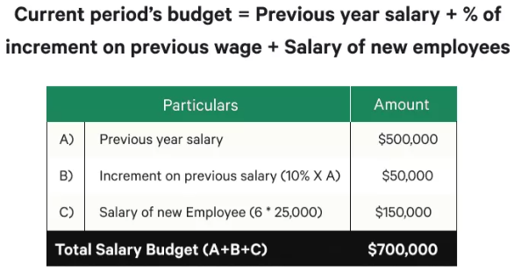
Figure 01: The incremental budgeting (Rees, 2015)
Activity-based budgeting: Activity-based budgeting refers to the top-down approach of budgeting that determines the number of inputs necessary to support the goals or outputs that have been established by the company. As an illustration, a company decides to aim for an output target of one hundred million dollars in revenues. The company will initially need to identify the tasks that need to be carried out to meet the marketing objective, and then it will need to discover the costs associated with performing these tasks (Banks & Giliberti, 2018).
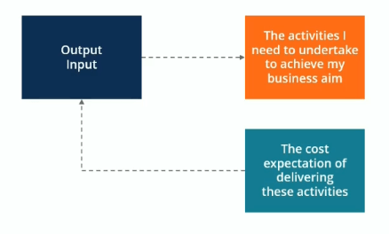
Figure 02: Activity-based budgeting (Banks & Giliberti, 2018)
Value proposition: The budgeting method known as value proposition budgeting, which is also known as priority-based budgeting, is focused entirely on examining and justifying the worth of every item that is included on an expense list. In the end, it is an attempt to determine where a company should spend their money to achieve a positive return on its investment. Companies that desire to access highly valued services can utilise value proposition methods of budgeting. Allocating most of the resources to highly profitable products or services can generate higher revenue (Cameron, 2010).
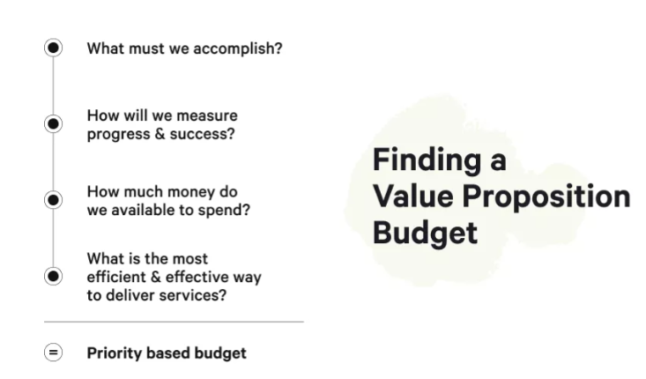
Figure 03: Value proposition budget (Banks & Giliberti, 2018)
Zero-based budgeting: The assumption that all division budgets start at zero and have to be reconstructed from scratch is made at the beginning of the zero-based budgeting approach, which is one of the most often used methods of budgeting. The ability to rationalise each expenditure is required of managers. The zero-based budgeting approach is an extremely stringent method that seeks to avoid making all expenses that are not regarded as being completely necessary to the effective and profitable functioning of the business (Jones, 2013). A budget that is created from the bottom up, like this one, can be a very effective method to "shake things up." It is a good idea to use the zero-based approach when there is an immediate need to contain costs, such as when a business is going through a financial restructuring or when there has been a significant market or economic downturn that requires it to drastically reduce the budget. This is one situation in which the zero-based approach is useful (Jones, 2013).
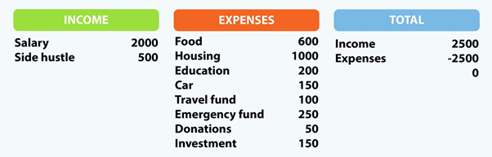
Figure 04: The zero-base budget (Jones, 2013)

The way how budgeting control can support sustainability
With the increase of awareness toward the environment, budgeting is coming a significant and famous tool of financial management for ensuring and promoting suitability and sustainable development. Green budgeting is such type of budget which used a budgetary control process to attain the environmental and climate objectives of an organisation. Evaluation of the environmental implications of budgetary and financial policies, as well as evaluation of the policies' coherence concerning the delivery of domestic and international commitments, are both components of green budgeting (Denscombe, 2014). The use of green budgeting could also assist in an informed debate and conversation that is evidence-based on the topic of sustainable growth. It has been found that nations that possess robust performance budgeting systems are more likely to make an effort to incorporate performance objectives that are connected to national environmental and climatic goals. Alternately, governments that already have well-established mechanisms for reviewing spending might want to concentrate on including considerations of the influence of measures on climate targets besides considerations of efficiency (Dyson, 2019). There are some important points about how budgetary control supports sustainability.
- Budgetary control helps to set the environmental and climate objectives of the business.
- Through budgetary control, businesses can incorporate environmental and climate objectives with business objectives.
- Budgetary control assists to measure the impact of business on the environment. Based on the impact they can the company can take the required corrective actions.
- To facilitate the accomplishment of national climate and environment goals, budgetary control helps to implement pricing mechanisms that take into account environmental externalities, such as emissions of greenhouse gases. These pricing mechanisms are typically implemented in the form of taxes and trading systems.
- Budgetary control also encourages employees to become more efficient and aware of the environment (Dyson, 2019).

Conclusion

The budget is very crucial for a business in increasing its performance. A budget helps to identify the deviation between the actual performance and budget values. The deviation helps to identify the sources and the appropriate corrective action. Furthermore, budgeting works as a standard for a company to measure the performance of different divisions, units and employees. There are several budgeting methods such as incremental budgeting, zero-based budgeting, value proposition and activity-based budgeting. Different budgeting methods are appropriate in different situations. Budgetary control has a significant contribution to ensuring sustainability.

References

Atkinson, A.A. et al. (2020) Financial management: Information for decision making. United States: Cambridge Business Publishers.
Cameron, G. (2010) “Budgeting and Businesses,” Economic Growth, pp. 9–15.
Collin, R.M. and Collin, R.W. (2010) Importance of budget in business. Santa Barbara, Calif: Greenwood Press.
Denscombe, M. (2014) Budgeting Process. Milton Keynes: Open University Press.
Dyson, J.R. (2019) Budgeting Methods and Implications. London: Pitman.
HANSEN, G.A.R.Y.S.C.O.T.T. (2017) Determinants of firm performance: An integration of budgeting process.
ICAEW (2001) UK GAAP Budgeting Tools and Techniques. London: Ernst & Young.
Jackson, S., Sawyers, R. and Jenkins, J.G. (2018) Financial management: A focus on ethical decision making. Mason, OH: South-Western.
Banks, A. and Giliberti, J. (2018) Budgeting. North Ryde, N.S.W.: McGraw-Hill Australia.
Lau, C.M. and Tan, S.L.C. (2005) “The importance of procedural fairness in budgeting,” Advances in Accounting, 21, pp. 333–356.
Jones, M. (2013) Green Budgeting. Chichester: Wiley.
McLaney, E. and Atrill, P. (2016) Environment and Budgeting, PDF EBook. Harlow: Pearson Education, Limited.
Rees, B. (2015) Budgeting control in Sustainability. London: Prentice Hall.
Sloman, J. and Jones, E. (2017) Essential Use of Budgeting Control for Business. Harrow: Pearson Education Ltd.

