

CONTRIBUTION OF DIGITAL TECHNOLOGY TO EFFECTIVE KNOWLEDGE MANAGEMENT IN THE UK CONSTRUCTION INDUSTRY

By: Manikonda Venkata Sushi Mahalakshmi
ID: 2406243
Supervisor: Daniela Hellyer

Project submitted as part of the requirements for the award of Master of Business Administration

September 2025
Acknowledgement
I would like to thank my supervisor immensely as they have provided me with priceless advice, constructive feedback, and support all through this research process. I would also like to heartily thank the construction professionals who took part in the survey and provided their helpful insights. I would like to thank my relatives and friends in particular because they always supported me and encouraged me. The completion of this dissertation would not have been possible without their patience and encouragement.

DECLARATION:
This work has not previously been accepted in substance for any degree and is not being concurrently submitted in candidature for any degree.

Signed: M.V.Sushi
Date:26/09/25

STATEMENT 1
This work is the result of my own investigations, except where otherwise stated.
Other sources are acknowledged by footnotes giving explicit references. A bibliography is appended.

Signed: M.V.Sushi
Date :26/09/2025

STATEMENT 2
I hereby give consent for my work, if accepted, to be available for photocopying and for inter-library loan, and for the title and summary to be made available to outside organisations.

Signed: M.V.Sushi
Date:26/092025
Abstract
Background: The UK construction industry is highly dependent on Knowledge Management (KM), due to the nature of the construction industry through fragmentation, high staff turnover and project-based structures, the construction industry is often inefficient and knowledge is often lost. The rise of digital technologies, which means that Building Information Modelling (BIM), cloud systems, Artificial Intelligence (AI), and digital twins, has provided a chance to increase the effectiveness of KM.
Aim and Objectives: The purpose of this study was to investigate the extent to which digital technologies can help in the successful KM in the UK construction industry. The goals were to determine the important technologies, their efficacy levels, barriers to integration, and possible adoption strategies.
Methodology: A quantitative survey was carried among the construction professionals in different capacities. Data analysis in SPSS was performed using descriptive statistics, correlations and regression. Theoretical grounding has been provided through using the ‘SECI model’ along with ‘Technology Acceptance Model’ or TAM.
Findings: The results show that digital adoption explains almost three-quarters of the effectiveness of knowledge management, which proves the claim that Building Information Modeling (BIM), artificial intelligence (AI), and cloud-based systems are key factors in the advancement of knowledge creation, storage, and dissemination. Nevertheless, the predictors were in a hierarchical agreement with the organisational culture, the commitment of the leadership and the digital competencies of the workforce. Nonetheless, interoperability, cost and change resistance problems continued to exist particularly among small and medium enterprises (SMEs). Of special interest, KM systems complexity was linked to the increasing integration problems, thus marking a socio-technical paradox.
Conclusions: Digital technologies increase KM significantly, yet they cannot be successful without cultural preparedness, leadership, and workforce capability. The study is theoretically useful because it makes the SECI and TAM valid in the UK, methodologically because it employs the quantitative analysis, and practically because it offers recommendations on the way to improve efficiency, innovation, and sustainability in construction.
Keywords: Knowledge Management (KM); Digital Technologies; Building Information Modelling (BIM); Artificial Intelligence (AI); Cloud Platforms; Digital Twins; UK Construction Industry; SECI Model; Technology Acceptance Model (TAM); Organisational Culture; Knowledge Sharing; Workforce Training; Barriers to KM; SMEs; Innovation and Sustainability.
Table of Contents
Chapter 1: Introduction 10
1.1 Research Background 10
1.2 Problem Statement 11
1.3 Research Rationale 12
1.4 Research Aim 13
1.5 Research Objectives and Questions 13
1.6 Significance of Research 14
1.7 Research Scope 15
1.8 Structure of Dissertation 15
Chapter 2: Literature Review 18
2.1 Introduction 18
2.2 Evolution of KM in Construction 18
2.3 Digital Tools for KM 22
2.4 Barriers to integrating KM technologies in construction firms 26
2.5 Theoretical Implications 29
2.6 Literature Gap 32
2.7 Conceptual Framework 33
2.8 Conclusion 33
Chapter 3: Methodology 35
3.1 Introduction 35
3.2 Research Strategy 35
3.3 Research Design 36
3.4 Research Philosophy 37
3.5 Data Collection 38
3.6 Population and Sample 40
3.7 Data and Analysis 41
3.8 Reliability and Validity 43
3.9 Research Limitations 44
3.10 Research Ethics 44
Chapter 4: Data Analysis 45
4.1 Introduction 45
4.2 Demographic Analysis 45
4.3 Descriptive Analysis 50
4.4 Hypothesis Testing using Correlation and Regression Model 51
4.4.1 Hypothesis 1 51
4.4.2 Hypothesis 2 54
4.4.3 Hypothesis 3 57
4.4.4 Hypothesis 4 59
4.5 Summary of the result 61
4.6 Discussion 61
4.7 Summary 63
Chapter 5: Conclusions and Recommendations 64
5.1 Introduction 64
5.2 Summary of Key Findings 64
5.3 Linking with Objectives 66
5.4 Recommendations 69
5.5 Contributions of the Study 70
5.6 Limitations of the Study 70
5.7 Suggestions for Future Research 70
References 71
Survey Questionnaire 89

List of Figures
Figure 1.7.1: Dissertation Structure 16
Figure 2.2.1: KM Enablers 19
Figure 2.2.2: BIM innovation and development 21
Figure 2.3.1: Application areas of AI in Construction Sector 23
Figure 2.3.2: BIM knowledge management cycle 24
Figure 2.4.1: Notable barriers to implementing KM 27
Figure 2.5.1: TAM 30
Figure 2.5.2: SECI Model 31
Figure 2.7.1: Conceptual Framework 33
Figure 4.1: Gender 46
Figure 4.2: Age 47
Figure 4.3: Educational Qualification 48
Figure 4.4: Current Job Role 48
Figure 4.5: Professional Experience 49

List of Tables
Table 4.1: Frequency Analysis 45
Table 4.2: Descriptive Statistics 50
Table 4.3: Correlation Test 52
Table 4.4: Regression Test 53
Table 4.5: Correlation Test 54
Table 4.6: Regression Test 56
Table 4.7: Correlation Test 57
Table 4.8: Regression Test 58
Table 4.9: Correlation Test 59
Table 4.10: Regression Test 60

Chapter 1: Introduction

1.1 Research Background
“Knowledge Management (KM)” has become one of the most important contributors to productivity, along with innovation and sustainability in project-based industries like construction. Needless to mention that the construction sector is highly dynamic in nature, and one of the main pillars of UK economy. Along with a “workforce of around 2.5 million”, UK construction industry comprises a set of multiple distinct sub-sectors with a contribution of approximately “107 billion to the UK economy” (Ganah and John, 2015). As this industry is intrinsically knowledge-based and necessitates a combination of design knowledge, engineering know-how, and on-site troubleshooting. In this regard, it is required to mention that construction is often characterised by knowledge loss, duplication of errors, and inefficiencies in knowledge transfer because of the project-based, fragmented nature of the industry. Therefore, the UK construction sector is also not an exception in this scenario.
As per Jallow et al. (2020), construction organisations are most likely to rely on project-specific knowledge; therefore, it is highly crucial to decrease error and to improve decision-making, which makes KM practices necessary to support organisational learning. It is acknowledged that unstructured KM may lead to loss of knowledge, duplication, and waste of resources in any industry across the globe.
In this rapidly growing era of digitisation, emergence of digital technologies plays an important role in terms of improving and enhancing every possible domain. “Building Information Modelling (BIM), along with cloud platforms, artificial intelligence (AI), and digital twins”, has provided a new possibility to record, store, and share both tacit and explicit knowledge. These tools have been found to enhance collaboration, decision-making and lifecycle management globally. Moreover, as per reports of Omrany et al. (2023), digital twins, specifically, constitute a paradigm shift with introduction of real-time performance data into predictive modelling, which increases the ability to discover knowledge and disseminate it. Wang and Chen (2023) further added by mentioning BIM has also emerged as a primary integrator of projects, providing a common digital space that facilitates lifecycle knowledge flows. These trends suggest that technology can be used as a mediator between different knowledge practices and integrated KM systems.
Reports have revealed that elements, which are deeply associated with KM, aid in heightening efficiency of construction industry and more than 50% of the respondents in the construction sector have agreed to factor that KM enables companies to “upsurge innovation, anticipate problems and enhance competitiveness” (Marinho and Couto, 2022). Additionally, more than 16.4% further believe that KM is most likely to heighten “experiences and lessons learned on completed projects”. Apart from that, UK Government has mandated the use of “BIM Level 2”, which strengthened significance of digitalisation, with KM being at the centre of industry modernisation (Awwad et al. 2020; Ganah and John, 2014). Regardless of these initiatives, productivity and innovation issues continue to exist, and uneven adoption between firms is still frequent, as well as resistance to change (Georgiadou, 2019). According to Zhang et al. (2024), digital technologies can play an important role in KM in theory, whereas they are controversial in practice due to barriers of cost, along with culture and interoperability. Therefore, considering multidimensional nature of this topic, this research paper takes a stand in that discussion, and sheds light on how digital technologies contribute to successful KM in the UK construction sector. Hence, the following section of this chapter presents a strong foundation of this research by highlighting problem statements, followed by research objectives and questions. Potential scope and research significance are also going to be mentioned as well.

1.2 Problem Statement
KM has been identified as one of the key aspects of enhancing learning and innovation in construction. However, there are diverse aspects of issues that can be found in this arena, like loss of knowledge across projects, along with continuous repetition of errors and ineffective transfer of experience. In this regard, Jallow (2024) argues that regardless of Industry 4.0 strategies, UK construction firms are most likely to face the same issues of translating digital innovations into long-term competitive advantage. In this regard, other researchers have addressed some causes of gaining competitive advantage are due to siloed and inconsistent use of knowledge throughout organisations (Rajagopal et al. 2022; Tsiu et al. 2025). This emphasises the contradictory character of the sector, which is knowledge-intensive yet inefficient in terms of knowledge, and produces endemic waste and inefficiency (Wibisono and Supoyo, 2023; Aslam et al. 2022; Hamalainen and Salmi, 2023).
As a solution, digital technologies have been introduced, and BIM and AI are positioned as central to modernising KM, which reduces issues, though they are still not able to mitigate them in a complete manner. Theoretically, government requirements like “BIM Level 2” requirement in the UK should have standardised practices (Awwad et al. 2020). In practice, though, BIM has not been fully utilised and integrated, and Demirdöğen (2023) also mentions existence of risk factors that undermine KM initiatives, including disjointed processes, lack of maturity models, and unavailability of assessment tools. Bigger companies are highly inclined in terms of implementing new technologies and tools; however, SMEs, are a significant part of UK industry lacks behind (Campbell et al. 2025; Qiao et al. 2023; Wiweko and Anggara, 2025).
There are multiple barriers can be found, which hinders successful integration. Although BIM and AI integration can provide an opportunity to perform predictive modelling, automation, and intelligent decision support, Olugboyega et al. (2025) and Alexandro (2025) pointed out that there are challenges to its practical implementation, including interoperability, loss of trained personnel, and the absence of evaluation criteria. In addition, Demirdöğen (2023) further notes that cultural resistance, insufficient training, and the lack of organisational alignment make these issues even more pronounced and do not allow KM to reach maturity. This is further supported by Jallow (2024), who states that the UK model of adversarial contracting and the temporary nature of project teams undermine cooperation and mistrust as well, which limits digital adoption.
It is quite evident that without proper KM integration, UK construction industry is in danger of continuing to be inefficient, leading to low productivity and resulting in stagnant innovation. As a result, projects will still repeat their mistakes and lose valuable knowledge between cycles. In addition to that, there is significant pressure on construction sector in order to remain highly sustainable. Strict rules and significant pressure have also been imposed upon this sector to ensure cost control and delivery certainty (Reis and Melão 2023; Rajagopal et al. 2022; Tsiu et al. 2025). Thus, by illuminating these fields, this research paper will close a pressing gap, which also contributes to the evaluation of the contribution of digital technologies to effective KM in the construction business in the UK. This reciprocally also helps in the discovery as well as the recruitment of effective tools that can be utilized. The recognition of barriers, as well as enablers, and strategies helps to make a significant contribution to the UK construction industry.

1.3 Research Rationale
The UK construction sector is on a brink and the growing complexity, the need to be more sustainable and the need to enhance the level of productivity is putting pressure on knowledge management (KM) to an unprecedented degree. Despite the intensive investment into digitalisation, the sector continues to experience inconsistent practices, lack of knowledge across projects and uncertain adoption of technologies (Ashok et al. 2021; Bolatan et al. 2022; Alves and de Carvalho, 2023). This study is therefore required to study how digital technologies may actually contribute to KM effectiveness not only with regards to the technical opportunities that are presented, but also regarding the cultural, organisational and strategic precondition of success (Irfan et al. 2022; Gupta et al. 2022).
This research is theoretically and practically warranted. In academic terms, despite such works as Jallow (2024) and Olugboyega et al. (2025), which deal with the problems of digital integration and AI-BIM potential, the literature is either general or theoretical, and there is little such evidence as empirical evidence in the UK. Demirdooghen (2023) also mentions that risks in KM remain and involve cultural resistance, lack of training, and evaluation criteria. In the UK, they are aggravated by adversarial contracting and the abundance of SMEs, which are often not able to afford digital adoption. The study aimed at determining the challenges and enablers related to the adoption of knowledge-management technologies, and the consequential results are likely to be useful to corporations, policymakers and training organisations. Through this, it will help close the digital divide between the large contractors and the SMEs so that the dividend of the digital knowledge management is more evenly spread throughout the industry.
The salient features of this work include the fact that it is contemporary. Digital technology in knowledge management is no longer a voluntary move, or a strategic requirement (Bolatan et al. 2022; Alves et al. 2023). As the demands in the UK construction industry continue to mount pressure on the need to bring in sustainable and efficient projects. Through the overall evaluation of the effects of the use of digital tools on the knowledge-management performance, the research will add to the improved comprehension of how businesses can go beyond digital compliance, thus, trying to achieve real innovation and sustainable competitive advantage.

1.4 Research Aim
The aim of the research is to critically examine the role of digital technologies in knowledge management within construction industry in UK.

1.5 Research Objectives and Questions
Following section offers an insight into the research objectives and questions:
Research Objectives:
“RO1: To identify key digital technologies used in KM within the UK construction sector.”
RO2: To appraise the effectiveness of technologies in enhancing knowledge creation, storage, and dissemination.
RO3: To examine the barriers to integrating KM technologies in construction firms.
RO4: To recommend strategies for improving implementation and adoption of technology-based KM.”
Research Questions:
“RQ1: To what extent does digital technology enhance the effectiveness of knowledge management practices in the UK construction industry?”

1.6 Significance of Research
This research paper revolves around the contribution of KM, especially in UK construction sector, and insights appear to be highly meaningful to both academic knowledge and practical improvements in “UK construction industry”. A large part of existing research in digital technologies in KM is either universal or focused on theoretical frameworks, with very few empirical data collected in UK context. Although some of studies, including those by Jallow (2024) and Olugboyega et al. (2025), address the issue of challenges of implementing Industry 4.0 strategies and possible areas of BIM and AI integration, there is a research gap regarding the interaction of the technologies with cultural and regulatory context of UK construction. Therefore, by anchoring analysis in this context, this research paper contributes detailed and locally-based knowledge that would enhance global knowledge on KM. Moreover, this research is a theoretical contribution because it incorporates several perspectives (Adi et al. 2021; Newman et al. 2021) In addition, research has social importance as well. Construction is a key point of national development, which determines housing, infrastructure, and economic growth. The inefficiencies of KM practices lead to cost overruns, along with delays, wastes, and weaken trust and sustainability goals of the population (Ashok et al. 2021; Irfan et al. 2022; Gupta et al. 2023). It is expected that this research will lead to the indirect promotion of sustainable, cost-effective, and innovative construction practices through the ability to better use digital technologies in the field of knowledge management (Al Shraah et al. 2022; Taherdoost and Madanchian, 2023). In general, the research will fill a theoretical vacuum, solve urgent issues in the industry, and guide policy-making and promote the welfare of society. Its results are likely to contribute to the improved knowledge of the influence of digital technologies on the knowledge management and define the feasible measures according to which the UK construction industry can increase its productivity and competitiveness, which is why the significance of this investigation can hardly be overestimated.

1.7 Research Scope
One of the major factors is that this research is solely focused on the UK construction industry, which is selected due to its nature of fragmentation, adversarial relationship, and a high level of project-based knowledge reliance. Moreover, this particular sector is fast digitalising, and it is an appropriate setting to study the role of digital technologies in KM effectiveness; therefore, sectoral scope is quite prominent. Moreover, this paper will look at digital technologies that are most commonly known to be used in KM, like AI along with BIM, digital twins and cloud-based platforms. All of these technologies have been cited in previous studies as having great potential in the capture, storage and dissemination of knowledge, although their applicability depends on context. On the other hand, organisational scope can be noted as well, as there are large firms along with SMEs that are taken into account, as the adoption patterns are different among them. Larger companies can usually afford to invest in more advanced digital systems, and SMEs are limited in resources; however, they make up most of UK construction industry. Knowledge of two sides of coin will provide a balanced picture of the industry.
Moreover, this research paper is only concerned with UK, where a unique regulatory environment is identified in terms of the government's mandate to implement “BIM Level 2” (Awwad et al. 2020; Jiang et al. 2022). Hence, it can be stated that this research paper is multiscopic in nature as it sheds light on UK construction sector along with relevant digital KM technologies and their adoption and effectiveness as well.

1.8 Structure of Dissertation
In order to form a logical and coherent flow of discussion, this research paper has been broken down into five distinctive sections, which are:

Figure 1.7.1: Dissertation Structure
(Source: Self-Developed)
- Introduction: First section, introduction provides a detailed background along with problem statement, aim, objectives and the rationale of the research. It positions the significance of digital technologies in the improvement of KM of “UK construction industry” and further presents the scope of the research.
- Literature Review: Second chapter of the research offers a critical analysis and reviews previously conducted studies of KM, digital tools, including BIM, AI, and digital twins, and barriers and enablers that affect adoption. Moreover, theoretical discussions are also going to be provided in order to offer a strong theoretical foundation for the research topic. Along with a conceptual framework, notable research gaps are also going to be mentioned in this chapter of research.
- Methodology: Methodology the third chapter contains details of the design of the research. Different approaches, philosophical perspectives are going to be discussed as well. Along with the source of information, a data collection method is chosen in this section and further explains the rationale of the methods used, reliability and validity as well as the ethics involved. As a part of “primary quantitative method”, a survey is going to be conducted.
- Data Analysis: The survey responses will be analysed with the aid of IBM SPSS, given that both descriptive statistics and test procedures like “chi-square, along with Pearson correlation and linear regression”, will be employed. These statistical analyses aid in assessing the relationship between KM practices, use of technology and effectiveness in KM practice. This will help to assess the role of digital technologies in supporting KM in practice, with a particular focus on that of the UK.
- Conclusions and Recommendations: The last section of the research paper is “Conclusions and Recommendations”, which summarises the main findings and discusses their implications not only in academia but also in industry and policy. Notable recommendations are going to be suggested in order to improve the efficiency and heighten improvement of the overall construction section with the help of KM practices. Moreover, potential limitations and important areas of future research are going to be mentioned.

Chapter 2: Literature Review

2.1 Introduction
“Knowledge management (KM)” has emerged as a vital competency in the construction sector, due to the temporal and dispersed character of construction projects, which has led to knowledge loss, along with inefficiencies and duplication of errors. In this regard, digital technologies like “Building Information Modelling (BIM), AI, along with cloud platforms, and digital twins” play an important role in terms of storing and sharing knowledge among project teams. This chapter of research paper offers a detailed discussion on contribution of such digital technologies in terms of managing knowledge with reference to UK construction sector. Along with different digital tools, effective barriers and potential complexities are also going to be highlighted in this chapter. Different theories and prominent gaps are also going to be included, followed by a conceptual framework.

2.2 Evolution of KM in Construction
Boamah et al. (2022) underline that tacit knowledge has always been at centre of value creation within construction industry, as experienced workers possess knowledge that is hard to codify and transfer. Wethyavivorn and Teerajetgul (2020) also emphasise that use of personal expertise predisposes organisations to knowledge loss, especially at times when rate of staff turnover is high. Although both studies emphasise importance of tacit knowledge, Boamah et al. (2021) state that leadership, trust, and motivation are needed to convert this knowledge into organisational capital. This means that critical tacit knowledge is vulnerable unless integrated into formal KM processes.
As Nor et al. (2020) Cui, (2025) state, construction sector is fragmented and project-based, with teams being disbanded after project is complete and knowledge being concentrated within departments. Dybek and Gldzinski (2023) and Pai et al. (2022) support this opinion by analysing RandD project organisations, where temporary organisations also pose same problem of knowledge retention and transfer. In UK, this decentralisation is exacerbated by the use of subcontracting, which tends to inhibit knowledge sharing across organisational boundaries. Al Sehrawy and Amoudi (2020) state that BIM has been sold as a digital warehouse to overcome these inefficiencies; however, cultural impediments to collaboration have limited potential. To support this, Fargnoli and Lombardi (2020), Maciá-Lillo et al. (2025) and Khan et al. (2024) note that although BIM has been employed to enhance safety knowledge, its implementation has not been homogenous, which demonstrates a discrepancy between tools and their efficient KM results. Furthermore, Wethyavivorn and Teerajetgul (2020) also argue that project lessons are not always documented because of time factor, and this results in repetition of errors. Boamah et al. (2022), Abdulmuhsin et al. ( and 2021) Mahdi and Nassar, (2021) further build on this claim by showing how an employment structure based on contracts diminishes employees’ motivation to share tacit knowledge, which increases loss of knowledge. Nevertheless, Boamah et al. (2021) state that such issues can be effectively addressed through effective enablers, like cultural support and strategic leadership, but degree to which they can eliminate such problems depends on organisational commitment. These perceptions show that although informal systems dominate globally, UK has made significant progress in incorporating formal digital systems, although cultural resistance remains a major impediment.
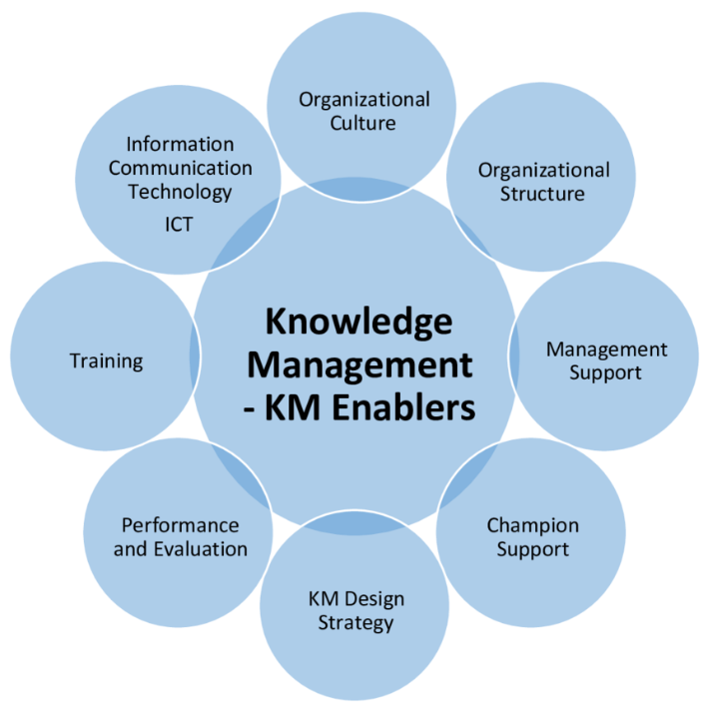

Figure 2.2.1: KM Enablers
(Source: Usman et al. 2021)
Figure 2.2.1 points out main enablers of KM, the main aspects that contribute to successful implementation of knowledge management in organisations, like, champion support and KM design strategy (Usman et al. 2021). Usman et al. (2021) mention that training increases the ability of employees to use KM practices, and “Information communication technology (ICT)” supports the storage and retrieval of knowledge as well as dissemination of knowledge. Li et al. (2023) add that knowledge sharing is weakest in cases of trust asymmetry, especially when the stakeholders involved have conflicting interests, as in case of contracting environments. This is consistent with results of Boamah et al. (2022), who stress that willingness to share knowledge is culturally contextual. In UK, where adversarial contractual norms are the norm, the absence of trust does not allow collaborative use of digital KM tools. According to Md and Mahesh (2020), Alfawaire and Atan, (2021), Tajpour et al. (2022) and Cillo et al. (2022) such deficits can be overcome through a knowledge-based safety culture, which can only work when the organisation is focused on collective learning rather than individual profits. This implies that cultural reformation is necessary to help maximise value of KM adoption. In this regard, Hu et al. (2021) have stated that BIM has been developed as a platform to discover knowledge, shifting from information storage to predictive analytics and decision-making. Zhang et al. (2024) go further to show how off-site construction is also supported by digital twins that enable flow of lifecycle knowledge. Altaie and Dishar (2024) advocated a combination of AI applications and KM processes, where efficiency and decision-making have been demonstrated to improve. Similar to other studies have also identified the role of AI in scaling KM; however, they note that workforce skills and training remain a barrier (Taherdoost and Madanchian, 2023; Polas et al. 2023; Morandini et al. 2023; Altaie and Dishar, 2024). In comparison, Md and Mahesh (2020) note that even advanced technologies can have no significant results in case safety culture is not embedded. Taken together, these studies demonstrate that the UK has already achieved some progress regarding implementation of BIM and AI; however, lack of competencies and cultural barriers remains a barrier to performance.
In line with this, Areed et al. (2020) highlighted that KM can only augment innovation when it is aligned with the strategic goals, and Blak Bernat et al. (2023) have further mentioned that stakeholder engagement in virtual project teams can only improve sustainability outcomes when combined with KM. Nonetheless, Boamah et al. (2025) argue that numerous construction organisations continue to use conventional retrieval systems and do not utilise AI-powered retrieval to fullest. This is more evident in UK, where government mandates on BIM implementation have not been reflected in the total integration of KM, an indication of a disconnect between the policy and practice.
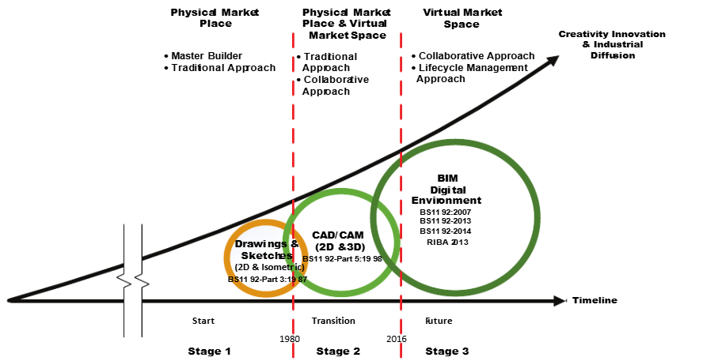

Figure 2.2.2: BIM innovation and development
(Source: Ganah and John, 2015)
Figure 2.2.2 depicts the evolution of KM in construction due to changing technologies depicted in; for instance, Stage 1 was based on drawings and sketching, reflecting some disjointed and manual KM within a purely physical marketplace. Stage 2 has introduced “CAD/CAM (2D and 3D)” with incomplete processes of digitisation and collaborative strategies, along with a move toward reusing KM in virtual environments (Ganah and John, 201). Stage 3 is digital realisation of BIM, driven by UK guidance (“BS1192 and RIBA 2013”), with a focus on lifecycle data and how to intelligently share information. Such a development indicates effect of digital technologies on KM in UK construction, leading to productivity, along with innovation, and industrial diffusion. Agostini et al. (2020) state that KM has developed over the years, and the initial generation of codification methodologies have been replaced by collaborative and inter-organisational views. This trend corresponds to shifts in building in which KM is less tacit and experience-based and more digital. However, as Boamah et al. (2021) and Nor et al. (2020) state, the drivers of motivation, leadership, and training are not well developed, which restricts KM maturity in practice. This is consistent with findings by Dybek and Głodziński (2023) that even organisations with advanced technology have trouble with knowledge fragmentation when cultural and behavioural enablers do not exist.
Combining these perspectives, Al Sehrawy and Amoudi (2020) and Hu et al. (2021) pay a lot of attention to BIM as a source of knowledge, whereas Altaie and Dishar (2024) and Taherdoost and Madanchian (2023) assert revolutionary potential of AI. Compared to that, Md and Mahesh (2020) and Li et al. (2023) state that barriers to adoption include organisational culture and trust gaps. Boamah et al. (2025) state that although world is advancing in application of AI-based retrieval, UK construction sector is still reluctant to make switch. Development of KM in construction industry is thus a journey from unstructured, fragmented practices to organised, technology-enabled systems (Evans et al. 2022; Kulkov et al. 2023; Berlato et al. 2025). Digital technologies are a great leap forward; while, development of KM in UK is not evenly distributed; thus, there is a need to have integrated strategies that integrate technological innovations with cultural and organisational change.

2.3 Digital Tools for KM
Suresh et al. (2016) stated that digital tools can improve KM in construction projects because they enable the creation, storage, and sharing of information more efficiently, improve decision-making, and reduce repetition of efforts. Yao et al. (2022) and Mihai et al. (2022) have confirmed this by demonstrating that such technologies as digital twins, cloud systems, and ICT infrastructures are repositories, communication spaces, and transactive memory systems that reinforce knowledge flows. Although Yao et al. (2022) warn, however, that most organisations use these tools in a piecemeal fashion and not as part of a comprehensive KM strategy. Ozturk and Yitmen (2019) have a more positive perspective, in that conceptualising BIM as a unifying platform that integrates disparate sources of knowledge, while acknowledging that success depends on consistent adoption and cultural alignment.
As Xiahou et al. (2025) point out, despite the potential impact of BIM and digital tools on quality management due to enhanced knowledge capture and transfer, effectiveness of tools is limited due to a lack of consistency in their implementation and poor strategic alignment. Chenchu et al. (2025) supplement this by explaining that digital technologies alone cannot solve KM obstacles, and social mechanisms such as SNA, which is employed to trace knowledge flows and develop trust, are also necessary. These arguments indicate that in UK, although BIM and AI have robust technical underpinnings, there are drawbacks to adversarial contracting and cultural silos that do not allow them to be fully effective.
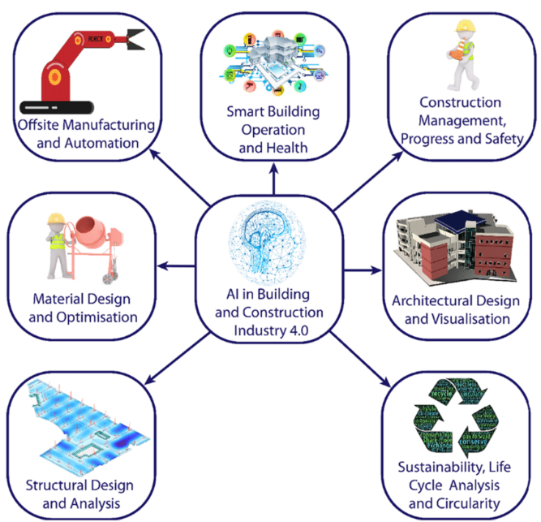

Figure 2.3.1: Application areas of AI in Construction Sector
(Source: Baduge et al. 2022)
Figure 2.3.1 points out various domains where AI can easily be applied in order to heighten accuracy and boost improvement. Baduge et al. (2022) argue that AI aids in maintaining higher sustainability through life cycle analysis, which not only makes construction procedures more efficient but also environmentally responsible and innovative as well. Anumba and Khallaf (2022) also emphasise the transformational nature of AI in construction KM as machine learning can be used to provide predictive insights, automate retrieval and assist decision-making processes. Pai et al. (2022) support this by stating that AI has the potential to establish synergy among people and technology and enhance efficiency of knowledge generation and sharing. Wang et al. (2022) warn that excessive use of AI may hinder tacit knowledge transfer because it decreases the chances of human interpretation and skills. This discussion shows that AI can enhance KM processes; however, it is required to be aligned with human judgement and organisational learning in UK sector to be most effective.
Hu et al. (2021) critically evaluate BIM as a knowledge extraction tool, claiming that, though there have been improvements in predictive analytics and knowledge discovery, issues like data interoperability and the absence of standards negate effectiveness of BIM. Wang and Meng (2019) also reflect this by examining transition of industry towards BIM-based systems of KM and demonstrate that a significant number of companies continue to see BIM as a design tool rather than a holistic KM system. Heaton et al. (2019) prove that BIM is more effective when applied in operations and maintenance, where it can assist in asset management and knowledge retention throughout life cycle.
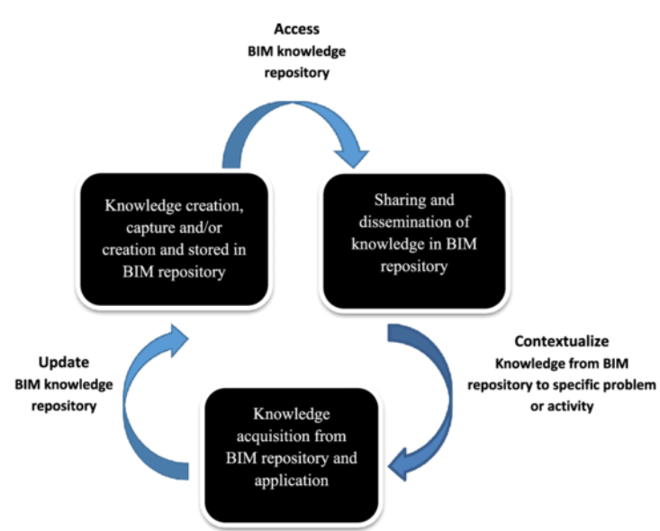

Figure 2.3.2: BIM knowledge management cycle
(Source: Fadeyi, 2017)
Figure 2.3.2 shows how BIM repositories can be effective in knowledge management. Fadeyi (2017) explains how knowledge is generated and stored, and subsequently shared among stakeholders. Through contextualisation, knowledge is contextualised in order to suit particular problems or activities, and thus can be applied. Therefore, new knowledge is added to repositories to ensure continuous improvement. This cyclic process highlights the role of BIM in enhancing the efficiency of knowledge generation, retention and sharing, which results in enhanced efficiency, along with better collaboration and higher innovation in construction projects. Marinho and Couto (2022) analyse giant construction enterprises and find that stakeholders consider digital tools to be essential in improving KM and decision-making. Nevertheless, they add that they are less effective due to resistance to culture and non-alignment with organisational objectives. The same conclusion is supported by Likhitruangsilp et al. (2019), who also note that leadership commitment, training, and resource allocation are factors that can enable BIM to succeed. Collectively, these insights indicate that although UK has been a leader in adoption of BIM due to government mandates, implementation remains largely ineffective, particularly among SMEs that lack financial and human resources.
Vu and Le (2021) propose a KM model to be used in context of design consulting companies where BIM can standardise design process, which improves transfer of knowledge and collaboration. This can be supported by El Mokhtari et al. (2022) and Wang and Chen (2023), as authors have mentioned that combination of BIM and project management enhances transparency, coordination, and knowledge sharing at project phases. Nevertheless, both papers admit that governance frameworks are necessary to ensure that digital tools do not entrench silos instead of breaking them. Chenchu et al. (2025) agree with this, claiming that technological platforms ought to be supplemented with relational mechanisms such as SNA in order to achieve actual transformation in knowledge dissemination. Yao et al. (2022) remark that digital twins and cloud platforms are increasingly used to create knowledge in real-time and store it long-term; however, when used in isolation, they reduce their potential. Suresh et al. (2016) and Berkani et al. (2025) are more optimistic, and according to them, even partial implementation of ICT systems can bring significant changes in project results due to minimisation of duplication and improvement of communication. This discrepancy is due to fact that although digital tools are always associated with enhancing KM effectiveness, benefits are optimised when such tools are adopted strategically and in an integrated manner.
Studies by Hu et al. (2021), Heaton et al. (2019), and Wang and Meng (2019) reveal that BIM is the most developed digital technology for storing and sharing knowledge, and that it has demonstrated positive effects when implemented consistently. Whereas, Pai et al. (2022), Wang et al. (2022), and Anumba and Khallaf (2022) explain that AI can enhance knowledge creation and retrieval; however, that it is not without obstacles to its application based on culture and skill. The works by Marinho and Couto (2022), Likhitruangsilp et al. (2019) highlight importance of leadership and organisational preparedness as conditions of effectiveness, and technology is not enough to revolutionise KM. Hence, Suresh et al. (2016), Yao et al. (2022), and Ozturk and Yitmen (2019) acknowledge positive effect of digital tools on knowledge creation, storage, and dissemination. According to studies by Anumba and Khallaf (2022), Pai et al. (2022), and Wang et al. (2022), AI can change, but it is required to match human knowledge. According to Chenchu et al. (2025) and Marinho and Couto (2022), organisational and social factors that precondition success are revealed. The UK construction industry can serve as an example of both improvement and shortcomings: on the one hand, BIM, AI, cloud-based systems, and digital twins are changing KM practices; on other hand, situation is mixed and dependent on strategic adoption, cultural change, and management support.

2.4 Barriers to integrating KM technologies in construction firms
Wang and Meng (2021) note that although BIM has a great potential to assist KM, barriers include interoperability, inadequate user skills, and incompatibility with existing knowledge systems. Tran and Nguyen (2024) support this opinion by stating that adoption of BIM is hampered by exorbitant costs, lack of training, and a disjointed organisational preparedness, especially in the developing world. Georgiadou (2019) and Elghaish et al. (2024) offers a UK-centred view, stating that despite compulsory nature of BIM in UK, the adoption of same in residential projects is hindered by cultural resistance, awareness, and insufficient incentives to smaller firms. These two perspectives indicate that although technological and financial obstacles are typical across world, UK situation is based on cultural and institutional improper fit rather than availability of technology itself.
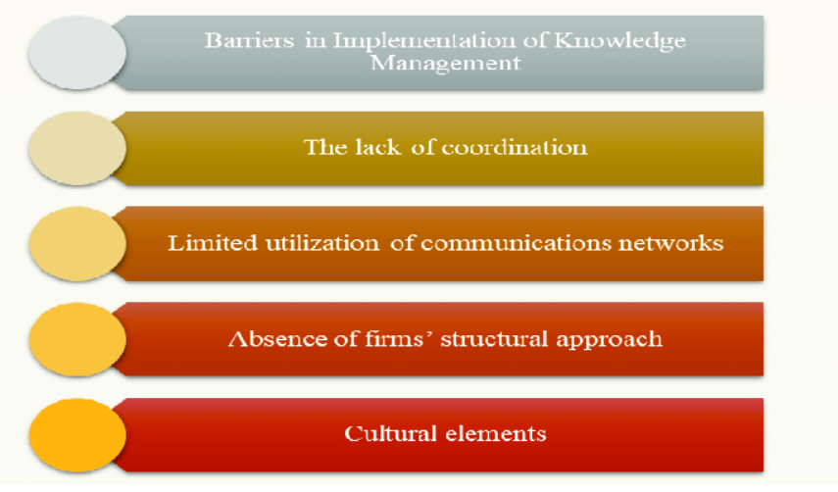

Figure 2.4.1: Notable barriers to implementing KM
(Source: Korkmaz and Bahidrah, 2018)
Figure 2.4.1 highlights four major barriers to application of KM in construction. Lack of coordination interferes with flow of knowledge among teams, and under-utilised communication networks limit flow of knowledge. Moreover, absence of a systematic process leads to a lack of institutionalisation of KM practices, and firms end up with a disjointed KM process. These considerations are also compounded by cultural aspects including resistance to change and unwilling to share knowledge hence highlighting the socio-technical issues that have hindered the adoption of knowledge management (KM) in organisations.
Rane (2023) has outlined a set of issues related to the adoption of Building Information Modelling (BIM) and artificial intelligence (AI) integration, such as data standardisation, inter-system interoperability, and the ability of the workforce to perform AI-based processes. Abioye et al. (2021) support these findings by stating that the main limitations to the use of AI in construction environments are uncertainties related to payback periods, the need of technical skills, and data privacy. Wang et al. (2022) move on to show that impeding structural aspects that do not allow the adoption of Construction 4.0 include poor digital infrastructure, fragmented supply chains, and regulatory paralysis. All these researchers are hinting at the fact that the adoption of knowledge management (KM) technologies has been limited by technical, financial, and regulatory considerations; despite its relative newness, the United Kingdom is still struggling with the issues of skill gaps and institutional inertia. Yusof et al. (2019) support the evidence that barriers to KM practices are not only technical but also cultural, in the form of unwillingness to share knowledge, lack of trust, and time limitations in the project delivery. The same tendencies can be noted in the small and medium-sized business (SME), where the resource constraints and hierarchical cultures do not allow adopting KM (Egwunatum & Oboreh, 2022). On the other hand, Thirumal et al. (2024) state that insufficient supportive ecosystems, especially regarding the implementation of digital technologies to facilitate the circular economy, is a constraint since companies do not have the necessary regulatory frameworks and collaborative platforms. All these findings lead to the conclusion that financial and technical barriers are often mentioned, but cultural and institutional ones are the most challenging to overcome, particularly in the markets dominated by SMEs, like the United Kingdom.
Andersson and Eidenskog (2023) have a knowledge infrastructure perspective, meaning that BIM implementation resistance cannot be reduced to skill gaps or financial limitations, but also because of organisational routines and professional identities that cannot be transformed easily. Similar findings are reported by Enshassi et al. (2019), who state that shortcomings of BIM in practice are related to a lack of support from top management, absence of collaboration among stakeholders, and misalignment of responsibilities. Korkmaz and Bahidrah (2018) echoes this by stating that KM implementation frequently fails due to fact that firms view it as an add-on, and thus invest little in resources in training and integration. The above views collectively demonstrate that the leadership and management commitment is critical in making KM technologies successful or not. In UK, although government has mandated implementation of BIM, lack of firm leadership in implementation of KM technologies has been a consistent obstacle to the adoption of KM technologies.
According to Abioye et al. (2021), AI presents specific issues that do not exist in case of BIM, like ethical issues, followed by algorithm transparency, and scepticism towards automation in organisations. This is confirmed by Wang et al. (2022), who demonstrate that use of AI in construction remains limited by inability to integrate it with current BIM and KM systems, resulting in a fragmented technological environment. In contrast, Rane (2023) indicates that the integration problems are still present; however, integrating BIM and AI has potential to enable predictive analytics and smarter KM activities when the barriers are overcome. This is to show that although some authors present AI adoption as a problem that is associated with risks and challenges, others hold the opinion that obstacles are temporary and can be eliminated through standardisation and training. Moreover, Enshassi et al. (2019) and Tran and Nguyen (2024) also note that cost of implementation and unpredictable returns remain one of greatest challenges. Egwunatum and Oboreh (2022) go further to mention that SMEs usually lack ability to absorb such expenses and have limited access to KM technologies. According to Georgiadou (2019), financial barriers are usually superseded by cultural and organisational resistance even in well-financed UK companies. These observations indicate that, though cost is the common deterrent, in developed economies like the UK, more subtle factors of culture and leadership are more significant impediments to integration.
Wang and Meng (2021) also emphasise fact that interoperability issues are not confined to technology alone but rather extend to organisational level, where siloed departments and weak communication fail to facilitate KM implementation. This is further supported by Yusof et al. (2019), who mention time pressure and project deliverables as practical obstacles to KM integration that discourage companies from putting efforts into it. According to Andersson and Eidenskog (2023), knowledge infrastructures tend to support legacy practices, and thus, there is not much room to redefine workflows through use of digital tools. All these arguments indicate that KM technology barriers are not stand-alone issues but rather they are enmeshed in the organisational and project delivery contexts, hence is why adoption of BIM in the UK is not uniform.
According to Thirumal et al. (2024), environmental sustainability introduces an additional layer of obstacles, as companies are not able to incorporate digital KM tools to facilitate the circular economy practices because of a mismatch between regulatory environment and technological capacity. Wang et al. (2022) agree with this by referring to poor cooperation on an industry level and a lack of consistency in digital strategies. However, Abioye et al. (2021) claim that new AI tools could alleviate these obstacles to some degree, as they will automate compliance and sustainability monitoring. This implies that the new pressures brought about by sustainability frameworks also bring about opportunities for KM tools in case firms are able to align technological adoption with the regulatory demands. According to Thirumal et al. (2024), challenges of sustainability also create new challenges, but also point out possibilities of KM alignment. Thus, obstacles to application of KM technologies in construction are complex in their nature: technical, financial, cultural, organisational, and regulatory. Whilst some authors point to structural and financial problems, others point to cultural inertia and a lack of leadership commitment. This duality is echoed in UK construction industry, which is technologically advanced and institutionally underdeveloped, and SMEs are over-represented. To resolve these obstacles, it is not just enough to invest in systems but also to transform culture, become a stronger leader and to have policies that will integrate digital adoption and strategic objectives (Singun, 2025).

2.5 Theoretical Implications
In order to offer a more critical analysis of this research, different interrelated theories have been discussed in the following section in a detailed manner:
“Technology Acceptance Model (TAM)”:
TAM provides a strong theoretical foundation, which aids in assessing how digital technologies contribute to effective KM, considering UK construction industry. TAM, in its essence, points out that two perceptions are defining the adoption of technology, which are “Perceived Usefulness (PU) and Perceived Ease of Use (PEOU)” (Schorr, 2023). In the context of construction, PU indicates extent to which technologies like AI or BIM can increase productivity, efficiency, and decision-making, whereas PEOU indicates extent to which stakeholders can find these tools easy to use and do not need a lot of effort and expertise to use them (Na et al. 2023).
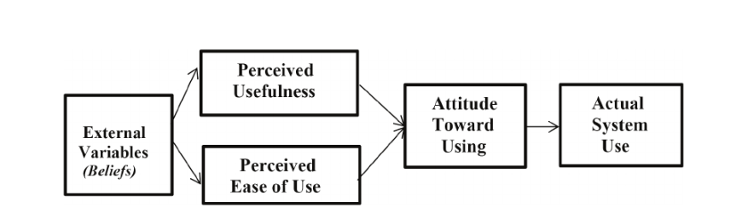

Figure 2.5.1: TAM
(Source: Schorr, 2023)
Na et al. (2022) assert that combining TAM with “Technology Organisation Environment (TOE) framework”, organisational competence, and social influence acts as external factors that influence PU and PEOU. Their results indicate that the construction companies implement AI-based technologies not only due to their technical potential, but also because the employees find them helpful to minimise mistakes, increase safety, and facilitate teamwork. Likewise, Na et al. (2023) verify that in both South Korea and UK, PU has a positive impact on user satisfaction and intention to use; however, cultural and contextual differences change intensity of relationships. In UK, it was established that personal competence has a direct influence on PU and PEOU, meaning that confidence and digital literacy of professionals is a significant factor that determines reception of KM technologies. This has direct implications for effectiveness of KM. The digital technologies, like AI-based decision support systems and BIM-based data repositories can facilitate knowledge creation and sharing only when construction professionals find tools useful and manageable. Therefore, TAM integrates all three constructs of PU, PEOU and contextual factors to conceptualise digital technologies as tools to support KM in UK construction industry, provided the acceptance of such technologies is strategically enabled by training, leadership support, and cultural alignment.
“Nonaka’s SECI Model”:
Developed by Nonaka and Takeuchi in 1995. SECI model is one of most influential KM models due to fact that it describes interaction between tacit and explicit knowledge that occurs in a continuous cycle to create organisational learning (Faith and Seeam, 2018; Jayasekera et al. 2022). Adesina and Ocholla (2019) point out that this dynamic model considers knowledge as a process and not a resource, which makes it especially applicable to an industry like construction, where cooperation and innovation are key.
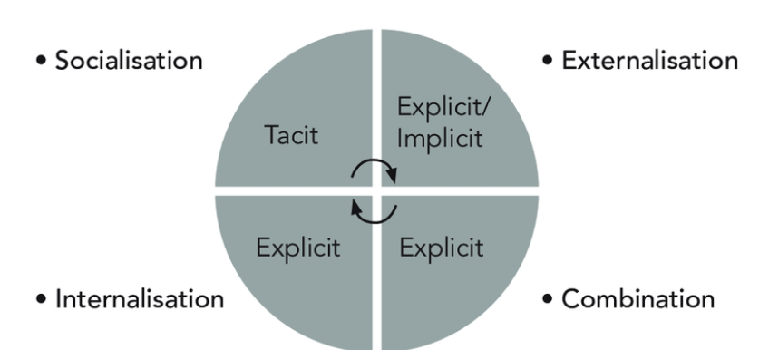

Figure 2.5.2: SECI Model
(Source: Faith and Seeam, 2018)
Figure 5 highlights four integral modes of knowledge conversion, which are “Socialisation, Externalisation, Combination and Internalisation”, and offer an organised way of generating, sharing and embedding knowledge in practice (Faith and Seeam, 2018). Referring to the context of UK construction sector, digital tools like BIM, along with digital twins, and cloud solutions strongly align with SECI process (Doan et al. 2021). Socialisation is boosted when project teams communicate within the collaborative BIM environments where tacit-to-tacit knowledge sharing occurs across disciplines, whereas Externalisation occurs when the knowledge of experience, like on-site problem-solving, is encoded in BIM models or digital repositories. Moreover, (Faith and Seeam, 2018) mentioned combination can be achieved with use of integrated platforms and digital twins by merging explicit data sources to form unified project knowledge in. Internalisation is facilitated by training platforms and simulations that instil digital knowledge into the skills and practices of workers. In this regard, Adesina and Ocholla (2019) asserted that focus of model on socialisation emphasises role of culture, leadership and trust in making digital tools a useful part of KM. Thus, it is evident that by incorporating SECI into digital innovation strategies, UK companies can more readily combine tacit skill with explicit digital products, minimising duplication, improving decision-making and maintaining a competitive edge.

2.6 Literature Gap
This research paper offers extensive insight into KM in reference to the UK construction sector; however, there are still some essential gaps that can be found. Researchers, including Wang and Meng (2021), Georgiadou (2019), and Tran and Nguyen (2024), underscore security of BIM in order to support KM processes, though studies have repeatedly demonstrated that this potential has not been realised in practice. It has also been noted that most literature cites interoperability along with cost and training as the barriers; however, there is a significant gap in longitudinal evidence of how UK firms maintain BIM-supported KM beyond initial implementation. Therefore, this creates a gap in knowledge in how BIM is used in creating and retaining knowledge over the long term in project life cycles in the UK. AI is a KM facilitator that forecasts analytics, automates, and recovers knowledge (Na et al. 2022; Na et al. 2023; Abioye et al. 2021; Rane, 2023). Nonetheless, majority of research is conceptual or exploratory, and little empirical data on AI adoption in construction projects in UK is available. Cross-national studies indicate that cultural variations influence perceptions of usefulness and ease of use, while little has been done to critically analyse how UK adversarial culture of contracting and the fragmented nature of projects would influence adoption of AI. This gap reveals necessity of context-related studies that would connect AI-enabled KM to organisational culture and project delivery outcomes.
Theoretical viewpoints also show constraints, although SECI model developed by Nonaka (Adesina and Ocholla, 2019) provides an understanding of processes of knowledge creation, implications of model in UK construction industry have been little studied through perspective of digital technology. Similarly, no extensive details can be found on factor of how TAM combines with socio-technical approaches in order to understand interplay between individual acceptance and organisational and industry-level obstacles. This creates a gap that has not been explored well on joint effect of culture, leadership and technological infrastructure on KM technology adoption. There is sufficient data to be found on barriers, which offers great insights into cultural, financial, and organisational barriers. However, there is barely any mention of any kind of solutions that can be implemented in order to reduce barriers or such interrelated complexities. Overall, it can be stated that there is a lack of empirical studies with a UK focus, incorporating technological, along with cultural and organisational approaches. This would address this by providing a more holistic insight into how digital KM technologies can deliver effective and sustainable results within UK construction industry.

2.7 Conceptual Framework
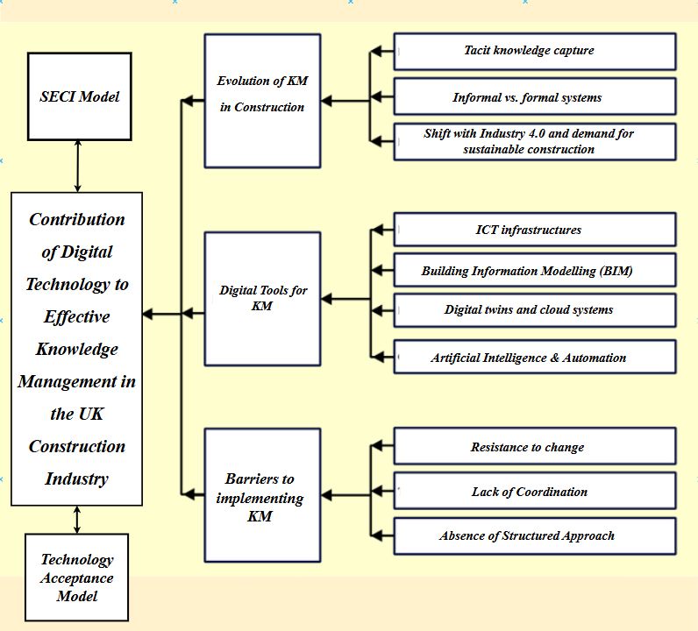

Figure 2.7.1: Conceptual Framework
(Source: Self-Developed)
Figure 2.7.1 demonstrates a detailed conceptual framework, which includes all of the important aspects of this research. Along with two important theoretical frameworks, different digital tools are also mentioned, like AI, along with BIM and digital twin, followed by notable barriers.

2.8 Conclusion
This literature review section offers a detailed discussion on different tools which aid in promoting the possibility of effective knowledge management in construction sector. BIM, AI, and cloud-based systems improve creation, storage, and dissemination of knowledge. However, their adoption is uneven in UK because of notable barriers that include an adversarial approach to contracting, fragmented supply chains, inadequate training, and scepticism towards innovation. Apart from that, theoretical frameworks like “SECI model of Nonaka, Technology Acceptance Model” have been utilised in order to explain how knowledge is generated, why technologies are embraced or not, and how social and technical factors have to be aligned. Different barriers are also identified, like, lack of coordination along with a structural approach and poor communication. Nonetheless, potential gaps have also been identified, like, lack of empirical studies that are specific to UK and connect digital KM technologies to long-term knowledge retention and sustainability practices. The identified gaps indicate necessity of more profound, UK-oriented studies that would combine theories of technology adoption with socio-cultural context. It also aids in ensuring that digital transformation promotes efficiency of projects as well as organisational learning and competitive edge in construction sector.

Chapter 3: Methodology

3.1 Introduction
In this chapter, the “methodological approach” to undertake a study into the role played by digital technology in “effective knowledge management (KM)” in the UK construction industry is set out. It elaborates and justifies the “philosophical stand”, “research design”, “method and strategy” utilised to deal with the “research aim and objectives” of the study. The discussion moves into the areas of “study philosophy”, “study design”, “survey-based research”, “data collection”, “population and sampling statistical procedures”, and “methods of analysis”, and then considers aspects of reliability, validity, limitations and ethical considerations (Gul, 2023). The chapter brings transparency and academic rigour to the research process. In this way, the research process can be coherent and can be replicated.
The main aim of this research is to explore how digital technologies contribute to effective KM in the UK construction sector. To accomplish the research, the paper is informed by the following objectives:
- To identify key digital technologies used in KM within the UK construction sector.
- To appraise the effectiveness of technologies in enhancing knowledge creation, storage, and dissemination.
- To examine the barriers to integrating KM technologies in construction firms.
- To recommend strategies for improving the implementation and adoption of technology-based KM

3.2 Research Strategy
The study approach used in this study has been informed by the fact that to present a strong, proper evidence on the role of digital technologies in “effective knowledge management (KM)” in the UK construction industry, the research strategy should be designed in such a way that acceptable generic evidence could be produced (Nyimbili and Nyimbili, 2024). The “quantitative research strategy” has been chosen, where the observable variables can be measured in addition to identifying the statistical relationships (Jayaratne, 2024). The technique has been well appreciated in the field of construction management studies due to its ability to generalise trends based on a large population and to yield results that are generalizable to other cases (Rashid and Sipahi, 2021). Since a “structured survey approach” has been used, the study has been placed to give reliable data on how technologies, like “Building Information Modelling (BIM)”, “cloud platform”, and the “digital twin”, have been incorporated in the KM practices.
The reasons behind the decision to use a “quantitative survey design” can be ascertained both on academic and practical grounds (Rashid et al. 2021). Academically, it has been pointed out that little or indeed no empirical, statistically underpinned research has been conducted regarding KM within a British construction context, with most of the literature being conceptual and qualitative in scope (Taherdoost, 2022). The “quantitative survey strategy” employed by the research has also made the research stronger in terms of reliability since the gathered information has been standardised, comparable and admissible in terms of “statistical analysis”. Concerning the strategy adopted, therefore, the selected strategy has provided a good basis for assessing how digital technologies have enhanced KM performance in the construction sector in the UK (Jamieson et al. 2023).

3.3 Research Design
The study has employed the “survey design”. The reason behind choosing this design is that it needed to come up with empirical evidence that is measurable or that can be generalised in the entire UK construction industry (Taherdoost, 2022). A survey method has been used, thus serving as a foundation of the research design, as structured data has been collected among a large and diverse population of professionals (Purwanto, 2021; Paudel et al. 2024). This decision is in line with the previous research on construction management, where the survey was believed to have contributed well in amassing the industry-wide trends provided that they are objective and reliable (Djafar et al. 2021).
“Survey design” has been preferred to the “qualitative or mixed method” ones because it is methodical in recording what is observable and applying statistics to it. “Interviews or case studies” are examples of qualitative techniques commonly employed to provide contextual depth, but are collectively ill-suited to yield generalizable results (Taherdoost, 2022). Moreover, “survey design” has enabled the research to acquire more data on an extensive sample in a cost and time-effective process, which makes it consistent with the goals of the research and the feasibility considerations of the study (Aschauer, 2021). With the use of Likert-scale and multiple-choice questions, the survey would provide quantifiable variables, which could be used in both descriptive and inferential statistical analysis (Saunders and Darabi, 2024).

3.4 Research Philosophy
“Research philosophy” provides the presuppositions that steer the examination and determinations of the creation of knowledge in scholastic research. In the research in management and social sciences, the “positivist paradigm”, “interpretive paradigm”, and “pragmatist paradigm” have gained widespread recognition (Saunders et al. 2015). These approaches have evolved separately based on different “ontological and epistemological assumptions”, and the decision to use one of them has serious “methodological design” implications in a dissertation.
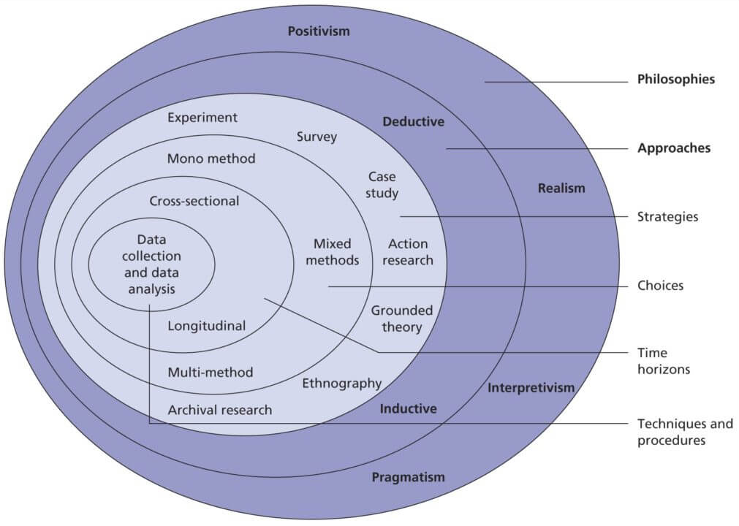
Figure 3.1: Research Onion
(Source: Saunders et al. 2015)
Positivism indicates that humans does not create reality, but rather they can use facts to measure and quantify it. In this case, the documentation relative to this paradigm will be considered as testable, verifiable, and generalizable. Also how Saunders et el. (2015) describes it, a positivist approach is logic and supportive of research studies that have definable variables and the establishing the various relationship amongst them sorely to them. In construction, the work of Urcia (2021) and Naeem et el. (2023) and Ali (202) used the positivist methodology to measure variables, ascertain the level of technology adoption, measure the knowledge sharing practices and ascertain what statistically plausible effect it has on the overall performance (2024).
Interpretivism has also helped in the study of cultural resistance, organization behavior and transmission of tacit knowledge. However, the method has been discovered to be wanting in terms of its ability to extrapolate the results to a wider population (Xhifica et al., 2024). There is a growing trend of pragmatic research using mixed-method designs that combine quantitative and qualitative data. This method is especially useful in complicated organizational studies that require the strict analysis of multidimensional knowledge constructs (Neumayer et al., 2023).
The dissertation is positivist in nature, that is driven by the requirement of extracting quantifiable, generalizable and objective evidence about digital technologies to improve knowledge management within the UK construction industry (Sumarni et al., 2024). Since the research aims imply the analysis of the correlation between the adoption of technology, the flows of knowledge, and the performance of the organization, the positivist framework is considered the most suitable. The paradigm makes it easier to design structured surveys and apply statistical methods, which produce findings that are both academically sound and of practical value to the sector.

3.5 Data Collection
The data-collection exercise has played a central role in this dissertation because it is the empirical basis on which the research objectives have been met. In line with a positivist paradigm and a quantitative methodological orientation, the data were obtained using a structured online survey that was conducted via a tool named Google Forms (Hasan and Bakar, 2022; Agapiou, 2022). This sampling platform was chosen due to its availability, efficiency in operation and automated responses in a standardized format, which reduced the likelihood of transcription errors and simplified further statistical analysis (Yang et al., 2023; Maqbool et al. 2023).
The fact that a questionnaire was used has been justified on a theoretical and practical grounds. Long known as a suitable instrument to retrieve data on large groups of people that are geographically disseminated within cost-effective time and resource limits, surveys are long recognised as a suitable instrument (Siswanto et al. 2025). With reference to this study, the UK construction industry has various stakeholders and can work in different regions, and the use of an online survey has allowed a high participation free of geographical barriers. Case studies or interviews, being multi-faceted sources of qualitative knowledge, have been discarded owing to their lack of scalability and generalisability (Noor and Fuzi, 2025; Dunivin, 2025).
The design of the questionnaire has been done by keeping in view the established theoretical frameworks, namely the “SECI model” of knowledge creation and “Technology Acceptance Model (TAM)”. The questions themselves have been modified based on earlier work in the knowledge management and digital adoption field, providing scholarly credibility and trustworthiness (Siswanto et al. 2025). The survey has been constituted of three sections. Demographic and organisational details, including job title, number of years of work experience, and the nature of the construction company, have been introduced into the first section and have facilitated the sorting of answers and the provision of context. The second part has dwelled on the usage of digital technology, where the questions have been prepared to determine the contribution of digital technology, such as the use of “Building Information Modelling (BIM)”, “cloud platforms” and “digital twins” on the creation, storage and communication of knowledge. Section three has reviewed the issues of digital knowledge management impediments and facilitators, which include leadership and management support, organisational culture and technological change resistance (Robinson, 2024; Shadmanfar and Makvandi, 2024).
The instrument has provided a “five-point Likert scale” to measure perceptions, attitudes and the degree of agreement. Such a method has allowed subjective opinions to be converted to measurable data that can be used in statistical analysis (Neumayer et al. 2023). There are also multiple-choice and ranking questions that would allow the researcher to capture the most commonly used digital technologies in construction knowledge management.
A pilot test of a small selection of the construction professionals has been performed to guarantee the usefulness and trustworthiness of a questionnaire. The pilot period has given input on the clarity of ambiguous questions, which has worked towards clarity and orderliness of the questions. The last tool has thus tried to have its accuracy coupled with conciseness, so that there is a maximisation of completion, without having the depth of the inquiry compromised. This questionnaire has been administered mainly by using professional network sites, which include LinkedIn, and also through special invitations via email (Sumarni et al. 2024). This approach has enabled the researcher to reach a purposive sample of practitioners in the industry, such as project managers, engineers, IT specialists and knowledge management officers. “Google Forms” has helped respondents to access the survey at their convenience, hence their participation rates have improved, and non-response biases have been reduced.

3.6 Population and Sample
The target population of the study has included professionals in the UK construction business since it is the group of individuals dealing with the adoption and implementation of digital technology in “knowledge management (KM)” (Ahmad and Wilkins, 2024). The selected population size is 245. The intended audience has consisted of project managers, engineers, those working in IT, and knowledge management officers, as each of them has been directly involved in the digital transformation and knowledge management practices in their organisations (Nyimbili and Nyimbili, 2024). Their opinions have proved critical in the assessment of how and why technologies like the “Building Information Modelling (BIM)” and “cloud computing”, and “digital twins” have shaped knowledge creation, storage and dissemination.
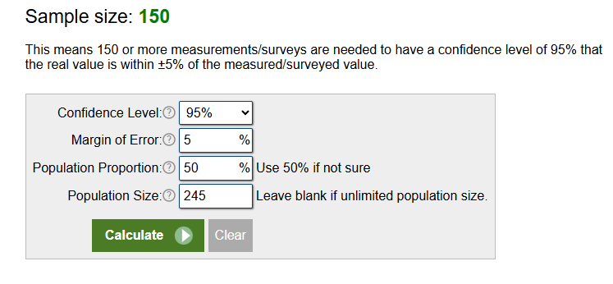
Figure 3.2: Sample size population
(Source: calculator.net, 2025)
The use of “purposive sampling” has been deemed the most appropriate in the context of the study since the research seeks to tap knowledge of people with a particular expertise and experience in the field of KM, as well as digital technologies. This method of “non-probability sampling” has helped ascertain that those professionals who possess pertinent knowledge have contributed to the dataset (Ahmad and Wilkins, 2024; Wang et al. 2023; Daniel et al. 2024). Hence, the quality and applicability of the findings are enhanced. The sample has been reached mainly due to professional networking websites like LinkedIn, further complemented by the use of email distribution, which has allowed us to reach across a wide range of organisations within the sector.
Almost, responses of 150 responses have been received, which is in keeping with methodological considerations that quantitative surveys at the postgraduate level require 20 questionnaires to generate adequate statistical power in the data analysis process (calculator.net, 2025). Out of 20 questionnaires, a total of 5 questionnaires have been prepared based on demographic-related and 15 questionnaires have been made related to of Independent Variables (Digital Technology, UK construction industry and cloud-based collaboration tools) and Dependent Variable (Effective Knowledge Management) (refer to Appendix).
The instrument deployed a two-part format, where part one gathered demographic variables: gender, age, highest attained level of formal education, current job position, and total circuit of professional experience. Part two operationalised the theoretical constructs by presenting twenty closed-ended items framed on a five-point Likert scale, where 1 indicated “Strongly Disagree” and 5 indicated “Strongly Agree.” The dependent construct knowledge management effectiveness was proxied by three subdimensions: the quality of decision-making, the level of collaborative practice, and the frequency and efficacy of knowledge-sharing behaviours. The independent predictors comprised: (1) the general and specific adoption of digital technologies (with particular mention of building information modelling, cloud storage and processing, and artificial intelligence applications); (2) the quantity and quality of training directed at enhancing the digital competencies of the workforce; (3) the degree of organisational and cultural endorsement of knowledge practices; and (4) recognised barriers to digital integration, including financial cost, standards of system interoperability, and expressions of staff resistance. Example questions are “Do you believe that KM technologies reduce repetition of mistakes and improve decision-making in your projects?” and “Does the lack of adequate IT infrastructure limit organisational ability to adopt KM technologies?” (refer to Appendix).
On this basis, the sample size has been adequate in achieving reliability and validity in the findings. In addition, the response rate obtained has provided an adequate ground for inferential statistical testing, including correlation analysis and regression analysis, whereby a significant relationship between variables can be derived (Ahmad and Wilkins, 2024).

3.7 Data and Analysis
The survey responses have been analysed to convert them into meaningful data in ways that are relevant to the ultimate research objectives. Following the “quantitative research design and positivist paradigm”, the analysis has been performed with the help of “IBM SPSS Statistics” as the programme is commonly accepted in the context of processing huge amounts of data and implementing effective statistical analyses. The application of SPSS has been justified based on its reliability to provide accurate results and the applicability of descriptive and inferential statistical techniques (Salman and Aleem, 2024). Roni and Djajadikerta (2021) have pointed out that the “credibility of a quantitative study” is enhanced when the available statistical software is utilised to reduce biases of the researcher and ensure replicability.
The analytical procedures have had a systematic process. Data cleaning was used to first identify cases that were not completely answered or did not match in answers, thereby removing invalid cases and leaving only valid cases that were analysed (Sarker et al. 2024; Adeniran and Onasanya, 2024). The period has played an important role in ensuring the integrity of data and data reliability (Saidu et al. 2023; Mweshi and Muhyila, 2024). After preparing the dataset, the “descriptive statistical methods” were used to describe the sample characteristics. Frequencies, percentages, mean and standard deviations have been computed to summarise the demographics of job position, years of experience, and type of organisation. Such descriptive measures have become critical in the comprehension of the composition of such a sample as well as contextualising further analyses.
The approach has allowed for to detection of such patterns, like whether higher engagement rates with "Building Information Modelling (BIM)" among senior managers were observed in comparison to the junior professionals, or whether organisations with higher numbers of employees had more uptake in “cloud-based platforms” (Rahman and Muktadir, 2021). “Chi-square tests” have also been useful in the determination of statistically significant associations between the categorical variables. The inferential statistical methods have been used to answer the questions of the study concerning the effectiveness of the digital tools as a means of knowledge management. “Correlation analysis” has been defined to determine whether single associations between selected variables are positive or negative as well as their magnitude. “Pearson correlation coefficients” have been assessed, and they yielded evidence that determines whether there are positive relationships between technology adoption and better knowledge creation, storage and dissemination. These correlations have been relevant in the tests of the hypothesis on the basis of the “Technology Acceptance Model (TAM)” (Delideli, 2024).
Besides the correlations, “regression analysis” has been deployed to determine the predictive performance of the independent variables on the KM effectiveness. The linear regression analysis model has been utilised to determine the various aspects of the constructs of ease of use perceived, organisational support and training provision in terms of their contributions to having a significant impact on the dependent variable of KM effectiveness. It is recommended to discuss the appropriateness of using the regression method in finding directional relations in social science studies. The “regression outputs” have given not only significance levels but also coefficients on the effect of the predictors, providing an indication of the relative strength of predictors and thus are useful in indicating which factors have been of most significance in promoting the digital KM practices in question (Wang, 2021; Keenan, and Rostami, 2021; Maqbool et al. 2022). The reason why these statistical methods were chosen can be justified by their agreement with the objectives of the research study and the common use of these techniques by other authors of like-minded studies (Blasco-Magraner et al. 2023; Keates et al. 2025). The use of “descriptive statistics” was such that there was clarity in the presentation of the sample profile, whereas the use of correlation and regression provided a deeper analysis of relations and predictive patterns (Willetts et al. 2021; Purwanto, 2021; Dzogovic et al. 2024). Finally, the analysis procedure has incorporated both descriptive and inferential statistical methods with the help of SPSS to answer the research questions rigorously (Rahman and Muktadir, 2021; Rahayu et al. 2024). Here the descriptive statistics with correlation as well as regressions analyses has been provided a strong evidence statistically of knowledge management by digital technology within the construction industry in the UK.

3.8 Reliability and Validity
Adequacy of reliability and validity of this research has been achieved by the establishment of rigorous design and test efforts (Coleman, 2022). The issue of reliability has been mitigated by adopting a structured questionnaire with closed-ended “Likert-type questions”, and “multiple choice questions” that have standardised responses, and minimise the chances of subjective interpretation. Internal consistency has also been reinforced using items that are adapted to other accepted instruments that have been used in the past to investigate the concept of knowledge management and the digital adoption process (Coleman, 2022; Leif et al. 2024; Enoch et al. 2025).
Validity has been improved as a pilot test was carried out on a small group of construction professionals, and this has helped in determining ambiguous or vague items. Revisions of this feedback clarified and aligned more of the questions with the goals of the research (Wang, 2021; Selvaretnam, 2024). Construct validity can be achieved by basing the questionnaire on the theory known as the “SECI framework” and the “Technology Acceptance Model (TAM)”.

3.9 Research Limitations
The study has various limitations in the methodology. The limitation of using a “quantitative survey” can be found in the fact that it has limited the in-depth insights since closed-ended questions have not allowed a richer understanding of views. Due to reliance on self-reported data, the potential for bias in the responses has been introduced as they might have been affected by personal views and organisational influences (Drolet et al. 2023). Surveys have also contributed to the lack of generalisability to the rest of the construction sector, despite ensuring relevancy to research objectives.

3.10 Research Ethics
The study has been carried out within the range of UWTSD ethics. The participants have learned about the purpose of the study, their anonymity, and it has been stated that the participants can withdraw at any time. Data has been gathered and kept in a secure way as stipulated by the GDPR laws (Armond et al. 2021).

Chapter 4: Data Analysis

4.1 Introduction
Research findings are presented in the following chapter by analysing collected data from surveys by using SPSS software. Demographic analysis of survey participants provides information on their gender, age, education, job position and working experience. The chapter continues with descriptive statistics, analysis of hypotheses through correlation and regression models. The discussion explains the findings with respect to the research objectives, followed by a conclusion of the main findings.

4.2 Demographic Analysis
In terms of ascertaining the extent to which demographic variables shape perceptions of knowledge management (KM) effectiveness and adoption, supplementary analyses were executed on the basis of subgroups. The independent-samples t-test and analysis of variance (ANOVA) were employed as analytical instruments when the data met the requisite assumptions.

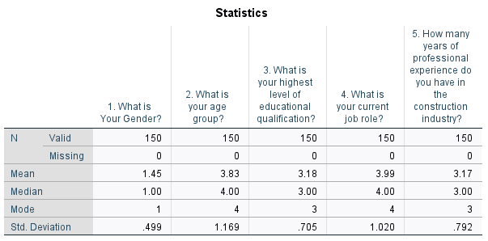

Table 4.1: Frequency Analysis
(Source: SPPS)
The demographic statistics as per Table 4.1, give an idea of the participants of the survey (N = 150). Gender analysis reveals a mean of 1.45, median and mode of 1, which reveals that the proportion of male respondents is high. The mean age of the group is 3.83, the median and mode of 4, indicating that the majority of the participants belong to the age of 36-45. As far as educational qualifications are concerned, the mean value of 3.18 and median and mode of 3 indicate that graduates predominate the sample. The job roles have a mean of 3.99 and a median/mode of 4, which indicates that most of the respondents have senior or managerial roles. The years of professional experience within the construction industry have a mean of 3.17, median and mode of 3, implying that the majority of the respondents have 6-10 years of experience in the construction industry. Therefore, it can be stated that the sample is a professionally experienced and male-dominated group of graduate participants.

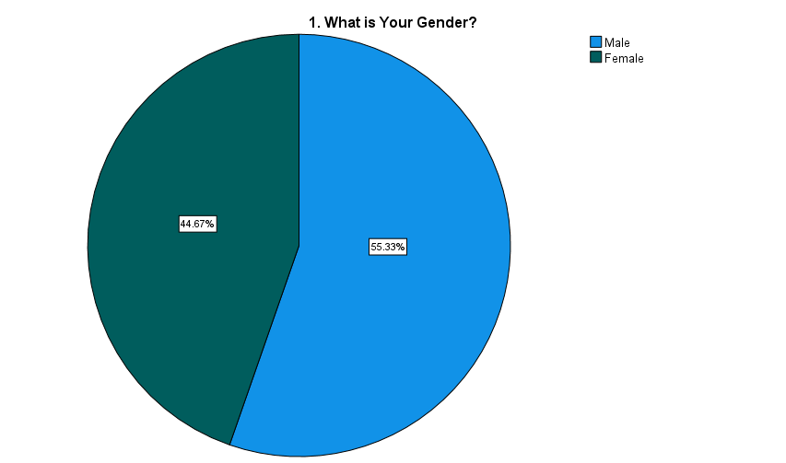

Figure 4.1: Gender
(Source: SPPS)
Figure 4.1 indicates that 55.33% of respondents are male as compared to 44.67% female. It shows a rather equal representation, although men are slightly more than women.
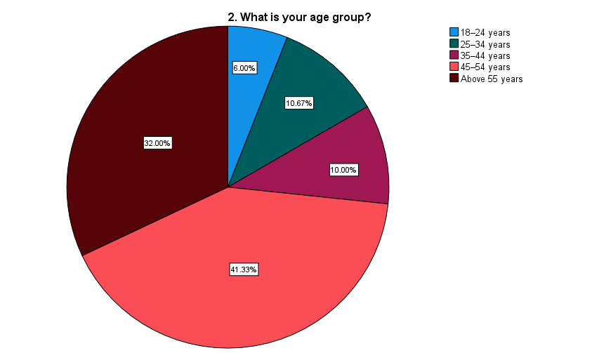

Figure 4.2: Age
(Source: SPPS)
Figure 4.2 shows highest percentage of participants (41.33%) falling within the age bracket of 35-44 years and 32% are older than 55 years. The smaller groups are in 25-34 (10.67%) and 45-54 (10%). Only 6% are aged 18-24, which shows the views of the mid-career and senior professionals.
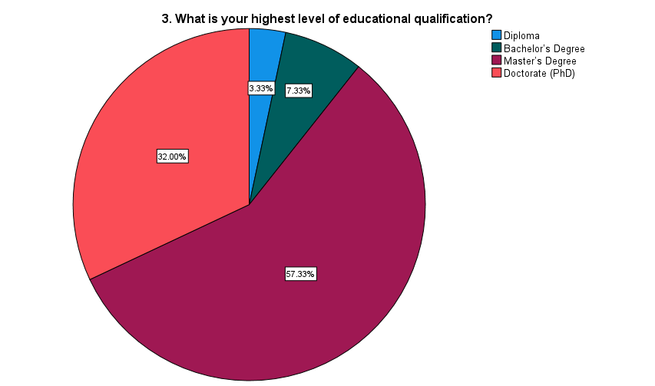

Figure 4.3: Educational Qualification
(Source: SPPS)
Figure 4.3 highlights that 57.33% respondents are highly educated, having a “master's degree”, and 32% have doctorate degrees. Bachelor's degree holders are 7.33% and those with diplomas are 3.33%.
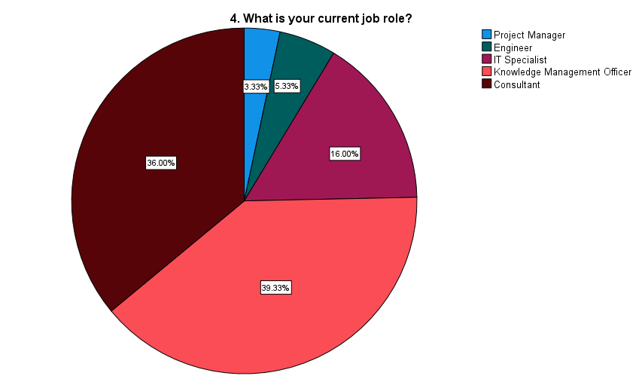

Figure 4.4: Current Job Role
(Source: SPPS)
Figure 4.4 denotes that 36% participants are consultants and 39.33% are knowledge management officers. Smaller groups are engineers (5.33%), IT specialists (16%), and project managers (3.33%).
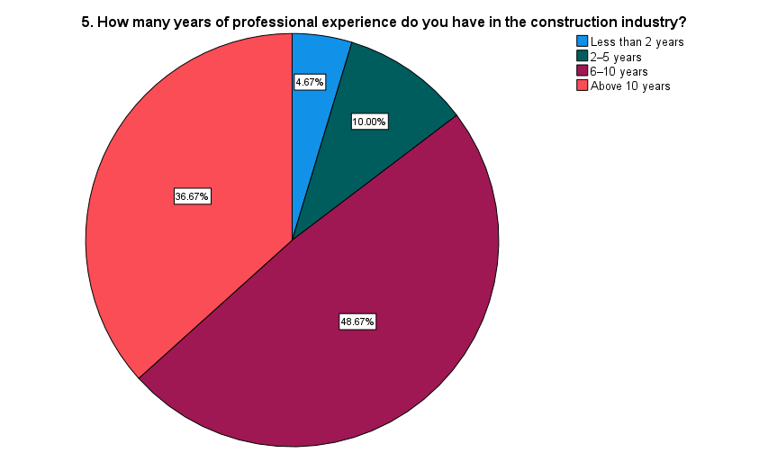

Figure 4.5: Professional Experience
(Source: SPPS)
Figure 4.5 shows that 48.67% of survey participants have 6-10 years of experience, followed by 36.67% with over 10 years. Smaller proportions report 2-5 years (10%) and less than 2 years (4.67%). It indicates that most of the respondents are experienced professionals, which increases the level of sectoral knowledge that they provide.
Professional experience: Respondents with a tenure exceeding a decade as practitioners evaluated KM effectiveness at a statistically elevated level when benchmarked against colleagues with a tenure of five years or fewer (p < .05).
Employment function: The cohort comprising consultants and dedicated knowledge management officers registered higher means on the adoption scales for digital KM tools than the contrasts comprising engineers and project managers.
Gender and educational attainment: The analyses did not yield statistically salient differences with respect to either KM effectiveness or adoption, implying a negligible influence exercised by these variables.
The results address that organisational function along with experience can impact demographic attributes for example, gender along with educational level, especially forecasting evaluative dispositions to KM programmes.

4.3 Descriptive Analysis
Summarizing the test analyses for descriptive has been done through considering SPSS to address central values and variance over different aspect. Such estimation related to the effectiveness of KM, digital technologies, cultural aid and training.

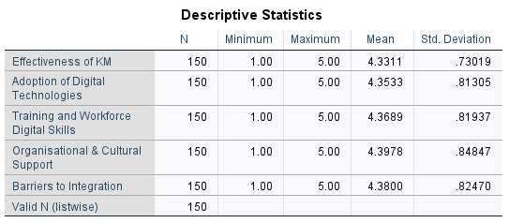

Table 4.2: Descriptive Statistics
(Source: SPPS)
Table 4.2 shows “descriptive statistics” of core constructs on which this research is based. The findings show that the overall perception of “effectiveness of knowledge management (KM)” is high with a mean of 4.33 (SD = 0.73). It indicates that participants are largely aware of the positive role of KM practices in enhancing project performance. Therefore, KM plays a central role in the learning of organisations in UK construction (Boamah et al. 2022). The use of digital technologies has an average of 4.35 (SD = 0.81), which indicates a high level of acceptance of digital technologies like BIM, cloud platforms and AI. It supports BIM as one of the drivers of integrated knowledge flows in the construction projects (Rathnasinghe et al. 2022). The high adoption rates are reflected in the moderate “standard deviation”, which indicates that the adoption may not be the same across the firms, especially between the large contractors and SMEs.
These findings prove this study is the opposite of the literature which only identifies barriers. This study is the first to show how digital tools are used in the UK construction sector, cultural and organizational enablers existing. Thus, this study aims to fill the gap in the literature for UK studies which go beyond barriers to examine how opportunities and constraints coexist.
“Training and workforce digital skills” have a mean of 4.36 (SD = 0.81) and are another positive area. Respondents seem to be certain about the ability of training initiatives to invest in digital literacy in the workforce. As “mean value” is close to 5, it denotes that the majority of participants have “strongly agreed” with the questions regarding "training and workforce digital skills”. Therefore, it can be said that KM needs both technological and human competence to be effective (Anshari and Hamdan, 2022). “Organisational and cultural support” had the highest mean (4.39, SD = 0.84), showing that the aspects of commitment and alignment of culture are critical facilitators. It highlights that cultural and leadership preparedness are the key factors that can make KM tools convert into practical gains (Raut et al. 2024). “Barriers to integration” also received a relatively high mean of 4.38 (SD = 0.82), which indicates ongoing problems like interoperability problems, cultural resistance, and financial limitations. Thus, it shows that there is a high level of support for the effectiveness of KM and adoption of digital, but also that barriers continue to play a significant role. Therefore, the duality of opportunity and constraint is confirmed in digital KM practices.

4.4 Hypothesis Testing using Correlation and Regression Model
Statistical techniques of inference were used to test the hypotheses of the study. Associative constructs were scrutinized with correlation technically, and the independent variables of adoption, training, culture, and barriers were set against the dependent variable of KM effectiveness to ascertain the predictive influence of the variables with regression analysis. These techniques were used in the study in order to allow the research to go beyond the descriptive techniques, to establish relationships in the data which are statistically relevant, thus answering the research objectives.

4.4.1 Hypothesis 1
This hypothesis has been tested for evaluating the relationship between IV1, ‘Adoption of Digital Technologies’ and DV ‘Effectiveness of KM’.
H1: “Adoption of digital technologies improves efficiency of KM in the construction industry.”
H0: “Adoption of digital technologies does not improve efficiency of KM in the construction industry.”
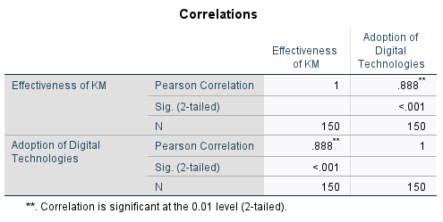

Table 4.3: Correlation Test
(Source: SPPS)
As per table 4.3, “Pearson correlation” between “effectiveness” and “adoption of digital technologies" are found 0.888 with p <.001. It is statistically significant and goes beyond the levels of strong effects and suggests that higher digital adoption is associated with much higher KM effectiveness perceptions among respondents. Such a high r begs to be questioned, however. It implies that the more digital tools, including BIM, cloud systems, or AI, are applied, the more KM is regarded as effective in general. Since the significance value is far less than 0.05, the outcome is statistically sound (Kwak, 2023).
The research supplies compelling confirmation that BIM and AI function as facilitators of knowledge management. Crucially, earlier scholarship acknowledged BIM’s promise but consistently underscored an absence of longitudinal or UK-relevant data. In contrast, the present study supplies empirical validation demonstrating that firms across the UK regard the uptake of digital methodologies as an immediate determinant of KM efficacy. It is however necessary to mention that correlation does not imply cause and effect. Companies that already have good KM systems are more likely to implement digital tools. Therefore, to justify the dependency, regression analysis is executed below.
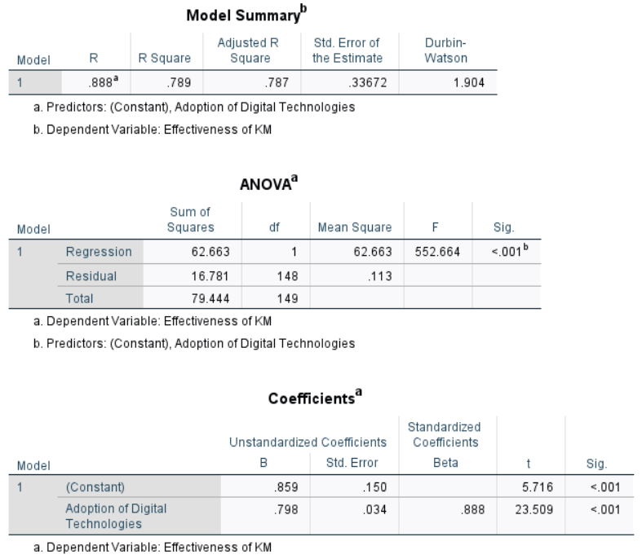

Table 4.4: Regression Test
(Source: SPPS)
The regression results in Table 4.4 indicate a very strong correlation between “adoption of digital technologies” and “effectiveness of KM”. The model accounts for approximately 79% of the variance in KM effectiveness (R² = .789), which is rather high in social science data. In “ANOVA analysis”, p < .001 indicates that the model is significant by accepting an “alternative hypothesis”. The coefficient of adoption (beta = .888, p <.001) shows that the greater the level of utilisation of the digital technology, the more effective KM is. Although this is a definite positive influence, the effect of size might be exaggerated. Other aspects such as leadership support, training, or company culture that tend to affect adoption and KM were not contained in the model. It implies that adoption alone cannot be used to explain everything. Nevertheless, the results lend much support to the alternative hypothesis (H1) and therefore, “Adoption of digital technologies improves efficiency of KM in the construction industry.” The work contributes to the literature by filling one current gap. Previous studies have underscored the promise of potentially harnessing BIM and AI technologies but emphasized adoption as sporadic and inconsistent (Georgiadou, 2019; Wang and Meng, 2021). In stark contrast, the evidence from this study indicates that firms in the UK, and especially those with experienced professionals, already consider digital adoption as a low-hanging fruit for KM. This could partly be attributed to the government BIM mandates, which, as the evidence suggests, have sped up the adoption of BIM across the sector.
Even so, the evidence suggests that the mere adoption of tools is not enough to account for the effectiveness of KM. Other elements such as, but not limited to, culture, leadership, and advanced digital skills, which will be addressed in the subsequent hypotheses, have interfaces with adoption. This indicates that whereas digital tools are indeed central, the advocacy for their use devoid of an ecosystem that fosters KM will be at best, short-lived.

4.4.2 Hypothesis 2
This hypothesis has been tested for evaluating the relationship between IV2, ‘Training and Workforce Digital Skills’ and DV ‘Effectiveness of KM’.
H1: “Training and workforce digital skills have a significant impact on effectiveness of KM in construction industry.”
H0: “Training and workforce digital skills have no significant impact on effectiveness of KM in construction industry.”
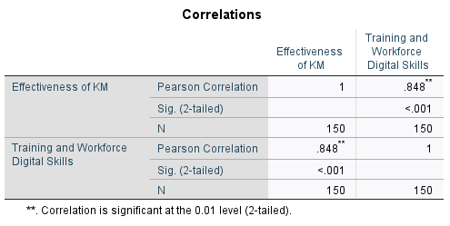

Table 4.5: Correlation Test
(Source: SPPS)
As per Table 4.5, “Pearson correlation” indicates that there is a strong positive correlation between training and workforce digital skills and KM effectiveness (r =.848, p <.001). It implies that the more digital skills the employees have, the more effective KM systems are perceived to be. Competence of the workforce is key to successful digital transformation in construction (Yang et al. 2025). The high value is partly a reflection of self-reported bias, where skilled staff naturally feel that systems are effective. Companies with well-established KM systems may be in a better position to train their employees. Although these reservations should be mentioned, the results clearly indicate that training is an essential facilitator of KM in the industry.The quantitative results reported here, derived from a sample of UK construction professionals, substantiate the hypothesis that formal training serves as a critical determinant of digital knowledge-management (KM) performance outcomes. By providing rigorous empirical evidence, the study addresses a prevailing lacuna concerning the human-competence dimension of KM adoption within the UK construction sector, to which prevailing literature has devoted insufficient analytical attention.

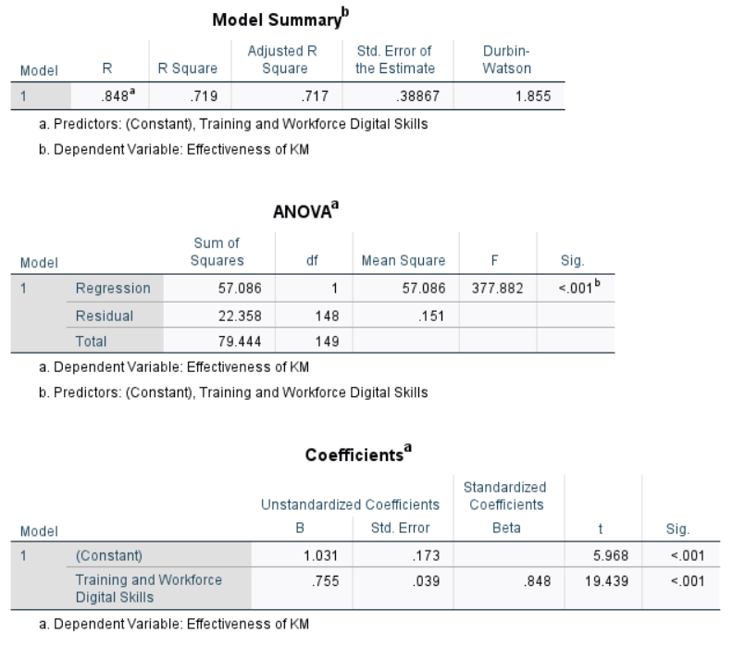

Table 4.6: Regression Test
(Source: SPPS)
According to Table 4.6, “regression analysis” supports “training and digital skills” as a predictor of KM effectiveness (R² =.719, F =377.882, p < .001), predicting a variance of almost 72%. The standardised coefficient (p < .001) shows that enhancement in training has a direct positive effect on perceived KM performance. The ability to measure the outcomes of KM technologies depends on digital literacy and staff training (Nikou et al. 2022). Nonetheless, a large R² may also indicate omitted-variable bias, and leadership and cultural support are also known to interact with training to affect KM outcomes. Nevertheless, the analysis indicates that investment in digital skills can significantly increase the effectiveness of KM in construction. Therefore, “Training and workforce digital skills have a significant impact on effectiveness of KM in construction industry.” This result shows that workforce capability is not an ancillary issue but rather a strategy component for KM success and resolves the literature deficiency regarding human capability in the UK construction industry and emphasizes training as a minimum requirement to realize the optimal value of digital technology integration.

4.4.3 Hypothesis 3
This hypothesis has been tested for evaluating the relationship IV3, ‘Organisational & Cultural Support’ and DV ‘Effectiveness of KM’.
H1: “Organisational and cultural support significantly influence KM effectiveness in construction industry.”
H0: “Organisational and cultural support does not influence KM effectiveness in construction industry.”
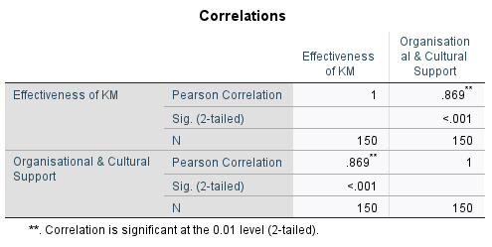

Table 4.7: Correlation Test
(Source: SPPS)
As per Table 4.7, “Pearson correlation” shows that the correlation between organisational and cultural support and KM effectiveness is very strong and positive (r = .869, p < .001). It indicates that with leadership commitment and a favourable culture, KM practices are much more effective. The magnitude of the correlation confirms that cultural preparedness usually overshadows technical adoption as a determinant of KM success (Alshareem et al. 2025). The high value, however, poses the issue of common-source bias as the respondents might give both variables high scores because they have positive perceptions of their workplaces. Accordingly, the analysis contributes to closing the observed lacuna regarding the operationalisation of established theoretical frameworks specifically, the Nonaka and Takeuchi SECI model within the context of digital knowledge management in the UK construction sector, and it further substantiates, through empirical evidence, of organisational culture and leadership effectiveness as antecedents of successful model deployment.

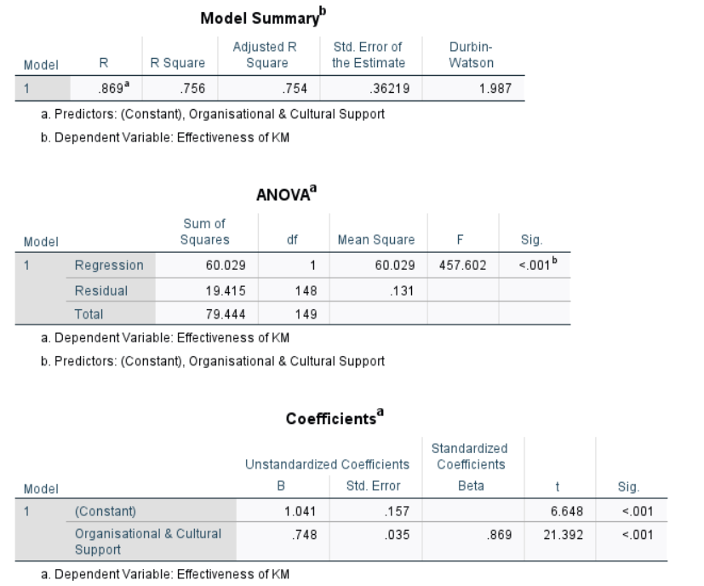

Table 4.8: Regression Test
(Source: SPPS)
Table 4.8 reveals that “organisational and cultural support” contributes to the variance in KM effectiveness by about 75.6% and the goodness-of-fit is confirmed by the ANOVA results (F = 457.602, p < .001). The large standardised coefficient (t = 21.392, p < .001) also indicates that cultural and leadership support are strong predictors of KM outcomes. These findings are in line with the SECI model of Nonaka, who emphasises the social aspect of creating knowledge. However, this predominance may mask the other important predictors, including digital infrastructure and skills of the workforce, which suggests the possibility of omitted-variable bias. Nevertheless, as “coefficient” and ANOVA p-value are highly significant, H0 is rejected. Therefore, “Organisational and cultural support significantly influence KM effectiveness in construction industry.” The above example shows that KM adoption in Digital form is greatly influenced by culture and leadership, which expands the SECI model to the UK context, and demonstrates that organisational alignment converts technological investment into sustainable knowledge outcomes.

4.4.4 Hypothesis 4
This hypothesis has been tested for evaluating the IV4 ‘Barriers to Integration’ and DV ‘Effectiveness of KM’.
H1: “Barriers to integration affect KM effectiveness in construction industry.”
H0: “Barriers to integration do not affect KM effectiveness in construction industry.”
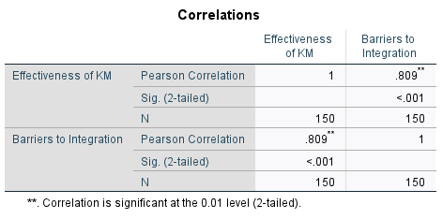

Table 4.9: Correlation Test
(Source: SPPS)
As per Table 4.9, “correlation” between “barriers to integration” and “KM effectiveness” is found as 0.809, which is close to 1 and is very strong and statistically significant. This positive relationship at face value appears to be counter-intuitive, as the more barriers, the less efficient KM should be. Nonetheless, the result could be a sign of the fact that organisations with more developed KM systems are also more prone to integration issues, including interoperability or cultural barriers. The present analysis reveals that obstacles to knowledge management do not simply retard maturation; rather, they intertwine with, and often intensify, the incremental phases of adoption. This insight extends the prevailing literature, which has tended to enumerate barriers without situational analysis, and redirects attention from lag-resolution to the longitudinal interplay of impediments and capability-building in leading UK enterprises.

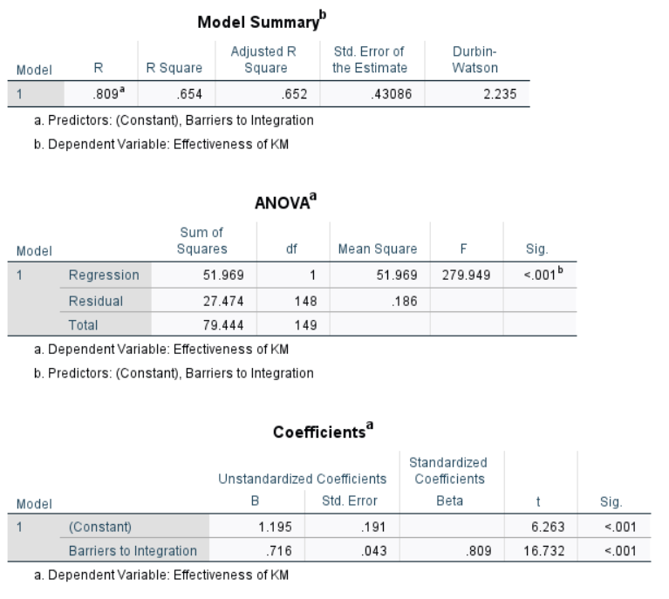

Table 4.10: Regression Test
(Source: SPPS)
“Regression model” in Table 4.10 indicates that “barriers to integration” contribute to the variance of KM effectiveness by 65.4% (R²=0.654). The model is also statistically significant as the ANOVA results (F = 279.949, p < .001) show. The coefficient's significant value of less than 0.05 indicates barriers are a strong predictor, although the positive sign creates some problems with interpretation. As opposed to implying that barriers can improve KM, it can mean that highly digitised firms report superior KM performance and the awareness of obstacles. The complexity of the situation confirms that resistance and cost pressures become more significant when KM systems expand (Champaneria et al. 2023). Therefore, “Barriers to integration affect KM effectiveness in construction industry.” This reframes barriers as challenges indicative of a dynamic level of maturity as opposed to static obstacles, showing that the challenges of integration grow with increasing level of adoption, and adds to empirical evidence on the increasing complexity of KM systems in firms in the UK.

4.5 Summary of the result
The result from the SPSS analysis in this study has found that KM effectiveness in the UK construction industry is mainly determined by digital and organizational factors . Use of digital technologies had the strongest explanatory impact with correlation r = .888 (p < .001) and regression variance explained 79% (R² = .789) confirming H1. Training and workforce digital competencies also had considerable impact, r = .848 (p < .001) explaining 72% of variance (R² = .719), supporting H2. Organizational and cultural support had parallel impact, r = .869 (p < .001) with 75.6% variance explained (R² = .756) supporting H3. Barriers to integration also had impact, r = .809 (p < .001) explaining 65.4% variance (R² = .654), supporting H4. This suggests that digital tools are major KM effectiveness factors, while the skill level of the workforce, managerial attitude, and sustained obstacles to integration are also critical.

4.6 Discussion
Key Digital Technologies Used in KM within the UK Construction Sector
“Building Information Modelling (BIM)”, Artificial Intelligence (AI), cloud-based platforms, and digital twins as the key technologies leading the KM in construction (Hu et al. 2021; Yao et al. 2022; Altaie and Dishar, 2024; Taherdoost and Madanchian, 2023). BIM is specifically singled out as a collaborative digital platform to store and share knowledge and AI provides predictive analytics and automation functions (Anumba and Khallaf, 2022; Pai et al. 2022; Morandini et al. 2023). Nevertheless, adoption is described as uneven, with big companies taking the lead and SMEs following because of resource constraints (Georgiadou, 2019; Egwunatum and Oboreh, 2022; Boamah et al. 2025). The literature also indicates that such technologies are commonly implemented in a siloed fashion as opposed to an integrated KM strategy (Ozturk and Yitmen, 2019; Marinho and Couto, 2022).
Data analysis depicts that the level of adoption is high, with a mean score of 4.35 and a positive correlation between digital technology adoption and KM effectiveness. Regression analysis shows that adoption is a significant predictor of KM success, a finding that is not in line with the literature, which is worried about fragmented implementation (Wang and Meng, 2019; Heaton et al. 2019). Such a discrepancy may be explained by the fact that the sample was composed mostly of experienced professionals with well-resourced organisations, unlike SMEs that are often mentioned in the literature. Theoretical approaches emphasise obstacles, but empirical data indicate a more pronounced tendency towards common implementation, probably due to governmental requirements in the UK about BIM (Ganah and John, 2015; Agostini et al. 2020).
Effectiveness of Technologies in Enhancing Knowledge Creation, Storage, and Dissemination As evidenced in the literature, both BIM and AI can enhance the lifecycle data management and collaboration and AI can optimise knowledge retrieval and predictive analytics (Fadeyi, 2017; Pai et al. 2022; Anumba and Khallaf, 2022; Baduge et al. 2022). Nevertheless, Hu et al. (2021) mention the problem of interoperability and integration that limits potential. Xiahou et al. (2025) stated that technology is not the only factor that guarantees success of KM without cultural alignment (Md and Mahesh, 2020; Li et al. 2023). The overall conclusions of the studies are quite optimistic, yet with a specific emphasis on the fact that the technical benefits are critical to the strategic integration and leadership support (Likhitruangsilp et al. 2019; Marinho and Couto, 2022).
Empirical results show high consistency in KM effectiveness and a high positive correlation between digital adoption and KM performance. “Regression analysis” indicates digital technology adoption can explain 79% of the variance in the effectiveness of KM, which means that technologies have a significant impact on knowledge processes in practice. It is in sharp contrast with the emphasis in the literature on inefficiencies and partial implementation, especially by SMEs (Georgiadou, 2019; Elghaish et al. 2024). This difference could be because literature tends to analyse sectoral averages or SMEs, whereas the survey represents the opinions of digitally mature organisations. As such, theoretical reasons on barriers are sound, but practical evidence shows that when digital tools are used effectively, they provide high KM returns (Suresh et al. 2016; Yao et al. 2022).
Barriers to Integrating KM Technologies in Construction Firms
Previous strides addressed that some of the barriers are technical (interoperability problems), financial (it is too expensive, ROI is unknown), cultural (resistance to change), and organisational (Wang and Meng, 2021; Georgiadou, 2019; Egwunatum and Oboreh, 2022; Tran and Nguyen, 2024; Yusof et al. 2019). Researchers claim that such issues are highly systemic and socio-technical and that integration is hard even in technologically advanced countries such as the UK (Andersson and Eidenskog, 2023; Enshassi et al. 2019; Korkmaz and Bahidrah, 2018). The adoption of AI also has ethical and trust-related concerns and SMEs are constrained by resources that hinder adoption (Abioye et al. 2021; Rane, 2023).
The survey findings indicate the existence of barriers with a mean of 4.38. Regression analysis indicates that barriers have a significant effect on the effectiveness of KM. Positive correlation seems to be counter-intuitive yet it is likely to represent the fact that more advanced KM systems are more complicated to integrate (Champaneria et al., 2023). Thus, although adoption is a driver of KM performance, there are barriers that exist and this necessitates the use of comprehensive strategies that will involve organisational culture, leadership and technical standardisation. It is consistent with literature, which emphasises socio-technical integration as opposed to technical fixes (Andersson and Eidenskog, 2023; Singun, 2025).
Recommend Strategies for Improving Implementation and Adoption of Technology-Based KM
Leadership commitment, cultural change, workforce training and strategic alignment are the most popular success factors of KM adoption in the literature (Usman et al. 2021; Likhitruangsilp and Kiet, 2019; Blak Bernat et al. 2023). Theoretical frameworks like TAM and SECI also emphasise the significance of the perceived usefulness, ease of use, and socialisation processes based on trust in the adoption process of technology (Adesina and Ocholla, 2019; Schorr, 2023; Nonaka and Takeuchi, 1995). These claims are confirmed by the data analysis. Strong predictors of KM success are training and workforce digital skills and organisational and cultural support. It proves that technical infrastructure is not enough to be effective; cultural preparedness and engagement of leadership are essential (Alshareem et al. 2025; Boamah et al. 2021; Nor et al. 2020).

4.7 Summary
The above chapter has discussed the results of survey data to determine the contribution of digital technologies to effective knowledge management (KM) in the UK construction industry. The chapter addressed that mature KM systems are associated with more technical and organisational challenges. The results show a two-fold reality: digital adoption is a powerful KM effectiveness driver, but integration challenges persist, and balanced approaches that focus on technical investment, skills development and cultural alignment must be implemented.

Chapter 5: Conclusions and Recommendations

5.1 Introduction
The chapter ends the research with a synthesis of the main findings and implications of the research on knowledge management (KM) within the UK construction industry. The research aimed to evaluate the impact of digital technologies on successful KM, such as Building Information Modelling (BIM), cloud, and Artificial Intelligence (AI) based on the quantitative survey analysed with the help of SPSS. The past chapters investigated the development of KM practices, the barriers, and hypothesis testing based on the SECI and Technology Acceptance Model (TAM) framework. It was found that, although digital adoption is one of the most important KM effectiveness drivers, organisational culture, leadership, and digital skills of the workforce are also essential facilitators. Meanwhile, there are still systemic obstacles such as interoperability, financial limitations, and change resistance. In this chapter, the key findings have been summarised and connected with the literature, and the contribution of the study to the development of theoretical and practical knowledge of digital KM in the UK construction industry is established.
This study demonstrably achieved all its research objectives. As for the first objective concerning the impact of digital technologies on KM effectiveness, digital adoption regression analysis explains 79% of the variance in KM outcomes. The second objective concerning the role of workforce training was fulfilled by the evidence that digital skills determine 72% of KM effectiveness. The third objective regarding the impact of organizational culture and leadership was confirmed by strong correlations (r = .869) and variance explained (R² = .756). The fourth objective concerning barriers to be analyzed was addressed by the novel finding that barriers, while challenging, are positively associated with KM maturity (R² = .654). Altogether, these findings indicate that there are new, UK-specific empirical insights added to the literature and the research objectives have been clearly achieved.

5.2 Summary of Key Findings
The results of this dissertation show that digital technologies contribute to KM effectiveness in the UK construction industry significantly; however, their contribution is conditioned by organisational, cultural and human factors. Four key themes that were identified include the role of digital adoption, cultural and leadership factors, workforce capacity, and sustained barriers.
Digital Adoption as a Primary Driver
The regression analysis revealed that digital adoption is the reason behind approximately 79 percent of the variance in KM effectiveness, which supports the idea that such technologies as BIM, AI, and cloud systems are the critical facilitators of knowledge flows (Wang and Chen, 2023; Omrany et al., 2023). Respondents affirmed that they rely much on BIM, as the UK government has a BIM Level 2 requirement (Awwad et al., 2020). The findings correspond to those of Yao et al. (2022), who define digital platforms as stores and transactive memory systems where tacit and explicit knowledge can circulate. Although previous research implied that adoption was uneven and the productivity results were low (Georgiadou, 2019), this study shows that technologies can bring significant KM returns when they are incorporated successfully.
Organisational Culture and Leadership
The information emphasises the importance of the organisational culture and the involvement of the leadership in facilitating KM. There were high correlations between cultural openness, leadership commitment and perceived KM effectiveness. This observation echoes the results of Lam et al. (2021), who purported that innovation capabilities are heavily reliant on favourable organisational cultures. In the SECI model, the tacit knowledge is transformed and institutionalised with the help of leadership (Faith and Seeam, 2018). On the same note, Ashok et al. (2021) note that KM practices are usually undermined by inertia and cultural rigidity. The results of the survey indicate that effective technology adoption is most effective in the presence of leadership-based strategies to promote trust, knowledge sharing, and cross-disciplinary collaboration.
Workforce Digital Skills and Training
Workforce training and digital literacy were identified by the respondents as one of the central enablers. Regression findings supported the assertion that digital skills are significant predictors of KM effectiveness, and therefore technical infrastructure is not sufficient to ensure success. This confirms the claims of Likhitruangsilp and Kiet (2019) and Usman et al. (2021), who highlighted training as one of the key success factors. The connection to the TAM framework is clear: the perceived ease of use and usefulness depends on the confidence and ability of users to work with digital tools (Adesina and Ocholla, 2019). As it was observed by Alshareem et al. (2025), technical adoption should be accompanied by cultural preparedness and involvement of leadership so that employees are not only prepared but also motivated to use digital systems effectively.
Persistent Barriers to Integration
Although there are obvious advantages, obstacles are still substantial. Interoperability issues, prohibitive prices, lack of clarity in terms of a payback, and cultural resistance were listed as the key barriers to the study as well as in previous research (Georgiadou, 2019; Wang and Meng, 2021). A mean of 4.38 in the barrier score shows that these are widespread issues among the practitioners. Interestingly, the results of regression showed a counter-intuitive positive relationship between barriers and KM effectiveness, which means that more developed KM systems are more complex to integrate (Champaneria et al., 2023). This paradox implies that mature digital systems enhance KM, but they subject organisations to more subtle interoperability and cultural issues. The results confirm the argument by Andersson and Eidenskog (2023) that socio-technical barriers are the most stubborn in the UK context, not only technical ones.
Theoretical Alignment
The results are in good agreement with the SECI and TAM frameworks. Digital platforms facilitate all four SECI processes, including socialisation, which occurs in collaborative BIM settings, externalisation, which is done through digital documentation, combination, which takes place through integrated datasets, and internalisation, which is realised through training and simulation (Faith and Seeam, 2018). Similarly, perceived usefulness and ease of use as TAM constructs were confirmed by the fact that digital literacy and training have a significant impact on adoption (Nnaji et al., 2023; Park and Park, 2020). Collectively, these frameworks describe the way in which knowledge is generated and shared as well as why digital KM tools are accepted or rejected by individuals and organisations.
The research confirms that digital adoption is a good facilitator of knowledge management but it depends on the integration with complementary processes to be successful. Digitisation of investments in the form of improved knowledge results require focus on organisational culture, leadership involvement, and workforce preparedness. The existence of the impediments, particularly in small and medium-sized businesses, remains acute due to the financial and cultural constraints (Georgiadou, 2019). Similarly, the results reveal the necessity of combined strategies that have to address technological, organisational and human aspects to ensure the long-term KM performance in the UK construction sector.

5.3 Linking with Objectives
The essence of the research was to determine how the digital technologies could be utilized to facilitate efficient knowledge management (KM) in the UK construction industry. It was a quantitative methodological strategy and involved the use of a survey instrument that had been tested via the SECI model and the Technology Acceptance Model (TAM), thus, delivering empirical evidence that elucidated the relationship between digital adoption, organisational culture, workforce skills set and KM outcomes. The results confirm that Building Information Modelling (BIM) is the strongest digital instrument that can be used to facilitate KM in the United Kingdom, which is justified by the fact that BIM Level 2 is a government-sponsored tool (Awwad et al., 2020). The respondents noted that they used BIM as a central repository to a larger extent, thus, facilitating them to collaborate and control the life-cycle information in accordance with the statement made by Wang and Chen (2023) that BIM aggregates projects on the same digital platform. Besides BIM, cloud-based tools were often used, which allowed sharing real-time information and mobility; this is consistent with the description of such tools as repositories and transactive memory systems provided by Yao et al. (2022). An increased awareness of artificial intelligence and digital twins, which make it possible to predict analytics, use real-time simulation, and automate knowledge flows, was also noted in the survey (Omrany et al., 2023). Combined, these results complement the current literature that recognizes BIM, cloud solutions, artificial intelligence, and digital twins as the key technological enablers of KM in building construction (Na et al., 2022; Wang et al., 2022). Regression analysis showed that digital adoption explained about 79 percent of the variance of KM effectiveness, which also highlights the significant role of digital tools in supporting knowledge processes. BIM and cloud systems were also found to be especially helpful in capturing and codifying tacit and explicit knowledge, thus minimizing the repetition of errors and inefficiencies - which Georgiadou (2019) notes. The outcome demonstrates knowledge-conversion mechanisms that the SECI model explains: BIM and digital twins can be used to externalise and synthesize knowledge, and training platforms can be used to internalise it (Faith and Seeam, 2018). There were also signs that these technologies have a strong contribution to collaboration, decision-making, and knowledge sharing in project lifecycles. These results are not in conflict with the fact that Yao et al. (2022) have proven that digital systems can be used as dynamic KM platforms, thus validating the fact that technologies are not only efficient but also crucial to the KM enhancement when integrated into the wider organisational processes. The obstacles proved to be a significant hindrance in spite of the benefits. Most of the barriers were found to be technical (e.g., interoperability and standardisation), financial (e.g., high costs, unclear ROI), and cultural (e.g., resistance to change, adversarial contracting), which is consistent with previous research by Wang and Meng (2021) and Yusof et al. (2019). The mean barrier score of 4.38 represented high perceived level of challenges amongst the respondents. Interestingly, the results of the regression showed a positive relationship between barriers and KM effectiveness, which means that more advanced KM systems have more chances to face complicated integration issues (Champaneria et al., 2023). This paradox implies that even though adoption improves the KM results, the digital transformation grows more complex as organisations advance their practices. Therefore, barriers cannot be regarded as only negative phenomena but as an inseparable part of the management of complex socio-technical systems (Andersson and Eidenskog, 2023). The findings justify a balanced intervention that combines technology and cultural, organisational, and human enablers. The findings of Usman et al. (2021) and Likhitruangsilp and Kiet (2019) are consistent with the study outcomes since the leadership commitment, training of the workforce, and cultural readiness were found as the strong predictors of KM success. The TAM framework can also support it, stating that the relationship between the perceived usefulness and ease of use among employees is mediated by the digital literacy and confidence (Adesina and Ocholla, 2019). In this aspect, the strategic initiatives should aim at integrating the digital investment and human-based programmes, such as formal training, knowledge-sharing incentives, and leadership-driven culture change (Alshareem et al., 2025). These activities are a way to fill the theory-practice gap in that the digital tools are not only easily accessible but also easily integrated into daily activities.
Addressing the Research Question
The following was the main research question: How effective and efficient does digital technology make knowledge management practices in UK construction industry? The statistics show that the role of digital technologies is strong and measurable, and adoption becomes the single most important measure of KM effectiveness. The results, however, also indicate that this enhancement does not just happen by default. It depends on the congruity of culture, involvement of leadership and the ability of the workforce. Barriers also complicate integration, but such obstacles can be addressed by using detailed plans that harmonize socio-technical systems. In this way, the research comes to a conclusion about the great contribution of digital technologies to KM, yet they should be integrated into favourable organisational settings.
Finally, the research has a contribution to theory and practice by proving that the efficient KM within the UK construction industry is not a technological process that is not influenced by the interplay of digital instruments, cultural preparedness, leadership, and human potential. The results generalise the SECI and TAM models into a UK construction setting and provide empirical support of their relevance. To practitioners, the study gives evidence that digital adoption is a worthwhile investment, yet long-term success demands investment in people and culture as well as technical infrastructure. Finally, digital technologies can be improved to a high level of KM, yet their actual potential is achieved only once they are used in a part of the integrated strategies that consider the complexity of construction organisations.

5.4 Recommendations
Recommendation 1: Integrate Digital and Cultural Strategies
Digital technologies such as BIM, AI and cloud systems boost KM, but they are dependent on organisational culture. Leaders are advised to promote transparency, value knowledge sharing, and respond to change resistance, as Lam et al. (2021) do. A two pronged emphasis on technology and culture is a guarantee of continued uptake. This research showed that the adoption of many digital technologies explains 79% of the variance in KM effectiveness (R² = .789), but the effectiveness is maximized only when it is supplemented with adequate culturally and professionally supportive leadership (r = .869, R² = .756). This finding is rather new to most of the literature, which often only focused on the barriers (Georgiadou, 2019; Wang & Meng, 2021). Thus, the recommendation is that UK firms need to not only invest in BIM and AI but also launch leadership-led initiatives to alter the culture in the organization to reduce resistance and facilitate sustained KM benefits.
Recommendation 2: Enhance Workforce Digital Competence
The results indicate that digital literacy is a good indicator of KM effectiveness. The companies need to invest in systematic training, simulation-based learning and workshops. Higher adoption as proposed by TAM can be achieved by enhancing ease of use and usefulness by developing skills (Adesina and Ocholla, 2019). The analysis confirms that the combination of training and digital skills account for 72% of the variance in KM effectiveness (R² = .719), which upholds the TAM’s ease-of-use principle. Previous literature, Usman et al. (2021), Likhitruangsilp & Kiet (2019), emphasized training as a requisite for success but lacked validation from the UK. This study serves that purpose. Hence, firms should adopt policy of refresher training, simulation based learning and workshops as a way of training for the purpose of building enduring competence which in turn, promotes effective KM adoption.
Recommendation 3: Support SMEs with Standards and Collaboration
SMEs face cost and interoperability barriers (Georgiadou, 2019). The industry bodies are supposed to facilitate subsidies, shared standards and platforms of cooperation in order to level the playing field. This will ensure that adoption of KM does not only happen in large firms, but it permeates the entire industry. While larger firms have high rates of adoption, the barrier mean score of 4.38 suggests SMEs continue to struggle the most with interoperability and costs. These results are in stark contrast to previous research which identified financial constraints, but failed to address context with advanced KM maturity. Therefore, it is incumbent on the industry bodies to develop support frameworks, common frameworks, and collaborative space in order to promote the inclusion of SMEs in the KM digitalisation.

5.5 Contributions of the Study
The article contributes to the field of research by placing the SECI and TAM frameworks in the context of the construction industry in the United Kingdom and thus demonstrating how digital technologies can support the creation and adoption of knowledge. The methodological value of the study is that it uses quantitative survey data and regression analysis to generate statistically robust findings to address a major gap in the UK-specific empirical literature. In practice, the authors propose industry-specific interventions that are directed at the adoption of digital, cultural preparedness, and workforce development in order to enhance the efficiency of operations, innovation, and the sustainability of competitive advantage.

5.6 Limitations of the Study
In several ways, this study is limited. The use of purposive sampling and the rather limited size of the sample diminish the relevance of the findings to the industry in the UK overall. Moreover, the cross-sectional survey design simply gives an image of the phenomenon, thereby limiting the possibility of making conclusions about the long-term trends. Furthermore, there is a threat of bias due to self-reported data, as the respondent might overestimate his/her digital adoption. Finally, there was no time and financial capacity to utilise qualitative methodologies, which would have offered a more nuanced study of the cultural and behavioural antecedents of knowledge management.

5.7 Suggestions for Future Research
Mixed-method designs, including surveys and case-studies, ought to be applied in the future, and it will be possible to make the findings more contextual. Longitudinal study is also beneficial in the following ways in the evolution of digital knowledge-management practices during the entire lifecycle of projects. The empirical evidence would also come in handy to provide comparative studies of the small, medium, and the large enterprise in terms of their adoption levels. Lastly, the advent of new technologies such as artificial intelligence, blockchain and digital twins must be discussed further regarding how they can resolve the issue of interoperability, trust, and predictive knowledge-management in the construction industry.

References
Abdulmuhsin, A.A., Hussein, H.D., AL-Abrrow, H., Masa’deh, R.E. and Alkhwaldi, A.F., 2025. Impact of artificial intelligence and knowledge management on proactive green innovation: the moderating role of trust and sustainability. Asia-Pacific Journal of Business Administration, 17(3), pp.765-795. https://www.emerald.com/apjba/article-abstract/17/3/765/1263239
Abioye, S.O., Oyedele, L.O., Akanbi, L., Ajayi, A., Delgado, J.M.D., Bilal, M., Akinade, O.O. and Ahmed, A., 2021. Artificial intelligence in the construction industry: A review of present status, opportunities and future challenges. Journal of Building Engineering, 44, p.103299. https://doi.org/10.1016/j.jobe.2021.103299
Adeniran, T.A. and Onasanya, S.A., 2024. Impact of e-learning on college of education lecturers’ knowledge of quantitative data analysis in SPSS. Indonesian Journal of Educational Research and Technology, 4(2), pp.121-128.DOI:10.14419/09pejd96
Adesina, A.O. and Ocholla, D.N., 2019. The SECI Model in Knowledge Management Practices: Past, Present and Future. Mousaion, 37(3). https://doi.org/10.25159/2663-659X/6557
Adi, W.A., Hiyassat, M. and Lepkova, N., 2021. Business strategy development model for applying knowledge management in construction. Journal of civil engineering and management., 27(4), pp.246-259.https://doi.org/10.1061/9780784485286.072
Agapiou, A., 2022. Barriers to offsite construction adoption: A quantitative study among housing associations in England. Buildings, 12(3), p.283.https://doi.org/10.3390/buildings12030283
Agostini, L., Nosella, A., Sarala, R., Spender, J.C. and Wegner, D., 2020. Tracing the evolution of the literature on knowledge management in inter-organizational contexts: a bibliometric analysis. Journal of Knowledge Management, 24(2), pp.463-490. https://doi.org/10.1108/jkm-07-2019-0382
Ahmad, M. and Wilkins, S., (2024). Purposive sampling in qualitative research: A framework for the entire journey. Quality & Quantity, pp.1-19.https://link.springer.com/article/10.1007/s11135-024-02022-5
Al Sehrawy, A. and Amoudi, O., 2020. A BIM-based conceptual model to manage knowledge in construction design. In Creative Construction e-Conference 2020 (pp. 2-12). https://www.academia.edu/download/91978074/068.pdf
Al Shraah, A., Abu-Rumman, A., Al Madi, F., Alhammad, F.A.F. and AlJboor, A.A., 2022. The impact of quality management practices on knowledge management processes: a study of a social security corporation in Jordan. The TQM Journal, 34(4), pp.605-626.DOI:10.1108/TQM-08-2020-0183
Alexandro, R., 2025. Strategic human resource management in the digital economy era: an empirical study of challenges and opportunities among MSMEs and startups in Indonesia. Cogent Business & Management, 12(1), p.2528436.https://doi.org/10.1080/23311975.2025.2528436
Alfawaire, F. and Atan, T., 2021. The effect of strategic human resource and knowledge management on sustainable competitive advantages at Jordanian universities: The mediating role of organizational innovation. Sustainability, 13(15), p.8445. https://www.mdpi.com/2071-1050/13/15/8445
Ali, I.M., (2024). A guide for positivist research paradigm: From philosophy to methodology. Idealogy Journal, 9(2). http://www.idealogyjournal.com/ojs/index.php/idealogy/article/view/596
Alshareem, K., Yafaa, A.M., Yusof, N.A. and Alabsi, A., 2025. Impact of Factors Influencing Organizational Readiness to Adopt the Build-Operate-Transfer Model in Yemen’s Infrastructure Projects. International Journal of Real Estate Studies, 19(1), pp.103-116. https://intrest.utm.my/index.php/intrest/article/download/402/194
Altaie, M.R. and Dishar, M.M., 2024. Integration of Artificial Intelligence Applications and Knowledge Management Processes for Construction Projects Management. Civil Engineering Journal, 10(3), pp.738-756. http://dx.doi.org/10.28991/CEJ-2024-010-03-06
Alves, J.L. and de Carvalho, M.M., 2023. Knowledge management and project uncertainty in open innovation context: Trends and contributions of literature. Brazilian Journal of Operations & Production Management, 20(1), pp.1530-1530.https://www.bjopm.org.br/bjopm/article/view/1530
Andersson, R. and Eidenskog, M., 2023. Beyond barriers–exploring resistance towards BIM through a knowledge infrastructure framework. Construction management and economics, 41(11-12), pp.926-941. https://doi.org/10.1080/01446193.2023.2218498
Anshari, M. and Hamdan, M., 2022. Understanding knowledge management and upskilling in Fourth Industrial Revolution: transformational shift and SECI model. VINE Journal of Information and Knowledge Management Systems, 52(3), pp.373-393. https://www.researchgate.net/profile/Muhammad-Anshari-2/publication/358711792_Understanding_knowledge_management_and_upskilling_in_Fourth_Industrial_Revolution_transformational_shift_and_SECI_model/links/6502c8888d6da36cc8788a95/Understanding-knowledge-management-and-upskilling-in-Fourth-Industrial-Revolution-transformational-shift-and-SECI-model.pdf
Anumba, C. and Khallaf, R., 2022, November. Use of Artificial Intelligence to Improve Knowledge Management in Construction. In IOP Conference Series: Earth and Environmental Science (Vol. 1101, No. 3, p. 032004). IOP Publishing. https://doi.org/10.1088/1755-1315/1101/3/032004
Areed, S., Salloum, S.A. and Shaalan, K., 2020. The role of knowledge management processes for enhancing and supporting innovative organizations: a systematic review. Recent advances in intelligent systems and smart applications, pp.143-161. https://doi.org/10.1007/978-3-030-47411-9_8
Armond, A.C.V., Gordijn, B., Lewis, J., Hosseini, M., Bodnár, J.K., Holm, S. and Kakuk, P., (2021). A scoping review of the literature featuring research ethics and research integrity cases. BMC Medical Ethics, 22(1), p.50. https://link.springer.com/article/10.1186/s12910-021-00620-8
Ashok, M., Al Badi Al Dhaheri, M.S.M., Madan, R. and Dzandu, M.D., 2021. How to counter organisational inertia to enable knowledge management practices adoption in public sector organisations. Journal of knowledge management, 25(9), pp.2245-2273.https://centaur.reading.ac.uk/95994/1/How%20to%20counter%20organisational%20inertia%20to%20enable%20knowledge%20management%20practices%20adoption%20in%20public%20sector%20organisations%20Jan2021.pdf
Aslam, M.S., Ali, I., Qammar, A., Kiwan, L. and Dhir, A., 2022. How knowledge acquisition creates a competitive edge? A qualitative inquiry from international consultancy alliance. International Marketing Review, 39(3), pp.653-681.https://researchportal.northumbria.ac.uk/en/publications/how-knowledge-acquisition-creates-a-competitive-edge-a-qualitativ
Awwad, K.A., Shibani, A. and Ghostin, M., 2022. Exploring the critical success factors influencing BIM level 2 implementation in the UK construction industry: the case of SMEs. International journal of construction management, 22(10), pp.1894-1901. https://doi.org/10.1080/15623599.2020.1744213
Baduge, S.K., Thilakarathna, S., Perera, J.S., Arashpour, M., Sharafi, P., Teodosio, B., Shringi, A. and Mendis, P., 2022. Artificial intelligence and smart vision for building and construction 4.0: Machine and deep learning methods and applications. Automation in Construction, 141, p.104440. https://doi.org/10.1016/j.autcon.2022.104440
Berkani, M.R.A., Chouchane, A., Himeur, Y., Ouamane, A., Miniaoui, S., Atalla, S., Mansoor, W. and Al-Ahmad, H., 2025. Advances in federated learning: Applications and challenges in smart building environments and beyond. Computers, 14(4), p.124.https://doi.org/10.3390/computers14040124
Berlato, M., Binni, L., Durmus, D., Gatto, C., Giusti, L., Massari, A., Toldo, B.M., Cascone, S. and Mirarchi, C., 2025. Digital Platforms for the Built Environment: A Systematic Review Across Sectors and Scales. Buildings, 15(14), p.2432.https://doi.org/10.3390/buildings15142432
Blak Bernat, G., Qualharini, E.L. and Castro, M.S., 2023. Enhancing sustainability in project management: The role of stakeholder engagement and knowledge management in virtual team environments. Sustainability, 15(6), p.4896. https://doi.org/10.3390/su15064896
Blasco-Magraner, J.S., Bernabé-Valero, G., Marín-Liébana, P. and Botella-Nicolás, A.M., 2023. Changing positive and negative affects through music experiences: a study with university students. BMC psychology, 11(1), p.76.DOI: 10.1186/s40359-023-01110-9
Boamah, F.A., Jin, X., Senaratne, S. and Perera, S., 2025. Transition from traditional knowledge retrieval into AI-powered knowledge retrieval in infrastructure projects: A literature review. Infrastructures, 10(2), p.35. https://doi.org/10.3390/infrastructures10020035
Boamah, F.A., Zhang, J., Cao, Z. and Horbanenko, O., 2023. An empirical study on the sharing of tacit knowledge by construction project workers in sub-Saharan Africa. Knowledge Management Research & Practice, 21(6), pp.1039-1051. https://doi.org/10.1080/14778238.2022.2105757
Boamah, F.A., Zhang, J., Wen, D., Sherani, M., Hayat, A. and Horbanenko, O., 2022. Enablers of knowledge management: practical research-based in the construction industry. International Journal of Innovation Science, 14(1), pp.121-137. https://www.researchgate.net/profile/Jianhua-Zhang-59/publication/353717298_Enablers_of_knowledge_management_practical_research-based_in_the_construction_industry/links/634d6f7b6e0d367d91a5d79d/Enablers-of-knowledge-management-practical-research-based-in-the-construction-industry.pdf
Bolatan, G.I.S., Giadedi, A. and Daim, T.U., 2022. Exploring acquiring technologies: Adoption, adaptation, and knowledge management. IEEE Transactions on Engineering Management, 71, pp.1950-1958.DOI 10.1109/TEM.2022.3168901
Campbell, C., Sands, S., Whittaker, L. and Mavrommatis, A., 2025. The AI intelligence playbook: Decoding GenAI capabilities for strategic advantage. Business Horizons.https://doi.org/10.1016/j.bushor.2025.08.004
Champaneria, M.K., Patel, R.S. and Oroszi, T.L., 2023. When blood pressure refuses to budge: exploring the complexity of resistant hypertension. Frontiers in cardiovascular medicine, 10, p.1211199. https://www.frontiersin.org/journals/cardiovascular-medicine/articles/10.3389/fcvm.2023.1211199/pdf
Chenchu, M.K., Ruikar, K. and Jha, K.N., 2025. Strategic social network analysis for overcoming knowledge management challenges in construction: an in-depth review. Engineering, Construction and Architectural Management. https://doi.org/10.1108/ecam-07-2024-0950
Cillo, V., Gregori, G.L., Daniele, L.M., Caputo, F. and Bitbol-Saba, N., 2022. Rethinking companies’ culture through knowledge management lens during Industry 5.0 transition. Journal of Knowledge Management, 26(10), pp.2485-2498. https://www.emerald.com/insight/content/doi/10.1108/jkm-09-2021-0718/full/html
Coleman, P., (2022). Validity and reliability within qualitative research for the caring sciences. International Journal of Caring Sciences, 14(3), pp.2041-2045. https://oro.open.ac.uk/81588/
Cui, J., 2025. The Explore of Knowledge Management Dynamic Capabilities, AI-Driven Knowledge Sharing, Knowledge-Based Organizational Support, and Organizational Learning on Job Performance: Evidence from Chinese Technological Companies. arXiv preprint arXiv:2501.02468. https://arxiv.org/abs/2501.02468
Daniel, E.I., Oshodi, O., Dabara, D. and Dimka, N., 2024. Towards closing the housing gap in the UK: exploration of the influencing factors and the way forward. Construction Innovation, 24(4), pp.965-985.DOI10.1108/CI-06-2022-0148
Delideli, J., (2024). Statistical Test Proficiency and Data Analysis Literacy through Statistical Package for the Social Sciences (SPSS) Workshop. Journal of Interdisciplinary Perspectives, 2(10), pp.254-264. https://doi.org/10.69569/jip.2024.0438
Demirdöğen, G., 2023. Development of knowledge management risk framework for the construction industry. Buildings, 13(10), p.2606. https://doi.org/10.3390/buildings13102606
Djafar, H., Yunus, R., Pomalato, S.W.D. and Rasid, R., (2021). Qualitative and quantitative paradigm constellation in educational research methodology. International Journal of Educational Research & Social Sciences, 2(2), pp.339-345. https://pdfs.semanticscholar.org/d93b/585e4f06a6f085f6d489642dd533d0b004ac.pdf
Doan, T.N.T., Nguyen, H.H. and Nguyen, T.K.V., 2021. The importance of knowledge management in organizations: an application of SECI model and suggestions for Vietnamese enterprises. Int. J. Educ. Soc. Sci. Res, 4(6), pp.312-320.https://ijessr.com/uploads2021/ijessr_04_541.pdf
Drolet, M.J., Rose-Derouin, E., Leblanc, J.C., Ruest, M. and Williams-Jones, B., (2023). Ethical issues in research: Perceptions of researchers, research ethics board members and research ethics experts. Journal of Academic Ethics, 21(2), pp.269-292. https://link.springer.com/article/10.1007/s10805-022-09455-3
Dunivin, Z.O., 2025. Scaling hermeneutics: a guide to qualitative coding with LLMs for reflexive content analysis. EPJ Data Science, 14(1), p.28.https://doi.org/10.1140/epjds/s13688-025-00548-8
Dybek, J. and Głodziński, E., 2023. Knowledge management challenges: case study of the R&D project-based organization delivering military products. Procedia Computer Science, 225, pp.1486-1494. https://doi.org/10.1016/j.procs.2023.10.137
Dzogovic, S., Cucovic, A. and Krasniqi, A., 2024. Science diplomacy in the negotiation of international business contracts: a critical assessment. Journal of Liberty and International Affairs, 10(1), pp.127-148.. https://doi.org/10.47305/
Egwunatum, S.I. and Oboreh, J.C., 2022. Factors Limiting Knowledge Management among Construction Small and Medium Enterprises. Journal of Engineering, Project, and Production Management, 12(1), p.25. https://doi.org/10.32738/jeppm-2022-0003
El Mokhtari, K., Panushev, I. and McArthur, J.J., 2022. Development of a cognitive digital twin for building management and operations. Frontiers in Built Environment, 8, p.856873.https://doi.org/10.3389/fbuil.2022.856873
Elghaish, F., Matarneh, S., Hosseini, M.R., Tezel, A., Mahamadu, A.M. and Taghikhah, F., 2024. Predictive digital twin technologies for achieving net zero carbon emissions: a critical review and future research agenda. Smart and Sustainable Built Environment.https://doi.org/10.1108/SASBE-03-2024-0096
Enoch, J., Matthews, D., Ghulakhszian, A., Sekhon, M., Callaghan, T., Crabb, D., ... and Taylor, D. 2025. Implementing patient and public involvement (PPI) in eye research: reflections from developing a research study on Geographic Atrophy treatment acceptability. Research Involvement and Engagement, 11(1), 90. https://doi.org/10.1186/s40900-025-00747-7
Enshassi, M.A., Al Hallaq, K.A. and Tayeh, B.A., 2019. Limitation factors of building information modeling (BIM) implementation. The Open Construction & Building Technology Journal, 13(1). https://doi.org/10.2174/1874836801913010189
Evans, M., Farrell, P., Elbeltagi, E. and Dion, H., 2022. Competency framework to integrate lean construction and integrated project delivery on construction megaprojects: towards a future of work global initiatives in multinational engineering organisations. Benchmarking: An International Journal, 29(6), pp.1913-1956.DOI:10.1108/BIJ-02-2021-0066
Fadeyi, M.O., 2017. The role of building information modeling (BIM) in delivering the sustainable building value. International Journal of Sustainable Built Environment, 6(2), pp.711-722. https://doi.org/10.1016/j.ijsbe.2017.08.003
Faith, C.K. and Seeam, A.K., 2018. Knowledge sharing in academia: A case study using a SECI model approach. Journal of Education, 9(1), pp.53-70. https://www.researchgate.net/publication/325967465_Knowledge_sharing_in_academia_A_case_study_using_a_SECI_model_approach
Fargnoli, M. and Lombardi, M., 2020. Building information modelling (BIM) to enhance occupational safety in construction activities: Research trends emerging from one decade of studies. Buildings, 10(6), p.98. https://doi.org/10.3390/buildings10060098
Ganah, A. and John, G.A., 2015. An overview of the feasibility of achieving level 2 building information modeling by 2016 in the UK. Journal of Civil Engineering and Architecture, 9(8), pp.885-894. https://doi.org/10.17265/1934-7359/2015.08.001
Ganah, A.A. and John, G.A., 2014. Achieving Level 2 BIM by 2016 in the UK. Computing in Civil and Building Engineering (2014), pp.143-150. https://doi.org/10.1061/9780784413616.019
Georgiadou, M.C., 2019. An overview of benefits and challenges of building information modelling (BIM) adoption in UK residential projects. Construction innovation, 19(3), pp.298-320. https://dx.doi.org/10.1108/CI-04-2017-0030
Gupta, S., Tuunanen, T., Kar, A.K. and Modgil, S., 2023. Managing digital knowledge for ensuring business efficiency and continuity. Journal of Knowledge Management, 27(2), pp.245-263.DOI:10.1108/JKM-09-2021-0703
Hamalainen, M. and Salmi, A., 2023. Digital transformation in a cross-laminated timber business network. Journal of Business & Industrial Marketing, 38(6), pp.1251-1265.https://doi.org/10.1108/JBIM-01-2022-0003
Hasan, F.F. and Bakar, M.S.A., (2022), October. From Google Forms to data repository: A new methodology in data collecting, data transforming, and information systems evaluation. In 2022 International Symposium on Multidisciplinary Studies and Innovative Technologies (ISMSIT) (pp. 710-714). IEEE. https://ieeexplore.ieee.org/abstract/document/9932809/
Heaton, J., Parlikad, A.K. and Schooling, J., 2019. Design and development of BIM models to support operations and maintenance. Computers in industry, 111, pp.172-186. https://doi.org/10.1016/j.compind.2019.08.001
Hossain, S. and Hakobyan, L., (2022). The Impact of Sustainability Terminologies of Swedish Manufacturing Companies on Consumer Perception: A Mono-Method Quantitative Study. https://www.diva-portal.org/smash/record.jsf?pid=diva2:1676245
Hu, Z.Z., Leng, S., Lin, J.R., Li, S.W. and Xiao, Y.Q., 2022. Knowledge extraction and discovery based on BIM: a critical review and future directions. Archives of Computational Methods in Engineering, 29(1), pp.335-356. https://doi.org/10.1007/s11831-021-09576-9
Irfan, I., Sumbal, M.S.U.K., Khurshid, F. and Chan, F.T., 2022. Toward a resilient supply chain model: critical role of knowledge management and dynamic capabilities. Industrial management & data systems, 122(5), pp.1153-1182.DOI:10.1108/IMDS-06-2021-0356
Jallow, H. Renukappa, S. and Suresh, S., 2020, December. Knowledge management and artificial intelligence (AI). In ECKM 2020 21st European Conference on Knowledge Management (p. 363). Academic Conferences International Limited. https://doi.org/10.1680/jmapl.15.00057
Jallow, H., 2024. Sustained competitive advantage using Industry 4.0 strategies: a case of UK infrastructure sector. https://wlv.openrepository.com/server/api/core/bitstreams/f8e79bcc-ca2b-428a-ae88-8b8644d3e01f/content
Jayasekera, K.G.T., Ahmad, A. and Azam, S.F., 2022. Managing Knowledge in Tourism Industry: A Nonaka's SECI Model. International Journal of Multidisciplinary Research and Publications (IJMRAP), 5(7), pp.73-78.https://www.researchgate.net/publication/368454921_Managing_Knowledge_in_Tourism_Industry
Jiang, R., Wu, C., Lei, X., Shemery, A., Hampson, K.D. and Wu, P., 2022. Government efforts and roadmaps for building information modeling implementation: Lessons from Singapore, the UK and the US. Engineering, Construction and Architectural Management, 29(2), pp.782-818.DOI:10.1108/ECAM-08-2019-0438
Keates, N., Martin, F., and Waldock, K. E. 2025. Autistic people’s perspectives on functioning labels and associated reasons, and community connectedness. Journal of autism and developmental disorders, 55(4), 1318-1328.DOI: 10.1007/s10803-024-06316-3
Keenan, M. and Rostami, A., 2021. The impact of quality management systems on construction performance in the North West of England. International Journal of Construction Management, 21(9), pp.871-883.DOI:10.1080/15623599.2019.1590974
Khan, A.N., Mehmood, K. and Kwan, H.K., 2024. Green knowledge management: A key driver of green technology innovation and sustainable performance in the construction organizations. Journal of Innovation & Knowledge, 9(1), p.100455. https://www.sciencedirect.com/science/article/pii/S2444569X23001506
Korkmaz, K.A. and Bahidrah, S., 2018. Implementation of knowledge management in construction projects. Advancements in Civil Engineering & Technology, 2(3), pp.1-14. https://doi.org/10.31031/acet.2018.02.000539
Kulkov, I., Ivanova-Gongne, M., Bertello, A., Makkonen, H., Kulkova, J., Rohrbeck, R. and Ferraris, A., 2023. Technology entrepreneurship in healthcare: Challenges and opportunities for value creation. Journal of Innovation & Knowledge, 8(2), p.100365.https://doi.org/10.1016/j.jik.2023.100365
Kwak, S., 2023. Are only p-values less than 0.05 significant? A p-value greater than 0.05 is also significant!. Journal of lipid and atherosclerosis, 12(2), p.89. https://pmc.ncbi.nlm.nih.gov/articles/PMC10232224/pdf/jla-12-89.pdf
Leif, E.S., Kelenc‐Gasior, N., Bloomfield, B.S., Furlonger, B. and Fox, R.A., 2024. A systematic review of social‐validity assessments in the Journal of Applied Behavior Analysis: 2010–2020. Journal of applied behavior analysis, 57(3), pp.542-559.DOI: 10.1002/jaba.1092
Li, X., Li, H., Zhang, R., Yin, Y., Sun, S., Bai, J. and Liu, R., 2024. Impact of asymmetric trust on construction project management performance: the mediating role of knowledge sharing. Engineering, Construction and Architectural Management, 31(11), pp.4538-4561. https://doi.org/10.1108/ecam-05-2022-0400
Likhitruangsilp, V.E.E.R.A.S.A.K. and Kiet, T.T., 2019. Key knowledge enabler factors for effective BIM implementation in construction organizations. Interdependence between Structural Engineering and Construction Management, pp.2-7. https://web.archive.org/web/20200709120742id_/https://www.isec-society.org/ISEC_PRESS/ISEC_10/pdf/CON-41.pdf
Maciá-Lillo, A., Mora, H., Jimeno-Morenilla, A., García-D’Urso, N.E. and Azorín-López, J., 2025. AI edge cloud service provisioning for knowledge management smart applications. Scientific Reports, 15(1), p.32246. https://www.nature.com/articles/s41598-025-14429-7
Mahdi, O.R. and Nassar, I.A., 2021. The business model of sustainable competitive advantage through strategic leadership capabilities and knowledge management processes to overcome covid-19 pandemic. Sustainability, 13(17), p.9891. https://www.mdpi.com/2071-1050/13/17/9891
Maqbool, R. and Amaechi, I.E., 2022. A systematic managerial perspective on the environmentally sustainable construction practices of UK. Environmental science and pollution research, 29(42), pp.64132-64149.https://doi.org/10.1007/s11356-022-20255-5
Maqbool, R., Arul, T. and Ashfaq, S., 2023. A mixed-methods study of sustainable construction practices in the UK. Journal of Cleaner Production, 430, p.139087.https://doi.org/10.1016/j.jclepro.2023.139087
Marinho, A.J.C. and Couto, J., 2022. Contribution to improvement of knowledge management in the construction industry-Stakeholders’ perspective on implementation in the largest construction companies. Cogent Engineering, 9(1), p.2132652. https://doi.org/10.1080/23311916.2022.2132652
MD, D. and Mahesh, G., 2021. Influence of knowledge-based safety culture in the construction industry: a stakeholder's perspective. International Journal of Workplace Health Management, 14(1), pp.111-128. https://doi.org/10.1108/ijwhm-11-2019-0150
Mihai, S., Yaqoob, M., Hung, D.V., Davis, W., Towakel, P., Raza, M., Karamanoglu, M., Barn, B., Shetve, D., Prasad, R.V. and Venkataraman, H., 2022. Digital twins: A survey on enabling technologies, challenges, trends and future prospects. IEEE Communications Surveys & Tutorials, 24(4), pp.2255-2291.DOI: 10.1109/COMST.2022.3208773
Morandini, S., Fraboni, F., De Angelis, M., Puzzo, G., Giusino, D. and Pietrantoni, L., 2023. The impact of artificial intelligence on workers’ skills: Upskilling and reskilling in organisations. Informing Science, 26, pp.39-68.https://doi.org/10.28945/5078
Mweshi, G.K. and Muhyila, M., 2024. Determining a Statistical Analysis for the Quantitative Study. Advances in Social Sciences Research Journal, 11(7). DOI: https://doi.org/10.14738/assrj.117.17018
Na, S., Heo, S., Choi, W., Kim, C. and Whang, S.W., 2023. Artificial intelligence (AI)-Based technology adoption in the construction industry: a cross national perspective using the technology acceptance model. Buildings, 13(10), p.2518.https://doi.org/10.3390/buildings13102518
Na, S., Heo, S., Han, S., Shin, Y. and Roh, Y., 2022. Acceptance model of artificial intelligence (AI)-based technologies in construction firms: Applying the Technology Acceptance Model (TAM) in combination with the Technology–Organisation–Environment (TOE) framework. Buildings, 12(2), p.90. https://doi.org/10.3390/buildings12020090
Naeem, M., Ozuem, W., Howell, K. and Ranfagni, S., 2023. A step-by-step process of thematic analysis to develop a conceptual model in qualitative research. International journal of qualitative methods, 22, p.16094069231205789. https://doi.org/10.1177/16094069231205789
Newman, C., Edwards, D., Martek, I., Lai, J., Thwala, W.D. and Rillie, I., 2021. Industry 4.0 deployment in the construction industry: a bibliometric literature review and UK-based case study. Smart and Sustainable Built Environment, 10(4), pp.557-580.https://doi.org/10.1108/SASBE-02-2020-0016
Nikou, S., De Reuver, M. and Mahboob Kanafi, M., 2022. Workplace literacy skills—how information and digital literacy affect adoption of digital technology. Journal of Documentation, 78(7), pp.371-391. https://www.emerald.com/insight/content/doi/10.1108/JD-12-2021-0241/full/pdf
Nor, N. M., Khairi, S., M. M., Rosnan, H., Maskun, R. and Johar, E. R., 2020. Establishing a knowledge-based organisation. Innovation & Management Review, 17(3), 235–249. https://doi.org/10.1108/inmr-05-2019-0065
Nyimbili, F. and Nyimbili, L., (2024). Types of purposive sampling techniques with their examples and application in qualitative research studies. https://www.researchgate.net/profile/Leah-Nyimbili/publication/378433792_Citation_Nyimbili_F_and_Nyimbili_L_2024_Types_of_Purposive_Sampling_Techniques_with_Their_Examples_and_Application_in_Qualitative_Research_Studies/links/65d8eb95c3b52a1170f26078/Citation-Nyimbili-F-and-Nyimbili-L-2024-Types-of-Purposive-Sampling-Techniques-with-Their-Examples-and-Application-in-Qualitative-Research-Studies.pdf
Olugboyega, O., Ejohwomu, O., Omopariola, E.D. and Osundare, O.K., 2025. Potential domains, challenges and evaluation standards for integrating artificial intelligence and BIM into construction processes. Frontiers in Engineering and Built Environment, pp.1-22. https://doi.org/10.1108/FEBE-09-2024-0056
Omrany, H., Al-Obaidi, K.M., Husain, A. and Ghaffarianhoseini, A., 2023. Digital twins in the construction industry: a comprehensive review of current implementations, enabling technologies, and future directions. Sustainability, 15(14), p.10908. https://doi.org/10.3390/su151410908
Ozturk, G.B. and Yitmen, I., 2019, February. Conceptual model of building information modelling usage for knowledge management in construction projects. In IOP Conference Series: Materials Science and Engineering (Vol. 471, No. 2, p. 022043). IOP Publishing. https://doi.org/10.1088/1757-899X/471/2/022043
Pai, R.Y., Shetty, A., Shetty, A.D., Bhandary, R., Shetty, J., Nayak, S., Dinesh, T.K. and D'souza, K.J., 2022. Integrating artificial intelligence for knowledge management systems–synergy among people and technology: a systematic review of the evidence. Economic research-Ekonomska istraživanja, 35(1), pp.7043-7065. https://doi.org/10.1080/1331677X.2022.2058976
Pai, R.Y., Shetty, A., Shetty, A.D., Bhandary, R., Shetty, J., Nayak, S., Dinesh, T.K. and D'souza, K.J., 2022. Integrating artificial intelligence for knowledge management systems–synergy among people and technology: a systematic review of the evidence. Economic research-Ekonomska istraživanja, 35(1), pp.7043-7065. https://hrcak.srce.hr/file/436942
Polas, M.R.H., Tabash, M.I., Bhattacharjee, A. and Dávila, G.A., 2023. Knowledge management practices and green innovation in SMES: the role of environmental awareness towards environmental sustainability. International Journal of Organizational Analysis, 31(5), pp.1601-1622. https://www.emerald.com/insight/content/doi/10.1108/ijoa-03-2021-2671/full/html
Purwanto, A., 2021. Education research quantitative analysis for little respondents: comparing of Lisrel, Tetrad, GSCA, Amos, SmartPLS, WarpPLS, and SPSS. Jurnal Studi Guru Dan Pembelajaran, 4(2).DOI:10.30605/jsgp.4.2.2021.1326
Qiao, J., Li, S., Xiong, S. and Li, N., 2023. How does the digital capability advantage affect green supply chain innovation? An inter-organizational learning perspective. Sustainability, 15(15), p.11583.https://doi.org/10.3390/su151511583
Rahayu, N.I., Muktiarni, M. and Hidayat, Y., 2024. An application of statistical testing: A guide to basic parametric statistics in educational research using SPSS. ASEAN Journal of Science and Engineering, 4(3), pp.569-582.DOI:10.17509/ajse.v4i3.76092
Rahayu, N.I., Muktiarni, M. and Hidayat, Y., 2024. An application of statistical testing: A guide to basic parametric statistics in educational research using SPSS. ASEAN Journal of Science and Engineering, 4(3), pp.569-582.DOI: https://doi.org/10.17509/ajse.v4i3.76092 p- ISSN 2776-6098
Rahman, A. and Muktadir, M.G., 2021. SPSS: An imperative quantitative data analysis tool for social science research. International Journal of Research and Innovation in Social Science, 5(10), pp.300-302 DOI:10.47772/IJRISS.2021.51012
Rajagopal, N.K., Qureshi, N.I., Durga, S., Ramirez Asis, E.H., Huerta Soto, R.M., Gupta, S.K. and Deepak, S., 2022. Future of business culture: An artificial intelligence‐driven digital framework for organization decision‐making process. Complexity, 2022(1), p.7796507.DOI:10.1155/2022/7796507
Rane, N., 2023. Integrating building information modelling (BIM) and artificial intelligence (AI) for smart construction schedule, cost, quality, and safety management: challenges and opportunities. Cost, Quality, and Safety Management: Challenges and Opportunities (September 16, 2023). http://dx.doi.org/10.2139/ssrn.4616055
Rashid, M.H. and Sipahi, E., (2021). The importance of quantitative research in language testing and assessment: in the context of social works. Linguistics and Culture Review, 5(S1), pp.317-330. https://lingcure.org/index.php/journal/article/view/1413
Rathnasinghe, A.P., Kulatunga, U., Jayasena, H.S. and Wijewickrama, M.K.C.S., 2022. Information flows in a BIM enabled construction project: Developing an information flow model. Intelligent Buildings International, 14(2), pp.190-206. https://www.researchgate.net/profile/Akila-Rathnasinghe/publication/346670100_Information_flows_in_a_BIM-enabled_construction_project_developing_an_information_flow_model/links/6346ca2b76e39959d6ba9d04/Information-flows-in-a-BIM-enabled-construction-project-developing-an-information-flow-model.pdf
Raut, S.K., Alon, I., Rana, S. and Kathuria, S., 2024. Knowledge management and career readiness: a review and synthesis. Journal of Knowledge Management, 28(7), pp.1821-1866. https://www.researchgate.net/profile/Sachin-Raut-5/publication/378391960_Knowledge_management_and_career_readiness_a_review_and_synthesis/links/65d75120adf2362b634c08a7/Knowledge-management-and-career-readiness-a-review-and-synthesis.pdf
Reis, J. and Melão, N., 2023. Digital transformation: A meta-review and guidelines for future research. Heliyon, 9(1).https://doi.org/10.1016/j.heliyon.2023.e12834
Robinson, R.S., (2024). Purposive sampling. In Encyclopedia of quality of life and well-being research (pp. 5645-5647). Cham: Springer International Publishing. https://link.springer.com/rwe/10.1007/978-3-031-17299-1_2337
Roni, S.M. and Djajadikerta, H.G., (2021). Data analysis with SPSS for survey-based research (pp. 161-217). Singapore: Springer. https://link.springer.com/content/pdf/10.1007/978-981-16-0193-4.pdf
Saidu, M., Shagari, S., Kabir, M. and Abubakar, A., 2023. Improving University Students’ Data Analysis Outputs through Effective Data Collection, Cleaning, Screening and Normalisation. Applied Quantitative Analysis (AQA), 3(2), pp.32-45.DOI:10.31098/quant.1951
Salman, H.M. and Aleem, D.N., 2024. An easy way to understand the Research Tools, Scales and Parametric & Non-Parametric Tests. Scales and Parametric & Non-Parametric Tests (October 14, 2024).http://dx.doi.org/10.2139/ssrn.4986837
Sarker, B.K., Sarker, D.K., Rani Shaha, S., Saha, D. and Sarker, S., 2024. Why apply SPSS, SmartPLS and AMOS: An essential quantitative data analysis tool for business and social science research investigations. SmartPLS and AMOS: An Essential Quantitative Data Analysis Tool for Business and Social Science Research Investigations (September 10, 2024). DOI: https://dx.doi.org/10.47772/IJRISS.2024.8090224
Saunders, M.N. and Darabi, F., (2024). Using multi-and mixed methods research designs. In Field guide to researching employment and industrial relations (pp. 71-87). Edward Elgar Publishing. https://doi.org/10.4337/9781035313891.00018
Saunders, M.N., Lewis, P., Thornhill, A. and Bristow, A., (2015). Understanding research philosophy and approaches to theory development. https://oro.open.ac.uk/53393/
Schorr, A., 2023. The technology acceptance model (TAM) and its importance for digitalization research: a review. Proceedings TecPsy, 2023, p.55. https://doi.org/10.2478/9788366675896-005
Selvaretnam, G. 2024. Facilitating feedback generation and group skill development through assessment design. Journal of Work-Applied Management, 16(2), 269-282.DOI 10.1108/JWAM-10-2023-0103
Shadmanfar, M.H. and Makvandi, F., 2024. Identifying barriers and facilitators of organizational knowledge sharing. International Journal of Innovation in Management, Economics and Social Sciences, 4(2), pp.23-43.DOI: https://doi.org/10.59615/ijimes.4.2.23
Singun, A.J., 2025. Unveiling the barriers to digital transformation in higher education institutions: a systematic literature review. Discover Education, 4(1), p.37.https://doi.org/10.1007/s44217-025-00430-9
Siswanto, D.H., Hanama, A. and Apriwulan, H.F., (2025). Teacher well-being and its influence on school effectiveness: A quantitative study. Journal of Educational Research and Practice, 3(2), pp.213-224. https://doi.org/10.70376/jerp.v3i2.348
Sumarni, S., Muhsin, M.A., Aeni, M.A. and Sari, L., (2024). Utilizing Google Form For Collecting Research Data for The Eighth Semester at The English Department of The Faculty of Teacher Training and Education in Indonesia. In Forum for University Scholars in Interdisciplinary Opportunities and Networking (Vol. 1, No. 1, pp. 295-305). https://conference.ut.ac.id/index.php/fusion/article/view/4641
Suresh, S., Olayinka, R., Chinyio, E. and Renukappa, S., 2017. Impact of knowledge management on construction projects. Proceedings of the Institution of Civil Engineers-Management, Procurement and Law, 170(1), pp.27-43. https://doi.org/10.1680/jmapl.15.00057
Taherdoost, H. and Madanchian, M., 2023. Artificial intelligence and knowledge management: Impacts, benefits, and implementation. Computers, 12(4), p.72.https://doi.org/10.3390/computers12040072
Tajpour, M., Hosseini, E., Mohammadi, M. and Bahman-Zangi, B., 2022. The effect of knowledge management on the sustainability of technology-driven businesses in emerging markets: The mediating role of social media. Sustainability, 14(14), p.8602. https://www.mdpi.com/2071-1050/14/14/8602
Thirumal, S., Udawatta, N., Karunasena, G. and Al-Ameri, R., 2024. Barriers to adopting digital technologies to implement circular economy practices in the construction industry: a systematic literature review. Sustainability, 16(8), p.3185. https://doi.org/10.3390/su16083185
Tran, H.V.V. and Nguyen, T.A., 2024. A review of challenges and opportunities in BIM adoption for construction project management. Engineering Journal, 28(8), pp.79-98. DOI:10.4186/ej.2024.28.8.79
Tsiu, S.V., Ngobeni, M., Mathabela, L. and Thango, B., 2025. Applications and competitive advantages of data mining and business intelligence in SMEs performance: A systematic review. Businesses, 5(2), p.22.; https://doi.org/10.3390/businesses5020022
Urcia, I.A., 2021. Comparisons of adaptations in grounded theory and phenomenology: Selecting the specific qualitative research methodology. International journal of qualitative methods, 20, p.16094069211045474.DOI:10.1177/16094069211045474
Usman, S.H., Zaveri, J. and Hamza, A., 2021. An integrated view of knowledge management enablers, components, and benefits: Comprehensive literature review. Journal of International Technology and Information Management, 30(4), pp.1-23. https://doi.org/10.58729/1941-6679.1520
Vu, P.N. and Le, T.V., 2021. Knowledge Management Model for Construction Design Consulting Companies. International Journal of Sustainable Construction Engineering and Technology, 12(5), pp.232-240. https://penerbit.uthm.edu.my/ojs/index.php/IJSCET/article/download/10493/4822
Wang, G., (2021), September. Application of SPSS Data Analysis in Moral Teaching of College English Course. In 2021 4th International Conference on Information Systems and Computer Aided Education (pp. 183-188). https://dl.acm.org/doi/abs/10.1145/3482632.3482670
Wang, H. and Meng, X., 2019. Transformation from IT-based knowledge management into BIM-supported knowledge management: A literature review. Expert Systems with Applications, 121, pp.170-187. https://pureadmin.qub.ac.uk/ws/portalfiles/portal/162208201/1_s2.0_S0957417418307796_main.pdf
Wang, H. and Meng, X., 2021. BIM-supported knowledge management: Potentials and expectations. Journal of management in engineering, 37(4), p.04021032. https://pureadmin.qub.ac.uk/ws/portalfiles/portal/421101201/BIM_supported_knowledge_management.pdf
Wang, J., Zhang, S., Jin, R., Fenn, P., Yu, D. and Zhao, L., 2023. Identifying critical dispute causes in the construction industry: A cross-regional comparative study between China and the UK. Journal of Management in Engineering, 39(2), p.04022072.https://doi.org/10.1061/JMENEA.MEENG-4943
Wang, K., Guo, F., Zhang, C. and Schaefer, D., 2024. From Industry 4.0 to Construction 4.0: barriers to the digital transformation of engineering and construction sectors. Engineering, construction and architectural management, 31(1), pp.136-158. https://doi.org/10.1108/ECAM-05-2022-0383
Wang, T. and Chen, H.M., 2023. Integration of building information modeling and project management in construction project life cycle. Automation in Construction, 150, p.104832. https://doi.org/10.1016/j.autcon.2023.104832
Wang, X., Zhang, X., Cheng, Y., Tian, F., Chen, K. and de Pablos, P.O., 2022. Artificial intelligence-enabled knowledge management. The Routledge Companion to Knowledge Management, pp.153-168. https://www.researchgate.net/profile/Xuyan-Wang-4/publication/359551653_Artificial_Intelligence-Enabled_Knowledge_Management/links/6304dc491ddd44702103056f/Artificial-Intelligence-Enabled-Knowledge-Management.pdf
Wethyavivorn, P. and Teerajetgul, W., 2020. Tacit knowledge capture in Thai design and consulting firms. Journal of Construction in Developing Countries, 25(1), pp.45-62. https://www.researchgate.net/profile/Gaotong-Chen-2/publication/389749821_Knowledge_management_in_construction_quality_management_current_state_challenges_and_future_directions/links/67eb753395231d5ba5a85a4a/Knowledge-Management-in-Construction-Quality-Management-Current-State-Challenges-and-Future-Directions.pdf
Wibisono, H. and Supoyo, M., 2023. Business transformation: exploring dynamic capabilities, technological innovation, and competitive advantage through the lens of resource-based view in construction services companies. Journal of Contemporary Administration and Management (ADMAN), 1(3), pp.263-270.DOI: https://doi.org/10.61100/adman.v1i3.93
Willetts, M., Atkins, A.S. and Stanier, C., 2021. Quantitative study on barriers of adopting big data analytics for UK and Eire SMEs. In Data Management, Analytics and Innovation: Proceedings of ICDMAI 2021, Volume 2 (pp. 349-373). Singapore: Springer Singapore.https://eprints.staffs.ac.uk/7083/1/CRC_ICDMAI_2021_Paper_195.pdf
Wiweko, A. and Anggara, A.W., 2025. A review of digital marketing practices among SMEs in Indonesia: Trends, challenges, and opportunities. International Research Journal of Economics and Management Studies IRJEMS, 4(5).Doi: 10.56472/25835238/IRJEMS-V4I5P140
Yang, X., Liu, Y., Ji, J., Liu, K. and Li, W., 2025. Digital transformation and the fluid workforce: skill development and capacity building for railway workers. Journal of Asian Architecture and Building Engineering, pp.1-16. https://www.tandfonline.com/doi/pdf/10.1080/13467581.2025.2463958
Yao, Y., Patterson, E.A. and Taylor, R.J., 2023. The influence of digital technologies on knowledge management in engineering: a systematic literature review. IEEE Transactions on Knowledge and Data Engineering, 36(2), pp.854-867. https://livrepository.liverpool.ac.uk/3170784/1/authors%20final%20version.pdf
Yusof, M.N., Yahaya, N.M., Awang, N., Hassan, N.N.B.N. and Cheen, K.S., 2019. The challenges in implementing knowledge management in construction industry. International Journal of Engineering and Advanced Technology (IJEAT), 8, pp.86-90. https://doi.org/10.35940/ijeat.e1012.0585c19
Zhang, Z., Zou, Y., Guo, B.H., Dimyadi, J., Davies, R. and Jiang, L., 2024. Knowledge management for off-site construction. Automation in Construction, 166, p.105632. https://doi.org/10.1016/j.autcon.2024.105632

Survey Questionnaire
Demographic Questions
1. What is Your Gender?
Male
Female
2. What is your age group?
18–24 years
25–34 years
35–44 years
45–54 years
Above 55 years
3. What is your highest level of educational qualification?
Diploma
Bachelor’s Degree
Master’s Degree
Doctorate (PhD)
4. What is your current job role?
Project Manager
Engineer
IT Specialist
Knowledge Management Officer
Consultant
5. How many years of professional experience do you have in the construction industry?
Less than 2 years
2–5 years
6–10 years
Above 10 years
Descriptive Questions
DV: Effectiveness of KM
6. Do you believe that KM technologies reduce repetition of mistakes and improve decision-making in your projects?
Strongly Disagree
Disagree
Neutral
Agree
Strongly Agree
7. Do you agree that KM tools strengthen collaboration and knowledge sharing among project stakeholders?
Strongly Disagree
Disagree
Neutral
Agree
Strongly Agree
8. Do your organisation share knowledge across teams and projects using digital tools?
Strongly Disagree
Disagree
Neutral
Agree
Strongly Agree
IV1: Adoption of Digital Technologies
9. Does your organisation rely on digital technologies to manage knowledge across projects?
Strongly Disagree
Disagree
Neutral
Agree
Strongly Agree
10. Do you believe that digital technology adoption in your organisation has improved knowledge sharing and collaboration?
Strongly Disagree
Disagree
Neutral
Agree
Strongly Agree
11. Do you believe the organisations keep up with emerging digital technologies for knowledge management?
Strongly Disagree
Disagree
Neutral
Agree
Strongly Agree
IV2: Training and Workforce Digital Skills
12. Do you think that digital skills knowledge of employees in your organisation is effective for KM practice?
Strongly Disagree
Disagree
Neutral
Agree
Strongly Agree
13. Does your organisation provide refresher training or workshops on digital tools for KM?
Strongly Disagree
Disagree
Neutral
Agree
Strongly Agree
14. Do you believe that the lack of digital skills among employees limits the effectiveness of KM?
Strongly Disagree
Disagree
Neutral
Agree
Strongly Agree
IV3: Organisational & Cultural Support
15. Do you believe that organisations’ culture encourages knowledge sharing across projects and teams?
Strongly Disagree
Disagree
Neutral
Agree
Strongly Agree
16. Is leadership support in promoting adoption of digital KM technologies?
Strongly Disagree
Disagree
Neutral
Agree
Strongly Agree
17. Does your organisation overcome cultural resistance to adopting digital KM technologies?
Strongly Disagree
Disagree
Neutral
Agree
Strongly Agree
IV4: Barriers to Integration
18. Do you believe that systems integration issues hinder effective KM?
Strongly Disagree
Disagree
Neutral
Agree
Strongly Agree
19. Does the lack of adequate IT infrastructure limit organisational ability to adopt KM technologies?
Strongly Disagree
Disagree
Neutral
Agree
Strongly Agree
20. Does high ‘implementation’ cost affect the adoption related to digital KM technologies?
Strongly Disagree
Disagree
Neutral
Agree
Strongly Agree

