Business report – Comparison of Mandarin Oriental Hotel Group and Premier Inn
Student: Monica Roman
Student number: 2128507
Module: BMIH50087 Financial Management for the Hotel Industry
Lecturer: Tristan Hawkins

Contents
Introduction 3
Revenue Comparison 4
Mandarin Oriental Hotel Group 4
Premier Inn. 5
Market Position Comparison 7
Mandarin Oriental Hotel Group 7
Premier Inn. 8
Comparing Growth Potential 10
Mandarin Oriental Hotel Group 10
Premier Inn. 10
Comparing Commitment to CSR 12
Mandarin Oriental Hotel Group 12
Premier Inn. 12
Conclusion 14
References 15

Introduction
In the dynamic landscape of the hospitality industry, the financial management strategies and practices adopted by key players play a pivotal role in determining their success and sustainability. This report embarks on an in-depth analysis and comparison of two prominent entities in the sector that belong to two different categories: value orientated Mandarin Oriental Hotel Group and cost orientated Premier Inn. These two organizations represent diverse approaches to the industry, with Mandarin Oriental renowned for its luxurious, high-end establishments and exquisite service, while Premier Inn excels in providing accessible and budget-friendly accommodations. Through a critical evaluation of their financial management strategies, this report aims to shed light on their respective strengths and weaknesses in four key areas: Revenue, Market Position, Growth Potential, and Financial Commitment to CSR. By delving into these critical facets, the report aims to provide valuable insights into how these organizations navigate the intricate world of hospitality finance, thus offering a comprehensive perspective for stakeholders, investors, and industry enthusiasts.

Revenue Comparison

Mandarin Oriental Hotel Group
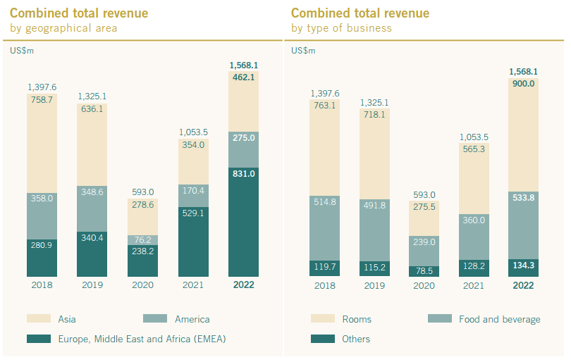
Figure 1: Last 5 years revenue of Mandarin Oriental. Source: (Mandarin Oriental, 2022)
Mandarin Oriental Hotel Group's financial performance in 2022, with a total revenue of 1,568.1 million, marked a significant recovery from the pandemic-induced low of 593 million in 2020 (Mandarin Oriental, 2022). This remarkable rebound, underscores the group's resilience and ability to adapt to challenging circumstances. The consecutive revenue growth post - 2020 reflects a strong recovery and resurgence, showcasing the brand's appeal to luxury travellers and its successful efforts to regain market share and profitability in the post-pandemic era.

Figure 2: Revenue Source of Mandarin Oriental. Source: (Mandarin Oriental, 2022)
The revenue breakdown of Mandarin Oriental Hotel Group highlights the significance of its core operations. With over 50% of total revenue generated from room rentals, it highlights the group's primary focus on providing luxurious accommodations. The substantial contribution of over 30% from food and beverage signifies the importance of dining experiences within their properties. Diversifying into other revenue streams is essential to reduce dependency on these two key areas and ensure financial stability, especially during market fluctuations or unforeseen challenges in the hospitality industry.

Premier Inn.

Figure 3: Last 5 years revenue of Premier Inn. Source: (Premier Inn., 2022)

Premier Inn's financial performance in the fiscal year 2021-22, with total sales of £1703.4 million, shows a remarkable improvement from the pandemic-induced low of £588.9 million in 2020-21. However, the peak income of £2071.50 million in 2019-20, right before the pandemic, has yet to be fully recovered (Premier Inn, 2022). This shows that, while Premier Inn has made a significant come-back, it may still be on the road to full recovery, highlighting the persistent issues confronting the hospitality industry in the aftermath of the COVID-19 epidemic.

Figure 4: Revenue sources of Premier Inn. Source: (Premier Inn., 2022)
Premier Inn's revenue composition indicates a heavy reliance on room rentals, which contribute to around 60-69% of their total revenue. This underscores their primary business focus on providing “a good night’s sleep” in basic accommodations. The contribution of 30-39% from food and beverage, while significant, is secondary. This reliance on room rentals may imply vulnerability to fluctuations in the accommodation market. Diversification into other revenue streams or strategies to boost food and beverage and other sources of income could help mitigate potential risks and enhance overall financial stability.

Market Position Comparison

Mandarin Oriental Hotel Group
Market Share:
Mandarin Oriental Hotel Group, an international luxury hotel brand, holds a relatively smaller market share compared to some of its competitors in the luxury hospitality segment, such as Four Seasons and Sandals. (Joviando & Kurniawati, 2022). The group focuses on quality rather than quantity, with a select number of properties in prime global locations. This strategy allows them to maintain exclusivity and offer a highly personalised experience to their guests. While their market share may be smaller, their per-property revenue is often significantly higher.
Customer Demographics:
Mandarin Oriental caters primarily to the high-end luxury market, attracting affluent and discerning travellers. Their customers typically fall into the following demographics:
- High net worth individuals
- Business executives and professionals
- Luxury travellers seeking unique experiences
- Affluent tourists looking for impeccable service and opulent accommodations in select locations
The brand is known for its attention to detail, personalised service, and cultural authenticity, which resonates with a sophisticated clientele seeking a refined and exclusive experience.
Brand Perception:
Mandarin Oriental is widely regarded as one of the most prestigious luxury hotel brands globally emphasising their oriental heritage. They have cultivated a reputation for excellence, luxury, and a commitment to preserving the cultural heritage of the locations where they operate. The brand is associated with:
- Unparalleled luxury and comfort
- Exceptional customer service
- Authentic and immersive cultural experiences
- A strong commitment to sustainability and environmental responsibility
Mandarin Oriental's brand perception is a significant asset, as it allows them to command premium prices and maintain a loyal customer base. Their consistent delivery of exceptional experiences reinforces their reputation in the luxury hospitality sector.

Premier Inn.
Market Share:
Premier Inn, a part of Whitbread PLC, holds a substantial market share in the budget and mid-range hotel sector in the United Kingdom. In UK, Premier Inn holds almost 11% of all hotel industry market share (Kham & Nhem, 2022). It is one of the largest hotel chains in the country, with a rapidly expanding presence across the UK and Ireland, and testing the German market. Premier Inn's strategy focuses on providing affordable and consistent accommodations, which has enabled it to capture a significant portion of the budget-conscious traveller market.
Customer Demographics:
Premier Inn's customer base is diverse and includes various demographics:
- Budget-conscious travellers: Individuals and families looking for affordable, yet comfortable lodging options.
- Business travellers: Professionals seeking convenient and cost-effective accommodations.
- Tourists: Visitors exploring the UK and Ireland on a budget.
- Long-stay guests: People requiring extended stays for work or other reasons.
Premier Inn's broad appeal is partly due to its competitive pricing, reliability, and the convenience of its locations, making it a popular choice among both leisure and business travellers.
Brand Perception:
Premier Inn is generally perceived as a reliable and good value for money hotel brand. It emphasizes comfort, cleanliness, and customer service. While it may not be considered a luxury brand, it has built a reputation for providing consistent quality at an affordable price point. Customers associate Premier Inn with:
- Affordable rates
- Comfortable beds
- A strong commitment to cleanliness and hygiene
- Convenient locations, often near major transportation hubs
Premier Inn's brand perception is highly positive as in a survey 68% people selected Premier Inn (Statista, 2023) as their preferred brand in hotel industry, and its reputation for providing reliable accommodations has contributed to its market success in the budget and mid-range hotel segment.
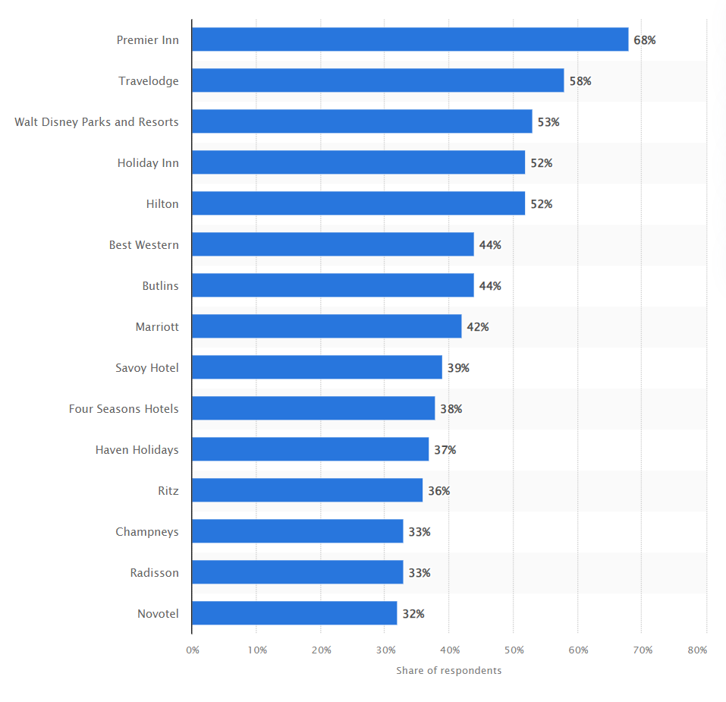
Figure 5: Most Popular Hotel brands in UK. Source: (Statista, 2023)

Comparing Growth Potential

Mandarin Oriental Hotel Group
Mandarin Oriental Hotel Group's growth potential appears promising as they expand their Exclusive Homes portfolio in Europe, Asia, the United States, and the Caribbean. This move aligns with several key factors:
Expansion Strategies: Their partnership with StayOne and the rapid 150% growth of their Exclusive Homes portfolio within a year indicate a successful expansion strategy (StayOne, 2023). By curating luxury vacation rentals in sought-after destinations to cater for different activities preferred by the guests (winter sports, beach, family events), they tap into the growing demand for unique and high-end travel experiences.
Market Opportunities: Mandarin Oriental's brand reputation for luxury and excellence positions them well to capitalise on the upscale vacation rental market. Their ability to identify and cater to affluent travellers seeking exclusive accommodations is a significant market opportunity.
Potential Barriers: Challenges may include competition from established vacation rental platforms, regulatory hurdles, and ensuring consistent quality and service across diverse properties. Managing and maintaining high standards across a growing portfolio will be crucial.
Overall, Mandarin Oriental's strategic expansion into Exclusive Homes presents substantial growth opportunities, leveraging their brand reputation and catering to the evolving preferences of luxury travellers.

Premier Inn.
Premier Inn's expansion into the Middle East, particularly the Kingdom of Saudi Arabia, demonstrates significant growth potential:
Expansion Strategies: Premier Inn's move to enter Saudi Arabia aligns with its successful expansion strategy in the Middle East. Leveraging its presence in the UAE and Qatar, the company can utilise its regional experience and brand recognition to enter a high-potential market.
Market Opportunities: Saudi Arabia offers substantial opportunities for hotel chains due to its growing tourism industry, driven by cultural attractions and economic diversification efforts (Joviando & Kurniawati, 2022). Premier Inn's reputation for quality and affordability can attract a wide range of travellers, including business and leisure visitors.
Existing Presence: Premier Inn's existing presence in the UAE and Qatar provides a foundation for growth, enabling cross-market synergies and operational efficiencies.
Potential Barriers: Challenges may include local competition, adherence to Saudi regulations, and cultural nuances. Navigating the specific business environment and establishing strong local partnerships will be essential.
Overall, Premier Inn's expansion into Saudi Arabia and the broader Middle East presents promising growth prospects, given the region's economic development and tourism potential.

Comparing Commitment to CSR

Mandarin Oriental Hotel Group
Mandarin Oriental Hotel Group's financial commitment to CSR initiatives, as reflected in its sustainability practices, community engagement, and ethical business practices, is notable:
Environmental Sustainability: Mandarin Oriental's pledge to reduce Scope 1 emissions from 16% since 2012 to 12% in 2022 demonstrates its commitment to environmental sustainability (Aznar et al., 2022). Achieving a 30% decrease in carbon intensity and better resource efficiency demonstrates their dedication to sustainability: 31% energy intensity and 16% water intensity reduction. They eliminated 99,9% single use plastic and obtained certification for 100% responsibly sourced products (Mandarin Oriental,2022).
Safe and Sound Audit: With an average group score of 93.4% in the Safe and Sound audit, the group prioritises the safety and well-being of both guests and employees, showcasing ethical business practices.
Community Engagement: Conducting 426 social impact initiatives and making significant donations of USD$1.69 million through the Mandarin Oriental Foundation underscores their active involvement in the communities where they operate, contributing positively to society (Mandarin Oriental, 2022).

Premier Inn.
Premier Inn's financial commitment to CSR initiatives reflects a multifaceted approach encompassing sustainability practices, community engagement, and ethical business practices:
Environmental Sustainability: Premier Inn's impressive reductions in food waste (32.3%) and carbon emissions intensity (50.1%) highlight their strong commitment to environmental sustainability (De Grosbois & Fennell, 2021). Their water-saving initiatives demonstrate responsible resource management.
Community Engagement: The donation of 200 hours of volunteering to local communities through new site openings highlights their dedication to community engagement (Céspedes-Lorente et al., 2023). Despite COVID-19 challenges, their reinstatement of volunteering programs in Q4 demonstrates an ongoing commitment to supporting local communities.
Financial Contribution: The substantial green contribution of £199 million and £31 million for sustainable procurement indicates a significant financial commitment to CSR initiatives (Premier Inn., 2022). This allocation of resources underscores their intent to drive positive social and environmental impact through responsible business practices.

Conclusion
Both Mandarin Oriental Hotel Group and Premier Inn exhibit distinct strengths and strategies within the hospitality industry. Mandarin Oriental excels in the luxury segment, focusing on exclusivity, personalised service, and sustainability. Premier Inn, on the other hand, thrives in the budget and mid-range market by providing affordable, reliable accommodations. Both groups display financial commitments to CSR, with Mandarin Oriental emphasising luxury and sustainability and Premier Inn prioritising efficiency and community engagement. The success of these brands lies in their ability to cater to diverse customer demographics and adapt to changing market dynamics. Ultimately, their unique approaches to the industry underscore their resilience and potential for sustained growth in their respective segments.

References
Aznar, J. et al. (2022) Sustainability Commitment, new competitors’ presence, and Hotel Performance: The Hotel Industry in Barcelona, Sustainability, 8(8), pp. 255–287. doi:10.3390/su8080755.
De Grosbois, D. and Fennell, D. (2021) Carbon footprint of the Global Hotel Companies: Comparison of methodologies and results, Tourism Recreation Research, 36(3), pp. 231–245. doi:10.1080/02508281.2011.11081669.
Financial Times (2023) Markets/Data: Mandarin Oriental Group International Ltd. Available at: https://markets.ft.com/data/equities/tearsheet/profile?s=M04:SES , (Accessed: 16 October 2023).

Financial Times (2023) Content: Premier Inn owner says inflation and labour shortages offer ‘growth opportunities.’ Available at: https://www.ft.com/content/e4c6f668-cfeb-466a-8db9-3e68d49612f5, (Accessed: 16 October 2023).
Ford, R.C. & Sturman, M. C. (2020) Managing hospitality organizations : achieving excellence in the guest experience. 2nd ed. New York: SAGE Publications, Inc.
Goleman, D. (2009) Ecological Intelligence. New York: Penguin Random House.
Information Resources Management Association (2018) Corporate Social Responsibility : Concepts, Methodologies, Tools, and Applications. Hershey, PA: Business Science Reference, IGI Global.
Information Resources Management Association (2020) Destination management and marketing: breakthroughs in research and practice. Hershey, Pennsylvania: IGI Global. Available at: https://doi.org/10.4018/978-1-7998-2469-5.
Joviano, J. and Kurniawati, K. (2022) The Effects of Overall Service Quality, Customer Value, Customer Trust, and Customer Satisfaction on Customer Loyalty in the Hotel Industry, Jurnal Ekonomi, Bisnis & Entrepreneurship (e-Journal) 16 (2), 156-169.
Kandampully, J., Juwaheer, T.D. and Hu, H.H. (2011) The influence of a hotel firm's quality of service and image and its effect on tourism customer loyalty”, International Journal of Hospitality & Tourism Administration, Vol.12, pp. 21-42.
Lueneburger, C. & Goleman, D. (2010) The change leadership sustainability demands. MIT Sloan Management Review, 51(4), 49-55.

Marcus, A.A. (2005) Management Strategy: Achieving Sustained Competitive Advantage. Singapore: McGraw-Hill Companies.
Martin, A. (2019) The Practical Guide to Understanding and Raising Hotel Profitability. 1st ed. London: Routledge.
Mandarin Oriental (2023) Our company. Available at: https://www.mandarinoriental.com/en/our-company (Accessed: 05 October 2023).
Mandarin Oriental (2022a) Annual report 2022. Available at: https://photos.mandarinoriental.com/is/content/MandarinOriental/corporate-20arMOIL, (Accessed: 29 September 2023).
Premier Inn (2022) Environmental, Social and Governance report 2021/22. Available at: https://www.premierinn.com/content/dam/pi/websites/desktop/why/force%20for%20good/final-esg-report-2021-2022.pdf , (Accessed: 05 October 2023).
Premier Inn (2023) News. Available at: https://mena.premierinn.com/en/news/premier-inn-mena-plans-ksa-venture-under-middle-east-expansion#:~:text=Dubai%2C%2021%20February%202023%20%E2%80%A6,potential%20business%20partners%20under%20way, (Accessed: 10 October 2023).

Statista (2023) Most Popular Hotel Brands UK 2022, Statista. Available at: https://www.statista.com/statistics/951262/most-popular-hotel-brands-uk/ , (Accessed: 29 September 2023).
Stay One (2023) Introducing Mandarin Oriental Exclusive Homes. Available at: https://www.stayone.com/mandarin-oriental-exclusive-homes, (Accessed: 16 October 2023).
Thomas, J.D. and Ryman, J.A. (2003) Understanding competitive advantage in the general hospital industry: evaluating strategic competencies”, Strategic Management Journal, 24, pp. 333-347.

Whitbread (2023) About Us: Our Business Model and Strategy. Available at: https://www.whitbread.co.uk/about-us/our-business-model/ ,(Accessed: 05 October 2023).

