Live Events Project Portfolio:

Feel Good Health & Wellbeing Event, March 17th, 2026.

Live Events Project, BMTP5021.

Deborah Jenkins.

Nia Mugford.

2404769.
Word Count – 2656.

AI Declaration.
I confirm that I have not used any AI tools in the research and creation of this assignment. I confirm that I have not presented any AI generated materials as my own work. I confirm I have copies of my drafts, notes, and other resources I used, which I may be asked to provide in evidence.

Event Plan Report
1. Event Overview.
Event Name: Feel Good Health & Wellness.

Event Type: A wellbeing fayre event.

Concept & Theme: The concept for our event was to promote and encourage wellbeing and self-care and love. We were aiming to create an event that serves as a space for people to engage in varying conversations on topics surrounding self-care, such as life motivation, sports, and medicinal practices. The theme is comprised of calming and neutral colours such as beige, cream, green, and yellows.

Target Audience: The primary target audience for the event is people who have an interest in wellbeing and self-care, regardless of ages.

2. Timing, Location & Programme.

Date & Time: Tuesday, March 17th, 2026.

Venue: The UWTSD Innovation Matrix.

Event Programme:
Registration & Welcome Speech – 10:00.
Key Activities/Sessions – 13:00-16:30 in the immersive room, stall vendors will be available from 10:00-16:00.
Breaks & Networking – Breaks not scheduled, networking can be conducted throughout the day.
Closing & Wrap-up – 16:00-17:00. The event is ending at 16:00, but our final demonstration in the immersive room ends at 16:30.

3. Aim and Objectives.
Overall Aim: to primary aim of this event is to help promote holistic wellbeing whilst also aiding community engagement, as well as integrating key industry members to promote their businesses with those who are seeking to get into wellbeing and self-love.

Objectives:
Objective 1 – promote awareness around health and wellbeing.
Objective 2 – provide connections between university students and the necessary support services needed.
Objective 3 – promote and encourage healthier lifestyle choices through the simple things, such as gym memberships or coffee alternatives.

4. Project Planning Techniques.
Work Breakdown Structure (WBS):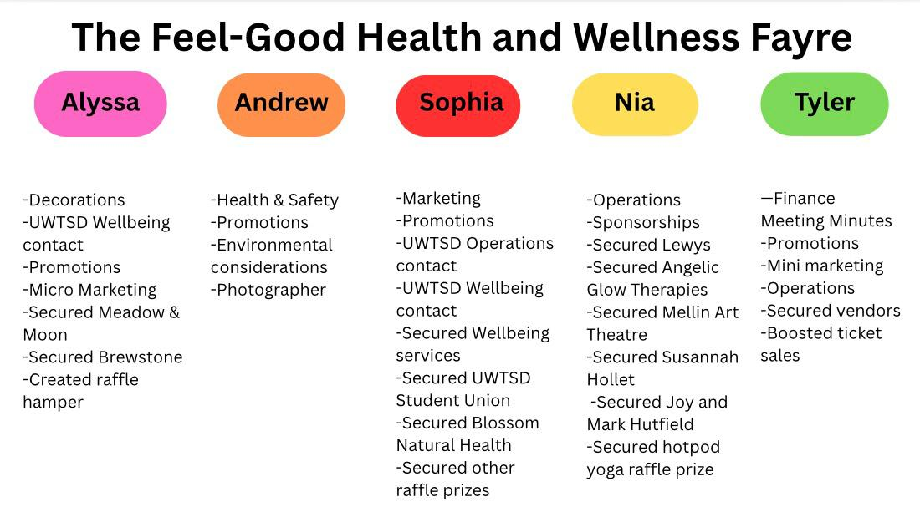
Gantt Chart: Gantt Chart was not sent or received in time for submission.

Running Order:
08:00 – Arrive at the event location and assist vendors with setting up their stalls.
09:00 – Finalise the decoration process.
09:30 – Host morning brief to vendors and staff.
10:00 – Event starts (vendors available from 10:00-16:00).
12:00-12:30 – Draw the raffle.
13:00-14:00 – Qi Gong class in immersive room.
14:00-14:30 – Susannah Hollett Crystals class in immersive room.
14:30-15:00 – MTA Pilates class in immersive room.
15:00-15:30 – Jemma Joel Life Coaching class in immersive room.
15:30-16:30 – Ian Standen Yoga class in immersive room.
16:30 -17:30 – Event close down.
17:00 – Event debrief.

EMBOK Domains: The Event Management Body of Knowledge, or EMBOK, is a framework that is structured model that serves to support the practical, study element of event management through degining key processes, and knowledge domains that are relevant to the field (O’Toole, 2011). It serves to intergrate the management of events with project management principles, to help create a series of charts that outline processes that are involved with managing events- including the scope of the event, stakeholder and sponsorship management, design, marketing, and financial management (O’Toole, 2011). The EMBOK framework aims to provide a logically sound structure to analyse and manage events systematically (O’Toole, 2011).

Administration: The administration domain focuses on the overall planning and coordination of an event. Project timelines with help to outline key milestones, such as venue booking, marketing launches, and the confirmation of suppliers. Responsibilities are allocated between the group members, which helps with ensuring efficient communication between members, whilst budget monitoring procedures will be implemented to help with the control of expenditure.

Design: The design and the theme of the event is comprised of very natural and nature-based themes; when discussing colour schemes that help convey a sense of calmness and neutrality. Through utilising these themes, people will feel a general sense of quietness and wellbeing, as green is often associated with health and self-care (large wellbeing companies such as Holland and Barrett use green as their primary colour scheme).

Marketing: Marketing will be carried out in various settings in order to help promote the event- such as social media, email promotion, and other outlets. Marketing is key to generating ticket sales for this event, which in turn will help with generating an income and revenue for all students participating.

Operations: Venue set-up will be conducted by all students involved in the group, whilst all safety measures have been conducted by an independent member of the group in accordance with their role allocation.

Risk Management: Any potential risks will be assessed and evaluated, before being implemented in our risk assessment within the appropriate channels and rated on a scale of low-medium-high as to how relevant of a risk it is.

5. Market Research & Target Audience.

Market Segments: Self-care is of incredible significance for Generation Z (birth years ranging 1997-2012), as evidenced by several studies that focus on the behvaiours and attitudes of Gen-Z. Younger millennials and Gen-Z- often referred to as GenZennials, often engage with self-care that serves to integrate spirituality, mental health management, and general wellness which then reflects a broader understanding of self-care that exceeds physical health (Park et al., 2023).

Competitor Analysis: There isn’t very much noticeable competition within this sector as of right now- we believe the event we are hosting is rather niche and is not something you would see several of at one time. However, it is worth noting that the Swansea Waterfront Museum is hosting a free wellbeing event from the 16th-19th of March, 2026, which does coincide with our event. The Waterfront Museum event is also free of charge, which makes the likelihood of more people attending the museum event over ours, higher than it otherwise would be if they were charging for tickets (Swansea.Scoop, 2026).

Consumer Preferences: No further research has been conducted regarding market segmentation or consumer preferences for this event.

6. Event Marketing Plan.

Marketing Channels: The primary method of marketing this event will be the use of our social media page- @feelgoodwellness.events, however marketing will also be carried out via email as we reach out to possible clients and sponsors for their collaboration. Posts will be shared weekly in the run-up to the event, and the week prior to the event, they will be posted daily in order to create as much excitement around the event as we can.

Promotional Timeline: We plan for the marketing to be conducted from the inception of the event, right up until the day of the event, in order to help with attracting as many visitors as possible, for as long as possible.

Key Messages & Branding: We have marketed the event as an opportunity for people to focus on their wellbeing, and as such, as have marketed it as an affordable event that is appropriate for all ages- as we believe that wellbeing should not be restricted to finances or age.

Sponsorship: We plan on reaching out to as many people as possible, whose visions align with our event plans. For example, we have conducted research into local, Swansea-based companies that share a vision and mission surrounding sustainability and wellbeing, as we believe it is easier to create collaborations between ourselves and those who share an interest in our themes.

7. Budget & Financial Plan.

Projected Income: The primary source of income for this event is the tickets, which are sold at £5 per ticket- this price includes access to the event, all demonstrations, and a raffle strip for our prizes. As a group, we are aiming to sell 50 tickets which would generate a total of £250 of revenue for us as a group, leaving each member with a total income of £50 per member.

Expected Expenditure: As a group, we have been incredibly fortunate to have discussed options with the university wellbeing team, who have kindly agreed to sponsor our event and provide funds for a majority of our needs for the event- including decorations, banners, and hoodies for the team to wear on the day. All members of this group are incredibly thankful for these opportunities provided by the wellbeing office.

Venue & Equipment: Equipment (decorations, banners) will be covered by the wellbeing office, venue provided for free by the university.

Marketing & Promotion: Banner provided by wellbeing office free of charge, social media free.

Staffing & Security: Free- level 4 and level 6 students will be volunteering.

Catering & Logistics: Free- catering provided by the university cafeteria.

Miscellaneous: Hamper raffle prize- £59 shared between all 5 members; a total of £11.80 per member.

External Suppliers: All vendors and and sponsors attending the event are attending for free.

Budget Report: As a group, we have not paid out of pocket for a good portion of the event due to the support of the wellbeing office- the only thing we as a group contributed to financially is one of the raffle prizes, and so financial tracking and reporting is unnecessary for our event.

8. Risk Management & Health & Safety

Risk Assessment: Attached below.

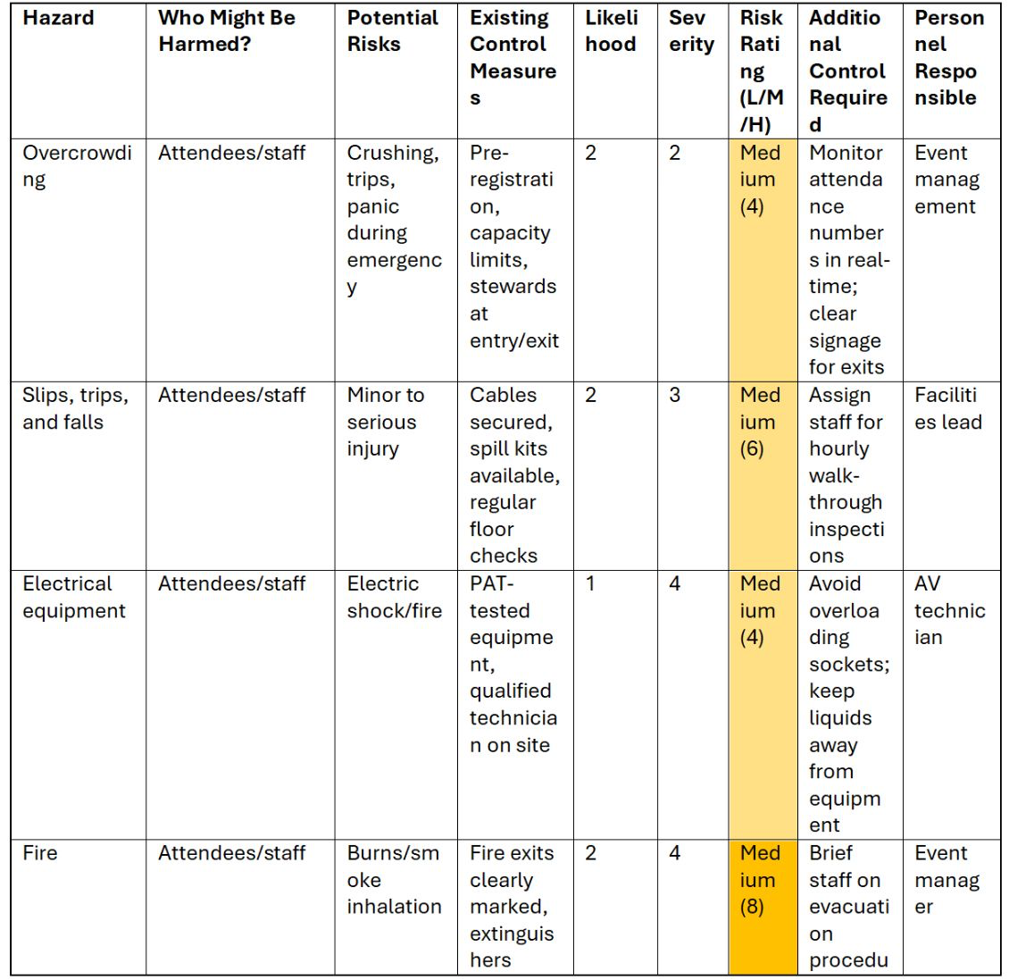
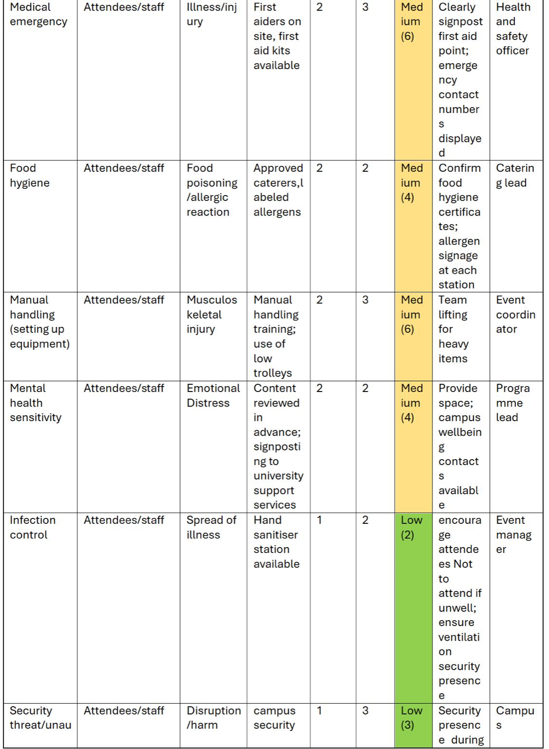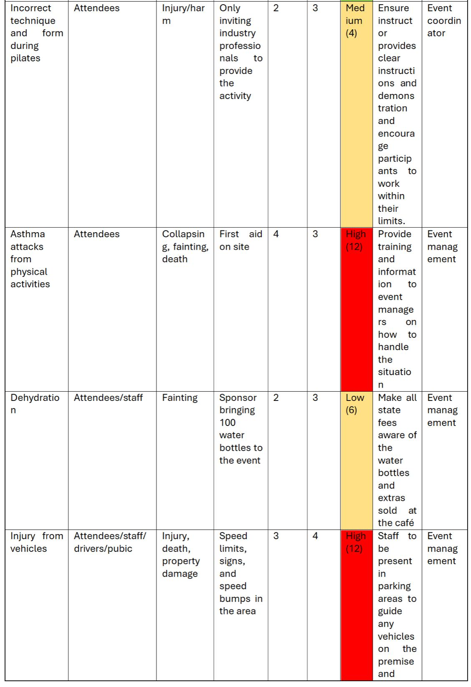
A = worst case outcome
B = Likelihood
Level of risk = A x B
- Low: Unlikely occurrence, minimal impact
- Medium: Possible occurrence, moderate impact
- High: Likely occurrence or significant impact

Health & Safety Measures: According to the health and safety supervisor, first aid kits will be available on site during the event. Security was not necessary to hire according to the health and safety supervisor, and crowd-control measures have been implemented in accordance with the shape of the building.

Legal Requirements: According to the health and safety supervisor, no licenses, permits, or insurance is needed as this is all covered by the UWTSD campus.

Public Liability Insurance: Not Applicable.

Required Licences: According to the health and safety supervisor, no licenses, permits, or insurance is needed as this is all covered by the UWTSD campus.

Emergency Plan: According to the health and safety supervisor, all exit routes and fire exits will be highlighted prior and during the event. The building is a rectangular shape and has exists on both ends of the building. Once all attendees and staff are evacuated, a head count will be performed.

9. Contingency Planning.

Alternative Venue: An alternative venue to the Innovation Matrix was the Dylan Thomas Centre, as discussed when planning the event in its earlier stages.

Weather Contingencies: Our event is indoors, and so this is not applicable.

Key Supplier Failures: We are not providing food or beverages from external suppliers- all of our F&B is coming from the UWTSD cafeteria. However, should any vendors or sponsors fail to show up for the event itself, we have hired a sufficient amount of stall holders for it to not be an issue, should one or two not show.

Crisis Communication Plan: it is crucial for us as hosts to maintain clear and honest communication with both vendors and visitors throughout the entire process of hosting and planning the event, in regards to crucial information surrounding the event. However, a crisis plan must also be implemented by the health and safety manager in case of unexpected or impromptu emergencies on the day of the event, or during the planning process.

10. Evaluation Strategy.

Post-Event Surveys: As a group, we plan on having a survey available at the event and to be sent out to visitors after the event, with questions surrounding the success of the event. Surveyors will be asked about elements such as value for money, how easy the day’s itinerary was to follow, and if they engaged with any of our physical sessions in the immersive room.
Key Performance Indicators (KPIs): The relevant KPIs for measuring the success of the event include factors such as ticket sales, the number of clients checked in on the day of the event, and capacity in the immersive room.

Attendance Measuring: Throughout the process thus far, we have been utilising the Eventbrite Organiser app in order to easily track new purchases and orders of tickets made for the event- on the app you are able to sell tickets on the day of the event, as well as check pre-purchased tickets in. A way to measure the attendance of the event would be to measure the amount of tickets registered and paid for on the day, alongside the number of tickets pre-purchased and checked in on the day.

Debrief Meeting: Our debrief meeting will take place on March 23rd, 2026.

11. Sustainability & Event Legacy.

Sustainability Considerations: Having the majority of sponsors be from the Swansea area is kinder to the planet re: emissions, as it means that less fuel is burnt in comparison to longer distances driven from wider to reach areas. Furthermore, there will also be recycling facilities available throughout the event, with signs clearly showing if a bin is intended for plastic waste, metal waste, cardboard waste, food waste, or general waste.

New Economics & Legacy: The event serves to promote awareness about healthier lifestyle choices, whilst encouraging healthy habits such as exercise, nutrition, and stress management. This event will also connect people with professionals in the field of wellbeing, support groups, and beneficial resources that can help with improving health. Furthermore, bringing people together in such an uplifting and encouraging environment can help motivate people to maintain this healthier lifestyle, which can then lead to a better wellbeing overall.

Event Impacts: Environmental impacts include the encouragement of sustainable awareness when it comes to recycling and upcycling, as well as certain vendors discussing things such as the benefits of maintaining marine life and the psychological benefits of doing so. Social impacts include the encouragement of community communication, with people travelling from varying regions of South Wales to attend the event- the event serves as a place for people from all areas of South Wales to meet and engage, where otherwise they may not have had such opportunities. Economic impacts include the fact that a majority of vendors are Swansea based- appearing at the event free of charge in exchange for exposure and promotion will eventually financially benefit the vendor in question.

12. Key Areas of Managing Event Operations

Staff Rota:

Staff | Jobs | Timings
Andrew Jones | Health and safety, decorating, way-finding | Monday (16th) 5pm-5:30pm  Tuesday (17th) 8am-5pm
Alyssa Stoneman | Marketing, promotions, decorating, vendor set up, check in, way finding | Monday (16th) 5pm-5:30pm  Tuesday (17th) 8am-5pm
Nia Mugford | Decorating, overseeing event, immersive room rep | Monday (16th) 5pm-5:30pm  Tuesday (17th) 8am-5pm
Sophia Rabaiotti |  | Monday (16th) 5pm-5:30pm  Tuesday (17th) 8am-5pm
Tyler-Belle Condon | Decorating, check in | Monday (16th) 5pm-5:30pm  Tuesday (17th) 8am-5pm
Riley Tippett - Volunteer | Decorating, vendor set up | Monday (16th) 5pm-5:30pm  Tuesday (17th) 8am-5pm
Poppy - Volunteer | Decorating | Monday (16th) 5pm-5:30pm  Tuesday (17th) 8am-5pm
Ethan Matthews - Volunteer | Decorating, vendor set up | Monday (16th) 5pm-5:30pm  Tuesday (17th) 8am-5pm
Lily Lewis - Volunteer | Decorating | Monday (16th) 5pm-5:30pm  Tuesday (17th) 8am-5pm

Logistics & On-Site Management: Crowd control and other logistical on-site management tasks will be handled by our health & safety supervisor on the day of the event, with contingency plans and emergency plans implemented for issues such as crowd control. Vendors will have been contacted prior to the event with on-site parking instructions.

Stakeholder Coordination: Most members of the group have been in frequent correspondence with sponsors and vendors throughout the process of hosting this event, and continue to do so now. On the day of the event, hosts and volunteers alike will be present to help with setting up facilities and stalls for the sponsors, in order to make as little work for them as possible.

13. Division of Work & Responsibilities.

Meeting Minutes: Tyler-Belle Condon.

Email Correspondence: Sophia Rabaiotti, Tyler-Belle Richards, Nia Mugford, Alyssa Stoneman (promoting and contacting vendors through emailing systems).

Task Assignments:

Alyssa – Decorations, promotions, marketing (partial).

Tyler – Finance, spreadsheet, meeting minutes, promotions.

Andrew – Team leader, health and safety.

Sophia – Marketing, promotions.

Nia – Operations Manager, promotions.

Coordinator: Alyssa, Tyler, Sophia; ensuring overall project direction and leadership.

Shaper: Alyssa, Nia, Tyler, Sophia; driving progress and keeping the team focused.

Plant: Alyssa.

Monitor Evaluator: Tyler, Sophia, Nia; assessing ideas critically and ensuring quality.

Implementer: Alyssa, Nia, Tyler, Sophia, Andrew; turning plans into actionable steps.

Completer Finisher: Alyssa; ensuring all details are perfected.

Resource Investigator: Alyssa, Sophia, Nia, Tyler; seeking external opportunities and connections.

Teamworker: Sophia, Nia; Promoting harmony and collaboration within the team.

Specialist: Sophia, Nia; Providing in-depth knowledge in key areas.

Reference list
O’Toole, W. (2011). Events Feasibility and Development. Taylor & Francis.
Park, S.Y., Yourell, J., McAlister, K.L. and Huberty, J. (2023). Exploring Generation Z and Young Millennials’ Perspectives of a Spiritual Self-Care App and Their Spiritual Identity (Skylight): Qualitative Semistructured Interview Study. JMIR Formative Research, [online] 7(1), p.e54284. doi:https://doi.org/10.2196/54284.
Swansea.Scoop (2026). Swansea Scoop 🦢 Things to do, events & eats on Instagram. [online] Instagram. Available at: https://www.instagram.com/p/DV3VkQ6jN2J/?utm_source=ig_web_copy_link&igsh=MzRlODBiNWFlZA== (Accessed 14 Mar. 2026).

