

BA Leadership and Management Skills in the Workplace
LCLM 6002 Design Thinking and Innovation
Individual Report: Design Thinking and Innovation through Digital Transformation
Written Portfolio
Student name: Cosmin Matei
Student ID: 2335151

Table of Contents
1.0 Introduction 3
2.0 Task 1: Key opportunity areas in the UK market 3
2.1 Emerging market trends and key opportunities in the UK market 3
2.2 User pain points 4
2.3 Market gaps 5
2.4 Technology enablers 7
2.5 Potential for scalability and sustainability 8
3.0 Task 2: Five stages of Design Thinking to Create a Venture 9
3.1 Empathise (with the chosen end users) 9
3.2 Define (Problem Statement) 9
3.3 Ideate (Innovative Solution Ideas) 10
3.4 Prototype (Minimum Viable Product) 12
3.5 Test (Testing and Refining the Solution) 12
4.0 Conclusion 13
References 15

1.0 Introduction
In the United Kingdom, the Covid-19 pandemic has triggered the digital transformation of businesses irrespective of their sectors. It has fundamentally altered the ways businesses interact with their customers and deliver products and services (Zaki, 2019). The large multinational firms have already started to invest in digital technologies. It has pushed the small and medium-sized businesses (SMEs), especially at the local level, to readily adopt the emerging technological trends, for instance, digital payment systems, e-commerce operations, virtual communication, etc., to maintain a relevant and convenient business practice in the contemporary scenario. Under the influence of these trends, consumer behaviours are also shifting towards digital shopping and engagement practices (Mogaji, 2023). If assessed from the perspective of digital thinking, these transformations from traditional business practices can offer major opportunities for innovation as well as new value creation. Design thinking, as defined by Barsalou (2017), is an action-oriented, needs-based, and solution-oriented approach to produce a creative action in line with technological feasibility and alternative solutions that can help satisfy individuals emotionally and gain constructive outcomes. Thus, this design thinking method includes five stages, i.e., Empathise, Define, Ideate, Prototype, and Test, to determine the unmet customer needs and address them with unique solutions. Considering this context, the current report has adopted a design thinking approach to critically analyse the current scenario of the UK market and identify feasible areas for entrepreneurial innovation further. The analysis first focuses on identifying the underlying opportunities in the UK market, followed by creating a new digital venture concept based on the five stages of the design thinking model.

2.0 Task 1: Key opportunity areas in the UK market

2.1 Emerging market trends and key opportunities in the UK market
With the emergence of the pandemic, the UK market has noticed a major shift towards tech-based services and e-commerce. If seen from the ‘empathise’ stage of design thinking, the changing consumer behaviour highlights different emerging trends. An accurate adoption of these trends can further foster favourable situations to leverage sustainable innovation and entrepreneurship. The rising preference for digital commerce can be identified as the first major trend. As Regine (2022) claimed, convenience has become a topmost priority for consumers while shopping and thus, expect a seamless experience in terms of payments, navigation, ordering, and deliveries. It is also noteworthy that this trend is no longer limited to urban areas but has spread into rural and suburban communities, which create opportunities for local businesses to pursue greater digital engagement with target customers. Hybrid service delivery models and the growth of community-based local commerce can be regarded as the other vital trends in the UK market. Starting from tutors and trainers to consultants and beauticians, every type of service provider offers both physical as well as virtual facilities. This, in turn, allows customers to have greater accessibility and flexibility, while marketers can find better reach. UK customers, at the same time, strongly prioritise local producers and brands. The report by Barclays (2025) informed that over 67% consumers think buying from British brands will be cheaper, while 40% look for purchasing UK-based alternatives rather than imported goods. This indicates that customer preference to engage with local brands is growing, although most of them lack proper digital infrastructure to meet the other evolving needs of UK consumers. Digital payment is another notable trend in the UK market. The report by Mintel (2026) highlighted that contactless transactions and digital payment methods, for instance, the use of mobile wallets, are growing in the UK, although 62% of consumers are concerned about security. If assessed from the perspective of innovation, these trends are undeniably lucrative to set up a new venture, considering an all-in-one digital commerce platform. The design thinking perspective, however, stresses the rising concerns, such as infrastructural issues or security purposes, that should be addressed to gain essential sustainability. On this note, based on the ‘define’ stage of design thinking, the central opportunity can be outlined as, ‘how might we help local service providers and businesses to digitally engage customers through an integrated platform?’.

2.2 User pain points
The identification of meaningful innovation opportunities strongly depends on the empathise stage of design thinking, which prioritises developing a detailed understanding of user experiences. In this context, a customer journey map (CJM) becomes highly effective as it helps identify the ways users interact with brands and the points where frustrations occur (Rosenbaum et al., 2017). A customer journey map has also been created here, considering this notion (see Fig. 1) to visually illustrate their interaction and also pain points.
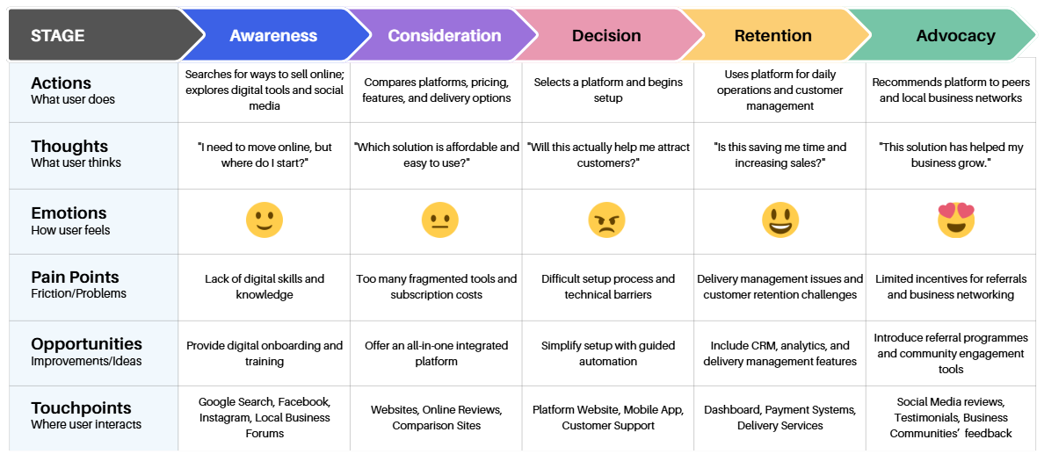
Figure 1: Customer Journey Map
(Source: Self-made)
At the awareness stage of the CJM, the first major pain point is the limited digital knowledge and capabilities of users. Many SMEs, as per Mohamed and Weber (2020), although they possess industry expertise, significantly lack essential digital skills. Activities, such as website creation or payment integration, may be overwhelming, but it leads to a slow adoption of digital technologies. The fragmentation of platforms and digital tools can be regarded as the second pain point in the consideration stage of CJM. Businesses often use separate tools or applications for communications, marketing, payments, and other activities, which often create complexities for users to constantly switch between platforms. It can therefore lead to major dissatisfaction. Further, pain points can be identified related to customer acquisition and retention in the final two stages of the customer journey. For instance, delivery and logistics-related issues, as well as limited loyalty and networking benefits, affect retaining the existing buyers and converting them into effective brand advocates. Insufficient customer data and its improper management through advanced analytics systems are also concerning in this context, that restrict brands from building long-term customer relationships. Thus, from the perspective of design thinking, it can be stated that these pain points inform the unmet user needs, and these should be understood in detail to design feasible solutions for better customer engagement.

2.3 Market gaps
On the basis of the pain points identified, the ‘define’ stage of design thinking can be strengthened further through the application of the 5W1H model (Who, What, Where, When, Why, and How). In line with the views of Kasemsarn (2022), this framework is highly useful to determinate the unmet market needs along with identifying the most underserved segments.
5W1H elements | Analysis
Who? | Local business owners, such as SMEs, retailers, private tutors, beauticians, fitness instructors, and other independent service providers who look for easy and affordable digital solutions.
What? | An integrated digital platform that combines all facilities, from navigation to delivery management, effectively.
Where? | In suburban and rural UK communities, where the facilities and adoption of digital infrastructure are comparatively less advanced than in urban regions.
When? | With the growing consumer demand for online services
Why? | Existing solutions are highly fragmented, which causes frustration and they are also expensive and complex for SMEs to use
How? | Through the creation of an affordable and user-friendly platform that specifically meets the requirements of local SMEs in the UK
Table 1: Identifying market gap through the 5W1H model
(Source: Self-made)
The application of this model, thus, highlights that the first market gap is the absence of simplified and affordable all-in-one digital business platforms that are uniquely designed to support SMEs, to be specific. The existing service providers usually prioritise individual functions, for instance, payment support, website creation, marketing campaigns, etc., but no such comprehensive solution is currently available in the UK market. The lack of hyperlocal digital marketplaces can be recognised as another critical gap. Major e-commerce platforms, for instance, ASOS, Shein, etc., dominate the online retail market. Very limited service providers are available who actively connect consumers directly with local producers and brands within their communities. The availability of support services related to digital transformation is also limited in the UK market. As per the report by BCG (2022), 37% of UK SMEs feel that they lack the capacity to manage multiple ICT handlings, while 25% think that their current digital tools are not resilient enough to protect them from evolving disruptions. This report also points out that 17% of SMEs disagreed on the point that their current connectivity tools can support them to effectively adapt to changing situations (BCG, 2022). This indicates that the market lacks offering practical guidance and accessible support solutions that SMEs uniquely require while navigating digital transformations. If assessed from the perspective of local delivery coordination, another gap exists as independent businesses usually maintain separate operations based on their geographic locations. Collaborative networking here can help them reduce operational costs and boost service efficiency at the same time. Thus, considering the design thinking principles, these gaps highlight major opportunities for innovation by addressing the unmet user needs that are critical in the evolving digital business environment.

2.4 Technology enablers
In the context of innovation and venture creation, technology stands as a critical enabler. The Innovation Ambition Matrix becomes highly useful here, as this framework can help determine the ways emerging and existing technology can be supportive of new business opportunities (Krings, 2025). This matrix categorises innovation into three levels, i.e., core, adjacent, and transformational, which has been applied here to find how a new solution can be generated to address the identified market gaps.
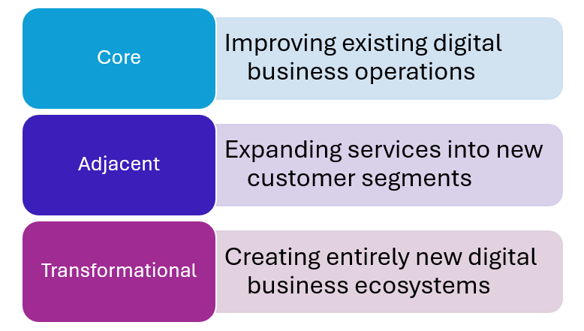
Figure 2: Innovation Ambition Matrix
(Source: Self-made)
At the core innovation level, the focus can be on improving the existing digital operations. This can be done by integrating cloud computing systems. As cloud-based systems are effective for managing a vast amount of data without investing in expensive hardware, they can offer the necessary cost-effectiveness to SMEs (Ashrafuzzaman, 2024). The opportunities related to adjacent innovation can be further availed by using digital payment systems and mobile technologies. Mobile-led platforms allow businesses to reach customers faster, and contactless payments offer more convenience to users. The integration of these technologies, therefore, can facilitate penetration into new market segments and increase brand reach across wider geographical markets. To achieve the transformational innovation, Artificial Intelligence (AI) can be the key. For instance, the use of recommendation engines, AI-powered chatbots, business analytics, etc., can help SMEs to improve overall customer experience, especially by offering them more convenience and ease of use. Integrated application programming interfaces (APIs) are also a noteworthy technology here in the transformational category. APIs are effective for integrating multiple services, such as payments, booking, delivery, relationship management, and many other things to ensure a seamless engagement between service providers and users (Jayaprakash, 2025). The use of this specific technology can also help address the pain point related to the fragmentation of digital tools, as identified before. Considering the ideate stage of design-thinking, an effective integration of these technologies can thus help formulate more user-oriented solutions.

2.5 Potential for scalability and sustainability
In line with the design thinking perspective, the assessment of a business opportunity must not only focus on desirability, but it needs to consider long-term scalability and sustainability of the proposed idea as well. The scalability perspective indicates that if a venture is created based on a Software-as-a-Service (SaaS) model, it can receive the advantage of acquiring more customers with a low incremental cost (Loukis et al., 2019). It can therefore help the business to achieve rapid growth by maintaining the necessary operational efficiency. The cloud-based infrastructure, at the same time, can offer the necessary flexibility for a cross-sectoral as well as a high geographic scalability. If assessed from the sustainability perspective, this venture contributes to boosting the local economy by supporting local commerce and UK SMEs. A strict focus on enhancing the competitiveness of local SMEs can further help create more employment opportunities to foster stronger community resilience. The priority of hyperlocal deliveries through major route optimisation can also help shape environmental sustainability by lowering carbon emissions. With the application of design thinking principles, therefore, the new venture can resolve user issues through an advanced, integrated technological solution, especially by considering a scalable business model for long-term value creation.

3.0 Task 2: Five stages of Design Thinking to Create a Venture

3.1 Empathise (with the chosen end users)
The empathy stage of the Design Thinking framework calls for understanding existing frustrations of the end users and identifying their unmet needs that can be fulfilled through the innovative solution (Dawbin et al., 2021). In the current case, the identified end users are small and medium-sized enterprises (SMEs). Research into the ecommerce market of the UK has shown that, though it indeed unveiled opportunities for profitability and growth, the barriers that particularly affect the SMEs include their struggles to maintain desired online visibility. Needless to say, the problems are specifically pronounced in the case of micro-businesses, farmers, independent retailers and beauty professionals, to name a few. It is so since, firstly, they operate with limited technical expertise. Secondly, they often do not have the spare funds needed to consolidate online presence essentially through repeated exposure of the consumers to their offerings. Further research into these SMEs reveal that, along with limited budgets for digital marketing, they usually rely on a disconnected ecosystem of digital tools for operations management. To elaborate, while using the social media platforms for marketing, for communication with potential consumers, they rely on separate messaging apps (e.g., WhatsApp). Moreover, they depend on different applications for booking and payments. This lack of integration of their operations expectedly leads to inconsistent consumer experiences and poor customer services (e.g., delayed or mixed customer enquiries) (Pelletier and Cloutier, 2019). Furthermore, subscribing to multiple applications at a time turns out to be costly for the SMEs.
If seen from the customers’ perspective as well, a cursory look at their activities will reveal their willingness to support SMEs and other local businesses. Nevertheless, the struggle regarding identifying reliable online suppliers is also genuine. It indeed connects with the problem that SMEs’ face regarding maintaining online presence to the desired degree. Along with visibility, the core problem lies in the barriers to seamless customer communication, which is intensified by this burden of the SMEs to navigate multiple digital tools simultaneously (Pelletier and Cloutier, 2019). Thus, empathy mapping of the core end user - the SMEs - reveal how they suffer from a fragmented ecosystem in ecommerce.

3.2 Define (Problem Statement)
The problem identified above can be transformed into a concise problem statement as follows:
“The SMEs in the UK are disproportionately affected in terms of effective participation in the ecommerce market mainly since they lack access to integrated digital tools at affordable prices, which is evident from their excessive reliance on a fragmented ecosystem consisting of multiple digital tools that causes inefficiency, customer dissatisfaction and high operational costs.”
In the course of explaining the problem statement, one can refer to the fact that the problem is not about digitalisation of commerce but the fragmented nature of the tools required to yield optimum benefits from this digitalisation. As briefly hinted above, the tools that these SMEs usually rely on mostly serve one aspect of the business each such as booking appointments, processing payments or communicating with customers. In other words, the SMEs have to give additional time and efforts than needed, which creates complications and harms the business (e.g., delayed response to consumer queries leads to losing the order altogether). In other words, as some scholars have tried to argue, it is not digitalisation but this fragmented digital ecosystem that affects business productivity adversely (Georgescu, Peter and Avasilcai, 2022). This problem is intensified further due to the limited financial capacity and technological expertise that the SMEs have to work with. This is equally true for the consumers in the sense that this fragmented ecosystem lies beneath the dissatisfaction of consumers with the SMEs. Needless to say, the online presence of the SMEs is crucial in contemporary times mainly for the consumers to identify and engage with their services (Kovalenko and Kuzmenko, 2020). Yet, essentially due to limited financial strength and technological expertise, the SMEs often fail to manage that, as noted above. In other words, this lack of an integrated solution consisting of all the necessary digital tools, along with customer dissatisfaction, also fails the SMEs in terms of having a competitive edge. The essence of the problem, thus, is captured in the problem statement.

3.3 Ideate (Innovative Solution Ideas)
The Ideate stage of the design thinking framework focuses on addressing the problems faced by the end users through innovative solutions/ideas (Dawbin et al., 2021). Now, as it is evident from the nature of the problem, the ideal solution should focus on addressing the SMEs’ lack of an integrated digital solution that, in effect, will support their local development. The solution proposed here is an enterprise called LocalConnect, which is essentially an integrated ecommerce platform that is likely to aid the SMEs across all aspects of their operation. In other words, LocalConnect is an integrated, affordable interface that supports SMEs regarding storefront creation, appointment booking, customer communication, payments and digital marketing through social media.
To assess how far this idea is innovative, the Innovation Matrix is invoked here. It is already highlighted above that the innovation matrix, also known as the Innovation Ambition Matrix, categorises firms’ innovation initiatives into three components - 1) core innovation (incremental), 2) adjacent innovation (expanding) and 3) transformation innovation (disruptive) (Indeed, 2026). Given the focus of core innovation on enhancing existing offerings and cementing a competitive position, the idea of LocalConnect stands out, as it offers an ecommerce model that directly addresses productivity and promises a competitive edge to the SMEs of the UK through enhanced digital relevance. In a sense, it also optimises operational costs of the SMEs by making them free from the overhead of purchasing multiple digital applications simultaneously. Adjacent innovation champions expansion into new markets or attracting new target segments, which is apparently irrelevant in the context of LocalConnect, as it is yet to rollout. However, LocalConnect’s adjacent innovation can be understood in terms of how it allows the SMEs to combine existing technologies that eventually serves their strategic goals to enhance user values. By combining required technologies, furthermore, it simplifies digital ecommerce, which can be treated as an innovation adjacent to its core offerings. Finally, transformational innovation talks about disrupting the existing market, which is somewhat consistent with the idea of ‘disruptive innovation’ (Christensen et al., 2018). LocalConnect’s disruption lies in its aggregation of existing yet unbundled digital tools relevant for the operation of the SMEs. In this regard, it managed to carve out its own revenue stream by offering integrated services at relatively affordable prices.
The way LocalConnect will enhance the end users’ journey is presented below:
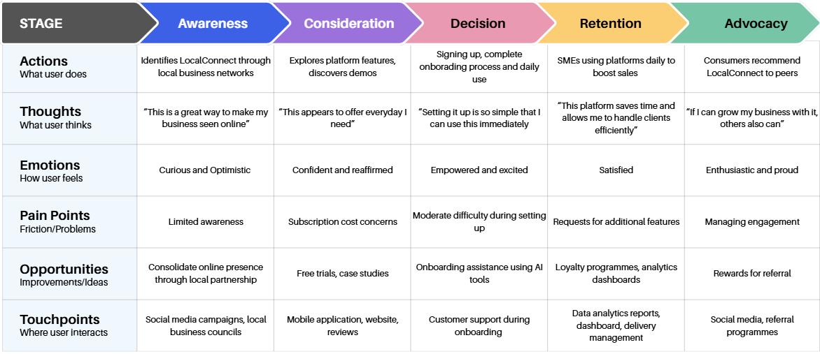
Figure 2: Updated Customer Journey Map after Introducing LocalConnect
(Source: self-generated)

3.4 Prototype (Minimum Viable Product)
LocalConnect is essentially a digitally-enabled platform that connects ecommerce customers with local SMEs/independent sellers when the latter need products that are not available through other ecommerce channels. Here, a prototype or minimum viable product (MVP) of LocalConnect is presented. MVP can be defined as the rudimentary, functional version of a product/service that offers the features generating core value and gathers feedback on its performance for scaling it up further (Lenarduzzi and Taibi, 2016). Here, the MVP of LocalConnect will reveal whether the SMEs are willing to use it by capitalising the keenness of the customers to explore local retailers.
The core features of LocalConnect’s MVP are: 1) product search & match, 2) stock levels dashboard, 3) collectibles list (i.e., a list of reserved products), 4) local delivery (subject to requests, priority and availability of logistics network) and 5) retailers’ profile. The product search & match feature is one of the key components of LocalConnect’s value proposition, as it is through this customers will find locally available products. One can argue that the feature of the inventory dashboard is related to supply chain transparency in terms of empowering the customers about the availability of the products (Sodhi and Tang, 2019). This is further reinforced by the list of reserved products so that the customers get to know whether the said product is available or not. Delivery requests will be processed based on distance i.e., the service radius within which the customer lies. Finally, the suppliers’ profile is crucial to know essentially about the sustainability credentials, which is also related to commitment to sustainability as a value-generating act.
The viability of this MVP for LocalConnect essentially lies in how it allows it to not only assess market demand but also capitalise on existing stock and third-party logistics services to address the unmet needs of the users. As noted above, feedback collected in this phase will be helpful to identify customers’ willingness to explore such options and also the bugs that need to be fixed in the following iterations. Overall, this MVP of LocalConnect appears potent to deliver all the promises made to the end users.

3.5 Test (Testing and Refining the Solution)
LocalConnect’s rollout started with a MVP, which essentially suggests that it follows the agile project management methodology that, briefly put, ensures an offering becomes effective through multiple iterations (Rasnacis and Berzisa, 2017). Thus, testing and refining the initial model is an integral part of LocalConnect’s management approach. The testing process will unfold in a phase manner.
Phase 1- MVP Testing: As shown above, a MVP will be designed as the initial version of the product. It will be subjected to testing by introducing it to select stakeholders i.e., local/independent retailers and potential users within a region in the UK. The rationale of this phase is to evaluate the relative ease of searching for the products by the consumers and the usability (i.e., ease-of-navigating) of the interface. The assessment of whether the MVP is simple or not will be subjected to the community retailers.
Phase 2- Pilot rollout: Once the prototype is approved, the pilot rollout session will begin. Again, a select group of stakeholders will be taken to run the pilot survey. Tentatively, the group will consist of 15-20 SMEs/independent retailers and 150-200 customers in a chosen region. The objective of this phase is to collect data pertaining to various aspects of use: a) search-order completion ratio, b) conversion rate of the SMEs, c) time taken for fulfilling orders and 4) customer retention rates. In any case, as this session of feedback relies entirely on quantitative data, the owners can also consider conducting interviews or focus groups studies for collecting qualitative data (Gill and Baillie, 2018).
Phase 3- Refinement: In this phase, the collected data will be analysed based on predetermined performance indicators. One of the major success indicators will be, for instance, search abandonment rate i.e., cases where customers or retailers have left the search process midway implying issues with navigation. In case of refinement as well, the principles of agile methodology will be upheld. In practice, this means that issues that are coming in the way of features of high value-generating potential will be prioritised. The refinement process will be treated as the threshold to continuous development until perfected.

4.0 Conclusion
To conclude, this report primarily focused on the opportunities and challenges that enterprises face as a result of massive growth of ecommerce. The report revealed that, though the drive of digitally transforming businesses began as a response to the pandemic, it led to different lucrative opportunities for the firms to capitalise. In any case, as it has been revealed by the existing research referred to here, customers’ willingness to adopt ecommerce channels is largely dependent on convenience. This, furthermore, led to the identification of a unique challenge that SMEs are subjected to i.e., the lack of an integrated system with all the digital tools required for them to operate smoothly. Using the design thinking principle, this report empathised with the SMEs and independent users regarding this problem, as it affects business productivity adversely while causing dissatisfaction to consumers. Afterwards, this report proposed LocalConnect, an innovative solution tested by the Innovation Matrix that offers an all-in-one platform to the SMEs with all the necessary tools. This report also expounded on the viability of LocalConnect’s prototype while revealing the high value-generating features of this solution. Finally, this report has also shown how LocalConnect will take the help of agile project management methodology to test and refine the prototype until perfection.

References
Ashrafuzzaman, M. (2024) ‘The impact of cloud-based management information systems on hrm efficiency: an analysis of small and medium-sized enterprises (SMES)’, Academic Journal on Artificial Intelligence, Machine Learning, Data Science and Management Information Systems, 1(01), pp. 40-56.
Barclays (2025) UK consumers commit to buying British, as two thirds report concerns about prices of imports following “Liberation Day”. Available at: https://home.barclays/news/press-releases/2025/04/uk-consumers-commit-to-buying-british--as-two-thirds-report-conc/ (Accessed: 14 June 2026)
Barsalou, L.W. (2017) ‘Define design thinking’, She Ji: The Journal of Design, Economics, and Innovation, 3(2), pp. 102-105.
BCG (2022) UK SMEs struggling to manage digital services amidst mounting economic challenges. Available at: https://www.britishchambers.org.uk/news/2022/09/uk-smes-struggling-to-manage-digital-services-amidst-mounting-economic-challenges/ (Accessed: 16 June 2026)
Christensen, C.M., McDonald, R., Altman, E.J. and Palmer, J.E. (2018) ‘Disruptive innovation: An intellectual history and directions for future research,’ Journal of management studies, 55(7), pp. 1043-1078.
Dawbin, B., Sherwen, M., Dean, S., Donnelly, S. and Cant, R. (2021) ‘Building empathy through a design thinking project: A case study with middle secondary schoolboys,’ Issues in Educational Research, 31(2), pp. 440-457.
Georgescu, A., Peter, M.K. and Avasilcai, S. (2022) ‘A business ecosystem framework for SME development through associative and non-associative business structures in the digital age,’ Cogent Business & Management, 9(1), p. 2143310.
Gill, P. and Baillie, J. (2018) ‘Interviews and focus groups in qualitative research: an update for the digital age,’ British dental journal, 225(7), pp. 668-672.
Indeed (2026) What is innovation matrix?, 28 Feb. Available at: https://ca.indeed.com/career-advice/career-development/what-is-innovation-matrix (Accessed: 15 June 2026).
Jayaprakash, D.B. (2025) ‘Understanding API Integration in Modern Enterprise Applications’, Journal Of Multidisciplinary, 5(7), pp. 637-645.
Kasemsarn, K. (2022) ‘A Marketing Plan for Applying 5W1H: A Case Study from Thailand’, The International Journal of Design Education, 16(1), p. 37.
Kovalenko, A. and Kuzmenko, Y. (2020) ‘Online marketing impact on micro-enterprises: an insight through visibility in search engines,’ Management & Marketing, 15(1), pp. 38-58.
Krings, W. (2025) ‘Empowering Innovation: A Novel Startup in Educational Advisory’, Journal of Next-Generation Research 5.0. 1(3), pp. 1-22.
Lenarduzzi, V. and Taibi, D. (2016, August) ‘MVP explained: A systematic mapping study on the definitions of minimal viable product,’ in 2016 42th Euromicro Conference on Software Engineering and Advanced Applications (SEAA) (pp. 112-119). IEEE.
Loukis, E., Janssen, M. and Mintchev, I. (2019) ‘Determinants of software-as-a-service benefits and impact on firm performance’, Decision Support Systems, 117, pp. 38-47.
Mintel (2026) UK Consumer Payment Preferences: 2026. Available at: https://store.mintel.com/report/uk-consumer-payment-preferences-market-report (Accessed: 15 June 2026)
Mogaji, E. (2023) Digital consumer management: Understanding and managing consumer engagement in the digital environment. London: Routledge.
Mohamed, M. and Weber, P. (2020, June) ‘Trends of digitalization and adoption of big data & analytics among UK SMEs: Analysis and lessons drawn from a case study of 53 SMEs’, In 2020 IEEE international conference on engineering, technology and innovation (ICE/ITMC) (pp. 1-6). US: IEEE.
Pelletier, C. and Cloutier, L.M. (2019) ‘Conceptualising digital transformation in SMEs: an ecosystemic perspective,’ Journal of small business and enterprise development, 26(6-7), pp. 855-876.
Rasnacis, A. and Berzisa, S. (2017) ‘Method for adaptation and implementation of agile project management methodology,’ Procedia Computer Science, 104, pp. 43-50.
Regine, K. (2022) Sosandar: Focusing on Convenience and the Consumer. SAGE Publications: SAGE Business Cases Originals.
Rosenbaum, M.S., Otalora, M.L. and Ramírez, G.C. (2017) ‘How to create a realistic customer journey map’, Business horizons, 60(1), pp. 143-150.
Sodhi, M.S. and Tang, C.S. (2019) ‘Research opportunities in supply chain transparency,’ Production and Operations Management, 28(12), pp. 2946-2959.
Zaki, M. (2019) ‘Digital transformation: harnessing digital technologies for the next generation of services’, Journal of Services Marketing, 33(4), pp. 429-435.

