

LOCATION: Swansea | LLEOLIAD: abertawe
LEVEL 5 | LEFEL 5
EXAMINATION PERIOD | CYFNOD ARHOLIADAU
may 2020 | mai 2020

MODULE CODE: M5X00404

POWERTRAIN AND CONTROL

TIME: 2 HOURS

TIME: 2 HOURS

answer 3 out of 4 questions

Equipment or materials required – Calculator
QUESTION ONE

The combustion process for internal combustion engines are usually defined using a function called the ‘Wiebe’ function.

- Explain the different terms that are used in the Wiebe function and what they represent.
(2 marks)

- Sketch what the complete Wiebe function looks like and explain how it is used to represent the combustion process.
(3 marks)

- The equation:
$$PV^{n}=Constant$$

Is used to model the compression and expansion phases of the combustion engine.

- What ‘process’ does this equation represent?
- What is ‘n’ and what does it represent thermodynamically.
- What does changing the value of ‘n’ effectively represent during compression
- What happens to ‘n’ during the combustion phase.
- What are the numerical limits for ‘n’ in modelling a normal petrol engine?

(5 marks)

- Recently, the British Government promised that it would introduce an outright ban on new petrol, diesel and hybrid vehicles by 2035. This has caused much ‘excitement and panic’ through the industry.

  - Why have ‘hybrids’ now been mentioned in this ban?
  - Do you believe that ‘all electric’ is a viable solution, and why?
  - Hydrogen is being proposed as an alternative fuel. How can this be used?
  - ‘Biofuels may be a partial solution’ – What are the pros and cons?
  - ‘Synthetic Fuels may be the answer’ – What are they and where do we get them?

(10 marks)

QUESTION TWO

You are required to analyse the performance of a BMW S1000RR, 1000cc, 4 cylinder, naturally aspirated engine induction system. The intake system consists of a plenum and variable intake system.

The aim is to optimise the system to achieve a power band from 10,000 to 14,475 RPM.
The camshaft is symmetrical and gives a valve duration of 300 degrees, assuming a maximum opening point at 107 degrees after top dead centre. Assume the speed of sound at 20°C is 330 m.sec⁻¹ and the density of air at 20˚C is 1.2 kg.m⁻³.

- Assuming the intake port length is 60mm, calculate the intake trumpet length to optimise power at 13,800 RPM. Explain fully the physics of your calculations and explain which harmonic you are using.
(7 marks)

- Now calculate the intake length required to achieve best tuning at 10,800 RPM. Explain which harmonic you are using and if you think these two lengths could be packaged as a variable intake system.
(3 marks)

- You are now required to carry out a harmonic analysis up to the 5th harmonic for both of the above lengths you chose to use. Which length do you believe provided the most useful harmonic spread?
(5 marks)

- The optimisation of the exhaust system is a similar process, but with a number of key differences. Explain what is different about the pulse tuning optimisation process for Exhaust Pulse Tuning.
(5 marks)

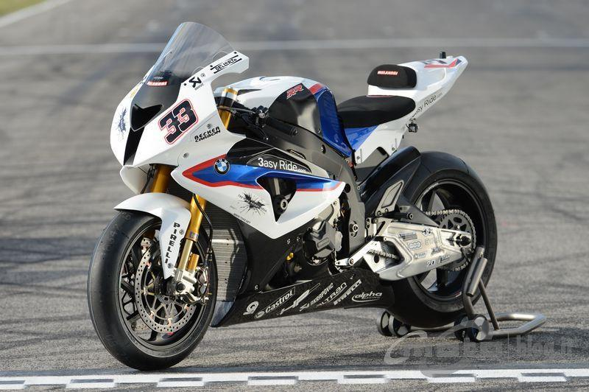

QUESTION THREE

The Upgrade BM62 camshaft for the M20 range of BMW engines (2.0, 2.3 and 2.5L) has the following specifications.

Cam Lift (mm) | 7.01mm Inlet/Exhaust | Cam Angle ATDC (°) | Valve Lift (mm)
Duration | 277 Deg Inlet/Exhaust | 110 | 10.651
Full Lift | Inlet 113 Deg ATDC | 111 | 10.654
LTDC | 1.40mm Inlet | 112 | 10.658
Timing | 25/72 72/25 | 113 | 10.660
Valve Lift (mm) | 10.66mm Inlet/Exhaust | 114 | 10.658
VC (mm) | 0.25mm Inlet/Exhaust | 115 | 10.654
 |  | 116 | 10.651

Assuming the total moving mass to be 0.172 kg, the spring stiffness of the valve springs
in the engine is 18,800 N.m⁻¹ with an initial compression of 4 mm, determine the following:

- Using your understanding of the valve’s dynamic motion, determine the valve acceleration (in m.s⁻²) at which float would be expected to occur.
(4 marks)

- With reference to the table above, calculate both the valve velocity (mm/°) and the valve acceleration (mm/°/°) at the provided lifts.
(3 marks)

- Sketch typical graphs of lift, velocity and acceleration and show what sign the acceleration would be at full lift.
(3 marks)

- The stock ‘red-line’ for the M20 motor is shown at 6,200 RPM. By determining the valve acceleration at this RPM (in m.s⁻²), prove that this RPM is safe in terms of potential valve float.
(5 marks)

- Assuming that you are able to increase the ‘rev limit’ of the M20, determine the RPM that you would expect valve float to occur and the safe limit that you would assume reasonable in a high-performance application.
(5 marks)

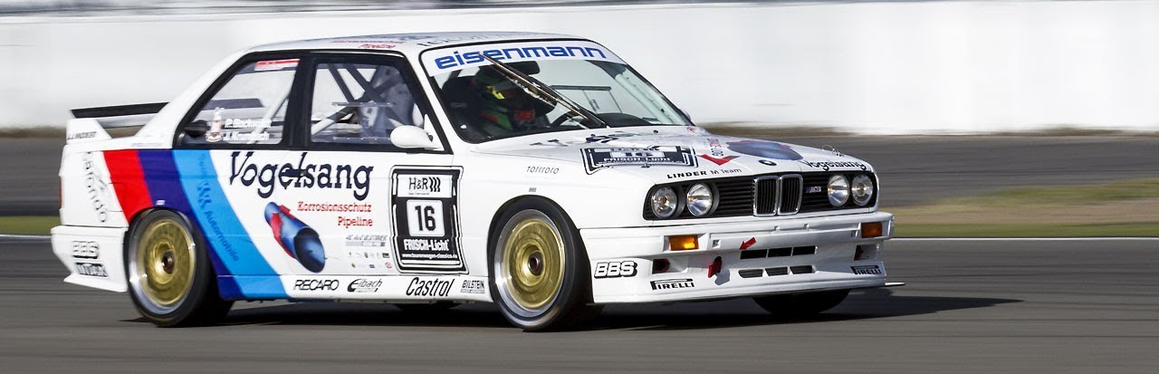
QUESTION FOUR

The following specifications are for the Fiat 500 TwinAir: 875cc, 8v, twin-turbo, two-cylinder engine with a compression ratio of 10:1, producing 63.4 kW @ 5500rpm and 145Nm @ 1900rpm at 1Bar boost pressure.

Assume that the cycle is a constant volume Otto cycle with instantaneous burning and heat input at Top Dead Centre (TDC). Assume that the intake stroke is complete at Bottom Dead Centre (BDC) and that the exhaust valve opens at BDC.

The engine is not quite adiabatic but has a polytropic index of 1.35 during compression and 1.31 during the expansion stroke.

Assuming that the manifold air temperature is 32°C @ 2Bar abs, Calculate:

- The temperature of the air/fuel mix just before the start of combustion.
(3 marks)
- The rise in temperature of the air/fuel mixture during combustion.
(6 marks)
- The temperature of the exhaust gas.
(2 marks)
- The peak pressure in the cylinder.
(4 marks)
- The potential energy recoverable from the exhaust gas per cycle.
(2 marks)
- Draw a P-V diagram for a real engine, labelling the 4 different parts of the typical four-stroke cycle and the important parameters of the cycle.
(3 marks)

You may use the following information:
Density of air at 35°C @ 2Bar = 3.52 kg m⁻³
Volumetric efficiency is 90%
Combustion efficiency is 90%
Calorific value of fuel = 44x10⁶ J kg⁻¹
Air/Fuel ratio = 14.7:1
Specific heat of air/fuel or exhaust gas at constant volume = 1007 J kg⁻¹ K⁻¹

Diwedd/End

