Module: Problem Solving and Decision Making
Module Code: BMSW 4004
Student ID: 2108084
Name: Andreea Oana Vlasceanu


Table of Contents
Task 01: Presentation Slides 3
Task 02 9
Introduction 9
Nature and Impact of the Problem 10
Causes and Effects of the Absenteeism Problem in the Organization 11
Family Responsibilities 11
Pregnancy and Maternity Leave 11
Minor Illnesses 11
Severe Medical Conditions 12
Injuries 12
Stress 12
Alcohol- or drug-related conditions 12
Horrible weather and transportation issues 12
Labor disputes or lockouts 12
Weak supervision, control, and the board 12
Unmet Expectations 12
Frequent job transfers 13
Workplace abuse 13
PESTLE analysis of the macro-environmental factors contributing to this critical problem 13
Political and Legal Factors 13
Economic Factors 14
Social Factors 14
Technological Factor 14
Environmental Factor 14
Probable Solutions Ways and Evaluation of the solutions ways of this Complex problem 14
Conclusion 16
References 17

Task 01: Presentation Slides

Slide 01

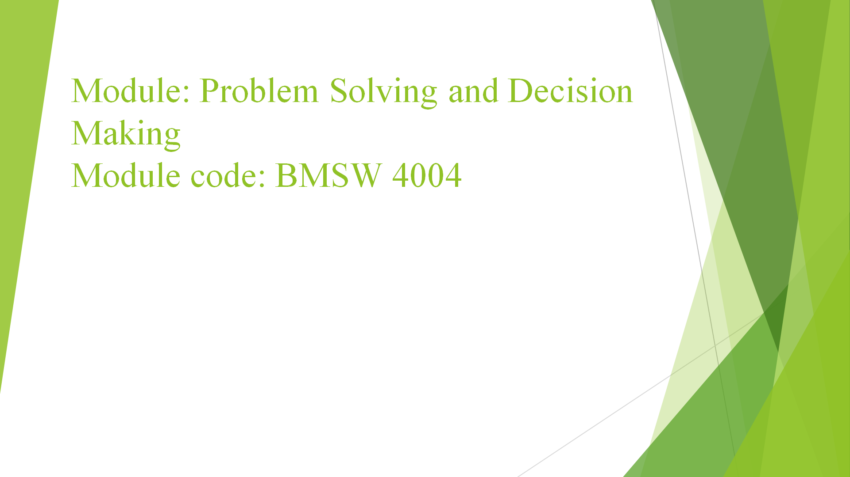

Slide 02
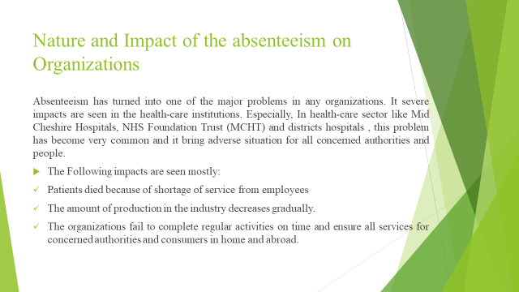

Slide 03
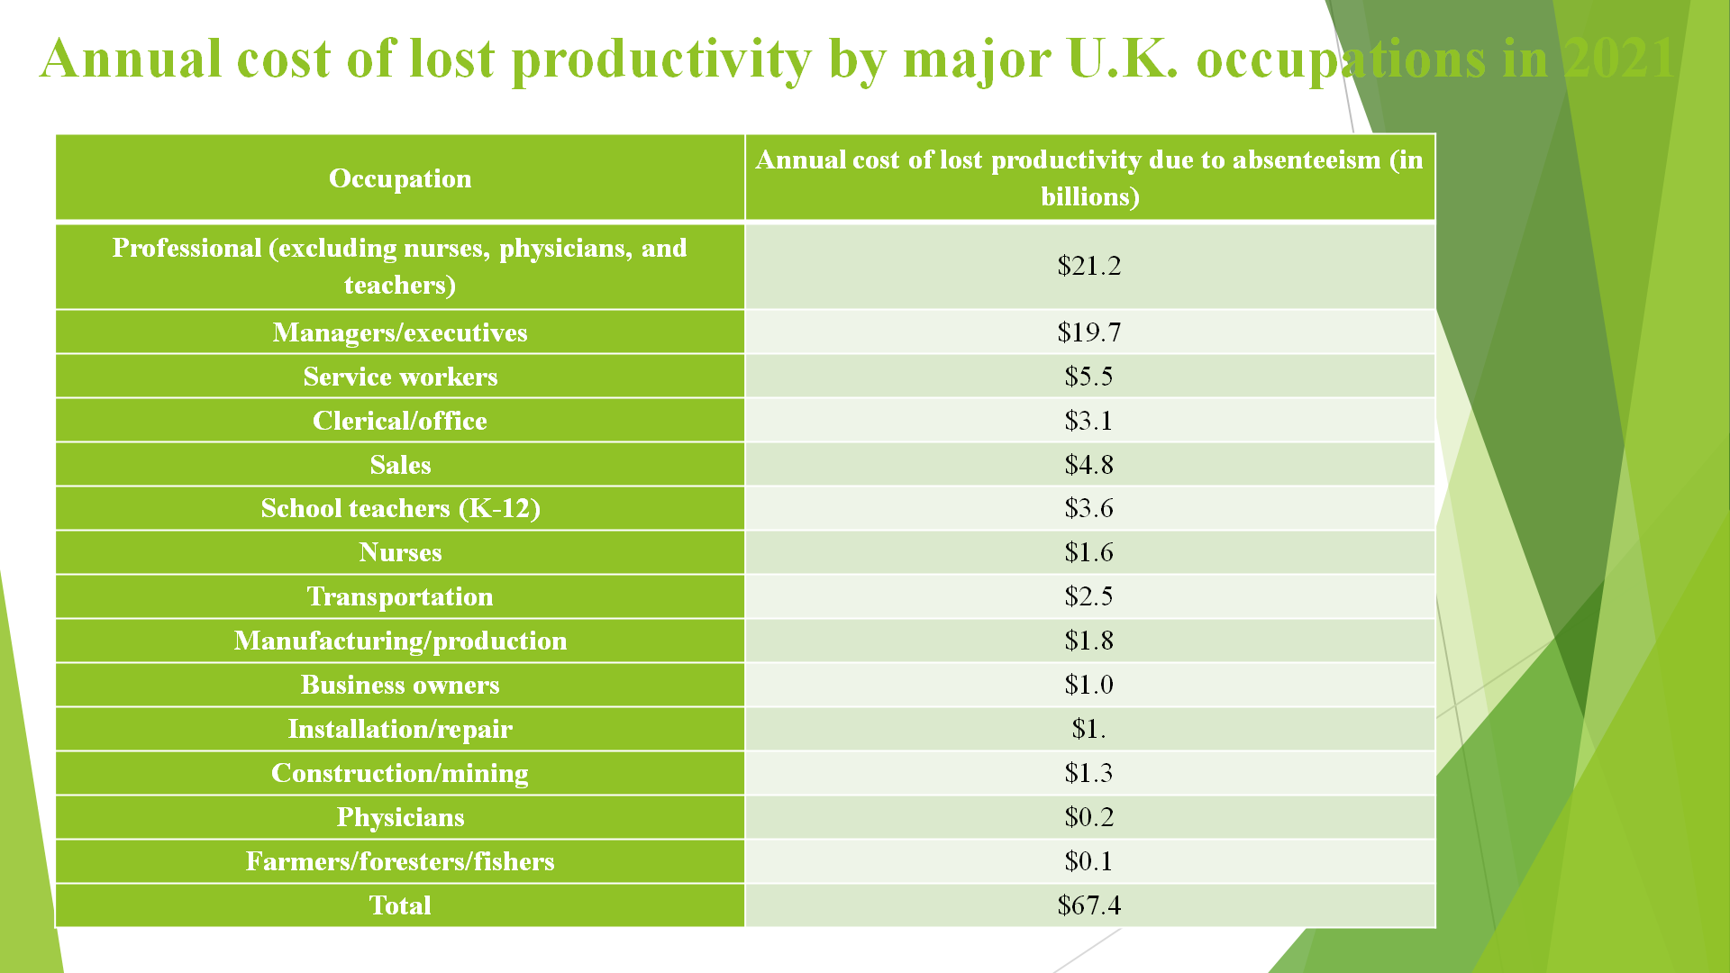

Slide 04
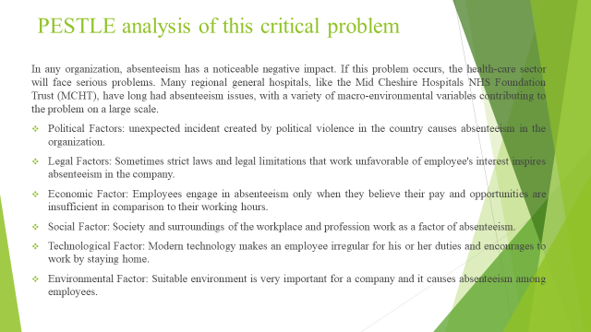
Slide 05

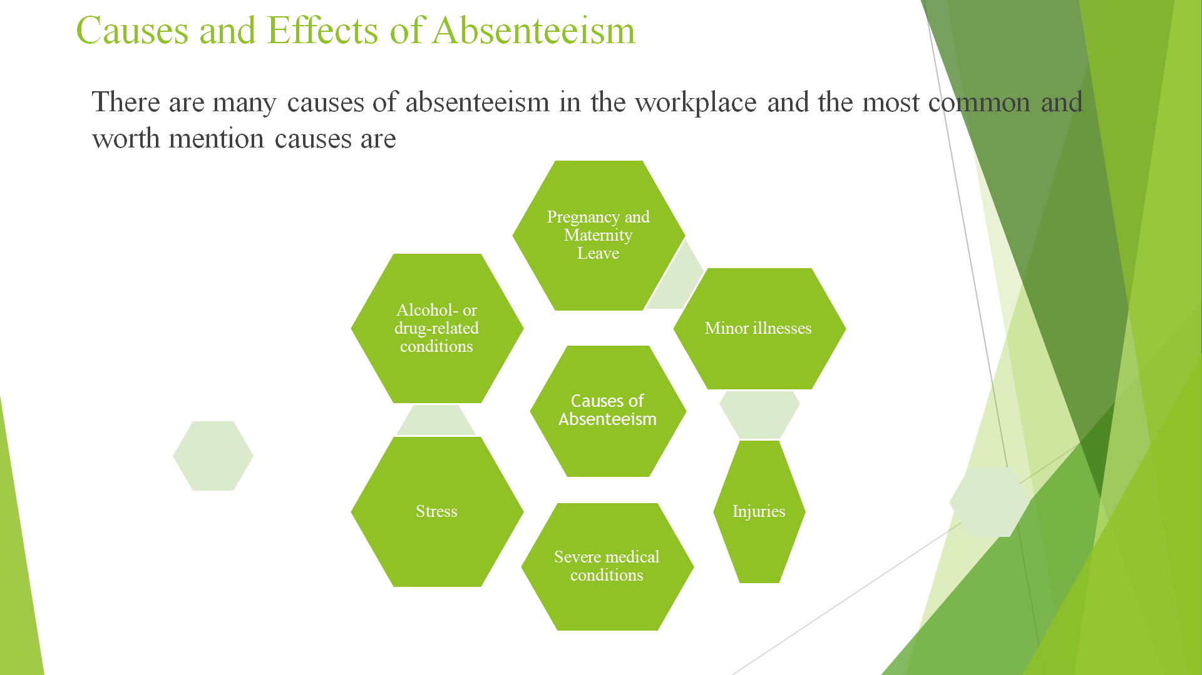

Slide 6
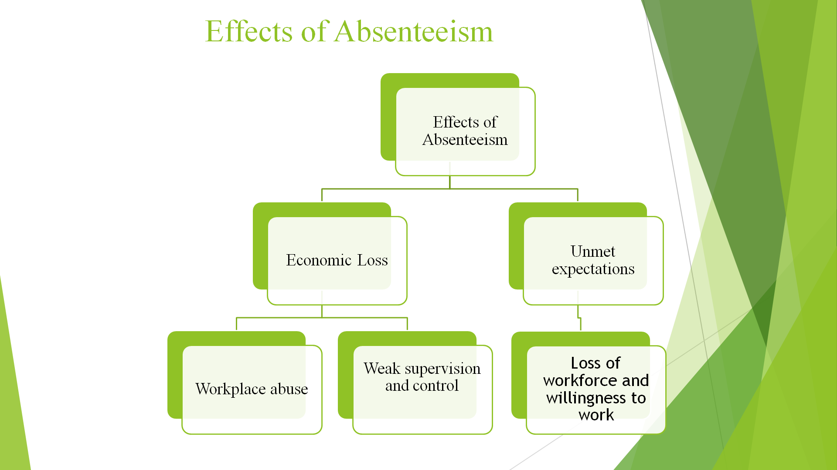

Slide 7
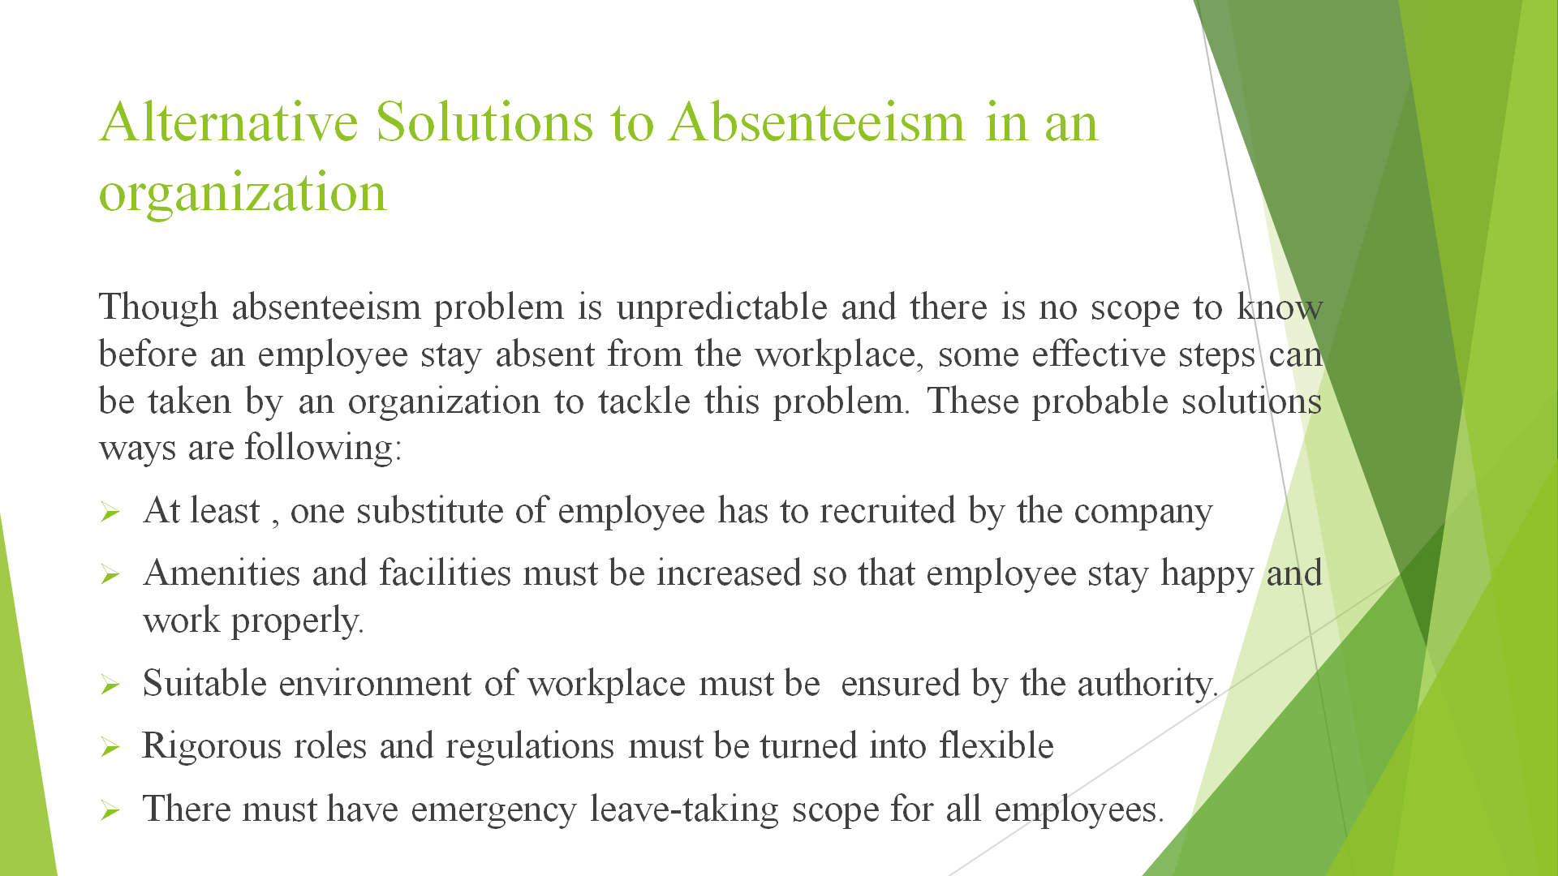

Slide 08
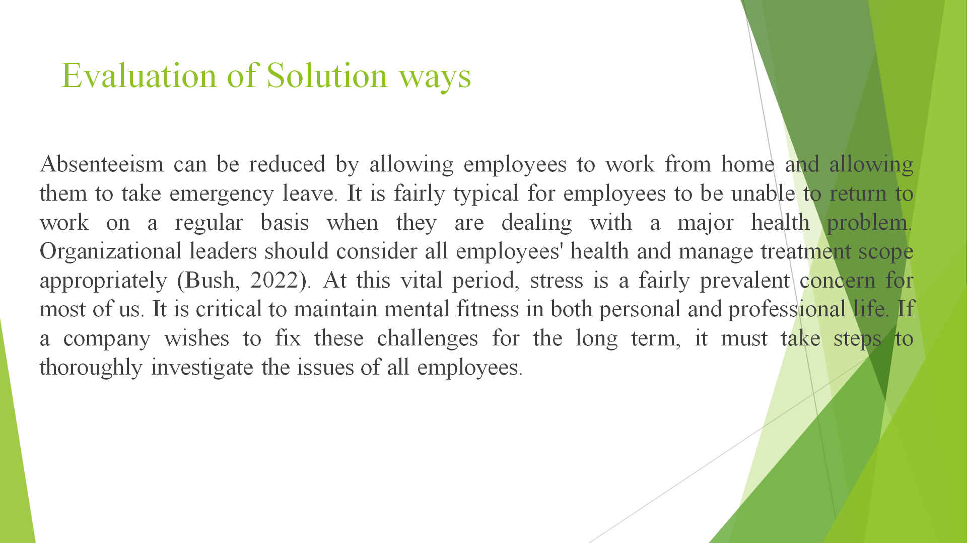

Slide 09
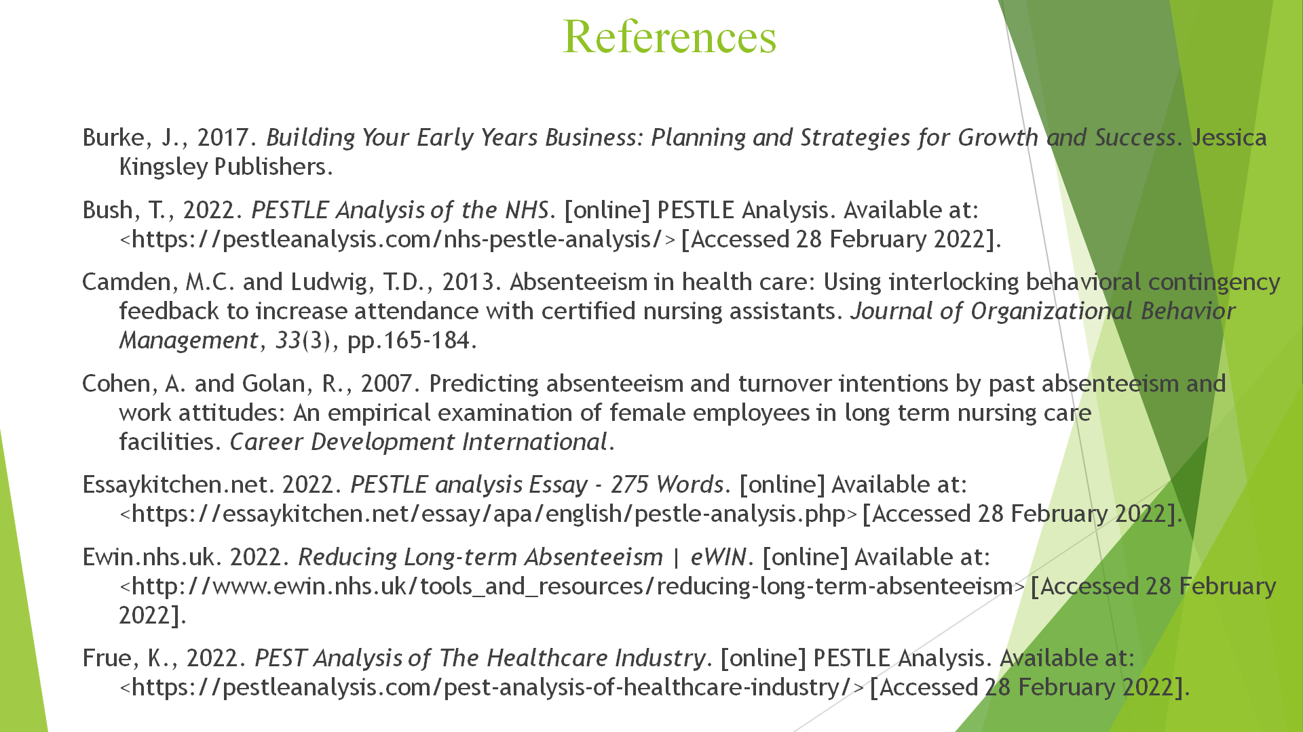

Slide 10
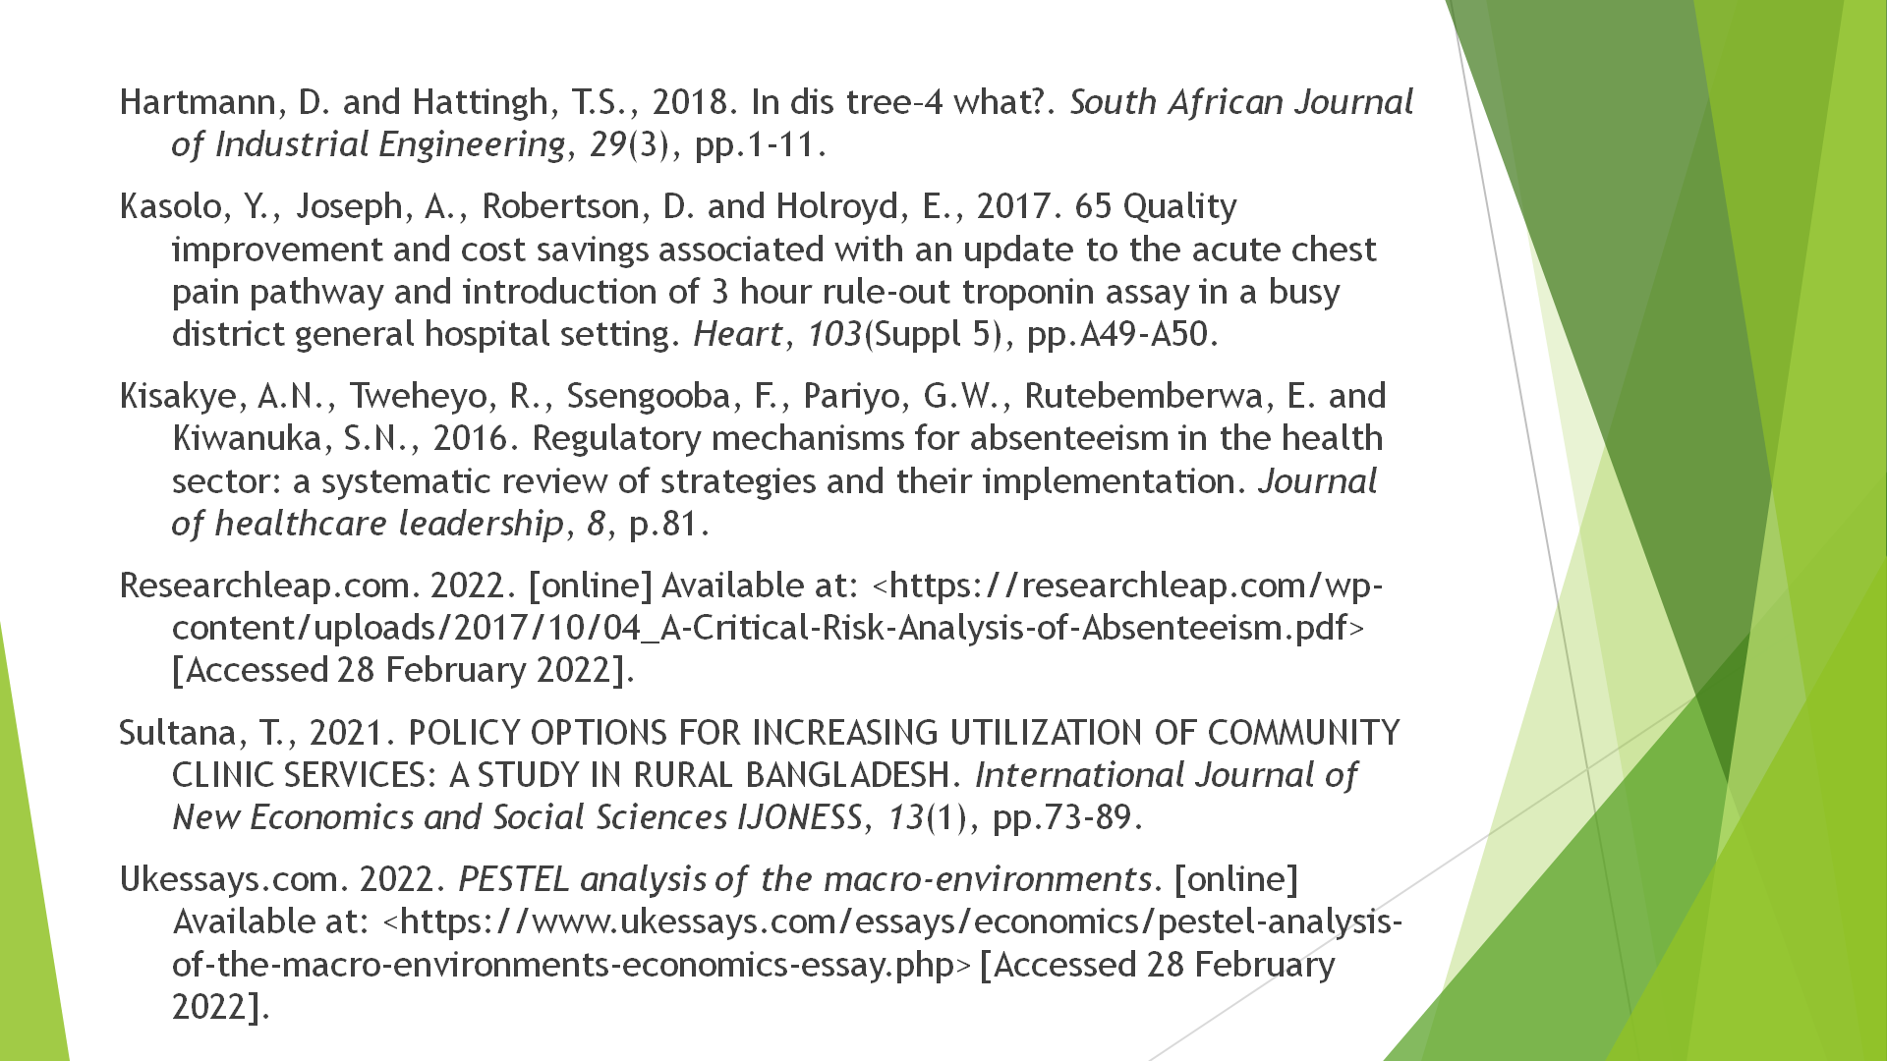

Task02

Introduction

Problem-solving is an interaction that involves recognizing alternative solutions for a particular situation and making decisions as part of critical thinking. Navigation is an activity that requires immediate action, whereas critical thinking takes time(Burke, 2017). To come up with a great arrangement, many preliminary steps and blunders are required. In the given study case, the Staff absenteeism problem of the Mid Cheshire Hospitals NHS Foundation Trust (MCHT) has been discussed. This is one the worst problems for any company and they have to pay a lot for this in the long run. Here, the nature and impacts of this critical problem on other employees and regular activities of the company have been analyzed. How macro-environmental factors supervise these critical issues has been assessed with the PESTLE analysis method. Cause and effect assessment of this problem has been added also. Finally, the probable solution ways of absenteeism in the chosen organizations has been diagnosed so that the organizations won’t have to face the same problem in the future.

Nature and Impact of the Problem

In the Health sector, when there arrives staff’s absenteeism problem, then there is no scope to skip taking strict steps to solve the critical issue. Because the negative impacts of this scope are very hampering. At present, the Mid Cheshire Hospitals NHS Foundation Trust (MCHT) has been facing this problem very largely and other organizations in the UK are also facing this critical problem (Robertson and Holroyd, 2017)
According to the Confederation of British Industry (CBI), absenteeism among manual professionals results in delayed creation, worse quality levels, interruption of work processes, low assurance, and overall disappointment, all of which reduce usefulness. Goodman and Atkin (1994) discovered that replacing an absent laborer with a less skilled specialist, either from within the organization or from outside, results in a drop in productivity, increased disciplinary activity, and an increase in workplace mishaps, among other negative repercussions. Despite this, Robbins and Judge (2004, p.28) point out that truancy can have both bad and beneficial consequences for a group. On the negative side, they also mention the impact of lost production and lower work quality; on the good side, they point out the benefit that could be gained from a weary representative's nonappearance when the concept of their task needs mental preparedness. This position is supported by Goodman and Atkin (1994, p.279), who claim that the influence is dependent on the voting demographic viable. While Coughlan (2004) does not specify any specific outcomes associated with truancy, she does agree that the effects are multi-layered, emphasizing that they are not limited to production losses or second-rate yields - which may eventually translate into a possible loss of clients - but also affect a truant's associates and supervisors immediately. Coughlan's perspective is confirmed by a review where respondents claimed that anyone, from coworkers to supervisors and departmental chiefs, who deals with a missing worker, is influenced by each incident of nonappearance ((Kasolo, Joseph, 2017)
Respondents frequently stated that collaborators who were expected to fill in for their absent partners were under increased strain and stress. Furthermore, laborers who have been absent from work will be assigned greater responsibilities, which will result in increased work pressure, leaving them helpless to avoid additional absences from work. Learns about the impact of non-attendance in educational settings and compares findings.According to Arnell and Brown (2012, p.172), a missing instructor's partners "may frequently feel more distressed, as they may need to prepare for the educator who is missing." Furthermore, "substitute educators don't constantly compare the standard homeroom instructor's daily plan and techniques to energize understudies to realize," resulting in decreased inspiration and spirit among students and less successful execution. In light of the foregoing information, it is apparent that non-attendance has a significant impact on the individual and their associates, executives, the organization as a whole, and, shockingly, the local region as a whole.

Causes and Effects of the Absenteeism Problem in the Organization
Unreasonable non-participation or regular lateness to a representative can reveal a lot about both the worker and the company, and it always warrants further investigation. While employees may have legitimate reasons for being absent from work, such as illness or personal concerns, the organization may also tacitly encourage this behavior through its actions or inaction. The following variables have been discovered to contribute to absenteeism:

Family Responsibilities
According to Vloebergs (2002), research has indicated that workers nowadays appear to value personal fulfillment over monetary reward. Individuals require more control over their professional lives and a greater emphasis on their personal lives. Family duties, particularly for mothers, may keep dedicated guardians away from work; for example, they may need to get their children ready for school in the morning or care for them when they are unwell. As a result, adjusting work and daily life must be a major administrative concern.

Pregnancy and Maternity Leave
Pregnant women may miss work to attend routine clinical check-ups, whereas maternity leave covers new moms' somewhat long-term unfortunate absences from work(Hartmann and Hattingh, 2018).

Minor Illnesses
Representatives may be plagued by illnesses such as colds, influenza, and brain aches to the point that they prefer to take time off work to seek medical attention.

Severe Medical Conditions
Serious illnesses such as HIV/Aids, hepatitis, stroke, and respiratory failure may need patients to adhere to a strict clinical schedule, such as attending check-ups regularly or taking drugs that have incapacitating side effects that prevent them from working.

Injuries
Whether injuries occur at work or elsewhere, impacted representatives will be unable to carry out their regular responsibilities or even report to work.

Stress
In the workplace, unexpected and extreme pressure can lead to a massive lack of appearance.

Alcohol- or drug-related conditions
It can be difficult to see a heavy drinker at work. It may take a clinical master to spot the early signs of alcoholism, such as routine lateness, because they are frequently linked to other difficulties, such as truancy.

Horrible weather and transportation issues
Extreme weather conditions, such as floods or heavy snow, can clog streets or trap people in their houses, making it impossible for them to get to work. Representatives may also be unable to work due to issues with their vehicles or strikes in the public transportation system.

Labor disputes or lockouts
Labor disputes and strike activity may cause employees to avoid the workplace or result in a lockout situation, in which the company refuses to let workers in(Camden and Ludwig, 2013).

Weak supervision, control, and the board
Some organizations have ineffective frameworks for screening and recording work participation, and representatives may take advantage of this poor management to skip work without proper approval or legitimate reasons.

Unmet Expectations
Employees may be absent from work if their assumptions about the working environment are incorrect. In such situations, absenteeism could be a way of expressing unhappiness with the executives (Ssengooba and Pariyo, 2016)

Frequent job transfers
When representatives are relocated from one office or location to another on a constant schedule, considerable valuable time is lost in the process of voyaging, transferring, and settling into the new environment.

Workplace abuse

Burke (2003) recounts a California case in which a jury awarded a 450-store Ralph's store chain $30 million in damages for failing to stop ahead supervisor's explicit and long-term sexual activity, as well as physical and psychological harassment of female sales representatives. During the preliminary hearing, the jury was aware of recurrent instances like stroking, harsh language and racist slurs, and the flinging of anything from pencils to phones. Even though this may be used to deal with a particularly egregious example of workplace mistreatment, it's simple to see why representatives would opt to be absent rather than face such harassment(Cohen,2007).

PESTLE analysis of the macro-environmental factors contributing to this critical problem

Absenteeism plays a visible negative role in any organization. Health-sector has to face severe problems if there occur this problem. In many districts general hospitals and Mid Cheshire Hospitals NHS Foundation Trust (MCHT), has been facingabsenteeismproblems for a long-time and lots of macro-environmental factors that have been contributing to this problem on a great scale. This issue has been assessed below going through the PESTLE analysis method

Political and Legal Factors
Political strikesand inconsistency of normal environment because of unexpected and political problems in a country or districtswork as a factor of absenteeism in the workplace. Besides, some strict legal obligations, employee legislation, and strict law for employees enhance absenteeism in the workplace (Golan, 2007).

Economic Factors
An employee goes through absenteeism only when they feel that the amount of salary and opportunities are not enough compared to their work-hour.

Social Factors
If any employee faces any social restrictions in the time of continuing office duty regularly then the employee stays absent from the workplace. A social perspective on any job is one of the great factors for an employee to stay in the assigned workplace for a long time (Kisakye, Tweheyo,2016).

Technological Factor
Technology has made our life so easy and our regular activities so flexible. If any employee feels that he or she can complete his duties staying away from home, then Absenteeism issues come in the front. Besides, many technologies work as a factor to lose attention on the workplace and duties.

Environmental Factor
The work environment is a crucial issue for an organization and an employee. If there is no suitable and required sound environment for work, the Absenteeism problem must appear in this organization.(Rutebemberwa and Kiwanuka, 2016)

Probable Solutions Ways and Evaluation of the solutions ways of this Complex problem
Employees have a family and they have to take care of these. Focusing on this issue, an organization can formulate policies to stay relaxed and to provide much time to the family when the family needs time. By launching opportunities to work from home and scope to take emergency leave, absenteeism can be decreased. Pregnancy and maternity leave are the two important issues for a company. Every company should provide ample leave in this very important but critical time of employees if they want to absenteeism problem. It is very common that, when staff will go through with a serious health problem, then it is not possible to join workplace in a regular basis. Organization authorities should think about the health status of all employees and manage proper treatment scope also (Bush, 2022). Besides, when staff has an instant injury, then the authority has to take steps to complete that staff’s regular duties by going through alternative ways. So, the company needs to manage an alternative way to face a critical shortage of employees in any unexpected situation. Stress is a very common problem to most of us at the present critical time. Stay mentally fit is very important for personal and professional life. An organization has to take steps to check these issues of all employees properly if the organization wants them to be solved for a long time. All employees do not stay near the workplace. If the company manages transport for attending workplace, it will decrease the absenteeism problem. It is worth mentioning that, the environment of the workplace and target fulfilling pressure are the two worst factors of absenteeism problem in an organization. For this, the authority should take effective steps. The most important thing that a company needs to tackle this problem is to make strong supervision, control, and management systems of employees in the organization. Only this step can solve all problems directly or indirectly(Frue, 2022).

Conclusion

The study looked into absenteeism as a quantifiable issue in organizations, or a percentage of whether or not a worker's needs are addressed by their work. Representatives who regard their jobs as unrewarding or as failing to meet their expectations will have a greater tendency to withdraw from the workplace. Work fulfillment is influenced by the concept of labor and the workplace, which leads to avoidance of work. Improving positions that provide representatives with a variety of tasks will, as a result, bring about greater fulfillment than regular ones, which will encourage workers to be accessible to work. Workers are also influenced by the type of supervision; a tyrannical boss is likely to agitate his employees. The essay indicates that absenteeism has a significant impact on the individual, his relatives, the association, and its clients.

References

Kasolo, Y., Joseph, A., Robertson, D. and Holroyd, E., 2017. 65 Quality improvement and cost savings associated with an update to the acute chest pain pathway and introduction of 3 hour rule-out troponin assay in a busy district general hospital setting. Heart, 103(Suppl 5), pp.A49-A50.
Sultana, T., 2021. POLICY OPTIONS FOR INCREASING UTILIZATION OF COMMUNITY CLINIC SERVICES: A STUDY IN RURAL BANGLADESH. International Journal of New Economics and Social Sciences IJONESS, 13(1), pp.73-89.
Hartmann, D. and Hattingh, T.S., 2018. In dis tree–4 what?. South African Journal of Industrial Engineering, 29(3), pp.1-11.
Cohen, A. and Golan, R., 2007. Predicting absenteeism and turnover intentions by past absenteeism and work attitudes: An empirical examination of female employees in long term nursing care facilities. Career Development International.
Camden, M.C. and Ludwig, T.D., 2013. Absenteeism in health care: Using interlocking behavioral contingency feedback to increase attendance with certified nursing assistants. Journal of Organizational Behavior Management, 33(3), pp.165-184.
Kisakye, A.N., Tweheyo, R., Ssengooba, F., Pariyo, G.W., Rutebemberwa, E. and Kiwanuka, S.N., 2016. Regulatory mechanisms for absenteeism in the health sector: a systematic review of strategies and their implementation. Journal of healthcare leadership, 8, p.81.
Burke, J., 2017. Building Your Early Years Business: Planning and Strategies for Growth and Success. Jessica Kingsley Publishers.
Bush, T., 2022. PESTLE Analysis of the NHS. [online] PESTLE Analysis. Available at: <https://pestleanalysis.com/nhs-pestle-analysis/> [Accessed 28 February 2022].
Essaykitchen.net. 2022. PESTLE analysis Essay - 275 Words. [online] Available at: <https://essaykitchen.net/essay/apa/english/pestle-analysis.php> [Accessed 28 February 2022].
Ewin.nhs.uk. 2022. Reducing Long-term Absenteeism | eWIN. [online] Available at: <http://www.ewin.nhs.uk/tools_and_resources/reducing-long-term-absenteeism> [Accessed 28 February 2022].
Frue, K., 2022. PEST Analysis of The Healthcare Industry. [online] PESTLE Analysis. Available at: <https://pestleanalysis.com/pest-analysis-of-healthcare-industry/> [Accessed 28 February 2022].
Researchleap.com. 2022. [online] Available at: <https://researchleap.com/wp-content/uploads/2017/10/04_A-Critical-Risk-Analysis-of-Absenteeism.pdf> [Accessed 28 February 2022].
Ukessays.com. 2022. PESTEL analysis of the macro-environments. [online] Available at: <https://www.ukessays.com/essays/economics/pestel-analysis-of-the-macro-environments-economics-essay.php> [Accessed 28 February 2022].

