

LEVEL 7 ASSESSMENT SPECIFICATION
Programme: Master of Business Administration

Module Name: Marketing Management
Module Code: LCMB7024

Name of Student: MANIKANDAN GOPALAKRISHNAN
Student ID: 2507423
Due Date: 19.11.2025
Table of Contents
Introduction 3
Element 1: Development of a Segmentation, Targeting, Differentiation, and Positioning (STDP) Analysis 3
Segmentation 4
Targeting 5
Differentiation 5
Positioning 6
Element 2: Marketing Mix (7Ps) 6
Element 3: Poster 10
Element 4: Reflection 12
Conclusion 13
References 14
Appendix: Poster 16

List of Figures
Figure 1: Logo of GymPod 3
Figure 2: Home Fitness Market Size & Trends 4
Figure 3: The 7Ps of the Marketing Mix 7

Introduction
This research is developed for The GymPod, which is an innovative, subscription-based home gym concept by the Gym Group, UK. It explores the brand’s strategic foundation by using the STDP and 7Ps Framework while aligning with the rising wellness and hybrid fitness trends. The research has emphasised the way in which technology, flexibility and affordability can define the urban fitness experiences and strengthen the Gym Group’s competitive positioning.
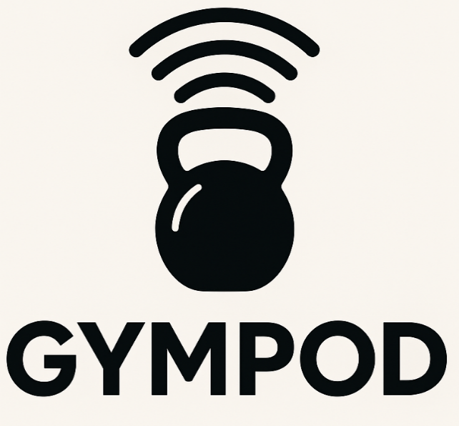
Figure 1: Logo of GymPod
(Source: self-created)

Element 1: Development of a Segmentation, Targeting, Differentiation, and Positioning (STDP) Analysis
The GymPod is the subscription-based modular home gym solution, which includes the compact hardware (foldable racks, adjustable resistance modules, and a cardio element), where the AI-enabled sensors, progress tracking, and live/on-demand coaching assist through the Gym Group App (The Gym Group, 2025). The brand is designed as an extension of the Gym Group’s value for money, no-contract ethos regarding the rising at-home “connected fitness” space. This offers a lower-cost, space-efficient alternative to the premium connected devices, such as; Tonal, Mirror, while leveraging the Gym Group’s scale and membership base. The Gym Group has reported £226.3 million of revenue and 891K members in the year 2024 for demonstrating the large customer funnel to the cross-sell a hybrid home and offline products (TGG Plc, 2025).
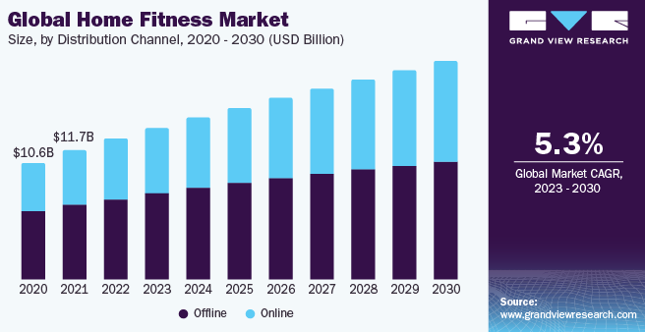
Figure 2: Home Fitness Market Size & Trends
(Source: Grand View Research, 2025)
The demand for home fitness remained structurally higher than the pre-pandemic levels, where the analysts estimated for the global home fitness equipment at USD 12.81 to 18.2 billion recently, with having the sustained mid-single digit CAGR’s as consumers blend in-person and at-home routines (Grand View Research, 2025). The smart/connected equipment and mirrors are noted as the fastest-growing sub segments, where consumers seek for both personalisation and convenience. The wellbeing and convenience are persistent as per consumer’s priorities. The McKinsey research addressed a persistent wellness trends and sticky behavior changes towards hybrid fitness and digital engagement (Falardeau, Glynn and Ostromecka, 2025).

Segmentation
Demographic | Age: 25–45 (young professionals, early parents).  Income: Middle to upper-middle (can afford subscriptions but price-sensitive).
Geographic | - Urban and inner suburban UK individuals (smaller homes, higher space constraints)  - The initial launch will be focused on the major metro areas.
Behavioral | - Remote and hybrid staffs who values the efficiency of the time and flexible schedules.  - Fitness enthusiasts, who can alternate between the home workouts and gyms.
Psychographic | Tech-savvy, time pressed people, who prioritise wellness, but dislike the high-cost hardware and long-gym commutes.
Firmographic | Employers and co-working operators, who are seeking for employee for wellness benefits and shared pod installations.

The niche smart segments are gradually rising, where smart fitness mirrors the market has been estimated as USD 339M in 2024 and forecast to expand over the decades as AI coaching becomes a mainstream element.

Targeting
Primary target
The urban professionals, aged between 25 to 45 years, dual income and single professionals, who are living in the flats with the limited space, and earning around £25k–£70k. These professionals value the convenience and digital experiences. They also seek for the regular exercising options but are constrained by the travel, time and space. They will pay a modest amount as in monthly fees besides making a larger upfront purchase.
Secondary targets
- Families / early parents, who expect short, and guided workouts at the home-based set-ups.
- Corporate wellness programs, such as bulk and subsidised subscriptions.
This specific group might heavily overlap with the Gym Group’s current membership base including; young, price-sensitive gym users, and large enough for justifying the subscription model and scalable logistics, such as; installation, returns, maintenance. The UK’s at-home fitness demands and the memberships scale can provide a ready conversion funnel.

Differentiation
- Price and model: The subscription + modest deposit removes the large upfront cost that might block the consumers, and flexible contractual alignment with the Gym Group’s no-contract image.
- Modularity and space efficiency: Unlike the fixed mirrors at the racks (Tonal), the GymPod components stow or transform the small flats (Kgpco, 2022).
- Integration with established ecosystem: Gym Group app single-on, cross-membership perks (including; hybrid use: in-club credits, class bookings) can assist in leveraging around 891K member base for ensuring a rapid adoption.
- Sustainability and environmental footprint: Refurbish or rotate equipment between the subscribers are necessary for lowering the cost and environmental footprint, which might deliver an operational advantage Vs the one-time hardware seller (Kgpco, 2022).
- Localised safety and pricing: UK-centric support systems, deliveries and warranty structure can tune to the urban housing constraints.

Positioning
Statement
“For the busy urban professionals who expects gym-quality results without the gym’s time, space or cost, the GymPod delivers a highly compact, subscription-based smart gym with the AI-coaching and on-demand classes, which is supported by the Gym Group’s affordable fitness network.”
Key messaging pillars might include the following:
- “Personal gym, zero clutter” (space/size benefit).
- “Gym quality, pay monthly” (value for money).
- “Hybrid freedom” (use at home + in-club benefits).
Pilot in London & Manchester through the targeted digital ads, in-club promotions, corporate wellness partnerships, including the referral discounts can assist in converting the existing Gym Group members. Using the data-driven on-boarding such as; fitness assessment + suggested Pod configuration are necessary for reducing the churn.

Element 2: Marketing Mix (7Ps)
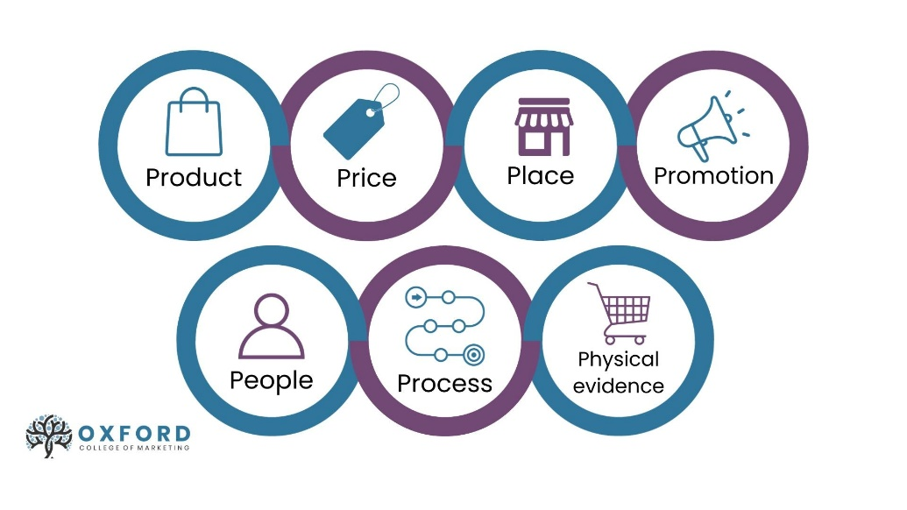
Figure 3: The 7Ps of the Marketing Mix
(Source: Oxford College of Marketing, 2024)
Product (Service offering and features)
The modular home-gym kit (compact strength factors might include adjustable resistance bands, a foldable cardio element) that has been bundled with subscription to the Gym Group App, delivers AI-driven coaching, on-demand, performance tracking and hybrid benefits (in club credits / class bookings). In this case, different service layers might include the following:
- Basic: hardware rental + app access (library + basic tracking).
- Premium: Includes live classes, 1:1 virtual coaching sessions and advanced AI form analysis.
- Corporate / Shared Pod: Multi-user access and management for offices/co-living spaces.
The installations and removal service, 24/7 remote support, public equipment refresh and refurbish programs, and the integration with the wearables. The modular design can enhance the small-home constraints and encourage the recurring revenue through subscriptions, besides than one-off hardware sales. This product strategy aligns with the growth of the home fitness and connected devices. The global home fitness equipment market has been USD 12.26 billion in 2024, and the smart mirrors segment USD 339 Million, addressed a rising and addressable market for the connected home fitness solutions (Fortune Business Insights, 2025).
Price (Pricing model and justification)
Model
The tiered monthly subscription + refundable deposit for the hardware can be noted as a major pricing model for the business idea. The suggested tiers for the services will include; Basic £24/month, Premium £39/month; deposit £99 refundable after 12 months. This will offer 3 to 6, and 12-month billing cycle with the discounts for the annual prepay and corporate bulk purchases.
Rationale
While being aligned with the Gym Group’s value positioning and typical customer willingness to pay. The Gym Group’s ARPMN (average revenue per member per month) has been £20.81 in 2024, where GymPod premium will command a modest uplift for the convenience and tech add-ons, while undercutting the high-end purchase of the hardware. The subscription can reduce the barrier to make an entrance into the devices such as; Tonal, while driving the predictable monthly revenue and improvement of the customer life values.
Place (Distribution and channels)
Direct channels
The D2C e-commerce on the Gym Group site and GymPod dedicated the microsite (online configuration to select the kit/modules).
Omni-channels
In the club-sales desks (cross-sell to existing 891K+ Gym Group members), pop-up showrooms at the metropolitan shopping areas for the demand and B2B channels addresses to the corporate and co-living operators. In this case, the pilot roll-out prioritises at the London and Manchester. The Gym Group’s membership scale can provide a ready conversion funnel for the launches and trials.
Promotion (Communication and launch tactics)
The acquisitions strategy includes targeted digital advertising, influencer collaborations, and performing experimental promotions for effectively reaching and converting the potential customers. Through using the data-driven digital campaigns across the search, social media and programmatic platforms, the brand can precisely target the fitness enthusiasts and urban professionals who are seeking for the health and wellness solutions. The partnerships with the influencers and micro-influencers in the urban lifestyles and the fitness niches can enhance the credibility and engagement by promoting the brand to their active audiences.
The performance measurement will be guided by the CAC or Customer Acquisition Cost and Lifetime Value or LTV modelling including; cohort-based retention analysis, and Net Promoter Score (NPS) tracking for assessing the advocacy and satisfactions (Janes, 2025). Timing of the campaign makes an alignment with the UK’s fitness market recovery trends, as some recent data from 2024 addresses that around 48% of UK adults are engaged in regular exercises.
People (staff, trainers & culture)
The frontline staff from the backbone of Gym Pod’s customer experience strategy, for ensuring the seamless service delivery and current engagement. The dedicated GymPod Customer Success Team overseas the on-boarding processes, while assisting the customers with better set-up, subscription management and support inquiries for ensuring that a smooth start has been initiated. The installation technicians are trained in compact urban build environments, while allowing them to handle the small-space set-ups in a professional and efficient manner. By complementing the physical service, a team of remote trainers certified in the virtual coaching delivers live and on-demand sessions, for maintaining high-quality and personalized fitness experiences for the users.
For reinforcing the trusts and expertise, GymPod employs the certified personal trainers and physiotherapists for creating, verifying and updating the training content, while ensuring both safety and effectiveness. Introduction of the “GymPod trainers” certification program has further standardized the virtual coaching standards and created higher credibility of the brand. Also, from the internal point of view, the culture is strongly customer-centric, with having strict service-level agreements or SLAs for the delivery, maintenance and repairs. The community managers organized the online challenges and local meet-ups for fostering the social motivation and replacing the camaraderie of traditional gyms.
Process (service delivery & operations)
The GymPod service delivery process has been designed in such a manner, so that it can ensure a seamless, technology-driven and customer-centric experience from the purchase to long-term engagement. The customer journey starts with the online purchase followed by the flexible scheduling for the delivery and installations, handled by the expert technicians who are trained for the compact urban spaces. One of the equipment are successfully installed the customers receive guided onboarding, including baseline fitness assessment is necessary for personalizing the app experience. The current engagement has been maintained through the regular app-based solutions, including the performance reviews and periodic hardware and refurbishment for ensuring the durability and optimal performances.
The operational efficiency has been achieved through the strategic logistics partnerships which enables the same-week delivery in the urban areas, modular packaging for the easy installations in some small flats (Silva and Nilsson, 2025). The technology processes including; automated billing, in-app scheduling, and remote diagnostics allows the proactive maintenance, while the AI-powered routines adapt the workouts for the user progressions. The transparent cancellation and return policy, is reflecting Gym Group’s no-contract model, which ensures higher customer trust and retention rates.
Physical Evidence (tangible cues & brand trust)
- Tangible signals: The GymPod will have sleek and compact hardware with having branded finishes, including professional installations and a tidy sable management for the small spaces. This will also include printed quick-start guides and safety stickers.
- Digital evidences: The polished app with have clear coach bios, including verified user testimonials, progress dashboards and studio-quality recorded classes.
- Trust marks: This will include the aspects like; warranty certificates, data privacy/security disclosures for biometric data, and sustainability reports on refurbishment cycles. Such cues will create a confidence in the service where the equipment has been rented and health data has been collected.

Element 3: Poster
Appendix
The GymPod — Bring the Gym Home
Tagline: “Your Personal Gym. Anytime. Anywhere.”
Brand Concept
The Gym Pod is an innovative and modular home gym solution that is going to be launched by the Gym Group UK and designed for the modern lifestyle of people. It combines smart, portable fitness equipment with the personalised virtual coaching through the Gym Group app, where all are under the flexible subscription-based models (The Gym Pod, 2025).
The Problem
In the current scenario, the busy professionals and remote workers crave for the fitness convenience, but have lack of space, time and funds for setting the full-scale gym. The traditional memberships of people often stay unused and most of the expensive equipment becomes cluttered (Smart Pod, 2025).
The Solution
The GymPod delivers higher gym-quality workout sessions at the home against a monthly subscription-based equipment kit (full-body, cardio and strength training). The equipment also includes complete smart sensors, progress tracking and AI-supported online trainers.
Target Market
Urban residents, small-home dwellers, and remote professionals aged 25–45 years, who value flexibility, innovation, and health.
Value Proposition
- Affordable & flexible – no long-term commitment
- Smart fitness powered by The Gym Group app
- Compact, sustainable, and stylish design
Why it Works?
The GymPod aligns with the rising home fitness and wellness economy by offering a scalable, tech driven model to the investors that can provide a major digital fitness experience.
Explanation of the Poster
The poster for the GymPod efficiently communicated the essence of the new brand and its strategic vision. At the core of the business idea, it presents the Gym group UK’s innovative response to the modern fitness challenges while mixing all technology, flexibility and accessibility into the seamless solution. The tagline of the business, “Your Personal Gym. Anytime. Anywhere” captures the concepts of convenience and personalisation that can define the brand value more effectively (The Gym Pod, 2025). The poster’s layout has been designed to become visually engaging and informative. The problem section addressed a rising issue faced by the current day’s professionals and remote staff, including lack of time, space, and affordability for traditional gym experiences (Smartpod, 2025). Emotional connection with the audience can assist in establishing the relevance and urgency of the product.
The solution of the business idea provides the interdiction of The GymPod as a modular and portable gym system that is supported by the flexibility of smart technology against a subscription-based service plan. The inclusion of the smart sensors, virtual trainers and app integration has reinforced the modern and tech-driven appeal while demonstrating that The Gym Group is evolving with the core market trends. Target audience profile for the business offers an enhanced clarity for both the investors and stakeholders by defining different demographics, such as; urban individuals (aged 25 to 45), who follows a fast-paced lifestyle and represents the rising and portable market segment. The value proposition of the business addresses some highly exclusive advantages, such as cost-effectiveness, adaptability, intelligent technology integration, and eco-conscious design.

Element 4: Reflection
Development of the GymPod as a new brand concept for the Gym Group has been noted as an enriching experience that can allow me to integrate the theoretical marketing models with practical, data-driven decision-making. The process of conceptualising the modular, subscription-based home gym service needs to have a deep understanding of emerging fitness trends, customer lifestyle shifts and technological innovations. By applying the STDP framework, I have learnt the way critical segmentation and targeting are identifying the viable niches, including urban professionals who are aged between 25-45 years. I have noted that, these specific group of people values the flexibility, convenience and affordability, for crafting the 7Ps marketing mix. These has been enhanced through my ability of making alignment with the aspects like; product, price, place, promotion, people, process, and physical evidence, with having a strategic vision of creating tech-enabled and customer centric fitness solutions.
Preparing the marketing strategy pitch has been highly valuable as it needs to transform the complex research and analytical insights into the clear and persuasive narratives. The pitch has demanded not only some strong strategic rationale, but also the efficient storytelling, including visual communications and confidence in the delivery process. I have improved my presentation and persuasion skills through focusing on how to connect the audiences in an emotional manner with the value proposition, such as; “Your personal Gym, anytime and anywhere”. By incorporating the real-life data, market forecasts and competitor assessment has made the pitch as more credible and practical. This specific phase has taught me how necessary it is to present the data visually while engaging in a simple way for sustaining the stakeholder attention and trust.
Throughout the process I have gained the major professional skills including strategic thinking, market research proficiency, including the creativity under the time constraints. I have also enhanced my analytical reasoning by strategically synthesising the secondary data from using some credible sources, such as; Statista and McKinsey for supporting the marketing decision-making process. The project has strengthened my ability for making a balance between the innovative thinking with the commercial feasibility, for ensuring that the ideas doesn’t creates an appeal but can be applied in a profitable manner.
I have also identified that, I can enhance my approach by incorporating the primary consumer research for validating the assumptions regarding customer preferences and pricing elasticity. By making a collaboration with the cross-functional teams, including; product designers and finance analysts, might cause more holistic strategy.

Conclusion
The GymPod represents a forward-thinking response to the evolving consumer fitness behaviors, blending smart technologies with the convenience and affordability. Through performing the strategic segmentations, targeting and differentiation, and application of 7Ps marketing mix, business concept offers a sustainable growth prospect.

References
Falardeau, E., Glynn, J., and Ostromecka, O. (2025). Sweating for the fitness consumer. McKinsey. Available at: https://www.mckinsey.com/~/media/mckinsey/industries/consumer%20packaged%20goods/our%20insights/sweating%20for%20the%20fitness%20consumer/sweating-for-the-fitness-consumer.pdf (Accessed on: 9th Nov 2025)
Fortune Business Insights (2025). Home Fitness Equipment Market Size, Share & Industry Analysis. Available at: https://www.fortunebusinessinsights.com/home-fitness-equipment-market-105118 (Accessed on 10th Nov 2025)
Grand View Research (2025). Home Fitness Market Size & Trends. Available at: https://www.grandviewresearch.com/industry-analysis/home-fitness-market-report (Accessed on: 9th Nov 2025)
Janes, D., (2025). LTV/CAC Ratio: What It Is & How to Calculate It. Available at: https://online.hbs.edu/blog/post/ltv-cac (Accessed on 10th Nov 2025)
Kgpco (2022). Optimizing ISP’s Customer Premise Equipment Investment with Forward and Reverse Logistics. Available at: https://www.kgpco.ca/about-us/news-and-events/customer-premise-equipment-refurbishment (Accessed on: 9th Nov 2025)
Oxford College of Marketing (2024). Understanding the 7Ps of the Marketing Mix. Available at: https://blog.oxfordcollegeofmarketing.com/2020/10/08/understanding-the-7ps-of-the-marketing-mix/ (Accessed on 10th Nov 2025)
Silva, N. and Nilsson, F. (2025). Exploring the circular last mile: reusable packaging in home delivery of food and groceries using a design science approach. The International Review of Retail, Distribution and Consumer Research, 35(4), pp.383-404. Available at: https://www.tandfonline.com/doi/pdf/10.1080/09593969.2024.2414082
Smartpod (2025). Gym Modular Building. Available at: https://www.smartpod.com/gym-pod/ (Accessed on 29th Oct 2025)
TGG Plc (2025). Full Year Results for the year ended 31 December 2024. Available at: https://www.tggplc.com/news-and-media/press-releases/full-year-results-for-the-year-ended-31-december-2024/ (Accessed on: 9th Nov 2025)
The Gym Group (2025). The Gym Group equipment and machines. Available at: https://www.thegymgroup.com/equipment/ (Accessed on: 9th Nov 2025)
The Gym Pod (2025). From solo to shared, your perfect Pod awaits. Available at: https://thegympod.com/ (Accessed on 29th Oct 2025)

Appendix: Poster


