Student Name: Ioana Dobre  Student ID: 2224087  Module Title: Foreign Languages and Cultural Awareness  Module Code: BMIH5003  Lecturer: Heidi Prosse | 
ASSIGNMENT 1: PORTFOLIO
(4 Components)

Component 1: Professional Reflection (500 words +/- 10%)

Weighting: 25%
Introduction
I came across several Japanese visitors this morning while doing breakfast service in the hotel restaurant, and we had a cultural misunderstanding. They were having trouble expressing what they wanted, as I could see when I was taking their orders. Their primary language is not English; therefore, they were having difficulty describing the various food and drink alternatives to me. I became frustrated with the language barrier and raised my voice, using exaggerated terms, in the hopes that this would improve their understanding. But all it appeared to do was make them more confused. My tone of speaking seems to have angered one of the visitors. Rather of becoming angry, I ought to have stayed composed and patient and tried to close the gap with basic words and gestures. It was unprofessional and culturally disrespectful for me to speak out in such scenario.
Description
Due to a language issue, I had trouble this morning having meaningful conversations with a few Japanese hotel customers during breakfast service (Patiar et al. 2021). I became angry and spoke in an exaggerated manner, upsetting one of the visitors.
Feelings
I became ashamed and rude when I saw how my acts may be interpreted in different cultural contexts. Not being able to comprehend the visitors' order preferences also made me feel irritated (Bokareva, and Yudina, 2020).
Evaluation
There were obviously problems with the way I handled the circumstance. Raising my voice did not solve the communication issue and was culturally inappropriate (Crawford, Weber, and Lee, 2020). I should have maintained my composure and looked for other methods to communicate with them, such using basic language, gestures, or displaying menu images. Being in the hospitality industry requires me to be sensitive to cultural differences and to be patient when obstacles arise.
Analysis
My own lack of cultural sensitivity and understanding was the primary issue. I assumed that making my speech more dramatic would be beneficial, but I was not concerned about how their culture may interpret it (Putra, Saepudin, and Utami, 2022). Language difficulties might be frustrating, but I need to learn how to control my emotions in a professional manner.
Conclusion
My abilities in cultural competency need to be strengthened to avoid such problems. This entails learning more about how various cultural communication styles vary and how to appropriately adjust. In addition, I must maintain my composure under duress and come up with inventive solutions for communication in situations when a straight language match is not feasible (Vergara et al. 2020). I was able to organise my ideas and draw significant conclusions from this experience by using Gibbs' approach. I now know more about how my actions could be seen from a cultural perspective and how crucial it is to have patience and sensitivity in these circumstances. I was able to identify areas in which I can strengthen my own cultural competency to avoid future misunderstandings thanks to the reflection process. When we make assumptions without considering other cultural viewpoints, cultural misunderstandings in hospitality might happen. We can give more considerate and inclusive service for all visitors if we continue to study and think on how to strengthen our intercultural communication abilities.
Action plan
I will investigate Japanese cultural customs and communication taboos more thoroughly. I will also register for our company's Cultural Awareness e-learning programme. I will slow down, utilise basic English, and use visual aids like drawings if I ever find myself in a language barrier again. If I am really puzzled, I will kindly inquire as to if an interpreter can help.
References:
Bokareva, E.V. and Yudina, E.V., 2020. Strategic management in the hospitality industry. Revista Turismo Estudos e Práticas-RTEP/UERN, (4), pp.1-8.
Crawford, A., Weber, M.R. and Lee, J., 2020. Using a grounded theory approach to understand the process of teaching soft skills on the job so to apply it in the hospitality classroom. Journal of Hospitality, Leisure, Sport & Tourism Education, 26, p.100239.
Patiar, A., Kensbock, S., Benckendorff, P., Robinson, R., Richardson, S., Wang, Y. and Lee, A., 2021. Hospitality students’ acquisition of knowledge and skills through a virtual field trip experience. Journal of Hospitality & Tourism Education, 33(1), pp.14-28.
Putra, F.K.K., Saepudin, P. and Utami, N.G.M.K., 2022. Preferred competencies for tourism and hospitality graduates: Evidence from longitudinal tracer studies. Journal of Technical Education and Training, 14(3), pp.94-104.
Vergara, C.N., Bunayog, E.B., Bayabos, C.D., Dapar, C.B., Ocon, J.A., Curay, M.G.D., Arroyo, R.A., Catublas, F.M., Uy, M.S.I., Morales, R.B. and Quimod, J.B., 2020. Impact of Online Learning Among Hospitality Management Students: Laboratory Actual Performance.
Component 2: Training Plan (500 words +/- 10%)

Weighting: 25%

Identified cultural misunderstanding.
The incident demonstrated how simple it is for cultural misunderstandings to happen, particularly when visitors have diverse language and cultural backgrounds. When confronted with linguistic obstacles, staff members may behave insensitively without intending to out of irritation or a lack of cultural knowledge (Lee, Yoon, and Lee, 2022). Both the hotel's reputation for inclusive service and the visitor experience are harmed by this. Proper staff training is essential to preventing these kinds of problems.
Training plan
Why?
According to research, inexperienced employees are more prone to unintentionally offend cultural norms by drawing the wrong conclusions. Customer loyalty and satisfaction are harmed by this (Marneros, Papageorgiou, and Efstathiades, 2020). Training makes ensuring employees have the skills necessary to politely adjust to various communication and cultural standards.
What?
The course will include eLearning modules covering important subjects such as various cultural communication styles, typical etiquette blunders to avoid, and methods for getting over language difficulties with the use of gestures, visual aids, or interpreters (Giousmpasoglou, Marinakou, and Zopiatis, 2021). To help implement what is learned, scenario practice sessions will also be included. Anonymized feedback about current cultural occurrences will be explored.
Who?
The training is required of all front-of-house employees, including those in food and beverage service, cleaning, concierge, and reception. An extra module on culturally sensitive leadership will be given to managers. The training will be given to new recruits as part of their onboarding procedure.
Where?
Employees may use their PCs or other devices to finish the eLearning. Meeting rooms will be used for scenario sessions during scheduled training periods. If necessary, larger meetings might take place in the staff cafeteria.
When?
Within the coming month, a first-time, full-day training session for the present personnel is planned. Skills will be maintained with subsequent half-day refreshers every month and onboarding workshops for new hires (Sigala et al. 2021). Performance evaluations will monitor and acknowledge completion.
The first full-day training will be divided into many sessions, planned on various days, and shifts to suit varying work schedules, so that all staff members may participate within the following month. To minimise any negative effects on operations, this may include assigning certain employees to early or late shifts on the days of their training. Organisational considerations like departmental work needs and workforce levels required during certain times will be considered when dividing the whole roster across the various training days. For instance, all concierge employees could show up to sessions planned at times when lobby traffic is normally less.
To ensure that attendance requirements are made apparent well in advance, managers will keep a careful eye on staff calendars at least two weeks in advance and reassign shifts proactively where appropriate. To substitute for missing employees during training hours, they will also backfill jobs (O’Mahony, and Lo, 2020). Every training day will be placed right away as a required entry into the staff scheduling system, ensuring that it is assigned automatically. There will also be frequent notifications about forthcoming classes. Managers will get in touch with staff members who did not sign up by mistake or oversight.
Although there will inevitably be some schedule modifications, giving the programme priority now will provide time for them to be made. Impact will be maximised by ensuring complete involvement across departments and shifts. To improve future refresher courses, input from the first programme will also be requested. Maintaining optimal practices in cultural awareness requires ongoing review. Through a more inclusive service strategy, we strive to achieve high completion rates that improve staff development and guest satisfaction by administering the training flexibly but methodically in response to organisational needs. Maintaining cultural competency requires constant skill maintenance and is an ongoing process.
References:
Giousmpasoglou, C., Marinakou, E. and Zopiatis, A., 2021. Hospitality managers in turbulent times: the COVID-19 crisis. International Journal of Contemporary Hospitality Management, 33(4), pp.1297-1318.
Lee, P.C., Yoon, S. and Lee, M.J., 2022. Are you ready? Perceived career readiness attributes of the hospitality management students. Journal of Hospitality & Tourism Education, 34(3), pp.157-169.
Marneros, S., Papageorgiou, G. and Efstathiades, A., 2020. Identifying key success competencies for the hospitality industry: the perspectives of professionals. Journal of Teaching in Travel & Tourism, 20(4), pp.237-261.
O’Mahony, B. and Lo, A., 2020. Learning through active engagement: case teaching in hospitality management. Asia Pacific Journal of Tourism Research, 25(10), pp.1059-1061.
Sigala, M., Kumar, S., Donthu, N., Sureka, R. and Joshi, Y., 2021. A bibliometric overview of the Journal of Hospitality and Tourism Management: Research contributions and influence. Journal of Hospitality and Tourism Management, 47, pp.273-288.
Component 3: Student Self-Reflection (500 words +/- 10%)

Weighting: 25%
Concrete Experience
I have saw a case of cultural misunderstanding between a hotel concierge and several foreign visitors from Asia during my Level 4 placement. When the concierge suggested restaurants and sights without considering variations in dietary needs and cultural norms, the visitors got visibly agitated. This was enlightening and caused me to reevaluate my own presumptions (Valachis, and Tachmatzidis, 2023). I discovered some linguistic difficulties while interacting with visitors from South America on a recent business trip (Gonzalez, Gasco, and Llopis, 2020). But by being persistent and making a mental note of the menu, I managed to comprehend their orders. Despite the language barrier, they also appeared grateful that I went above and above to make sure everything was clear. This experience confirmed that the multicultural communication skills I have been trained on had a beneficial effect on actual visitor encounters.
Reflective Observation
Upon seeing this scenario, I began to critically examine my own communication and intercultural competence. I reflected on previous interactions I had with visitors of different origins and wondered whether I may have been more understanding at the time without realising it. This encounter made me see how simple it is to inadvertently offend someone when one is unaware of cultural norms (Bavik, and Kuo, 2022). I was reminded of how important it is to continue practicing skills and understanding new cultures after thinking back on this recent good experience. I may have easily lost confidence or started to rely on preconceptions over time if I had not exposed myself to fresh viewpoints via study and situation-based learning. The hospitality sector requires a mindset that prioritises ongoing development of cultural competency.
Abstract Conceptualization
My viewpoint was widened by further investigating cultural differences following this placement experience. Concepts like individuality vs. collectivism, high/low context communication techniques, taboos around food, religion, and gift-giving, among others, were among the things I learnt. With the aid of this new conceptual knowledge of various cultural standards, I was able to see how simple it is to mistakenly assume cultural commonalities rather than appreciating differences (Webb, and Legg, 2021). This cycle of reflection has made me see that developing cultural awareness and observation is a lifetime process. Simple experiences both good and bad teach us priceless lessons if we examine our own actions and assumptions closely (Gardini, Ottenbacher, and Schuckert, 2020). Though application and self-evaluation solidify altered attitudes, formal education provides conceptual skills. We may be unaware of our own prejudices, but an inquiring mindset may help dispel them.
Active Experimentation
I will keep pushing myself to try out new cross-cultural abilities in the future via polite conversations, educational chances, and individual study. I think I can provide inclusive service if I continue to be receptive to many life experiences outside of my own cultural reference points. To further our professional and personal growth, I will also invite colleagues to participate with me in this process of reflective experiential learning (Felicen, 2022). Equipped with this augmented understanding, I deliberately endeavoured to modify my visitor encounters and ask more deliberate queries. For examples, I have learnt to ask specifically about dietary preferences or limits rather than assuming things while accepting meal orders. In accordance with various cultural standards, I also attempted maintaining polite eye contact and displaying open body language. Testing novel, culturally aware methods gave me more confidence to put what I had learned to use.
References:
Bavik, A. and Kuo, C.F., 2022. A systematic review of creativity in tourism and hospitality. The Service Industries Journal, 42(5-6), pp.321-359.
Felicen, S.S., 2022. Tracer Study for Bachelor of Science in International Hospitality Management Graduates from 2013 to 2016. Asia Pacific Journal of Educational Perspective, 9(1).
Gardini, M.A., Ottenbacher, M.C. and Schuckert, M. eds., 2020. The Routledge Companion to International Hospitality Management. Routledge.
Gonzalez, R., Gasco, J. and Llopis, J., 2020. Information and communication technologies and human resources in hospitality and tourism. International Journal of Contemporary Hospitality Management, 32(11), pp.3545-3579.
Valachis, I. and Tachmatzidis, D., 2023. Employees’ metacognitive knowledge and skills assessment in tourism and hospitality. Journal of Tourism Management Research, 10(2), pp.123-139.
Webb, T. and Legg, M., 2021. The emerging need for hospitality students with analytical skills. Journal of Hospitality & Tourism Research, 45(5), pp.892-894.
Component 4: Training Presentation (6 Slides)

Weighting: 25%
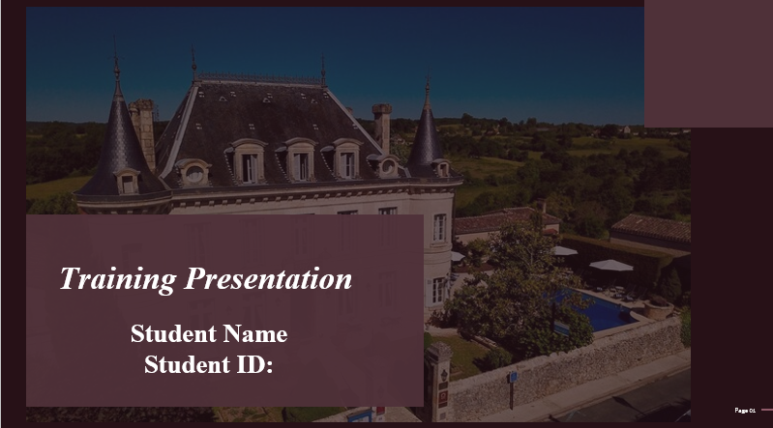
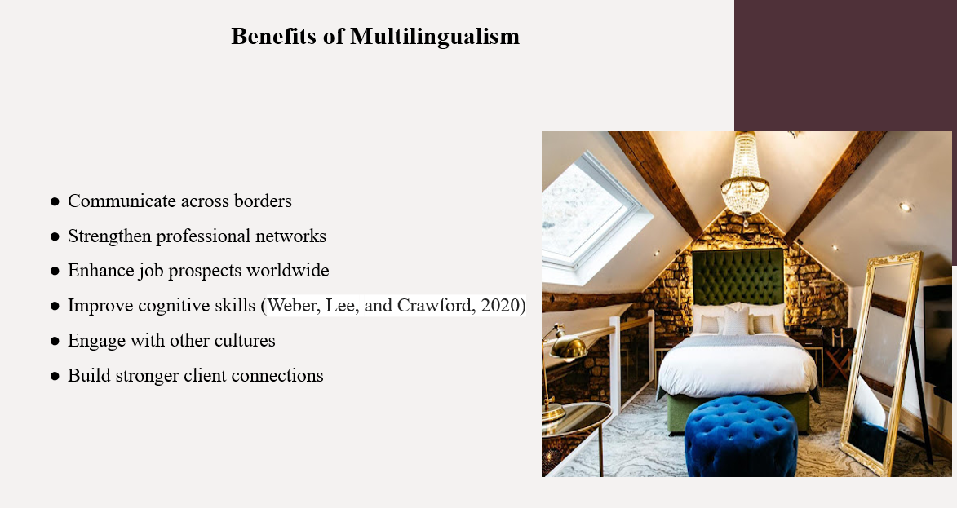
Speaking more than one language has many advantages, both personally and professionally. Being bilingual improves cognitive function and broadens one's perspective on the world. It makes it possible to interact with more works of art, media, and information from other cultures. Being bilingual at work increases an employee's value as a part of global teams. Relationships are strengthened and communication is improved by speaking in the client's native language. In an age of extensive travel, tourism, and digital connection between all points of the globe, it also offers doors to global professional prospects. In general, multilingualism has several benefits for both people and companies.

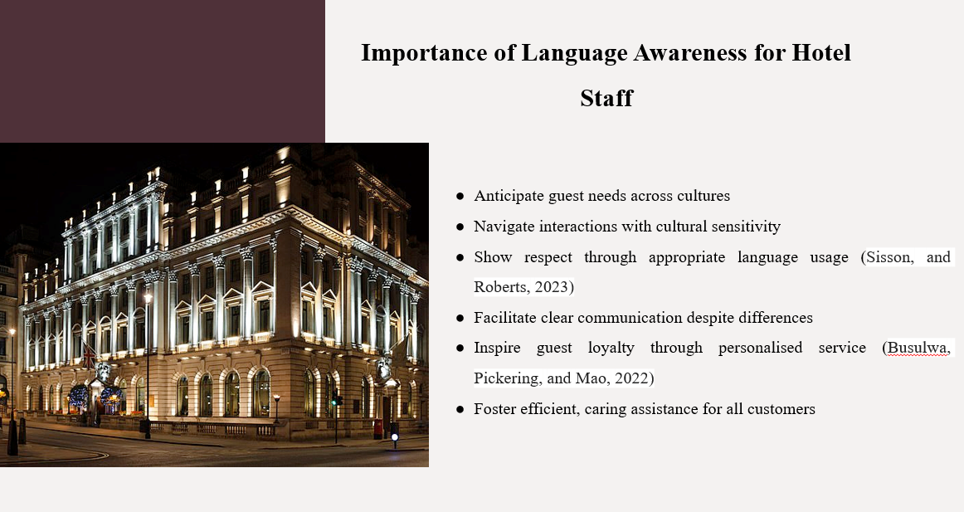
When the hotel staff is linguistically competent, they can serve foreign visitors much better. Recognising cultural expectations around inquiries, grievances, and casual conversation enables employees to handle situations with ease and avoid miscommunication. Understanding other people's niceties, greets, and gestures demonstrates respect for their cultural customs. For the French customers, language plays an effective role. The awareness of the hotel employees about the language can eventually enhance the quality of the services of the organisation as well as developing the level of customer satisfaction of the organisation.
He fr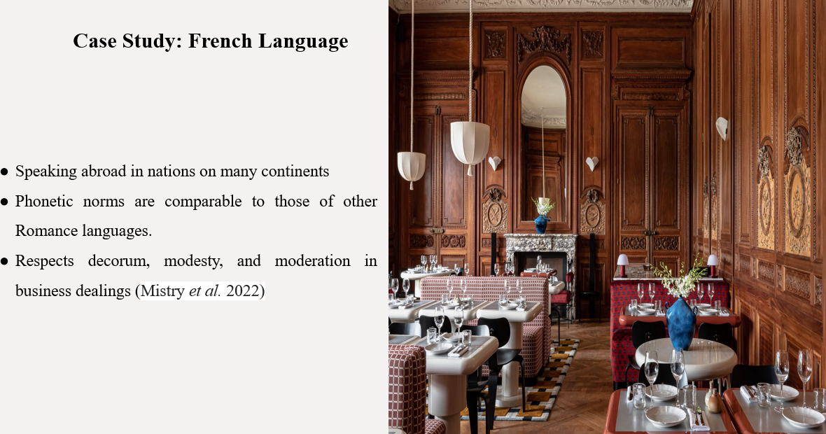
It can be said that French is one of the most effective languages that can be as a factor of multilingual approaches. Although, it has been seen that French is one of the toughest languages all over the Europe, it can have a positive impact on the cultural dimension of the hospitality company. The cultural dimensions of the people effectively vary based on the location and society. By using the French language and ethnicity as an example, it has been noted that effective phonetic and non-verbal awareness can eventually enhance the quality of the services of a hospitality organisation.
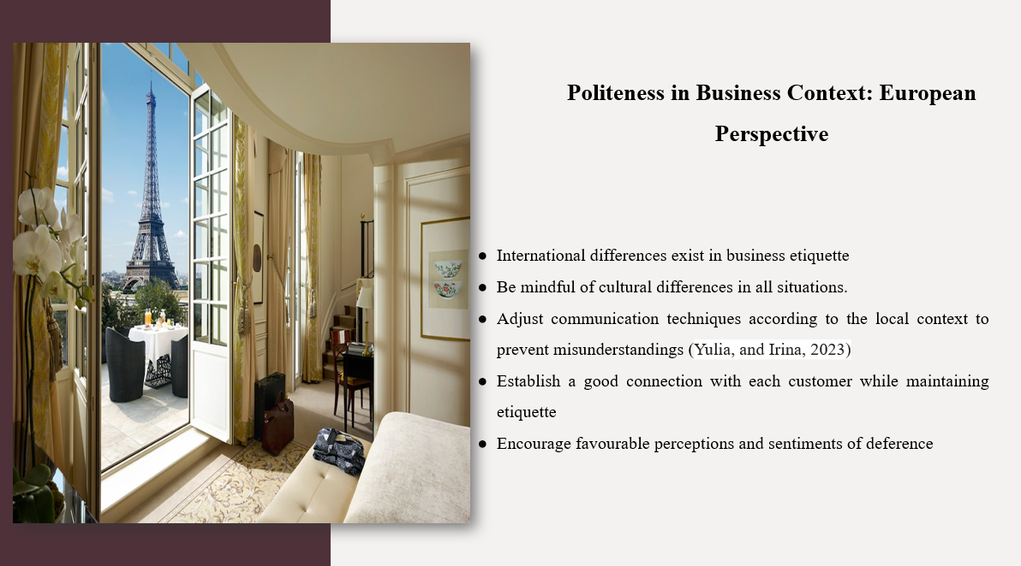
The awareness of the various approaches of a language is effectively important within the hospitality industry. It has been seen that in the case of Europe, the use of effective language awareness can enhance the reliability of the company towards its employees. Finnish people, in contrast to their Mediterranean counterparts, place more weight on meaningful conversations than social graces. When hotel staff members possess this kind of expertise, they can effortlessly handle a wide range of customer contacts and prevent mistakes caused by regional miscommunications. For example, rapport might be established while maintaining decorum by treating Norwegian businesses with respect and avoiding rigid formality or over-familiarity with Finns. Across language barriers, subtle social graces are crucial for creating a good first impression and making visitors feel understood and appreciated.
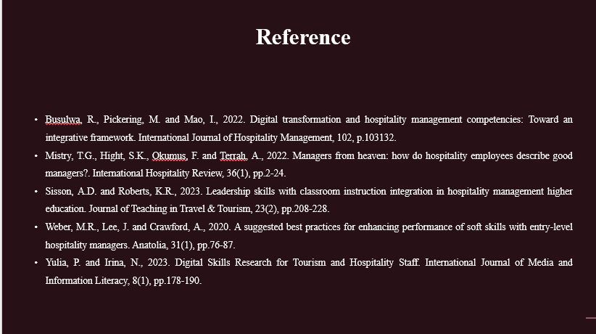
References:
Busulwa, R., Pickering, M. and Mao, I., 2022. Digital transformation and hospitality management competencies: Toward an integrative framework. International Journal of Hospitality Management, 102, p.103132.
Mistry, T.G., Hight, S.K., Okumus, F. and Terrah, A., 2022. Managers from heaven: how do hospitality employees describe good managers?. International Hospitality Review, 36(1), pp.2-24.
Sisson, A.D. and Roberts, K.R., 2023. Leadership skills with classroom instruction integration in hospitality management higher education. Journal of Teaching in Travel & Tourism, 23(2), pp.208-228.
Weber, M.R., Lee, J. and Crawford, A., 2020. A suggested best practices for enhancing performance of soft skills with entry-level hospitality managers. Anatolia, 31(1), pp.76-87.
Yulia, P. and Irina, N., 2023. Digital Skills Research for Tourism and Hospitality Staff. International Journal of Media and Information Literacy, 8(1), pp.178-190.

