  Academic Poster  Module Code: BMHP6029  Psychological Classifications and Provisions | Rim Abdulhamid  Student No. 2321169  Lecturer: Neale Haddon

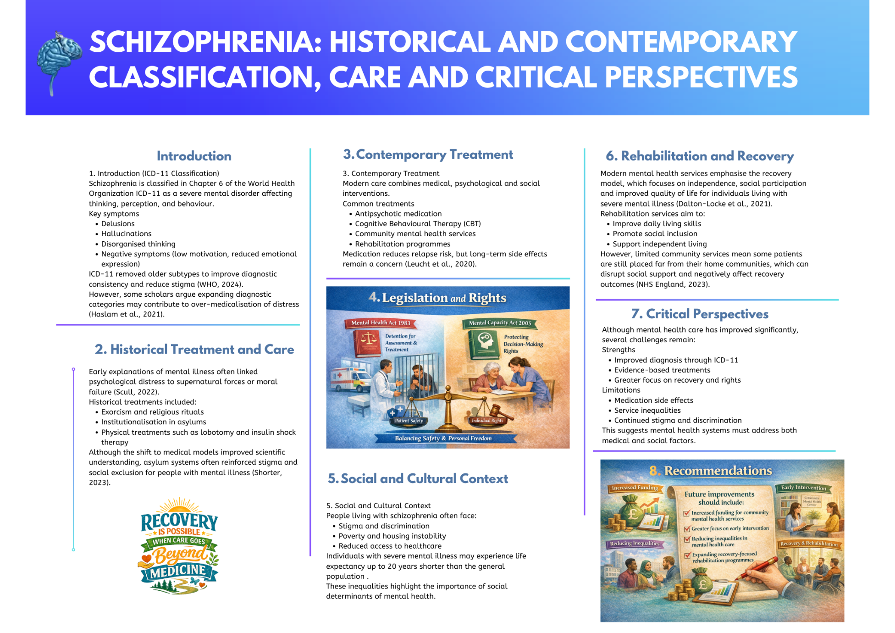

Figure 1: Schizophrenia: Historical and contemporary classification, care and critical perspectives poster (Author’s own work created using Canva, 2026).

Refrences:
Dalton-Locke, C. and Houngbedji, N. (2025) Mental health rehabilitation models for people with complex psychosis: a systematic review. BMC Psychiatry. Available at: https://pmc.ncbi.nlm.nih.gov/articles/PMC12379344/ (Accessed: 3 March 2026).
Haslam, N. (2016) ‘Concept creep: Psychology’s expanding concepts of harm and pathology’, Psychological Inquiry, 27(1), pp. 1–17. Available at: https://gwern.net/doc/sociology/2016-haslam.pdf (Accessed: 2 March 2026).
Haslam, N., Tse, J.S.Y. and De Deyne, S. (2021) ‘Concept creep and psychiatrization’, Frontiers in Sociology, 6, Article 806147. Available at: https://pmc.ncbi.nlm.nih.gov/articles/PMC8716590/ (Accessed: 28 February 2026).
Killaspy, H. et al. (2020) ‘Predictors of moving on from mental health supported accommodation in England: national cohort study’, The British Journal of Psychiatry, 216(6), pp. 331–337. https://doi.org/10.1192/bjp.2019.101 (Accessed: 3 March 2026).
Leucht, S. et al. (2021) ‘Examination of dosing of antipsychotic drugs for relapse prevention in patients with stable schizophrenia: A meta-analysis’, JAMA Psychiatry, 78(11), pp. 1238–1248. https://doi.org/10.1001/jamapsychiatry.2021.2130 (Accessed: 27 February 2026).
NHS England (2023) Community mental health transformation programme – NHS partnership working with the third sector. Available at: https://www.england.nhs.uk/long-read/nhs-england-community-mental-health-transformation-programme-nhs-partnership-working-with-the-third-sector/ (Accessed: 29 February 2026).
Ormel, J., Hollon, S.D., Kessler, R.C., Cuijpers, P. and Monroe, S.M. (2022) ‘More treatment but no less depression: The treatment-prevalence paradox’, Clinical Psychology Review, 91, 102111. https://doi.org/10.1016/j.cpr.2021.102111 (Accessed: 4 March 2026).
Scull, A. (2022) Madness in Civilization: A Cultural History of Insanity. London: Thames & Hudson. Available at: https://www.thamesandhudson.com/products/madness-in-civilization (Accessed: 4 March 2026).
Shorter, E. (2023) A History of Psychiatry: From the Era of the Asylum to the Age of Modern Medicine. 2nd edn. Hoboken: Wiley-Blackwell. Available at: https://books.google.com/books/about/A_History_of_Psychiatry.html?id=-Oybg_APowMC
World Health Organization (2024) International Classification of Diseases 11th Revision (ICD-11): Schizophrenia (6A20). Available at: https://icd.who.int/browse/2024-01/mms/en#334423054 (Accessed: 1 March 2026).

