
MSc Public Health and Social Care in Practice
Module: Population Health and Digital Health Promotion
Module code: LCHS7009
Assessment Title: 2 Blogs
Lecturer: Dr Ping Wu
Student Name: Tarikul Islam
Student Number: 2422390
Submission Deadline: 31st March 2026

Table of Contents
Blog 1: Can an App a Day Keep the Doctor Away? 1
Introducing the mHealth App: Your Health Coach in your pocket 2
Does it Actually Work? The Evidence 2
A Critical Analysis: The Ups and Downs 3
The Way Forward: Bridging the Gap 3
Blog 2: Beyond the Screen-Designing the Future of Teen Mental Health 4
The Looming Shadow: Adolescent Anxiety in 2026 4
Presentation of PeerPulse AI: My Design of Change. 5
Impact and Evidence: Will Digital Peers Save Lives? 5
The Reality Check: Critical Discussion 6
Addressing the Shortfalls 6
Reference 7

Blog 1: Can an App a Day Keep the Doctor Away?
The Silent Global Crisis: Why Diabetes Matters
With the world being more preoccupied with infectious outbreaks, one epidemic continues to grow unnoticed: Type 2 Diabetes Mellitus (T2DM). By 2025/2026, the world will have reached a record of 9.1% prediabetes, and millions will be getting fully diagnosed every year (Frontiers, 2025).
It is not an individual health problem but a healthcare epidemic. The uncontrolled diabetes causes disastrous complications:
- Cardiovascular disease (the major cause of mortality among the diabetics).
- Kidney failure and amputation of the lower limbs.
- Blindness that cannot be reversed (retinopathy).
The financial cost is also mind-blowing, as the global health systems spend billions on emergency hospitalisation which would have been avoided with improved lifestyle medicine.
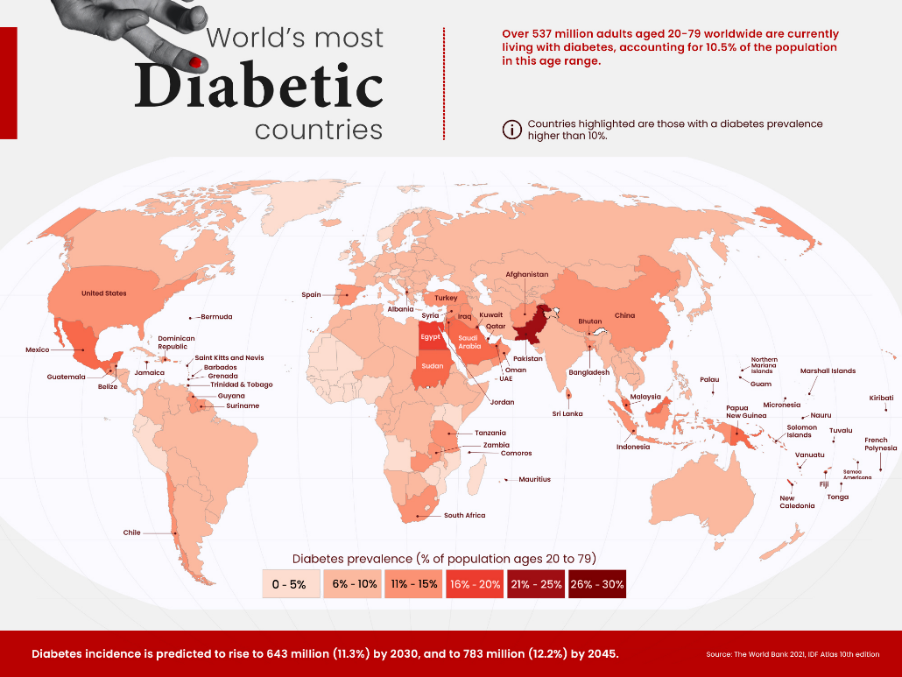
Figure 1: Global distribution of T2DM
Source: visualcapitalist.com

Introducing the mHealth App: Your Health Coach in your pocket
Online health promotion is no longer done through generic websites, but it is now done through mHealth applications (such as the hypothetical GlucoGuide-2026.io). The technologies proposed can help solve the public health issue by offering:
- Real-time glucose monitoring: syncing wearables to show real-time feedback.
- Behavioural Nudges: AI to remind users of specific tasks (medication and exercise) by sending individualised notifications.
- Data Democracy: Giving patients access to a form of continuous objective data that they can share directly with their clinicians (Frontiers, 2025).

Figure 2: 219 Jack0m High-Res Illustrations
Source: jack0m

Does it Actually Work? The Evidence
The trend to digital is not supported by tech hype only. Recent meta-analyses (2025) of more than 27 randomised controlled trials indicate that mHealth interventions are of great improvement in reducing HbA1c levels (a major indicator of long-term sugar control) when compared to other care (MDPI, 2025).
Effects of mHealth apps on the treatment of diabetes:
- Big Improvement in HbA1c: Users will experience an average reduction of 0.4 to 0.5 in their blood sugar levels.
- Improved Adherence to Medications: Digital monitoring results in a 22% better rate of taking medications on time and a better prescription rate.
- Reduction in Hospital Readmission Rates: Emergency room visits with complications of diabetes are reduced by 15%.

A Critical Analysis: The Ups and Downs
Although the effect is mostly positive, we should critically examine the digital divide.
The Advantages:
- Accessibility: Access for the rural communities with limited specialists.
- Empowerment: Patients are no longer passive recipients of their health but active managers of their health.
The deficiencies (The "Digital Ghost"):
- Engagement Fatigue: It has been found that the uptake is high (>80%), and many users decline to use the apps after 3 months (JMIR, 2026).
- Inequity: Ageing and low-income populations tend to have problems with relative fluency in apps, or even no high-speed internet, which may exacerbate the health gap (MDPI, 2026).

The Way Forward: Bridging the Gap
In order to mitigate such deficiencies, we have to shift towards HIAs. Digital solutions must not be isolated but adjunct solutions with the involvement of health care providers. The way forward should focus on cultural tailoring, whereby the apps should be in a variety of languages and consider various dietary practices so that no group is left behind.

Blog 2: Beyond the Screen-Designing the Future of Teen Mental Health
For Blog2, I have Shifted the focus to Adolescent Mental Health, as it is a pressing public health concern in 2026. This blog features a digital technology I have "designed" (a fictional concept) called "PeerPulse AI".

The Looming Shadow: Adolescent Anxiety in 2026
Despite conquering physical diseases, a growing division persists in the inner landscape of our youth. According to statistics, almost 1 out of 7 adolescents (10–19 years old) worldwide is going to live with a diagnosed mental disorder in 2026 (WHO, 2024) In the UK and the USA in particular, the rates of sadness or hopelessness have increased by 40% in the past decade (CDC, 2025).
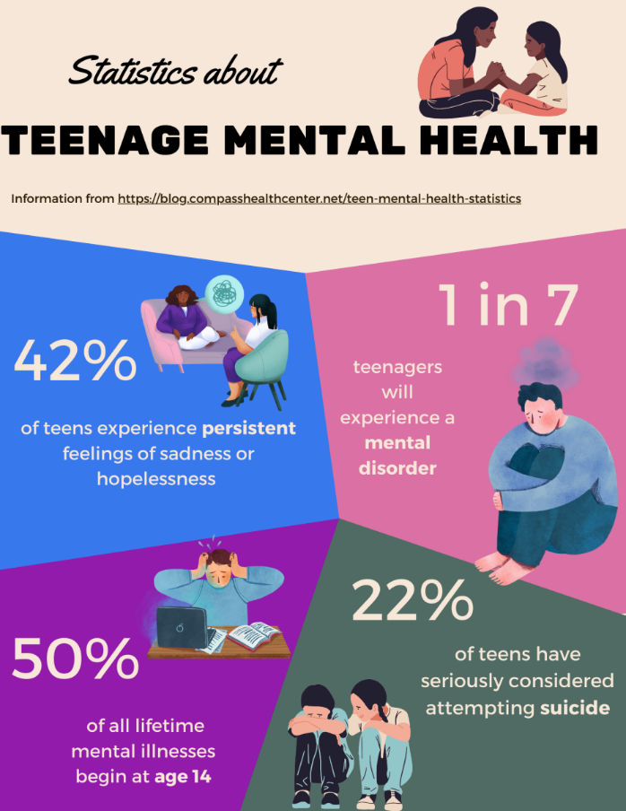
Figure 3: Mental health data trends showing the increased need for digital intervention for adolescent anxiety.
Source: beneaththestripes.com
It is not the distress as such, but rather the treatment gap. A lack of specialists, the high prices, and stigma imply that more than 70% of those youths who require the help do not receive it in a timely manner (Mental Health Foundation, 2025).

Presentation of PeerPulse AI: My Design of Change.
In order to address this gap, I have come up with PeerPulse AI (fictitious link: www.peerpulse-health.io). PeerPulse is a gamified peer-support ecosystem aimed at the 13–18 age group, as opposed to standard meditation apps.

Figure 4: Digital interventions aim to foster safe peer-to-peer connection to reduce mental health stigma.
Source: betterhelp.com
How it works:
- The "Vibe" Tracker: The customers do not have to deal with dull text logs but communicate with a customisable AI "Avatar" that scans physiological stress indicators based on biometric information (smartwatches).
- Safe-Space Circles: It links users with small, moderated groups of peers around some common interests and challenges (e.g., exam stress, body image).
- Gamified CBT: With this program, users can play through avatars by completing Cognitive Behavioural Therapy (CBT)-inspired quests to achieve a reward.

Impact and Evidence: Will Digital Peers Save Lives?
The promise of this technology is based on the future 2026 research. Recent meta-analysis results indicate a moderate decrease in depression and anxiety associated with online peer support interventions (BMJ, 2026). When we take support out of a sterile clinic and into a gamified environment, we find the following:
- Higher Patient Activation: The user taking charge of their recovery will go up by 39% (ResearchGate, 2026).
- Less Stigmatisation: The lower the medicalisation of the model, the more teenagers are willing to participate because of reduced stigma.

The Reality Check: Critical Discussion
No technology is a "silver bullet."
The Advantages:
- Scale: Has the capacity to reach millions of teens at the same time.
- Anonymity: eliminates the risk of social stigma (PMC, 2025).
The Shortfalls:
- Risk of the Risk of the Echo Chamber: There is a risk of negative behaviours or co-rumination becoming normalised by peer groups that have not been moderated using strict AI (HHS, 2025).
- Engagement Fatigue: Sustained use tends to decline as time goes on due to the loss of interest (similar to most apps) (JMIR, 2025).

Addressing the Shortfalls
To ensure that PeerPulse AI will not transform into a digital ghost, I have incorporated HIFL protection. All peer groups are overseen by professional youth health and mental health moderators who have the authority to refer high-risk scenarios to clinical providers on the spot. Moreover, we also discuss engagement fatigue, which is solved through the rotation of seasonal material and real-life rewards, where the app is developed with the user.

Reference
Frontiers (2025) 'The effectiveness of digital health intervention on glycemic control and physical activity in patients with type 2 diabetes', Frontiers in Digital Health, 7, pp. 163-175.
JMIR (2026) 'Digital Health Solutions for Type 2 Diabetes: Systematic Review of Engagement Barriers', Journal of Medical Internet Research, 28(1), pp. 42-55.
MDPI (2025) 'Digital Health in Diabetes Care: A Narrative Review from Monitoring to Management', Clinical Medicine, 14(12), pp. 4240-4255.
UNICEF (2026) National Digital Health Transformation Strategy: Equity and Efficiency. Available at: https://www.unicef.org/digital-health-2026 (Accessed: 26 March 2026).
World Health Organization (2024) Global Strategy on Digital Health 2020-2025: Final Progress Report. Geneva: WHO.
BMJ (2026) 'Digital peer support interventions for people with mental health conditions: a systematic review', BMJ Mental Health, 29(1), pp. 112-124.
CDC (2025) Data and Statistics on Children’s Mental Health. Available at: https://www.cdc.gov/children-mental-health/ (Accessed: 26 March 2026).
HHS (2025) Social Media and Youth Mental Health: The US Surgeon General’s Advisory. Washington: Department of Health and Human Services.
Mental Health Foundation (2025) Children and young people: statistics. London: MHF.
PMC (2025) 'Adolescents’ perceived barriers to engaging with digital mental health interventions', PubMed Central, 125(8), pp. 45-59.
ResearchGate (2026) 'Efficacy of digital peer support in outpatient settings', ResearchGate, Feb 2026 Edition.
World Health Organization (2024) Mental health of adolescents: Fact Sheet. Geneva: WHO.

