University of Wales Trinity Saint David
Motorsport Engineering
Torsion of shafts
Marcus Tenniswood
2501145
04/01/26
Mechanics and Dynamics
ACHA4026
Word Count- 1484

Contents
Introduction 2
Experimental Procedure 2
Results and Analysis 4
Raw Results 4
Brass 4
Aluminium 4
Steel 5
Analysis and Graphs 5
Brass 5
Aluminium 6
Steel 6
Evaluation 7
Further Work 7
Conclusion 7
References 7

Introduction
In this report, all aspects of the experimental procedure surrounding a torsion experiment of multiple types of material will be shown. The results gained from the experiment that took place are then analysed and conclusions are drawn based on what was found. This information is then used to figure out further ways to optimise the experiment and identify any issues that occurred. In the torsion experiment, values such as force and twist angle are recorded using the set-up apparatus, these values can then be calculated and applied to find out further values. These final calculations allow for a deep understanding of the attributes and then applications of each material, based on their observed qualities. The aims of the experiment were to find out how material affects torsion and to calculate the modulus of rigidity of each sample to compare the materials.

Experimental Procedure
To conduct this experiment, a rig was setup to allow for the specimen to be placed and examined. This included a Work Panel, with mounting holes throughout, and 2 sides of a chuck. There was a rotating side and a fixed portion of the chuck, this is where the sample was placed. In Figure 1, the apparatus can be seen setup, without a sample or set of weights.
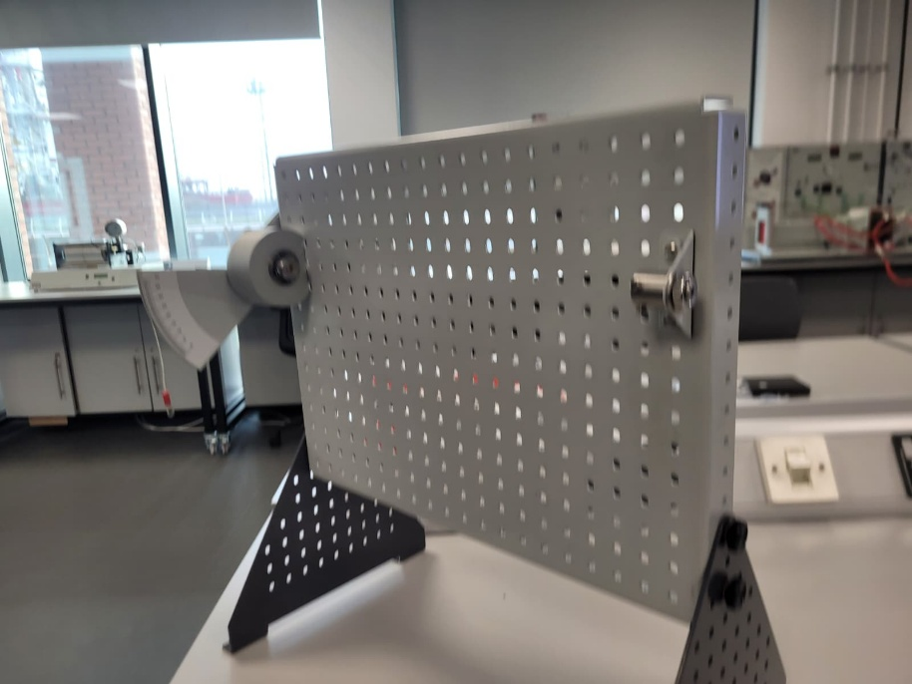
Figure 1

Visible on the right side of the apparatus is the fixed chuck, and on the left is the rotating chuck, part of this is a measure of angle, which is used to record the twist angle. A closer view of this is visible in Figure 2.
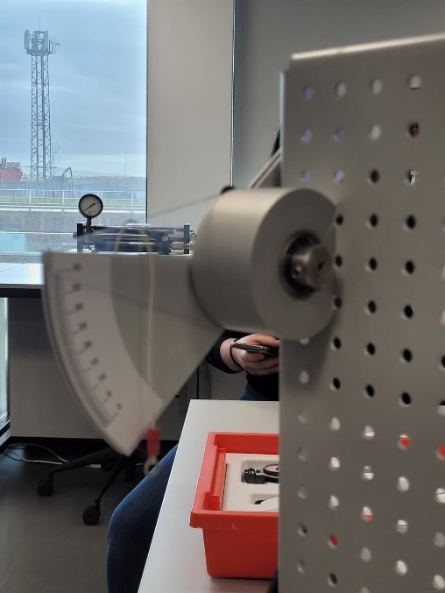
Figure 2
The first sample is then inserted into this apparatus, which requires an Allen key to unlock and then tighten the clamp. Then the main body of the experiment takes place, where a set of weights is slowly increased, in 100g increments, whilst the twist angle is recorded at every interval up until 500g for the brass and steel samples, but only to 400g for the aluminium sample, this is because the rod could be twisted beyond elastic limit. Visible in figure 3 is the full setup with the sample of brass in the chucks and the full weight of 500g on the sample.
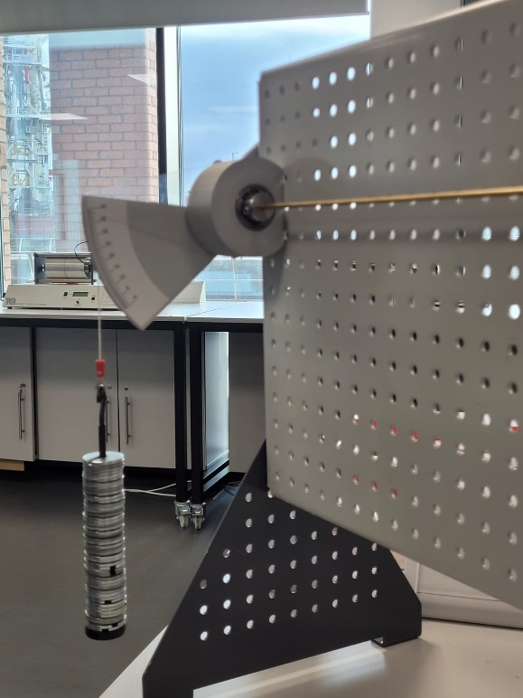
Figure 3
Once all values have been obtained, the sample is switched and the experiment begins again for a different material. To perform this experiment to the best level, it is important the weights are placed slowly onto the rig, a jolt can add excess force which can damage the rod and skew the results, adding inaccuracy. Whilst there aren’t many safety procedures required for this experiment, it is important to note that weights could drop and cause injury so precautions must be taken to avoid this. Also before each sample is inserted into the chuck, it needs to be measured for both length and diameter which are essential to calculate values needed for analysis.

Results and Analysis

Raw Results

Brass
Load (g) | Load (N) | Twist Angle (degrees)
100 | 0.98 | 5.1
200 | 1.96 | 11.5
300 | 2.94 | 17.5
400 | 3.92 | 23.0
500 | 4.91 | 29.5

Aluminium
Load (g) | Load (N) | Twist Angle (degrees)
100 | 0.98 | 7.5
200 | 1.96 | 15.5
300 | 2.94 | 23.0
400 | 3.92 | 31.0

Steel
Load (g) | Load (N) | Twist Angle (degrees)
100 | 0.98 | 3
200 | 1.96 | 4.5
300 | 2.94 | 7.5
400 | 3.92 | 10.0
500 | 4.91 | 13.0

These are the raw results of all recorded data in the actual lab session, other than measured values of Length which was 0.34m for all samples and a diameter of 3.1mm which was the same across all samples.

Analysis and Graphs

Brass

Visible in the graph above is the relationship between Torque multiplied by length (y axis) vs the Polar moment of area multiplied by the Twist angle of the material in radians. This relationship allows for us to find the gradient of a trendline which serves as the G (The sheer Modulus of the material). For brass, the gradient of the line is 4*10^10Pa, which can also be written as 40GPa. According to Matweb, the range for the shear modulus of brass is between 26.9-44.1GPa. The value recorded in the lab session sits inside of this range; therefore, it is an accurate result. The value also visible on the graph is R^2, a value closer to 1 demonstrates a linear relationship, this shows that the data collected within this experiment follows a predicted and expected relationship. This combined with the value of G being within the expected range means that the results can be trusted and they are accurate. Below is completed table of data, both calculated and lab recorded, which was used to create the graph above.

load (N) | twist angle degrees | Torque | TL | Jϑ | Twist angle Radians
0.98 | 5.1 | 0.098 | 0.033 | 8.10E-13 | 0.089
1.96 | 11.3 | 0.196 | 0.067 | 1.79E-12 | 0.197
2.94 | 17.5 | 0.294 | 0.100 | 2.78E-12 | 0.305
3.92 | 23 | 0.392 | 0.133 | 3.65E-12 | 0.401
4.91 | 29.5 | 0.491 | 0.167 | 4.69E-12 | 0.515

Aluminium

Once again visible in this graph is the relationship between Torque multiplied by length (y axis) vs the Polar moment of area multiplied by the Twist angle of the material in radians, however this graph shows this relationship for the aluminium rod. For this example, there is only 4 data points, between the values of 100g-400g. This was to prevent the risk of the aluminium rod being twisted beyond the elastic limit. However, the data can still be analysed, and the value of G can still be calculated. For this graph G was calculated to be 30GPa. Matweb has a value of shear modulus of 25GPa, this is close to the calculated and measured value, however slight inaccuracy may have occurred and will be evaluated in a later section. The R^2 value is closer to 1 than the previous graph, which suggests an even stronger linear relationship between the observed values.
load (N) | twist angle degrees | Torque | TL | Jϑ | Twist angle Radians
0.98 | 7.5 | 0.098 | 0.033 | 1.19E-12 | 0.131
1.96 | 15.5 | 0.196 | 0.067 | 2.46E-12 | 0.271
2.94 | 23 | 0.294 | 0.100 | 3.65E-12 | 0.401
3.92 | 31 | 0.392 | 0.133 | 4.92E-12 | 0.541

Steel

Observed in the final graph from the experiment, the Steel has a Shear Modulus value of 80GPa, which lines up exactly with MatWebs value of 80GPa. However, on the graph there is offset between the values which levels out with the trendline, but nevertheless the values still suggest inaccuracy within the experiment. This could be caused by several reasons, but the graph levelled out and the result was not affected negatively by this. The R squared value was also very close to 1, which suggests the “off” results counteracted each other and overall, the values are linear and the graph suggests the correct things.
load (N) | twist angle degrees | Torque | TL | Jϑ | Twist angle Radians
0.98 | 3 | 0.098 | 0.033 | 4.76E-13 | 0.052
1.96 | 4.5 | 0.196 | 0.067 | 7.15E-13 | 0.079
2.94 | 7.5 | 0.294 | 0.100 | 1.19E-12 | 0.131
3.92 | 10 | 0.392 | 0.133 | 1.59E-12 | 0.175
4.91 | 13 | 0.491 | 0.167 | 2.06E-12 | 0.227

Evaluation
To eliminate errors throughout this experiment and also in the analysis of the data several methods were used. Such as putting the weights on in 25g increments for the 100g amounts, this prevents spikes in force by reducing the total amount of instantaneous torque on the system. However, this has the drawback of increased human interaction with the system, where mistakes can take place and potentially human error could affect the experiment. Although in the experiment that this data was recorded in, it is clear this did not negatively impact the results. Another way errors were eliminated was by multiple people reading the scale for the twist angle, as the scale is small it is difficult to ensure it is read perfectly, therefore more opinions allow for less error.

Further Work
To further improve this experiment, given unlimited time and funding, replacing anything that involves human interpretation and interaction with machines, such as the scale system for the torsion angle being replaced with a digital version, this would remove the risk of parallax error and interpretation issues. More simply, doing this experiment in a temperature-controlled environment would also help give more consistent results, although it is unlikely to have caused much of an issue with the experiment detailed in this report. Given more time, the experiment should have been repeated 3 times and averages should have been drawn from the results, this also would have allowed for anomalous results to be discarded. One final way the experiment could’ve been improved, is by applying the force by using a calibrated torque machine, which increases the force digitally and perfectly accurately, eliminating human risk of too much torque by error.

Conclusion
In conclusion, the experiment that took place produced near perfect values for the shear modulus of all the materials tested, either being exactly right, within range or just below the expected values. The data and graphs produced allowed for understanding of any potential errors and ideas and plans for how to correct any issues in future experiments were also explained.

References
Sheer Modulus of Brass- Available at:
https://www.matweb.com/search/datasheet_print.aspx?matguid=d3bd4617903543ada92f4c101c2a20e5 (accessed: 03/01/2026)
Sheer Modulus of Aluminium- Available at:
https://www.matweb.com/search/datasheet.aspx?bassnum=AMEAL00 (accessed: 03/01/2026)
Sheer Modulus of Steel- Available at:
https://www.matweb.com/search/datasheet.aspx?bassnum=MS0001&ckck=1 (accessed: 03/01/2026)

