Reaching for the Stars
  - A Discussion of how the Religious Application of Astronomy Contributed to the Success of the Ancient Egyptian Civilisation

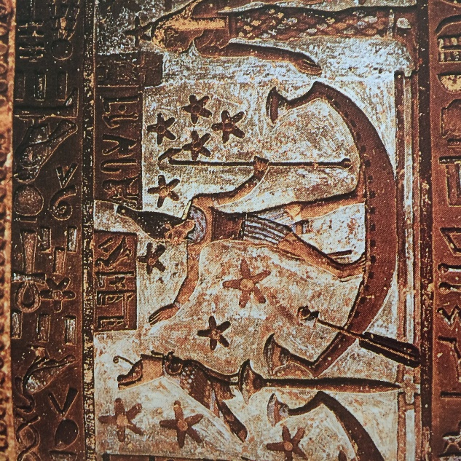
By Ashleigh Harrison
1500414

Dissertation submitted in partial fulfilment of a B.A. (Hons.) in Ancient History with Ancient Egyptian Culture

University of Wales Trinity Saint David
May 2018

Word Count: 10,432

DECLARATION
This work has not previously been accepted in substance for any degree and is not being concurrently submitted for candidature for any degree

Singed………………………………………….. (candidate)
Date…………………………………………….



Undergraduate Dissertation coversheet & feedback form

PLEASE COMPLETE THE TOP SECTION OF THIS FORM AND SUBMIT ONE COPY WITH YOUR DISSERTATION
For completion by student:
Student Name: Ashleigh Harrison

Student University Email: 1500414@student.uwtsd.ac.uk
Module code: AHSK6002 | Student ID number: 1500414 |  |  |  | Educational support needs:  Yes/No
Dissertation title: Reaching for the Stars: A Discussion of how the Religious Application of Astronomy Contributed to the Success of the Ancient Egyptian Civilisation

Supervisor: Dr Katharina Zinn |  |  | Word count: 10,432
I confirm that this is my original work and that I have adhered to the University policy on plagiarism.
Signed ……………………………………………………………
For completion by the first marker:
Comments:

First Marker’s Mark:  Signature: |  |  |  | Date:
For completion by the second marker (if appropriate):

Comments:

Second Marker’s Mark:  Signature: |  | Date:
NB. All marks are provisional until confirmed by the final examination board.

How agreed mark was decided upon—comments for External Examiner:

Proposed Mark:

Signature of External Examiner:

Final Agreed Mark:

Contents Page
Acknowledgements……………………………………………………………………………………………………………………….i
List of Illustrations………………………………………………………………………………………………………………………..ii
Abstract………………………………………………………………………………………………………………………………………iii
Introduction…………………………………………………………………………………………………………………………………1
Religion………………………………………………………………………………………………………………..………………………2
Astronomy and Life………………………………………………………………………………………………………………………5
Astronomy and Death…………………………………………………………………………………………………………………14
Gods and Astronomy………………………………………………………………………………………………………………….22
Pyramids…………………………………………………………………………………………………………………………………….29
Conclusion………………………………………………………………………………………………………………………………….40
Bibliography……………………………………………………………………………………………………………………………….41

Acknowledgements
I would like to thank Dr Katharina Zinn for being my supervisor for this dissertation and for allowing me to have the pleasure to be taught some wonderful modules which have opened my eyes to Egyptian culture during my time here.
I would also like to give thanks to Dr Errietta Bissa for accepting me onto the course and always helping me feel capable of more than I ever imagined.
To my family and friends, I thank you all for supporting me through my degree, always reassuring me that I have what it takes to accomplish anything and for helping me through the toughest of times, and especially for waiting on me hand and foot for all the times I had a migraine.
And finally, without this person, university would have been considerably more difficult, but thanks to her determination, thoughtfulness and caring nature, university felt like home. I thank Kim Eames for everything she has helped me through during my degree. Whether it be academic or personal, she has been more than amazing in helping me through everything that life has thrown at me.

List of Illustrations
Figure 1 (Title image) Osiris in his solar boat, Dendera. Hancock and Faiia 1998: 63
Figure 2 Calendar of Festivals carved on the wall at Kom Ombo, Oakes and Gahlin 2002: 362
Figure 3 Priest observing and recording the stars, Verner 1997: 453
Figure 4 Winged sun disc above the temple of Ramesses III, Krupp 1983: 309
Figure 5 Winged sun disc above the Temple of Khonso, sun lodged between two peaks representing the akhet, Krupp 1983: 309
Figure 6 Second shrine of Tutankhamun, Hancock and Faiia 1998: 88
Figure 7 Astronomical ceiling of Senenmut, Wilkinson 1948, Metropolitan Museum of Art
Figure 8 Ceiling of Seti I, Hancock and Faiia 1998: 89
Figure 9 Ceiling of Seti I, Vannini 2006
Figure 10 Ceiling of Ramesses VI, Goyios 2009
Figure 11 Osiris in the celestial boat, Krupp 1983: 20
Figure 12 Grain sprouts from the dead Osiris symbolising growth and rebirth, Krupp 1983: 20
Figure 13 Diagram of the 'Stretching of the Cord' ceremony, Red Chapel, Karnak, Verner 1997: 72
Figure 14 'Stretching of the Cord' ceremony, Temple of Amun Ra, Karnak, Krupp 1983: 25
Figure 15 Method for astral orientation, Lehner 1997: 212
Figure 16 Diagram of Giza plateau showing major alignments, Lehner 1997: 107
Figure 17 Angles of the 'air shafts' leading to the destinations of the pharaoh, Krupp 1983: 102
Figure 18 Diagram of the 'air shafts' pointing towards Orion and Thuban, Bauval and Gilbert 1994: 100
Figure 19 Pyramids laid out to reflect Orion's Belt, Jackson and Stamp 2002: 180
Figure 20 Satellite view of Giza plateau showing a similar pattern to Orion's Belt, Jackson and Stamp 2002: 162
Figure 21 Man holding a sky with stars, Temple of Hathor, Hancock and Faiia 1998: 90
Figure 22 The pyramids as Orion and the Nile as the Milky Way, Hancock and Faiia 1998: 95

Abstract
In the modern world, religion is often disregarded, replaced by scientific observations to explain the world’s creation as opposed to the gods of all beliefs. It is often viewed negatively as a thing which holds back scientific developments for the good of humanity. Today, science and religion are seen as two completely separate domains, almost opposites. These modern conceptions of religion are often projected onto the Egyptian civilisation, therefore there is a possibility that the effect of religion on Egyptian society may be misinterpreted. The most notable effect being that their religious beliefs closed their minds to more advanced scientific discoveries.
With this dissertation, I hope to revise these views and show that the Egyptian civilisation was successful because of the close connection between religion and astronomy. Through an examination of the most fundamental parts of Egyptian culture, such as agriculture, time, temples and tombs, I aim to show that the religious application of astronomy was evident in every aspect of their lives and deaths.

Introduction

The sun, the moon and the stars. To the modern mind, these celestial objects are often in the background, go unnoticed unless they become a little brighter, or there is less light pollution. To us, they mean little in our everyday lives, but to the ancient Egyptians, they meant everything. The act of stargazing was fundamental to their lives, from religious festivals and agriculture, to constructing temples and planning their journey to the afterlife, everything in their culture sprang from the skies. However, it was not just astronomical observations which the Egyptians relied on, it was the most important aspect of their culture that put them progressively ahead of their time. This was religion. Through an analysis of some of their most important events dominated by religion, I aim to show that astronomical observations were there from the very foundations of the Egyptians’ religious culture and continued to be looked upon for religious guidance in all aspects of their civilisation. I will also apply a structuralist approach to show how religion and astronomy were applied to the everyday life of an Egyptian to make Egypt a successful civilisation and argue how they were inseparable and worked simultaneously to create a functional and stable society. Many scholars however, note how religion held the Egyptians back in the development of astronomical science, but I am not questioning what the Egyptians could have achieved without religion, I am emphasising what they did achieve because of religion. To us, the sky is merely day and night, but to the Egyptians, it represented life and death.

Religion

We identify ancient Egypt as a devoutly religious culture with their beliefs ubiquitous in all aspects of their lives, depicted through art, temples, tombs, ceremonies, festivals and so much more. It is essentially impossible to escape. Therefore, this chapter will cover the general aspects of their beliefs in order to create a sense of the Egyptian mind and how religion would affect their day to day lives, which will help to establish an informed perspective through later chapters.

Despite religious aspects to their culture, there was no word in the Egyptian language for religion. However, judging by the extent of religious symbolism, there was perhaps no need to label their belief as it was intertwined with life. Not only did religion impact their life, but it played a major role in death. It could even be suggested that religion was so powerful that their deaths consumed their lives as the afterlife was the goal of an Egyptian. We see this in numerous practices in architecture which connect mortals, mainly the pharaoh, to the divine world upon their deaths. This is reflected in the upheld belief that the pharaoh was identified in life with Horus, and in death he was associated with Osiris. The Egyptians’ religious beliefs influenced the way in which they therefore viewed the skies. The most notable of this was the two horizons. The East was considered to be the direction of birth and resurrection as this is where the sun rises, whereas the West was associated with death as the sun appeared to be swallowed up in this direction. The importance of the two horizons is seen in the myths which involve the gods, most notably Nut, the sky goddess, as it is believed she swallowed the sun and the stars (signalling their deaths) and then gave birth to them again. This was a cycle of birth, death, and rebirth; a cycle which an Egyptian believed would happen to themselves, so it would appear that the myths of the gods were developed and used to explain life and its mysterious course, and religious cults perhaps developed from these myths, which the priesthood took advantage of to increase their own divine authority, and this led to a reinforcement of divine and celestial beliefs which an Egyptian both piously and literally looked up to.

So was Egyptian religion a religion which evolved through the observance of nature? It certainly incorporates several natural aspects such as life cycles and the patterns of the sky. This may suggest that science, in particular astronomy, had its origin in religious beliefs which were imposed on the natural world around them that was so vital for the Egyptian civilisation to progress. Morenz argues that science and astronomy were so closely linked to religion and its cosmological beliefs that it in fact suffered in its development which consequently hindered the Egyptian civilisation. However, I disagree with this statement as I believe if it was not for the deeply religious relationship which the Egyptians had with the sky, then Egypt would not have been this enigmatic, powerful civilisation with precisely engineered monuments that still enthral us today. This is supported by the structuralist approach in which Macionis defines as ‘a framework for building theory that sees society as a complex system whose parts work together to promote solidarity and stability’. I believe this applies to the Egyptian civilisation, as religion structured the Egyptians’ lives so much so that astronomy became a vital aspect of their religion, thus their society was structured around these two principal aspects.

To support this assertion, I will look at various situations in which astronomy and the sky was consulted to allow the Egyptians to make decisions in both their lives and their deaths. The following chapters will discuss astronomy and life, bringing together religion, agriculture and calendars and how this revolved around the celestial objects; a discussion of astronomy and death and how it influenced a person’s life and what they thought regarding the afterlife; and the gods and astronomy, and the king as a mediator between the two worlds; the pyramids, their theories of astral and solar orientation, change in beliefs, and a place of ascension to heaven.

Astronomy and Life

In this chapter, I would like to focus on how astronomy and religion were incorporated into the everyday lives of the Egyptians. The most important aspect of their lives were the calendars which they adapted to the cycles of the moon, the sun and the stars. Parker, an established author on Egyptian astronomy and its calendars, notes the earliest of these calendars was based on lunar cycles and adjusted to star patterns. The use of this calendar was to synchronise the sky with the flooding of the Nile which was important to know for the agricultural cycle which was vital to their survival. They divided their year into three seasons which had four months each. Each month contained roughly thirty days and were named after a significant religious festival; ‘flood season (akhet); planting and growth season (peret); and harvest and low water season (shomu).’ This at first seems like an appropriate method of organising the calendar, but this in fact presented a problem, this only covered 360 days out of the 365 day cycle of the earth’s orbit around the sun, so eventually, the lunar calendar fell out of sync with the seasons. Herodotus states that the Egyptians, through astronomical observations, discovered the solar year and thereby divided the year into twelve parts. He adds that each month contained thirty days and at the end of the 360 days, five extra days were added. These were known as the epagomenal days, and this would keep the days in time with the seasons. Herodotus, in his opinion, states that the Egyptian method of calculating the seasons is far more advanced than the Greek method as that way required an inclusion of a whole month every two years. This method of mapping the seasons and celestial changes became so successful that Julius Caesar employed an Egyptian astronomer, Sosigenes of Alexandria, in order to modify the solar calendar. This was only slightly adapted so that the calendar was more exact to the precise length of the year. This is the calendar that we still use today.

Despite the invention of the solar calendar, in which the phases of the moon were ignored, the Egyptians did not completely abandon the lunar calendar. The lunar calendar kept the correct timings for the performance of religious ceremonies, but the straightforwardness of the civil calendar was preferable for the running of daily events. The lunar calendar though, fell behind the solar calendar by eleven days meaning important events would occur later each year. This was solved by simply adding an extra month as and when was needed. The adding of an extra month was typically signalled by the arrival of Sirius and this was referred to as wep ren pet, meaning ‘opener of the year’ as it shows the first predawn appearance of the heliacal rising of Sirius. Therefore, the combination of the lunar and civil calendar meant that the moon stayed in relation to the seasons, the sun, Sirius and the Nile which allowed the Egyptians to remain in touch with the ‘world’s sacred order’.
With the creation of the solar calendar, the Egyptians were able to create a twenty four hour day. The observers, usually priests, would watch for the arrival of certain stars to mark the passage of time. These stars were known as the decans which were thirty six stars that helped to divide the months into ten day periods. The first morning of the year in which a decan star appeared at dawn announced the start of a new ten day period. This method of timekeeping was also used at night. As sundials could not be used during the night, the Egyptians had to adapt their ‘clocks’. They did this by recording when each decan star rose above the horizon as this signalled the next hour. We would think that with thirty six decans that day and night would be split into eighteen hours each, but because of the changing duration of night depending on the seasons, adaptions had to be made. This is where the annual flooding of the Nile, the summer solstice and the appearance of Sirius came into use. As this was the most critical time of the year, observers noted that the length of the night was twelve decans long, so the length of the day and night was fixed equally into twelve parts.
This way of dividing time via the stars has very practical uses and at first does not appear to connote any religious beliefs about the sky or other celestial objects. It is only when the Egyptians began to personify, or rather deify the stars, that myths and religious beliefs began to influence ideas about the passage of time and the order of the universe. The inundation for example, is a clear event which used astronomy in both a practical sense and a religious sense. The inundation of course, had to be calculated in accordance with the stars for agricultural purposes, as farmers needed to know when to plant their crops, but this regular pattern of the movement of the stars developed into myths as an explanation of world order. The myth in the case of the inundation tells of Isis and Osiris. Isis, the personification of Sirius, was a crucial aspect of the inundation as it appeared as though she arrived to signal the flood. She was associated with the rebirth of life, so it is no wonder the Egyptians revered her as the ‘Mistress of the Year’. Texts in the Temple of Dendera support this theory of Isis being the bringer of the inundation as they record that she ‘coaxes out the Nile and causes it to swell’. Osiris, depicted in the skies as Orion, was also an important god/constellation as he kept in time with the decans, and since he was the most recognisable constellation in the night sky, the Egyptians could quickly locate him and use him to know what part of the year they were in.
So with the separation of day and night divided appropriately depending on the time of year, the Egyptians would be able to map the circle of the stars around the North Pole, and this could essentially be used as a dial on a celestial clock to tell the time. Whether this type of star clock is the same star clock as the ones depicted on monuments and in tombs is questionable, but Lockyer believes that this idea of a star clock with the stars as dials is in fact what the Egyptians have been accredited with. Several diagonal star clocks are depicted on the inside of coffin lids dating from the 9th-12th dynasties. They show grid diagrams of the decans by name and were recorded in the sequence which they appeared in the night sky. The stars would shift one square and one column representing its earlier appearance in the sky every ten days. In addition, burial chambers are often decorated with the earliest known examples of constellations, calendars, the thirty six decans and star clocks. One may wonder what the point of these star clocks and diagrams was in burial chambers and on coffin lids. After all, time keeping was only for the living, was it not? This will be discussed in the next chapter, but for now, it would be appropriate to conclude that the observation of the skies first came into use for the Egyptian civilisation in order to help them survive. In the everchanging seasons, a predynastic race of beings relied on accurate timings of the seasons for agricultural success. As Lockyer points out, ‘success came from those who knew when it was best to plough and sow and reap and mow, and the only means of knowledge was at first the observation of the heavenly bodies.’ He puts into perspective that the dawn of astronomy did not in fact contain any religious motifs, that was an aspect which followed later.
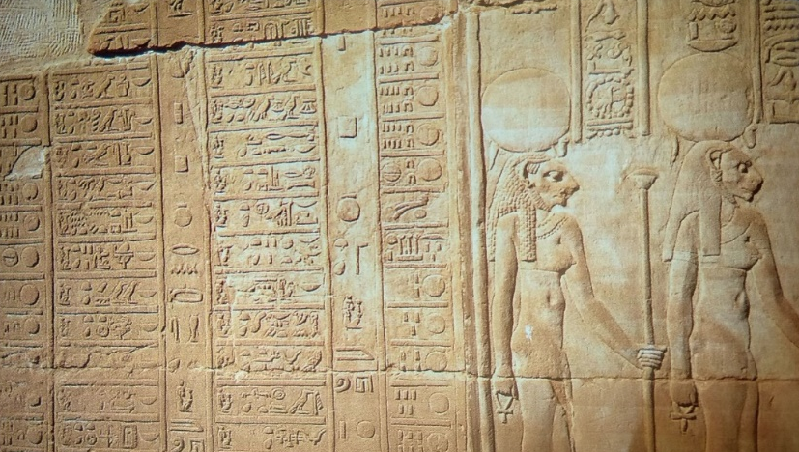
The calendar and star clocks became used for another purpose as well as agriculture. This purpose was for religious festivals and ceremonies. Morenz explains that it was for this reason that astronomy evolved. It was crucial that various rituals and rites were carried out on the correct days, so a list of calendrical festivals were placed outside temples and other religious buildings so that Egyptians knew what ritual to undertake and when. (See Fig. 2) Star clocks were of great importance as they ensured that religious activities which had to be performed at night were done at the correct times. The festivals provided the Egyptians with clear indications to the month of the year they were in, which made the seasons of flooding, planting and harvesting more identifiable and memorable. The rituals are a religious display of myth and celestial nature fabricated by the cult to boost their authority in the matters of the divine world. They, the observers of hours who were likely members of the priesthood, kept this cult alive by their persistent observance of the stars which the Egyptian civilisation relied upon. (See Fig. 3)
Figure 2. Calendar of Festivals carved on the wall at Kom Ombo, Oakes and Gahlin 2002: 362
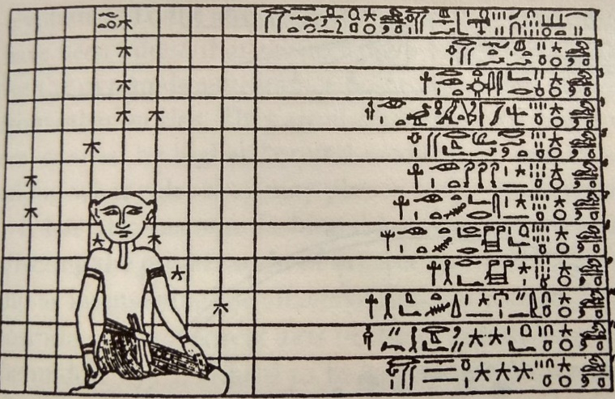
The days of the religious calendar, based on the lunar months, often had names which described the activity of that day and depending on their names, these days were considered lucky or unlucky days. Certain myths lay behind these days and these would influence an individual’s actions for that day. For example, a day that a god had made a successful journey was considered a ‘lucky’ day, however, a day that two gods had fought was considered an ‘unlucky’ day. The Egyptians invested their lives in this calendar as it informed them when they could carry out certain activities. Such activities included the performance of rituals, making offerings, and making peace with dead relatives. I would like to suggest here that the creation of lucky and unlucky days appears to be an early form of astrology which early prophets or diviners may have taken advantage of to appear that they were of one with the gods. Further evidence of this may be hinted at in a passage by Herodotus which explains how calendars were used to predict a child’s character and future depending on the day they were born:
Figure 3. Priest observing and recording the stars, Verner 1997: 453
‘The Egyptians have ascertained the god to whom each month and day is sacred and they can therefore tell, according to the date of the child’s birth, what fate is in store for him, how he will end his days, and what sort of person he will become’.
This seems to represent a kind of horoscope, in which the sky on the day of a person’s birth determined their outcome in life. So did the Egyptians consider astronomy and astrology to be one and the same? If so, then this would explain why the only texts distinguishing astrology as a separate entity found in Egypt date from the Roman period onwards. Furthermore, Herodotus does not make clear when in Egyptian history that calendars were used in this way, but since there are astrological implications, we can only assume that he is referring to the later periods of Egyptian civilisation.
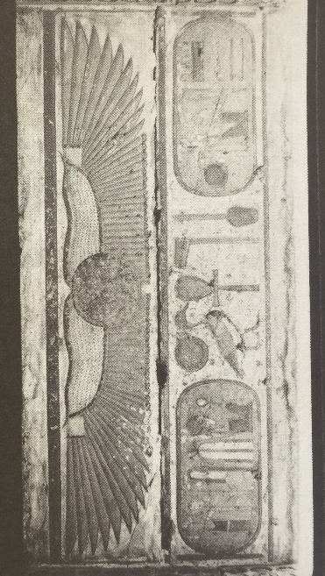
Calendars and the sky were the catalyst in the operation of Egyptian religious beliefs. Krupp notes how it was the sky which governed the festivals that the Egyptians most dutifully followed, and these religious festivals shaped the Egyptian civilisation through the religious cults which were responsible for monitoring the sky. As the religious rituals and festivals based on the calendar were inextricably linked to temples, it was important that the temples too were connected to astronomy. Lockyer suggests that temples would have been constructed in alignment with the sun, particularly to emphasise the importance of the summer solstice as this was linked to the inundation. For example, he explains how the axis of the Temple of Amun Ra at Karnak was oriented towards the sun so that an exact observation of the solstice could be timed. He further argued that a structure south east of the temple was used to observe the winter solstice sun. His main point is that temples were used as astronomical observatories so that the precise days of the solstices could be determined. However, Krupp argues that not all temples could have been observatories as some were not aligned, therefore, it may be a case that only certain temples were designated to the observation of the skies, while others simply catered to the performance of celestial ceremonies. Whatever the case, Lockyer explains that it is ‘fair to say that many thousands of years ago, the Egyptians were perfectly familiar with the solstices and more or less fully with the yearly path of the sun’.
Figure 4. Winged sun disc above the temple of Ramesses III, Krupp 1983: 309
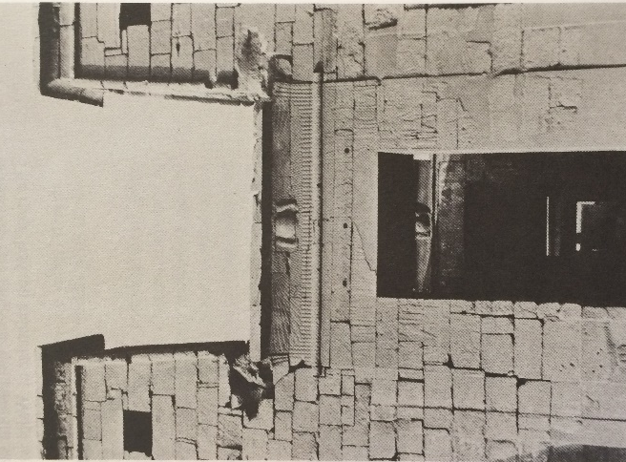
Krupp adds that inscriptions inside the Temple of Dendera hint at it being an observatory. It contains a scene depicting the stretching of the cord ceremony- a ceremony performed to create the layout of a building. As this ceremony was based on a consultation of the stars, it would confirm that Dendera was laid out in accordance with the skies, suggesting it was used as an observatory to watch the rising of Sirius and celebrate the arrival of the New Year. There are also symbolic indications of the way in which some temples were orientated. For example, winged discs were often seen above entrances of New Kingdom and Ptolemaic temples, and since the winged discs symbolised the sun, this may have reflected the solar purpose of the temple; examples of which are seen in the temple of Ramasses III and the temple of Khonsu. (See Figs. 4 and 5) The fact that solar discs are not seen in temples before the New Kingdom may show the changing beliefs between solar and astral orientations that were constantly adapting throughout the evolution of the Egyptian civilisation and were reflected in religious buildings. The orientation of such buildings may have been a way to affirm the connection between the king and the heavens, which showed him as an authoritative figure responsible for connecting the divine and mortal worlds. The temples therefore, may have also been used to link life to death and the heavens, which were located in the skies. Beliefs were conjectured about life after death and how the skies were the destination of an Egyptian. So religious festivals were a way to keep track of the year, and the calendars were kept in time with these festivals. The religion of the skies and the association it had with the heavens would eventually develop into beliefs about the afterlife, and astronomy would play a crucial role in helping an Egyptian to fulfil those beliefs.
Figure 5. Winged sun disc above the Temple of Khonso, sun lodged between two peaks representing the akhet, Krupp 1983: 309

Astronomy and Death

In the previous chapter, we looked at how astronomy and religion played a role in the organisation of Egyptians’ lives. In this chapter, we will explore how astronomy and religion were connected to their deaths or rather their after lives. We will look at various beliefs about what the Egyptians considered the afterlife to be and discuss the gods and stars in connection to death. The role of the king will also be examined to show how life and death were connected and that the two realms functioned together to form the cycle of life.
To help our understanding of the link between astronomy and death, examining some fundamental parts of the afterlife and what that involved would be useful. As we know, the temple with its rituals was at the centre of Egyptian life, and this began to embody the union between heaven and earth which was symbolic of death and rebirth. Birth was considered to mean growth and order, whereas death would signify chaos. So to prevent chaos, death was never a final stage. Instead, rebirth and renewal were played out in the skies, which would not only mean order could be restored, but also that nobody really died as they essentially achieved immortality which was in the realm of the stars. So with death began the journey to the skies to reside with the gods for all eternity. From this sprang an abundance of astronomical depictions in tombs showing the journey of the celestial objects and their destinations, so this made it apparent that the Egyptians believed in a link between death and astronomy. There were several elements to the afterlife: the sky, the abyss, the duat (netherworld) and the akhet (horizon), and texts make it clear that the akhet was where the dead undertook a transformation in order to be able to occupy the afterlife. According to these texts, the duat was supposedly located between Orion and Leo and was often described as a maze of corridors and passageways which were inhabited with monsters. Hancock and Faiia have compared this description to the passages within the pyramids and the Sphinx and have argued that these buildings may have been created as a kind of simulator depicting the realm of the duat so that recruits could ‘immerse themselves, perhaps in total darkness, perhaps for days, in order to gain foreknowledge of the afterlife realm.’ This meant the living could prepare themselves for what they would face when they died. This is not completely implausible as we know there are several textual depictions of the duat to prepare the Egyptians, so as Hancock and Faiia explain, this ‘simulated netherworld’ would be an additional way to prepare for death.
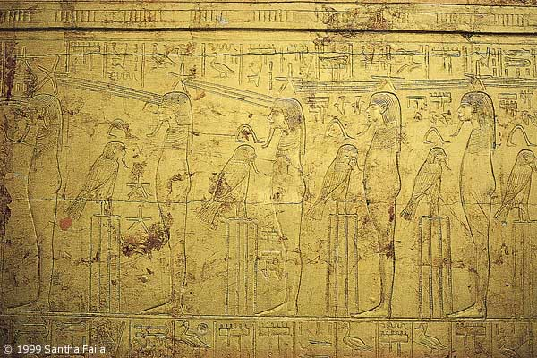
The Egyptians held these beliefs close to them both in life and in death, and this is evident in that the deceased had funerary texts buried with them showing that the heavens were in the sky and that upon death, they would ascend there. A shrine in Tutankhamun’s tomb depicts figures who look up to the stars which are connected to their foreheads by rays. (See Fig. 6) This depiction can easily be interpreted as the figures gazing upon their planned destination which makes it plain to see that the afterlife was in the realm of the stars. This prompts the question, how did the Egyptians ascend to the skies? There are several methods of ascension mentioned in the Pyramid Texts, such as riding on the back of falcons or geese, using incense to waft them up to heaven, climbing a ladder which was the arms of the gods, travelling by boat which sailed them there, or even transforming into a bird and flying there. Utterance 699 of the Pyramid Texts seems to suggest that the deceased would gain the ability of flight upon death, ‘May you soar like a falcon, may you fly aloft like a heron, may you travel to the West [live,] be alive! Be young beside your father, beside Orion in the sky.’ Since the sky was inhabited by birds, it would make sense for the deceased to transform into a bird, or ride one or be able to fly amongst them. Furthermore, since the ba (the entity of a person) was often symbolised as a bird, it was said that the ba was the way the deceased ascended to the skies.
Figure 6. Second shrine of Tutankhamun, Hancock and Faiia 1998: 88

The most depicted scene of ascension is of the deceased journeying to the afterlife in the solar boat beside Ra. It may at first seem strange for the Sun God to travel in a boat in the sky, but as boats were the prime source of transport, providing the Egyptians with access to supplies via the River Nile, this symbolism is appropriate. This led to a number of boat models or boat depictions on ceilings within tombs so that an Egyptian was able to journey to the afterlife. On a grander scale, boat shaped pits and even buried life size boats were discovered near Khufu’s Great Pyramid. Zahi Hawass, a leading Egyptian archaeologist, believes that the boat pits reflect the solar beliefs of the Old Kingdom pharaohs. He argues that the boats are in fact solar boats intended only to function in the afterlife via spells, allowing the pharaoh to make his journey to the afterlife.
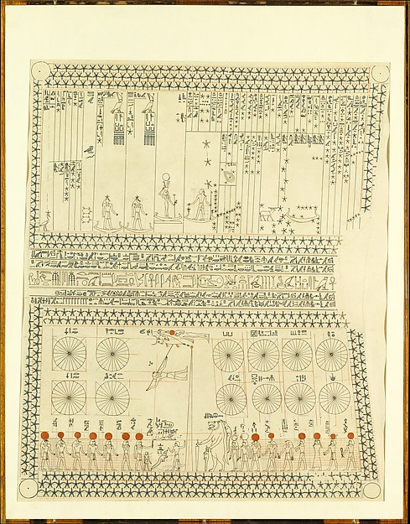
Boats were most commonly depicted on the ceilings of New Kingdom tombs, and it is ceilings which we shall explore in this next section. I would like to cover three examples of these astronomical ceilings which belong to different dynasties and compare them to show the developments in how the Egyptians viewed the afterlife, its inclusion of solar and astral deities, the calendar, and even the king’s role among the stars.
Figure 7. Astronomical ceiling of Senenmut, Wilkinson 1948, Metropolitan Museum of Art
The first of these astronomical ceilings is from the 18th Dynasty tomb of Senenmut. (See Fig. 7) The ceiling is split into two panels with the bottom portion depicting huge circles which are in twenty four equal parts. These represent the circumpolar stars around the North Pole and the twenty four sections support the notion that the day was divided into twenty four hours. We are only able to identify certain stars and constellations with our own, such as Sirius, Orion, Ursa Major and Draco, as it hard to match ancient depictions of constellations with the modern day ones due to changes in the sky across the millennia. The circles are divided into three groups of four which refer to the seasons of akhet (top right row), peret (the four on the left), and shomu (bottom right row). The top portion has been identified with the planets in relation to Sirius, with Mars possibly presented as the empty boat as it moved in retrograde motion to the other planets. This ceiling with its charted seasons and star movements shows how interlinked the sky was to the seasons, religion, and since it was in a tomb, how it still held importance in the afterlife. Also, as I mentioned in the last chapter, timekeeping was also for the dead, as this example of a clock and calendar was for funerary purposes- to keep track of the time of day in the afterlife.
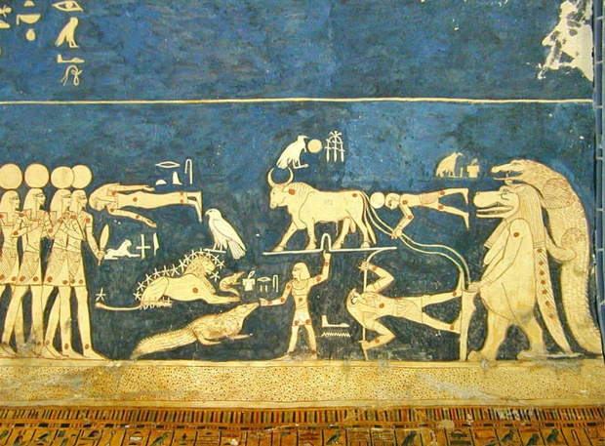
The next ceiling is from the 19th Dynasty belonging to Seti I. This ceiling is a lot less ordered than Senemut’s but it still divided into columns representing the calendar. There are scenes depicting anthropomorphised versions of the constellations (See Fig. 8) and what appears to be the journey of Seti himself to the realm of the gods. The constellations show a hippopotamus with a crocodile on its back leaning on what is said to be the Bull’s Thigh. These are agreed to be the constellations of Draco and the Big Dipper. It is also possible that the lion figure represents Leo, the human facing it is Orion, and the bull above is Taurus, although there is much debate on this matter.
Figure 8. Ceiling of Seti I, Hancock and Faiia 1998: 89
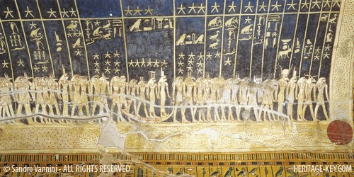
The journey scene shows four central gods sailing in a boat and has Isis following behind Osiris, just as Sirius follows Orion in the night sky, so the myths in fact reflect the stars in this funerary imagery. (See Fig. 9) Therefore, we are able to see both destinations that the pharaoh would travel to- the circumpolar stars (which are the imperishable stars representing eternity as they never set) and the constellation of Orion which are the traditional destinations seen in the pyramids which will be discussed in a later chapter.
Figure 9. Ceiling of Seti I, Vannini 2006
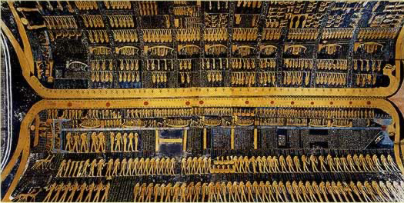
The final ceiling is from the 20th Dynasty belonging to Ramesses VI. (See Fig. 10) His tomb has a stronger emphasis on the Sun God and the astronomical texts within the tomb often involved the journey that he undertook through the skies, day and night, known as the Book of the Day and the Book of the Night. There are several depictions showing the journey of the king to the sun which was symbolic of the rebirth of the king. The solar boats are seen sailing along the body of Nut, the personification of the sky who ‘swallowed the sun and the stars in the west and gave birth to them in the east’. Nut is presented twice in this ceiling along the length of the chamber which symbolised the sky at day and the sky at night, so the journey of the king and the gods would be split into the two halves of the day with twelve hours each. A passage in the Pyramid Texts alludes to the king’s boat journey:
Figure 10. Ceiling of Ramesses VI, Goyios 2009
‘The Nurse Canal is opened, the Winding Waterway is flooded, the Fields of Reeds are filled with water, so that the king is ferried over on it to that eastern side of the sky, to the place where the gods fashion him, where he is born again new and young’.
It is likely that these areas are places within Nut’s anatomy, concluding that the king and Ra sailed through her body to be reborn again.
In comparison, these ceilings spanning three separate dynasties contain many similarities about the beliefs about the sky and its association with the deities. However, there is a clear development from the calendar and the seasons being the dominant aspect in Senenmut’s tomb, to the gods and the journey to the afterlife in the later tombs. The lack of a journey by boat to the sky in Senenmut’s tomb is explained by the fact that he was not a king, he was only an advisor to the pharaoh. Therefore, it seems the emphasis on a celestial journey to achieve immortality was only depicted in royal tombs as this journey only applied to the pharaoh, as he was considered divine, so could join the gods in their realm. The various depictions of astronomy in tombs helps us to conclude that the Egyptians believed that the gods dwelt in the skies and were responsible for the important events in life, such as the seasons and the flood, and that the king- as a god on earth- needed to join the gods in death so that he could continue the administration of the calendars.
The king’s role in the afterlife was just as important as it was on earth. Texts inform us that he regulated the night and kept the hours moving forward. He is also accompanied and guided by Osiris and Isis in the maintenance of the calendar and the seasons. So his role in the afterlife was to maintain order just as he maintained order on earth for the stability of Egypt. Not only does the king make a journey to Orion, he also becomes Osiris. Osiris stood for rebirth and resurrection, and since the constellation of Orion endured death every morning and rebirth every night, it was therefore equated with Osiris. To the Egyptians, the nightly appearance of Orion was proof of life after death. So because the king joined the imperishable stars, he would achieve eternity, and by joining Orion, he became one with Osiris, symbolising death and rebirth. The Pyramid Texts confirm this rebirth of the king, ‘you shall live! You shall rise with Orion in the eastern sky, you shall set with Orion in the western sky.’
From this chapter, it is evident that the Egyptians adorned celestial images in their tombs as they believed that the calendars and stars would be used in the afterlife, so to be buried underneath these ceilings was a way to be able to look upon the sky, stars and gods-all their religious needs and requirements for the afterlife- all in one scene.

Gods and Astronomy

As revealed in the astronomical ceilings, the gods were a crucial part of the ancient skies. This chapter will focus on the incorporation of some of the most important gods who played a role in the running of the skies, the calendars and the construction of buildings. Krupp discusses how ancient cultures believed that in the time of creation, all animals and beings could talk and interact with one another. In ancient Egyptian culture, those beings were the stars, but he explains how the Egyptians still attempted to communicate with them. As the stars were believed to be gods, offerings were made to them in order to reveal information about the seasons so they could know how to administer their agricultural tasks. The gods were the ones who kept world order, so when order fell into chaos, myths concerning the gods were created to calm the people and ensure them that with piety, natural order could be restored. This is seen as structural functionalism in which Bowie explains that religion was used as a way for people to make sense of their world and the chaotic events which come with it.
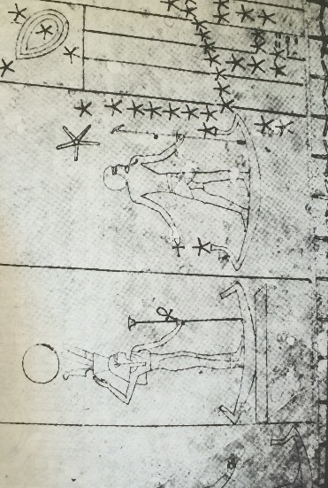
The most important and well known of these myths, was the myth of Isis and Osiris. Their celestial counterparts, Sirius and Orion, were vital in the division of the seasons and the construction of the calendar for agricultural purposes. The cycle of the seasons reflects growth, death and rebirth and this is the theme represented in both the skies and the myth. In the myth, the murdered Osiris was thrown into the river and had floated out of Egypt through the Nile. Isis, on hearing about the death of Osiris, began her search to find her dead husband. In the sky, we see how Orion departs the night sky, followed by Sirius, therefore reflecting Isis’ search for Osiris. Furthermore, the myth is detailed in the ceilings and other celestial diagrams with Isis and Osiris sailing in the celestial boats, with Osiris in the front either looking back at or away from Isis. (See Fig. 11)
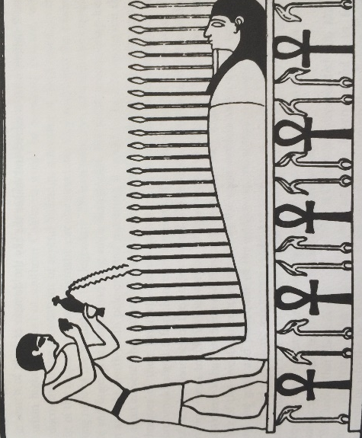
Isis and Osiris also have astronomical significance on their own. Isis was important because as Sirius, she appeared at the time of the inundation, so Sirius gives life to the Nile just as in the myth, Isis revives Osiris. This also represents her as the Mother of the New Year as this coincided with the inundation. The importance of Osiris however, had several funerary connections with him as opposed to the regulation of the annual flood important for survival. His myth, involving his own death and resurrection, was echoed in the skies. The setting of the sun and its rebirth in the morning reflected this myth. In addition, a ceremony recorded at Dendera shows how the Egyptians lit 365 lamps with the temple itself surrounded by 365 trees in honour of Osiris, and this is symbolic of his association with the solar year which was 365 days long. An image showing grain growing from the body of the dead Osiris (See Fig. 12) also shows how he was symbolic of growth and rebirth- the most important aspect which completes the cycle of the cosmic order. Isis and Osiris were, of course, the parents of Horus, and Horus was the divine personification of the king. Therefore, there is a close connection between the king and his duties which involved the stars and the gods.
Figure 1. Osiris in the celestial boat, Krupp 1983: 20
Figure 12. Grain sprouts from the dead Osiris symbolising growth and rebirth, Krupp 1983: 20
The king was viewed by his people as the one who could keep order by assuring an annual flood would take place, monitoring the movements of the celestial objects, and also protecting the land from the chaos of nature and enemies. Furthermore, the king was the mediator between mortality and divinity and this was reinforced through celestial and divine symbols incorporated into the king’s cartouche and his crown which had upon it the divine solar cobra. Moreover, when he made public appearances on his throne, this was paralleled with the sun being born from the horizon.
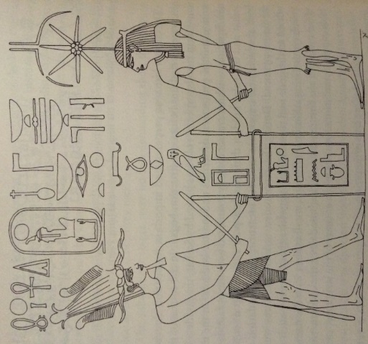
One of the most fundamental astronomical roles which involved the king and a god is the ceremony known as the Stretching of the Cord’. (See Figs. 13 and 14) This was a ceremonial ritual which required the king to mark the foundation points of religious buildings, such as temples, with reference to the stars. The goddess who accompanied him in this ceremony was Seshat. She was an important goddess associated with writing, record keeping, and laying out temples. She was Thoth’s counterpart who was closely associated with the calendar and keeping the world in order. Her appearance associates her with celestial objects and the funerary sphere. For example, her dress is a leopard skin, so as leopards are nocturnal, there is the suggestion of astral symbolism. The leopard skin is also the kind of dress worn by the priests in the ‘Opening of the Mouth’ ceremony. In the ceremony, the adze used to revive the dead king symbolised the Big Dipper. This suggests that the leopard’s spots on the dress represented the night sky. Evidence to support this is found in Tutankhamun’s chamber which contained a leopard statue wearing a spotted linen garment. On closer inspection, it was apparent that each spot was actually a star made of solid gold. In addition, her headdress appears to be a seven pointed star with upturned bull horns above it. The seven pointed star, the horns and the adze all suggest that Seshat was indeed associated with the Big Dipper, as that constellation is known as the Bull’s Thigh which is made up of seven bright stars. This suggests that Seshat was consulted to allow the king to a create an alignment with the Big Dipper in the ‘Stretching of the Cord’ ceremony.
Figure 13. Diagram of the 'Stretching of the Cord' ceremony, Red Chapel, Karnak, Verner 1997: 72
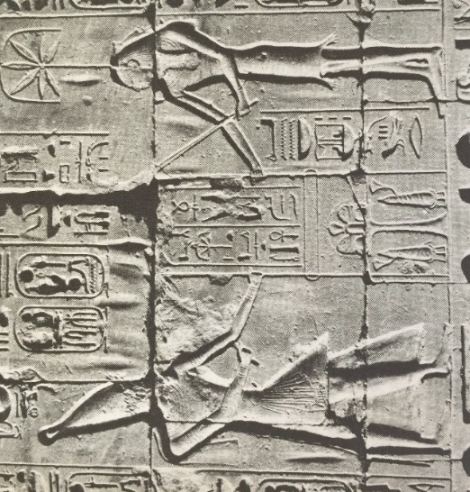
Texts explain the process of the ceremony, revealing how the king would observe the stars and their positions, then with the help of Seshat, he would mark out the foundations of the building. An inscription at Dendera explains ‘With his glance towards the ak of the Bull’s Thigh constellation, he establishes the temple of the Mistress of Dendera.’ The king himself announces ‘Looking to the sky at the course of the rising stars, recognising the ak of the Bull’s Thigh constellation, I establish the corners of the temple of Her Majesty.’ The ak mentioned refers to the Bull’s Thigh’s position. Depictions in the Temple of Horus at Edfu show Seshat accompanying the king in placing mallets in the ground to mark the foundations of the building. The rope in between the mallets is the cord that was stretched to line the walls of the buildings. The inscription alongside it relates how the king grasped the stake and held the measuring cord with Seshat. With this, he examined the stars, searching for the Bull’s Thigh constellation and is then able to establish the corners of the temple.
Figure 14. 'Stretching of the Cord' ceremony, Temple of Amun Ra, Karnak, Krupp 1983: 25
Another relief for the foundation ceremony can be seen at Giza which comprises the same methods as other inscriptions of the ceremony, but also includes that for the king to be in exact alignment with the Bull’s Thigh, he used Seshat’s headdress as a tool to guide him. Further inscriptions reveal that animal sacrifices were offered to the gods, and tablets with the king’s name on and models of the important tools used in the foundation ceremony were laid out in the corners of the building’s foundation.
The Stretching of the Cord had to be accurate, which meant that the king could not have done this as it would have required a much more complicated and drawn out procedure. His observation would have had to be done at a certain time and in a certain position for the building to be aligned with the correct star. Therefore, the ceremony may have just copied the real procedure which was most likely done in advance by his servants. So the Stretching of Cord was most likely just ceremonial, a performance by the king to keep up his public appearance as a king who was able to communicate with the gods, ensuring that he remained a powerful and divine figure to his people. Structuralism is also seen here through the way rituals were regarded as something meaningful and provided people with a sense of purpose. Additionally, seeing their king in public would have strengthened and established their belief in the king as a god, which reinforced social unity and stability; aspects which were fundamental to the functioning of their society.
Lastly, we will discuss the most important goddess who is responsible for the births and deaths of all celestial objects- the sky goddess, Nut. Nut was believed to swallow the stars and the sun, and this represented their deaths. However, she would also give birth to them again after they had sailed through her celestial body.
The myth of Nut and the birth of her children, Isis, Osiris, Nephthys and Seth is also used as a way of explaining the development of the calendar from a 360 day year to a 365 day year. In the myth, Nut had been forbidden to give birth on any day of the 360 day year. Thoth intervened and challenged the moon in a game. Thoth managed to win and demanded extra light which was enough to create five more days in the year. Nut was able to give birth to her children on four of the days, with the fifth day associated with the birth of Horus the Elder. From this, we can see how the myths of the gods were intertwined with the sky and the calendars, showing how astronomy and religion became inseparable.
In Ptolemaic times, the Egyptian goddess Hathor began to represent motherhood, creation and birth. The sunrise was her child, so the celestial significance of this suggests that she had become identified as Nut, as this was everything she represented. In addition, Nut had a deep connection to the king. She was believed to have suckled the king as a baby, then after his death, she was the one who lifted him to her body and kept him safe in the heavens. Furthermore, as she is associated with birth and rebirth, it was common for her to appear on the ceilings of tombs and on the underside of coffin lids so that the dead could lay directly under her body. One theory proposes that the sarcophagi themselves are in fact a symbol of Nut. If this is correct, then it symbolises the dead being reborn from her womb. In addition, as Osiris is the son of Nut, and also associated with rebirth, it is as though the deceased are reborn from her womb, and this means that they are reborn as Osiris, which was the king’s goal in the afterlife. As she also gave birth to Ra, the deceased was also considered to be the Sun God.
From this chapter, we are able to recognise the significance that the myths of the gods played in the structuring of the Egyptian calendars and the seasons to help them organise their daily lives. It has also shown us how the gods were consulted in the construction of religious buildings which were designed with the gods themselves in mind. Furthermore, death and rebirth are also major aspects associated with the gods and their myths. Everything important to the Egyptians has been intertwined with astronomy and religious beliefs. The structures they created combined all these factors, especially in the most impressive and well known structures of all- the pyramids.

Pyramids

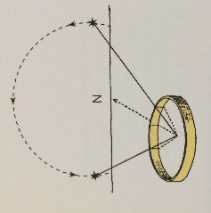
In a previous chapter, we discussed methods of ascension. This chapter will discuss the most magnificent way of getting to heaven- the pyramids. We will explore several theories surrounding both the inside and the outside of the pyramids as a way to make the journey from earth to heaven. The pyramid structure is a design of the Old Kingdom pharaohs as tombs for themselves, the earliest mass constructed of which is Djoser’s Step Pyramid at Saqqara. The possible intention of this pyramid design is to create a stairway like structure which would allow the deceased to climb to heaven to be with the gods. There is evidence in the Pyramid Texts which explicitly reveal the purpose of the pyramids, ‘a staircase to heaven is laid for him (the king) so that he may mount up to heaven thereby’. Furthermore, the hieroglyph meaning ‘ascent’ is depicted as a step pyramid which shows that the language also reflects the notion of the pyramids as beacons for ascent. In addition, attempts at deciphering the word ‘pyramid’ in Egyptian (mer) have been made in order to find meaning. Mer was translated to mean ‘place of ascension’, although it is debated as to whether this is the true meaning of this word. Whatever the meaning of mer, it is certainly believed that the pyramids, as tombs, were places for the kings to depart to the heavens. The connection between the pyramids and the heavens is a belief which ancient civilisations have demonstrated all over the world, and Lehner suggests this was a representation of a mountain which reached up to the heavens allowing the deceased to access their intended destination. Lehner also believes that the pyramid was a place of transformation, a structure which would enable the king to prepare for his ascent. He adds that its design may have been to allow the king to take off towards heaven. Additionally, the reflection of the light of the sun and moon on its limestone slopes would have been a spectacular sight.
The king was aimed for two destinations, the stars and the sun, so with this comes two theories about how the pyramids were aligned; astral and solar. So what methods were used to align the pyramids in such a way? Lehner’s method for astral alignment proposes that a circular wall would be built high enough to block out all but the night sky from a person standing inside the circle. The wall would represent a fake horizon. Facing north, the rising and setting points of a star would be recorded on the wall. The points were extended to the floor and met at the centre of the circle. True north was found by bisecting the angle of the two lines. (See Fig. 15)
Figure 15. Method for astral orientation, Lehner 1997: 212
Evidence for solar alignment of the pyramids has been found in the Temple Texts which refer to ‘the shadow’ and ‘the stride of Ra’, so Lehner has proposed that solar alignment may have been accomplished by placing a vertical pole in the ground. A shadow was recorded three hours before noon and as the sun set. The two lines formed an angle and when this angle was bisected, it gave true north. By carrying out his own experiments with these methods, he has concluded that astral alignment is far more accurate than solar alignment. Therefore, considering the pyramids were built with such accuracy, it would be appropriate to assume that pyramids were orientated in relation to the stars.
Archaeologist Kate Spence has examined the accuracy of alignments in different pyramids and has found that alignments improved up to Khufu’s reign, but after his reign, it began to decline. She suggests that this is due to the changing star positions in the sky at the time of the building of each pyramid. For example, during Khufu’s reign, she suggests that there was no ‘north star’. Instead, the Egyptians would have identified a pair of stars which, when vertically aligned above the northern horizon, would have allowed true north to be determined. Therefore, as the star positions changed over time, the pyramid alignments would have become more imprecise.
Although it has been determined that astral orientation is more accurate, some pyramids do show signs of solar orientation. Lehner discovered what he believed to be solar alignments at Giza. He notes how the sunset during the summer solstice sat between Khufu’s and Khafre’s pyramids, and this created the symbol of the akhet, which was a sun disc between two mountains. He believes this was a symbol which represented predynastic ways of calculating the stages of the year. Therefore this suggests that the pharaohs of the Old Kingdom worshipped the sun, and this was reflected in the orientation of their pyramids.
One reason for solar orientation as opposed to astral orientation may be due to the Solar cult becoming increasingly important in the 4th Dynasty with the worship of Ra. This is evident from inscriptions such as ‘beholds the perfection of Ra’ within the pyramids. Djedefre’s pyramid, for example, was supposedly oriented to the sun, and he is also the earliest pharaoh known to have taken the title ‘Son of Ra’. Hawass explains that Khufu saw himself as God (the sun) so built his pyramid with solar symbology to affirm his divinity. Hawass adds that Khufu’s chamber was positioned so that he could be aligned with the akhet of the sun which only confirms the proposed solar beliefs of the Old Kingdom. Another reason for solar orientation could be due to the shape of the pyramid. The shape of a pyramid reflected the way the sun’s rays cut through the clouds in a triangular motion, and the sun’s rays were symbolic of a ramp or stairway to heaven. So with the pyramid understood to be a symbol representing the sun’s rays as a means to get to heaven, it is easy to see why there was an increase in the popularity of solar beliefs in the 4th Dynasty. Furthermore, as the pyramids were once encased in limestone, they would have reflected the sun which would have been blinding to the Egyptians. This may have reinforced the notion that the king was in fact God, which in turn validated the king’s power and authority.
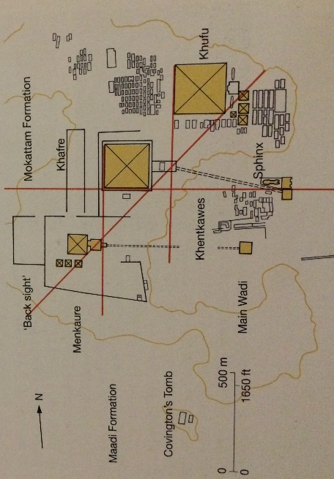
The orientation of pyramids was adapted to suit the religious beliefs at the time. This means we are able to use astronomy to discover whether solar or astral aspects influenced the direction of pyramids, thus revealing the beliefs of the Egyptians. The first clue in determining the orientation of a pyramid is by examining the entrance to it. What has been uncovered is that tombs predating the Giza complex were oriented north-south so that the entrance was placed on the north side meaning the tombs were directed at the circumpolar stars. The 4th Dynasty tombs, including the pyramids were instead oriented east-west. (See Fig. 16) One suggestion for this difference is that tomb robbers knew where the entrances of the tombs were, therefore by changing the direction, it lessened the risk of them finding the entrance. However, it is much more likely that the changes in orientation were due to changes in afterlife beliefs. The changes began to reflect beliefs in Ra, so the new concept of east-west was to fulfil the adoption of solar beliefs that influenced the 4th Dynasty kings.
Figure 16. Diagram of Giza plateau showing major alignments, Lehner 1997: 107
Despite the solar influences shown at Giza on the outside of the pyramids, what is in the inside reveals beliefs pointing towards astral influences. It is possible that even before the Old Kingdom, beliefs about Osiris and the afterlife had already begun to emerge. The evidence for this is found in a predynastic grave pit. What was uncovered was a body lying in the foetal position and facing west, surrounded by possessions. The foetal position suggests the notion of rebirth, the direction of the body is associated with the horizon, (in which the stars died as they dropped below it) and the possessions may be buried with the deceased for the idea that they could be used in the afterlife. All three aspects incorporate notions from an astral religion and an early belief in rebirth, eternity, and becoming Osiris. These are the same beliefs that we see demonstrated by the designs on the walls hidden inside the Giza pyramids of the Old Kingdom.
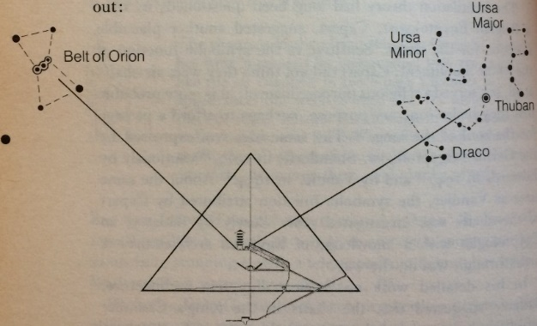
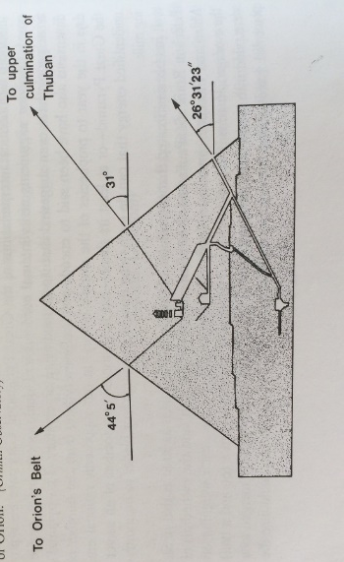
Inside the pyramids, many chambers and passages have been revealed which have raised a number of theories about their purposes. The greatest speculation concerns the ‘air shafts’ on the north and south sides of the pyramids which lead diagonally from the burial chamber to the outside of the pyramid. (See Figs 17 and 18) These shafts have been titled so because they were originally believed to provide ventilation to the deceased, but with further examination, it was concluded that they would not have been able to provide air conditioning as no other tombs or pyramids have them. In addition, the angles at which they slant would not have been an effective way of circulating air. A second theory claimed that, like temples, they were used as observatories to regulate the calendars, but with the insertion of a camera, it was discovered that both shafts bend horizontally before reaching the chamber. This find made it impossible to observe anything at all from inside the pyramid. However, by investigating the direction of the orientation of the shafts, it was discovered that they related to two areas of religious significance. In 1964, archaeologists theorised that the shafts were aimed towards specific stars. Virginia Trimble calculated that the north shaft, during the time the pyramid was built, was aimed at the circumpolar stars, most notably Thuban, today known as Draco the Dragon. Thuban was recognised as the leader of the imperishable stars and was possibly the closest that the Egyptians had to a north star. This then was an appropriate choice for the shaft as it symbolised eternity, a power which all kings desired to achieve. When investigating the southern shaft, it appeared that it was aligned with Alnilam, the middle star of Orion’s Belt. The significance of Orion’s Belt is displayed in other tombs. The ceiling of Senenmut, for example, shows three stars with a striking resemblance to Orion’s Belt. The stars in Orion’s Belt were part of the decans which were important for administrating the hours of the day, but, more importantly, Orion represented Osiris, a god symbolic of death and rebirth. Additionally, as the shaft is aimed at the groin area, it suggests a fertility aspect, therefore emphasising the notion of rebirth. Thuban and Orion’s Belt are confirmed in the Pyramid Texts as celestial destinations where the king would go to be reborn and live for eternity. Therefore, it seems that the shafts were intended as tunnels to guide the king to the correct parts of the sky. The pyramids then, although astronomically aligned, did not actually reveal any interest in the science of astronomy, they were instead only to fulfil their funerary beliefs. Chadwick refers to this as ‘Shepherds’ Astronomy’, meaning principal, scientific elements of astronomy were well known and considerably used, but it did not establish anything considered as scientific.
Figure 18. Diagram of the 'air shafts' pointing towards Orion and Thuban, Bauval and Gilbert 1994: 100
Figure 17. Angles of the 'air shafts' leading to the destinations of the pharaoh, Krupp 1983: 102
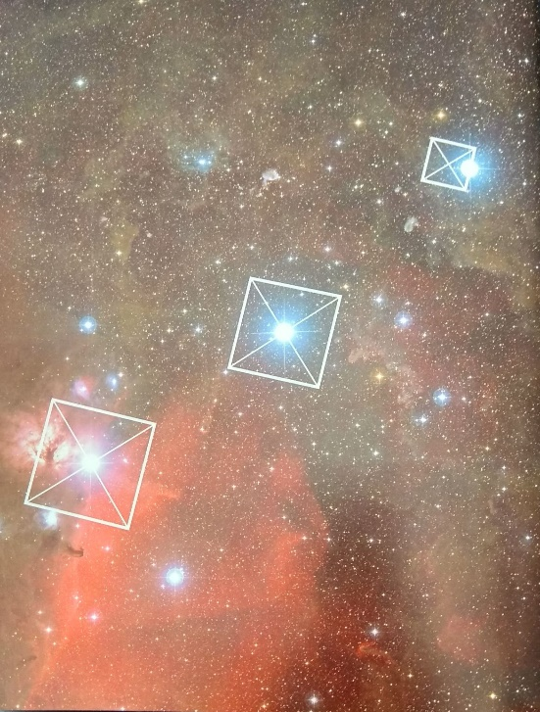
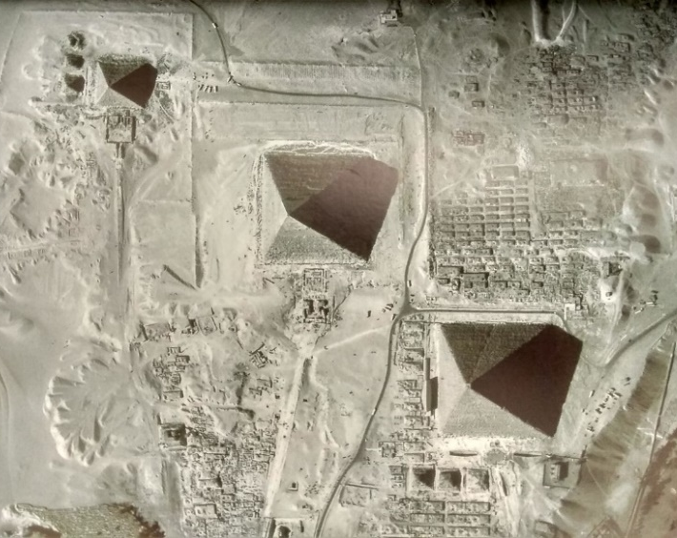
As well as Orion’s Belt being the destination for rebirth, Bauval and Gilbert have also suggested that the three pyramids of Giza are aligned with the Belt. When investigating this theory, they found that heaven was believed to have a counterpart on land. This was found to be Rostau at Giza. This translated as ‘gateway to the other world. With the belief that the pyramids were aligned with Orion’s Belt, and their theory that Giza was heaven’s counterpart, they began looking for more pyramids that were aligned with the rest of the constellation. They were able to find two pyramids which corresponded to Orion’s left foot and his right shoulder. However, nothing could be found depicting the other stars in the constellation. He suggests that those pyramids were either never built, or had long disappeared under sands or been demolished. The pyramids correlating to the foot and the shoulder were in such a state that it is likely that those ‘missing’ pyramids had crumbled long ago. However, there is one problem with their theory. Orion does not completely match the Giza pyramids. Although the pattern of both the stars and the pyramids are strikingly similar, (See Figs. 19 and 20) the directionality of the map would actually have to be turned upside down in order to correctly be aligned to the belt. Moreover, the brightest star is in the middle of the belt and the biggest pyramid (which should therefore be in the middle) is in the wrong position.
Figure 19. Pyramids laid out to reflect Orion's Belt, Jackson and Stamp 2002: 180
Figure 20. Satellite view of Giza plateau showing a similar pattern to Orion's Belt, Jackson and Stamp 2002: 162
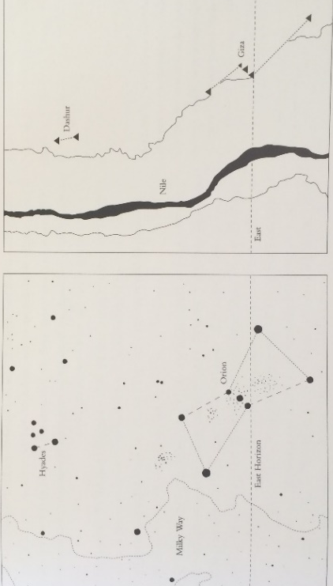
Despite this, I believe there is some truth in Bauval and Gilbert’s theory. I propose that the Egyptians recreated the constellation of Orion on the ground so that when the gods looked down, they would see the heavens as the Egyptians saw them. I therefore argue that the pyramids of Giza were not aligned with Orion but were instead mapped out on the ground. If this is correct, it shows a monumental amount of planning carried out by the Egyptians to recreate the heavens for the gods to see. To support this statement, passages from the Book of What is in the Duat reveal that to achieve eternal life, exact replicas of what is in the body of Nut should be built on the ground: ‘whosoever shall make an exact copy of these forms, and shall know it, shall be a spirit well-equipped both in heaven and in earth, unfailingly, and regularly and eternally’. This appears to suggest that mapping the earth to the sky was something the Egyptians believed in. Hancock and Faiia further suggest that pyramids and temples may have been ‘part of a deliberate and long-term program to copy sky to ground- literally, to build heaven on earth.’ With all the pyramids on the west of the Nile, and Orion on the west of the Milky Way, the Nile therefore seems to replicate the Milky Way. (See Fig. 22) This only adds to the theory that the pyramids were mapped to the stars. Although this theory has not been proven, it is difficult to dismiss the evidence which supports the idea that the Egyptians wanted a heaven on earth.
Figure 22. The pyramids as Orion and the Nile as the Milky Way, Hancock and Faiia 1998: 95
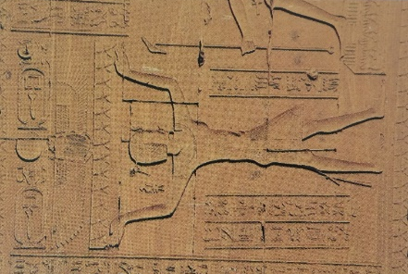
The pyramids and their alignments have inspired archaeologists to look for more astronomical orientations. Using geophysical surveys, archaeologists have been able to go deep within the pyramids and even under the desert sands to explore the land for ‘hidden Egypt’ as it is believed that only one percent of ancient Egypt has been discovered. By using modern day equipment to calculate the stars’ positions as they would have appeared over ancient Egypt, astronomy, with the use of geophysical surveys, can help us find possible structures deep underground which have astronomical and religious significance. This is an ongoing project, which, if successful, will be revolutionary and advance our current understanding of ancient Egypt.
Figure 21. Man holding a sky with stars, Temple of Hathor, Hancock and Faiia 1998: 90
From this observation of pyramid purposes and alignments, Hadingham concludes that the Egyptians and the construction of the pyramids played no part in observing astronomy for scientific purposes. They did not seek the true reasons for the transitioning of stars or the ‘death’ of the sun. Instead, astronomy was used to reinforce their religious beliefs and reflect these ideologies through impressive structures, enabling them to create a powerful nation. The monuments constructed for the dead king enhanced his power and his appearance as a powerful ruler, which was reflected in the unity of his people. His established authority identified in the dominating structures of the land which spread a message that helped to protect his people and his land from foreign threats. The pyramids were not therefore, just a tomb designed to get the king to heaven, they were also a means of displaying success, power, and stability of the land, even after the king’s death. Lehner agrees with this statement, acknowledging that religion and astronomy were catalysts in the development of Egypt as a successful and stable civilisation. The pyramids often appear to a modern mind, especially one with minimal faith, as a wasteful project as there is a lack of connection between the pyramids and their purposes in the modern era, but with the ongoing research into the religion and its link to astronomy, one is able to see how the pyramids were a necessity to fulfil the beliefs of the Egyptians.

Conclusion

It can be said then, that from a discussion of the most important aspects of ancient Egyptian culture throughout this dissertation, it is clear to see how astronomy was used in order to structure their lives. An examination of the adaptations of the calendars has revealed that the Egyptians depended on the observation of the skies for their survival. What has also been shown, is that there was more to astronomy than simply watching the trajectory of stars and other celestial objects as there were also deeply rooted religious beliefs which were used as an explanation for the heavenly movements. These beliefs started with myths of divine beings who would keep order on earth, and these beliefs infiltrated into the core of Egyptian culture and became central to the state, especially concerning the king and his persistence in identifying himself as a god in order to establish his authority. Religion and astronomy undoubtedly overlap, and this has been shown to be most apparent in funerary beliefs and the construction of the pyramids. The pyramids were not only the ultimate step to heaven, but were the structure which tied together heaven and earth, whilst also creating an image of power and strength to enemies, helping them to keep a stable nation. If we set aside our own knowledge of the universe and how it works, we are able to see that religion was the force that pushed the Egyptians to achieve the biggest, the best, and the most powerful of structures, to connect themselves to the sky and gods within it to attain the ultimate goal of eternity, not just in heaven, but on earth as well. By literally reaching for the stars, the Egyptians were able to create one of the greatest and most successful civilisations in the history of the earth.

Bibliography

Assmann, J. 2001. The Search for God in Ancient Egypt. New York: Cornell University press.

Bauval, R. and Gilbert, A. 1994. The Orion Mystery. London: William Heinemann Ltd.

Bowie, F. 2000. The Anthropology of Religion. Oxford: Blackwell Publishers Ltd.

Chadwick, R. 2005. First Civilisations: Ancient Mesopotamia and Ancient Egypt. London: Equinox Publishing Ltd.

Clagett, M. 1995. Ancient Egyptian Science: Calendars, Clocks and Astronomy. Philadelphia: American Philosophical Society

David, A. R. 1986. The Pyramid Builders of Ancient Egypt. London: Routledge and Kegan Paul.

Dobecki, T. L. ‘Geophysical Exploration at the Giza Plateau, Egypt a Ten Year Odyssey’ 2005. Earthdoc.org http://www.earthdoc.org/publication/publicationdetails/?publication=43557 [Accessed 5th May 2018]

Goyios, A. ‘Astronomical Ceiling of Ramesses VI’ 2009. Blavatskyarchives.com
http://blavatskyarchives.com/mackeysd/mackeysd.html [Accessed 30th April 2018]

Hadingham, E. 1983. Early Man and the Cosmos. London: William Heinemann Ltd.

Hancock, G. and Faiia, S. 1998. Heaven’s Mirror: Quest for the Lost Civilization. London: Michael Joseph Ltd.

Herodotus, The Histories. A. D. Godley (trans.). 1920. Cambridge: Harvard University Press.

Jackson, K. and Stamp, J. 2002. Pyramid Beyond Imagination: Inside the Great Pyramid of Giza. London: BBC Worldwide Ltd.

Krupp, E. C. 1983. Echoes of the Ancient Skies: The Astronomy of Lost Civilisations. Oxford: Oxford University Press.

Krupp, E. C. 1997. Skywatchers, Shamans and Kings: Astronomy and the Archaeology of Power. New York: John Wiley and Sons, Inc.

Lambek, M. 2002. A Reader in the Anthropology of Religion. Oxford: Blackwell Publishers Ltd.

Lehner, M. 1997. The Complete Pyramids. London: Thames and Hudson Ltd.

Lockyer, J. N. 2006. The Dawn of Astronomy: A Study of Temple Worship and Mythology of the Ancient Egyptians. New York: Dover Publications, Inc.

Macionis, J. J. and Gerber, L. M. 2010. Sociology. Canada; Pearson Education.

Morenz, S. 1992. Egyptian Religion. New York: Cornell University Press.

Novakovic, B. 2008. ‘Publications of the Astronomical Observatory of Belgrade’ 85, 19-23.

Oakes, L. and Gahlin, L. 2002. The Mysteries of Ancient Egypt. London: Lorenz Books.

Sellers, J. B. 1992. The Death of Gods in Ancient Egypt. London: Penguin Books Ltd.

Shaw, I. 2000. The Oxford History of Ancient Egypt. Oxford: Oxford University press.

Smart, N. 1969. The Religious Experience of Mankind. New York: Charles Scribner’s Sons.

Snape, S. 2011. Ancient Egyptian Tombs: The Culture of Life and Death. Chichester: John Wiley and Sons Ltd.

Spence, K. 2000. ‘Ancient Egyptian Chronology and the Astronomical Orientation of Pyramids’, Nature 408, 320-324.

Tyldesley, J. 2011. The Penguin Book of Myths and Legends of Ancient Egypt. London: Penguin Books Ltd.

Vannini, S. ‘Astronomical Ceiling of Seti I’ 2006. Flickr.com https://www.flickr.com/photos/sandrovannini/4137890163 [Accessed 30th April 2018]
Verner, M. 1997. The Pyramids: Their Archaeology and History. Academia: Prague.

Wilkinson, K. ‘Astronomical Ceiling of Senenmut’ 1948. Metmuseum.org. http://www.metmuseum.org/art/collection/search/544566?sortBy=Relevance&amp;ft=Senenmut+ceiling&amp;offset=0&amp;rpp=20&amp;pos=6 [Accessed: 30th April 2018]

Assmann 2001: 1
Assmann 2001: 1
Hancock and Faiia 1998: 113
Hancock and Faiia 1998: 116
Tyldesley 2011: 16
Assmann 2001: 54
Morenz 1992: 8
Morenz 1992: 7
Macionis and Gerber, 2010: 14
Krupp 1983: 172
Oakes and Gahlin 2002: 331
Oakes and Gahlin 2002: 331
Hdt. Hist. 2.4
Hdt. Hist. 2.4
Hadingham 1983: 21
Hdt. Hist. 2.4
Hadingham 1983: 21
Hadingham 1983: 21
Krupp 1983: 172
Krupp 1983: 172
Krupp 1983: 175
Hadingham 1983: 21
Hadingham 1983: 21
Hadingham 1983: 21
Krupp 1997: 291
Krupp 1997: 291
Krupp 1983: 21
Krupp 1983: 21
Krupp 1997: 289
Lockyer 1894: 343
Lockyer 1894: 343
Krupp 1983: 107
Oakes and Gahlin 2002:112
Lockyer 1894: 3
Lockyer 1894: 3
Chadwick 2005: 117
Morenz 1992: 8
Morenz 1992: 8
Chadwick 2005: 117
Morenz 1992: 8
Morenz 1992: 8
Krupp 1983: 173
Oakes and Gahlin 2002: 446
Oakes and Gahlin 2002: 446
Hdt. Hist. 2.82.1
Chadwick 2005: 115
Krupp 1983: 173
Oakes and Gahlin 2002: 446
Lockyer 1894: 109
Lockyer 1894: 109
Krupp 1983: 257
Krupp 1983: 257
Hancock and Faiia 1998: 56
Krupp 1983: 257
Krupp 1983: 258
Krupp 1983: 308
Krupp 1983: 309
Krupp 1997: 291
Krupp 1983: 231
Lehner 1997: 9
Krupp 1983: 100
Krupp 1983: 101
Lehner 1997: 28
Lehner 1997: 29
Hancock and Faiia 1998: 80
Hancock and Faiia 1998: 81
Hancock and Faiia 1998: 81
Oakes and Gahlin 2002: 391
Hancock and Faiia 1998: 88
Oakes and Gahlin 2002: 391
Lehner 1997: 32
Pyr, 699, Sellers 1992: 69
Lehner 1997: 28
Krupp 1997: 293
Lehner 1997: 32
Oakes and Gahlin 2002: 329
Oakes and Gahlin 2002: 327
Oakes and Gahlin 2002: 430
Krupp 1997: 289
Clagett 1995: 62
Novakovic 2008: 19
Novakovic 2008: 19
Krupp 1983: 107
Hancock and Faiia 1998: 89
Hancock and Faiia 1998: 89
Krupp 1983: 106
Krupp 1983: 106
Krupp 1983: 107
Oakes and Gahlin 2002: 116
Lehner 1997: 28
Hancock and Faiia 1998: 90
Oakes and Gahlin 2002: 117
Pyr, Oakes and Gahlin 2002: 401
Oakes and Gahlin 2002: 402
Smart 1969: 287
Krupp 1983: 100
Krupp 1983: 101
Krupp 1997: 289
Krupp 1983: 101
Krupp 1997: 288-289
Sellers 1992: 123
Pyr, Oakes and Gahlin: 53
Krupp 1997: 68
Krupp 1997: 68
Sellers 1992: 185
Bowie: 2000: 22
Krupp 1983: 22
Tyldesley 2011: 109
Krupp 1983: 19
Krupp 1983: 19
Krupp 1983: 22
Krupp 1983: 258
Krupp 1983: 16
Krupp 1983: 21
Krupp 1997: 223
Shaw 2000: 100
Shaw 2000: 99
Krupp 1983: 75
Krupp 1983: 75
Krupp 1983: 24
Krupp 1983: 25
Krupp 1983: 25
Krupp 1983: 25
Krupp 1983: 25
Krupp 1983: 26
Krupp 1983: 26
Jackson and Stamp 2002: 25
Krupp 1983: 26
Krupp 1983: 26
Krupp 1983: 26
Krupp 1983: 26
Jackson and Stamp 2002: 25
Verner 1997: 71
Krupp 1983: 26
Jackson and Stamp 2002: 25
Krupp 1983: 26
Lambek 2002: 431
Tyldesley 2011: 52
Oakes and Gahlin 2002: 330
Krupp 1983: 258
Tyldesley 2011: 52
Tyldesley 2011: 52
Tyldesley 2011: 52
David 1986: 43
David 1986: 43
Pyr, Krupp 1997: 292
Krupp 1997: 293
Lehner 1997: 34
Krupp 1997: 285
Lehner 1997: 35
Krupp 1997: 293
Jackson and Stamp 2002: 29
Lehner 1997: 212
Lehner 1997: 214
Lehner 1997: 214
Lehner 1997: 214
Spence 2000: 320-324
Spence 2000: 320-324
Krupp 1997: 290
Krupp 1997: 290
David 1986: 43
Lehner 1997: 34
Lehner 1997: 120
Krupp 1997: 289
Krupp 1997: 289
Jackson and Stamp 2002: 106
Lehner 1997: 6
David 1986: 46
Shaw 2000: 93
David 1986: 46
Shaw 2000: 93
Shaw 2000: 93
Snape 2011: 9
Oakes and Gahlin 2002: 391
Krupp 1997: 287
Krupp 1997: 287
Chadwick 2005: 152
Chadwick 2005: 152
Krupp 1997: 287
Krupp 1997: 287-288
Krupp 1983: 105
Krupp 1997: 287
Bauval and Gilbert 1994: 239
Krupp 1983: 105
Krupp 1983: 105
Krupp 1997: 287
Chadwick 2005: 115
Bauval and Gilbert 1994: 116
Bauval and Gilbert 1994: 116
Hancock and Faiia 1998: 51
Bauval and Gilbert 1994: 124
Krupp 1997: 291
Ibid, 240, Hancock and Faiia 1998: 89
Hancock and Faiia 1998: 90
Hancock and Faiia 1998: 90
Lehner 1997: 106-107
Dobecki 2005
Dobecki 2005
Handingham 1983: 23-24
Krupp 1997: 294-295
Lehner 1997: 9
Shaw 2000: 99
Krupp 1997: 294

