

Program Name: BA (Hons) Leadership and Management Skills in the Workplace

Module Name: Organisational Culture of British Airways Company
Module code: LCLM 5005 LON
Lecturer: Dr Rameses Manalang
Student name: Glenda Cortez Marino
Student number: 2325919

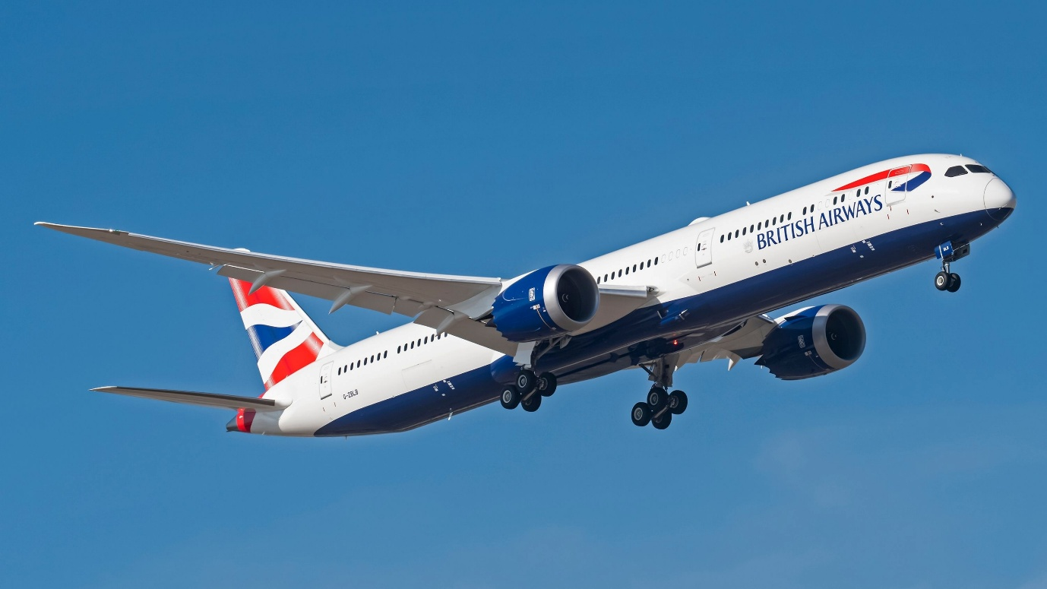
(British Airways,2025)

Table of Contents

Introduction 3
2.0. Organisational Culture of British Airways 3
2.1. Nature of British Airways Organisation Culture 4
2.2. Cultural Characteristics and Practice 5
3.0. Influence of Culture on Structure and Decision Making of British Airways 6
3.1. Organisation structure on shaped by culture 7
3.2. Decision Making Processes of British Airways 8
3.3. Critical Analysis of British Airways 9
4.0. Application of Schein’s Model of Organisational Cultural. 10
4.1. Overview of Schein’s Model of Organisational Cultural 11
5.0. Organisational Culture and Adaptation to the External Environment 13
5.1. External Pressures of British Airways 14
5.2. Cultural Response to External Changes 15
5.3 Critical Evaluation of British Airways. 15
Citical evaluation of organisational 16
6.0. Organisational Culture as an Enable 17
Culture Enable 18
6.1-Organisational Culture as a Barrier 18
7.0- Conclusion 19
8.0 RECOMMENDATIONS 19
9-Reference 20

Introduction
British Airways organisational culture plays avital role in shaping how a company operates plans to achieves their strategic objectives and reflects the shared values, and beliefs, behaviours, and working practices that influence employee performance and customers satisfaction. In the culture aviation industry is essential a strong organisational for ensuring safety service, quality teamwork, and operational efficiency.
British Airways is one of the United Kingdom leading airlines has developed a culture focused on customer services, professionalism, innovation, and continuous improvement. The company encourages collaboration, diversity, employee development, and high ethical standards to maintains their competitive position in the global airline industry and evaluates how this culture influences employee motivation, customer experience, strengths , challenges and role in long term success in a competitive aviation environment (British Airways, 2024). This organisation is one of the United Kingdom leading airline and recognised global carrier, providing passenger and cargo services to destinations across Europe, North America, Asia, Africa and Middle East and founded in 1974, the airline has established a strong reputation for safety, customer service and operational excellence the organisation is part of international group who supports international grow and competitiveness, the airline operates primarily from London Heathrow Airport and relies on effective leadership and clean organisation(Robbins, S.P and Judge,2023).

2.0. Organisational Culture of British Airways
British Airways has developed and organisational culture entered on safety, teamwork, innovation, customer services, and continuous improvement, that airline encourages collaboratively work to employees while maintaining high operation and safety standards, and the culture promotes inclusivity, professionals’ development and accountability, helping staff adapt to change in the aviation industry customer experience(British Airways, 2024). Also, supporting innovation by investing in digital technology and employee training to improve operational efficiency and service quality and this strong organisational culture is enabled to achieve its strategy’s objective the airline, maintain a competitive position in terms of global aviation industry and enhance employee engagement( Schein and Schein, 2021).


(British Airways, logos of th)

2.1. Nature of British Airways Organisation Culture
British Airways is a leading international full-service airline that provides passenger and cargo transport across domestic and global destinations. As part of the international Airline Group (IAG), the airline is committed to delivering safe, dependable, and high-quality services while meeting the needs of diverse customers through Economy, Premium Economic, Business, and First-Class travel.
The organisational culture of British Airways has been built on the core values of safety, customer focus, innovation, teamwork, and inclusivity, Safety is the highest priority.
British Airways promotes a culture of innovation, inclusivity, teamwork, and continuous improvement. The airline invests in innovative technologies to improve operational efficiency, enhance customer experience, and support environmental sustainability, it values diversity and equal opportunities by encouraging an inclusive workplace and developing employees from diverse backgrounds. The teamwork and cross-functional collaboration help improve problem solving and operational performance. British Airways also invests in staff training and development to strengthen skills and maintain high service standards, its culture encourages ethical behaviour, accountability, and open communication, enabling employees to deliver excellent customer service, improve operational efficiency, and maintain the airline competitive position in the global aviation industry(Robbins and Judge, 2023; British Airways, 2024).

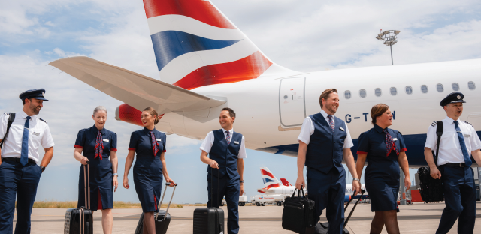

(British Airways, Celebrate)

2.2. Cultural Characteristics and Practice
The airline characteristics fosters a safety-first culture, reflecting the critical importance of rigorous safety standards and compliance in the aviation industry. This culture is reinforced through continuous training, transparent and open communication, and an initiative-taking approach to risk management (Alvesson,M.2002).
Customer service excellence is a contrast of British Airways cultural identity. The airline emphasises personalised service, attentiveness, and responsiveness, pointed to enhance passenger experience across all touchpoints. This customer-oriented ethos is embedded in employee training programs and performance metrics, ensuring alignment with organisational values.
Innovation and adaptability are also of central of British Airways cultural practices. The airline actively embraces technological advancements and digital transformation to improve operational efficiency and customer engagement. This forward-looking mindset encourages employees to contribute ideas and participate in change initiatives, fostering a culture of continuous improvement. The airline promotes an inclusive workplace environment that values diverse perspectives and equitable opportunities. This commitment is reflected in recruitment policies, employee resource groups, and leadership development programs aimed at nurturing talent from varied backgrounds, and cultural characteristics and practices are strategical this aligned with its business objectives, reinforcing a resilient, customer-focused, and innovative organisational environment that sustains its competitive advantage in the global airline industry(British Airways, 2024).

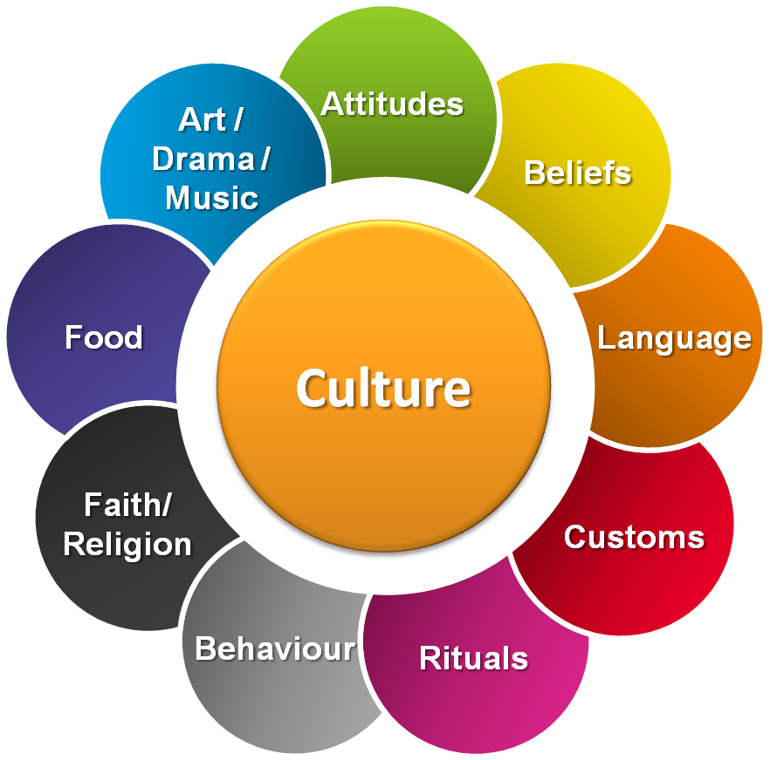
( Bpb-us-e1.wpmucdn.com)

3.0. Influence of Culture on Structure and Decision Making of British Airways
The organisational culture of British Airways significantly influences on structural design and decision-making processes, creating a dynamic interplay that supports the airline’s strategic objectives and operational effectiveness, this culture attribute encourages participative decision-making, enhancing creativity and problem-solving capabilities across functional departments(Hartnell,C.A.,Ou, A.Y. and Kinicki, A. 2011).
The culture of open communication and teamwork further influences decision-making by promoting transparency and shared accountability. This cultural practice reduces bureaucratic delays and supports faster consensus-building, which is critical in the fast-paced aviation industry. British Airways’ culture profoundly shapes its organisational structure and decision-making processes by embedding values that promote safety, inclusivity, innovation, and collaboration. This alignment ensures that the airline remains agile, competitive, and capable of delivering high-quality service in a complex and regulated environments (British Airways,2024).

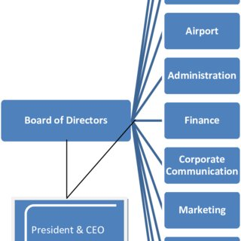
( British Airways, 2024)

3.1. Organisation structure on shaped by culture
The organisational structure of British Airways is strongly influenced by corporate culture, the airline uses a hierarchical and functional structure that promote clear communication, accountability and operational functional efficiency is culture of safety, customer service and teamwork shape how responsibilities are assign across departments such as flight operations and engineering, customer services ground handling, managers encourage collaboration while ensure employees follow aviation regulation and company policies. This culture supports effective decision-making ,improves coordination between teams, and helps British Airways deliver reliable, high-quality services. The organisational structure is enabled to achieve the airline strategic objectives while maintaining excellent customers satisfaction and operational performance.
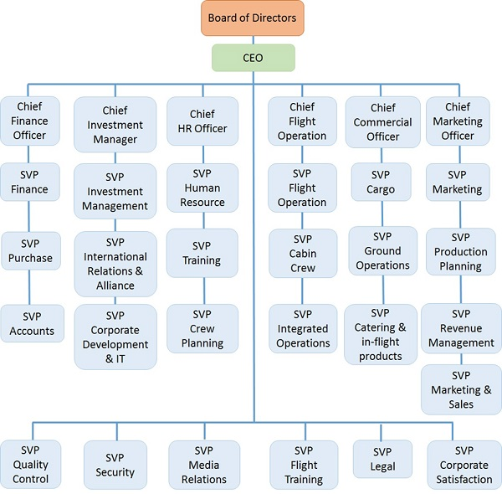
`(British Airways, 2024)

3.2. Decision Making Processes of British Airways
British Airways employs a multifaceted decision-making process that reflects its complex operational environment and cultural values. The airline integrates both centralised and decentralized decision-making approaches to balance strategic oversight with operational agility.
At the strategic level, decision-making is centralised within the executive leadership team, including the Chief Executive Officer and senior directors. This centralisation ensures alignment with the airline’s long-term vision, regulatory hicompliance, and financial objectives. Critical decisions related to safety, regulatory adherence, and major investments are typically made at this level to maintain consistency and control.
Communication plays a pivotal role in British Airways’ decision-making processes. The culture of open communication and transparency facilitates timely information flow, consensus-building, and shared accountability, which are essential in the fast-paced aviation industry. British Airways’ decision-making processes are characterised by a strategic balance between centralised control and decentralised empowerment, supported by cross-functional collaboration, data-driven insights, and transparent communication. This integrated approach enables the airline to navigate complex challenges while maintaining agility and operational excellence.

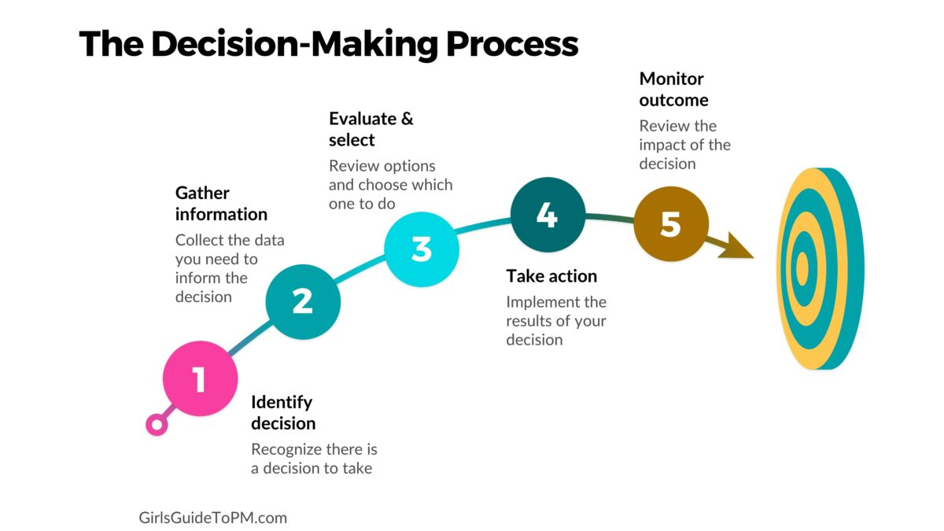

3.3. Critical Analysis of British Airways
British Airways has developed a strong organisational culture that supports customers services, operational efficiency and safety, the airline has faced challenges, customer services complaints, industrial dispute, and operational disruptions, and while the company invests in innovation and staff development and organisational change and this can create resistant on some aspects of employees.
Despite these challenge , British Airways continues to strengthen leadership, staff train and digital transformation and the airline must continuous improving employee engagement, communication and customer experience while adapting to change market conditions and passenger expectations(British Airways,2024).


( Marketing word cloud)

4.0. Application of Schein’s Model of Organisational Cultural.
Edgar Schein’s model of organisational culture provides a valuable framework for understanding the underlying cultural dynamics at British Airways. Schein’s model identifies three levels of culture: artifacts, espoused values, and basic underlying assumptions, each of which can be observed within British Airways organisational environment.
a.Artifacts
Artifacts represent the visible and tangible elements of culture. At British Airways, these include the airline’s branding, customer service protocols, safety procedures, and physical work environments such as aircraft cabins and offices. The airline’s emphasis on professionalism and customer experience is evident in uniform standards, in-flight service rituals, and the design of customer touchpoints. Additionally, safety artifacts such as checklists, training manuals, and compliance documentation reflect the airline’s operational priorities.
b. Espoused Values
Espoused values are the stated principles and strategies that guide behaviour within the organisation. British Airways explicitly promotes values such as safety, customer-centricity, innovation, inclusivity, and collaboration. These values are communicated through corporate mission statements, employee training programs, and leadership messaging. The airline’s commitment to these values shapes policies related to employee conduct, customer service standards, and innovation initiatives.
c. Basic Underlying Assumptions
At the deepest level, basic underlying assumptions are the unconscious, taken-for-granted beliefs that drive behaviour. At British Airways, these assumptions include the belief that safety is paramount and non-negotiable, that customer satisfaction is essential for business success, and that continuous innovation is necessary to remain competitive. These assumptions influence everyday decision-making, risk management, and the organisational response to challenges.
helps explain Schein’s model to British Airways provides a comprehensive understanding of the airline’s organisational culture, highlighting the interplay between visible practices, stated values, and deep-seated beliefs that collectively shape its identity and operational effectiveness. (Schein and Schein, 2017 ; British airways, 2024).

Schain’s Model

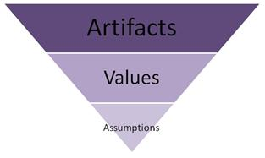

( Schein, 2010)

4.1. Overview of Schein’s Model of Organisational Cultural
The overview of Schein’s Model of Organisation culture of British Airways the alignment of these three levels within British Airways fosters a coherent and resilient organisational culture that supports operational excellence and strategic agility. Understanding this model aids in comprehending how British Airways manages cultural change and sustains its competitive advantage in the dynamic aviation industry.
British Airways embodies a corporate culture deeply rooted in safety, customer-centricity, innovation, inclusivity, and collaboration, which collectively underpin its operational success and global reputation.
Innovation and adaptability are also central to British Airways cultural practices. The airline actively embraces technological advancements and digital transformation to improve operational efficiency and customer engagement. This forward-looking mindset encourages employees to contribute ideas and participate in change initiative.
Inclusivity and diversity form another pillar of British Airway’s culture. The airline promotes an inclusive workplace environment that values diverse perspectives and equitable opportunities. This commitment is reflected in recruitment policies, employee resource groups, and leadership development programs aimed at nurturing talent from varied backgrounds.
Collaboration across departments and hierarchical levels is encouraged to break down silos and enhance organisational agility. British Airways culture supports open communication, teamwork, and shared accountability, working a resilient, customer-focused, and innovative organisational environment that sustains its competitive advantage in the global airline industry. are vital for coordinating complex operations and delivering seamless service. So, British Airways’ cultural characteristics and practices are strategically aligned with its business objectives. (British Airways 2024).


British Airways 2024

5.0. Organisational Culture and Adaptation to the External Environment
British Airways has developed an organisational culture this is enabled to adapt external environment changes the airline include technological advancements, change customers expectations, environment sustainability, and increase competition, the airline organisation promotes a culture of innovation, continuous learning, and collaboration, allowing employees to respond effectively to industry changes and operational changes(Jonhson et al., 2020).

British Airways also investing in digital technologies, employee development, and improve operational efficiency and customer satisfaction for business sustainable practice. (British Airways, 2024).
The organisation encourages teamwork, adaptability, open communication, help employee embrace organisational changes and maintaining high service standards in aviation dynamic market. By organisation culture aligning with strategic objectives and external market demands, British Airways strengthens has resilience, supports long-term growth and keep a competitive advantage in the global airline industry. (Robbins and Judge, 2023).
British Airways also investing in digital technologies, employee development, and improve operational efficiency and customer satisfaction for business sustainable practice. (British Airways, 2024).
The organisation encourages teamwork, adaptability, open communication, help employee embrace organisational changes and maintaining high service standards in aviation dynamic market. By organisation culture aligning with strategic objectives and external market demands, British Airways strengthens has resilience, supports long-term growth and keep a competitive advantage in the global airline industry. (Robbins and Judge, 2023).

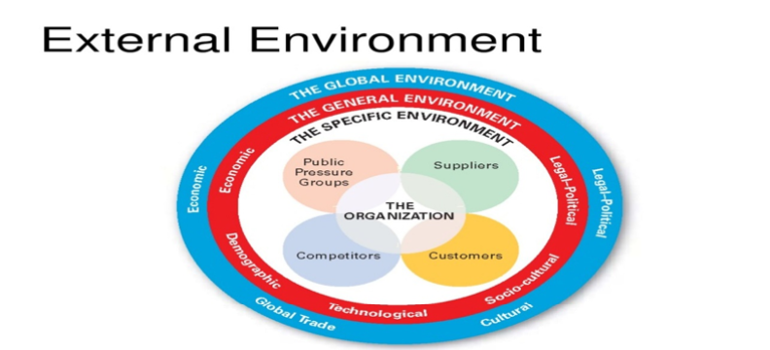
.
( Jones & George, 2020 )

5.1. External Pressures of British Airways
British Airways the organisation culture is shaped by external factors like a geopolitical instability, regulations, technological change , market competition, and sustainability. The airline promotes resilience, innovation, compliance, and customer focus to respond effectively to these challenges. Also, is continuous improvement efficiency through digital technology and satisfy changing customer expectations.
Environmental responsibility, including reducing carbon emission and investing in sustainable aviation fuel, is also a key cultural priority and support operation excellence while enabling the organisation to remain competitive, adaptable, and responsive in the rapidly changing global aviation industry(International Airlines Group 2024).

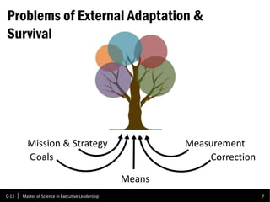
( Schain, 2010 )

5.2. Cultural Response to External Changes
British Airways has adapted to organisational culture in response to external changes like as technological advancements changing customer expectations, environmental sustainability, economic uncertainty, and the Covid-19 pandemic, the airline promotes a customer-focused culture that encourages employees to provide high-quality service while adapting to changing passenger need (British Airways, 2024)
During the Covid-19 pandemic, British Airways introduced new health and safety procedures, digital check-in services, and flexible booking policies to protect passengers and employees while maintaining operation. The organisation also invested in digital technologies to improve customer experience through mobile applications, and enhanced online communication, British Airways environmental growing concerns has strengthened this commitment sustainability by investing more fuel-efficient aircraft, supporting sustainable aviation fuel initiatives, reducing carbon emission these initiatives reflect a culture that values innovation, (International Air Transport Association (IATA,2024) corporate responsibility and long-term environmental stewardship, continues learning to help employees adapt to industry change and serve customers from different cultural backgrounds collaboratively and professional development, British Airways has created a culture that supports. Organisational change while maintaining high service standards and this adaptability has remain competitive in the rapidly changing global aviation industry (Schein and Schein, 2021).

5.3 Critical Evaluation of British Airways.
Strengths
a- Functional Specialization and Efficiency: British Airways functional organizational structure promotes specialization, allowing departments such as Flight Operations, Engineering, and Customer Service to develop deep expertise. This specialization enhances operational efficiency and safety compliance, which are paramount in the aviation industry. ( Ogbonna, E. and Harris, L.C. 2000)
b- Strong Safety Culture: The airline's culture prioritizes safety primarily, supported by rigorous training, clear protocols, and continuous monitoring. This focus ensures regulatory compliance and fosters passenger trust.
c- Customer-Centric Approach: British Airways emphasizes high-quality customer service, reflected in its training programs and service standards. This focus helps maintain brand loyalty and competitive differentiation.
d- Innovation and Adaptability: The airline actively pursues technological innovation and digital transformation, enabling it to improve operational processes and customer experience.
f-inclusive and Collaborative Culture: British Airways promotes inclusivity and cross-functional collaboration, which enhances employee engagement and facilitates problem-solving across departments.
Challenges
a- Risk of Departmental Silos: Despite efforts to encourage collaboration, the functional structure can lead to silos, limiting communication and coordination between departments.
b- Managerial Overload: The flattened hierarchy, while promoting agility, can result in broader spans of control, potentially overburdening managers, and affecting leadership effectiveness.
c-Complex Decision-Making: Balancing centralised strategic decisions with decentralised operational autonomy can sometimes cause delays or inconsistencies, especially in fast-moving situations.
d- Sustaining Cultural Values: Maintaining a strong culture of innovation and inclusivity requires ongoing commitment and resources, which can be challenging in a large, complex organization.
f-External Pressures: The airline faces significant external pressures such as geopolitical instability, fluctuating fuel prices, and regulatory changes, which require continuous cultural and strategic (Hartnell, C.A, Ou, A.Y, and Kinicki, A.(2011).

Citical evaluation of organisational
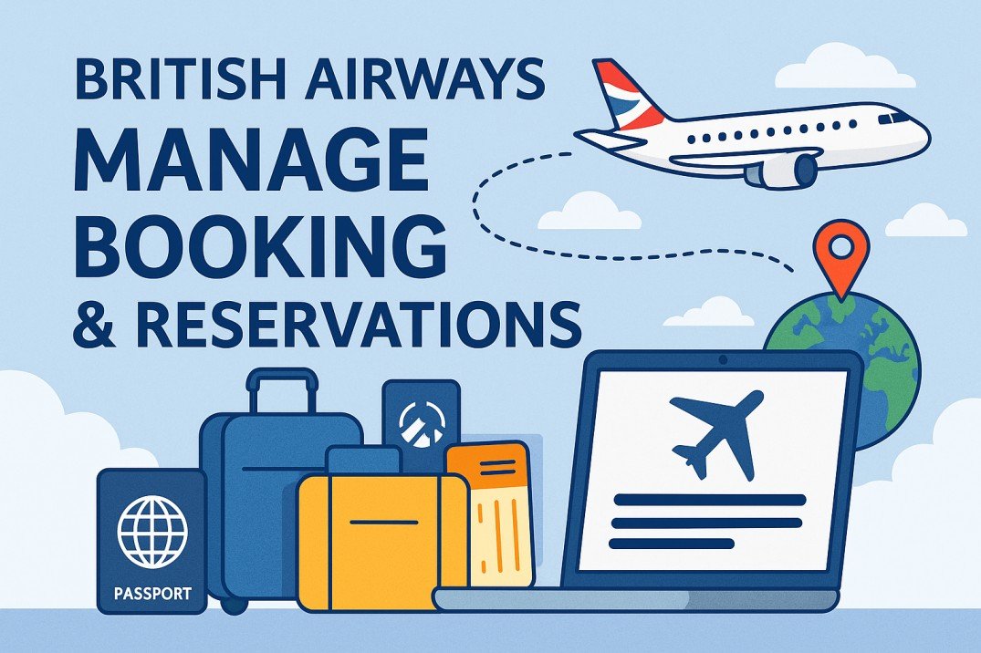

( British Airways, 2026 )

6.0. Organisational Culture as an Enable
Organisational culture acts as a vital enabler at British Airways by aligning employee behaviours, values, and attitudes with the airline strategic goals and operational demands. This culture fosters a shared sense of purpose and commitment, which enhances motivation, collaboration, and engagement across diverse functional areas. By embedding core values such as safety, customer-centricity, innovation, and inclusivity, British Airways creates an environment that supports high performance and continuous improvement. (British Airways, 2024)
The culture enables effective communication and decision-making by promoting transparency and trust, the essential in the fast-paced and safety-critical aviation industry. Is also encourages adaptability and resilience, allowing the airline to respond proactively to external pressures like regulatory changes, technological advancements, and market competition (Jonhson et.,2020)
Moreover, British Airways’ culture facilitates cross-functional teamwork and knowledge sharing, breaking down silos and fostering innovation. This collaborative environment empowers employees at all levels to contribute ideas and take ownership of their roles, driving operational efficiency and superior customer experience (Robbins and Judge,2023)
The organisational culture at British Airways is a foundational enabler that aligns individual and collective efforts with strategic objectives, supports agile responses to challenges, and nurtures a resilient, innovative, and customer-focused organisation. This cultural strength is crucial for sustaining competitive advantage in the dynamic global aviation industry.

Culture Enable
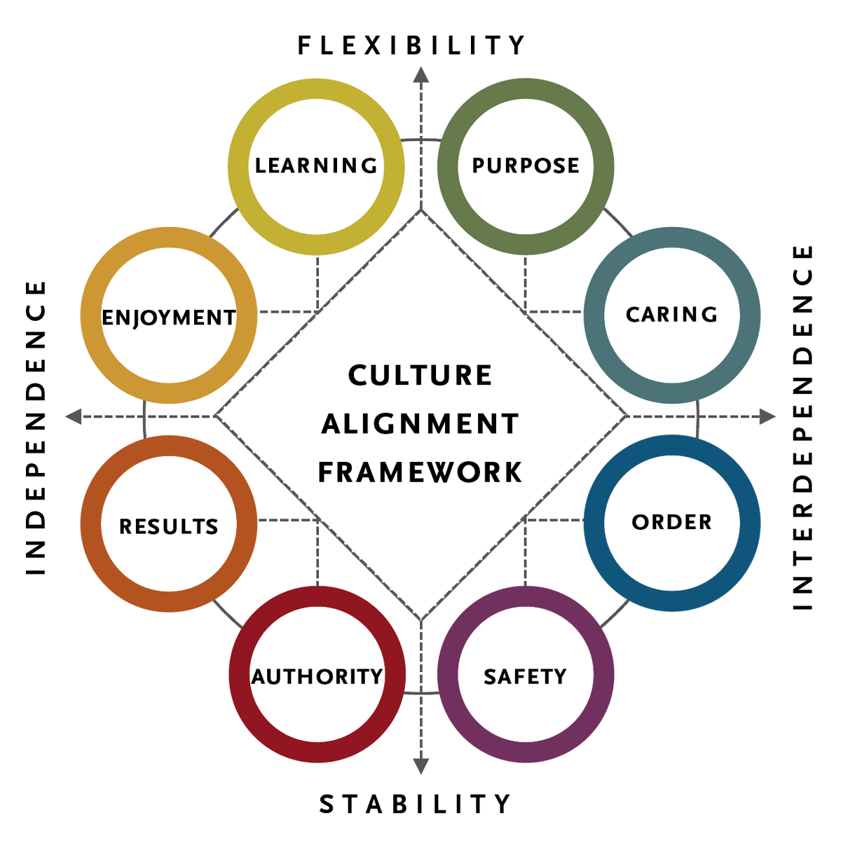
(Groysberg et at. 2028)

6.1-Organisational Culture as a Barrier
Although British Airways has made significant progress in modernising and organisational culture has a several culture barriers and this continuo to affect to organisation effectiveness and one major challenge is bureaucratic inertia ,where hierarchical structure can slow decision-making and reduce organisational agility despite efforts to simplify processes (Johnson et al.,(2020). This can delay innovation, reduce responsiveness to customers need, and limit the airline ability to adapt quickly in the highly competitive aviation industry (British Airways, 2024)
Another barrier organisation is employee resistance to change, particularly among long-serving staff who may be more comfortable with traditional leadership style, and established organisation often experience resistance when introducing new technologies, leadership approaches, and organisational changes like resistance can reduce employee engagement and slow the implementation of digital transformation and collaboration working practices (kotter,1996).

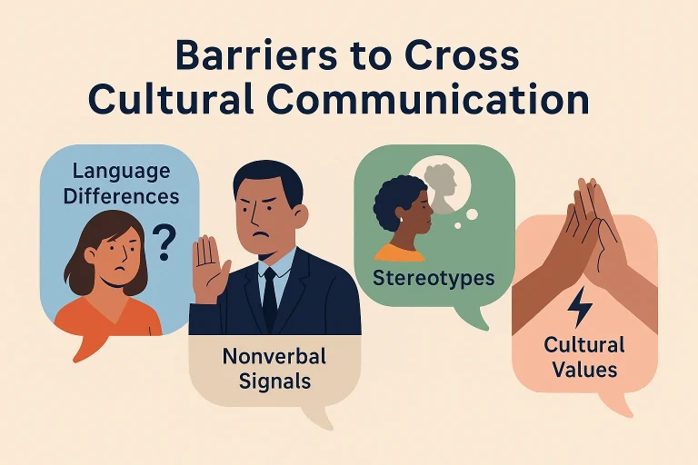
(Hofstede, Hofstede and Minkov, 2010)

7.0- Conclusion
- British Airways demonstrates how organisational structure and culture work together to support business performance and long-term success. The organisational structure promotes clear responsibilities, operational efficiency, and specialist expertise, while its culture of safety, customer focus, innovation, and teamwork supports employee engagement and service quality. And these strengths enable the airline to remain competitive in the global aviation industry. Also, the organisation faces challenges, including departmental silos, slower cross-functional communication, and the need to improve decision-making agility in a rapidly changing business environment. (Robbins and Judge, 2023)
- British Airways continue competitive strengthening collaboration between departments , investing in leadership development, and encouraging a culture of continuous improvement and adaptability, and addressing these challenges while maintaining a strong organisational values, and improve operational performance, enhance customer satisfaction, and sustain in competitive advantage in the evolving aviation industry(British Airways, 2025)

8.0 RECOMMENDATIONS
British Airways should continue improving collaboration across departments to reduce communication barriers and support faster decision-making and the airline should investing in leadership development and continuous employee training to help staff adapting to organisational changes and new technologies, also encouraging open communication and employee involvement in decision-making this can resistance to change and increase engagement. ( Kotter, 1998)
British Airways should continue investing in digital innovation and data driven systems to improve operational efficiency and enhance the customers experience, and strong organisational culture maintaining focused on safety, teamwork, and continuous improvement will be enable the airline to respond effectively to changing customer needs and market conditions and can improve service quality. Strengthen employee performance, increase organisational flexibility, and maintain its competitive advantage within the global aviation industry (Schain and Schein, 2021).

9-Reference
1-British Airways (2024) Annual Report and Accounts 2023. Available at: https://www.iairgroup.com/en/investors/financial-information/annual-report (Accessed:14 July 2026)
2-International Air transport Association (IATA) (2024) Annual Review 2024, Available at: httpps://www.iata.org/en/publications/annual-review/ (Accessed:14 July 2026)
3-Schein,E.H. and Schein, P.A.(2021) Organizational Culture and Leadership. 5th edn. Hoboken, NJ: JOHN Wiley & Sons. Available at: https://www.wiley.com/en-us/Organizational+Culture+Leadership%2C+5th+Edition-p-9781119212041
(Accessed: 14 July 2026)
4-Kotter,J.P. (1998) Leading Change. Boston, MA: Harvard Business School Press. Available at: https://store.hbr.org/product/leading-change/6966 (Accessed: 14 July 2026).
5-British Airways (2024) Sustainability. Available at: https://www.britishairways.-com/content/information/about-ba/sustainability (Accessed: 14 July 2026).
6-International Airline Group (2024) Annual Report and Accounts 2024. Available at: https://www.iairgroup.com/en/investors/results-and-report/annual-report (Accessed: 14July 2026).
7-Johnson, Gusiches, K., Whittington, and Angwin. (2020) Exploring Strategy. 12th edn. Harlow: Pearson
8-Robbins,S.P. and Judge, T.A. (2023) Organizational Behaviour. 19th edn. Harlow: Pearson.
9-Ogbonna,E.and Harris, L.C. (2000) ‘Leadership style, organizational culture, and performance: Empirical evidence from UK companies’, International Journal of Human Resource Management, 11 (4), pp. 766-788. Accessed: (15 July 2026).
10-Hartnell, C.A, Ou, A.Y. and Kinicki, A. (2011) Organizational culture and organizational effectiveness: A meta-analytic investigation of the competing values frameworks theoretical suppositions, Journal of Applied Psychology, 96(4), 677-694. Accessed: (15 July 2026).
11-International Airlines Group (2024) Annual Report and Accounts 2024. Available at: https://www.iairgroup.com/en/investors-and-shareholders/financial-reporting/annual-reports ( Accessed: 15 July 2026).
12-British Airways (2025) People: Inclusion, Diversity & Representation. Available at British Airways-People: Inclusion, Diversity & Representation. (Accessed : 15July 2026)
ttps://upload.wikimedia.org/wikipedia/commons/2/2b/Boeing_777-236ER_-_British_Airways_(G-VIID).jpg British_Airways_(G-VIID).jpg

