

Cloud-Based Web Services

Name: Sai Harsha Jangili
Student ID: 1908692

Introduction
Cloud-based web development entails the design, development, and deployment of cloud web applications that are forms of highly technologically evolved web applications. Currently, there are numerous sophisticated web- and cloud-based solutions that allow users to create simple web, mobile or computer applications within a short time [1]. This paper explains the meaning of cloud computing, the benefits, and drawback associated with cloud-based web development, and costs. Besides, examples of cloud computing are given and their reliability and scalability examined. Further, virtualisation and containerisation related to cloud computing are assessed. The development process for node.js applications that can be executed in Docker is also evaluated.

Cloud Computing
Cloud computing is gradually being adopted by organisation in various industries. The technology entails a novel type of data storage of the contemporary environment. Though it comes in multiple variations, and it is not usually easy to select the service provider with the ideal type to fit the business needs [1]. To better understand cloud-based computing incidence, the technology is typically used by organisations or individual users to access information technology resources and services on demand through the Internet [2]. The computing technology entails the storage and access to data and other computing services in most cases remotely over the internet rather than the conventional computer's hard drive. Besides, cloud computing is supported by the idea of online data storage and application hosting. This is as opposed to the traditional technique of storing and launching the application from a local hard drive [2].
The cloud computing technology should however not be mistaken with the technology behind Network Attached Storage (NAS), utilised by various organizations using a computer server in local (local server). These local networks and servers are different from the underlying information technology of cloud computing [2]. Though, multiple NAS techniques permit remote data access through the Internet. Overall, cloud computing techniques entail the exchange, access, and storage of information, software application, and other IT asset over the Internet platform. Alternatively, if the exchange, storage, and access of these resources are is synchronised with other information technologies on the Internet. In order to utilize the web application hosted in the cloud perform, users that needed is to execute the software, should have internet access. Figure 1 below illustrates an architecture of a typical cloud-computing [2].
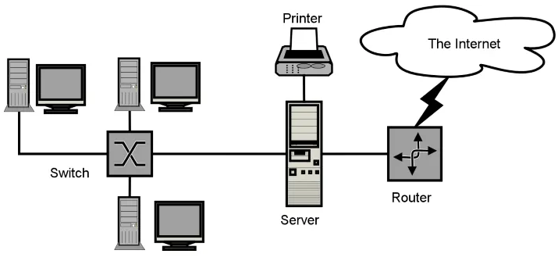
Figure 1: Cloud computing Architecture [2]

The cloud image in Figure 1 is used figuratively to illustrate the architecture and data flow of could computing over the internet. This comparison dates back to the time when the gigantic infrastructures of internet server farms were represented in the form of a large white cloud that gets connections and distributing information whereas floating [2]. Cloud computing technology allows companies to acquire information technology assets as a service. This is comparable to how electricity is consumed, unlike the creation and maintenance of IT infrastructure internally [2].
According to the US National Institute of Standards and Technology, Cloud Computing is a model for instituting on-demand network access to a shared package of configurable computing assets [3]. These resources are for instance networks, servers, storage space, software, and services [3]. The cloud-computing technology can be provisioned rapidly with minimal management effort and interaction with the service provider. The Cloud model emphasises availability and consists of five significant attributes, three delivery models, and four deployment models [3].

Benefits and Drawbacks

Benefits
Cloud computing offers several tools that are easy to use. As such makes it possible to overcome the traditional constraints of information technology tools, from installation to updating, including data storage management. Since the cloud service provider takes care of everything, the company can focus on its core business. Cloud Computing, allows remote collaboration since users can assess data and applications instantly regardless of their physical location [4]. It is an ideal solution for sharing data and creating a collaborative platform with ease, in a situation where employees are increasingly nomadic and where teleworking is booming. Cloud application service providers also ensure very high service availability, which is a valuable guarantee for companies. Also, cloud computing makes it possible to do away with the acquisition of equipment. It can be an ideal solution for young companies who can start their activity without significant investment. The cloud application can assist companies to manage their additional needs and their peaks of daily business operation at controlled costs [4].
Cloud computing offers numerous benefits for company users and end-users. The top three advantages are self-service provisioning, elasticity, and pay-as-you-go. Self-service provisioning enables end-users to access business information technology assets real quick and on-demand. Elasticity offers the opportunity to streamline the usage of resources based on the needs of the business. Subsequently, pay-as-you-go allows businesses to pay only for the resources spent [4]. Other benefits of cloud computing are the ability for the company to test the business plan affordably and easily. Cloud computing supports business agility and helps solve information technology management issues simply without having to make a long-term commitment [6]. During application development, cloud computing reduced research time for developers on application settings.

Drawbacks
Some key drawbacks to clouding computing are security issues, limited flexibility, minimal control, host lock-in, high costs, and uptime [4]. Data confidentiality and security emerge given that the data is hosted outside the company. The service provides hosts the data of the user company. It can therefore pose a potential risk for the company to have its data misused or stolen. It is therefore a matter of ensuring that the provider has sufficient security and that it offers a confidentiality policy concerning user data [5]. Dependency is another drawback of the cloud computer since if the company needs specific features, it can be difficult to convince the vendor to offer those features. And in general, if there is a problem, the business depends on the supplier's customer service. It is thus a matter of selecting a reliable and trustworthy cloud service provider [5].
Bandwidth can increase the company budget: The bandwidth that would be required to put this in the cloud is gigantic, and the costs would be so great that it is more beneficial for the company itself to purchase the storage than to hire an external cloud service provider [4]. The cloud-based application performance may be reduced: A public cloud might not improve application performance. Besides, cloud reliability is a significant risk when putting an application that gives competitive advantages or that contains customer information in the cloud [5]. Company size matters for the deployment of this technology; for instance, if the company is big then its resources are big. This will need adequate spending on the cloud. Though, the productivity gains are much greater when the company shifts from a small consumption of resources to a higher consumption [5].

Costs Implication for Cloud Computing
Cloud computing tends to turn capital expenditure into operating expenses, as companies buy their IT systems as a service, rather than physical servers [7]. This helps businesses to eliminate the sharp increases in IT spending that traditionally accompany new projects. Businesses are increasingly adopting cloud computing infrastructure and services to increase flexibility and relieve pressure on capital budgets. The aspect does not imply that cloud computing is necessarily or always cheaper than keeping applications in-house. Applications that have a stable and predictable demand for computing power can prove to be less expensive. In principle, these cloud services are invoiced based on a scheme "pay-for-use". For instance, when the company rents a (virtual) server in Amazon EC2, the company does not pay for the duration and the passing used [8]. As a result, the basic cost of cloud computing is much lower, as it is not necessary to make big investments. This also allows small businesses that do not have the capital necessary to operate a data center and to enter the competition with big enterprises [8].
On the negative side, cloud computing attracts numerous hidden costs during its implementation. When assessing the cost savings with cloud computing, the review would indicate that the real costs of the service provider could be affordable [9]. However, in practice, the machine virtual may not work efficiently thus requiring the use of a physical machine and in addition, items such as the bandwidth charges, the monitoring, support, and maintenance might attract additional cost in pricing and the use of alternative service if the server slows down [9]. By way of illustration, virtual servers Might attract jurisdiction taxation costs for availability, network traffic authorisation, and time reception. The additional charges might also comprise the support, monitoring, and maintenance) of a power of calculation where it allows a volume defined for the network traffic greater than 4000 Gb [10].

Cloud computing Scenarios/Examples
There are three main examples of cloud computing services that businesses can adopt to support their online service provision. Internet-as-a-Service (IaaS), Platform-as-a-service (PaaS), and Software-as-a-Service are prevalent examples of computer computing technologies. Amazon EC2 and Backspace are examples of public IaaS while V-Plex, Fujistu, and EMC offer private IaaS. Microsoft Azure, App Gear, and Force.com are public PaaS whereas Oracle Fusion, IBM, and CloudBurst provide private PaaS services. Sales, NetSuite are also good examples of public SaaS [2].
Adobe Spark provides SaaS for video editing online, photo editing. The platform has had to manage more than seven hundred thousand entries in three days and more than twenty-five thousand simultaneous users by time. This peak could be handled without problems by Adobe Spark through the infrastructure Amazon [11]. To small businesses, Amazon may be a solution effective to be able to provide a service that adapts to a request may vary strongly. Another example is the PaaS use of cloud computing by MySpace. Generally, MySpace has features to simulate more than one million simultaneous users. Besides, the social network platform has a one-time and intensive platform supported by Amazon web service to support effective online data exchange and collaboration as well as video chatting [12].

Reliability and scalability

Scalability
Most PaaS is highly scalable, for instance, Windows Azure Microsoft as a.NET cloud platform on which the user can deploy the application that it has itself developed. The user aspects of scalability and reliability are guaranteed [14]. In PaaS, the user has application control that it deploys, but also data that are generated while the PaaS architecture is a generic and portability and is less easy to ensure than in IaaS [15]. Ideally, in order to ensure good scalability (and sometimes also for security reasons), the platform can prevent the use of some functions (e.g. prohibition of certain types of SQL queries that are considered to be very performance) [15]. In practice, this translates into a level of portability diminished and a J2EE application correct could not be deployed on one or the other platform from PaaS as the result of the use of some functions prohibited by the PaaS provider service [14]. Deactivation of some features.
Platform as a service is powerful, for instance, more than two billion videos are viewed daily on YouTube (every minute does not add less than 24 hours of new video equipment), and billions of web pages are viewed and indexed. PaaS and SaaS can handle graphically in-line images and much more. Most SaaS and PaaS RELY on technology to make available a number almost infinite of resources (power of calculation, storage of data), all in a flexible manner [16]. A scenario simulation was conducted on MySpace to simulate one million concurrent platform users. The simulation was a one-time and rigorous test achieved through Amazon. To achieve this, they used 800 instances of Amazon for 20 minutes [13]. It was established that one million users used the platform simultaneously at a speed network of 16 gigabits by second and six terabytes of data transferred by time and 77000 hits by second [13].

Reliability
Reliability across SaaS, PaaS, and IaaS services vary however most of these services such as observed in Amazon web services, Google App, YouTube is reliable. Service providers of public cloud, in general, offer a good level of availability in most cases above 90% [18]. These cloud computing architectures are robust given that the failure of an individual component does not result in an unavailable reliance system.

Importance of Scalability and Reliability in Cloud-based Systems
Scalability allows the business to adapt to the changing requirements of an application within the limits of the infrastructure. According to the scalability principle, IT resources are added or deleted in a limited procedure to meet the demands of the applications, when necessary [19]. Conversely, for reliability, the downtime should be eliminated since its impact is much greater than in the case of a seller, traditional, given a large number of users. Besides, multiple cloud-based solutions depend on each of the other, for instance, a SaaS application running on the infrastructure IaaS another provider: in the event of failure of a service (IaaS), all the as-a-service in depending we will be impacted [17]. Another importance of reliability is that high productivity for companies is assured since business continuity is guaranteed even when the cloud-based platform experiences downtime [19].

Virtualisation and Containerisation

In the context of Docker, containerisation entails an operating system through which cloud-based applications are executed in isolated user spaces referred to as containers, all utilising the same shared operating system (OS). Conversely, Virtualisation utilises software to develop an abstraction layer over computer hardware, which permits the hardware components of a single computer. This might include computer processors, memory, and storage, which are separated into numerous virtual computers, prevalently known as virtual machines (VMs) [20]. Major differences exist between the latter and the former which include the following.
Regarding insulation, In the case of virtualisation, VM isolation is performed at the hardware level (processor / memory / storage) with virtual access to the cloud's resources through a hypervisor [21]. Further, virtual machines offer an environment with more IT resources than most applications need. Conversely, in the case of containerisation, isolation is performed at the level of the OS. A container would execute natively under Linux and will share the host machine's kernel with other containers [21]. Using little memory compared to any other executable thus making it lightweight as illustrated in Figure 2 below.
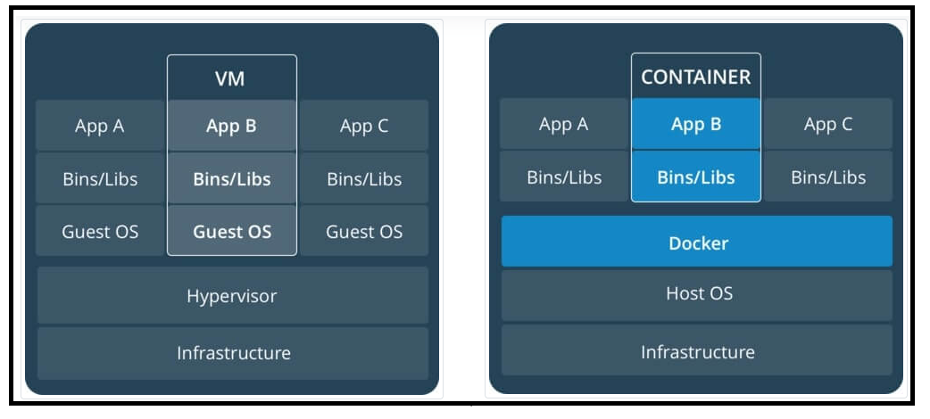
Figure 2: Insulation between virtualisation and containerisation
Containers offer a technique to virtualise an operating system in order to execute numerous workloads on a single operating system request. This is as opposed to virtualisation, where the computer hardware is virtualised to execute numerous operating system requests. Containers’ scalability, reliability, and portability streamline application development [21]. Regarding maintenance and upgrade, and patching of the OS, VMs that are upgraded one by one on each guest OS should be patched independently. In contrast, in containers, only the container host OS (the hardware hosting the containers) should be upgraded. This shortens considerably maintenance [21].

Evaluate development of Node.js Application in Docker 435
Docker is an open platform for developing, shipping, and running containerised applications. Docker allows you to separate your applications from your infrastructure so that you can deliver software quickly [22]. During the development of the Node.js, system to be executed by Docker, I followed the simple steps which included not launching the application as root, hid the node_modules, and utilised the application’s CI / CD system or internal server to keep sensitive credentials out of the container image then the system was made explicit with construction tags. The following steps were used;
First, I developed a new directory where the application’s files are hosted then in the directory I created a package.json file that defined the system and its dependencies. Then I executed npm install and generated a package-lock.json which was copied in the Docker image. Thereafter I wrote a server.js file that described the software in Express.js framework as shown in the snippet below.
'use strict;

const express = require('express');

// Constants
const PORT = 8080;
const HOST = '0.0.0.0';
// software
const app = express();
app.get('/', (req, res) => {
res.send(My App);
});

app.listen(PORT, HOST);
console.log(`Running on http://${HOST}:${PORT}`);
I then created an empty file in the directory known as Dockerfile and executed the Dockerfile. Then I defined the image to develop the application from using FROM node:14. Then I created the directory in which the application will be hosted as shown in the snippet below.
# Create app directory
WORKDIR /usr/src/app
The image was obtained from the installed Node.js and NPM in the application dependencies through npm binary. The application source code was bundled inside the Docker image utilising COPY command using port 8080 and created EXPOSE instruction to map the Docker function. I then defined the command to execute the application using the CMD command that described the application’s runtime as shown in the snippet below.
your server:
CMD [ "node", "server.js" ]
The Docker file obtained a new look as shown in snippet below;
FROM node:14
# Create app directory
WORKDIR /usr/src/app
# where available (npm@5+)
COPY package*.json ./
RUN npm install
# Bundle app source
COPY . .
EXPOSE 8080
CMD [ "node", "server.js" ]

The next step was to build the Docker image, as I used the application Dockerfile to execute -tflag command allowed to tag the image docker images command:
docker build . –t <your username>/node-web-app

The image was displayed as follows
$ docker images

REPOSITORY TAG ID CREATED
node 14 1934b0b038d1 5 days ago
<user>/node-web-app latest d64d3505b0d2 1 minute ago
Then the image was executed using -druns command using the detached mode in the container, leaving the container running in the background. The -pflag redirects a public port to a private port within the Docker container [22].
docker run -p 49160:8080 -d <user>/node-web-app
After which the app was printed as shown in the snippet below;
# Get container ID
$ docker ps
# Print app output
$ docker logs <container id>
# server
Running on http://localhost:8080

References
[1] Pike, R., Pittman, J.M. and Hwang, D., 2017. Cloud-based Versus Local-based Web Development. Information Systems Education Journal, 15(4), p.52.
[2] Harkut, D. G., Kasat, K. N., & Shah, S. A. (2019). Introductory Chapter: Cloud Computing. In: Cloud computing: technology and practices (pp, 1-10). London, IntechOpen.
[3] Badger, L., Grance, T., Patt-Corner, R. and Voas, J., 2012. NIST SP 800-146 cloud computing synopsis and recommendations. Nat. Inst. Standards Technol., Gaithersburg, MD, USA, Tech. Rep.
[4] Harkut, D. G., Kasat, K. N., & Shah, S. A. (2019).Advantage and Disadvantage of Cloud Computing. In: Cloud computing: technology and practices (pp, 4-7). London, IntechOpen.
[5] Shaikh, F.B. and Haider, S., 2011, December. Security threats in cloud computing. In 2011 International conference for Internet technology and secured transactions (pp. 214-219). IEEE.
[6] Liu, S., Yang, Y., Qu, W.G. and Liu, Y., 2016. The business value of cloud computing: the partnering agility perspective. Industrial Management & Data Systems.
[7] Yoo, C.S., 2011. Cloud computing: Architectural and policy implications. Review of Industrial Organization, 38(4), pp.405-421.
[8] Jadeja, Y. and Modi, K., 2012, March. Cloud computing-concepts, architecture and challenges. In 2012 International Conference on Computing, Electronics and Electrical Technologies (ICCEET) (pp. 877-880). IEEE.
[9] Dillon, T., Wu, C. and Chang, E., 2010, April. Cloud computing: issues and challenges. In 2010 24th IEEE international conference on advanced information networking and applications (pp. 27-33). IEEE.
[10] Mazrekaj, A., Shabani, I. and Sejdiu, B., 2016. Pricing schemes in cloud computing: an overview. International Journal of Advanced Computer Science and Applications, 7(2), pp.80-86.
[11] Brown, C.W. and Nyarko, K., 2013. Software as a service (SaaS). In Cloud Computing Service and Deployment Models: Layers and Management (pp. 50-69). IGI Global.
[12] Miller, M., 2008. Cloud computing: Web-based applications that change the way you work and collaborate online. Que publishing.
[13] Wirtz, B.W., Schilke, O. and Ullrich, S., 2010. Strategic development of business models: implications of the Web 2.0 for creating value on the internet. Long range planning, 43(2-3), pp.272-290.
[14] Aggarwal, V., Sengupta, S., Sharma, V.S. and Santharam, A., 2012, November. A scalable master-worker architecture for PaaS clouds. In 2012 SC Companion: High Performance Computing, Networking Storage and Analysis (pp. 1268-1275). IEEE.
[15] Badger, M.L., Grance, T., Patt-Corner, R. and Voas, J.M., 2012. Cloud computing synopsis and recommendations. National Institute of Standards & Technology.
[16] Jamsa, K., 2012. Cloud computing: SaaS, PaaS, IaaS, virtualization, business models, mobile, security and more. Jones & Bartlett Publishers.
[17] Snyder, B., Ringenberg, J., Green, R., Devabhaktuni, V. and Alam, M., 2015. Evaluation and design of highly reliable and highly utilized cloud computing systems. Journal of Cloud Computing, 4(1), pp.1-16.
[18] Bauer, E. and Adams, R., 2012. Reliability and availability of cloud computing. John Wiley & Sons.
[19] Mesbahi, M.R., Rahmani, A.M. & Hosseinzadeh, M. Reliability and high availability in cloud computing environments: a reference roadmap. Hum. Cent. Comput. Inf. Sci. 8, 20 2018. https://doi.org/10.1186/s13673-018-0143-8
[20] Roy, G., Washbrook, A., Crooks, D., Qin, G., Skipsey, S.C., Stewart, G. and Britton, D., 2015, December. Evaluation of containers as a virtualisation alternative for HEP workloads. In Journal of Physics: Conference Series (Vol. 664, No. 2, p. 22-34). IOP Publishing.
[21] Li, W. and Kanso, A., 2015, March. Comparing containers versus virtual machines for achieving high availability. In 2015 IEEE International Conference on Cloud Engineering (pp. 353-358). IEEE.
[22] Mardan, A., Mardan and Corrigan, 2018.
Node Microservices with Docker and AWS ECS. In Practical Node Second Edition. pp, 431-472s. Apress, Berkeley, CA. https://doi.org/10.1007/978-1-4842-3039-8

