Surveying Principals in Construction
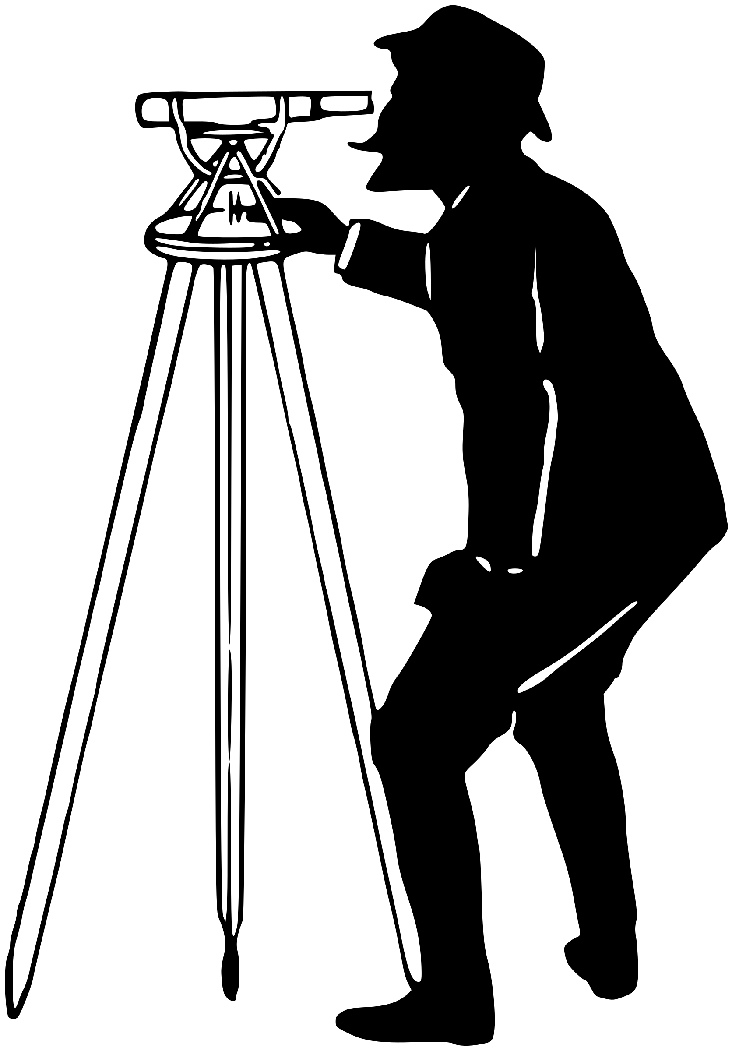

Elliott Lewis
Table of Contents

Introduction 3
Surveying Principals 3
Surveying classifications 3
Geodetic surveying 3
Plane Surveying 3
Classification based on equipment 4
Classification based on method 4
Triangulation 4
Traversing 4
Trilateration 5
Classification based on purpose 6
Forestry survey 6
City Survey 6
Hydrographic survey 7
Cadastral survey 7
Mine survey 7
Photogrammetric surveys 7
Surveying listed buildings 8
Listed buildings 8
Reason for building survey 8
Desktop study 9
Equipment 9
Heat loss 9
Damp 9
Measurement where access is limited 10
Survey report 10
Risk 10
What does a good report contain? 11
Conclusion 11
References 11

Introduction
This report will cover the recognised surveying classifications before discussing one of the classifications in more depth and exploring the different types of surveying within it. It will discuss the application of digital surveying technologies in the surveying of listed buildings and provide examples of equipment, methods used and how this data can be captured and used to produce calculations and technical reports.

Surveying Principals
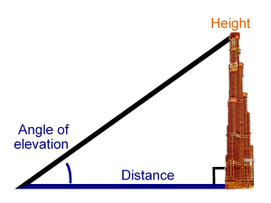
Surveying is the taking and using of measurements such as altitude, angles and distances to produce maps and plans for buildings, roads and infrastructure. These plans can then be used to set out the roads or buildings by surveying the land and accurately designing the proposed construction on the ground. The final main purpose is using the 3 core forms of measurement to analyse engineering operations for example assessment of a building before it’s sold or surveying listed buildings.

Surveying classifications
Surveying is primarily classified as:
1.Geodetic Surveying
2. Plane Surveying

Geodetic surveying
Geodetic Surveying is used to determine areas and locations of points on the earth’s surface that are so big the curvature of the earth must be taken into account. These large areas, typically over 250km2, are mapped by having 2 stations many kilometres apart with the latitude and longitude of each point determined by astronomical means. The distance between both stations known as the curved line or base line is then accurately calculated. The position of the third point is determined by the angle it makes with each end of the curved line and this is continued until the entire area has been mapped (Columbia University, 2013)

Plane Surveying
Plane surveying is used mainly for smaller areas typically under 250km2 and where high precision is not required. This method ignores the curvature of the earth as unlike geodetic surveying the line between both station is considered as a straight line (Civil Engineering Terms, 2018)

Classification based on equipment
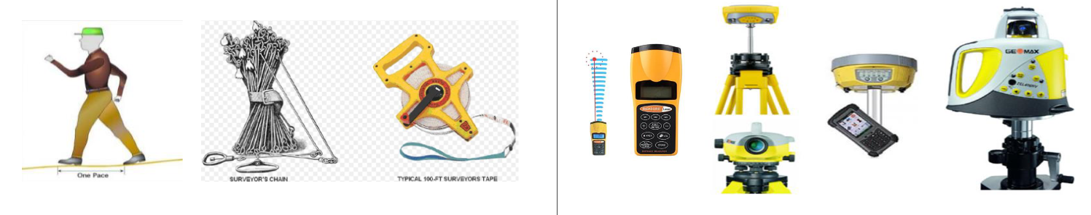
Surveying can be classified based on the equipment used. Over the years, traditional surveying equipment used to measure distance angle and altitude have been replaced by more efficient digital technologies saving time and money. See image below showing pacing, chains and tape which for hundreds of years have been used to carry out liner measurements to construct many different structures. See image below showing the modern digital replacements commonly used in industry today. Although a laser can accurately calculate distances the fundamentals of measurements are the same and have been for centuries.

Classification based on method
There are three main methods that can be used in surveying.

Triangulation
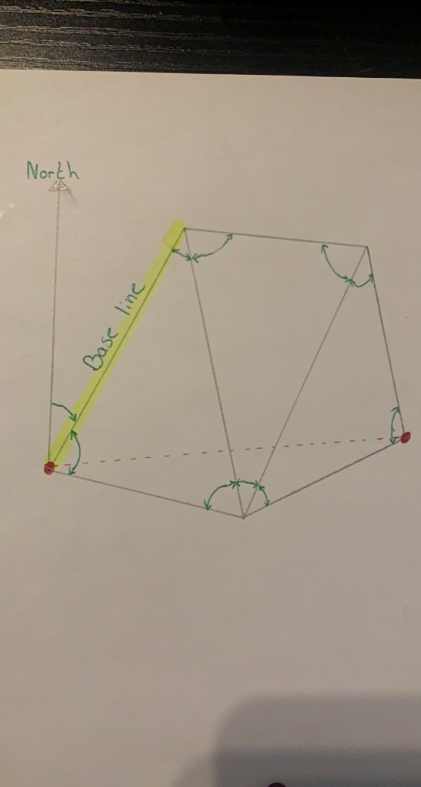
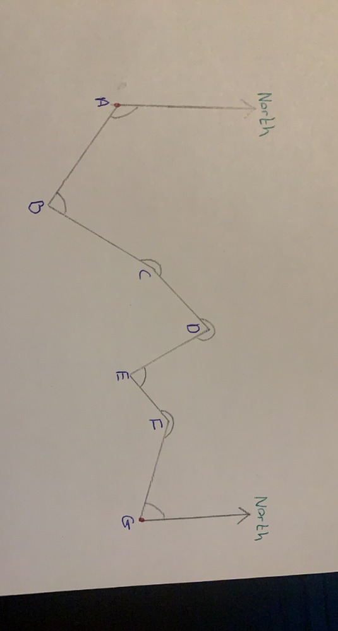
See image below showing how triangles are used to form a series of control points from 2 known stations.

Traversing
Traversing uses a known point to begin a series of connected lines.
Closed tied starts from a known point and ends at known point.
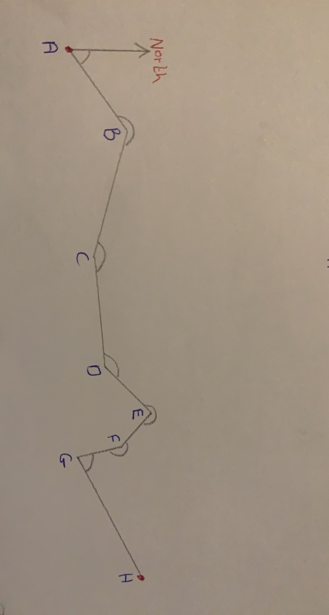
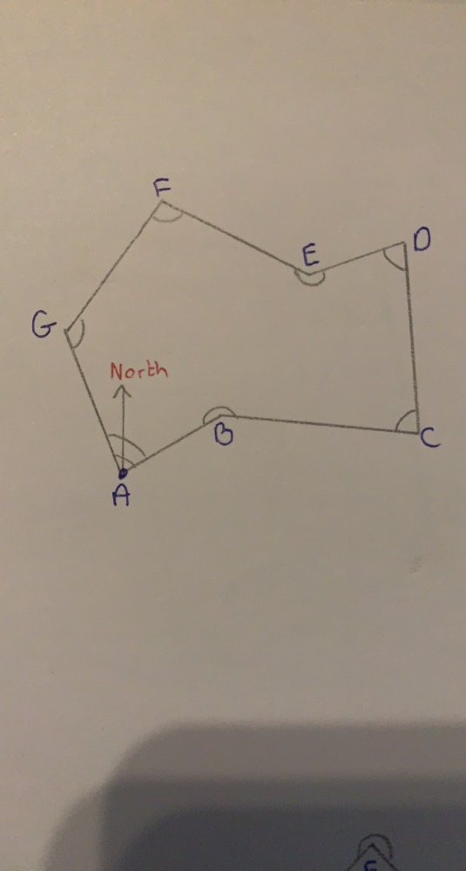
Closed loop starts at known point and ends in the same place it started, see below.
Open starts at known point finishes at unknown point, see image below.

Trilateration
Is the method of surveying in which the lengths of the sides of a triangle are measured by electronic means and used to compute angles. See below.
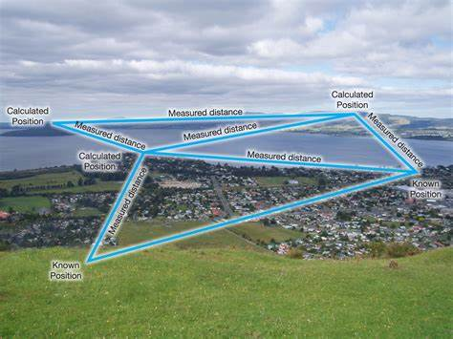
Surveying Methods | Intergovernmental Committee on Surveying and Mapping (icsm.gov.au)

Classification based on purpose
There are many different types of surveying dependant on what purpose the survey needs to achieve.

Forestry survey
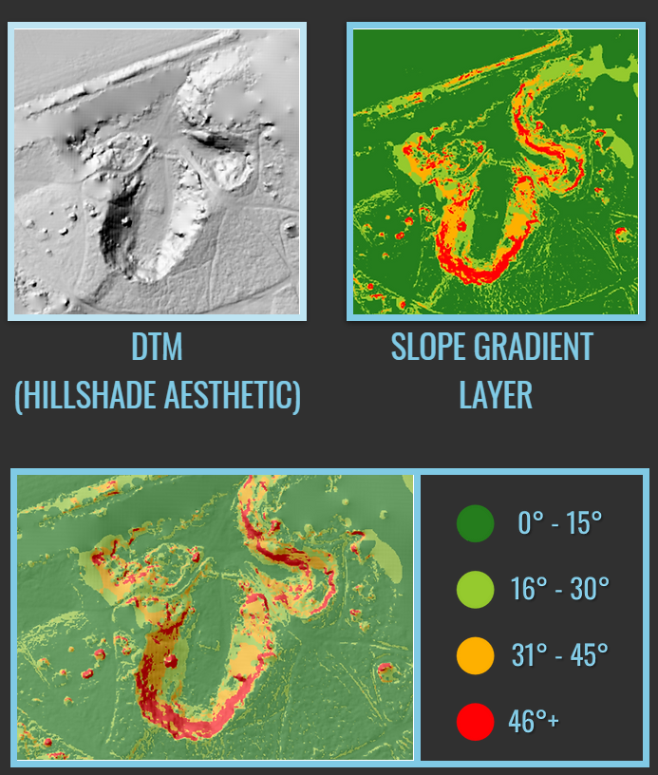
Forestry surveys are used to map trees and vegetation using modern digital technologies to gather accurate geospatial data. Information gathered from aerial photography during the survey can be used to identify boundaries, tree health, storm damage and map this data on interactive software and create layers to allow for different elements to be viewed. Using the geospatial and elevation data from the survey areas of land that are more sloped can be identified which can help indicate the suitable and unsuitable areas to plant more trees and vegetation (see figure 12). These surveys can play a huge part in increasing the manageability of large woodland areas and also monitor environmental factors (Forest surveys, 2020)

City Survey
City surveys are used to create maps available to the public that have information about property lines and boundaries, landmarks, areas that are protected such as for ecological and many other important elements people may want to know mainly when considering planning. The Swansea local development plan is a city survey that is available online and is presented interactively allowing for layers to be turned on and off dependant on what information is being looked for (Swansea development plan, 2019)
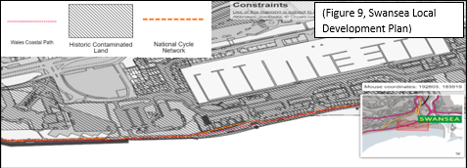
Example of Swansea Mariana

Hydrographic survey
Hydrographic surveying also referred to as underwater surveying focuses on water whether it be lakes, the sea or coasts lines for example. The surveys focus on elements such as water depth, tidal measurements and underwater objects such as ship wrecks, coral, and rocks. A type of hydrographic survey is the bathymetric survey which is carried out by a moving ship as it collects data. Due to the ship moving unlike a land survey where the apparatus is stationary, certain allowances are made to compensate for the ship’s movements (Marine site, No date)

Cadastral survey
A cadastral survey is used mainly to legally define boundaries and can be used in courts during disputes. Rather than being scientific a cadastral survey is mainly used for its legal authority and accuracy. A cadastral survey will show accurately and in line with the properties deeds for the land (Info bloom, 2021)

Mine survey
Mine surveys are used within the mining industry for many different purposes. They can be used to explore potential new mining opportunities. This is done by collecting underground and surface data and merging them from 3D view maps indicating the stratifications of the ground and areas of significant interest. Mine surveys can also be used for planning. Ground and aerial surveys can help plan and locate potential new access roads, power lines etc for proposed new sites. Surveys can also be used to monitor and track performance and production by using lasers and drone to calculate volumes of in situ ore and stockpiles. Finally, laser scanning and drones can be used by mining surveyors to calculate and determine heap slope stability and monitor tailings of dams, reducing the risk of an environmental disaster. (Mining survey Specialist, 2020)

Photogrammetric surveys
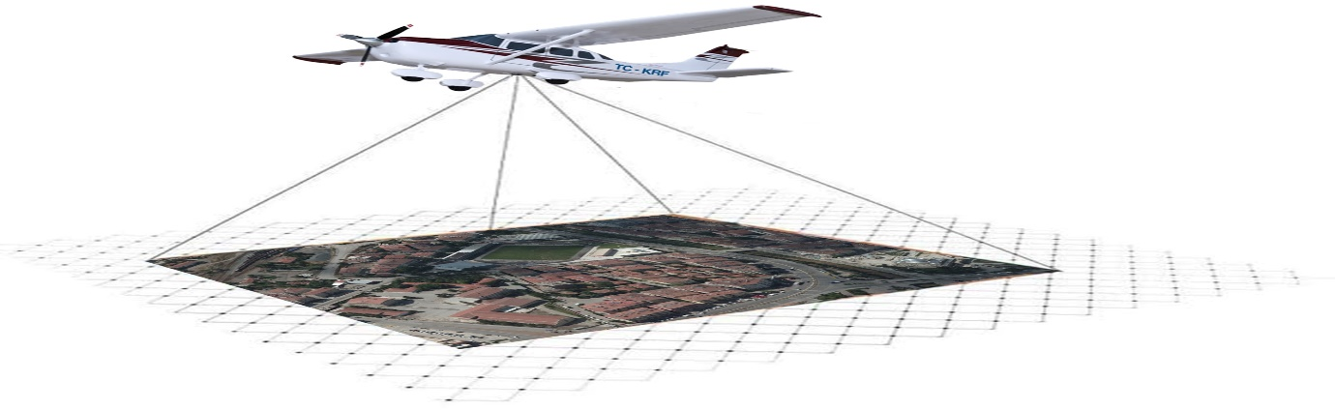
Photogrammetric surveys map and gather data through the process of recording, measuring and interpreting photographic images and models of electromagnetic radiation. The mathematics behind photogrammetry is triangulation as discussed at the beginning of this report. Lines of collimation can be developed from every camera, down to the points on the object by recording from at least two different locations. These lines intercept mathematically to create 3D coordinates of the required points. Photogrammetric surveys can produce extremely accurate topographic maps and plans. (GeoGis,2020)

Surveying listed buildings
To conduct a high-quality survey on a listed building its vital the survey is planned and provides detailed and easy to follow recommendations and data regarding the structures condition.

Listed buildings
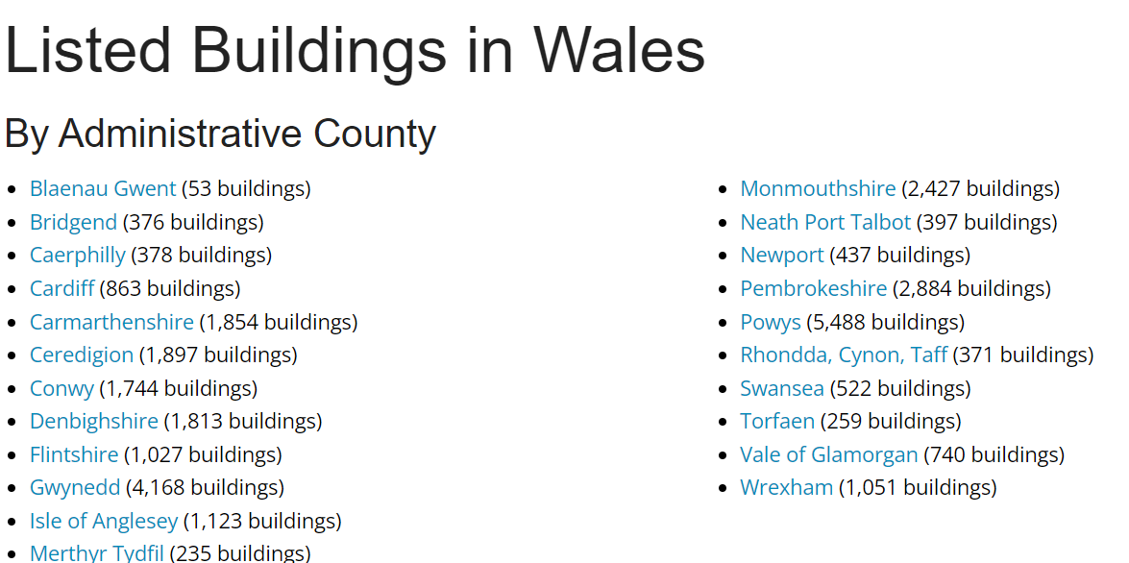
Buildings which have important architectural or historical importance are marked as being listed, meaning any proposed work must be approved to ensure it does not affect its importance. In 2016 there were over 30,000 listed buildings in Wales and 376,00 in England. Listed building are classified by 3 grades. Grade I being the most significant buildings and are of exceptional interest account for only 2.5% of all listed buildings. Grade II * are buildings that are very important and considered to be more special than Grade II buildings. Grade II* account for 5.5% of all listed buildings in Wales and England. Finally accounting for the other 92% are Grade II listed buildings which have architectural or historical importance. These are the most likely listed properties to be privately owned (Home Protect, 2021). See figure below for a breakdown of the number of listed buildings in different Welsh counties. It is evident to see that more rural counties such as Carmarthenshire, Gwynedd and Powys have significantly more listed buildings than cities such as Cardiff and Swansea. This could be for a number of reasons such as the overdevelopment of cities and the importance of space plus also many buildings were damaged in Swansea and Cardiff during the second world war.
https://britishlistedbuildings.co.uk/wales#.Ydyi19HP02x

Reason for building survey
There are several different reasons a building survey may be carried out. The main reason would be if there were concerns regarding the property whether it be damp or subsidence. Another reason would be if a building was being sold and an assessment on its current condition is required to determine its true value. Also, if an old building was going to be redeveloped a building survey could highlight the extensity of the work required and also indicate the highest risk areas which could potentially be prioritised to make the building safe.

Desktop study
In order to conduct an efficient building survey, it is vital that all preparation work is carried out prior to visiting site. Analysing the ‘as built’ drawings will help determine the extensity of the work, the construction method of the building and will also help in determining what equipment will be required on site if, for example, there are access issues. Taking advantage of existing information such as property deeds, previous planning applications and fire plans will help build a better picture and understanding of the building which will effectively save time on site. Especially when surveying older buildings, having an understanding of the asbestos elements is not only vital for health and safety reasons, but also it provides budget costs if there is a need for a licenced contractor to carry out removal work.

Equipment
There are a variety of both traditional and modern technologies that can be used to maximised the quality and accuracy of a building survey.

Heat loss
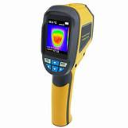
Especially when surveying listed buildings, the use of a thermal camera can be extremely helpful to identify heat loss and thermal bridging. The heat loss may be caused by damage or a construction defect. With sustainability being a very important factor, identifying issues like this can help reduce heating costs and reduce the consumption of fossil fuels. (Jewson,2021)

Damp
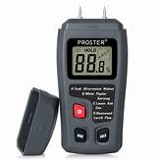
Electrical damp meters also known as moisture meters are small handheld devices with two prongs at the top. The readings are gained by pressing the prongs into a substrate and then an electrical current is passed through the prong and any moisture that’s present is transmitted to the second prong (RS, No date). The damp meter then measures the resistance to the passage of the current between both prongs, the greater the current that passes the lesser the level of measured resistance will be. The result is then given as a percentage of moisture detected withing the surface being tested (Chudley and Greeno, 2016)

Measurement where access is limited
There are many different situations where access to assess a certain element may be restricted for example if the access route is in poor condition such as a rotten stair case or even anything at height such as flat roofs or ceiling voids.

Equipment
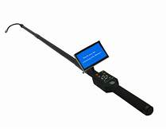
See figure of a telescopic inspection camera which can be used to take pictures of roofs and gutters which can then be used in the report to help illustrate a defect. They are lightweight and telescopic so are easily portable. Also taking advantage of equipment like the telescopic inception cameras reduce the health and safety risk to the surveyors as it reduces their need to work at height.
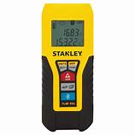
An optical distance measurement tool can be useful to calculate areas of rooms and distances quickly and efficiently which can then be used to produce building plans and drawings. They are also extremely helpful in awkward spaces and where access is restricted making the survey considerably easier than using a traditional tape measure.

Survey report
Once all the information has been captured on site, any calculations and additional information will be collated prior to starting the final report.

Risk
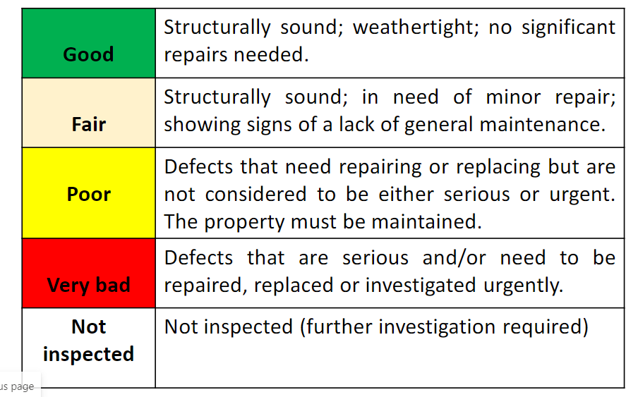
The report will include an initial assessment evaluating the condition of walls, floors and drainage looking at many things for example the type of material, construction method, detailing of damp proof course. The initial assessment is usually broken down into 4 parts and then graded good, fair, poor, very bad or not inspected. The first part being external accounting for anything outside of the property, then the building interior is accounted for and finally both the ground and services will be assessed. The information provided will be brief and accurate providing clear solutions and potentially included budget costs to provide an estimated cost of the required work. The structure of the report will be presented with a title, a brief summary, contents, introduction, main body, conclusion and then finally appendices.

What does a good report contain?
Information such as the property status, occupancy and what specialists were in attendance such as structural engineers and ecologists all should be included in the report as they hold significant importance. For example, if the building is occupied by a family with small children and the survey identified unsafe live services this is a much greater risk than if the house was unoccupied. Also, information such as the weather should be included because if it’s raining heavy at the time of inspection drainage issue or water ingress may be increasingly more obvious than a warm dry summers day. The details beyond the basic measurements could prove critical to the validity of a survey.

Conclusion
To conclude its clear to see that surveying pays a huge role in the construction and civil industry not only for ensuring accurate buildings and infrastructure are built but also for sound maintenance and longevity.

References
Chudley, R. and Greeno, R. (2016) Building Construction Handbook 11th Ed: Routledge
Civil Engineering Terms (2018) Plane Surveying. Available at: Definition of Plane Survey | Civil Engineering Terms (Accessed: 27th December 2021)
Columbia University (2013) Geodetic Surveying. Available at: www.cc.columbia.edu/cu/cup/ (Accessed: 27th December 2021)
Forest surveys (2020) UAV Mapping. Available at: https://www.forestsurveys.uk/ (Accessed: 27th December 2021)
GeoGis (2020) Photogrammetric Surveys. Available at: https://geogis.rs/en/services/photogrammetric-survey/ (Accessed: 30th December 2021)
Home Protect (2021) Classification of listed buildings. Available at: Classification of listed buildings 2019 | HomeProtect (Accessed: 28th December 2021)
Info Bloom (2021) What is a Cadastral Survey. Available at: https://www.infobloom.com/what-is-a-cadastral-survey.htm (Accessed: 27th December 2021)
Jewson (2021) Flir i3 Thermal Imaging Camera. Available at: https://www.jewson.co.uk/p/flir-i3-thermal-imaging-camera-JTH07250 (Accessed: 30th December 2021)
Marine site (No Date) A Guide to Hydrographic Surveys. Available at: https://www.marineinsight.com/tech/a-guide-to-hydrographic-surveys/ (Accessed: 27th December 2021)
Mining survey Specialist (2020) Mine Survey. Available at: https://miningsurveys.com/services/ (Accessed: 28th December 2021)
RS (No Date) Moisture meters. Available at: https://uk.rs-online.com/web/c/test-measurement/environmental-test-measurement/moisture-meters/ (Accessed: 30th December 2021)
Swansea council (2019) Swansea development plan. Available at: https://archive.swansea.gov.uk/ldp (Accessed: 27th December 2021)

