Elliot Jenkins (2029907)
5-27-2022

University of Wales Trinity St David- Richard Sutton
Reflective group project
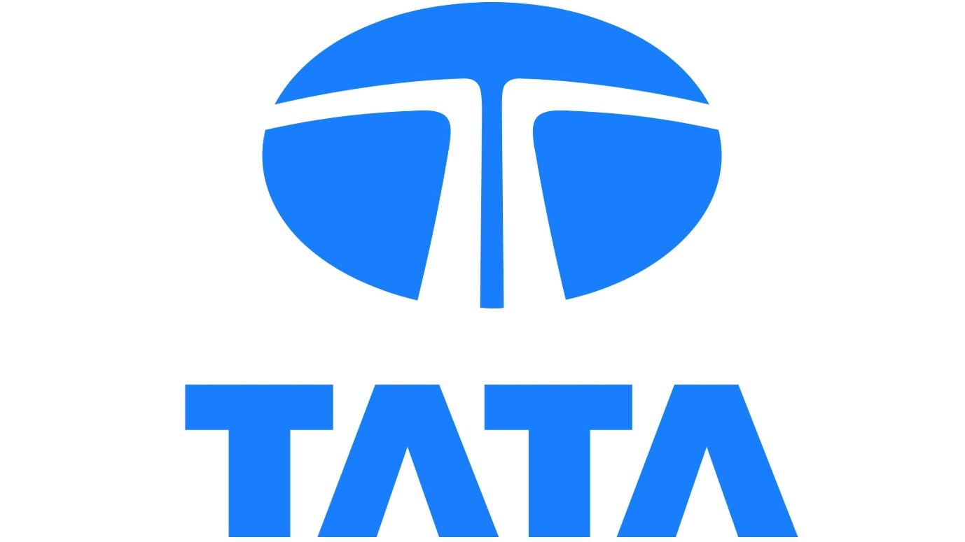

Abstract

Purpose
The purpose of this project was to identify issues within the Granulated Coal Injection Plant, Tata Steel. Selecting one issue based on research, then progressing it in order to come up with a solution to fix the issue, picking the best of my ideas based on scoring systems and feasibility issues.
Methods
Thorough research has been carried out regarding design and workplace processes. Methods used to identify range from brainstorming, RAG system and score matrix to identify the best possible solution. Following a PDS and Feasibility study to ensure all specifications are met.
Findings
Initially several issues were identified. Access to carry out maintenance on coke ploughs, posing to be the biggest threat based on delays of coke being supplied to the Blast Furnaces. Effecting the running of production and failing to hit target. A simple but effective solution to improve the access to conduct maintenance on the coke ploughs is by installing a permanent platform that doesn’t require the conveyor belt to stop when carrying out maintenance. Designed by using the internal resources such as the Design Office to ensure the platform meets requirements and regulations. This resulting in no loss of coke being supplied to the Blast Furnaces, which also minimises any stoppages in production.
Results
Following implementation, the project and design will reduce the stoppages of the conveyor belt due to maintenance, which will improve the rate of coke to the coke bunkers supplying the Blast Furnaces. Which will result in minimising any costly production stoppages due to loss of coke. Once installed there shouldn’t be any belt stoppages due to scaffolding having to be erected and removed for maintenance needed on the coke ploughs.

Table of Contents
Abstract 2
Introduction 4
Method 6
Project Problem Idea 1 ( Chosen Idea) 7
Project Problem Idea 2 8
Project Problem Idea 3 9
Project Charter 10
Project Charter 1 11
Project Charter 2 12
Selection Criteria Matrix 14
RAG Status 15
Conclusion summary 15
Feasibility study 16
Gannt Chart 17
Product Design Specification 20
Research 21
Technical Report 23
Analysis 24
References 25
Figures 26

Introduction

The steel works in Port Talbot which is currently owned by Tata Steel has been manufacturing steel since 1947. “It produces up to 3.5 million tonnes of hot and cold rolled steel coils per year” (BBC News, 2017). The Blast Furnace is a vital part of the steel making process as it provides that iron in which steel is made. Iron is made from various raw materials such as coal and coke which is supplied to the Blast Furnaces via the Granulated Coal Injection Plant, it is here that coal is prepared by crushing lump below 5mm and drying the coal from eight percent moisture down to below one percent moisture. Raw coal is firstly brought to the Granulated Coal Injection Plant via boat, which are unloaded by cranes at the harbour, it is then placed into the coal yards using bucket wheels. From the yards coal is taken via conveyor belt to the screen house where it is crushed to below five-millimetre, coal is transport from the crushers to the process plant where it is dried to below one percent. Coal is transported from here via conveying air transport lines to the Blast Furnaces where it is used as fuel.
Coke is also another raw material that is used within the iron making process, it is also used as a fuel and a material that helps keep the furnace temperature stable. Coke is made via the Morfa Coke Ovens and is transported to the Coke Wharf via tipping artic lorries, where they are tipped in the coke wharf where the coke is stored. These coke wharf bunkers are emptied via coke ploughs that run horizontally to bottom of the bunkers, coke ploughs have rotating tips which feed a conveyor belt beneath. These coke conveyors feed the coke bunkers, which stores coke which then supplies the Blast Furnaces continuously as it is dependent on the raw material to produce iron.
For every 250 tons of iron produced 80 tons of coke is required. 960 tons of coke is required by one Blast Furnace every twelve hours 1920 ton is required by both Blast Furnaces over a twelve-hour period. With operations running at twenty-four hours a day seven days a week. If there were an occurrence where the Blast Furnaces were not able to get the sufficient amount of coke required due to a break down of one of the coke ploughs it could result in costs such as £40,000 an hour, worst case potentially costs of £1,000,000 a day if the Blast Furnaces were to completely shut down. Not only does it affect the production of iron but affects the bio products produced within the process, Blast Furnace Gas is used a fuel for other parts of plant such as the heat that dries the coal. Blast Furnace Gas is also used around the Tata Steel site in departments such as Energy, Coke Ovens and as previously stated the Granulated Coal Injection Plant. Without Blast Furnace Gas more expensive fuel is used such as Natural Gas which is far more costly.
The supply of coke from the Granulated Coal Injection Plant to the Blast Furnaces is critical for Tata Steel to stay profitable. Weekly and annual targets producing iron are expected to be made, preventing lengthy delays will improve production rates and enable the process to become more reliable, producing more iron tonnages. To improve the reliability of the process it is essential to identify projects and engineer new ways in which we can carry out maintenance or improve the process altogether. However. Improving the system is important but in the industry of steel making reducing the cost in the process or maintenance tasks can also be highly detrimental.
The aim of this reflective project report is to illustrate and identify the methods in which a project is undertaken. To pinpoint an issue with the production process, to which a solution or improvement can be made, and a project be fulfilled. An evaluation will then be conducted, discussing the methods that can be used to illustrate the improvements, weaknesses and strengths of the project that was completed. Three maintenance issues will be discussed, analysed with one of the issues progressed if deemed beneficial by conducting feasibility studies and research into the chosen issue.

Method

When conducting a project an area must be identified in which improvement needs to be made, this can be found by using a tool such as SAP in which parts of plant are exposing themselves by malfunctioning regularly, or maintenance to plant is resulting in high maintenance costs. One way in which a project can be decided is simply by conducting a brain storming activity with other engineers to discuss and group areas in which improvements would be welcomed. Figure 1 shows a recent brainstorming activity conducted within the Carbon Department; this was initiated in order to identify which part of plant needed to be improved. “Brain storming in project management helps generate multiple ideas, we can reach a specific solution from these ideas” (Mishra 2020)
Figure 1 - Brain Storming Activity Jenkins, (2022)
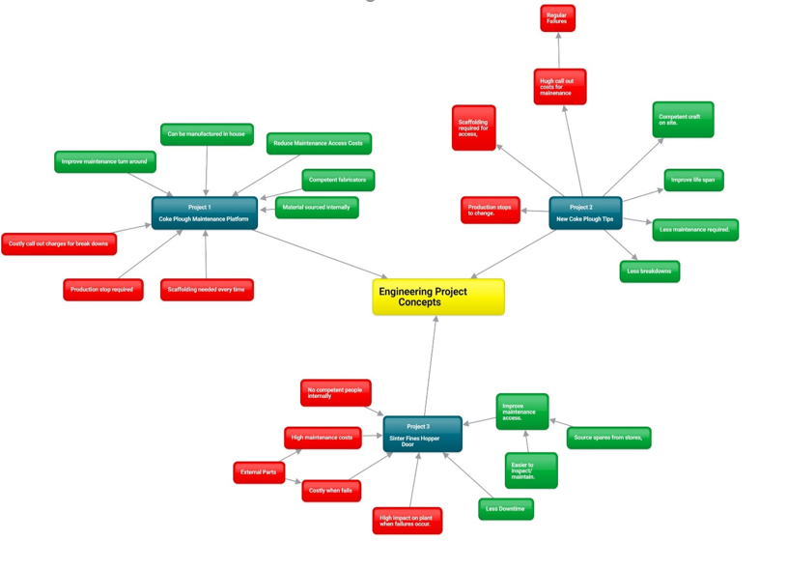

Project Problem Idea 1 ( Chosen Idea)

Coke Plough Maintenance Platform
Project Idea 1 is based upon the cost and accessing the coke ploughs to carry out maintenance. Currently the only form of access to conduct maintenance is by erecting scaffolding which incurs high costs if used regularly. The process of the job is as follows.
- Conveyor belt below is isolated by an electrician.
- Scaffolding can be erected.
- Conveyor belt is re started to regain coke levels by back up coke plough once isolation is removed.
- Maintenance can be carried out from platform.
- Conveyor belt isolated again by an electrician after maintenance completed.
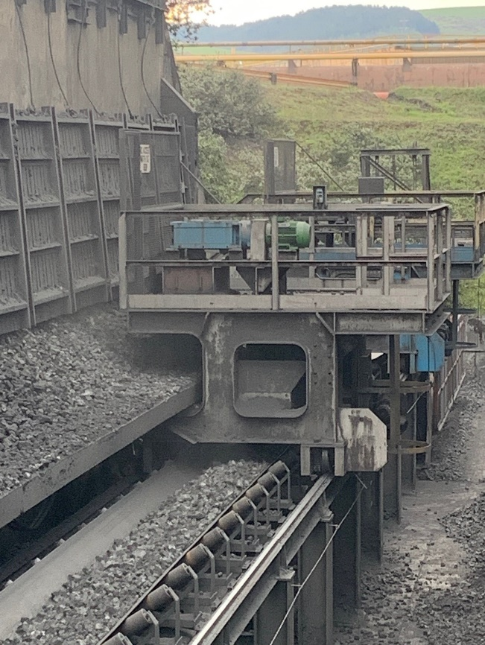
- Scaffolding is then removed.
Figure 2 - Coke Plough - Tata Steel, Jenkins (2022)
Scaffolding would be erected here in order to gain access. It would then be boarded to have a surface to work off.

Preventative maintenance is carried out on coke ploughs every 6 weeks, meaning that scaffolding is erected and dismantled each time, this doesn’t include any breakdowns that also occur within this six week period. Scaffolding can tally up and become extortionate at the end of the year with recurring failures with the coke plough tips or other parts of the coke plough such as the motor, gear box, or coke plough wheels failing.

Project Problem Idea 2

Coke Plough tips

Project idea number 2 was based on the maintainability of the coke plough tips, these are used by the coke plough to retrieve coke from the coke wharf which feeds the conveyor belt underneath. In some instances, coke plough tips wear quicker than the 6 weeks period in which they are predicted to last. Thus, causing an unreliable feed of coke to the conveyor belt which worst case scenario could cause the levels of coke in the bunkers to lower. This could cause the Blast Furnaces to crash off which incurs costs such as £40,000 an hour, due to the coke ploughs having 6 tips the event of this happening is unlikely but still possible. As shown below in figures 3 and figure 4 the tips are mild steel, but we are finding that the tips are not lasting the required lifespan intended. Furthermore, due to poor access to conduct the replacement of the coke plough tips, a newer design could prove effective when trying to reduce the costs of scaffolding needed to access them. Also, reducing the amount of time taken when needing to stop the conveyor belt to erect and dismantle the scaffolding when maintenance is completed. The root cause of the short life span of the tips could be due to the material they are made from, a potential solution could be a more suitable hard-wearing material which could be used instead, not only to prolong the life span but to reduce maintenance costs and production stops to replace them.
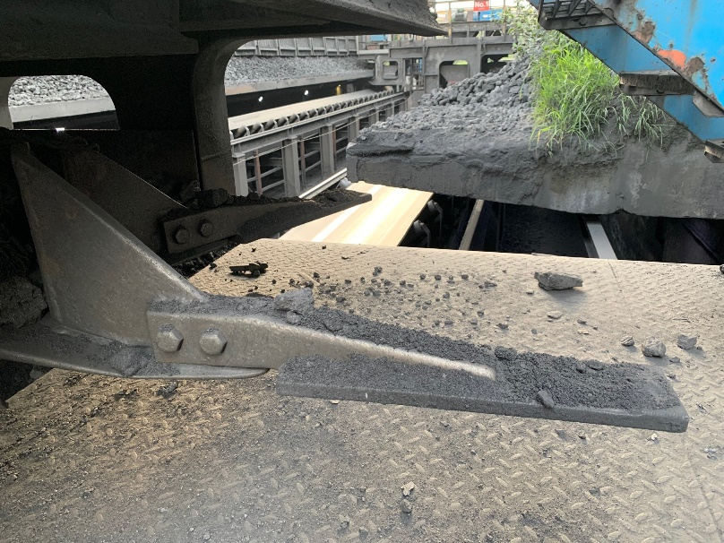
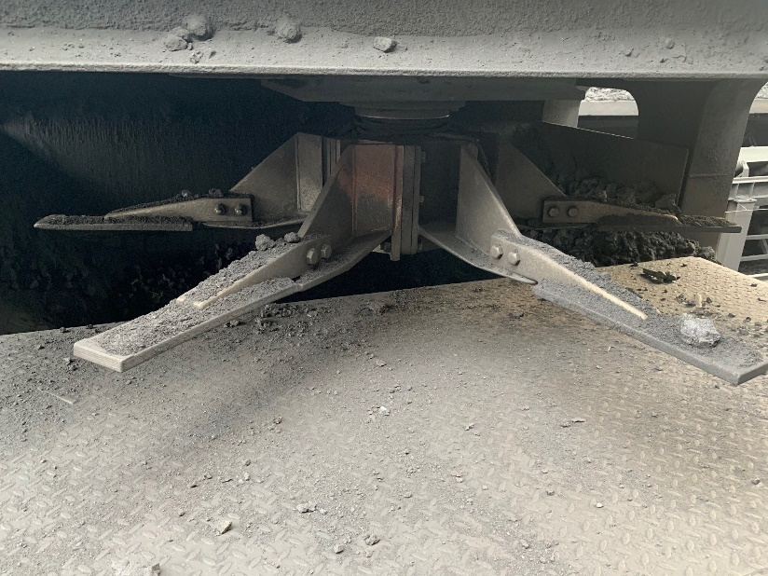
Figure 3 Coke Plough Tips 1 - Tata Stee l Jenkins (2022)
Figure 4 Coke Plough Tips 2 - Tata Steel Jenkins (2022)

Project Problem Idea 3

New Hydraulic Sinter Fines Bunker Doors

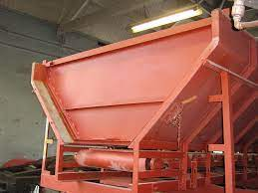
Project idea number 3 is based on the Sinter Fines hopper door, these consist of two bunker doors that are operated by a cylinder with an internal hydraulic tank. With the intention of maintenance to be conducted on these cylinders, guards must be removed in order to gain access, the cylinders then must be removed from their seating to perform maintenance consisting of duties including checking oil levels for example. This is a timely process to just perform basic tasks, proposed is a new system where an external tank and hoses are fitted to two pistons that operate the doors. If any maintenance tasks require to be carried out they can be done externally where guards do not need to be removed to gain access. Moreover, issues experienced with the current design can be eliminated by changing the design to the new suggested, which will not only save time but also manpower when carrying out the tasks required. Reduction in manpower needing to do these tasks will potentially reduce the overall maintenance costs at the end of the financial year.
Figure 4 Sinter Fines Hopper Door - Tata Steel Jenkins (2022)

Project Charter

After the brain storming has been completed on three potential projects, the next step is performing project charters for each of the issues. Project charters normally are concise documents which explains the project clearly and briefly. Project charters usually distinguish the scope of the intended project, share the project aims, in addition to acting as an agreement between the project sponsor in this case Coal Injection Plant and stake holders being the Blast Furnaces, detailing responsibilities. Project charters are created to pitch and obtain approval, key stake holders will use the project charters with a view to suggest changes and approve the project as indicated by Martins (2021). The Project charters were conducted on the three issues from the brain storming, evaluating the purpose, owners, workshop leader, expectations, resource team and process sponsor.
Without a project charter being in place Karim (2012) explains that problems can occur such as risks of reduced value if strategies, and strategic benefit are not written, decided, and officially acknowledged . Achieving hierarchy, or management to approve things becomes hard, without having a project charter there is no clear, recorded statement of the projects goals which can lead to the project failing before it has even begun. With no project charter the project can change numerous times, with a chance of deviating from the delivering goal set out at the start of the project, resulting in a possible financial burden to the company.

Project Charter 1
Coke Plough Maintenance Platform
Process Name & Purpose:  Coke wharf plough maintenance platform required. The purpose of this platform is to eliminate the cost of erecting scaffolding every time maintenance is required on the coke plough. Furthermore, the platform will also help make the coke plough more accessible to work on compared to when the scaffolding is erected. By adding this platform, it will also reduce the time it takes organising the scaffold as well as time it takes to complete permits that is involved when using scaffolding. | Process Owner:  Granulated Coal Injection Engineer
Workshop Leader:
Jamie Parker
Process Boundaries:  Starting Point: Coke Wharf Plough.  Ending Point: Coke Wharf Conveyor Belt. | Team Members:  To be determined.
Process Sponsor:  Granulated Coal Injection Department , Tata Steel | Process Sponsor Expectations:  Expectations are for there to be a permanent platform fabricated and installed ,resulting in scaffolding no longer being required therefore saving future costs when carrying out maintenance.
Resource Team:
To be determined.

Project Charter 2
Failure of Coke Plough Tips.
Process Name & Purpose:  Failure of coke plough tips used to feed coke conveyor, which feeds a coke bunker. The purpose of improving or changing the design of the plough tips is to increase the lifespan, also improving their maintainability. Maintenance is required at least every six weeks on the tips, with break downs likewise occurring within the six week period. Each time they fail scaffolding is required to carry out the maintenance, which also affects the running of the conveyor belt beneath, as it needs to be isolated to erect/dismantle the scaffold. Each time a coke plough tip fails the feed of coke supplied to the bunkers reduces, which will affect the Blast Furnace production rates if the levels decrease, costs of up to £40,000 an hour can occur if a Blast Furnace does not have coke. | Process Owner:  Granulated Coal Injection Engineer
Workshop Leader:
Jamie Parker
Process Boundaries:  Starting Point: Coke Wharf Plough.  Ending Point: Coke Wharf Conveyor Belt. | Team Members:  To be determined.
Process Sponsor:  Granulated Coal Injection Department , Tata Steel | Process Sponsor Expectations:  Expectations are for there to be an improvement in design of the coke plough tips. For them to have a larger life cycle, to reduce the need in maintenance, and scaffolding costs that they require.
Resource Team:
To be determined.

Selection Criteria Matrix

A tool that was used to select which project idea is most practicable and beneficial moving forward was the selection criteria matrix. “ A selection matrix evaluates and prioritizes a list of options and is a decision-making tool.”(Tague, 2015). The selection criteria matrix is a tool in which assesses and ranks a list of options that you format into the matrix, it is also a good visual tool to show those who look at it the results very clearly and how you achieved those same results. With the three projects in the vertical columns and subheadings in the horizontal columns you can work out which project is most viable. The matrix is a good tool when needing to narrow a numerous choices into one choice, it is very important to score each rating scale consistently.
The subheading used for the project were :

- C1 – Easy to implement.
- C2 – Feasible.
- C3 – Cost Effective.
- C4 – Time.
- C5- Easy to maintain.

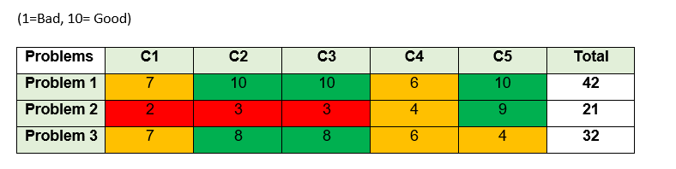
Figure 5 Selection Matrix – Tata Steel
After constructing the selection matrix, it was visible to see that the first project “ Coke Wharf Plough Permanent Platform” is the most viable project to continue due to it scoring the highest with 42. Moreover, has scored the highest due to the fact that it will overall save money after being installed because scaffolding will no longer be needed, in addition provide a better working platform compared to scaffolding. The platform will also not require any maintenance when constructed due to being made from mild steel and will be painted with red oxide paint to reduce the chance of rust from occurring. The fabrication of the platform will be carried out by Tata Steel craftsmen rather than use contractors, this is also a plus as it keeps the money inside the business rather using a contractor outside of the business which money would then leave the company.

RAG Status
Red | Amber | Green
Red = Negative
Amber = Neutral
Green = Positive

As shown in the selection matrix criteria, a RAG system ( red/amber/green) was used to visually highlight the results of the matrix. The RAG system helps to emphasize the more economical project considering the cost, and downtime. The green areas indicating positive, amber a neutral result and red representing negative results. The RAG system can be used in project management to visually show the status in which a project is currently sitting, “as it can help in more easily and quickly determining and addressing potential risks and issues”( Harrin, 2016).

Conclusion summary

After constructing the selection matrix in addition with the RAG system, it is evident to see that the “Coke Plough Maintenance Platform” is the most sustainable project to continue with because it scored the highest with forty-two. This has scored the highest due to data showing that it will save money after being installed due to scaffolding no longer being needed. The platform will also not require any immediate maintenance after being constructed due to it being made from mild steel, that will be coated with red oxide paint to prevent it from corroding. The fabrication of the platform will be carried out by Tata Steel craftsmen rather than outsourcing to contractors, this is key to saving money as it is using in utilising in house labour, thus keeping money within the company.
The project that identified to resolve is an area in which needs to be improved and is critical to the efficiency of maintenance carried out on the coke ploughs. There have been multiple delays recently due to the time it takes to erect scaffolding, for scaffolding to be erected the conveyor belt must be stopped, this results in no coke being transferred to the bunkers. The risk of losing the coke levels in the bunkers are very costly, £40,000 an hour if the Blast Furnace needs to come off due to no coke, but also the cost of erecting scaffolding every six weeks to carry out maintenance is costly. This does not include breakdowns that happen within those six weeks also. When maintenance or breakdowns occur on coke ploughs the coke plough must be driven to the parked bay, once they are in position an electrician will isolate both plough and conveyor belt, scaffolders will then erect scaffolding up to the coke plough. With the conveyor belt being isolated the backup coke plough is unable to supply the conveyor with coke, resulting in no coke being taken to the bunkers and the levels lowering. Once the scaffolding has been erected isolations may be taken from the conveyor, once the maintenance is carried out the same process of isolating the belt must repeat again to remove the scaffolding this resulting in the coke levels lowering again.

Feasibility study

With the project selected from the selection matrix, the project can progress onto the feasibility stage of the project. A feasibility study is an assessment that contemplates all project related components , such as financial, legal, planning and technical( Drury, 2021). One of the main project’s feasibility is whether the project can generate a return financially or will cost the company more money in the long run. Generally, a feasibility study measures the practically of a suggested project or plan. Below are the contents that was carried out when conducting the feasibility study.
1. Executive summary.
2. Description of product and uses.
3. Technical and design.
4. Product and marketplace.
5. Organisation and staffing.
6. Scheduling.
7. Economic feasibility.
8. Findings and recommendations.

Gannt Chart

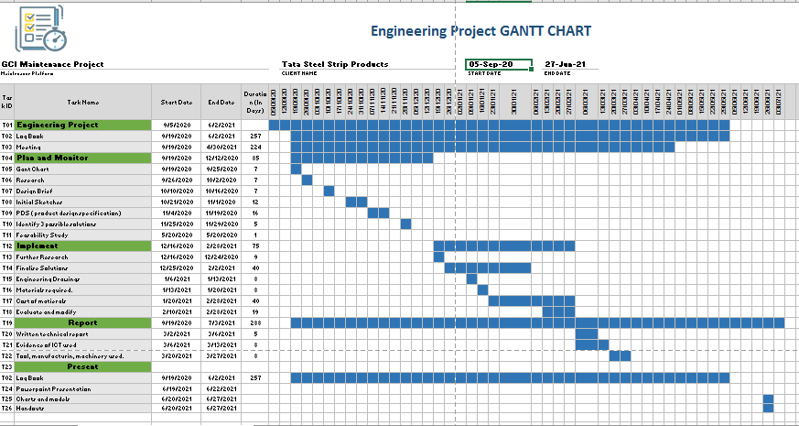
Figure 5 – Gantt Chart Tata Steel Jenkins (2022)

A Gantt chart was used during the project and is useful when planning and designing a project. It gives a clear timeline to follow for guidance allowing you to see if you are on target for completion of a project. On the left-hand side, it will show a list of stages/tasks at where your project is at. The top of the page shows a bar which illustrates the time of the scale of the project. Each stage has its own timescale, represented by the smaller bars across the page. This will show a start and end date to each task you need to carry out, in some cases, tasks can overlap each other. This just means that one task may have run out or has been planned to run alongside another, you do not generally need to complete one task before starting another. However, a timeline can change and its good practice to revise this as you move through your project.
Using a Gantt chart can allow you to see all the stages in detail. This can be very beneficial when completing a project. It gives a clear and concise timeline to follow. Tasks can be delegated to team members through the Gantt chart depending on the size of the project.
Just like the Gantt charts, the concept behind critical path analysis, is that you cannot start some tasks until others have finished. These tasks need to be complete in sequence/ order with each stage being completed before the next task is carried out.

Product Design Specification

The PDS outline obligations that must be met by the stakeholders to ensure a successful final product. It will contain all the details of engineering activities and any information required to complete the project. Information such as timescales, cost, and safety can be found within the PDS. It is designed to ensure that all requirements set out by the customer are met in the final design. The intended use of the products should be stated in the PDS. When creating a PDS the use of the words, shall, should, must and will, will determine requirements that need to be fulfilled or are used for the guidance.
The main headings covered in the PDS were:
- Performance
- Working Environment
- In life Service.
- Maintenance
- Product Cost.
- Competition.
- Shipping and Transportation.
- Quantity.
- Size.
- Weight.
- Manufacturing Facility.
- Materials.
- Product Life Span
- Standards and Specifications.
- Ergonomics.
- Customer.
- Quality and reliability.
- Shelf Life.
- Processes.
- Timescales.
- Testing.
- Safety.
- Market Constraints,
- Patents.

Research

As previously stated one of the important factors of this project was to reduce the cost in scaffolding when needing to carry out maintenance on the coke ploughs. Currently there is a maintenance plan every 6 weeks on the coke ploughs to check parts such as the coke tips, to the gear box and motor that helps move the tips. The cost of this is shown below:
Figure 6 Scaffolding Quote - Tata Steel Jenkins (2022)

By following the maintenance plan throughout the year every 6 weeks the cost of the scaffolding alone would be £22,051. Unfortunately, breakdowns also occur on the coke ploughs, by using SAP checks can be done to go back throughout the year and find the data on how often outside of the maintenance checks do the coke ploughs breakdown and require scaffolding.
By using SAP data was found to suggest coke ploughs break down an additional 10 times throughout the year, resulting in scaffolders being called out in addition. This incurs another charge totalling £25,444 with the original cost of scaffolding for planned maintenance being £22,051 resulting in a yearly total of £47,495. To check if this project is cost effective and feasible, research needs to be conducted into the cost of the materials needed to fabricate and make the maintenance platform required. With the design office supplying the drawings of the platform they also can supply the information of the parts required to construct the platform.

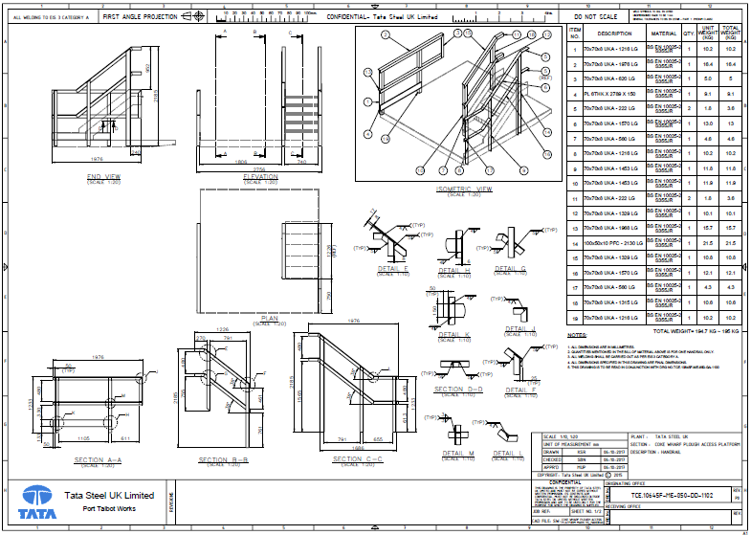
Figure 7 Design drawings and parts – Tata Steel Jenkins (2022)
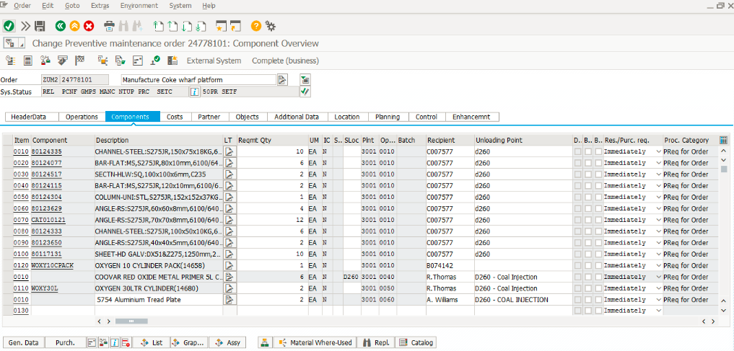
With the design office supplying the drawings of the platform they also can supply the information of the parts required to construct the platform.
Figure 8 Material SAP - Tata Steel Jenkins (2022)

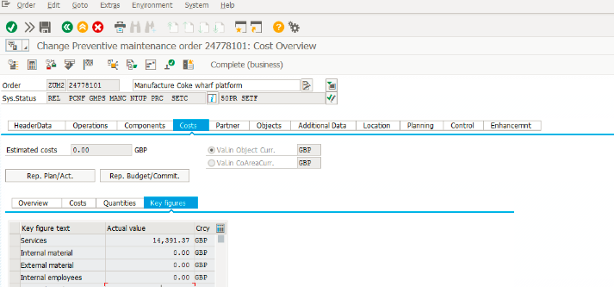
With SAP showing me the cost of the material individually, it will automatically tally up with the total cost of the material overall as shown below in figure 9.
Figure 9 Material Cost - Tata Steel Jenkins (2022)
As shown, the overall cost of the material required to fabricate the coke plough maintenance platform is £14,391, this is a third of the yearly cost of £45,496 that is spent on scaffolding to access the coke ploughs. This makes the project highly feasible and would result in an overall saving of £31,105 per annum, as there are another three coke ploughs that are used there is a potential saving of £124,420 if these platforms were fitted to the other 3 coke ploughs.

Technical Report
Throughout the design process it was important to stick to design specification. When initially researching reliability issues within Carbon Department it was aware that all specifications and legislation would have to be met in the solution to the problem. In this case, following all engineering standards that tata steel requires and legislation we adhere to.
The coke plough permanent platform was created to reduce maintenance costs, access issues and prevent delays would have to meet specifications such has, material specs, legislation and meet all safety standards. It was suggested that the maintenance platform would eliminate the need for scaffolding once completed, which had been specified in my PDS. Following the product design specification allowed me to meet all criteria to complete my product to the highest standard.

Analysis

The main goal of the assignment was to carry out a project that would improve the production process and that could also save the company money. Overall, the goal was met by constructing a platform that cost £14,391, where as the scaffolding cost alone cost £45,496, as previously mentioned a total saving of £31,105 is achieved. If the project was continued onto the other 3 coke ploughs the savings would triple and would also limit the amount of times the conveyor belt would need to stop thus not affecting the running of production.
One area of improvement during the course of the project would be defining the critical path, although a Gantt chart was completed, the critical path was not defined. By not defining the critical path deadlines could have been missed causing delays in the platform being installed, part of the workforce could have been left with no work to continue meaning the company is paying employees to do nothing. As Shaw (2022) suggests any delays in the critical path would ultimately affect deadlines causing missed key milestones. Shaw (2022) also propose that failing to analyse the project during the lifespan would expect to see failings and unexpected challenges occur, overlook critical information could be surpassed , or errors in the work process that grow as the project unfolds.
A negative part of the project was the way in which information was passed to the employees involved. Information was not visible to all parties involved, key information was only distributed to employees at staff level and not team members. This essentially was a root cause in issues such as craft members now knowing what tasks they were on day to day, due to covid several members of the party were isolating for periods of time and information on how to progress certain tasks was lost. By making everyone within the working team aware of the tasks to be completed by sharing information and keeping information somewhere visible to all members involved a few delays may not have occurred due to communication. The Gannt chart was also not kept in places where everyone could see it, resulting in issues where people were uncertain exactly how much the project had progressed and what was expected of them next.
Additionally, other negative issues within the project were do to employees being overworked. This was mainly due to the pandemic when covid 19 first started, many of the workforce isolated due to health reasons. This meant that the individuals that were attending work with double the work load, although the project did not go over the projected time line individuals did feel over worked at the end of it. Questionnaires were handed out at the end of the project that were answered anonymously asking questions such as how they felt the project went and what could have been done better. The results were that even though the finish date was achieved on time they felt overworked in doing so, and next time additional members will be required to back fill people that were isolating so that the workload will be more balanced. Before the next project is carried out, employee’s workload will be monitored to make sure the employees are assigned the correct task for their skillset, Cavey (2020) recommends that by focusing on your employees work as a unit, you will achieve you milestones faster and more efficiently.

References

BBC News (2017) Tata Steel Thyssenkrupp merger: Safeguard Welsh jobs call. [online] 20 Sep. Available at: https://www.bbc.co.uk/news/uk-wales-41330282. Accessed 25 May 2022
Cavey, C (2020) A guide to an effective team workload management [online] 29th May. Available at: A Guide to an Effective Team Workload Management (hubstaff.com)
Drury, A (2021) What is a feasibility study {online} 08th August 2021. Available at : Feasibility Study Definition: How Does It Work? (investopedia.com)
Harrin, E (2016) What does RAG system mean [online] 25th November. Available at: What Does RAG Status Mean? (pmtips.net)
Jenkins, E (2022) ‘Reflective Group Project”. University Trinity St David. Unpublished essay.
Karim, S (2012) A project with no project charter [online] 4th May. Available at: ProjectManagement.com - A Project With No Project Charter?
Martins, J (2021) 3 Elements every project charter needs. [online] 5th April. Available at: How to Write a Project Charter, with Examples • Asana
Mishra, A (2020) Brainstorming in project management [online] 19 May. Available at: Brainstorming in Project Management - Management Weekly Accessed 27 May 2022
Shaw, A (2022) What is Project Analysis and Why is it Important. Available at: What is Project Analysis and Why it is Important? (smarttask.io)
Tague, N.R. (2015). The quality toolbox. New Delhi, India: Infotech Standards India Pv. Ltd.

Figures

Figure 1 – Brainstorming Activity
Figure 2 - Coke Plough - Tata Steel
Figure 3 Coke Plough Tips 1 - Tata Steel
Figure 4 Coke Plough Tips 2 - Tata Steel
Figure 5 Selection Matrix – Tata Steel
Figure 6 Scaffolding Quote - Tata Steel
Figure 7 Design drawings and parts – Tata Steel
Figure 8 Material SAP
Figure 9 Material Cost - Tata Steel

.

