
Six sigma project
Ben Rowland-Jones

April 29, 2024
University of Wales Trinity Saint David

Table of Contents
1.0 Introduction 2
2.0 Main Findings 3
2.1 Define Phase 3
2.1.1 Project Charter 3
2.1.2 Process Map 6
2.2 Measure Phase 6
2.2.1 Data Collection Plan 7
2.2.2 Failure Mode Check Sheet 8
2.2.3 FMEA 9
2.3 Analyse Phase 11
2.3.1 Pareto Graph 11
2.3.2 Five Whys Analysis 12
2.4 Improve Phase 13
2.4.1 FMEA Corrective Action 13
2.5 Control Phase 14
2.5.1 Preventative Maintenance 14
2.5.2 Sensor Data and Error Codes 15
2.5.3 Gage R&R Study 15
3.0 Conclusion 16
4.0 Bibliography 17

1.0 Introduction

Renishaw plc is a multi-national, world leading precision engineering company that was founded in 1973 by Sir David McMurtry and John Deer when Sir David invented the world’s first touch-trigger probe in order to overcome a quality inspection problem with Concorde engines. Since then, Renishaw has expanded its products, with one of the ventures being the up and coming additive manufacturing (AM) sector (Renishaw, 2024).
The Renishaw AM machine is called a RenAM500Q, the “500” coming from the power rating in one of the four high powered lasers used in the machines. The “Q” stands for “Quad”, a note to the machines four laser optical system. These machines 3D print parts by melting metal powder in a process called laser sintering. With a combined two kilowatts worth of laser energy which is directed by a series of optics to achieve the desired shape, this manufacturing process is capable of producing precise, complex parts that would not be possible in subtractive manufacturing (Sathish, 2022). The image below, in Figure 1, shows the RenAM500Q machine:
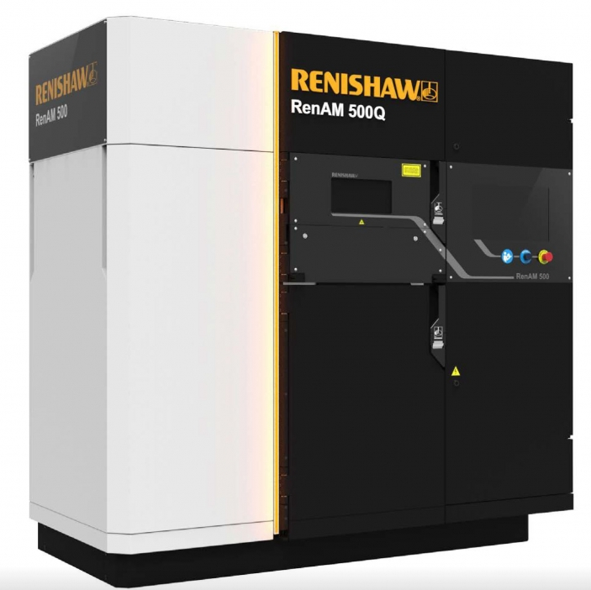
Figure 1, RenAM500Q Machine (Tech-Labs, 2024)
This project will cover the identification, analysis and future control of a fault that was found within a test rig that is used on the RenAM500Q production line. This fault has caused significant production downtime and hours of engineering resource; which ultimately lead to orders going into arrears and having to extend shipment dates thus, dissatisfying customers. The purpose of this project is to identify and resolve this fault, which would lead to a large decrease in downtime and an improved first time pass rate.

2.0 Main Findings

2.1 Define Phase

2.1.1 Project Charter

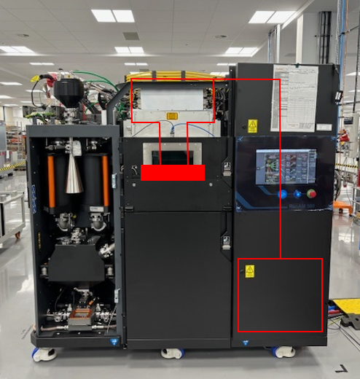
The RenAM500Q machine uses four lasers to sinter metal powder to be able to print complex geometries; but to be able to use the laser energy effectively, it must be redirected into the correct path and end location. This is achieved using an optical path which comprises of fibre optic cables, laser filters, mirrors and lenses. Below, in Figure 2, shows a stripped down version of the RenAM500Q machine with red annotations to denote the optical path from the lasers (red square) to the powder bed, where the metal is sintered:

Figure 2, RenAM500Q Machine (Rowland-Jones, 2024)
The silver unit on the top of the machine (green square) is the optical module, which is where all of the optical lenses and mirrors are that reflect the lasers to the desired target. This optical module has its own production process separate from the RenAM500Q machine, the reason being that it is a sensitive unit which is susceptible to static and contamination, so it must be in a controlled environment. After the optical module is fully assembled, and before it gets fitted to a RenAM500Q machine, it must be fitted to an end-of-line (EOL) test rig.
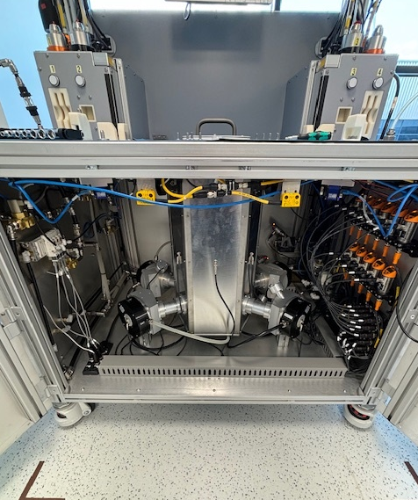
The EOL test rig has its own lasers and optics system which mimics that of a RenAM500Q; which is used to test the optical modules by firing lasers through it and monitoring the results via four cameras and multiple temperature and flow sensors at different points in the process. Instead of a powder bed, the laser energy is absorbed by four beam dumps, which are monitored by temperature sensors. Figure 3 below shows the EOL test rig:

Beam dumps
Temperature and flow sensors

Figure 3 (Rowland-Jones, Drift Rig Cabinet, 2024)
The entire system is cooled using an intricate cooling system which comprises of two water circuits and a thermal exchange unit; one circuit is the chiller unit, which is what cools the water down and is known as the primary circuit. The primary circuit flows into the thermal exchange unit, cooling the intercooler inside before exiting the thermal exchange unit and going back to the chiller. The other circuit is known as the process circuit, which cools the EOL test rig and the optical module that is fitted to it, taking the cool temperature from the intercooler within the thermal exchange unit. This cooling system can be seen below in Figure 4:
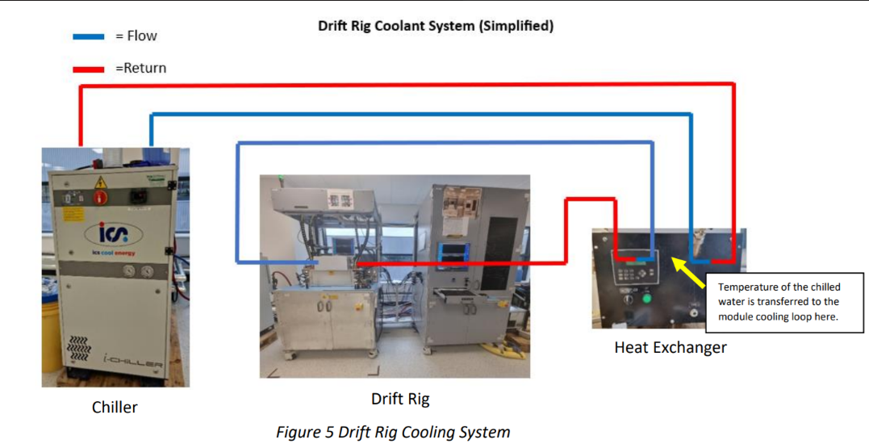
Figure 4 (Sealy, 2024)
A module that is fitted to the EOL test rig is put through a test that lasts three hours; the first ninety minutes of the test is testing the module for laser focus and linearity values, positional accuracy and beam dump saturation. The final ninety minutes of the test is looking for thermal drift; which is when the laser beam drifts from its target due to an increase in temperature. The thermal drift test comprises of firing the lasers at full 500W power in the same spot for ninety minutes and measuring how far the beam drifts.
The problem with the EOL test rig is that it sometimes stops the test midway into the ninety minute thermal drift test, and gives the error code “spot fell outside of safety limits” with no other information or data to go on. This means that finding the root cause of this error is extremely difficult as the spot could fall outside of safety limits for a number of reasons including optical, mechanical or electrical failures.
Going back to November 2023, the “spot fell outside of safety limits” was occurring every time an optical module was being tested, sometimes stopping the test with minutes remaining. Due to the limited functionality of the script used to test the modules, the test had to be repeated from the start, even though certain tests had already passed. This lead to around an hours machine downtime per optical module, which equates to eight hours downtime per month. This error became more frequent until eventually, the production line was on stop as the test would not complete due to the test rig coming up with the error.

The goal of this project is to diagnose the source of the error and rectify the issue, thus improving the pass rate of the test rig and get the production line going again. The criteria for success would be an increase in the first time pass rate of the EOL test rig by at least 50%, and the reduction of production downtime by at least six hours per month. As the production line was on stop, the timeframe for the project deliverables was as soon as possible; with the restart of the production line being the main representation of improvement.

2.1.2 Process Map

The first stage of the EOL test rig is to fit the optical module, which involves lifting the unit on and connecting the lasers, coolant pipes and cables to the unit. The unit then undergoes a pressure test, which is a thirty second test that checks there are no leaks in the module or test rig; which is achieved by blasting compressed air through the unit.
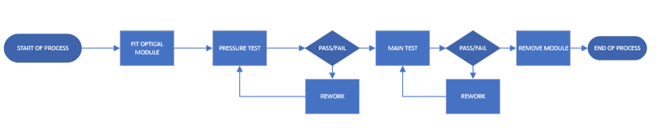
Once it has been confirmed that there are no leaks in the system, the main three hour test commences, where the coolant system starts to circulate coolant around the optical unit and test rig at a target temperature of 18⁰C. Once the main test has finished, and if it has passed, the module will be drained of its coolant and removed from the test rig. A full EOL test rig process map is shown below in Figure 5 below:

Figure 5, Process Map (Rowland-Jones, Process Map, 2024)

2.2 Measure Phase

In order to find the root cause of the issue, a sample of data from the test rig was taken to try and determine any patterns or possible reasons why the test came to a stop. This data came in the form of the .csv (comma separated values) files that are automatically generated from the test rig after every test. These files include test start and end times, parameters and numerical test results that are used to ascertain whether or not an optical module is good enough to be fitted to a machine.
As this data provides a pass/fail criterion, the data that is collected is known as attribute data; it can only ever be good or bad, there is no in-between or alternative results. The data itself, however, does have some variation as the fundamental type of technology being tested is optics. Below in Figure 6 are two screenshots of two separate test files taken from the same optical module one test after the other the EOL test rig:
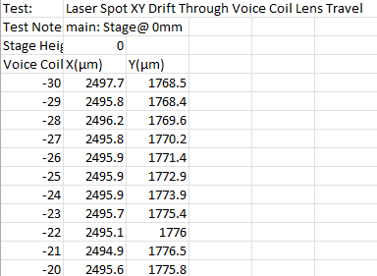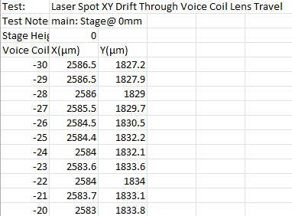
Figure 6 (Rowland-Jones, Test Results Comparison, 2024)
As shown, there is variation in all of the data points collected within the test; mainly due to the fact that these numbers are at micron ($x{10}^{-6}$) level, which is extremely difficult to fully replicate, especially when you take into consideration the number of optics (nine in total) from the start of the optical path to the end. The number of optics will add considerable variation to the test results, as each optic is different to the next and is potentially fitted by different operators.

2.2.1 Data Collection Plan

As previously mentioned, the data was collected from the test rig by transferring the .csv files onto a local PC and interpreted by a process expert. From this data, the most prevalent fault codes will be extracted and added to a tally chart which will be used to determine the most common fault code, aiding the fault-finding analysis. Test data from the last six months will be extracted, which equates to eighteen optical modules worth of test data.
As this data already exists due to the automatic .csv file generation, the time frame for extracting the data from the test rig is twenty-four hours. The data will be pulled from the test rig via file transfer from the shared network where the test results are stored, to be reviewed and manipulated by the Process Improvement Technician in the area. An example of the type of test results that were extracted from the rig can be found in Figure 7 below:
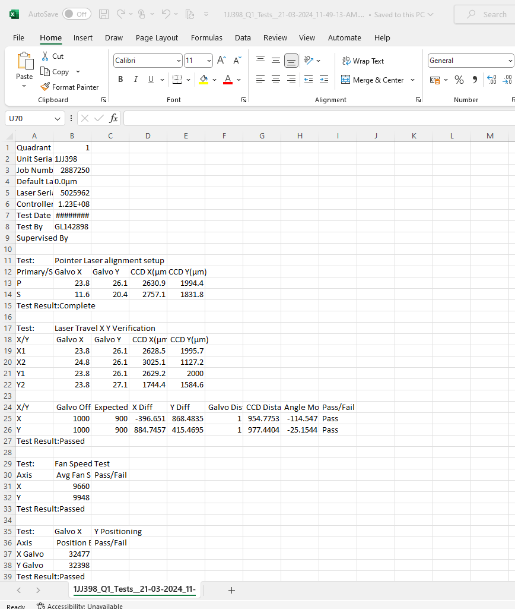
Figure 7 (Rowland-Jones, Test Data, 2024)

2.2.2 Failure Mode Check Sheet

In order to categorise the failure modes and determine the most frequently occurring failure, a tally sheet was created using Microsoft Excel, with the columns being the different failure modes; including “spot fell outside of safety limits” and “Focus Range”. This tally chart will be used as the data points for a pareto graph which will be used as a data analysis tool in the analyse phase of this report. Below in Figure 8, is the tally chart:
Failure Mode: | Failure Count (Last 6 Months):
Pilz Packet Time Out | 4
Focus Offset Failure | 1
Spot Fell Outside of Safety Limits | 19
Object Reference Not Set | 3
Unexpected Error | 2
Max Drift Exceeded Limits | 4
Figure 8 (Rowland-Jones, Failure Mode Tally Chart, 2024)
As shown, the most frequent failure mode is “spot fell outside of safety limits” which, as previously stated, has occurred constantly on every optical module for the last six weeks. The other two highest failure counts were “Pilz packet time out” and max drift exceeded limits”. The Pilz packet error refers to the Pilz safety PLC which controls the rigs interlock and safety systems, whereas the max drift exceeding limits refers to a genuine optical module failure during the ninety minute thermal drift test. The “spot fell outside of safety limits” failure mode was to be further analysed and a root cause analysis to be carried out to try and reduce the amount of failures.

2.2.3 FMEA

Failure modes and effects analysis (FMEA) are used as a measure of potential failure modes and their effects; with each failure mode given a severity, occurrence and detection rating out of ten. These numbers are multiplied together to give a risk priority number (RPN). The RPN numbers are used as a priority list to work from (Sharma, 2018). Below in Figure 9 is an FMEA carried out on the EOL test rig:
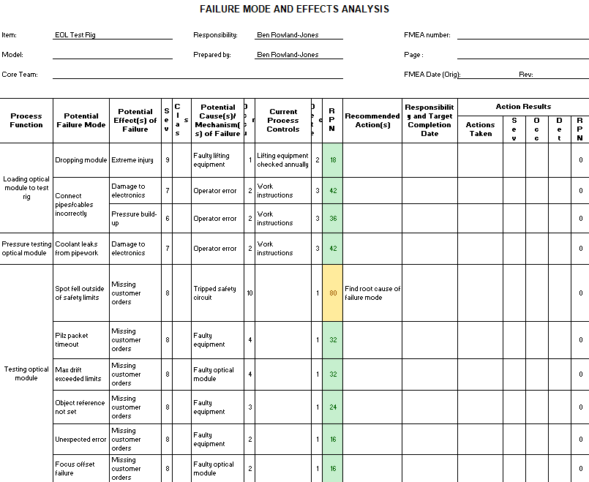
Figure 9 (Rowland-Jones, EOL Test Rig FMEA, 2024)
As shown above, the largest RPN number is the “spot fell out” failure mode, which is the failure mode that is the main focus of this report. The severity scores an eight as it will cause extreme customer dissatisfaction by missing orders and not supplying the AM build line with optical modules. The occurrence scored a ten as this failure mode is happening on every optical module that is being tested and is currently putting production on hold. The detection is scored at one as the module will not pass the test as the safety circuit cuts out and does not continue.

2.3 Analyse Phase

2.3.1 Pareto Graph

A pareto graph (named after Vilfredo Pareto) is a popular Six Sigma tool that works on the principle that eighty percent of errors are found to be caused by twenty percent the causes (Pyzdek, 2021). Using this principle, and the data from the tally chart in the measure phase above, the following pareto graph (Figure 10) was generated using Microsoft Excel:

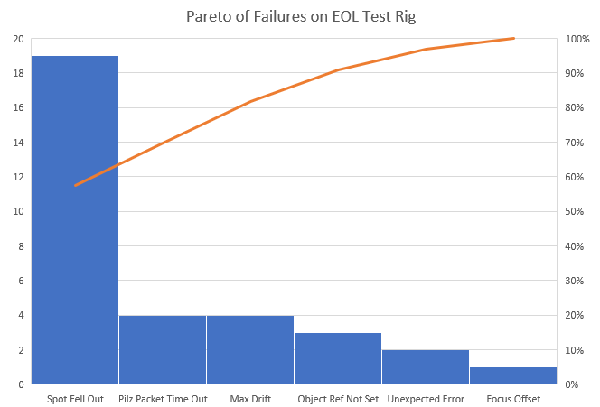
Figure 10 (Rowland-Jones, EOL Test Rig Pareto Graph, 2024)
This graph confirms that the “spot fell outside of safety limits” is the key failure mode that should be investigated further as even if the frequency was halved, it would still mean a twenty seven percent reduction in overall failures on the rig. Unfortunately, “spot fell outside of safety limits” could be caused by a number of different systems including mechanical, electrical or optical. To determine the root cause of this error, further analysis techniques must be used.

2.3.2 Five Whys Analysis

A five whys analysis is used to look beyond the symptoms of an issue to gain clarity on the root cause, by asking why certain things are happening within a faulty system. It does not have to be five levels of questioning, rather asking the question until the root cause is found (Lean Enterprise Institute, 2024). In order to apply this technique to the EOL test rig, a manual test needed to take place where all four lasers were fired at full power. This would emulate the ninety minute thermal drift test; but using the data acquisition (DAQ) software on the rig would allow for the monitoring of temperature and flow sensors. Sensor monitoring is not available during a production test due to the automated nature of it.

Why is the spot falling outside of safety limits?

After running a production test, it was noticed that at around twenty minutes into the thermal drift test the computer displayed the “spot fell out” message. At the same time, the safety circuit opened the contactors which cut the power supply to the lasers thus, giving the appearance of the spot falling outside of safety limits when actually the laser spot had been switched off by the safety circuit.

Why did the safety circuit open the contactors?

To answer this question, the manual test had to be carried out where all four lasers were fired at full power into the beam dumps and the DAQ software was open and displaying temperature and flow rates of the test rig. It was noticed that the beam dump temperatures were increasing rapidly from ambient temperatures of 22⁰C toa temperature of 35⁰C which is when it tripped the safety circuit. This is because the temperature sensors have a safety feature where if the temperature value reaches a certain value (in this case 35⁰C), the safety circuit would cut power to the lasers to prevent internal damage.

Why did the beam dumps overheat?

Once the discovery was made that the beam dumps were overheating, the process cooling circuit (which is the rig pipework and the thermal exchange unit) was checked over to see if there were any obvious issues. Once that avenue was explored, it was found that the incoming primary coolant from the chiller was 20⁰C and the process coolant leaving the thermal exchange unit was 28⁰C. This meant that the thermal exchange unit was not transferring the cooler temperature from the chiller into the test rig.

Why was the thermal exchange unit not cooling the test rig?

After removing the thermal exchange unit and replacing it with a spare, the overheating problem was still persistent; this lead to the chiller being the main focus in trying to find the root cause of the issue. After disconnecting the cooling circuit one pipe at a time and by process of elimination, it was found that a particle filter trap within the chiller was full of coolant residue and contamination. This was restricting the flow of coolant into the thermal exchange unit, which did not allow for the cooler temperature to be transferred to the test rig which caused the beam dumps to overheat; ergo the particle filter trap was the root cause of the “spot fell outside of safety limits” error code.

2.4 Improve Phase

2.4.1 FMEA Corrective Action

Now that the root cause has been found, the main action of the improve phase is fixing the issue by clearing the blockage in the particle filter trap and reconnecting the pipework. The original thermal exchange unit was then refitted to the test rig and, to prove out the fix, the golden optical module was installed and put through the normal three hour long production test three times in a row and the “spot fell out” error code did not appear once.
After running the golden unit and achieving three pass results, it was removed and production was taken off hold and allowed to continue. This reduced the occurrence of the failure mode from a ten down to a three, which brought the RPN down from eighty to twenty four, as shown in Figure 11 below:
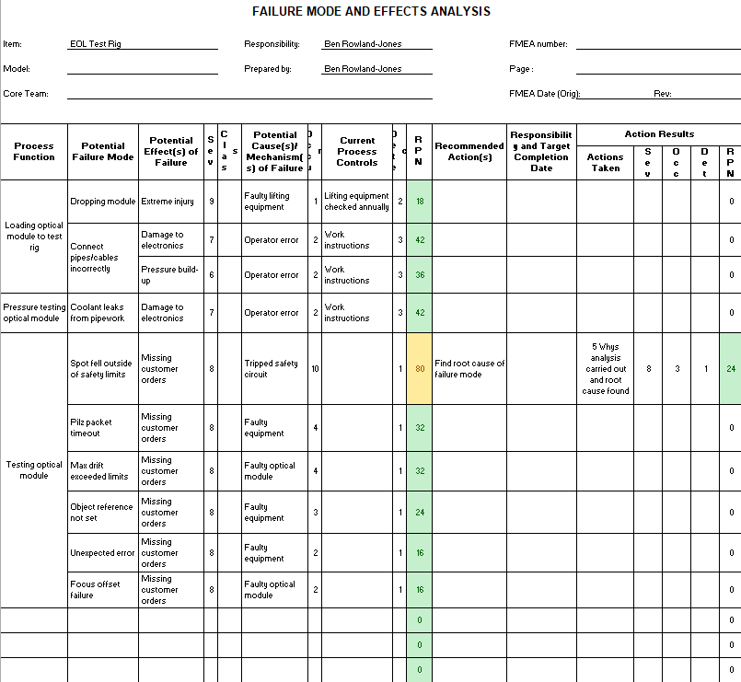
Figure 11 (Rowland-Jones, FMEA Corrective Actions, 2024)
As a result of finding the root cause of the “spot fell out” issue, overall failure rates on the EOL test rig have reduced by fifty seven percent. It has also made the testing process more robust as instead of failing tests for rig issues, the optical modules can now be tested for genuine faults.

2.5 Control Phase

2.5.1 Preventative Maintenance

One of the first things that needs to be controlled to be able to prevent this issue from happening again is to amend the current preventative maintenance instructions (PMI) to specify checking and cleaning the particle filter trap on a regular basis to keep it from getting blocked. As it has taken four years for the blockage to appear, checking the filter trap once every six months is a good enough check for this problem and should prevent it from blocking again.

2.5.2 Sensor Data and Error Codes

Another way of keeping this process under control would be to export the temperature and flow sensor data to the .csv files that are generated by the rig after every test. This would remove the need for a manual test in the future to see which sensor in the system was alarming out and because .csv is a text file, it would not take up a lot of memory on the network location.
Having more descriptive failure modes would make the fault finding process on the test rig less time consuming and thus, keeping the process under control. This could be achieved by displaying which system tripped out the safety circuit; that information could be found on the Pilz safety PLC. The error codes could also mention which sensor tripped out and by what value, which could be fed back using the Pilz PLC or the DAQ software on the test rig.

2.5.3 Gage R&R Study

Longer term, a Gage R&R study and a process capability study could be carried out to ascertain whether or not the rig is capable enough in its current set-up to test the optical modules going forward. From these studies, actions could be assigned to a projects team to improve the test rig and make it more repeatable and reproducible.
A projects team could take the .csv files exported from the test rig and use them in Minitab software to generate a process capability study. The raw data as it is cannot be used as there are too many tests and variables to be able to create a usable capability analysis.

3.0 Conclusion

To conclude, this Six Sigma project followed a DMAIC approach starting off with the define phase where a project charter was written which included a project scope, problem statement and process map which identified the problem with the EOL test rig. After that came the measure phase where the data was evaluated and found to be attribute data that was in the form of .csv files automatically generated by the rig. This data was to be collected by a process expert from the network location as part of the data collection plan. An FMEA was generated which displayed the potential failure modes and their RPNs which helped to prioritise the work conducted on the test rig.
The next phase, analyse, consisted of a pareto graph which graphically displayed the error codes during the last six months on the test rig; this highlighted the “spot fell out” error as the focus point of the project. There was then a 5 Whys analysis carried out on that failure mode which lead to the discovery of the blocked particle filter. This blockage was the focus of the improve phase, as the blockage was fixed which rendered the rig as usable.
Lastly, in the control phase there were three actions laid out for a potential projects team to take up, the first of which was an update to the PMI instruction to check for blockages in the filter trap every six months. The next action was to improve the data that is generated by the rig to show sensor data and more precise failure modes. Lastly, a Gage R&R and process capability studies would be of great benefit to the test rig to see if it is able to accurately and repeatedly test the optical modules in its current state.

4.0 Bibliography
Lean Enterprise Institute. (2024). 5 Whys. Retrieved from Lean Enterprise Institute: https://www.lean.org/lexicon-terms/5-whys/
Pyzdek, T. (2021). The Lean Healthcare Handbook. Tucson: Springer, Cham.
Renishaw. (2024). Our History. Retrieved from Renishaw: https://www.renishaw.com/en/our-history--32458
Rowland-Jones, B. (2024). Drift Rig Cabinet. Pontyclun, RCT, Wales.
Rowland-Jones, B. (2024). EOL Test Rig FMEA. Swansea, Swansea, Wales.
Rowland-Jones, B. (2024). EOL Test Rig Pareto Graph. Pontyclun, RCT, Wales.
Rowland-Jones, B. (2024). Failure Mode Tally Chart. Pontyclun, RCT, Wales.
Rowland-Jones, B. (2024). FMEA Corrective Actions. Pontyclun, RCT, Wales.
Rowland-Jones, B. (2024). Process Map. Swansea, Swansea, Wales.
Rowland-Jones, B. (2024). RenAM500 Machine. Pontyclun, RCT, Wales.
Rowland-Jones, B. (2024). Test Data. Pontyclun, RCT, Wales.
Rowland-Jones, B. (2024). Test Results Comparison. Pontyclun, RCT, Wales.
Sathish, K. (2022). A Comparative Study on Subtractive Manufacturing and Additive Manufacturing. Advances in Materials Science and Engineering.
Sealy, L. (2024). EOL Test Rig Cooling Circuit. Pontyclun, RCT, Wales.
Sharma, K. D. (2018). Failure Mode and Effect Analysis (FMEA) Implementation: A Literature Review. Journal of Advanced Research in Aeronautics and Space Science.
Tech-Labs. (2024). RenAM500Q. Retrieved from Tech-Labs: https://tech-labs.com/products/renam-500q

Word count: 3629

