+

Graduate Diploma Professional Police Practice

LEVEL 6 - 40 Credits

Workbook title: Competency Based Workbook 2 (DHEP)

(SOUTH WALES POLICE, GWENT POLICE AND UWTSD)

Learner name: Leteisha Dayman
Learner’s University Registration Number:
2134492

FACULTY OF BUSINESS AND MANAGEMENT
PUBLIC SERVICE PROGRAMME

Module title: Policing in the Workplace 3 (DHEP) - BMPP6001D

Workbook Guidance

Please read these notes carefully. They provide essential information. The documents you will use in developing your workbook are on the following pages.

What is the workbook for?

The purpose of this workbook is to enable learners to demonstrate and provide evidence of how they meet the learning outcomes set by the College of Policing, for the Graduate Diploma in Professional Policing Practice. You are being asked to outline your experiential learning based upon your theoretical understanding in a range of operational situations.

- Wellbeing and Resilience
- Criminal Justice
- Conducting Investigations
- Decision making and discretion
- Maintaining Professional Standards
- Leadership and Team working
- Policing the roads
- Information and Intelligence

You may wish to use the same incidents as you have outlined in the Occupational Competence Portfolio.

How should the workbook be presented?

Blank electronic copies can be found on Moodle of this workbook. You must submit this document electronically therefore it is important that you save your work regularly and upload the final typed version through Turnitin on Moodle.

Word count policy can be found in chapter 7 of the Academic Quality under section 7.7 (this applies to presenting work above and under the specified word count).
(https://www.uwtsd.ac.uk/media/uwtsd-website/content-assets/documents/academic-office/aqh-chapters/chapters---en/Chapter_07_Assessment_Taught_Programmes_Pages_72-79-UPDATED-05-11-2019.pdf)

Reflective practice is a core aspect for your workbooks and although there is a variety of useful resources on Moodle, there is one particular book, that is specifically based on reflective practice in policing, here is a link to one chapter from Selina Copley’s Reflective Practice for Policing Students:
https://moodle.uwtsd.ac.uk/pluginfile.php/298870/mod_resource/content/1/Reflective%20Practice%20for%20Policing%20Students%20-%20Selina%20Copley%20Chapter5.pdf

How is the workbook assessed?

Advice and support about the completion of this workbook is available to you. Please contact Kelly Andrews direct using k.andrews@uwtsd.ac.uk with any questions or queries you may have.

Dates of workbook submission can be located within the General information tile within Moodle.

Once submitted your workbook will be assessed and marked independently. You will be provided with individual feedback once the work has been marked.

Confidentiality

It is important that no individual can be identified either directly or indirectly from the information in the workbook. However, you must:

- adhere to guidance in the Candidate Handbook about confidentiality.
- not identify individuals including witnesses, victims, or offenders by name.
- not write information that enables any individual to be identified indirectly through the description you provide. This includes references to names, colleagues, places (including hospitals, schools, town, villages, streets) specific incidents which were high profile and could be identified due to past publicity, other professionals or any other personal information including medical or other conditions.
- take personal responsibility for adhering to confidentiality rules.
- not include any dates of any incidents or anything that specifically identifies an actual incident.

Please be aware that any content that is deemed to be inappropriate, disrespectful, or abusive will not be tolerated. Following review of any content of this nature the information will be shared with the employer of the student responsible.

Should any health and wellbeing concerns be raised because of disclosures made by the student within this workbook, the employer of the student will be informed.

NOTE

Your workbook will be submitted electronically via Turnitin on Moodle. Guidance on this is in the Candidate Handbook.

Remember that the workbook is YOUR responsibility you must not rely on the assessor or anyone else to pick up any confidentiality breaches as this is your work and you must accept full responsibility for confidentiality. Meeting all the confidentiality requirements is particularly important.

Dyslexia and other special circumstances

If you have any condition that you feel may affect your ability to deal with any part of the programme, please see the Candidate Handbook for further guidance. The University has a Student Services Unit that may be able to help but it is the learner’s individual responsibility to contact them.

Competency Based Workbook 2 - Learner Workbook

Guidance:

- Your workbook must contain items 1 - 5 below (in the order given).
- You should use the pro-forma to insert your text within each section.
- Note that this module has 2 components with each weighted at 50% of the overall 100% marks total.
- You should upload your completed document as a saved pdf file of this workbook; if this is not possible then a Word Doc file is acceptable. Do not send a scanned file from a photocopier, an apple.dot file, or a Microsoft publisher file as Turnitin will not be able to assess them, despite you being able to upload them.

Contents

Component 1  50% | Area of Professional Practice | Word count
Task 1 | Vulnerability and Risk  Evidence-based policing | 2000
Task 2 | CHOOSE ONLY 1 OF THESE 'ADVANCED LEARNING AREA’ OPTIONS. IT SHOULD BE ONE THAT HAS BEEN AGREED WITH THE FORCE TO STUDY IN YEAR 2. | All options are 2000 words
Task 2  Option 1  Option 2  Option 3  Option 4  Option 5 | Response Policing  Policing Communities  Road Policing  Information and Intelligence  Conducting Investigations | 2000
 | Bibliography

Task 1

Relevant areas of the National Policing Curriculum:
Vulnerability and Risk, Evidence-based policing

You must choose a policing incident in which you played a significant role with a victim of crime or anti-social behaviour and reflect on what happened.

Give a brief description of the incident including social and legislative contexts and any relevant cultural, ethnicity and language issues.

Critically evaluate the appropriateness of different approaches (by professionals and the police) in supporting or managing vulnerable people or people at risk of harm.

Explore what works in relation to tackling repeat victimisation and repeat offending. Consider the use of evidence-based policing.

2000 words (+/- 10%: include your actual word count at the end of each section)

ANSWER:

In approaching my assignment, I will employ the Gibbs Reflective Model as a structured framework to guide my process of critical reflection. This model offers a systematic approach to examining experiences, allowing me to delve deeply into my thoughts, emotions, and actions related to the topic at hand. By using this reflective tool, I aim to gain valuable insights, identify areas for improvement, and develop a deeper understanding of my learning journey throughout the assignment (Adeani, 2020).

Those are:

Description: Describe the experience or situation you are reflecting on, providing context and details.
Feelings: Reflect on your emotions and reactions during the experience, considering how they influenced your actions.
Evaluation: Evaluate the experience objectively, analysing what went well and what could have improved.
Analysis: Analyse the underlying factors that contributed to the outcome of the experience, including personal beliefs and external influences.
Conclusion: Draw conclusions from your analysis, identifying key insights or lessons learned.
Action Plan: Develop an action plan based on your conclusions, outlining specific steps for future improvement or application of learning.
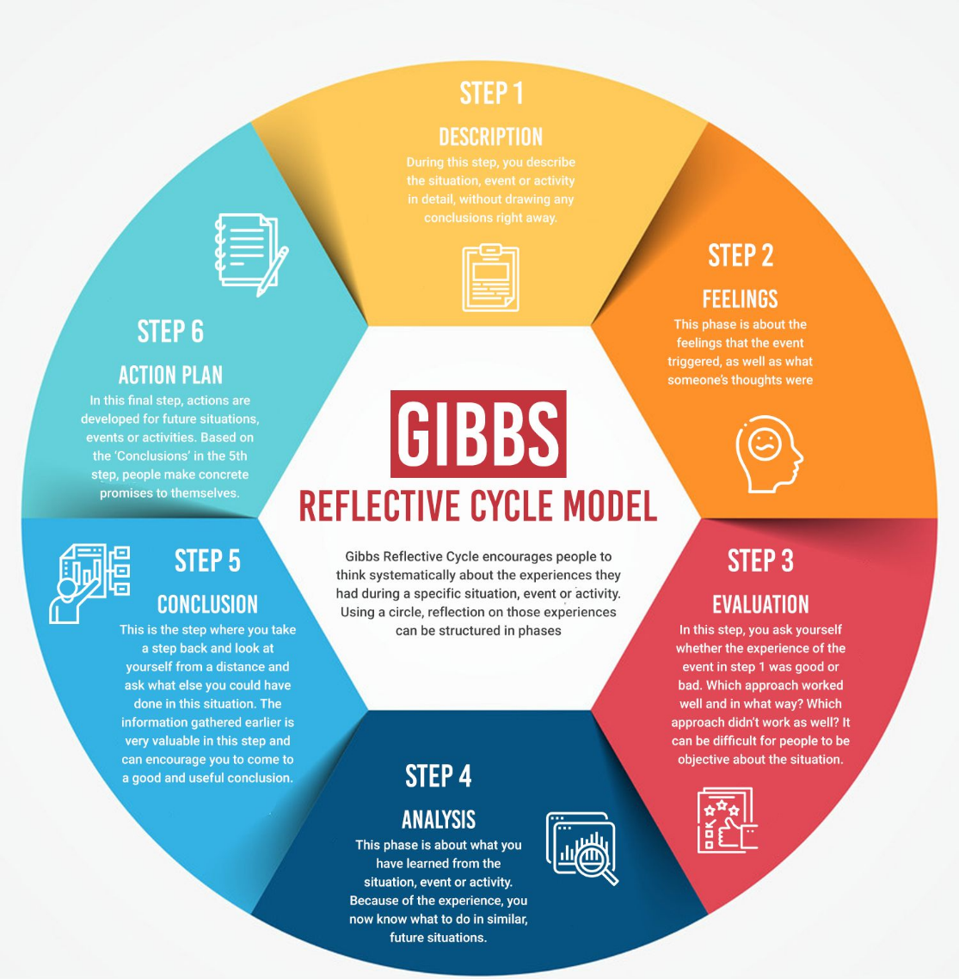

Description: The Incident

The incident in question, that I will be examining occurred after I was instructed to attend an emergency call involving a 17-year-old female. The female stating, she had been raped. Prior to my engagement, the control room had enquired if the perpetrator was still present and if the female’s safety was still at risk. For instance, by establishing if there are any warning markers of the male, this allows the officer to assess the threat, risk, and harm. It was established that the female had made the disclosure of the assault at a friend’s address after leaving the male’s address.

Feelings and evaluation of the incident

The incident had been extremely impactful to me due to witnessing the female is such distress. Officers faced many traumatic events every single day, which causes distress to their overall wellbeing and may cause officers mental health issues such as Post Traumatic Stress Syndrome (Campbell, 2008). To ensure no further distress was caused I worked to approach the victim in a compassionate and supportive manner by giving her time to talk and to process the incident, she then stated she felt empowered and more comfortable when discussing the incident.

Police officers face significant stress when dealing with rape incidents due to the sensitive and emotionally challenging nature of these cases. Officers are tasked with supporting survivors, conducting thorough investigations, and ensuring the perpetrator is held accountable, all while managing their own emotional reactions to the distressing details of the crime. The pressure to gather crucial evidence and provide compassionate support to survivors amidst the complex legal and procedural requirements adds to the stress experienced by officers during these investigations. Despite the challenges, police officers strive to uphold professionalism and empathy in their response to rape incidents, recognising the importance of their role in delivering justice and support to survivors.

In cases of sexual assault, the "golden hour" refers to the critical time immediately following the assault when prompt and comprehensive care is crucial for the well-being of the survivor and the success of forensic evidence collection (Rose,2021). The principles of the golden hour in rape cases emphasise the importance of timely and victim-centred response, which includes:

- Immediate Medical Care: Providing the survivor with immediate medical attention to address any injuries, prevent or treat sexually transmitted infections (STIs), and offer emergency contraception to reduce the risk of pregnancy.

- Forensic Evidence Collection: Conducting a forensic examination within the golden hour to collect crucial evidence such as DNA samples, which may be vital for identifying the perpetrator and supporting legal proceedings.

- Trauma-Informed Support: Offering trauma-informed care and emotional support to the survivor, acknowledging the impact of the assault and empowering them to make informed decisions about their care and next steps.

- Victim-Centered Approach: Prioritising the survivor's needs, autonomy, and well-being throughout the entire process, including medical care, evidence collection, and engagement with law enforcement.

- Coordination of Services: Coordinating efforts between healthcare providers, forensic experts , police, and victim support services to ensure a seamless and comprehensive response to the survivor's needs.

- By adhering to the principles of the golden hour in rape cases, responders can maximise the effectiveness of their interventions, support survivors in their recovery journey, and increase the likelihood of successful prosecution if the survivor chooses to pursue legal action against the perpetrator.

Sexual offences first responders within the police force undergo specialised training to effectively respond to and support survivors of sexual violence. This training equips officers with the necessary knowledge and skills to provide compassionate and victim-centered care while ensuring the preservation of forensic evidence (Scoglio et al, 2021). Topics covered often include trauma-informed interviewing techniques, understanding the dynamics of sexual violence, cultural competency, and legal procedures related to sexual offences. By receiving comprehensive training, police first responders are better prepared to approach cases of sexual assault with sensitivity, empathy, and professionalism, thereby enhancing the quality of support provided to survivors and improving the investigative process (Rumney and McPhee, 2023).

When evaluating the incident and collecting the evidence, my awareness was the potential emotional impact therefore establishing a balance between collective evidence and insuring sensitivity of the matter. In this incident, I needed to collect oral swabs and asked the female to wipe with a specific tissue which is provided in the early evidence kits that are used for all sexual assault and rape incidents. The early evidence kits provide multiple swabs, urine pots, evidence bags and gloves.

Step by step of the sexual Assault Referral centre (Analysis)

Upon arrival at the SARC, the victim is greeted by staff who assist with registration. This includes providing basic personal information and details about the assault. Next will be a trained healthcare professional conducts an initial assessment to determine the victim's immediate medical needs and any urgent interventions required. This may include addressing physical injuries, providing emergency contraception, and testing for sexually transmitted infections (STIs) (South Wales Police, 2024).

If the victim chooses to proceed with a forensic examination, which she did in this incident, they are taken to a private examination room where specially trained forensic nurses or doctors conduct a thorough examination to collect forensic evidence. This process is conducted sensitively and with the victim's consent at each step. Throughout the process, the victim receives medical care and support tailored to their individual needs. This may include addressing injuries, providing medication to prevent STIs, and offering emotional support from trained counsellors or support workers (South Wales Police, 2024).

Victims of crime, particularly those affected by rape, receive crucial support aimed at addressing their immediate needs and facilitating their recovery journey. This support often includes access to specialised counselling services, medical care, and legal advocacy.

The negative aspects of SARC

Victims of sexual assault seeking support at Sexual Assault Referral Centres (SARCs) in the UK often encounter distressing experiences that profoundly impact their well-being. Research by Johnson (2022) revealed that victims frequently report feeling retraumatised due to insensitive questioning and a lack of privacy during examinations at SARCs. Additionally, a study by O'Doherty et al (2023) found that victims faced significant delays in accessing services at SARCs, leading to heightened levels of anxiety and frustration. These negative experiences have long-lasting effects on survivors, contributing to increased rates of depression, post-traumatic stress disorder (PTSD), and difficulty in forming trusting relationships (Hester,and Lilley, 2018.). Consequently, survivors may face barriers in seeking essential medical and psychological support, further exacerbating their trauma and hindering their path towards recovery and justice. It is imperative for SARCs to address these shortcomings promptly and implement comprehensive reforms to ensure that victims receive the compassionate and effective care they deserve (Norman, 2022).

Topping (2022) states that officers demonstrating explicit victim blaming and a lack of belief in the victims had a signification impact in the overall investigations and leads in the victim to feel unheard. Topping (2022) also suggests that due to officer’s high workload and high demand, victims of crimes such as rape are not delt with appropriately. Therefore, as an organisation these issues need to be addressed and reviewed to establish the best outcome for the survivors.

Repeat victimisation and repeat offending

Trudle (2022) implies that autistic individuals are at an increased risk of experiencing victimisation. According to Trudle (2022) a meta-analysis found just over 40 percent of Autistic individuals have become victims of crime. The data suggests 47 percent of Autistic individuals are bullied, 16 percent of are a target for child abuse and 40 percent of Autictic individuals experience sexual victimisation (Trudle, 2022). Just over 80 percent of autistic individuals experience multiple forms of Victimisation.

Community policing efforts play a vital role in building trust and engagement with local residents, which helps identify and address underlying issues contributing to repeat victimization (Tilley, 2007). Initiatives such as neighbourhood watch programs and community safety partnerships empower residents to take an active role in crime prevention and reporting, fostering a sense of ownership and collective responsibility for public safety (Chainey, 2008).

Police also implement targeted interventions and diversion programs to address the root causes of offending behaviour and provide support to individuals at risk of reoffending. Rehabilitation services, mental health support, and substance abuse treatment are integral components of these programs, aimed at breaking the cycle of crime and facilitating successful reintegration into society (Zara and Farrington , 2015). Multi-agency collaboration between the police, probation services, social services, and other stakeholders ensures a holistic approach to addressing the complex needs of individuals involved in the criminal justice system (Abel and Lewis, 2015).

Technological advancements and data-driven strategies are utilised to identify patterns of crime and allocate resources effectively to prevent repeat victimisation. Predictive analytics and crime mapping tools enable police forces to identify hotspots of criminal activity and deploy targeted interventions to disrupt criminal networks (Chainey, 2008). Additionally, offender management systems and electronic monitoring enhance supervision of individuals with a history of offending behaviour, reducing the risk of reoffending, and enhancing public safety (Tilley, 2005).

Conclusion and Action Plan, and the use of Claires Law, MARACs and PPNS.

Claire's Law, also known as the Domestic Violence Disclosure Scheme (DVDS), is a legislative measure in the UK designed to empower individuals to seek information from the police regarding their partner's history of domestic violence or violent offenses. This law serves as a critical tool in aiding individuals to make informed decisions about their safety and well-being within relationships. Claire's Law underscores the importance of transparency and awareness in preventing domestic violence, providing individuals with the opportunity to access vital information that could potentially save lives and protect vulnerable individuals from harm (SWP,2024). This is a new law tackling reoffending rates and the protection of the public.

MARAC meetings play a vital role in supporting victims of domestic abuse by bringing together various agencies to assess and manage the risks they face. During these meetings, information about the victim's situation is shared, enabling agencies to develop coordinated action plans tailored to the individual's needs. This collaborative approach ensures that victims receive comprehensive support, including access to essential services such as counselling, legal advocacy, and safe accommodation. By facilitating a multi-agency response, MARAC meetings contribute to enhancing the safety and well-being of victims, holding perpetrators accountable, and helping individuals break free from the cycle of abuse (SWP,2024).

Public Protection Notices (PPNs) are valuable tools used by police to manage and mitigate risks posed by individuals who present a threat to public safety. By imposing specific conditions or restrictions on the individual's behaviour, such as prohibiting contact with certain individuals or entering specific areas, PPNs aim to prevent further harm to individuals or communities. The effectiveness of PPNs lies in their ability to provide a swift and targeted response to emerging threats, enabling authorities to intervene and safeguard vulnerable individuals promptly. Additionally, PPNs serve as a deterrent, sending a clear message to individuals engaged in criminal activity that their behaviour will not be tolerated. While PPNs can be effective in certain cases, their success relies on close collaboration between police and agencies, effective monitoring of compliance, and ongoing risk assessment to ensure the continued safety of the community (SWP,2024).

Conclusion and Action Plan

In conclusion, there are many ways to tackle victimisation and repeat victimisation. Supporting services such as counselling to victims of crime and including those of repeat victims can help them cope with trauma and reduce the vulnerabilities. Books such as sex education can also prevent rapes and educate children (Clonan-Roy et al, 2021). Officers can also work towards a safe community by utilising better community policing. Which can lower the rates of repeat victimisation and vulnerable individuals being targeted by the presence of more officers engaging with the community and understanding what is going on and focusing on crime prevention.

To prevent victimisation of our most vulnerable, better forms of education and awareness through schools and training provided to the public could be applied to raise awareness of what to look out for and when to report. Officers can work towards this by providing training, advertising, and attending schools to educate the future population (Muir, 2021).

Word count :2181

Task 2

Choose 1 of these 5 options to answer

(Note for officers who have an interest in becoming a detective and wish to specialise in this role, you MUST choose option 5)

  - Response Policing.
  - Policing Communities.
  - Road Policing.
  - Information and Intelligence.
  - Conducting Investigations.

Task 2 Option 1:

Relevant areas of the National Policing Curriculum:

Response Policing

A core part of the policing mission is to prevent crime and disorder. Domestic abuse causes both serious harm and constitutes a considerable proportion of overall crime

You should choose a domestic abuse incident that was of a complex nature, in which you played a significant role in providing a response.

Critically assess the challenges associated with a domestic abuse incident that you have attended, and the strategies developed for effective policing in such challenging situations.

2000 words (+/- 10%: include your actual word count at the end of each section)

ANSWER:

Task 2 Option 2:

Relevant areas of the National Policing Curriculum:

Policing Communities

Criminal justice faces ever more challenges from society. While official figures show a drop in police recorded crime in the UK the distribution of crime shows a more complex pattern with violent crime showing a rise.

Regarding community policing chose an incident that you have attended that presented a complex issue for the community, and that you played a significant role in providing a response.

Critically evaluate a range of interventions that you have employed to promote community engagement that assisted in resolving the issue.

2000 words (+/- 10%: include your actual word count at the end of each section)

Answer:

Task 2 Option 3

Relevant areas of the National Policing Curriculum:

Road Policing

The police are the lead agency for collision investigation and have the primary duty to investigate and establish the circumstances that have led to road deaths and life changing injuries.

Describe a serious collision that you attended and in which you took a significant role (e.g., initial reporting officer, scene manager, lead investigator).

Critically evaluate the evidence base that you dealt with and strategies that could be implemented to reduce the likelihood of it reoccurring.

2000 words (+/- 10%: include your actual word count at the end of each section)

Answer:

Task 2 Option 4

Relevant areas of the National Policing Curriculum:

Information and Intelligence

You should choose an investigation that you have been involved in that was of a complex nature, in which you played a significant role.

Critically analyse an investigation, that you have led, commenting on the effectiveness of the National Intelligence Model and the importance of the role played by cross border cooperation in relation to your information and intelligence.
Reference how effective information and intelligence was used within your operation, and how you used specialist intelligence roles to support your complex investigation.

2000 words (+/- 10%: include your actual word count at the end of each section)

Answer:

Task 2 Option 5

Relevant areas of the National Policing Curriculum:

Conducting Investigations

You should choose an investigation that you have been involved in that was of a complex nature, in which you played a significant role.

Critically evaluate the processes employed in a complex investigation you have been involved in, and the fast-track actions that you have utilised.

Evaluate the support you have provided to victims, witnesses, and offenders (where appropriate) during a complex investigation and reference the management of your own personal values and attitudes in relation to this.

2000 words (+/- 10%: include your actual word count at the end of each section)

Answer:

The pursuit for justice, through investigation, is a defining cornerstone of its legal and societal framework in the United Kingdom. The principles of investigating are fairness, accountability and the safeguarding of individual’s rights which hold paramount significance. At the heart of upholding the principles of a criminal justice system lies a sophisticated and an intricate system of investigations (Davis ,2011). Whether it is uncovering financial fraud in the streets of London or solving a rural crime in the countryside investigating forms the backbone of maintaining order and ensuring the rule of Law.

This assignment examines the complex investigation I had delt with, through exploring the demanding and intricate processes that underpin the investigation. I will be assessing the techniques, strategies, and methodologies that investigators employ to untangle webs of deceit, solve crimes, and ensure justice is upheld (Davis ,2011).

Through this exploration, I aim to appreciate the vital role that complex investigations play in upholding justice, accountability, and public safety, while always having the victim’s safety and voice in consideration.

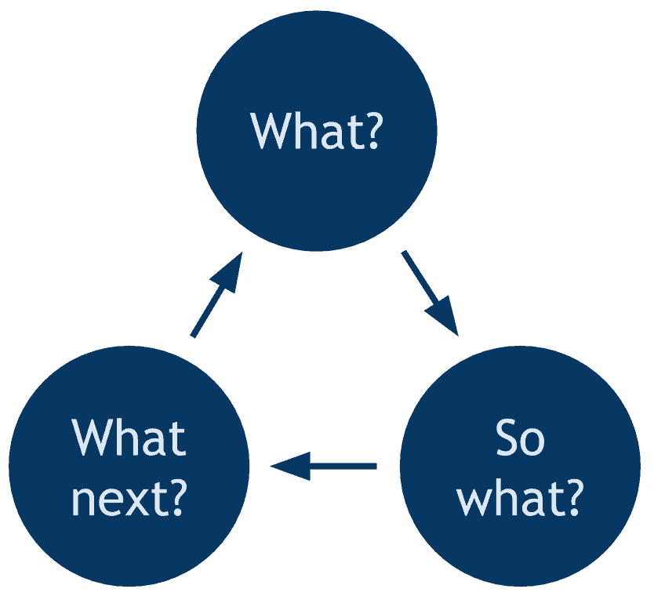
Through this assignment I will be referring to Borton model of reflection, this model encourages individuals to examine their experiences through a multifaceted lens, considering factors such as personal values, cultural influences, and social context. By integrating elements of experiential learning and social justice, the Boston Model offers a dynamic platform for exploring complex issues, fostering empathy, and promoting meaningful dialogue. Through the application of the Boston Model, individuals can gain deeper insights into their own perspectives, enhance their understanding of others, and cultivate a more inclusive and socially conscious approach to personal and professional development (Moon,2006).

WHAT?
Dealing with a Burglary

Firstly, I will begin by explaining a complex incident I attended, which was a burglary. I had to be very time efficient whilst attending a burglary due to the golden hour principles for capturing evidence, witnesses, and potential suspects (Jacobson, Jessica and Maitland, Lee and Hough, Mike, 2003).

On route to the incident, I had contacted the control room to gather information as we were on the way to attend the scene. I was informed, a female’s home had been broken into and that she was severely distressed and was unaware who had done this. As I made their way to the scene, I had asked if there were any dog units available to enter the home to check no unknown persons were still present at the address. As I arrived, I had created a scene by cordoning the initial property and initiated a pathway so there was less chance of officers standing on crucial evidence (Gardner, and Krouskup, 2018). Just after arriving on scene the dog unit arrived. They then entered the property and initiated the search. They concluded that there were no unknown persons in the home address. I then activated my body warn to capture any evidence.

I began by speaking to the victim of the home, to establish the circumstances. I then contacted the criminal investigation department and the crime scene investigation unit (Miller, 2002). CID are a specialised unit that deal with complex crimes such as burglaries and murders, CID officers have further trained in more complex forms of investigations such as different searching techniques and different interviewing techniques. CSI officers are a key part in any investigation, as they capture the evidence by taking photos of the scene and capturing evidence that CID or response officers might have missed.

I had contacted these departments as it is vital to obtain photos of the scene and complex areas of the investigation. I had took witness statements from the homeowner and her current boyfriend to establish if contact had been made to them or if they believed they were aware of the potential individual who committed the burglary (Miller , 2002).

I begin house to house enquires as this establishes if there was any CCTV covering the area in which the burglary had occurred or if any person had witnessed anything. After completing house to house enquiries, no persons had heard or seen anything and no persons had any CCTV covering the area or had been working, which caused further issues to no witnesses (Mennell, and Shaw, 2005).

As I completed the house to house enquires, I then had a call from the CSI unit. They informed me that due to the time of it being 0200hrs in the morning and no available officers they would not attend. Therefore, the CSI unit stated that I had to take photos and seize any items that seem out of place or out of the ordinary. After being informed of this I then took photos of each bedroom as well as a recording through my body worn camera of the scene.

The homeowner later informed that the unknown person had placed cello tape over her home, such as the doorways, windows and walls. The intruder also moved the camera in the home. Therefore, through the witness statements, we had established that there may be potential forensic evidence on the tape and on the camera that had been moved. I then placed gloves on and seized the camera and each pieced of tape in separate evidence bags, which I had confirmed is the correct method by CIS (McCartney, and Shorter, 2020). Before seizing the evidence, I firstly took photos of the evidence in their original positions for most accurate evidence.

So What ?

In the realm of complex investigations, the golden hour unfolds as a pivotal time within the initial states of an investigation. Spanning the critical sixty minutes threshold, it encapsulates the paramount moments when investigators quickly and meticulously procure vital information such as witness statements and evidence to preserve the integrity of potential evidence (Franjić, 2018). The concept of the golden hour emphasizes the delicate balance between time and precision, underscoring the significance of seizing the opportunities in the initial stages to fortify the inquiries foundations.

When investigating a burglary, there is a 10-point plan that needs to be followed to insure I cover all investigative areas and document correctly. The points of the plan are:

- The RP, IP and RO: who is the injured party or reporting person?
- Establish the scene: understand the entry and exit points.
- The MO: what is the motus operandi and pattens in the address?
- Extent of the search: establish where the cordons of the search need to begin and end, for example, any outbuildings.
- Stolen and Ignored property: establish if any property has been damaged or stolen. establish if there is any property that had been left behind, that might have been stolen due to expense of the property, such as a TV.
- Potential suspects
- House to house of the area, establishing any CCTV available or any witnesses.
- CSI
- Other information that does not fall into these areas.
- The officers’ observations of the incident and establish what outstanding actions that would need to be completed if it is not feasible in that time.
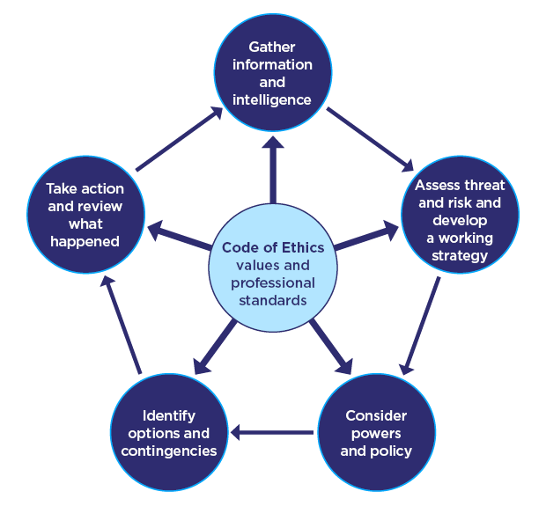

The National Decision Model

The National Decision Model (NDM) is a framework used by police forces in the UK to guide decision-making processes in various situations. It provides a structured approach to assessing incidents, considering factors such as risks, priorities, legal considerations, and available resources (Rogers, and Smith, 2018).

In practice, the police use the NDM to assess each incident they encounter, whether it involves a crime, public safety issue, or other concerns. The model consists of several steps:

- Gather Information: Police officers gather as much relevant information about the incident as possible, including details about the situation, individuals involved, and any potential risks or threats.

- Assess Threats and Risks: Using the information collected, officers assess the level of threat and risk posed by the incident. This includes considering the safety of individuals involved, as well as the potential for escalation or harm.

- Consider Legal and Ethical Factors: The NDM emphasises the importance of considering legal and ethical considerations in decision-making. This includes ensuring actions are lawful, proportionate, and in line with ethical standards.

- Identify Objectives: Based on the assessment of threats, risks, and legal considerations, officers identify clear objectives for addressing the incident. This may include goals such as ensuring public safety, apprehending suspects, or resolving conflicts peacefully.

- Evaluate Options: Officers consider various options for responding to the incident, weighing the potential outcomes and consequences of each approach.

- Take Action: Once a decision is made, officers take appropriate action to address the incident, working towards achieving the identified objectives.

- Review and Reflect: After the incident are resolved, officers review their actions and reflect on the decision-making process. This includes considering what went well, what could be improved, and any lessons learned for future incidents.

Overall, the National Decision Model serves as a structured framework to guide me in making effective and accountable decisions when responding to incidents. By systematically considering relevant factors and evaluating options, I can work towards resolving incidents in a manner that prioritises public safety, upholds legal standards, and respects ethical principles.

WHAT NEXT?

After the investigation, I had to consider the safeguarding of the female. I had stated to the female to stay in her parents’ home for the time being, as we were unable to fully secure the property. Therefore, this leaves room for risk if the female remains at the property. I then completed a public protection notice for the female as she believed the break in had been due to a previous ex-partner.

The introduction of a Public Protection Notice (PPN) alongside a Multi-Agency Risk Assessment Conference (MARAC) signifies a groundbreaking approach to enhancing public safety and victim support. The PPN serves as a comprehensive framework, prioritising victim-centricity and tailored protection plans, while the MARAC fosters seamless interagency collaboration among law enforcement, social services, healthcare professionals, and community organisations. Together, these initiatives ensure an initiative-taking and coordinated response to assessing and mitigating risks to victims of crime, empowering them with information and support while safeguarding their well-being. This innovative integration of a PPN and MARAC represents a significant advancement in public protection strategies, setting a precedent for comprehensive and collaborative approaches to addressing complex societal challenges (Welsh Government ,2024). PPNs can also help the victim receive support such as ring doorbells (Jacobson, et al, 2003).

The female was very grateful of this support and stated she will benefit from these services as she also has a young daughter who was now also scared to attend the home. Due to this being a domestic incident, officers have also informed the female of the charity Live Fear Free, which allows the female to speak to individuals who are not police officers and deal specifically with victims (Welsh Government ,2024). Live Fear Free is a charity in Wales dedicated to supporting those affected by domestic abuse, sexual violence, and other forms of violence against women, men, and children. They offer a confidential helpline, advocacy services, and access to specialist support organisations. Their goal is to empower survivors, raise awareness, and aim to end violence in all its forms (Welsh Government, 2024)

Tailored support through a victim referral by South Wales Police involves a meticulous and personalised approach to addressing the unique needs of each victim. This specialised assistance encompasses a range of services tailored to the individual circumstances of the victim and the specific nature of the crime they have experienced (Jacobson, et al, 2003). This could include providing dedicated victim support officers who offer emotional guidance and practical assistance, such as arranging safe accommodation or connecting victims with counselling services. Additionally, South Wales Police may collaborate with partner agencies to offer specialised support, such as legal aid for navigating the criminal justice system or referrals to community organisations for ongoing assistance. By prioritising the individual needs of victims and offering targeted support, South Wales Police aims to empower victims, facilitate their recovery, and ensure they receive the necessary assistance to navigate the aftermath of the crime effectively (Jacobson, et al, 2003).

On reflection, it would have been beneficial to have CSI and CID to attend the incident at the very beginning rather than potentially attending in the later days to come, as this would affect the overall evidential window and golden hour. I believe the effectiveness of myself, had been positive as I attended the scene as soon as possible and began the 10 point burglary plan. On reflection, South Wales police had not provided the best outcome for the victims as, CID and CSI did not attend in the first instance. In reflection I could have been more effective by dealing with the incident quicker and also having a better understanding, furthermore this had been my first burglary incident and felt where I was unsure I could have researched more prior attending the incidences. This incident has encouraged me to read more information on crimes I may attend in the future.

The South Wales Police also offer a high range of training opportunities to officers that allow and educate officers on the wide range of scenarios and possible outcomes. This allows and trains officers to be prepared for all scenarios and which this can be applied in real life. South Wales Police officer training to officers every eight weeks which range from first aid, diversity, and safeguarding.

Word count: 2199

Authentication signature: LDayman

Please sign to confirm that the work submitted is your own and has not been copied from another:

Signed: LDayman

Date:11/03/2024
Bibliography
- Abrahams, N., Mhlongo, S., Dunkle, K., Chirwa, E., Lombard, C., Seedat, S., Kengne, A.P., Myers, B., Peer, N., Garcia-Moreno, C. and Jewkes, R., (2021.) Increase in HIV incidence in women exposed to rape. AIDS (London, England), 35(4), p.633.

- Adeani, I.S., Febriani, R.B. and Syafryadin, S., (2020). Using GIBBS’reflective cycle in making reflections of literary analysis. Indonesian EFL Journal, 6(2), pp.139-148.

- Campbell, R., (2008). The psychological impact of rape victims. American psychologist, 63(8), p.702.
- Chainey, Tompson,and Uhlig,(2008.) The utility of hotspot mapping for predicting spatial patterns of crime. Security journal, 21, pp.4-28.

- Clonan-Roy, K., Goncy, E.A., Naser, S.C., Fuller, K.A., DeBoard, A., Williams, A. and Hall, A., (2021.) Preserving abstinence and preventing rape: How sex education textbooks contribute to rape culture. Archives of sexual behavior, 50, pp.231-245.

- Davis (2011). Principles of Investigation. Academic Forensic Pathology. 2011;1(4):378-381. doi:10.23907/2011.053

- Franjić, S., (2018). Legal aspects of Forensics. Forensic Science Today, 4(1), pp.009-017.

- Gardner, R.M. and Krouskup, D., (2018). Practical crime scene processing and investigation. CRC Press.

- Grove, L., Tseloni, A. and Tilley, N., (2012.) Crime, inequality, and change in england and wales. In The International crime drop: new directions in research (pp. 182-199). London: Palgrave Macmillan UK.

- Hales, G.K., 2022. The impact of adverse childhood experiences on psychosocial functioning (Doctoral dissertation, University of Sheffield).

- Hester, and Lilley ( 2018.) More than support to court: Rape victims and specialist sexual violence services. International review of victimology, 24(3), pp.313-328

- Jacobson, Jessica & Maitland, Lee & Hough, Mike. (2003). The Reducing Burglary Initiative: investigating burglary.
- Johnson, (2022). Are survivors of sexual assault blamed more than victims of other crimes?. Journal of interpersonal violence, 37(19-20), pp.NP18394-NP18416.
- Kemshall, H. and Maguire, M., 2021. Public protection, partnership and risk penality: The multi-agency risk management of sexual and violent offenders. In Governing Risks (pp. 319-346). Routledge.

- Kirkner, A., Lorenz, K. and Ullman, S.E., (2021.) Recommendations for responding to survivors of sexual assault: A qualitative study of survivors and support providers. Journal of interpersonal violence, 36(3-4), pp.1005-1028.

- Kolb, D.A. (2015) Experiential learning: experience as the source of learning and development. 2nd edn. New Jersey: Pearson Education pp.47-54

- McCartney, C. and Shorter, L., (2020). Police retention and storage of evidence in England and Wales. International Journal of Police Science & Management, 22(2), pp.123-136.

- Mennell, J. and Shaw, I., 2005. Science and technology at the crime scene. Measurement and control, 38(3), pp.75-78.

- Miller, M.T.,( 2002.) Crime scene investigation. In Forensic science (pp. 143-164). CRC Press.

- McGuire, Evans, Kane, McGuire, Evans, and Kane, (2021.) Victim Counselling and Support: A Review of Police, Community and Therapeutic Interventions. Evidence-Based Policing and Community Crime Prevention, pp.361-415.

- Moon, (2006). Learning journals: A handbook for reflective practice and professional development. Routledge.

- Mucci, and Scalabrini, (2021.) Traumatic effects beyond diagnosis: The impact of dissociation on the mind–body–brain system. Psychoanalytic Psychology, 38(4), p.279.

- Muir,.,( 2021). Taking prevention seriously: the case for a crime and harm prevention system. Strategic Review of Policing in England and Wales, 25(2).

- Norman, J., Fox, A., Harding, R., Majid, A., Williams, E., Davies, K. and Horvath, M.A., 2022. Critical reflection: The importance of case reviews and reflective practice in rape and serious sexual offences investigations. International Criminology, 2(3), pp.276-285.

- O'Doherty, Carter, Lutman-White, Caswell, Jackson, Feder, Heron, Morris, and Brown, (2022). Multi-disciplinary Evaluation of Sexual Assault Referral Centres (SARCs) for better Health (MESARCH): protocol for a 1-year cohort study examining health, well-being and cost outcomes in adult survivors of sexual assault attending SARCs in England. BMJ open, 12(5), p.e057449.

- Osidipe, T. and South, J., (2021.) Police in England and Wales. Global Perspectives in Policing and Law Enforcement, p.83.

- Rogers, C., (2016. )Intelligence Gathering and Police Systems. In Policing Cyber Hate, Cyber Threats and Cyber Terrorism (pp. 129-148). Routledge.

- Rogers, C. and Smith, B., (2018.) The College of Policing: Police education and research in England and Wales. Higher education and police: An international view, pp.87-106.

- Rose, A., (2021). Forensics: The Golden Hour. Modern Police Leadership: Operational Effectiveness at Every Level, pp.223-233.

- Rumney, P.N. and McPhee, D.,(2023.) Vulnerability, resilience, and rape: Uncovering the hidden work of police officers during rape investigations. International Review of Victimology, p.02697580231151974.

- Scoglio, A.A., Marine, S.B. and Molnar, B.E., (2021). Responder perspectives on justice and healing for sexual violence survivors. Psychology of violence, 11(1), p.1.
- Smith, Heyes, Fox, Harrison, Kiss, and Bradbury, (2018). The effectiveness of probation supervision towards reducing reoffending: A rapid evidence assessment. Probation Journal, 65(4), pp.407-428.

- South Wales Police (2024) Rape, sexual assault and other sexual offences | south wales police, Support for rape and sexual assault. Available at: https://www.south-wales.police.uk/ro/report/rsa/alpha-v1/advice/rape-sexual-assault-and-other-sexual-offences/%C2%A0 (Accessed: 20 January 2024).

- Tidmarsh, P., Sharman, S. and Hamilton, G., (2021.) Police officers’ perceptions of specialist training, skills and qualities needed to investigate sexual crime. Police practice and research, 22(1), pp.475-490.
- Tilley, (2005). Handbook of crime prevention and community safety. Willan Pub.
- Tilley, Robinson, and Burrows, (2007). The investigation of high volume crime. Handbook of criminal investigation, pp.226-254.

- Topping, (2022) Sarah Everard murder sparked UK reckoning with male violence, say charities, The Guardian. Available at: https://www.theguardian.com/uk-news/2022/mar/03/sarah-everard-sparked-uk-reckoning-with-male-violence-say-charities (Accessed: 20 January 2024).

- Trundle, G., Jones, K. A., Ropar, D., & Egan, V. (2023). Prevalence of Victimisation in Autistic Individuals: A Systematic Review and Meta-Analysis. Trauma, Violence, & Abuse, 24(4), 2282-2296. https://doi.org/10.1177/15248380221093689

- Welsh Government (2024) Providing help and advice about violence against women, domestic abuse and sexual violence, GOV.WALES. Available at: https://www.gov.wales/live-fear-free (Accessed: 20 January 2024).

- West Yorkshire Police (2024) The 10 principles of crime prevention, West Yorkshire Police. Available at: https://www.westyorkshire.police.uk/advice/10-principles-crime-prevention/10-principles-crime-prevention/10-principles-crime-prevention (Accessed: 20 January 2024).

- Zara, and Farrington, (2015.) Criminal recidivism: Explanation, prediction and prevention. Willan.

