Name:__Collette Owen_______________________________

Student Number: __2517697______________________
__________________________________________________________

WORKSHEET 4 – TESTING

- Original code:
[Copy and paste your original code from Moodle into this box. Do not change it.]
# Task A:

def treasure_location1():
print("\n💰 INCREDIBLE! You've found a treasure chest! 💰")
print("You've discovered 1000 gold coins!\n")

def treasure_location2():
print("\n💰 INCREDIBLE! You've found a treasure chest! 💰")
print("You've discovered 1000 gold coins!\n")

def treasure_location3():
print("\n💰 INCREDIBLE! You've found a treasure chest! 💰")
print("You've discovered 1000 gold coins!\n")

def treasure_location4():
print("\n💰 INCREDIBLE! You've found a treasure chest! 💰")
print("You've discovered 1000 gold coins!\n")

def treasure_location5():
print("\n💰 INCREDIBLE! You've found a treasure chest! 💰")
print("You've discovered 1000 gold coins!\n")

print("\n🏴‍☠️ Welcome to Treasure Island! 🏴‍☠️")
print("There are 5 treasure chests hidden across the island (locations 1-50)")
choice = int(input("\nWhere would you like to search? "))

#Task B

if choice == 7:
treasure_location1()
elif choice == 17:
treasure_location2()
elif choice == 22:
treasure_location3()
elif choice == 34:
treasure_location4()
elif choice == 36:
treasure_location5()
else:
print("❌ No treasure found at location\n")
if treasure_location1 == 6 or 8:
print("🔥 BURNING HOT! The treasure is practically beneath your feet!")
elif treasure_location2 == 16 or 18:
print("🔥 BURNING HOT! The treasure is practically beneath your feet!")
elif treasure_location3 == 21 or 23:
print("🔥 BURNING HOT! The treasure is practically beneath your feet!")
elif treasure_location4 == 33 or 35:
print("🔥 BURNING HOT! The treasure is practically beneath your feet!")
elif treasure_location5 == 37:
print("🔥 BURNING HOT! The treasure is practically beneath your feet!")
print("End of program\n")

Code Testing

First, create a test rig, so that you can see the generated numbers before testing the programme - so that you can see what you’re doing!

For each test below, run your code and enter the values provided. Provide a screenshot of what happened when the programme ran. Did the programme behave correctly or did it do something unexpected? Fill in a box for each test below. You should present 11 separate boxes, 1 for each test. (Note: the first box is provided as a template)

Test the following:

- Guess is an exact match on the first number in the set
- Guess is an exact match on the last number in the set
- User enters their guess as -4
- User enters their guess as 55
- Within 2 of a number (below)
- Within 2 of a number (above)
- Within 5 of a number (below)
- Within 5 of a number (above)
- Within 2 of two numbers
- Within 2 or 5 of three numbers (you may need to run your program a few times to generate a suitable number set, or you can hard code the values into the test rig)
- What happens if a duplicate number is generated within the random number set?

Test:
- Guess is an exact match on the first number in the set

Screenshot(s) of output:
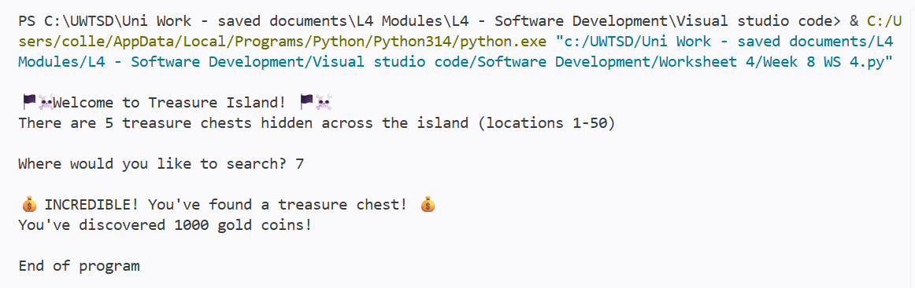
Result: Did the program behave as expected ie syntactically and logically correct?
YES (delete as appropriate)

If NO, what problems were encountered and why? Suggest how things could be improved.

(Copy and paste box above for each of the rest of the tests)

Test:
2. Guess is an exact match on the last number in the set

Screenshot(s) of output:
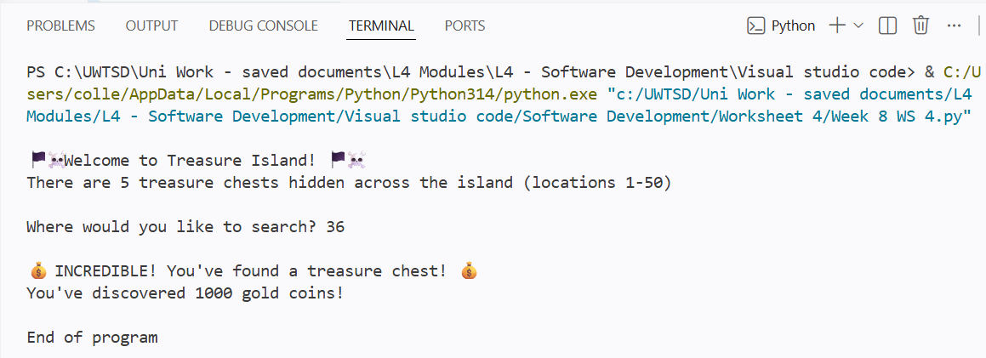
Result: Did the program behave as expected ie syntactically and logically correct?
YES (delete as appropriate)

If NO, what problems were encountered and why? Suggest how things could be improved.

Test:
- 3. User enters their guess as -4

Screenshot(s) of output:
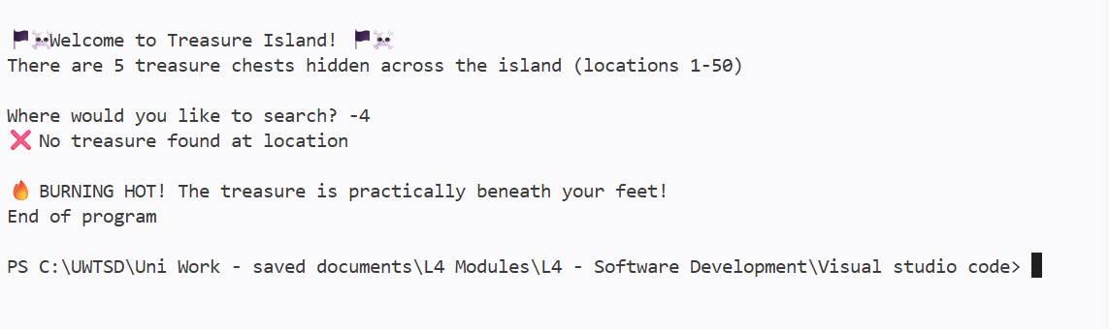
Result: Did the program behave as expected ie syntactically and logically correct?
NO (delete as appropriate)

If NO, what problems were encountered and why? Suggest how things could be improved.

It should have returned an alternate response as only 1-50 are valid entries. I need to add a value to restrict use of data outside of set values.

Test:
4. User enters their guess as 55

Screenshot(s) of output:
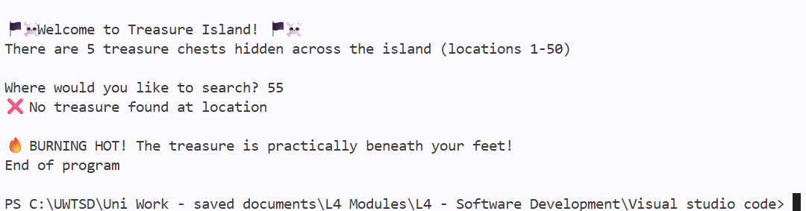
Result: Did the program behave as expected ie syntactically and logically correct?
NO (delete as appropriate)

If NO, what problems were encountered and why? Suggest how things could be improved.

Same issue as number 3, no limitation on what value can be input by the user.

Test:
5. Within 2 of a number (below)

Screenshot(s) of output:
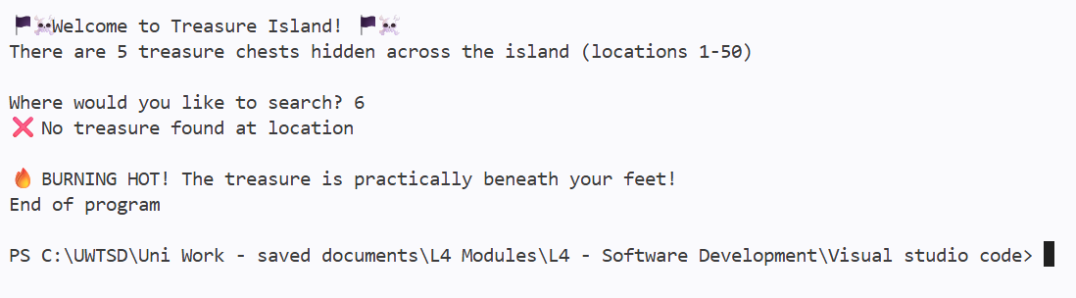
Result: Did the program behave as expected ie syntactically and logically correct?
YES (delete as appropriate)

If NO, what problems were encountered and why? Suggest how things could be improved.

Test:
6. Within 2 of a number (above)

Screenshot(s) of output:
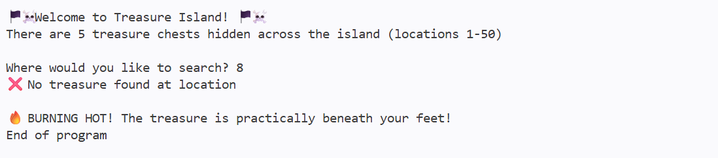
Result: Did the program behave as expected ie syntactically and logically correct?
YES (delete as appropriate)

If NO, what problems were encountered and why? Suggest how things could be improved.

Test:
7. Within 5 of a number (below)

Screenshot(s) of output:

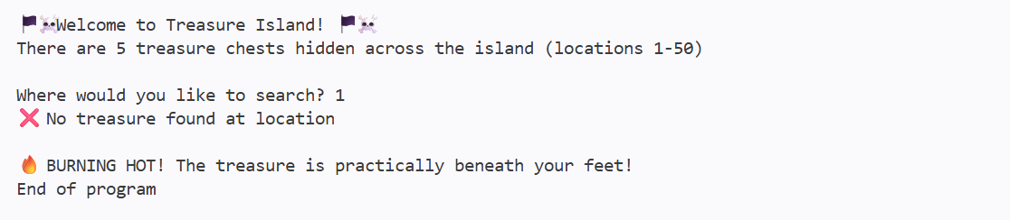
Result: Did the program behave as expected ie syntactically and logically correct?
NO (delete as appropriate)

If NO, what problems were encountered and why? Suggest how things could be improved.

Partly expected as there is no treasure there, but the “Burning Hot” Message is not correct.

Test:
8. Within 5 of a number (above)

Screenshot(s) of output:
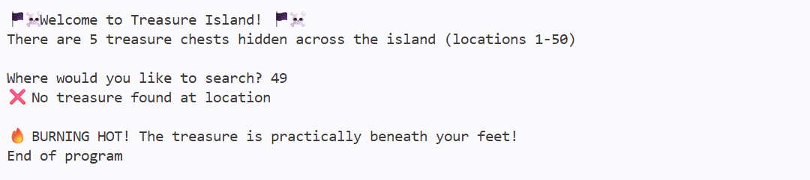
Result: Did the program behave as expected ie syntactically and logically correct?
NO (delete as appropriate)

If NO, what problems were encountered and why? Suggest how things could be improved.

Partly expected as there is no treasure there, but the “Burning Hot” Message is not correct.

Test:
- 9 Within 2 of two numbers
Screenshot(s) of output:
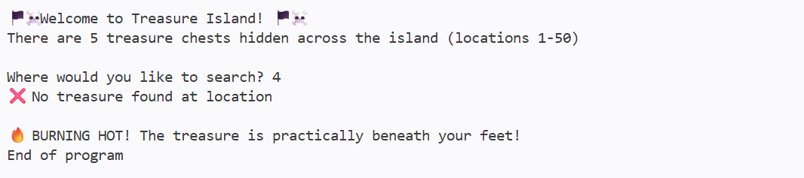
Result: Did the program behave as expected ie syntactically and logically correct?
NO (delete as appropriate)

If NO, what problems were encountered and why? Suggest how things could be improved.

The correct ranges have not been input.

- Consider the results of the above tests and revisit your original code in order to address the tests that failed. (Note: you may not be able to solve all of the problems that were originally encountered, but solve as many as you can.)

Paste your full revised code here :

[Copy and paste your full revised code here – note, do not use a screenshot]

This was unfinished, this was my attempted to correct the errors:

# Task A:

def treasure_location1():
print("\n💰 INCREDIBLE! You've found a treasure chest! 💰")
print("You've discovered 1000 gold coins!\n")

def treasure_location2():
print("\n💰 INCREDIBLE! You've found a treasure chest! 💰")
print("You've discovered 1000 gold coins!\n")

def treasure_location3():
print("\n💰 INCREDIBLE! You've found a treasure chest! 💰")
print("You've discovered 1000 gold coins!\n")

def treasure_location4():
print("\n💰 INCREDIBLE! You've found a treasure chest! 💰")
print("You've discovered 1000 gold coins!\n")

def treasure_location5():
print("\n💰 INCREDIBLE! You've found a treasure chest! 💰")
print("You've discovered 1000 gold coins!\n")

print("\n🏴‍☠️ Welcome to Treasure Island! 🏴‍☠️")
print("There are 5 treasure chests hidden across the island (locations 1-50)")
choice = int(input("\nWhere would you like to search? "))

#Task B
treasure_locations = [7, 17, 22, 34, 36]
user_guess = 50

smallest_distance = 100
for treasure in treasure_locations:
distance = abs(user_guess - treasure)
if distance < smallest_distance:
smallest_distance = distance

if choice == 7:
treasure_location1()
elif choice == 17:
treasure_location2()
elif choice == 22:
treasure_location3()
elif choice == 34:
treasure_location4()
elif choice == 36:
treasure_location5()
else:
print("❌ No treasure found at location\n")
print("End of program\n")

