Confucius Institute Summer Camp in Beijing, China
1st to 14th July 2018

Spend two weeks in Beijing this summer! Visit China’s iconic historical sites such as the Forbidden City, the Great Wall, and much more. For Free!
Here’s what we provide … For Free!
- Accommodation at Beijing Union University’s student halls
- All meals for two weeks in Beijing
- Basic Chinese language tuition
- Tours and trips around Beijing
- Visits to media companies and Beijing’s leading digital media lab (tbc)
What’s the catch?
You have to register with the Confucius Institute and take a short Chinese language and culture course (March – June 2018). You have to pay for visas & flights, but you may qualify for a travel bursary.
Interested?
Email confuciusinstitute@uwtsd.ac.uk or attend the information fair 13.00 -14.00 on 7 March 2018 (Wednesday) in the Chinese Business and Culture Centre, Confucius Institute, UWTSD Business School

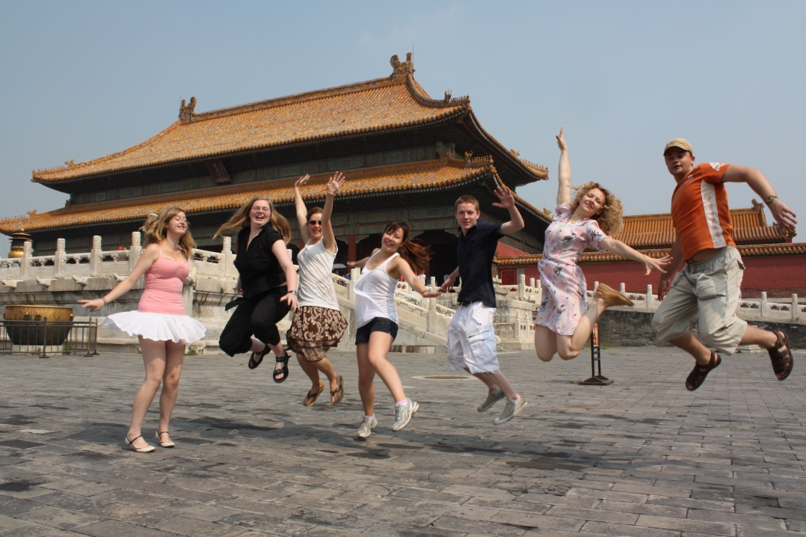
A journey to a thousand miles begins with a single step. – Confucius

