A Practitioners Guide
To Transition In The Early Years



By
Imogen Jones
Student Number 2216692
Introduction
Whilst children are in early years they will face many transitions and as practitioners and facilitators it is our job to ensure that these transitions take place as smoothly and positively as possible. Within our role we must strive to provide the children with the support and encouragement they need to thrive and achieve to the best of their potential and abilities.
As stated by Welsh Government in (2019) this stage of development lays building blocks for future learning. The importance of this stage in a child’s life can impact on their future so must be dealt and handled with care, compassion and a understanding of child development to provide the correct support for a child to flourish.
Within this document we will be exploring the transition and all it entails for children, families and practitioners. Some of these children will possibly not been to settings before whilst others may have attended creche’s or spent time with child minders or extended family.
It is important to remember that transitions can be difficult for anyone.
Transitions and its importance
‘Transitions are the moves children and young people make from home to an early learning and childcare (ELC) setting, from there to primary, from stage to stage, from primary to secondary, between schools and from secondary to further education and beyond.’ (Parentzone Scotland, no date).
As well as events that will continue throughout their life in education transitions for children will also take place throughout their time in a setting and throughout the day. Some daily transitions might be
- Morning drop off and home time
- Change of activities throughout the day
- Play and lunch times
- Indoor to outdoor learning
As well as transitions during their time through education and within learning and care settings children will also potentially have experienced transitions at home within their life time according to (Twinkl, no date). Such as
- A new sibling
- Move of house
- Family breakdown
- Loss/bereavement
- Illness
The above transitions can be separated in to categories called horizontal and vertical transitions. Horizontal transitions referring to more daily changes that may take place, where as vertical transitions link to certain events and will not take place regularly. (Open University, 2017)
The importance of transition is not solely for the child but also of great importance to the parents and carers. It is key to build positive relationships and have an open dialogue with carers to ensure that all parties are providing the child and family with the support required for a positive transition for all involved.
Laverick (2007) supports this idea of communication with families being of importance and believing that establishing relationships with families is one of the 4 key components for appropriate transitional support.
Dockett, Perry and Kearny (2021) suggest that transition for children is shaped not only by their own experiences but those of their family also. With parents possibly keen for children to recreate their own experiences or have a different experience completely.
As practitioners we can help nurture a positive outlook for not only a child’s perspective of school and transition but also a parent/carer by building solid foundations of communication. Parents may have had their own negative experiences with settings but ‘When you and parents or carers understand and trust each other, you’ll all be better able to work together to support children’s wellbeing and development.’ Raising children website (2018)
For relationships to grow and develop practitioners also need to feel comfortable and confident. Parents may look to us for support or comfort and we need to be equipped to deal with circumstances that may arise in order to continue to forward the relationships already fostered.
Practitioner’s want to feel valued, trusted and respected by parents. (Schärer,J, 2018). For this to be achieved it is essential to continually develop and build upon relationships with parents and to have a strong team to build the practitioners confidence and demonstrate a united team to the families at the setting. Suggesting to families that all practitioners are skilled and valued workers within the setting.
A smooth transition is the most desired route for a child and their family but as practitioner’s it is important to be aware of barriers that may arise.
As a practitioner you may encounter families that English is an additional language for (EAL) or in Wales, Welsh as an additional language (WAL). Tailoring your language and dealing with families in a non-judgemental manner is key to building bonds with families who may need this extra support. Howell, (2020) commented that it was through EAL families engagement as well as the child’s that improvement could be seen.
Settings may also experience families who have visual or hearing impairments. To engage fully with these families practitioners should be conscious to use verbal and non-verbal gestures, clear concise voices, appropriate body language or facial expressions. If needed use the resources available to provide support for these families accessing agencies that can aid their transitions. Practitioners should be aware of these factors whether it be dealing with a child or parent with the impairment. (NDCS, 2016) found that low expectations by professionals and parents effected the success deaf children may incur.
When dealing with children and families where ALN may be present it is of vital importance that the situation is dealt with in a professional manner. When initially approached parents may be reluctant to hear or unaware of the observations a practitioner has made. Having an open body language, non-judgemental attitude and a honest conversation about the observations made will keep pathways between home and settings open.
It is also important to listen to a parent with concerns. To shut their observations down can cause animosity and have a detrimental effect on relationships that could eventually reach the child. (Central South Consortium, 2020) have recognised that transparency and information are key to empowering individuals, as well as having regard for parents’ views and promoting their role in decision making.
Nursery resources (2019) makes us aware that 70% of a child’s life is not spent in a setting but with family and the wider community, making their judgements and thoughts of equal importance.
This also links into Bronfenbrenner’s belief of the biological model. Seen below
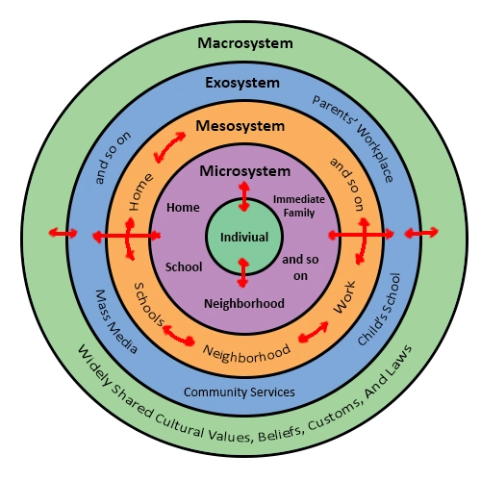 (Psychology Wiki, n.d.)
An individual will develop and evolve based on the experiences they have in different environments with different people. This makes parents and carers adept at spotting areas where support may be required.
Teachers provide important secondary roles but can not provide interaction that of a primary carer. (Galut, 2001)

What do children need?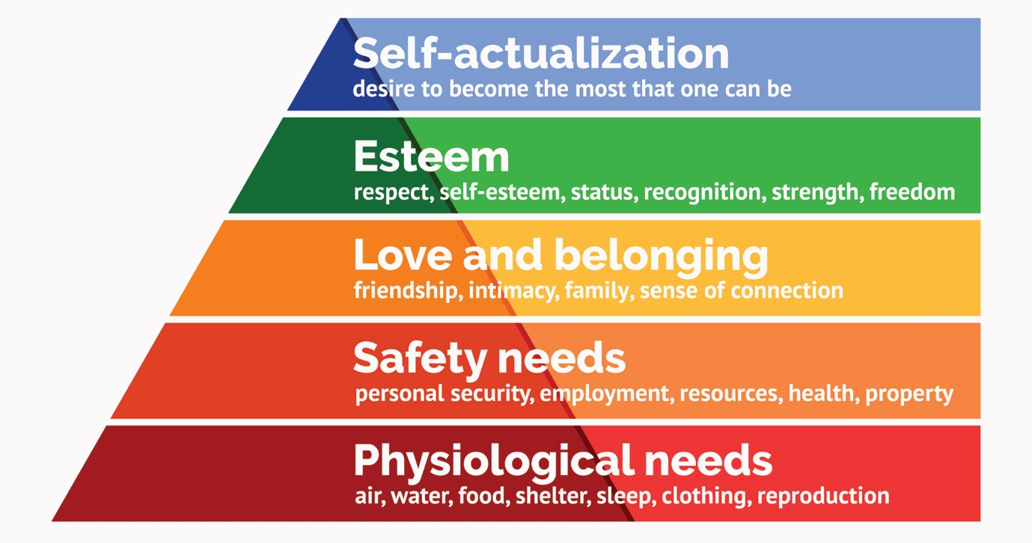
(Simply Psychology 2022)
Maslow’s hierarchy of needs that he first introduced in 1943 suggested that humans were motivated at first to meet their basic needs before moving on to pursue more advanced needs. Maslow took interest in how people made themselves happy, believing that a number of basic needs must be met before achieving one’s actual goal and progressing through the above pyramid. (Cherry, 2022)
Poston (2009) believed that we are all effected by Maslow’s hierarchy of needs theory but that if life experiences from early on were positive it would build a strong foundation for life.
Whilst Maslow’s theory believes that by providing the most basic needs will support a child we are now seeing the emergence of taking a holistic approach when supporting children. Taking in to account diet, nutrition, exercise and well-being. Snelling (2018) believes that to educate the whole child we must essentially include physical health.
Children’s relationships grow and flourish through a continuous interaction known as serve and return. Serve and return provides the child with experiences unique to their needs and enjoyment. The lack of interaction with the serve and return process can have a negative effect on the development of the child in many areas including physically and emotionally. (National Scientific Council on the Developing Child, 2004 cited on Harvard.edu)
Through the lack of interaction with serve and return situations children’s needs are not being met so could result in the child not being able to achieve their full potential.

Support from Practitioners
Support from practitioners will be crucial for the child’s transition into school. Staff must be aware of the importance transitions have on a child’s life.
As stated in the Nurturing North Ayrshires Recovery (no date) they believe that children’s lives are significantly affected by transitions. And that some of the key points for practitioners to support this are
• Increasing felt safety to support transitions
• Re-establishing connections
• Navigating Loss
• Practising appreciation
The image below shows the core beliefs of the 6 principals of nurture according to Nurture UK (2021).
This diagram highlights the importance of transition as well as others in the development of the child. This belief again refers back to the practitioners taking a holistic view for the child to gain the maximum levels of success through a focus on emotional and developmental needs as well as their academic needs.
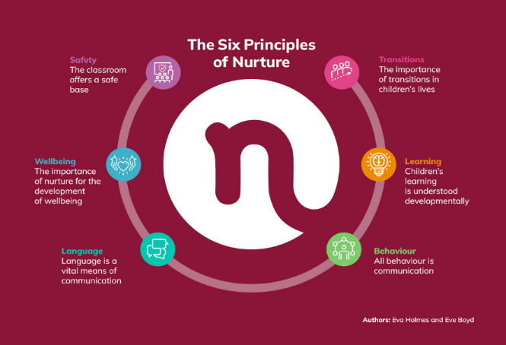

Practitioners should aim to provide high quality transition for children that is consistent.
Birth to 5 matters.org (no date) believes for children to experience high quality transition there are several key factors for practitioners to be aware of and help develop to aid children within the situation. An awareness of the importance that transition holds and the impact it will have if handled correctly or otherwise, that transition is an event not a process, transition can make children vulnerable, it can open professional dialogue and recognises the importance for a child to be known.
For practitioners to help successfully aid the transition of a child to the setting communication is of key importance with all involved.
For children to be nurtured by adults it requires the building of relationships that are trusting, positive and reciprocal. The website early years matters (2007) supports this by stating that learning is supported when children feel safe and secure.
John Bowlby’s attachment theory also supported the suggestion that the more secure in a situation a child feels with the support surrounding them the less inclined they will be to look for physical closeness to help deal with any stresses or anxieties. (Pound,2006)
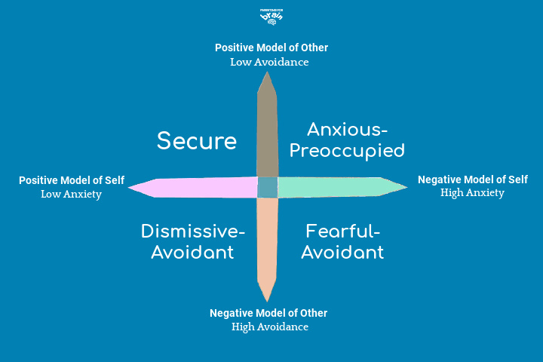 (Annon, ND)
Bowlby believed in the idea of the 4 types of attachment as shown in the diagram above, believing humans formed protective and comforting relationships but it was Mary Ainsworth who further developed Bowlby’s studies and was of the opinion that differences for the individual with the quality of the relationship made a difference. (Crittenden, 2017)
Practitioners that are confident within their role are most likely to not worry about looking at others but solely looking at the child, and committing to their learning and development. (Abbott and Langston, 2004)

Transition before starting at the setting
Transition before children start at a setting is good opportunity for all parties to gather information and lay the foundations for building successful relationships.
Transitional activities provide children, families and practitioners with the opportunity to become familiar with new people, policies and buildings.
Home Visits
Many settings now engage in home visits with practitioners meeting children for the first time in their own environment. This is believed to be a reassuring process for the child. (O’Conner, 2021)
Home visits also provide practitioners valuable insight in to the home life, conditions and situations of the family. It can give the providers opportunities to offer support and suggest agencies who may be able to work with families to improve current situations.
When in the home of children and families practitioners must remain sensitive to situations and information that may be discussed. This is a perfect time to discuss topics that need to be conducted in a more private setting as oppose to within a group.
Working With Agencies
Before some children start school, they may already be involved with outside agencies who request meetings with the family and school to aid in the transition that will be occurring.
All parties involved must be completely transparent for the long-term benefits of the child.
Agencies that you may encounter could be:
- SALT – Speech and Language Therapy
- HV – Health Visitor
- Social workers
- Physiotherapists
- Nurses
- Resilient Families
- Educational psychologist
- Occupational Health
If a child is presenting with ALN it could be more likely you encounter some of these agencies and work with them for a prolonged period of time so it is of great importance to also build high quality and engaging relationships with them.
One Page Profiles
One page profiles are a working document that most schools encourage all children to have. They are fed information from all relevant parties within a child’s life to build a profile to help make their school life as positive as possible. Family, peers, practitioners, other agencies are all able to contribute to build a clear picture of a child’s likes, dislikes, triggers, needs and so on. Children are included in the process choosing a template they relate to and also giving their own insight.
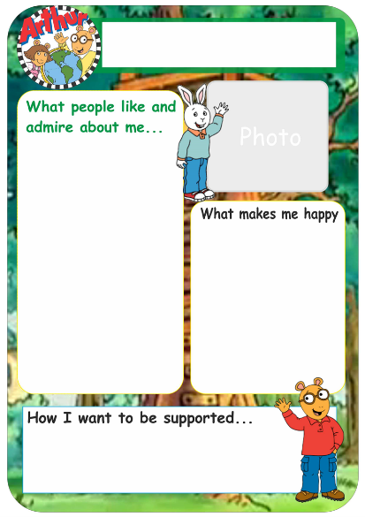 (sheffkids.co.uk, n.d.)
Link Up / Stay And Play Sessions
Children may be invited to attend sessions for short periods of time within their new setting. Other new children may be present for this which provides the opportunity to meet others in perhaps similar situations with similar feelings.
The Covid pandemic made this part of transition even harder for some children with schools and setting having to think of other ways to introduce children to what would soon become their new learning environment.
Staff were able to make video tours or classrooms, meet and greet staff through teams and PowerPoints all to continue to provide and build community and relationships for the families in their care. (Northern Alliance Covid-19 Transitions Framework, n.d.)
Show And Tell
Before starting school, some settings provide children with a small bag or envelope and encourage them to fill it with things that are important to them from home. When in school they are able to show this to their class and explain a part of their world to everyone. This will serve as a reminder in the build up to starting school that a new time in their life is about to begin.

Play
Play can be defined many ways and interpreted differently by individuals. It can provide children with a variety of opportunities to develop. Recent theories believe it can contribute to problem solving, communicating, creativity and social understandings. This belief can be linked to the studies of Piaget and Vygotsky. (Pound, 2006)
(Gov.scot, 2020) agrees with these recent theories stating in their play pedagogy kit that through play a child develops their cognitive, social, emotional and physical capacities.
Play can help children through transitions by allowing them to display and process emotions, understand and experience new situations as well as engage with new people whether it be children or adults.
The 5 C’s that contribute to a positive transition are believed to be:
- Child centred
- Communication
- Consistency
- Culture
- Collaboration
By ensuring we follow these practices we will be building connections with our children through mediums such as play that will contribute to their adjustment within a new setting. By building these 5 C connections through mediums such as play the children’s brains cells are being formed, tested and refined. (Dunlop, 2020)
Practitioners and settings that provide nurturing and stimulating experiences will establish brain connections wiring, these will develop neural connections which will sustain through life. (www.beststart.org, n.d.)
As practitioners it is our duty to provide children with high quality learning and play experiences. The Welsh Government has dedicated a play policy to ensure children receive the best in this area of their development. It is believed to be the first of its kind in the world. In the policy Welsh Gov, (2002) stated that a rich and stimulating environment should be accessible to all children.
As well as a learning tool for areas such as language, problem solving or creativity play may also be developed and used by children as a way to de stress or learn to regulate themselves in situations.
Cathey, 2018 believes that the more transitions and stress a child is going through the more time they need to play.
As well as play being an integral part of a child’s development it is also a right that every child has.
The UNCRC is made of a total of 54 articles all for the sole purpose of protecting and developing children. Ensuring that they can have the best possible life. Article 31 states that a child has the right to rest, play, culture and the arts. UNCRC,
By denying children the right to play we are denying them a fundamental part of being a child. Hindering their development and not allowing them a basic need.
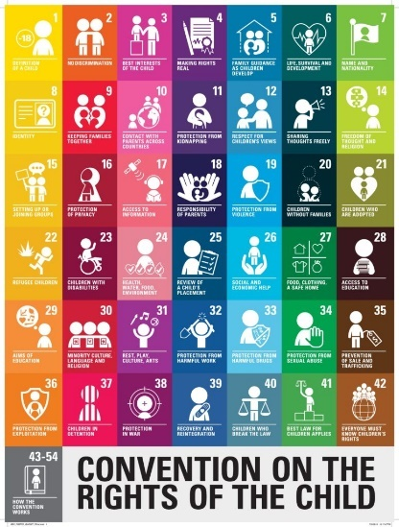

Whilst we discuss the importance of play it is important to remember that play must also be risky and provide new and exciting opportunities.
The Best Play document (2020) list 7 objectives all of which the Forest Schools movement has supported and incorporated.
Two important principals are principal 1 encouraging play to be child led and directed with freedom and control to take from it what they desire.
Principal 7 fosters the thought that children gain in all areas of development whilst playing and takes the approach of how we can help to holistically support the development of the child. Forrest School Portfolio, (2022).
By helping to support the child develop through a holistic approach through play it is providing them with the skills to better handle situations such as transitions.
John Dewey believed that experiential learning is at the heart of early childhood education. Allowing children, the opportunities to explore and play to develop. (Luff, 2018)
As supported by Dewey we need to encourage children to be curious to develop their play skills which in turn will develop them holistically.
(Ryan, 2019) described curiosity three ways, it motivates to fill in the gaps and reduce uncertainty, to explore and learn for one’s self and a variation in curiosity.
For children to become curious and explorative in their play do we believe that they need to have rich and stimulating environments? Piaget believed that practitioners needed to provide materials that encouraged children to advance their thinking and learning. His theory helped develop beliefs on active and discovery learning and peer interaction. (Hargraves, 2021)

References
Aspirations for a seemless transition (no date) the Patterson foundation. Available at: https://www.thepattersonfoundation.org/blog/aspirations-for-a-seamless-transition-from-vpk-to-kindergarten.html (Accessed: November 10, 2022).
Welsh Gove (2019) Foundation Phase Nursery A guide for parents and carers. Available at: https://gov.wales/sites/default/files/publications/2019-03/foundation-phase-nursery-guide-for-parents-and-carers.pdf (Accessed on: 10th November 2022).
Parentzone Scotland (no date) What are transitions. Available at: https://education.gov.scot/parentzone/my-child/transitions/what-are-transitions/# (Accessed on: 10th November 2022).
Anon, (n.d.). Transitions – Birth To 5 Matters. [online] Available at: https://birthto5matters.org.uk/transitions/. (Accessed on 10th November 2022).
Clarke, V. (2020). Different Types of Transitions in Child Development. [online] Twinkl.co.uk. Available at: https://www.twinkl.co.uk/blog/different-types-of-transitions-in-child-development. (Accessed on: 10th November 2022).
Docket, S., Perry, B. and Kearny, E. (2012). Family transitions as children start school. [online] aifs.gov.au. Available at: https://aifs.gov.au/sites/default/files/fm90e.pdf(Accessed 10 Nov. 2022).
Laverick, D.M. (2007). Starting School: Welcoming Young Children and Families into Early School Experiences. Early Childhood Education Journal, 35(4), pp.321–326. doi:10.1007/s10643-007-0201-8. Available at: https://link.springer.com/article/10.1007/s10643-007-0201-8 Accessed on: (10th November 2022)
Raising Children Network. (2018). Effective communication with parents: for professionals. [online] Available at: https://raisingchildren.net.au/for-professionals/working-with-parents/communicating-with-parents/communication-with-parents#:~:text=Effective%20communication%20builds%20understanding%20and. Accessed on: (10th November 2022)
Anon, (n.d.). [Image]. Available at: https://www.simplypsychology.org/maslow-needs4.webp. Accessed on: (10th November 2022)
Cherry, K. (2022). The Five Levels of Maslow’s Hierarchy of Needs. [online] Verywellmind. Available at: https://www.verywellmind.com/what-is-maslows-hierarchy-of-needs-4136760. Accessed on: (10th November 2022)
POSTON, B. (2009). An Exercise in Personal Exploration: Maslow’s Hierarchy of Needs. [online] Association of Surgical Technologists. Available at: https://www.ast.org/pdf/308.pdf. Accessed on: (10th November 2022)
Snelling, A. (2018). Reconsidering Maslow: The Role of the School Health Policy in a Holistic Approach to Child Health and Wellness. Journal of Education & Social Policy, [online] 5. Available at: https://d1wqtxts1xzle7.cloudfront.net/73277302/e0f6359ce593525833b61612ec4e70ae2817-with-cover-page-v2.pdf?Expires=1668123649&Signature=QXt1iiTk-0yWTNfw8sveZRzIgMbbdQens5J6QxmW1viKigwyVfu1LDwVohS4DU9-9AJ73Xo3a57VPtd4lAvDqxK7Vhz7ikinsvxX7Ykx2plH8mdWuJ-n8uOD~6~szPzdTCnBtH8unVQSbiWmrJlU8vlOXcdqYvx-lsQgw3cAEamOxav89FisJPTfrl~PgvcXgtYfjhVmIls4O1URJ0P-m53hjS-V8Dn~353wybvl6fWIjrAj0WelSq5lemKB4uTucrNxPIwKf6xSJXBHBYiHzdMBHquxa9MwnENT9Y64kRNAiBcSdNtmLbC2TZQmo8X5bmpmVZzARJ1s6~VELciw-A__&Key-Pair-Id=APKAJLOHF5GGSLRBV4ZA (Accessed 10 Nov. 2022).
North Ayrshire. (n.d.). Nurturing North Ayrshires Recovery. [online] Available at: https://www.northayr-edpsychs.co.uk/wp-content/uploads/2020/08/Workbook-Transitions.pdf. Accessed on: (11th November 2022)
Holmes, E. and Boyd, E. (2021). The 6 Principals of Nurture. Available at: https://www.nurtureuk.org/what-is-nurture/ Accessed on: (11th November 2022).
www.open.edu. (n.d.). OLCreate: NNCO_TA Developing and managing relationships: 3 Children’s transitions. [online] Available at: https://www.open.edu/openlearncreate/mod/oucontent/view.php?id=79794§ion=3. Accessed on: (22nd November 2022).
EYFS (2007). Positive Relationships. [online] Early Years Matters. Available at: https://www.earlyyearsmatters.co.uk/eyfs/positive-relationships/. Accessed on: (22nd November 2022) .
Pound, L. (2006). How Children Learn : from Montessori to Vygotsky: Educational Theories and Approaches Made easy. Step Forward Publishing.
Anon, (n.d.). Available at: https://www.parentingforbrain.com/attachment-theory/. Accessed on: (22nd November 2022).
Crittenden, P. (2017). Gifts from Mary Ainsworth and John Bowlby. Sage, [online] p.4. Available at: https://www.researchgate.net/profile/Patricia-Crittenden/publication/318699360_Gifts_from_Mary_Ainsworth_and_John_Bowlby/links/59e0df8ca6fdcc7154ce9b3e/Gifts-from-Mary-Ainsworth-and-John-Bowlby.pdf Accessed: (22nd November 2022).
National Scientific Council on the Developing Child (2004). Young Children Develop in an Environment of Relationships: Working Paper No. 1. Retrieved from www.developingchild.harvard.edu. Accessed on: (22nd November 2022)
Abbott, L. and Langston, A. (2004). Birth to Three Matters. [online] Google Books. McGraw-Hill Education (UK). Available at: https://books.google.co.uk/books?hl=en&lr=&id=NSor3aEJ8QUC&oi=fnd&pg=PA56&dq=the+importance+of+practitioners+feeling+valued+by+parents&ots=10mbOzKpEI&sig=JYTq61Y_NTxu-p_VJCWvTDO2Jq4#v=onepage&q=the%20importance%20of%20practitioners%20feeling%20valued%20by%20parents&f=false Accessed: (22nd November 2022).
Janine Hostettler Schärer (2018) How educators define their role: building ‘professional’ relationships with children and parents during transition to childcare: a case study, European Early Childhood Education Research Journal. Available at: https://doi.org/10.1080/1350293X.2018.1442041 Accessed on: (22nd November 2022).
Pound, L. (2006). How Children Learn : from Montessori to Vygotsky: Educational Theories and Approaches Made easy. Step Forward Publishing.
Gov.scot. (2020). Early Level Play Pedagogy Toolkit | Learning resources | National Improvement Hub. [online] Available at: https://education.gov.scot/improvement/learning-resources/early-level-play-pedagogy-toolkit/. Accessed on: (29th November 2022).
Dunlop, A. - W. (2020). Making Research and Practice Connections: what does this mean for Transition to School in Scotland? [online] health scotland. Available at: file:///C:/Users/wfhstaff/Downloads/aline-wendy-dunlop-university-of-strathclyde%20(1).pdf Accessed on: ( 29th November 2022).
Welsh Gov (2002). welsh assembly Government Play Policy. [online] Welsh Gov. Available at: https://www.playwales.org.uk/login/uploaded/documents/Play%20Policy/Wales%20play-policy-e.pdf Accessed on: ( 29th November 2022).
Cathey, K. (2018). The Importance of Play in School Transitions. [online] the center for family empowerment. Available at: https://www.centerforfamilyempowerment.com/blog/2018/10/1/the-importance-of-play-in-school-transitions Accessed on: ( 29th November 2022).
Anon, (n.d.). {Image} Available at: https://www.playscotland.org/resources/crc_poster_leaflet_final-indd_/ Accessed on: (29th November 2022).
UNCRC,(1989) Available at: https://www.unicef.org.uk/wp-content/uploads/2010/05/UNCRC_united_nations_convention_on_the_rights_of_the_child.pdf .Accessed on: (29th November 2022).
National Playing Fields Association (2000). Best Play. [online] Available at: http://www.freeplaynetwork.org.uk/pubs/bestplay.pdf Accessed on: (29th November 2022).
Forest School Portfolio. (2022). 2.7 - Evaluate the key principles of play and their relevance to Forest School - Forest School Portfolio. [online] Available at: https://www.forestschoolportfolio.com/unit-3-learning-and-development-at-a-forest-school-programme/2-7-evaluate-key-principles-play-relevance-forest-school/ Accessed on: (29th November 2022).
Howell, M. (2020). Top 10 best practices for empowering schools to support EAL families (part 1) - Operoo. [online] Operoo. Available at: https://www.operoo.com/2020/08/07/top-10-best-practices-for-empowering-schools-to-support-eal-families-part-1/ Accessed on: (29th November 2022).
NDCS (2016). Supporting deaf young people through transition. [online] gov.uk. Available at: https://www.cumbria.gov.uk/elibrary/Content/Internet/537/3953/6769/6772/4301111949.pdf?timestamp=435308635 Accessed on: (29th November 2022).
Central South Consortium (2020). ALN Information Advice and Guidance. [online] merthyr.gov.uk. Available at: https://www.merthyr.gov.uk/media/6741/aln-parent-guide-2020-eng.pdf Accessed on: (29th November 2022).
Nursery resources (2019). Communication With Parents in EYFS and It’s Importance. [online] Nursery Resources | Blog. Available at: https://www.nurseryresources.org/articles/parents-as-partners/communication-with-parents/. Accessed on: (29th November 2022).
Psychology Wiki. (n.d.).{Image}. Bioecological model. [online] Available at: https://psychology.fandom.com/wiki/Bioecological_model. Accessed on: (29th November 2022).
Galut, M.N. (2001). Bronfenbrenner ’ s Ecological Systems Theory. [online] Available at: https://d1wqtxts1xzle7.cloudfront.net/44165922/bronfenbrenners_ecological-with-cover-page-v2.pdf?Expires=1669750966&Signature=HSpaigkTMmm5TfLtzwl1KrGqYQ2QUxEaTt2d8QVI7CpskbiJl8ua8~juPD0nN0YSgFMNnECropTHt0SIkd0eforL4lylxsSKc9Hn-LTNIXpvSzYsf73MOp9QUX9tUC~6qfiEhwWmSt83Z5~XhDVknsQq~LUfRSDIxvsVDVIf8fetAGBWdGw6--jkjYeLgJCLL4RJNoMdSVWYYFYfAXPmd0XSzZD77EtTpjfrYcszMB69wcW6pY2WSgeNa7gyIXJlBsjOAiNSsvKHsLgDOjQ-B1uw1vjFYeMVczQo98tRKuRak5w5RRCSYyjLi97ihRyBBf5zpdF4XAZ8Wgl~dYY9fQ__&Key-Pair-Id=APKAJLOHF5GGSLRBV4ZA Accessed on: (29th November 2022).
www.beststart.org. (n.d.). On Track. [online] Available at: https://www.beststart.org/OnTrack_English/1-importance.html#:~:text=Providing%20responsive%2C%20nurturing%20and%20stimulating Accessed on: (29th November 2022).
O’Conner, A. (2021). Round my House. [online] Nursery World. Available at: https://www.nurseryworld.co.uk/news/article/round-my-house Accessed on: (29th November 2022).
sheffkids.co.uk. (n.d.). Resources. [online] Available at: https://sheffkids.co.uk/resources/ Accessed on: (29th November 2022).
Northern Alliance Covid-19 Transitions Framework. (n.d.). [online] northernalliance.scot. Available at: https://northernalliance.scot/wp-content/uploads/2020/07/NA-Transitions-Framework-FINAL-1-1.pdf Accessed on: (29th November 2022).
Luff, P. (2018). Early childhood education for sustainability: origins and inspirations in the work of John Dewey. Taylor & Frances Online. [online] Available at: https://www.tandfonline.com/doi/full/10.1080/03004279.2018.1445484?needAccess=true Accessed on: (29th November 2022).
Ryan, R. (2019). Oxford Handbook Of Human Motivation. S.L.: Oxford Univ Press Us. Available at: https://books.google.co.uk/books?hl=en&lr=&id=hNShDwAAQBAJ&oi=fnd&pg=PA157&dq=john+dewey+curiosity&ots=i7xEm6DEhn&sig=_vYBWY-ae7bzK0mOHfITvmEEcAQ#v=onepage&q=john%20dewey%20curiosity&f=false Accessed on: (29th November 2022).
Hargraves, D.V. (2021). Piaget’s theory of education. [online] THE EDUCATION HUB. Available at: https://theeducationhub.org.nz/piagets-theory-of-education/. Accessed on: (29th November 2022).

