Tittle Page



REFLECTIVE PORTFOLIO

Student name: Petko Tonev Petkov

Student number: 2125440

Module name: Professional Career Development

Module code: BMSW4005_BIRM

Lecturer Name: Masud Ibrahim

Table of contents

Introduction 3
Personal competencies and personal development plan 3
SWOT analysis 4
Personal development plan 5
Reflection on the learning style theories I have learnt in this module 6
The impact of learning in the workplace 6
Reflective learning about the concepts I have learned 7
Conclusion 8
Reference list 9

- Introduction
The focus of this report will be on various learning style theories, the application of SWOT and PDP analytic tools to my own personal career plans by analysing what external and internal factors can impact the progress of my career. I will also use a suitable reflective model to assess some of the concepts I learned throughout the personal career development module depicting how and why they will be applicable and useful to my own work and career experience. Briefly touching onto the tasks which we had to complete during the module which are an open book assessment as well as a mock job interview. Using mainly Gibb’s reflective model I would like to evaluate my PDP and create an action plan using the “6 steps in his model of evaluation: description, feelings, evaluation, analysis, conclusion and action plan”.

  - Personal skills and competencies
In relation to the personal skills required for the job position that I applied and got interviewed for earlier in the module of PCD I have gathered a few – good customer service, good communication and interactive skills, also competency in digital till and pharmaceutical electronic prescription systems, the ability to work in a team as well as working under pressure in order to complete the daily tasks. Some of these skills take practice and other skills require a specific training for this field. This training is usually provided and carried out by the specific branch you work for. I have previously had the training done and I have experience working in pharmacy for the past 2 years. All the skills required I have enhanced by shifting between different branches of the company I worked for.

1.2 What I have learnt - In addition, the Personal Career Development module has gradually improved my understanding about interviews and how to ensure that the interviewing panel are left with the impression that the experience and work ethics I have established are suitable for the position I am applying for and therefore I will be a committed and an ambitiously driven employee in their company. This can be ensured by dressing appropriately and choosing the words in which you present yourself and your background in terms of work and qualifications which specifically suit the position you are applying for!

- SWOT analysis
SWOT stands for Strengths, Weaknesses, Opportunities and Threats. This analytic tool is very efficient in my view because it depicts the key factors which may impact an individual’s achievements or desired goals in their career in this case.
However, it could result in an “improper action” being taken due to it “not prioritising the factors by significance” as Richard M Crowder and Gary B Wills stated in their evaluation of SWOT. What does a SWOT analysis look like? (See figure 1)

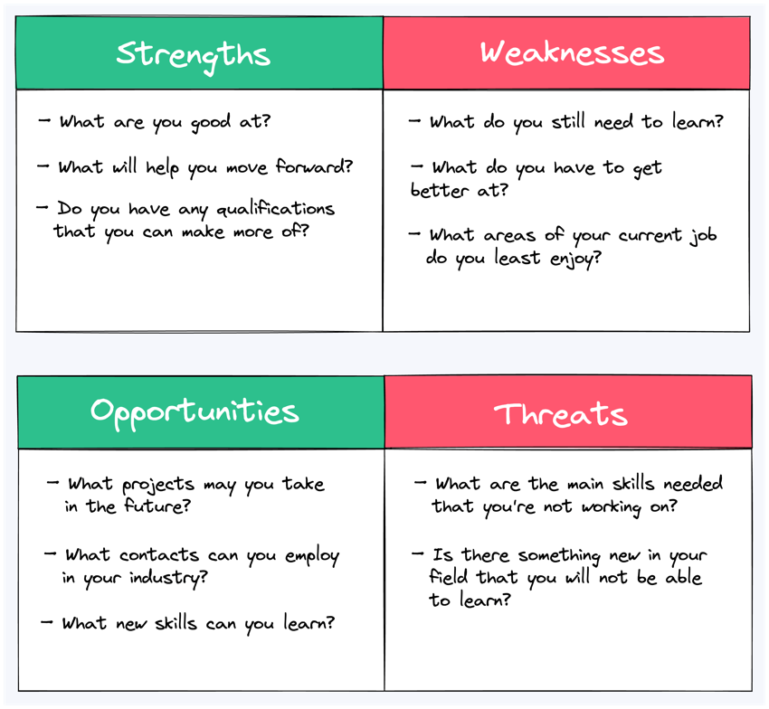
Figure 1:

Strengths: The skill to deliver a sufficient customer service, the ability to understand and empathise with people’s struggles and complications. I also have and require the skill to work with Microsoft apps as well as the digital electronic prescription system which is used in pharmacies. Another strength of mine is working very well under pressure and when the pharmacy is busy, you need to have a steady pace and serve all patients on time in order to keep them calm and satisfied by offering good service.
Weaknesses: I get easily irritated if someone is being rude, this is a weakness because I must learn how to stay calm and collected whilst explaining to the customer/patient why their medication is not ready to collect or why has the prescription not been sent to us by the surgery. Another weakness of mine is getting too focused on a certain job and when customers enter the workplace
Opportunities: Opportunities are new open doors, some opportunities this job and profession path offers is that the branch pays for your training with it also a dispenser course which is quite expensive to finance on your own. The opportunity to get to know people who work in the medical field and get to know how they work and absorb some of the practices and habits of work ethics they have. This citation confirms my viewpoint and opinion about opportunities being given and taken away or used for the competition - “Regarding externally related, opportunities are realities in the greater environment that can be exploited to benefit the entity” (Teoli, 2019)
Threats: Main threat is that I am slow in learning and grasping different digital systems. Computers are my weakness, and this is a threat because in my job I must have to apply this skill all the time. In addition, I am quite culturally uneducated as the UK is a widely diverse country and place to live, therefore there are many thin lines you don’t want to cross with people of certain cultural background.

  - Personal Development Plan - (PDP)
In order to work and/or pursue this career path I will have to sacrifice some personal incompetency’s and become more viable within the pharmaceutical working environment. This PDP will help me progress in my work and would also give me a boost start at improving myself to fit the requirements for the position I desire to pursue. As (Bitani and Khairi, 2019) say in their description and definition of the use of a PDP – “This combination of company practices with individual supporting conditions such as employees' motivation to understand when PDPs work best is a novel approach to understanding PDP effectiveness and hopes to add to both theoretical and practical understanding.”

Figure 2:
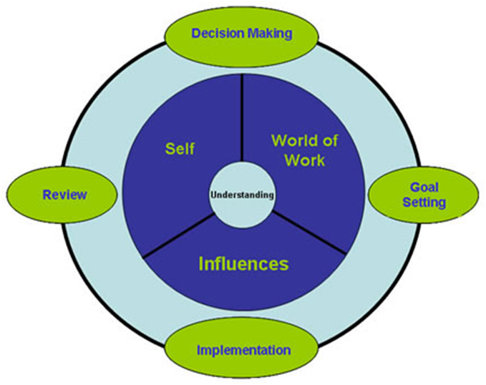

Date | My Targets/Objectives | Resources | Appropriate action | Success measurement and evaluation
April 2023 | Cultural education and understanding of different people’s traditions and habits as representatives of another culture | Journal, Books, Articles | I will read many religious and cultural books and articles in order to understand how their culture is different to mine and what is an appropriate manner to communicate with certain people. | Seeing and getting familiar with the cultures of people based on race, religion, region, ethnicity etc.
May 2023 | Enhancing my digital skills | YouTube videos, courses such as the University of Wales course which I am doing now “skills for the workplace” | In order to achieve steady useful skills in digital and computing competence I need to take on the job to interact with technology more than I have done up till now. | Being able to access and perform the required digital tasks.
June 2023 | Learning how to shift from one task to another when I am required to do so at work | Getting familiar with all the elements at my workplace and strive to deeply enhance them | This can be achieved by getting better and improving myself in terms of focus and concentration skills but also trying to do some meditation in order to develop a focus skill. | Reaching a satisfaction in this element of improvement would be difficult however achievable. It will be mostly dependent on the day and situation.

- Reflection on learning style theories learnt during this module.
Review of the theories of learning styles I have learned in this module The visual and auditory learning styles that I learned about in this module, which are both part of the VARK learning model, will be very helpful to me as I work in a pharmacy.

Visual Learning: Visual learning, which helps the learner focus more on the learning style, is the process of comprehending various knowledge with the aid of maps, images, graphics, etc. (Motley, 2020). Throughout the course, I have gained knowledge about a variety of topics, including self-awareness, employment opportunities, the recruitment and selection process, and the teacher's visually presented CV writing strategy. I was able to concentrate better during the lecture and learn the material quickly as a result.

Auditory learning: A person's career and self-development depend greatly on their ability to listen to others, which enables them to properly learn about a variety of issues (Kronholz, 2020). The auditory learning style refers to the process by which the teacher instructs the students verbally and in an auditory format. I have learned various techniques in auditory format throughout the course of my higher education, in a module other than visual strategy (Rickinson, 2021). For instance, in week 7 I received instruction on the auditory format of the mock interview process, which assisted me in understanding the proper method of conducting interviews—a requirement for obtaining a good job as a fresher.
- Reflection on the concepts I have learnt during the module.

By using Gibb’s reflective model, i will analyse my goals and achievements and what I have learnt throughout this module and therefore create an action plan with specific goals to look forward to reaching.
Description: The goal of this module was to teach students various skills essential for career success and self-development. In the first lesson, the instructor provided an overview of the topics that would be covered throughout the module, including self-awareness, employment opportunities, strategies for recruitment and selection, the creation of CVs, the actual process of conducting interviews, etc. Also covered were appropriate learning styles.
Feeling: Throughout the project's completion, I received various assignments on various subjects. I had to research the topics the teacher assigned, which impacted my learning process and caused me to encounter various challenges. The fact that we were frequently required to work in teams on different projects influenced me to develop very difficult teamwork skills, which I had to learn in this module. Different self-awareness skills, such as time management, living an organized lifestyle, and technology, were taught by the lecturer, and they were both motivating and difficult to learn in order to complete the module.

Evaluation: I had to participate in a variety of development activities to improve my digital and computing skills also my CV was enhanced and thinking abilities in order to complete all the module's tasks, and this has helped me become a more polite student. I gain knowledge of career pursuit with this module's instruction in the actual recruitment process and selection tactics. As a result, I will have a competitive advantage over others when looking for a permanent position. In addition to the arrangement for CV writing, the mock interview session, etc. was enticing and captivating, giving me the professional development skills necessary to pursue a successful career in the future (Buckley et al, 2021).

Analysis: Self-awareness is a crucial component of both personal and professional development; I realize after reflecting on my experiences in the module. I can make better decisions and take proactive measures to accomplish my goals if I take the time to reflect on my own strengths, weaknesses, and goals. Additionally, I was able to practice my communication skills and get helpful feedback from my lecturer during the mock interview experience, which was very beneficial.

Action plan: I intend to review the career development materials from the course, develop a plan to reach my personal and professional objectives, and continue my education. Additionally, I want to search for more opportunities for feedback and skill development, like networking occasions and mentorship programs. I will read various case studies of actual events that will aid in the development of my analytical and thinking skills, which are necessary for successfully managing a sales team with accurate forecasts (Stuart, 2021). In order to gain a competitive edge and advance my career, I will also continue to learn cognitive skills and proper CV writing. I need to shift and begin serving them immediately however my attention is focused on another task. This could be improved by organising and
prioritising the jobs at my workplace.

- To Conclude
Analysing personal skills with a SWOT analysis is very important for the development of career and personal skills because it enables one to know oneself. My goal is to work in a pharmacy. I need effective customer communication if I'm to achieve my goal because it will enable me to better integrate and comprehend how customers view the demand for the products I sell. However, I will use the personality development plan to improve my digital and computing skills since they will prevent me from succeeding in my sales department career. I will be able to communicate with my customers effectively and analyse any situation well thanks to the visual and auditory learning styles I developed in my higher education.

REFERENCE LIST
Buckley, R.G., Donovan, M.S., Graham, I.R., Goff, W.B. and Kane, C.J., 1998. Prospective comparison of unenhanced spiral computed tomography and intravenous urogram in the evaluation of acute flank pain. Urology, 52(6), pp.982-987.

Divan, A., Ludwig, L.O., Matthews, K.E., Motley, P.M. and Tomljenovic-Berube, A.M., 2017. Survey of research approaches utilised in the scholarship of teaching and learning publications. Teaching and Learning Inquiry, 5(2), pp.16-29.

Eisele, L., Grohnert, T., Beausaert, S. and Segers, M., 2013. Employee motivation for personal development plan effectiveness. European Journal of Training and Development, 37(6), pp.527-543.

Fleming, G. (2018). Study Strategies for the Visual Learning Style. [online] ThoughtCo. Available at: https://www.thoughtco.com/visual-learning-style-p2-1857113.

Ghazinoory, S., Esmail Zadeh, A. and Memariani, A., 2007. Fuzzy SWOT analysis. Journal of Intelligent & Fuzzy Systems, 18(1), pp.99-108.

Kronholz, J.F. (2020). Self-Help Career Services: A Case Report. The Career Development Quarterly, 63(3), pp.282–288.

Phadermrod, B., Crowder, R.M. and Wills, G.B., 2019. Importance-performance analysis-based SWOT analysis. International journal of information management, 44, pp.194-203.

Rickinson, B. (2021). The relationship between undergraduate student counselling and successful degree completion. Studies in Higher Education, 23(1), pp.95–102.

Teoli, D., Sanvictores, T. and An, J., 2019. SWOT analysis.

