- Introduction
  - In this report, I will be answering research methods questions. These questions will include different types of data analysis and regression analysis. The data analysis consists of 5 different types of data using statistical tests, using either Microsoft excel or SPSS. To answer the multiple regression analysis question, I will need to include for example if the significant p value of the ANOVA test, better known as the F test, is less than or equal to 0.05 and similarly, if the P value in the T test is less or equal to the number. This report will show what the tests are looking for.

  - The purpose of this report is too:

    - Descriptive analysis of the data using histogram charts as necessary.
    - The full output from Excel or SPSS
    - The result of the tests and a short discussion/clarification of the implications
    - Regression analysis and full output from Excel or SPSS
    - Showing the results and a conclusion of the findings.

1.3 By constructing the report in this way, it will become easier to demonstrate the answers that I got from these tests. This report will help in saying what needs to be done for certain data analysis, such as what tests should be done and what multiple regression is and what it can do to help give an answer.

2.0 Data analysis
2.1 Driving errors for day and night
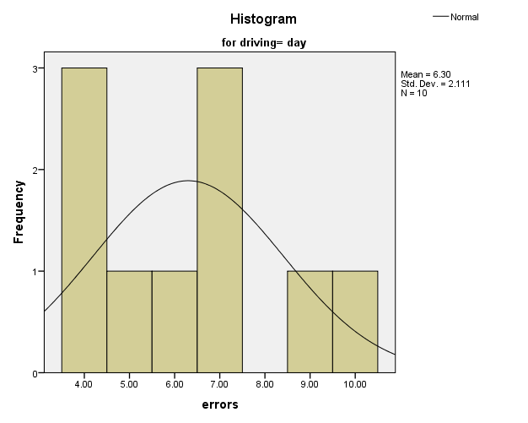

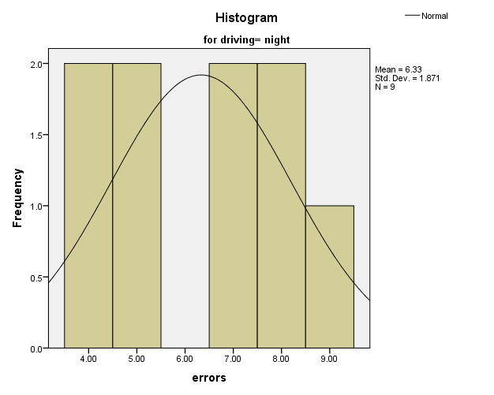

20 drivers were tested on a driving simulator either during the day or at night.
Having seen the normality tests, the data has come back as normally distributed. However, the kurtosis and the skewness of the histograms are very strange. The skewness from the data for the day, is over the normally distributed number of 0. However, the skewness for the night is under 0. The kurtosis for both sets of data are lower than 3, but both have negative numbers, meaning that the histograms will consist of negative kurtosis. Also, the skewness for both sets of data show that the actual skewness is not more than twice the number that the standard error is. It was quite difficult to decide which test would be suitable which test would be suitable for this data. Despite the histograms looking slightly abnormal, because of the kurtosis and skewness, I decided that the test that will be required for these sets of data will have to be a parametric test.

2.2 Errorsday and Errorsnight data
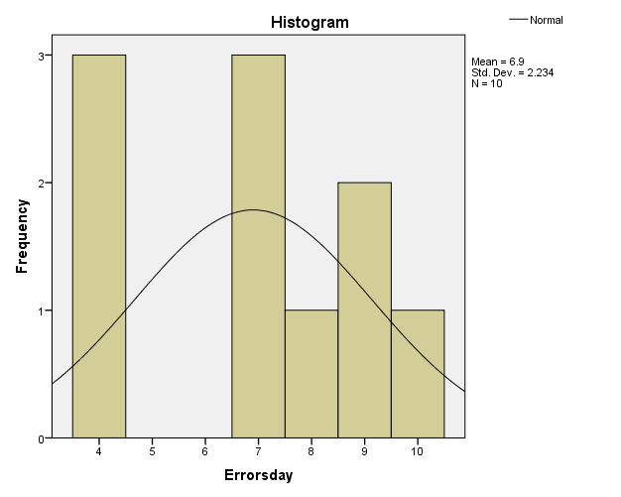

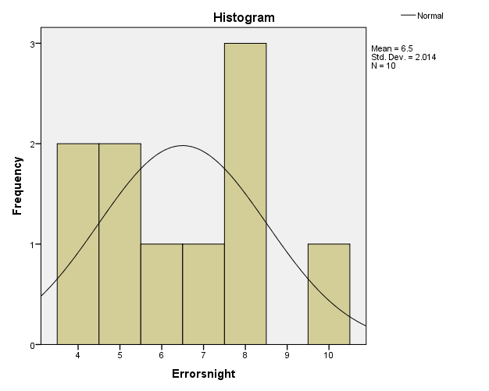
10 drivers were tested on a driving simulator either during the day or at night. It was predicted that more errors would be made at night.
Having looked at the normality tests, all of the data has a number that is bigger than 0.05, meaning that the data is normally distributed. Also, by having seen the skewness and the kurtosis, the distribution from the graphs seem to be normal. Also, the skewness for both sets of data, errorsday and errorsnight, are over the value 0, meaning in that the data may not be normally distributed. According to Charles Zainotz, if the value of the skewness and the kurtosis is more than twice the amount of the standard error, this will indicate that the data won’t be either symmetrical or normally distributed. This was another example of how this data is normal, meaning that the data can be used in parametric tests. As this data is paired, it would of have to be the paired samples test.
Having seen the result from the paired samples T test, the significance number is over the level of 0.05, meaning that we will retain the null hypothesis and say that the drivers who drove in the night will make more errors than if they drove during the day.

2.3 Data for Swanson and Toytown
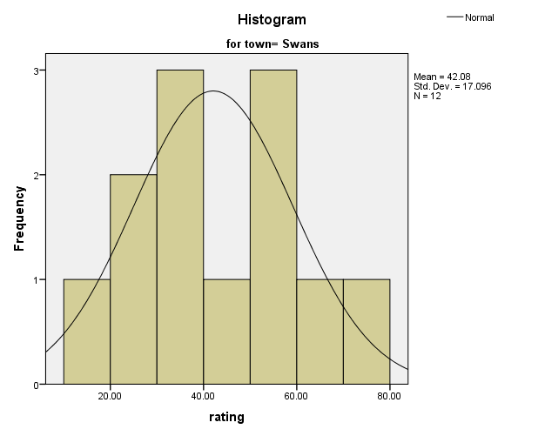

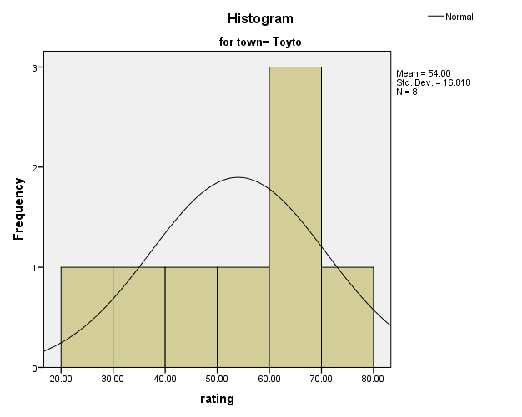

Two groups of people were asked to rate a new train service on a scale of 0 to 100. It is estimated that Toytown will have a service higher rated than Swansong. .
Having seen the normality tests, it is clear that the data is more normally distributed. The kurtoiss for both towns are negative, and also are below 3. The skewness swansong is over 0, meaning in positive skew, and toytown has negative skewness. Having seen the descriptive statistics as well, I decided to use a parametric test. The test is called the independent samples T test because these two types of data are independent. The independent samples T test compares two independent samples together by determining if the population means are different.
The significance is higher than the level, meaning that we retain the null hypothesis and say that Toytown will have a bigger rating in its services than Swansong.

2.4. Data for old and new recipes for the chocolate bars.
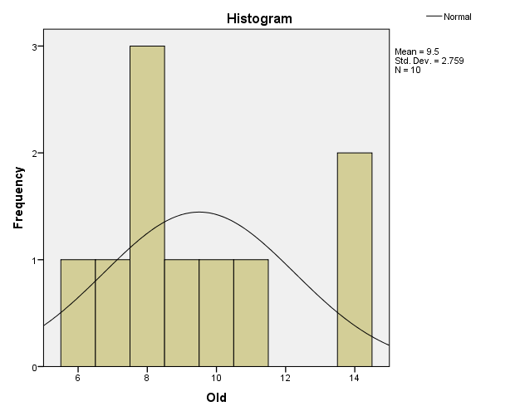

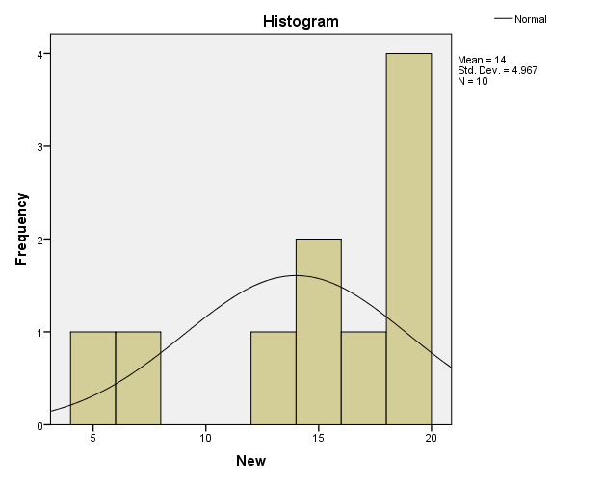
10 people were asked to rate a chocolate bar comparing the old with the new recipe on a scale of 1 to 20. It is hoped that the new recipe will have a higher rating.
With the normality tests, make for interesting reading. For the first test, the Simonov test, it shows that the data is normally distributed. However, looking at the other test, the Shapiro Wilk test, claims that the data, more so with the new, is not normally distributed. Having two different answers from these tests, I decided to choose the Shapiro Wilk test because according to Todd Grande, it is the most reliable out of the two normality tests. After looking at the descriptive statistics, the figures look very different. The skewness of both sets of data are very different. The skewness for the data for old, is higher than 0, but the skewness for the other data is very small, and by a decent gap. However, despite this, both skewness’s are not twice the amount of the standard error. Also, the kurtosis for both sets of data are below the number 3 but are negative, meaning that there is negative kurtosis in the histograms. However, finding the data is doesn’t have much structure to it, I decided to do a Non parametric test. The non parametric test that I used was the wilcoxen signed rank test.
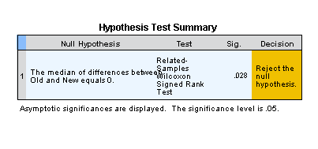 As the test shows the significance is less than the significance level, meaning that I reject the null hypothesis and say that there isn’t much difference between people liking the two recipes.

2.5. Data for tax law and political party.
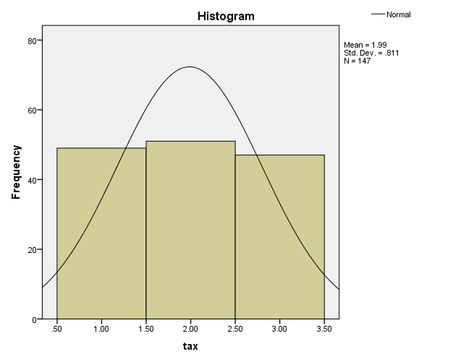
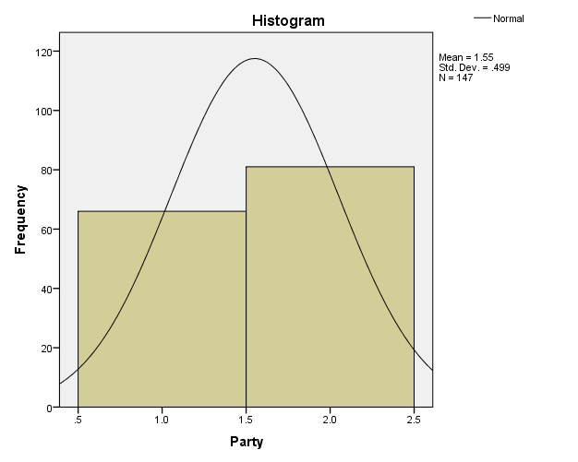

A survey of US voters asked whether they were for (1), against the tax (2) or had no opinion at all (3) about a forthcoming change to tax law. The voters were also asked what political party they favoured: Republican (1) or the liberal Democrat (2). Does party affiliation affect views about the tax change?
With both the Shapiro Wilk and Smirnov normality tests coming out as the number 0.00, that means the data is statistically significant. Having a look at the data in the descriptive statistics, the median numbers are the same. With both medians being the number 2, this meant that the right test for this set of data will have to be a non parametric test. After having a look at the kurtosis, they are both negative numbers, meaning in the histogram having a negative kurtosis. The skewness the first set of data, the political party, is below 0, and with the number being 0.025, the skewness is normal. The skewness for the second set of data is negative, and is much smaller than the first one. Whilst the skewness isn’t double the number of the standard deviation, and the histogram for the tax data will have a negative skewness, meaning it is not normal. Considering these pairs of data are both nominal data, the test will have to be the right one. This data appears to be related, meaning for a related samples test. For non parametric test, it’s called the Wilcoxen signed rank test.
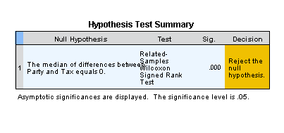
With this result, and the significance being still 0.00, the decision is to reject the null hypothesis and that the party affiliation seems to be having an effect on the views of having a tax law.

3.0. Regression analysis
2nd Part
Regression analysis is a form of a predictive model technique that helps to investigate the relationship between two different types of variables, dependant and independent variables. Regression analysis is important for analysing data and can be used in businesses.
The question for this part is can the students lecture attendance, tutorial attendance and monthly private study hours be used to predict the final mark. To help answer the question, I used SPSS.
The first regression analysis used is called linear regression. Linear regression was used on the final mark, lecture attendance and tutorial attendance. Linear regression helps with establishing a relationship between one or more independent variables and the dependant variable itself. (Sunil Ray, August 14th 2015, comprehensive-guide-regression). The other regression analysis required is called the multiple linear regression analysis. Multiple linear regression is very similar to linear regression and is a common theme of the linear.

3.1 Final Mark

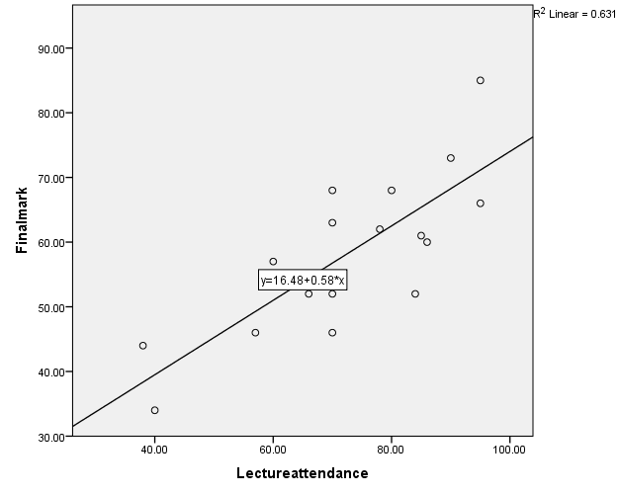

This is the first linear regression used. This graph has fitted into it a line of best fit. This graph consists of both the final mark and lecture attendance. As seen in the coefficients table, they have the same values on the equation on the scatter graph shows, meaning not only does the coefficients table help to correspond to the scatter graph itself, but also that the line of best fit is confidently correct. (SPSS-tutorial, 2017, how-to-draw-a-line-of-best-fit.) In this scatter graph, it shows quite a few outliers in it. An outlier is a certain type of observation that is a fair distance away from the other observational targets. Outliers can occur randomly, but they can also make analysing data much more complicated, because that usually means that a decision has to be made about if the data is normally distributed. Also, the R square value, which is in the graph, is in the model summary. In this case, it is 0.795. This scatter graph at the top also shows the value for R squared, which also occur in the model summary table. The pupil with the joint highest attendance got the biggest mark, meaning that the attendance of lectures could have an effect on the mark. Both P values for the f test is statistically significant. The P value for the t test is equal to 0.05.

3.2 Lecture Attendance

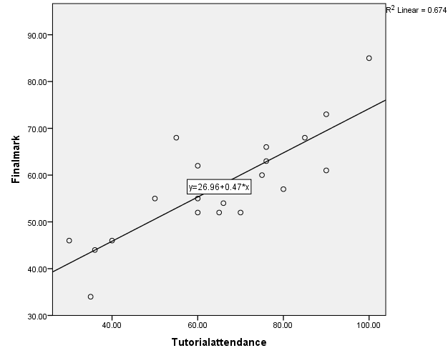

This is the second linear regression used. Again, the equation on the line corresponds to the coefficients table, showing again that the line of best fit is confidentially put in. The R square value for this scatter graph is 0.821. These are the results for the scatter graph to show. There are also a few outliers in this linear graph as well. However, there are also more dots that are closer to the line of best fit, meaning that the data should be more easier to analyse, and also become more normally distributed. This graph shows that the tutorial attendance does have an effect on the student’s final mark. An example is the student who had the best attendance got the highest mark. Both the P values for the f and t tests are statistically significant.

3.3 Tutorial Attendance

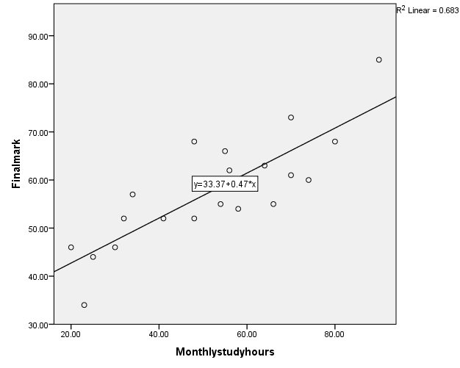
This scatter graph as outliers but they are not as far as the other two graphs. Meaning that there could be a link between the student’s final mark and their monthly study hours. There are only a few outliers in this graph. The amount of study hours monthly could have an effect on the final mark. An example is that did a very little amount of studying will have the worst mark and the student that did the most studying will get the highest mark.

3.4
Final mark= lecture attendance, tutorial attendance and monthly study hours

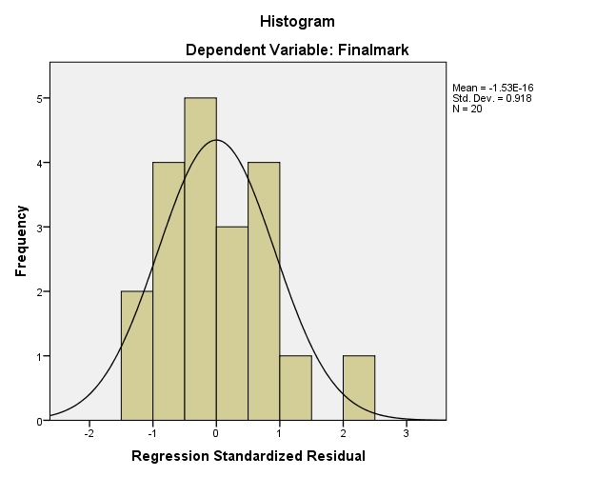

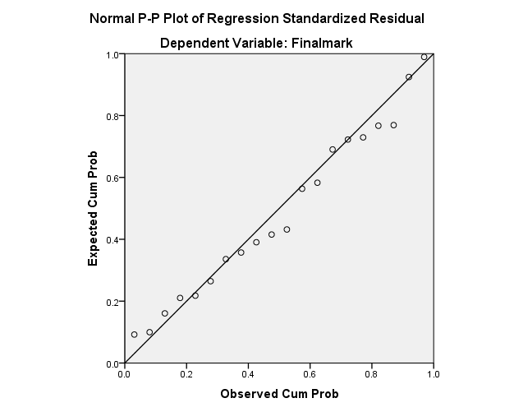

This scatter graph indicates that the data is normally distributed, despite having outliers. The outliers can also be seen on the histogram. Having seen the coefficients table the P value for the t test are all over 0.05, meaning that overall this data is normal. Apart from the monthly study hours, it is equal to 0.005. Meaning this part is statistically significant. For the F test, the P value was below the level, making it statistically significant. This data compares well to the originals because all of the scatter graphs all have a few outliers but generally follow the same pattern. Most are expected get lower marks, considering the amount of plots under the line. This data predicts that most, who either haven’t studied or attended lectures or tutorials will get low marks.

- Conclusion
  - As shown in the report, there are different tests that can be conducted in certain circumstances. This report has explained what kind of procedures need to be taken if the data isn’t normally distributed and saying how the data is or isn’t normal. This report has helped to explain what data analysis is and consists of and how to answer it.
  - This report has also shown what regression analysis is and what it can consist off. This report has shown what tests multiple regression has and what they mean. Also, what how to work out and check if multiple regression has helped to answer the data.

Bibliography
http://www.itl.nist.gov/div898/handbook/eda/section3/eda35b.htm
http://www.real-statistics.com/tests-normality-and-symmetry/analysis-skewness-kurtosis/
https://libguides.library.kent.edu/SPSS/IndependentTTest
https://www.analyticsvidhya.com/blog/2015/08/comprehensive-guide-regression/
http://www.dummies.com/education/math/statistics/how-to-determine-a-p-value-when-testing-a-null-hypothesis/
https://www.spss-tutorials.com/how-to-draw-a-regression-line-in-spss/
https://www.youtube.com/watch?v=uI0bXSCG-NA

