AI Assignment
Laurice Keogh – 2115745

Contents
Abstract 1
Introduction 1
Problem Statement 1
Methodology 2
Experiments 3
Results 20
Discussion 24
Conclusion and recommendations 25
References 25
Appendix 26

Abstract
This report investigates how machine learning can be used to analyse and predict churn in customer datasets. Python is used within the Jupyter Notebook program. Data cleaning techniques are reviewed before delving into analysis on demographics and churn rate or reason. It is important for businesses to know about churn rate because it can help them retain customers and make more money. Techniques like hyper tuning are included to have optimal performance.

Introduction
[8] In recent years the telecom industry has been suffering from a loss of customer base. [2] Businesses like this can run churn analysis to determine why customers are leaving and prevent this in the future by making changes to key areas. The report focuses on machine learning models applied to a dataset to determine these metrics. Python coding language is applied through the jupyter notebook to investigate the data quality, mitigate issues, apply machine learning models, and highlight areas of high churn for the business to know where improvements should be made.

Problem Statement
Customers often leave their current/past businesses for new ones.[1] As a business, losing customers is a financial loss, and it is cheaper to retain customers than make new ones. Businesses can apply learning models to their datasets to understand how many customers are leaving and why. This can be tracked over time, and this allows for forecasting analysis. One technique that businesses can apply is the [1] The churn rate is calculated by dividing the lost customers by the number of customers at the start, and then multiplying that figure by 100. The higher the churn rate, the more customers are leaving, whereas the lower the churn rate, the less are leaving. Lower churn rate is more positive for businesses to see. [2] Churn rate is important because it can increase customer satisfaction and prevent customers from leaving if the business can identify problem areas.
[8] The telecom industry has been struggling since the covid-19 pandemic with loyalty lessening by 22%. It has been found through research studies that bad customer service, and bad service avenues. Telecom companies like this one would spend more acquiring new customers than looking after and keeping previous customers. [8] The Bain & Company did an analysis that showed 5% less churn increased revenue by 25%. Understanding customer demographics and churn trends can help a business find the problems.
Machine learning algorithms are important to determining churn status because [9] they can analyse large datasets and find patterns easily. There are libraries that can be imported to the workspace which can help identify the optimal learning model that should be applied. Different techniques can improve the learning models such as [9] train and test splits which make sure the test sets are unseen during the training for credibility. Evaluation metrics can reveal the effectiveness of the model and can be useful when comparing models themselves for which ones are more effective. Hyperparameter tuning with grid searching and random searching also increases effectiveness of the models. Companies should investigate their datasets to have good prior understanding before applying learning models.

Methodology
There are many different learning models that can be applied to datasets involving churn. The most suitable options for the Telco Customer dataset are logistic regression (LR) and Support Vector Machine (SVM).
[3] Logistic regression classes everything into two groups like ‘will churn’ or ‘won’t churn’, otherwise known as binary classification. It is a supervised machine learning algorithm using a sigmoid function where the values assigned are between 0 and 1. This is an ideal algorithm to deal with yes/no values such as those present in the Telco Customer dataset.
[4] Support vector machines are a predictive tool that handles high dimensional data. The SVM is particularly useful for unbalanced data to make the results more reliable. It uses a hyper-plane to separate data into groups, increases the margin between each classification, and it works on groups that aren’t easily separated/more complicated data.
The models work differently because [4] logistic regression is lineally classed whereas support vector machines can handle non-linear and more complicated data. Logistic regression commonly has overfitting in high-dimensional spaces whereas the SVM performs well.
Data preparation and pre-processing are key to having good quality analysis. [5] Factors such as missing/null values or the presence of outliers can skew data or be incompatible with learning models. Unnecessary and un-useful columns can be dropped from the dataset. Another way of navigating null values is to fill them with the median or average figure for the column, which allows for a bigger sample dataset to be used.
Categorical data is usually incompatible with learning models and machine learning algorithms. [6] This data should be identified and converted into a numerical format for optimal analysis. Having sub-optimal data will affect the validity of results. This step is crucial for the training.
Datasets often have columns with varying ranges and for comparisons to be made then these need to be normalised/scaled. [7] It is essential for learning models like SVM which rely on distance metrics. It also makes the data more easily understandable when working from the same scale. There are different types such as min-max which is appropriate when the lower and upper bounds (0 and 1) are known.

Experiments

Data preparation and preprocessing

Inserting libraries
The first step was to insert the following libraries. There are a range of libraries for data manipulation, visualisation, modelling, preprocessing, and metrics.
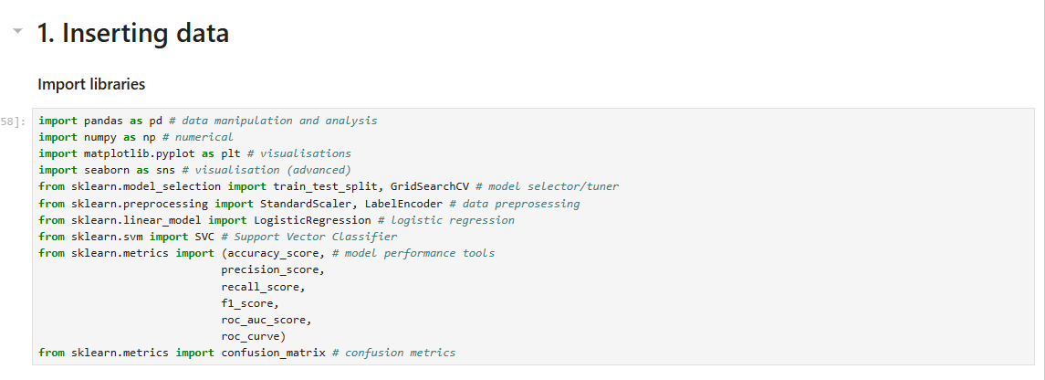

Inserting data
Connecting to the dataset is essential to being able to view, edit, and manipulate it.

Establishing connection and understanding the data
The following code snippets looking at the first and last 10 rows allowed the programmer to verify connectivity to the data, and also view a sample of it. It is useful to view the code to understand the structure. The data shows a mix of numeric and categorical columns.
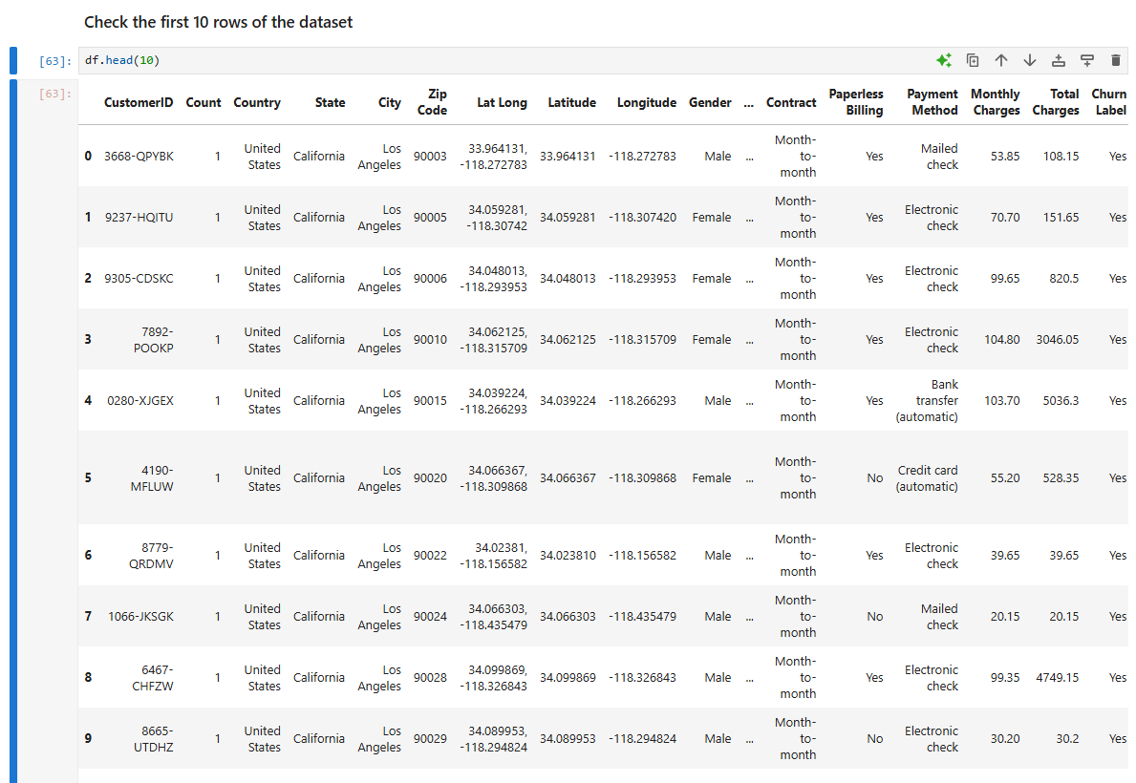
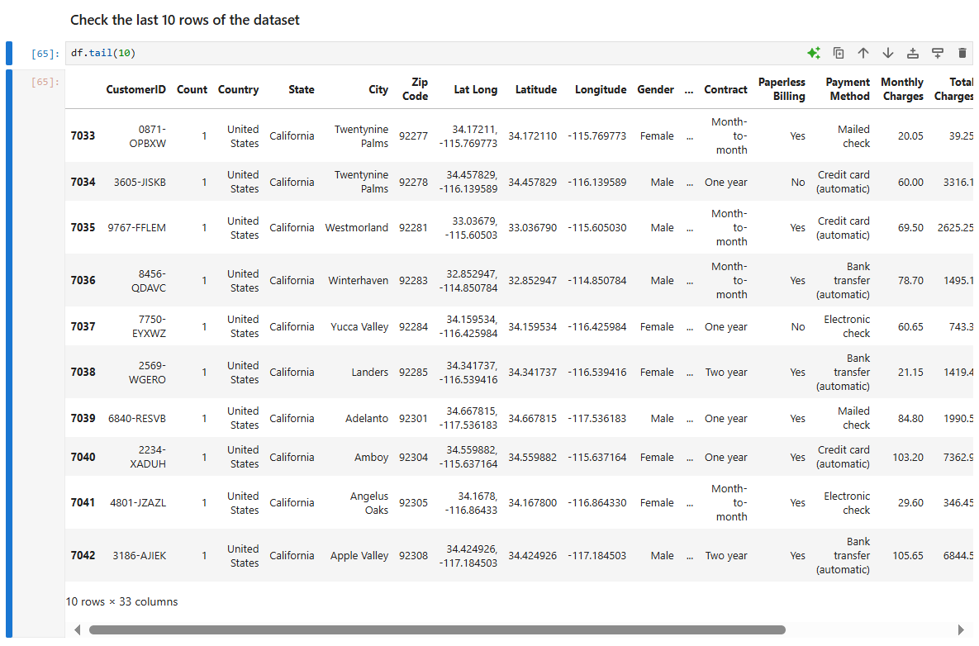

Basic statistical figures
Numerical columns have been described to get an understanding of the statistical figures. The count, mean, standard deviation, minimum, maximum, and percentiles are described.
There are 7043 entries is the dataset, with averages like 32.37 months tenure, $64.76 monthly charges, $4400.40 CLTV and a churn rate of 26.5% with scores between 5 and 100. The higher the score, the higher probability of churn. The range of 5-100 shows variation in the data with different risk levels.
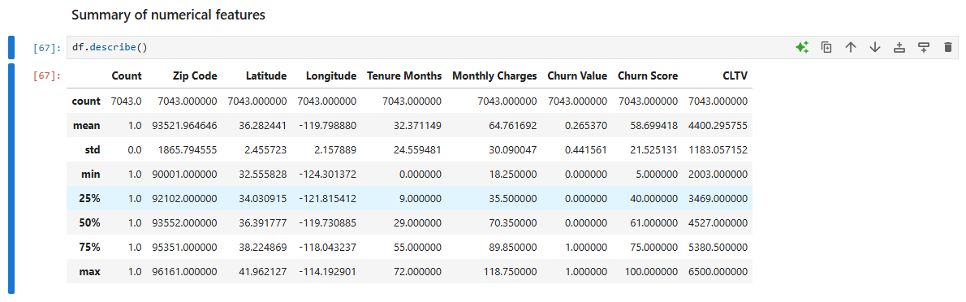

Data type and missing value check
It is imperative that a clear understanding of the dataset occurs prior to any algorithms being applied. There are 6 numerical columns and 24 categorical columns. Missing values are present in ‘Churn reason’ with only 1869/7043 not null. The dataset is small at 1.8MB suggesting quick run time on more complicated code. There are a range of demographic and person identifiable information included.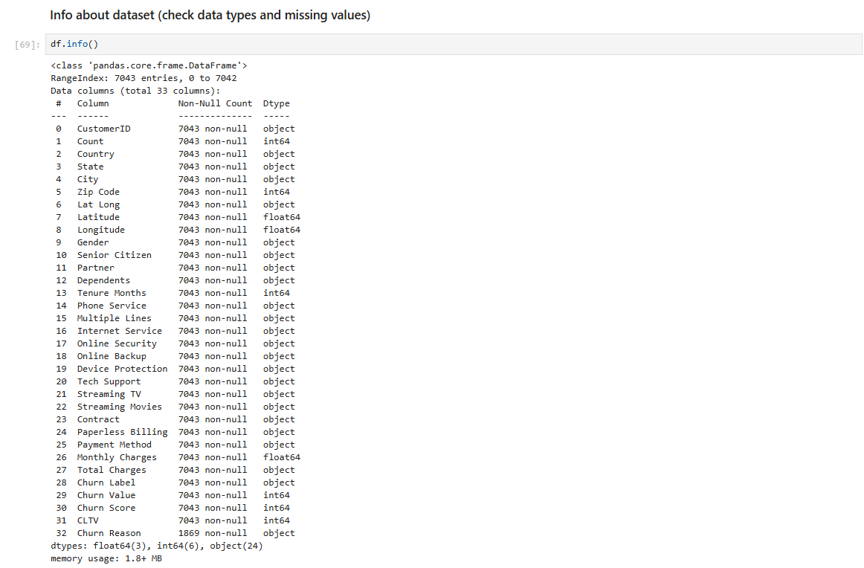

Unique columns
Unique columns should be identified in the early stages because if every row has a unique value or exactly the same value, it is useful for analysis purposes. The columns identified to be dropped include ‘CustomerID’, ‘Count’, ‘Country’, ‘State’. Other columns can be dropped for having too much variation including ‘City’, ‘Zip code’, ‘Lat Long’, ‘Latitude’, ‘Longitude’. Binary columns are identified by 2 unique values and these include ‘Gender’, ‘Senior Citizen’, ‘Partner’, ‘Dependents’, ‘Phone service’, Paperless billing’, ‘Churn label’, ‘Churn value’. Total charges can be identified as needing preprocessing such as converting strings to a numerical value. Further evidence for dropping ‘churn reason’ is here with 20 unique values only. All other columns have potential for good data quality and are kept included. Categorical column over 2 unique values will need encoding.
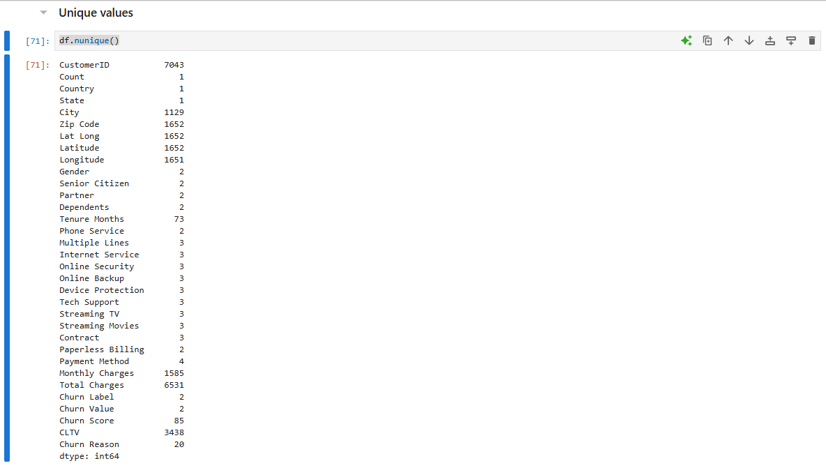

Dropping columns
The following columns qualified for being dropped including, ‘Churn value’, ‘Lat Long’, ‘CustomerID’, ‘City’, ‘Count’, ‘Country’, ‘State’, ‘Zip code’, ‘latitude’, and ‘longitude’.

Grouping numerical columns
Grouping the numerical columns will help the application of techniques and algorithms later on. The numerical columns include ‘Tenure months’, ‘monthly charges’, ‘Churn score’, ‘CLTV’, and ‘Total Charges’. Total charges is in the wrong format at this point but it will be altered later on. Only these columns would need scaling so it is easier to group them.

Grouping categorical columns
Grouping the categorical columns also helps later on because they are likely to need encoding to convert text to numbers so that algorithms can understand the data. The categorical columns include 'Gender', 'Senior Citizen', 'Partner' ,'Dependents', 'Phone Service', 'Multiple Lines', 'Internet Service', 'Online Security', 'Online Backup', 'Device Protection', 'Tech Support' ,'Streaming TV', 'Streaming Movies', 'Contract', 'Paperless Billing', 'Payment Method', 'Churn Label', 'Churn Reason’.

Convert ‘total changes’ column
The column total changes are in the wrong format so this snippet changes the column to numeric, any values that won’t convert will be replaced by ‘NaN’. ‘NaN’ can easily by overwritten. The mean average of the whole column is inserted in its place, allowing for a more complete dataset.
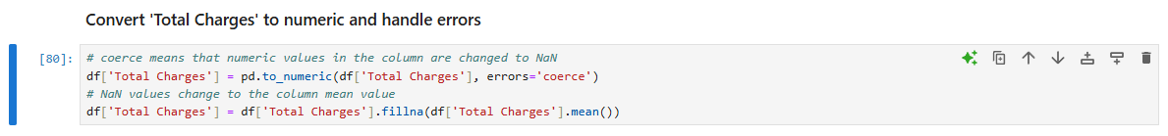

Dataset copy
A copy is created of the dataset because sometimes the categorical labels are useful and other times the numerical substitutes are more appropriate. Having both versions protects data quality and allows for easier experimentation.

One-hot encoding
The pd.get_dummies function converts everything from categorical to numerical like 0 and 1. It only applies this to the specified categorical columns and drops the first category in every column to avoid the dummy variable trap. This is where alteration of results can happen. This is important for the learning models and algorithms later on.
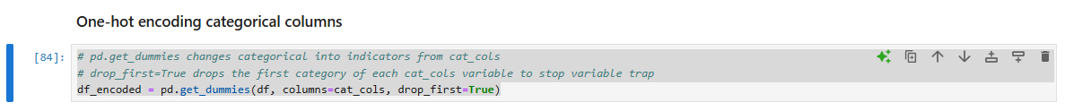

Features and target
The dependent variable needs to be separated from the independent variables for machine learning. This is done by excluding the ‘Churn Label_Yes’ from the X and including only that column in the Y.
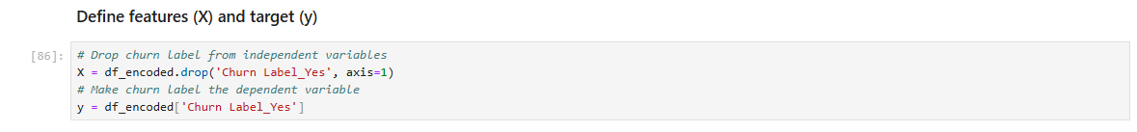

Training sets
The model needs to be trained to be able to predict. The features and targets are split to give 80% to training and 20% to testing the unseen portion of the data. This is done to reduce the risk of overfitting where the model performs ‘too well’ bur it is actually inaccurate. It is reproducible because of the fixed random seed, and the distribution is preserved by stratify.
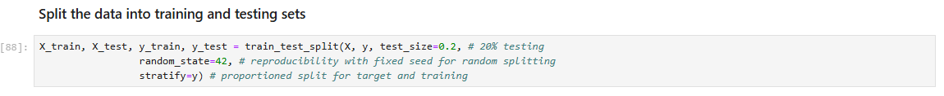

Scaling
Scaling means that a mean of 0 and standard deviation 1 is applied to numerical features using the fit and transform. This is important to linear models and SVM.
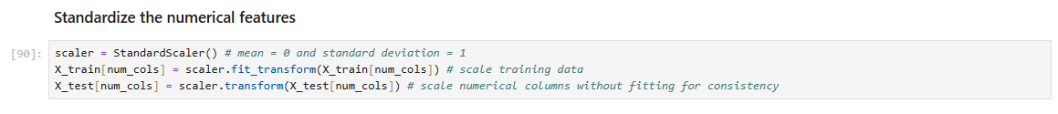

Univariate analysis of numerical columns
The high standard deviation shows that there is significant variable in customer base.
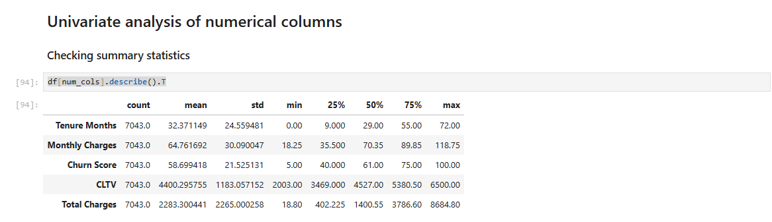

Univariate analysis of categorical columns
At first glance, the common churn reasons include poor support, competitor offerings, and service dissatisfaction.
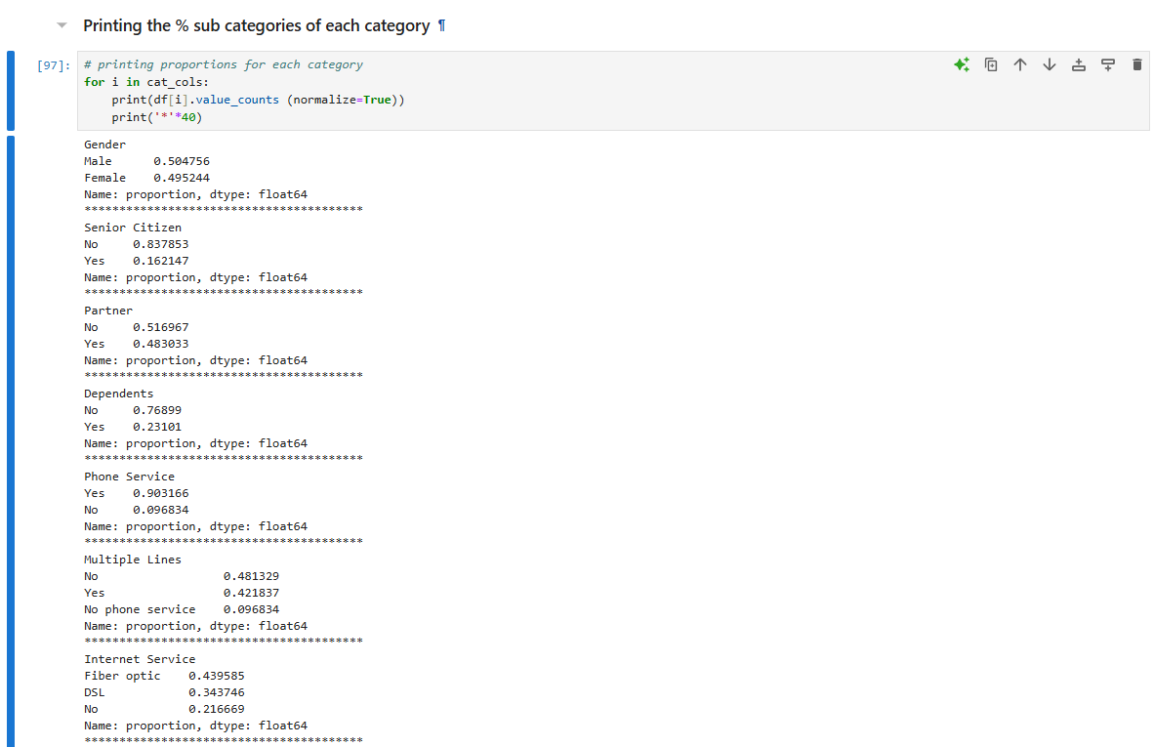

Numeric visualisations
Visualisations offer quick feedback/results. Tenure mostly lasts between 0 and 10 months, the monthly charges are highest near 20, the churn between 20 and 60 indicates a lot of customers have low churn which is positive news, the customer lifetime value is quite even. There is skew in total charges and monthly charges, and some outliers across the dataset are present.
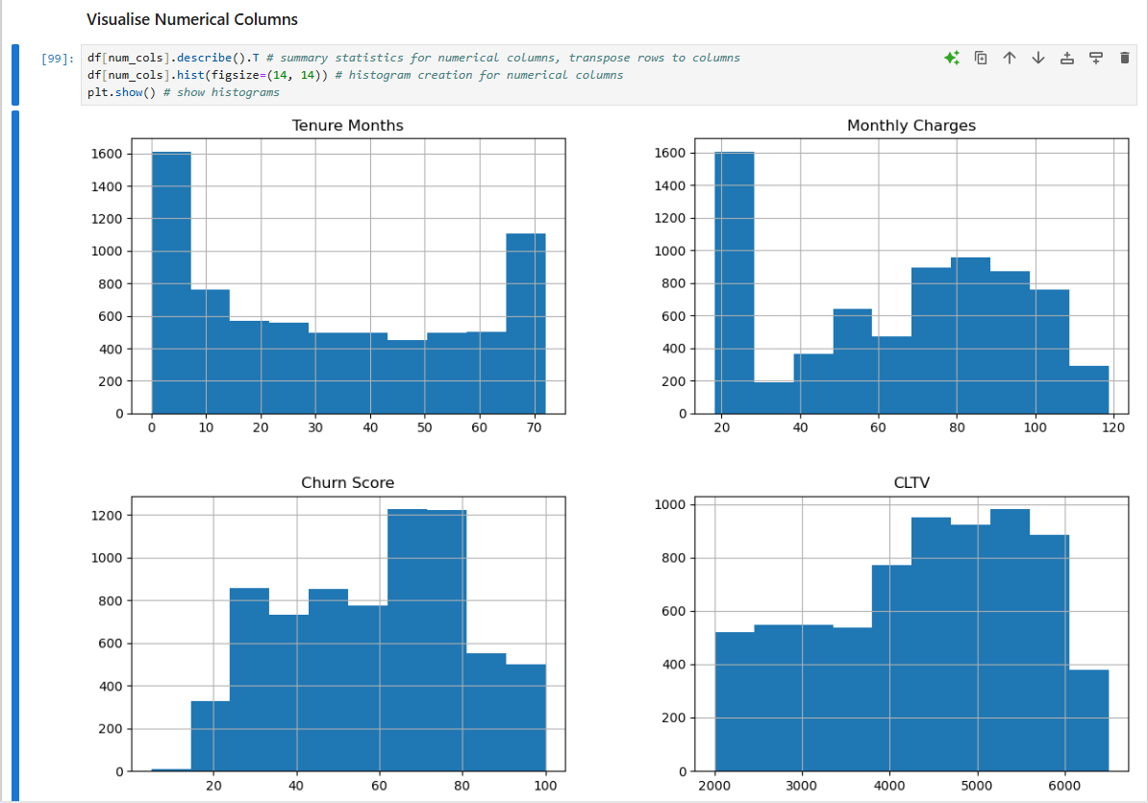
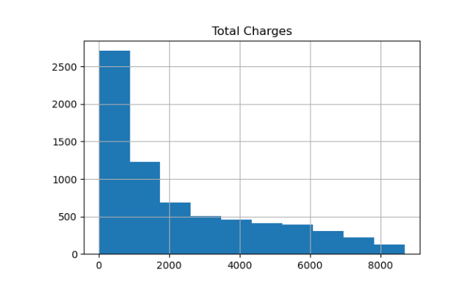

Bivariate and multivariate analysis of categorical columns
The key findings from this section include how customers with partners were less likely to churn, non-senior citizens were less likely to churn, customers using the paperless billing system were more likely to churn, and the electronic check payment method showed as more likely to churn. Customers on month-to-month contracts were more likely to churn and fibre optic service users were more likely to churn.
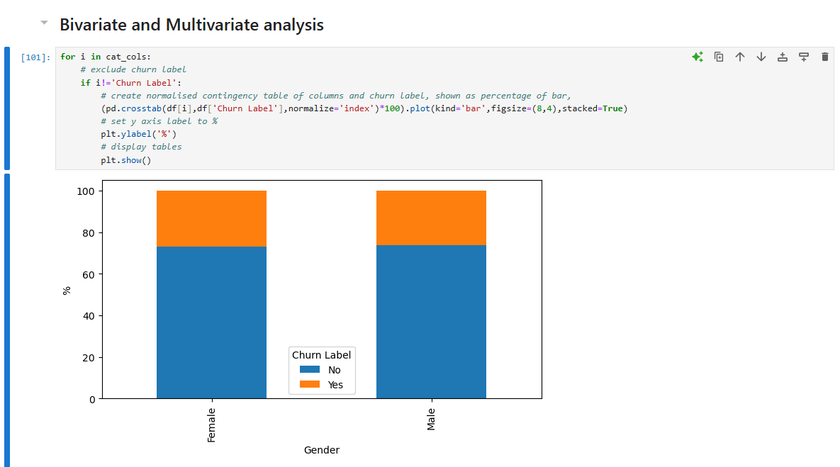

Numerical Confusion matrix
In this display, when the numerical column is against itself then the correlation is perfect (1). Tenure and total charges have strong correlations making them more complex.
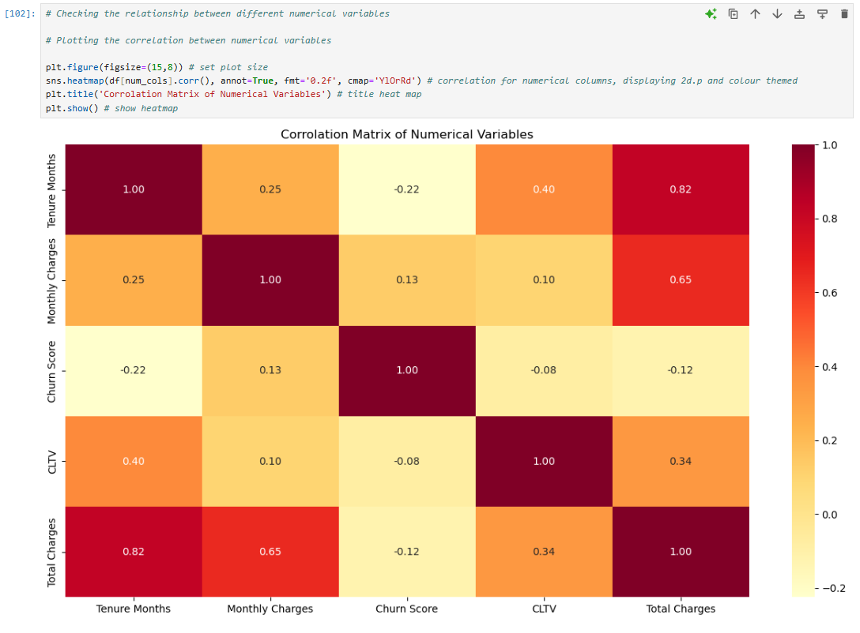

Machine learning model development (logistic regression)
The machine learning model is started and uses the training data to predict. The model is trained and makes predictions.
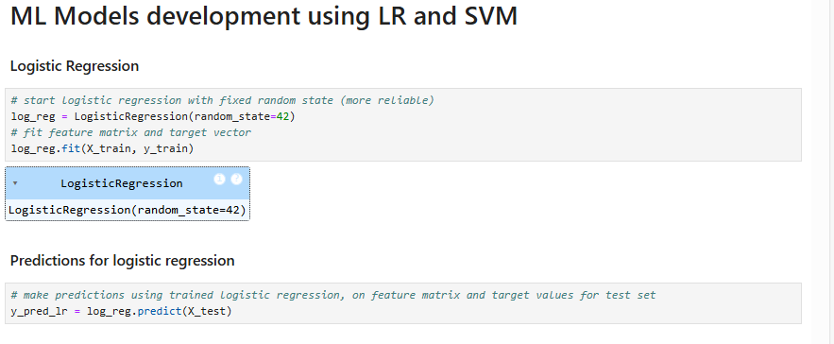

logistic regression evaluation metrics
The model has high performance because all metrics are above 0.97. This means that the model should make reliable predictions and handle true/false positives appropriately.
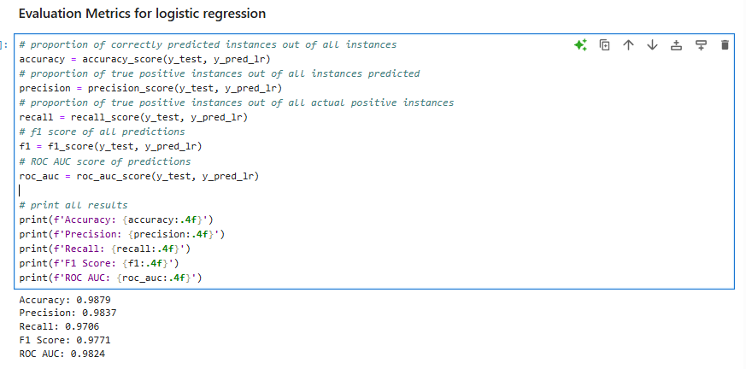

Logistic regression confusion matrix
The confusion matrix shows that there were 363 correctly predicted churn (True positives) and 6 incorrectly predicted churn (False positives). There were 1029 correctly predicted not churn (True negatives) and 11 incorrectly predicted not churn (False negatives). These results show the dataset to have high accuracy for predicting in both the churn and not churn criteria.
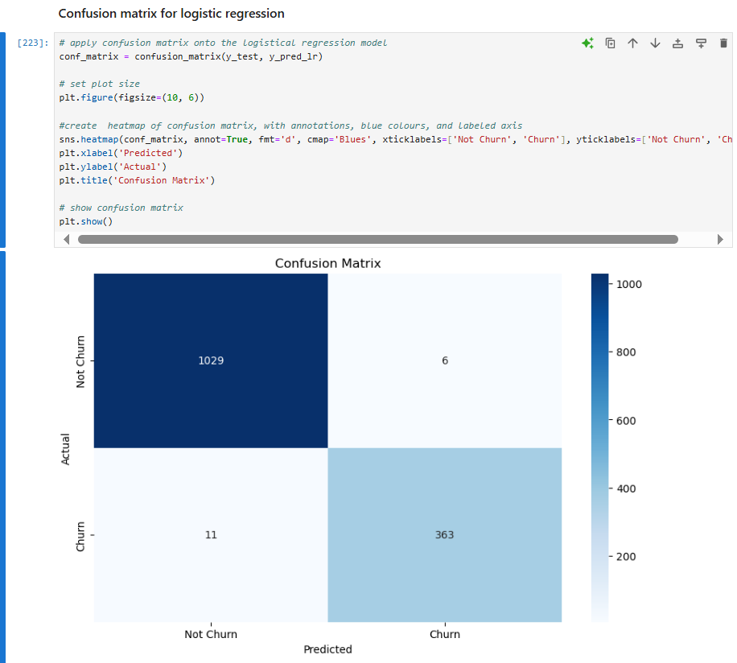

Support vector machine initialisation and prediction
The machine learning model is started and uses the training data to predict. The model is trained and makes predictions. To identify the performance of binary classes the ROC AUC are used to determine positive and negatives.

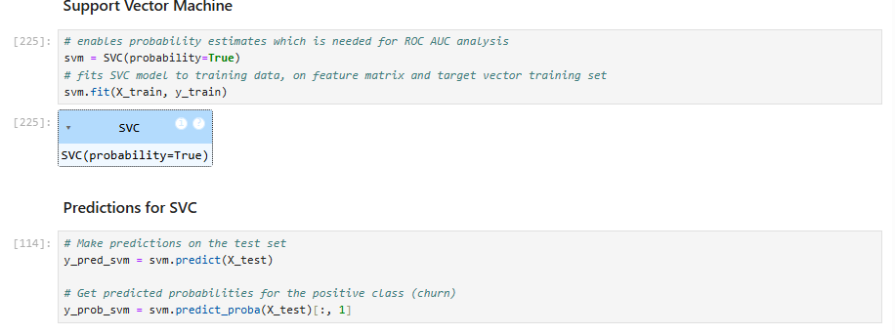

SVM evaluation metrics
The model has high performance because all metrics are above 0.97. This means that the model should make reliable predictions and handle true/false positives appropriately.
The model is highly accurate with most churn predictions right, is very good at finding churn cases, has a good balance of precision and recall with F1, and has good ability to see the difference between churn and not churn through the ROC AUC.
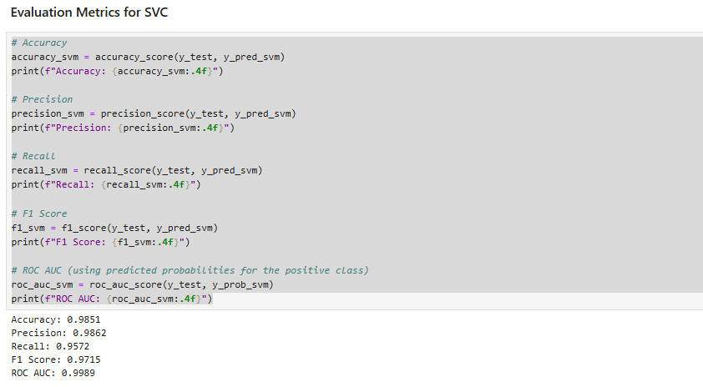

SVM Confusion Matrix
The true negatives were 1030 and true positives were 358 which shows good accuracy in the predictability. Only 5 false positives and 16 false negatives occurred which shows an effective model to predict churn for this dataset.
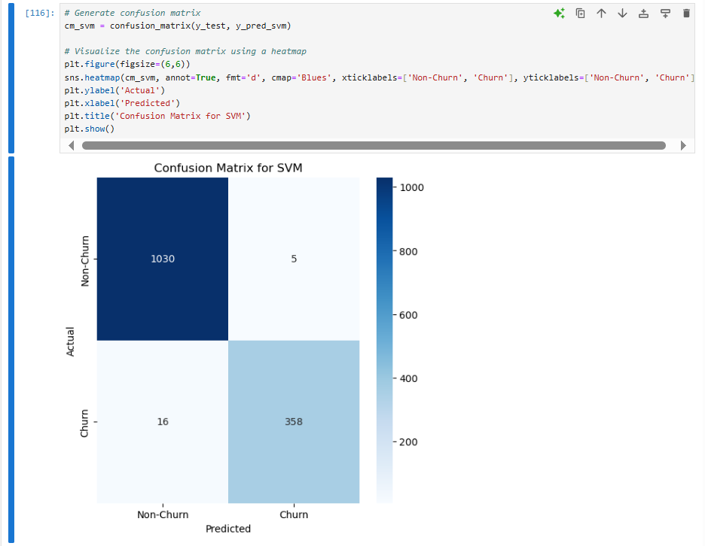

Comparison performance of logistic regression and SVC
From printing the results, it is clear that both models perform well. Logistic regression has a higher accuracy, recall, F1 score and AUC-ROC. SVM has a higher precision. Both models are effective, but the logistical regression performs better.

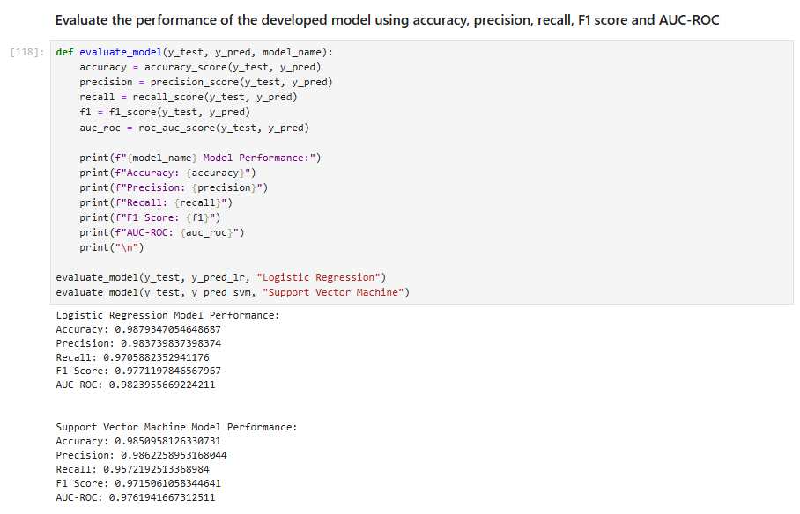

Hyper tuning
A parameter grid is essential for testing hyperparameters. Regularisation parameters lessen the complexity of data, kernel specifies the type used, gamma specifies the co-efficient affecting decision boundaries, and the class weight handles imbalance. A 5-fold validation was used providing logs for fitting, and all CPU’s available could be used for faster processing.
The output indicates that 48 hyperparameter combinations are possible for the 5-fold cross validation and this gives 240 models.
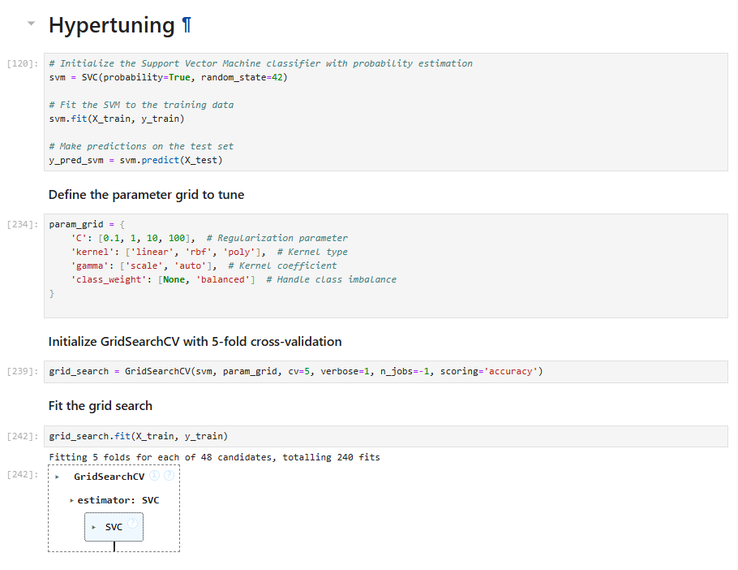

Best hyperparameter/model from grid searching
The best hyperparameter is C ‘10’, class weight ‘none’, gamma ‘scale’, and kernel ‘linear’. These offer the most accurate results on cross-validation. Less regularisation and linear boundary are best suited, and scale/none are common choices.
The best model considering the best hyperparameters allows for optimum reliability and accuracy.
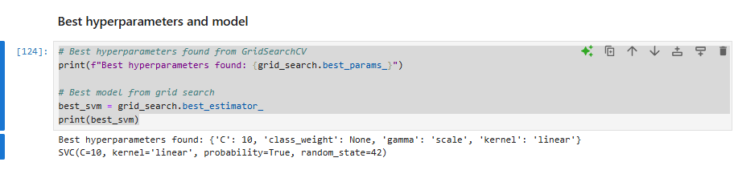

Prediction and evaluation
The best performance for SVM has 99.22% accuracy, 100% precision, 97.06% recall, 98.51% F1 score, and 99.98% ROC AUC. This is very high performance differentiating churn and not churn.
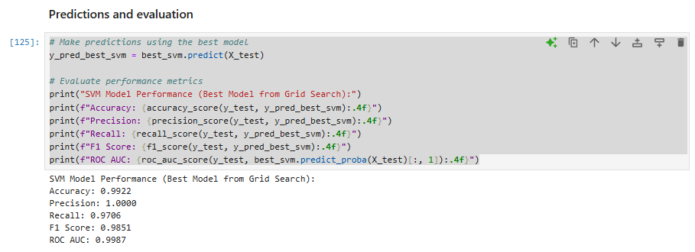

Confusion Matrix
True negatives (1035) and True positives (363) are extremely high, and there were no false positives and only 11 false negatives.
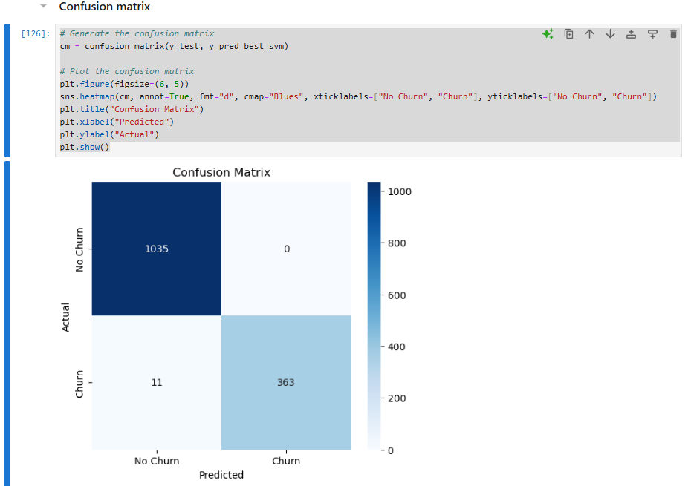

Hyperparameter tuning for logistic regression
The grid is set up with 3 solvers, including regularisation strength c (0.1, 1, 10) and 5-fold cross validation. The best hyperparameters are searched and found 75 models.
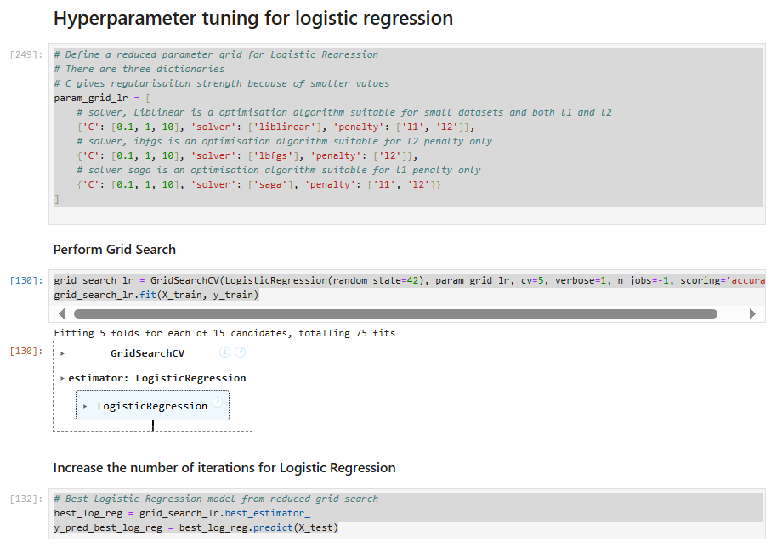

Evaluate performance metrics
Based on the best hyperparameters, the metrics are accuracy 0.9943, precision 0.9946, recall 0.9840, F1 score 0.9892, and ROC AUC 0.9910. The cross-validation accuracy after tuning is 0.9876 showing consistent performance across folds.
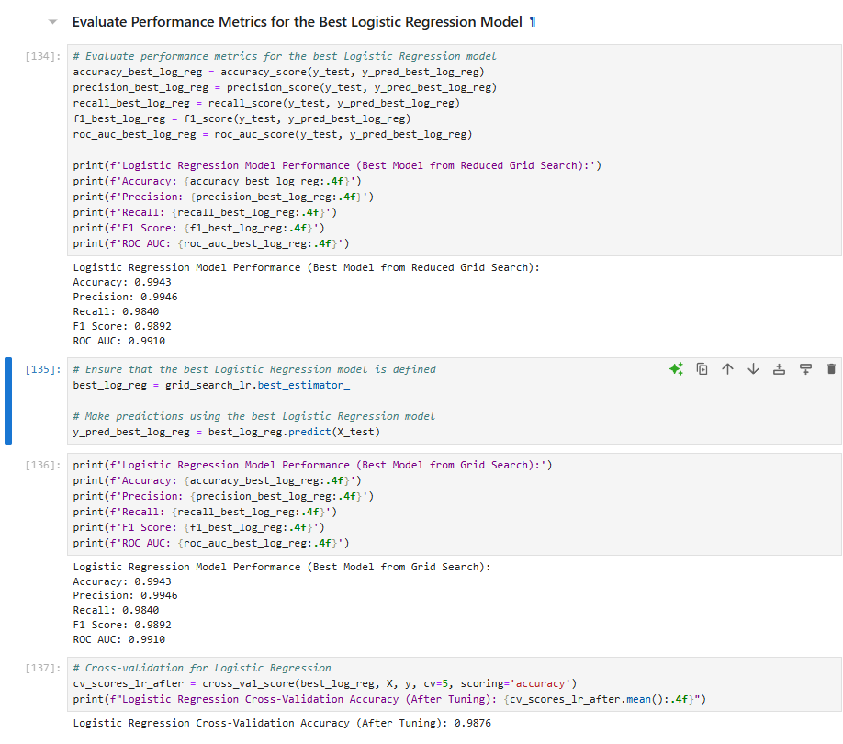

Results

Logistic Regression vs. SVM Comparison after tuning
Logistic regression SVM
Accuracy before - 0.9879 Accuracy before – 0.9851
Accuracy after - 0.9943 Accuracy after – 0.9922
Precision before – 0.9837 Precision before – 0.9862
Precision after – 0.0.9946 Precision after – 1.0000
Recall before – 0.9706 Recall before – 0.9572
Recall after – 0.9840 Recall after – 0.9706
F1 before – 0.9771 F1 before – 0.9715
F1 after – 0.9892 F1 after – 0.9851
Hyperparameter tuning improved both models. LR saw an increase in accuracy, precision, recall and F1 because of tuning. SVM saw all metrics improve with perfect precision and very high recall and F1. If precision is most important then SVM is better, and if balance precision or recall is more important then LR is better.
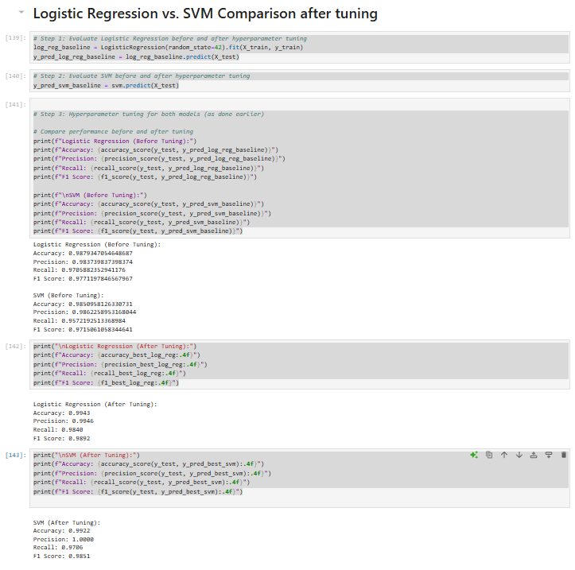

Visualising performance metrics
It Is clear from this comparison which metrics are the highest performing, and which ones have increased after tuning.
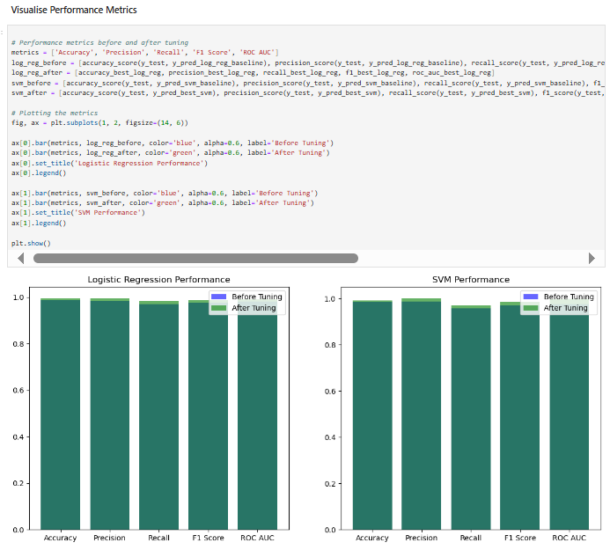

Feature importance for logistic regression
The feature importance analysis shows which have the biggest impact on customer churn, looking at what could be increasing or decreasing churn rate. The most positive churn reasons/reasons to leave include long distance charges (11.9), competitors offering more data (10.8), competitors having better download speeds (10.4), the attitude of support personnel (10.3) and competitors having better deals (10.3). The negative influences/the reasons people do not churn are the phone service (-3.6) and longer tenure (-2).
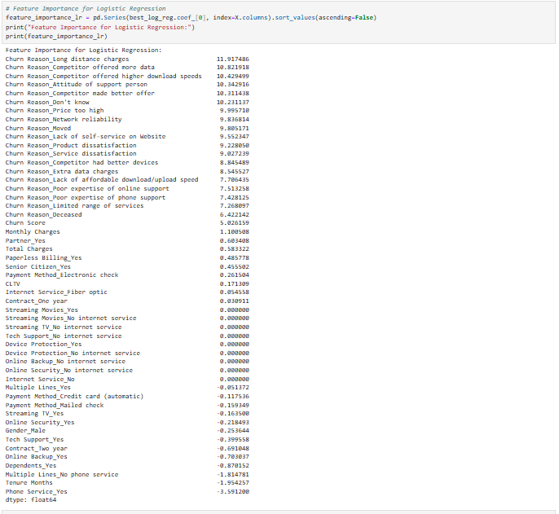

Feature importance for SVM
The biggest influence on churn includes the attitude of the support person, the competitors offering quicker download speeds, and the competitor offering more data. Some other potential churn reasons include the competition making a better offer, the competition having better devices, prices being too high, and bad network connectivity.
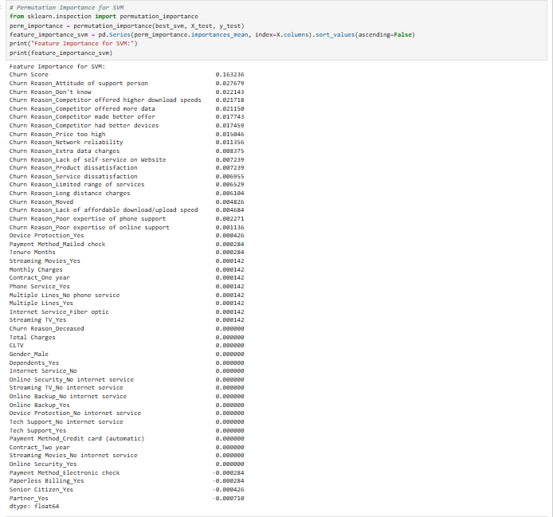

Discussion
Both the LR and SVM models had good performance metrics initially but after hyperparameter tuning all the metrics increased. The logistic regression had a better recall and F1 score than the SVM, but the SVM achieved perfect precision after tuning which insinuates that the model would be more accurate at predicting. The key factors affecting churn in this data set when using logistic regression include long distance charges, competitors having more data and better download speeds. The key factors when considered SVM include attitude of the support workers. Both models highlight other companies being competitive, and this is where the company should consider making changes to retain customers. It is recommendable that the customer support for the company is improved because the attitude of staff is a churn reason. At risk customers should be identified and contacted to ensure good communication and service. Loyalty programs and offers could make customers stay with this company.

Conclusion and recommendations
The overall quality of the dataset after removing the unnecessary columns was to a high standard even before any machine learning algorithms or hyper tuning was applied. However, by doing the hyper tuning it did improve the prediction models for both logistic regression and SVM. Whilst both increased, the SVM return 100% accuracy which makes this the more reliable predictability model. The company should prioritise the SVM feature importance which includes altering the download speeds and keeping up competition with other companies. Due to the LR also having high metrics the company could also target download speeds and customer service to achieve lower churn rates.
In future it would be beneficial to the company to explore the customer lifetime value further. [10] This predicts the average amount of money that customers will make you and it can inform the business of how beneficial it is to keep this customer, enabling better financial management.

References
[1] M. Danao, “What Is Churn Rate & How Do You Calculate It? – Forbes Advisor,” www.forbes.com, Mar. 02, 2023. [Online]. Available: https://www.forbes.com/advisor/business/churn-rate/.
[2] "What is Churn Rate - Definition, Examples & How To Use It," AgencyAnalytics. [Online]. Available: https://agencyanalytics.com/kpi-definitions/churn-rate.
[3] GeeksforGeeks, “Understanding Logistic Regression,” GeeksforGeeks, May 09, 2024. [Online]. Available: https://www.geeksforgeeks.org/understanding-logistic-regression/.
[4] F. Tabsharani, “What is support vector machine (SVM)? - Definition from WhatIs.com,” WhatIs.com, Aug. 2023. [Online]. Available: https://www.techtarget.com/whatis/definition/support-vector-machine-SVM.
[5] C. Goyal, “Missing Values | Treat Missing Values in Categorical Variables,” Analytics Vidhya, Apr. 27, 2021. [Online]. Available: https://www.analyticsvidhya.com/blog/2021/04/how-to-handle-missing-values-of-categorical-variables/.
[6] GeeksforGeeks, “Encoding Categorical Data in Sklearn,” GeeksforGeeks, Jun. 12, 2024. [Online]. Available: https://www.geeksforgeeks.org/encoding-categorical-data-in-sklearn/.
[7] S. Jaiswal, “What is Normalization in Machine Learning? A Comprehensive Guide to Data Rescaling,” Datacamp.com, Jan. 04, 2024. [Online]. Available: https://www.datacamp.com/tutorial/normalization-in-machine-learning.
[8] J. Reilly, “The Machine Learning Revolution: Telco Customer Churn Prediction,” Akkio, Jan. 05, 2024. [Online]. Available: https://www.akkio.com/post/telecom-customer-churn.
[9] “LinkedIn,” Linkedin.com, 2024. [Online]. Available: https://www.linkedin.com/pulse/model-selection-choosing-right-algorithm-your-data-santhosh-sachin-i0njc/.
[10] J. Murariu, “Customer Lifetime Value (CLV or LTV) Formula: How to Calculate It Correctly,” InnerTrends, Aug. 05, 2022. [Online]. Available: https://www.innertrends.com/blog/customer-lifetime-value.

Appendix
https://youtu.be/bN5ikYD-zDE
Video presentation is linked above.

