Mobile Application Development II
  - Lecture 9 Lab Tutorial Exercise

The Criminal Intent App Part IV

Objectives
In today’s exercise, you will implement a ViewPager, which will allow users to navigate between list items by swiping across the screen. You will also implement a Date Picker Dialog.

Exercise 1: Implementing Swipe Views
- Open up your Criminal Intent project.
- Note: you may want to back up the previous version of your app if you are not using any version control.
- Add a new empty activity to your project called CrimePagerActivity and generate a layout file for it too.

The activity_crime_pager Layout File
- Open up the layout file created.
- Replace the default Relative Layout with the following:
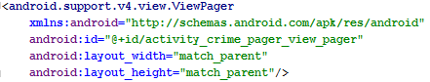

The CrimePagerActivity Java Class
- Open up the Java class for the CrimePageActivity.
- Modify its definition so that it inherits from android.support.v4.app.FragmentActivity.
- Create the following two global variables before the onCreate method.
// will provide access to the view pager in the layout

// access to the list of crimes
- Next set the two variables declared in the last step in the onCreate method as follows.
// Initialise reference to the view pager in the layout

// Get the list of crimes from the Crime Lab
- As you will be swiping between fragments, you need a reference to the Fragment Manager.
// Get a reference to the fragment manager
- A ViewPager requires a PagerAdapter. Android provides the FragmentStatePagerAdapter that you can inherit from. It includes many of the details needed to swipe between fragments.
The FragmentPagerAdapter requires two methods to be implemented:
  - getCount() – the number of items
  - getItem(int) – the item at the specified integer position. This will ensure the right crime is displayed when the user swipes the fragment view.
- Set the view pager’s adapter as follows. Android Studio should automatically generate the getCount and getItem methods for you. If not, add as follows:
// Set the View Pager's adapter
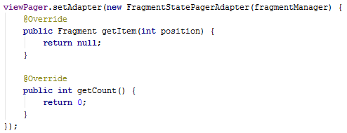

The Get Item Method
- Replace the return null statement in the getItem() method with the following:
// Get the crime at the specified position

// Create and return a new Crime Fragment object using Crime Fragment's newInstance() method
// passing in the crime id of the Crime to display

The Get Count Method
- Return the size of the crimes collection as follows:
// return the number of crimes

Setting the Current Item
- You also need to set the current item for the view pager based on the current crime ID. Add the following highlighted block of code after the end of the viewPager.setAdapter(…); block
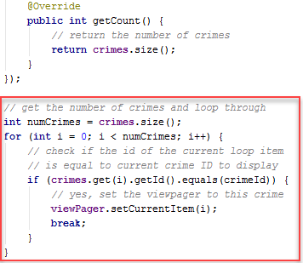

Exercise 2: Replacing Crime Activity
- Open up the CrimeActivity class. Locate the following constant variable and copy it.
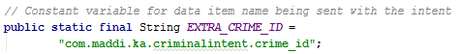
- Return to the CrimePagerActivity class and paste the copied constant variable.
- Return to the CrimeActivity class again and locate the newIntent method. Copy the entire method.
- Now go back to CrimePagerActivity and paste the copied method after the existing onCreate method.
- Make the following highlighted change to the copied code.
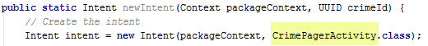
- Next, locate the onCreate() method in the CrimePagerActivity class and insert the following after the setContentView … statement. You can also copy and paste this from CrimeActivity.
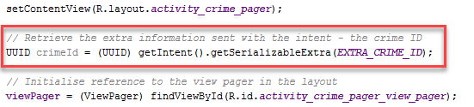

Updating Crime List Fragment
- Next you need to update crime list fragment to use crime pager activity.
- Open up CrimeListFragment
- Locate the onOptionsItemSelected() method and make the following highlighted change (simply replace CrimeActivity with CrimePagerActivity).
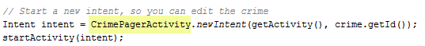
- Also locate the onClick method in the CrimeHolder and do the same as above – replace CrimeActivity with CrimePagerActivity.
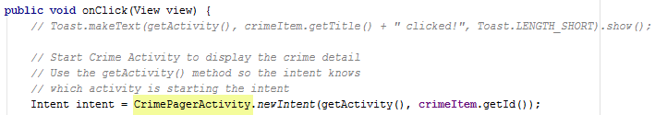
- Also insert the following highlighted line to set the default date for a new crime to today’s date.
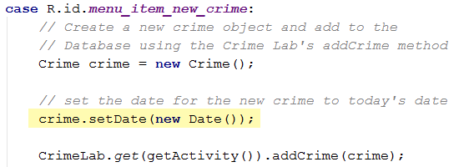

Tidying Up
- Open up activity_fragment.xml and delete the reference to CrimeActivity
- Do the same (previous step) in activity_crime.xml
- Open up the Android Manifest file and delete the reference to CrimeActivity.
- Delete the CrimeActivity from the project
- Save your changes and test.

Exercise 3: Implementing Dialogs
- In this exercise, you will implement a dialog for selecting the date of a crime.
- Make sure your build.gradle (Module app) file has the following dependency.

Create the Date Picker Layout
- Create a new layout resource file called dialog_date.
- Open up the text XML view and replace the content with the following.
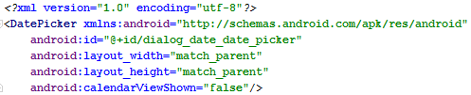
- Implementing it this way, makes it easier to change the layout later on if required.

Creating a Dialog Fragment
- To implement the DatePicker you will extend Android’s DialogFragment class. It requires:
  - Overriding the onCreateDialog() method and returning an instance of a Dialog object.
  - Implementing the Click Listener to define a callback method to execute when the user selects a date and clicks the OK button.
- Create a new class called DatePickerFragment and make it inherit (set its superclass) from android.support.v4.app.DialogFragment.
- Import the following libraries.
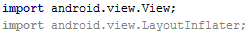
- Add a private variable of type DatePicker, which will reference the date picker added to the layout.
- Next, generate the following “override method”: onCreateDialog
- In the onCreateDialog method, you will return a new date picker dialog and set the default date to the current date. Add the following to the onCreateDialog method.
  - Get the current date and the different date parts.
// Use the current date as the default date in the picker
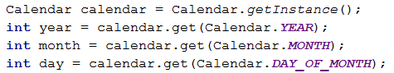
  - You need to inflate the fragment view with the dialog date layout created. Add the following:
// Inflate the fragment view with the dialog date layout
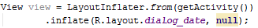
  - Get a reference to the date picker added to the dialog_date layout and initialise the current date.
// Get a reference to the date picker in the date_dialog layout
// Initialise the date to the current date
  - Create a new AlertDialog and return it from the method as follows.
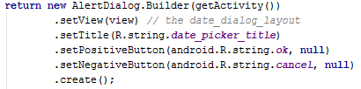
- You will probably notice that all the event listeners have been set to null. You will change this shortly.

Updating Crime Fragment
- Next, you will update crime fragment to use the date picker dialog.
- Open up your Crime Fragment class.
- The dialog requires a tag for the fragment manager to identify it. Add the following constant
- Create an OnClickListener method for the crime date button. The method creates a new instance to the DatePickerFragment and then displays it.
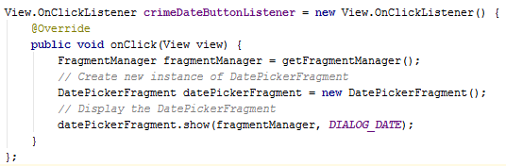
- Locate the onCreateView method and locate the line of code that disables the crime date button and replace it with the following, which sets the onclick listener for the button.
- Save your changes and see if the date picker dialog works.
- You will probably notice that at the moment it is not saving the date. That is because you have not yet implemented the event listeners for when the user sets the date.

Persisting the Date
- You need to pass the current crime date (if one exists) to the date picker and back to the crime fragment (when updated) to store with the rest of the crime details.
- We are going to use our standard method of passing data between fragments using fragment arguments and the commonly used design pattern (Lecture 7, slides 15 – 17).

The Date Picker Fragment
- Open up the date picker fragment java class.
- Add the following constant which will be the identifier for the date data passed between the fragments.
// Constant to identify crime ID argument passed to fragment
- Create a newInstance method in DatePickerFragment that accepts a Date parameter passed to the fragment when it is created.
  - You can copy the newInstance method in CrimeFragment and make the following highlighted changes.
  - Note that you will also need to import java.util.Date
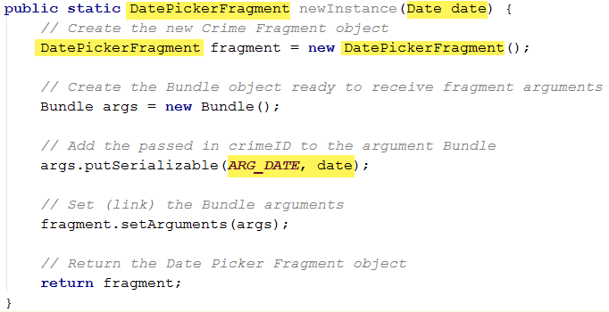
- Next, you need to update the date dialog to use the date passed in to the fragment.
- Locate the onCreateDialog method and add the following:
// Get the date passed as an argument to the date picker fragment
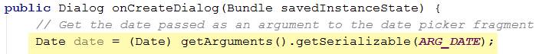
- Now set the date picker calendar to default to the passed in date.
// Use the passed in date argument as the default date in the picker

The Crime Fragment
- Next you need to modify crime fragment to call date picker’s newInstance() method. Return to crime fragment.
- Locate the date button’s on click listener method.
- Make the following change.
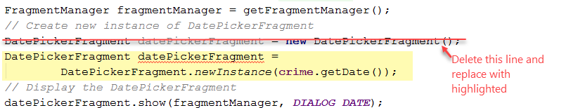

Crime Lab
- Open up Crime Lab.
- Locate the getContentValues() method and make the following highlighted change – change toString() to getTime() as shown.

Returning the Selected Date to Crime Fragment
- Because we are dealing with fragments, there is no startActivityForResult() method to use to pass data back to the starting fragment. Instead you use the setTargetFragment() method.

The Crime Fragment
- Open up Crime Fragment and add the following constant as an identifier request code for the date picker fragment.
- Locate the date button’s on click listener and add the following (the highlighted code) to set the target fragment for the result.
// Set the target fragment for the result of the date picker fragment
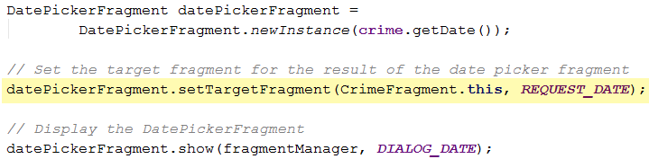

The Date Picker Fragment
- The date picker now needs to send the selected date back to crime fragment.
- Return to the date picker fragment and add the following constant as an identifier for the date being sent back. Replace the highlighted with your application namespace.
- Create the following new method to send the result (selected date) back to the target fragment.
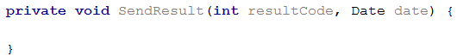
- Add the following steps to the SendResult method.
  - Check that a target fragment to receive result exists
// check that there is a target fragment to receive result
// if not, return and exit early
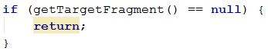
  - Create a new intent to send the selected date back to the target fragment
// Create new intent and send the selected date back
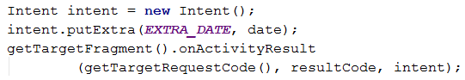
- Finally, you need to call this new SendResult() method when the user clicks the OK button (Positive button) on the date picker.
- Locate the onCreateDialog button and replace the null part of the .setPositive(…, null) line with the following.
Hint: if you type new and select OnClickListener, it will automatically generate some of the code for you.
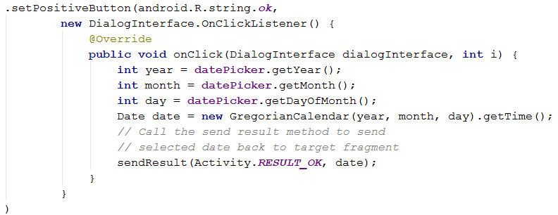

The Crime Fragment
- It’s back to crime fragment again to retrieve the date sent back.
- Generate the following override method: onActivityResult.
- Delete the call to super.onActivityResult(…) line
- Add the following:
  - Check the result code. If it is not okay, return and exit early.
// Check result code - if NOT ok, return and exit early
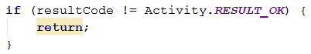
  - Check the returned request is for the date. If it is, update the crime with the returned date as follows:
// Check the request code returned is for the date
// Retrieve the date
// Set the crime's date to the returned date
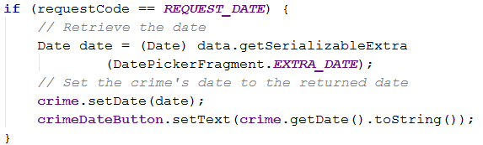

Refactoring common code
- Select the last line of code – crimeDateButton.setText(…)
  - Right-click and select Refactor Extract Method
  - In the window that opens, set the method name to updateDate and click OK. If prompted:
    - Keep Original Signature
    - Yes to allow other references to be updated.
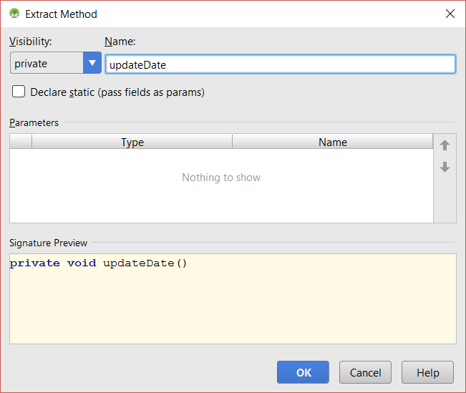

- Locate the onCreateView method and replace the line of code that sets the text for the crime date button - crimeDateButton.setText(…) with a call to updateDate().
- That’s all for today

Adapted from Android Programming: The Big Nerd Ranch Guide

