

Jamie Hodges

Dynamic Stress-Strain Investigation

UWTSD
Physics

OME HNC Level 4
Academic Year: 2024

July 2024

UWTSD
Physics

OME HNC Level 4

Academic Year 2024

Jamie Hodges

Dynamic Stress-Strain Investigation

© UWTSD 2024. All rights reserved. No part of this publication may be reproduced without the written permission of the copyright owner.

Academic integrity declaration
I declare that:
- the thesis submitted has been written by me alone.
- the thesis submitted has not been previously submitted to this university or any other.
- that all content, including primary and/or secondary data, is true to the best of my knowledge.
- that all quotations and references have been duly acknowledged according to the requirements of academic research.
I understand that to knowingly submit work in violation of the above statement will be considered by examiners as academic misconduct.

Table of Contents
Academic Integrity declaration i
- Materials 2
1.1 Projectile
1.1.1 Properties 3
1.1.2 Choice Discussion 3
1.2 Armour Plate
1.2.1 Properties 3
1.2.2 Choice Discussion 3
2. Introduction 5
3. Modelling
3.1 Part Dimensions 5
3.1.1 Projectile 5
3.1.2 Armour Plate 6
3.2 Initial Model
3.2.1 First Impact 6
3.2.2 Second Impact 7
3.3 Final Model
3.3.1 First Impact 8
3.3.1.1 Direct Stress 8
3.3.1.2 Shear Stress 9
3.3.1.3 Velocity 10
3.3.2 Second Impact 11
3.3.2.1 Direct Stress 11
3.3.2.2 Shear Stress 12
3.3.2.3 Velocity 13
4. Conclusion 14
5 References 15

Materials

Projectile

Properties
The material selected for the projectile within the simulation was a tungsten alloy containing Nickel and Iron. The data collected for this alloy is listed in Figure 1.

Projectile Features
Material Tungsten Alloy
Density [kg/m³] 17600
Modulus of Elasticity [GPa] 314
Poisson’s Ratio 0.28
Melting Temp [K] 3695 [1]
Johnson-Cook Damage Parameters
D1 0
D2 0.33
D3 -3
D4 0.042
D5 0
Johnson-Cook Plastic Model
A [kPa] 2e6
B [kPa] 1.77e5
n 0.1368
C 0.0195
m 1.6972 [2]
[Figure 1] Table of Material Properties for Projectile

Choice Discussion
A tungsten alloy was chosen to maintain realistic ballistic modelling. Tungsten alloys are used in many armour piercing ballistic projectiles because it “has a high melting point, high density, high strength, low thermal expansion coefficient, corrosion resistance, and good mechanical processing, and other comprehensive properties.” [3]

Armour Plate

Properties
The material selected for the armour plate within the simulation was a titanium alloy (Ti-5). It is made up of titanium, tin, aluminium, zirconium, niobium, molybdenum and silicon [4]. The data collected for this alloy is listed in Figure 2.

Choice Discussion
Ti-5 was chosen due to its high strength and durability making it a harder material to penetrate, giving a wider variety of velocities for the projectile to travel at before collision. [4]

Armour Plate Features
Material Titanium Alloy (Ti-5)
Density [kg/m³] 4480
Modulus of Elasticity [GPa] 110
Poisson’s Ratio 0.31
Melting Temp [K] 1863.15 [5]
Johnson-Cook Damage Parameters
D1 -0.03
D2 0.29
D3 0.37
D4 0.012
D5 3.1
Johnson-Cook Plastic Model
A [MPa] 840
B [MPa] 712
n 0.3
C 0.011
m 0.81 [4]
[Figure 2] Table of Material Properties for Armour Plate
[Figure 2] Table of Material Properties for Armour Plate

Introduction
This report demonstrates how different velocities affect the stress and strain within an oblique ballistic impact of a projectile into an armour plate. All the modelling in this report was completed on ABAQUS. The materials selected for both parts within the assembly were chosen in order to maintain realistic ballistic accuracy.

Modelling

Part Dimensions

Projectile
The projectile 2D dimensions are shown in Figure 3. The 2D sketch was then rotated 360⁰ around the central line and the tip diagonal was smoothed into a more curved surface.
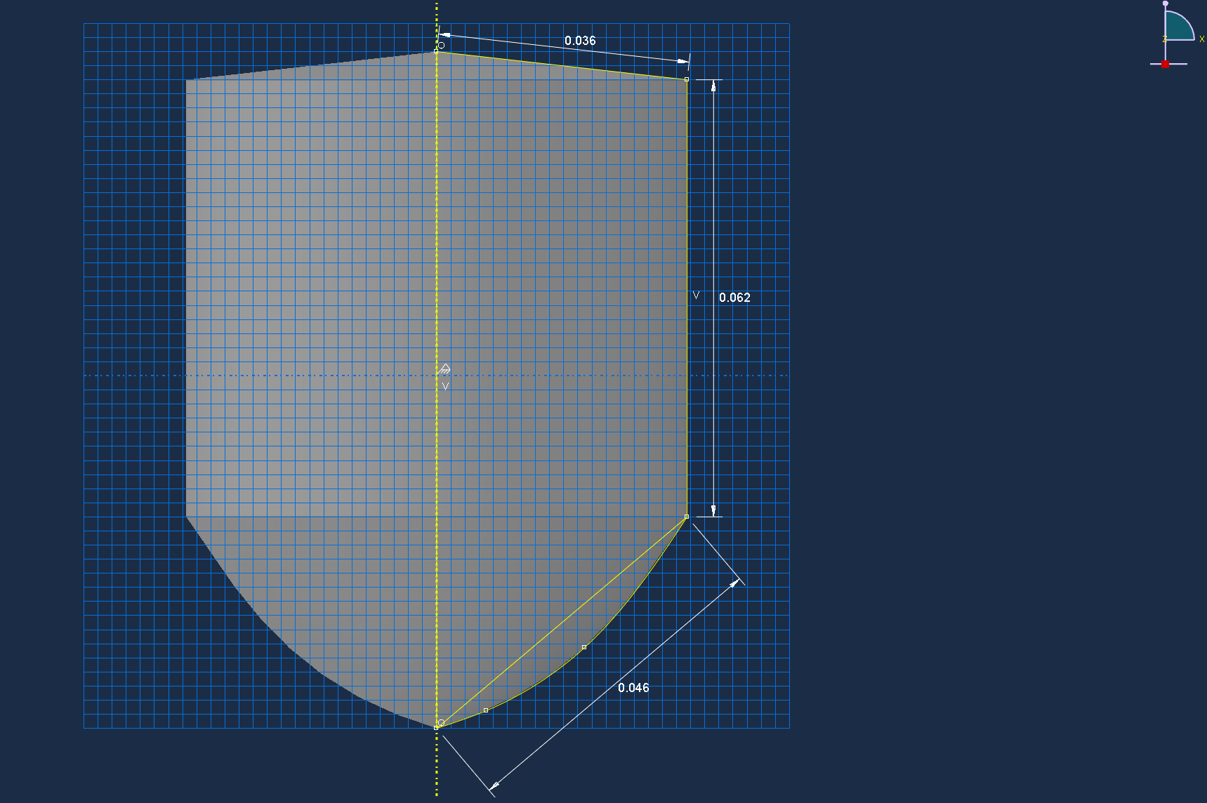
[Figure 3] – Projectile Dimensions

Armour Plate
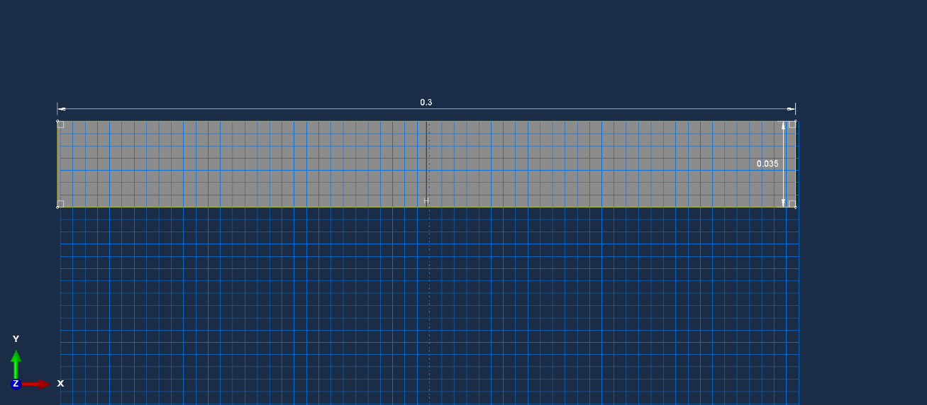
The armour plate 2D dimensions are shown in Figure 4 and it has a depth of 0.3m.
[Figure 4] – Armour Plate Dimensions

Initial Model

First Impact
The first ballistic model highlighted some errors within the mesh as the elements within the projectile were damaged upon impact and then they deleted which left an incomplete model that wasn’t an accurate representation of the impact damage (Figure 5). However, the projectile did remain lodged within the armour plate it was just that the software did not demonstrate the damage properly.

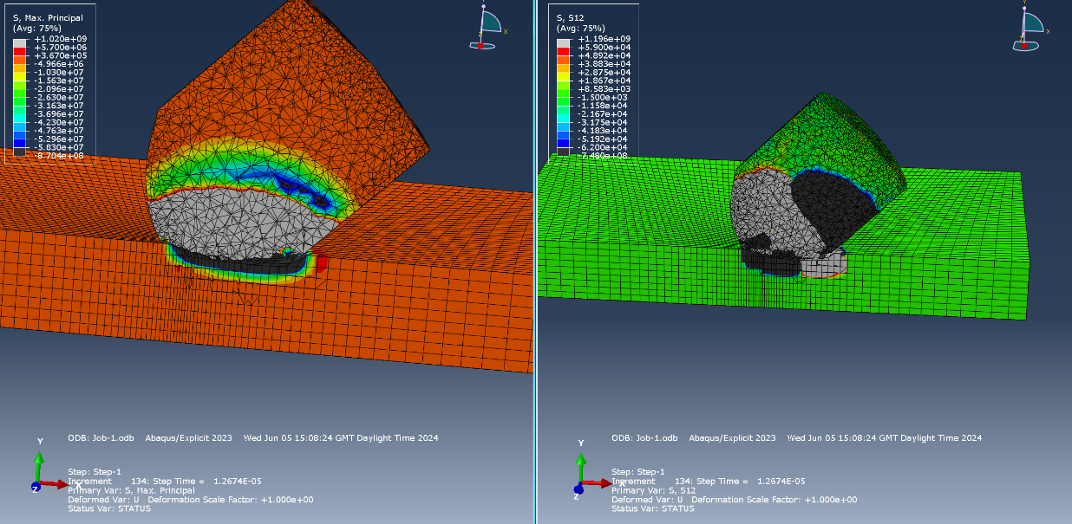
[Figure 5] – Job 1 from initial model.

Second Impact
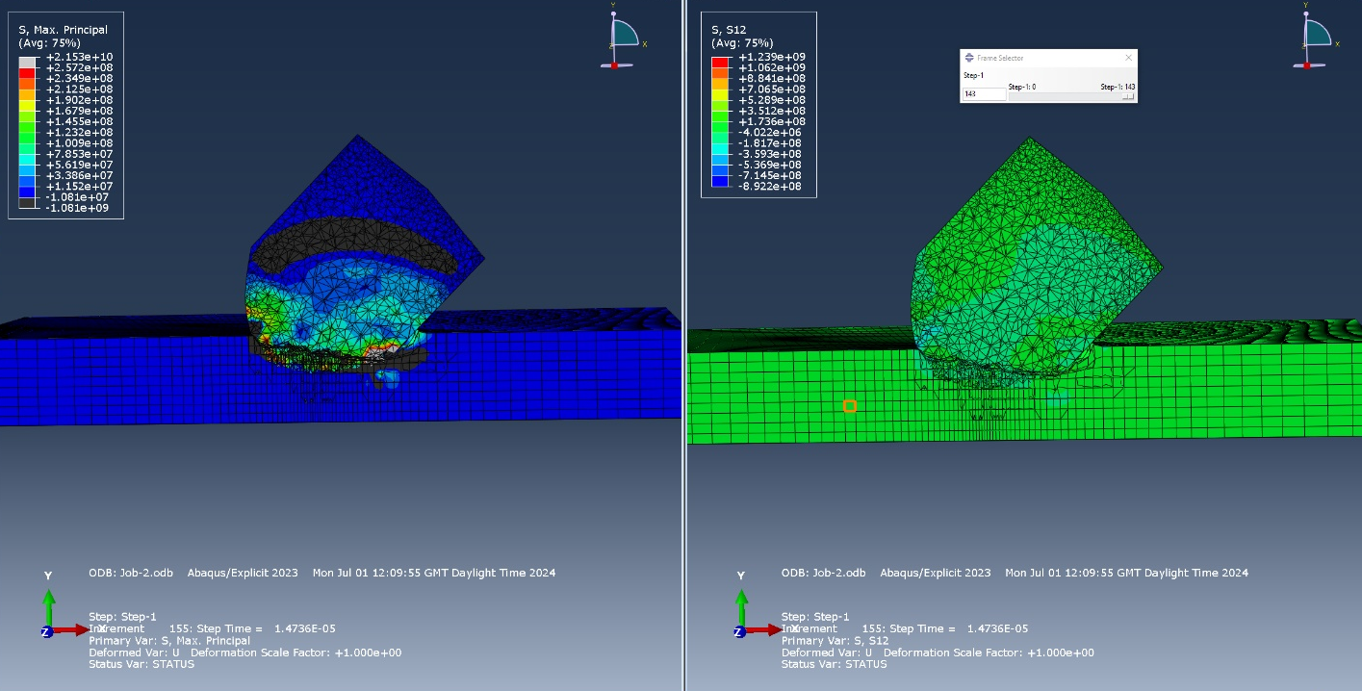
Similarly to the first impact, the second impact also had modelling inaccuracies due to damaged element deletion which was more of an issue at the higher velocity in comparison to the first impact (Figure 6).
[Figure 6] – Job 2 from initial model.

Final Model

First Impact
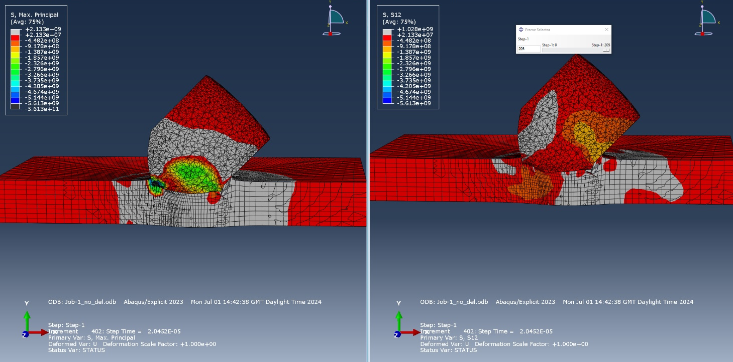
After taking into consideration the limitations of the initial model, the element deletion was turned off and the results afterwards were significantly improved (Figure 7). The first impact was run at ≈1200ms⁻¹ and at an oblique angle (45º). Compared to the previous model, there was also more tension damage visible as well as the plate surface beginning to react to the impact, which was a result of correcting the mesh and turning off element deletion.
[Figure 7] – Job 1 from final model.

Direct Stress
After the initial impact, there is a tension wave that is created from the contact point which cases the plate to crack (Figure 8). On the trailing edge of the impact point, the direst stress is a result of tension which can be seen by the positive value of 1.285 GPa. The plate also starts to crack on the bottom surface, again due to tension, at a value of 1.728 GPa.
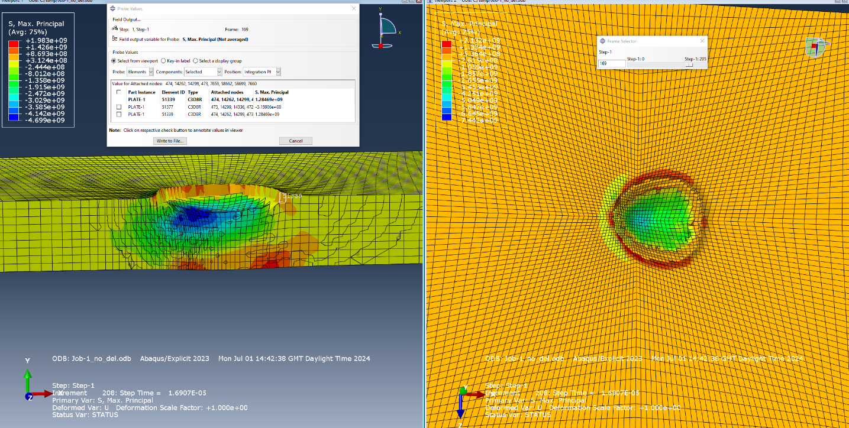
[Figure 8] – Job 1 from final model impact point (direct stress)

Shear Stress
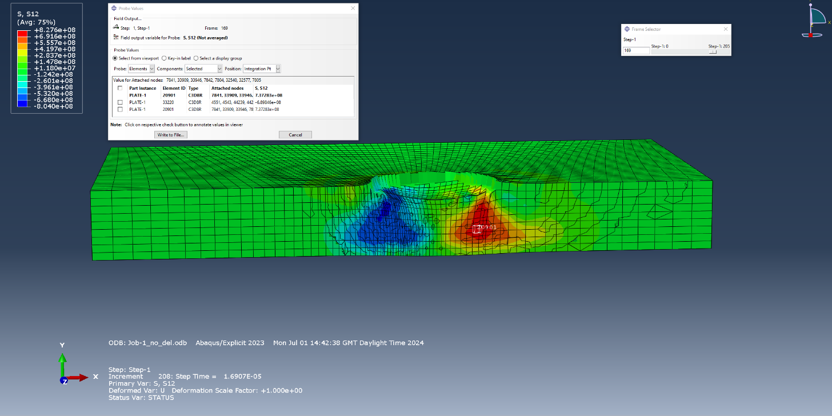
There is also a large amount of shear stress (Figure 9) which can be clearly seen within the model. This stress cascades down from both the leading and trailing edge of the impact point. Both the shear stress values are very similar despite one being negative as shear stress is just as destructive no matter the direction. The leading edge has a value of -690 MPa and the trailing 737 MPa.
[Figure 9] – Job 1 from final model impact point (shear stress)

Velocity
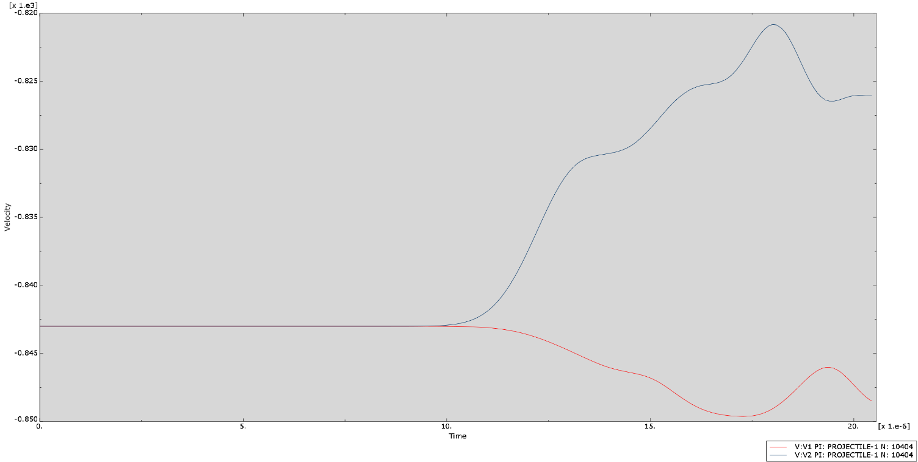
The projectile initially travels at ≈1200ms⁻¹ (1192.2ms⁻¹) which is -843ms⁻¹ in both the x and y directions. In Figure 10, V1 is the velocity in the x axis and V2 is the velocity in the y axis. As the projectile impacts the armour plate, V2 decreases if magnitude and V1 increases slightly which suggests that the projectile ricochets off the plate slightly but does in fact slow down after impact.
[Figure 10] – Job 1 from final model velocities

Second Impact
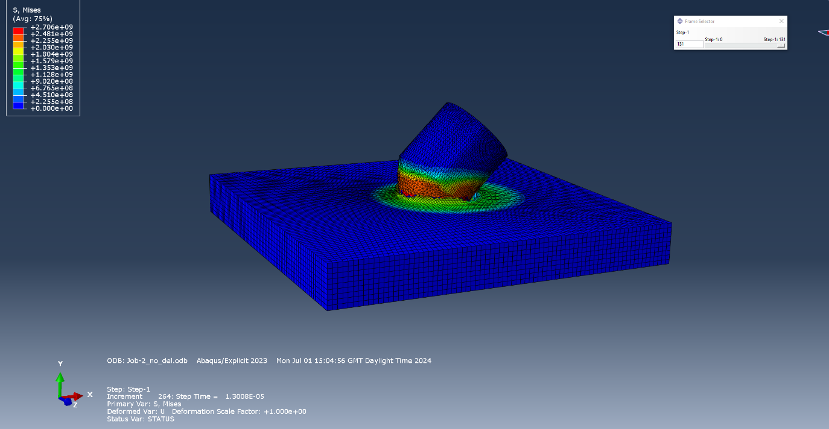
For the second model, the element deletion was also turned off for the final model. The second model was run at 2150ms⁻¹ at an oblique angle (45º). The final model showed a lot more plate deformation compared to the initial model for the same velocity (Figure 11). The projectile also penetrated much further compared to the initial model.
[Figure 11] – Job 2 from final model

Direct Stress
The faster velocity highlights the limitations of the Johnson-Cook damage parameters as the plate cracks due to large amounts of compression compared to tension at the slower velocity of Job 1. There are still spots of tension damage, primarily on the bottom surface on the trailing impact point (Figure 12) at 2.04 GPa. Most of the compression comes from the leading edge after impact with a magnitude of -2.896 GPa. These results are both much higher than the slower velocity in Job 1.

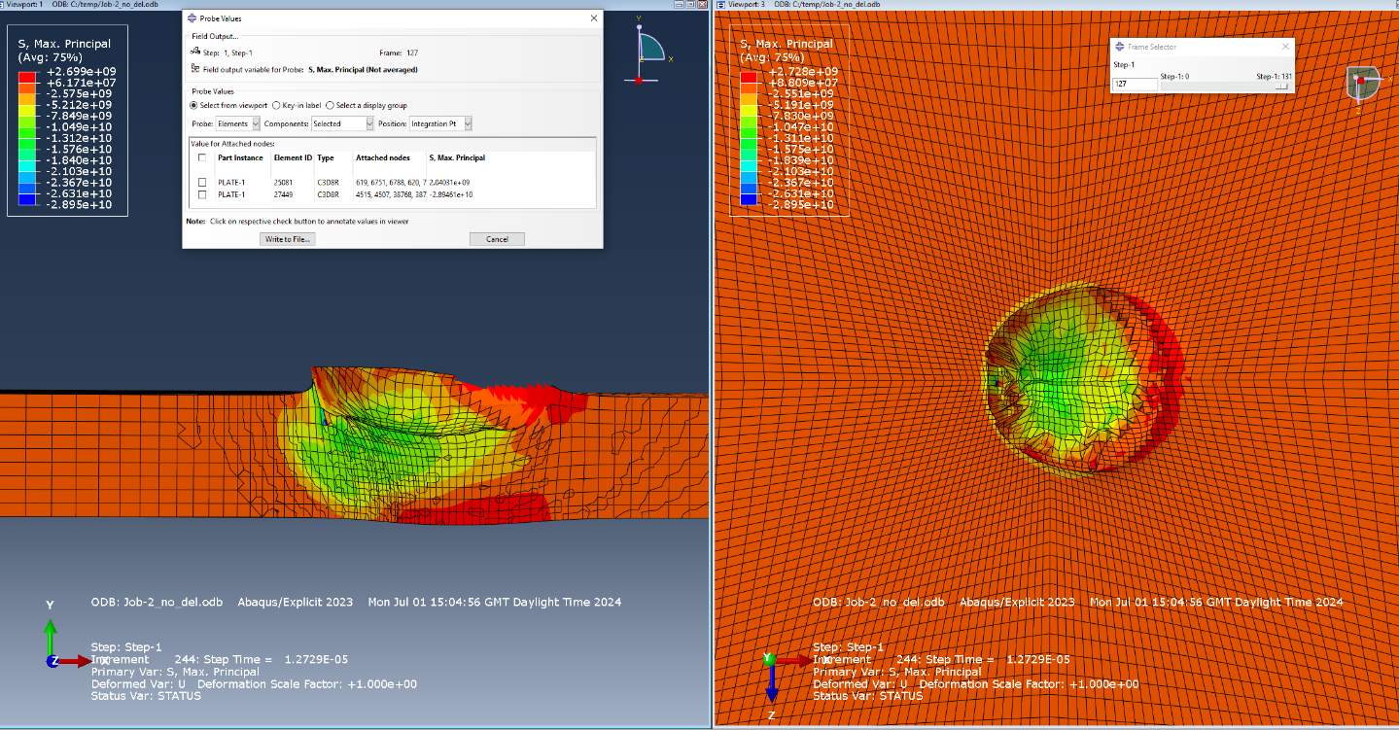
[Figure 12] – Job 2 from final model impact point (direct stress)

Shear Stress
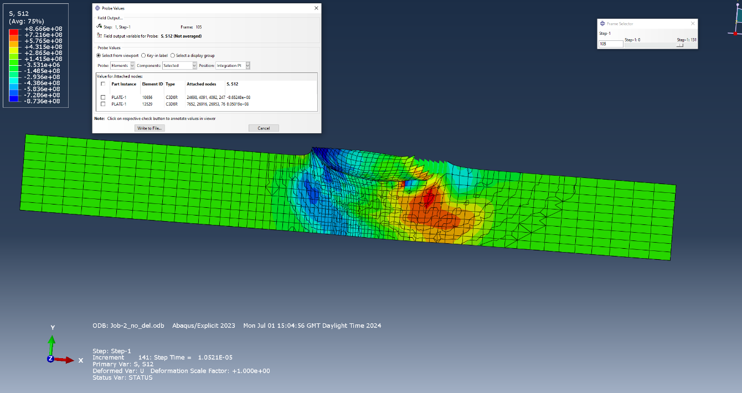
Similarly to the first impact, there is also large amounts of shear stress present at both the leading and trailing edge of the impact point (Figure 13). The shear stress at its maximum is -865 MPa for the leading edge and 805 MPa at the trailing edge which is significantly higher than the slower velocity from Job 1.
[Figure 13] – Job 2 from final model impact point (shear stress)

Velocity
The projectile initially travels at 2150ms⁻¹ which is -1520ms⁻¹ in both the x and y directions. In Figure 14, V1 is the velocity in the x axis and V2 is the velocity in the y axis. After impact, the x velocity increases slightly whereas the velocity in the y direction decreases significantly. This suggests that the projectile ricochets off the plate slightly in the x direction but ultimately the overall velocity decreases after impact.
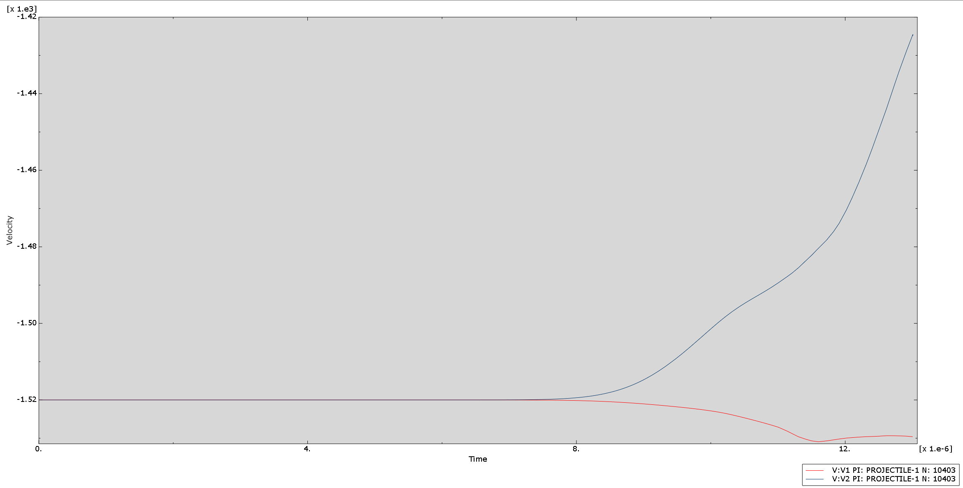
[Figure 14] – Job 2 from final model velocities

Conclusion
Overall, the comparison of both direct and shear stress at two velocities shows a significant difference. The slower velocity causes primarily tension and lower amounts of shear stress compared to the faster velocity which causes more compressive direct stress. In both impacts, the models clearly portray the damage that a tungsten projectile can cause to titanium armour plating which reinforces the reasoning why tungsten alloys are used frequently for high calibre artillery within the defence sector.

References

[1] L.M. Brescani, A. Manes, T.A. Romano, P.Lavarone, M. Giglio, “Numerical modelling to reproduce fragmentation of a tungsten heavy alloy projectile impacting a cermamic tile; Adaptive solid mesh to the SPH technique and the cohesive law,” International Journal of Impact Engineering, vol. 87, pg 3-13, Jan 2015. Accessed: Jun. 4, 2024.
[2] H. Hafizoğlu, N. Durlu, “Effect of sintering temperature on the high strain rate-deformation of tungsten heavy alloys,” International Journal of Impact Engineering, vol. 121, pg 44-54, Jun 2018. Accessed: Jun. 4, 2024.
[3] Advanced Refractory Metals “Tungsten Alloy for Bullets,” Refractory Metals and Alloys, Feb. 05, 2021. https://www.refractorymetal.org/tungsten-alloy-for-bullets/#:~:text=The%20reason%20why%20tungsten%20alloy%20can%20be%20used Accessed: Jun. 5, 2024
[4] R. Bobbili, B. Ramakrishna, V. Madhu, “Dynamic compressive behaviour and fracture modelling of Titanium alloy IMI 834,” Journal of Alloys and Compounds, vol. 714, pg 225-231, Aug 2017. Accessed: Jun. 5, 2024
[5] MatWeb “MatWeb – The Online Materials Information Resource,” https://matweb.com/search/DataSheet.aspx?MatGUID=0a4b3bc6094c4bf8b522e290a8ce3010. Accessed: Jun. 5, 2024

