

MBA

BMMB7026
Managing Marketing Change

The Impact of Sustainability as a Key Driver of Marketing Change: A Critical Analysis of British Airways

Assignment 2

Individual Report
Executive Summary
Sustainability will be developed as the driver of marketing change in British Airways in this report. It examines how the airline industry is evolving as a result of the increased regulation of the environment, consumer needs and competition. The strategic response of British Airways, such as the Sustainable Aviation Fuel investment, fleet refresh, and carbon abatement, is reviewed in terms of such frameworks of the PESTLE appraisal as Porter's Five Forces, STP and marketing mix. The report summarises that despite the active approach of British Airways towards sustainability strategy, the company lacks efficiency in the context of cost, limiting the scale of green technologies, and credibility. The recommendations are geared towards improving transparency, scaling sustainable investments, and customer engagement.
Table of Contents
Introduction 3
Task 1: Critical Evaluation of Marketing Activities 4
British Airways Overview 4
Sustainability as a Driver of Change 4
Importance of Sustainability to British Airways 6
Macro & Micro Environment Analysis (PESTLE + Industry Drivers) 6
Porter’s Five Forces (Competitive Environment) 7
STP Analysis (Marketing Strategy Evaluation) 8
Marketing Mix (7Ps) 9
Critical Evaluation of Sustainability Strategy 10
Strengths and Weaknesses 11
Change Management (Kotter’s Model) 12
Task 2: Conclusions (Shortcomings of Strategy) 14
Task 3: Recommendations 15
Conclusion 17
References 18

Introduction
The airline industry is in a very regulated and sustainability-focused global operating environment. It goes without saying that these carbon emissions, as produced by the aviation industry, are the major cause of heightened scrutiny of the industry by governments, regulators, investors and even consumers. This has also resulted in sustainability being a peripheral issue of corporate responsibility to a strategic and marketing issue. The concept of sustainability has been identified as an instrument of change in marketing in the airline industry, specifically on British Airways (BA), in this report. It is an analysis of the new external environmental pressure and its implications on the marketing strategy, and how BA has responded. The analysis captures relevant marketing and change management theory to assess strategic change and determine constraints and recommendations that can be made to improve the latter. The concept of sustainability as a marketing motivation aspect at BA is initially explained in the report with a brief overview of the organisational environment of BA. It then analyses the external environment by PESTLE and Porter's Five Forces, with subsequent analysis of STP and marketing mix. Finally, it applies change management theory in practice and concludes with strategic recommendations.

Task 1: Critical Evaluation of Marketing Activities

British Airways Overview
Organisational Context
British Airways (BA) is an airline of the United Kingdom (a subsidiary of the International Airlines Group (IAG)) that is one of the largest and most competent full-service carriers of the United Kingdom. It has a global web of forward and backward destinations of 1-2 hours and more in the aviation sector, competing in both the high-end and price-sensitive segments (Cameron and Green, 2015). The competitive environment in which the organisation competes can be defined as very competitive, with stiff competition being presented by the legacy carriers, such as Lufthansa and Emirates and low-cost airlines, such as Ryanair and Easy Jet.
British Airways, being a constituent part of IAG, is able to experience the benefits of economies of scale and shared strategic capabilities, particularly in managing fleet, procurements and sustainability initiatives. It is, however, also characterised by high reputational pressure as a flag carrier, whereby demands are high with regard to service quality, corporate responsibility and environmental performance.
Characteristics and Marketing Implications of the Industry
The airline sector is a complex structure because of high change of operations, regulatory structures, changes in fuel prices and changes in the macro economies (Buchanan and Badham, 2008). The business premium travel is highly inelastic, and the leisure market is highly elastic and, as such, is a dual market pricing and positioning issue.
On the marketing front, the airlines must not only compete with respect to price and availability of routes, but competition is beginning to take on another dimension: brand recognition, confidence and even ethical responsibility as perceived by the end-user. Particularly purported in the context of sustainability, environmental performance has recently become an iconic brand equity. This implies that the British Airways marketing strategy should not only be consistent with the expectations of quality delivery of services to customers in the market but also with the evolving demands of accountability towards the environment and a responsible business approach.

Sustainability as a Driver of Change
Sustainability Conceptualising
Sustainability can also be defined as development that will meet the needs of the present generation without compromising the abilities of future generations to meet their needs, according to the definition that was developed by the Brundtland Commission (1987). Sustainability has long since stopped being an environmental concern in the construct of marketing, but has also become an element of overall strategic decision making, branding, value creation to customers and corporate legitimacy (Burnes, 2014). The concept of sustainability in contemporary marketing theory has increased to become part of the value-based marketing, wherein organisational success is not only measured by how successful it is, but also by how socially and environmentally successful it is. The change is an indication of a larger shift in transactional ways of marketing to relationship-oriented and purpose-oriented ways of marketing.
Change in Consumer Behaviour and Product Expectation
This has brought about a lot of shift of the consumer expectations because of the increased awareness of the problems of climate change and environmental degradation. They are not just testing the airlines based on price, convenience and quality of the service any more, but environmental performance has entered into the list of assessing factors influencing the purchasing decisions. Air travel carbon emissions are of particular concern to the airline industry, which is undergoing this transformation. Sustainability consumer behaviour research indicates that the needs and preoccupations with the environment play an increasingly important role in determining what and where to travel, particularly in younger and more ethical consumer groups. This has also witnessed the incorporation of sustainability in the perceived brand value and competitiveness differentiation.
Strategic Marketing Implications
The application of sustainability in the marketing strategy has far-reaching implications for organisations such as British Airways. The first step should be to ensure that there is company identity alignment with environmental responsibility, as well as operational practices that should be aligned with brand messages. Second, it complicates the formulation of the value propositions with the airlines needing to balance environmental responsibility and a low price with service and price expectations (Hayes, 2014). Moreover, sustainability has become a reputational factor to which brand equity has a direct influence. Customer trust and loyalty can also be earned by organisations perceived to be responsible environmentally, and imagined inaction or greenwashing is lethal to credibility. Sustainability has thus ended up being a strategic marketing driver that offers positioning, differentiation and competitive advantage in the long-term in the airline industry.

Importance of Sustainability to British Airways
BA is one of the most carbon-intensive sectors, meaning that it has to deal with strong regulatory and social pressure. Governments are implementing carbon tax, emissions trading schemes, and net-zero ambitions, which have direct implications on the airline cost base and strategic path (Kotter, 2009).
At the same time, expectations of customers are changing. Although price is still dominant, brand legitimacy is becoming, to a large extent, environmentally responsible, especially in the high-end market segments. As a result, sustainability now enters the national carrier's positioning of BA.
This presents dangers and chances. Lack of adaptation poses regulatory and reputational risk, and active sustainability investment enhances differentiation and competitive sustainability over the long term (Aaker, 2015). Nonetheless, due to the high cost and the technological constraints, the short-term impacts are limited, and this has created a dilemma between the economic performance and environmental protection.

Macro & Micro Environment Analysis (PESTLE + Industry Drivers)
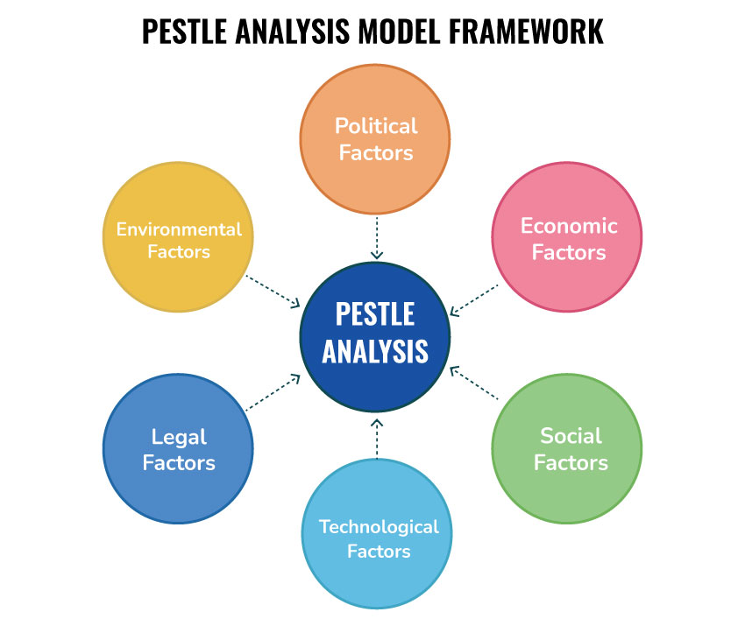
Figure 1: PESTLE Analysis Model (Kobrin, 2022)
Political
The government climate policies, taxing carbon and carbon emission regulations cause these changes. BA has to adhere to the UK and international environmental frameworks and implement sustainability in its strategy.
Economic
Unstable prices of fuel are a cause of inflation, limiting investment capacity. Sustainable Aviation Fuel (SAF) is much more expensive than traditional fuel, which creates obstacles to its rapid deployment and puts a strain on costs (Bieling, Stock and Dorozalla, 2015).
Social
The level of environmental consciousness of consumers is rising. Customers are more conscious of carbon impact, particularly among the young travellers; this influences brand perception and segmentation.
Technological
Innovation related to SAF, aircraft efficiency, and emissions reduction technologies is the focus of long-term sustainability. However, full decarbonisation of long-range aircraft is not technologically available (Danciu, 2013).
Environmental and Legal
The climate change pressures and legal reporting requirements support the significance of transparency and the measurable reduction of emissions. In operational legitimacy, there must be compliance.
In total, sustainability is one such strategic need that is heartily endorsed by outside forces rather than an option in marketing.

Porter’s Five Forces (Competitive Environment)
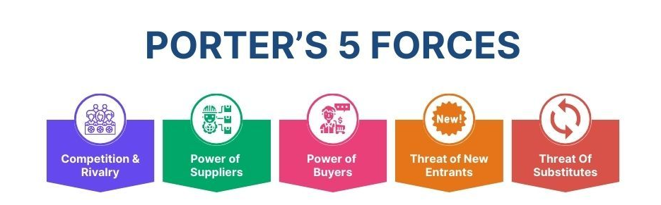
Figure 2: Porter’s Five Forces (Ruel, 2025)
Competitive Rivalry
The airline industry is extremely competitive, as full-service and low-cost airlines make identical flights. The notion of being sustainable has entered into the brand positioning as another point of competition.
Threat of Substitutes
Another substitute to short-haul travel is high-speed rail and virtual meetings. Rail is also gaining popularity as far as less emissions are concerned (Foreman et al., 2014).
Buyer Power
Buyer power is also high due to the fact that switching costs are low, and the prices are transparent. Consumer choice is also being affected by sustainability, especially in the high-end market segments.
Supplier Power
Aircraft manufacturers and fuel suppliers possess great bargaining power. Limitations of supply in SAF also increase dependency and pressure on costs (Kim and Mauborgne, 2004).
Threat of Substitutes
The barriers to entry based on capital are high, and regulatory barriers. Nevertheless, indirect effects can be caused by niche, sustainable or low-end entrants when it comes to expectations.
In general, sustainability is internalised in the process of competitive interactions and influences demand and strategic reactions.

STP Analysis (Marketing Strategy Evaluation)
Segmentation
British Airways operates in a highly differentiated aviation industry that is highly differentiated with customer needs being largely varied according to the goal of travel, income and behavioural styles. From a marketing perspective, the primary variables that are utilised to segment are demographic, behavioural and psychographic variables.
Business travellers form a premium market which is less price sensitive and demand a higher degree of reliability, frequency and quality of services. Leisure travellers, on the other hand, tend to be more price-sensitive and tend to appreciate the affordability and accessibility of the destinations (Kim and Mauborgne, 2014). An increasing sub-group on either side are eco-conscious customers, who use sustainability factors into travelling choices. This section applies especially to the current strategic direction of British Airways.
Targeting
British Airways has employed a differentiated targeting strategy with a main emphasis on high-end business and more and more higher-end leisure fliers, albeit with availability at the top side of the market, with the help of a wider route base. In this framework, sustainability is playing an incremental value role to enhance the perception of value amongst high-end customers who would have a higher reaction towards ethical branding and corporate responsibility actions.
Such an approach to targeting, however, leads to strategic tension as well. As much as sustainability is very appealing to the environmentally conscious groups, it may not be an important aspect when considering the price-conscious consumers, since they are more price-sensitive than environmentally conscious. Therefore, British Airways will be forced to find the balance between sustainability communications and its overall value proposition without losing some of its key customer bases.
Positioning
British Airways is a high-quality full-service global airline whose position is based on quality, reliability and national brand heritage. To reinforce its responsible aviation and long-term environmental responsibility policy, the airline has very recently added sustainability to this positioning (Aaker and Moorman, 2023).
This strategy should help British Airways fulfil the evolving consumer demands and maintain its age-old premium status. However, one of the potential pitfalls is sticking to the consistency between perceived positioning and actual operations in life. Unless the sustainability claims are met with real changes in the environment, reputational injury and a deficiency of brand loyalty are likely.
On the whole, the STP analysis shows that sustainability is more and more promoted in the market segmentation and positioning strategy of British Airways, yet its efficiency relies on the credibility, consistency, and compatibility with the overall drivers of customer values.

Marketing Mix (7Ps)
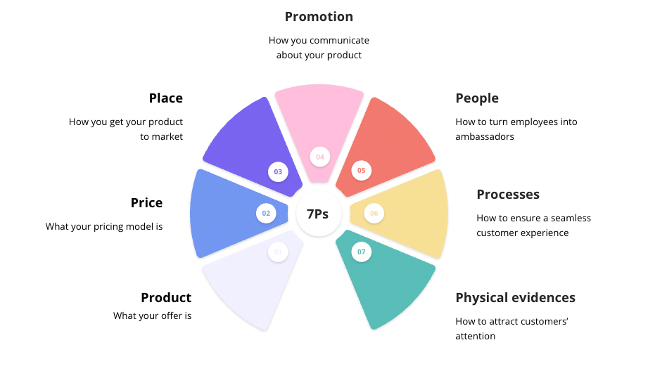
Figure 3: Marketing Mix (7Ps) (Chernev, 2020)
Product
Air travel is a core product that has since been extended to have features of sustainability like SAF investment, upgrading of fleet and options to have carbon offsets.
Price
BA is also a high-quality pricing. Sustainability pressure costs, and this can impact the fare structure (Kotler, Keller and Chernev, 2022).
Place
Heathrow hub and international routes networks are the benefits that BA is enjoying. Distribution and sustainability communication are increased by the use of digital platforms.
Promotion
The marketing of the product is adopting sustainability messages. Regardless, credibility is required so as to shun greenwashing risks (Kaufman, Horton and Soltanifar, 2023).
People
Customer experience and brand culture, e.g. sustainability culture, change with the assistance of employee engagement.
Process
Sustainability goals, such as fuel efficiency and digitalisation, are more and more reflected in the operational processes (Kotler and Armstrong, 2023).
Physical Evidence
Modern aircraft and luxurious lounges are beneficial in brand positioning. The sustainability cues are evident in newer fuel-efficient aeroplanes.
In general, the concept of sustainability is found throughout all 7Ps, but it needs to be aligned in communication and delivery of operations.

Critical Evaluation of Sustainability Strategy
Strategies Tension: Cost vs. Value Creation
Sustainability provides British Airways with a basic strategic dilemma between short-term cost and long-term value creation. The capital-intensive and uncertain and non-guaranteed returns of investments are A Sustainable Aviation Fuel (SAF), modernisation of their fleet and spending on carbon mitigation within a short period of time. Strategically in the market, however, these investments can be credited to heightening the brand equity and the trust of the stakeholders and competitive positioning in the long run (Malhotra, Nunan and Birks, 2020).
This poses a typical trade-off situation in strategic management where the companies need to weigh shareholder needs of profitability and the increased stakeholder need for environmental responsibility. In the case of BA, though, sustainability is becoming more of a licence to operate as opposed to an optional investment.
Not in Differentiation, Competitiveness in Sustainability
Although British Airways makes sustainability an element of its brand name, its true competitive effect is limited by the acceptance of similar initiatives by all industry players. Most of the major airlines are prioritising sustainability using SAF, optimisation of their fleet and carbon reduction plans and therefore sustainability has slowly replaced as a differentiating attribute to a prerequisite.
This is in tandem with the competitive convergence, in which companies in a mature industry will mimic common strategic reactions to external forces (Kotabe and Helsen, 2022). This means that sustainability is not as likely to generate a long-run competitive advantage unless it is condensed with deeper creativity or performance.
Greenwashing Threat and Credibility Gap
Another risk in British Airways is that there might be a mismatch between the sustainability messages and the working reality. The message of environmental responsibility should be effectively placed in marketing communications by demonstrating tangible and open results. Otherwise, the organisation may experience some allegations of greenwashing that may immensely disrupt brand trust.
In academic literature, academic studies show that the scepticism of consumers on corporate environmental statements is increasing, particularly in high-emitting industries such as the aviation industry (Chernev, 2020). In this way, such aspects are put forward as credibility to ascertain whether marketing is effective in positioning sustainability.
Low Change of Behaviour and Consumer Behaviour
Although the idea of sustainability is increasingly taking root within the psyche of consumers, there is an unequal distribution of its impacts on real consumer purchasing behaviour. Price, convenience and route access have continued to be the major factors since they have been part of the decision-making process in most of the airline segments. This leads to the discrepancy between espoused values of consumers and actual market behaviour, the attitude-behaviour gap.
When it comes to the case of British Airways, that means sustainability may actually enhance the brand image; however, that does not mean that the sustainability would necessarily relate to the measurable shift in demand, at least within the highly price-sensitive segments (Nagle, Müller and Gruyaert, 2023).
Strategic Implication
As a strategy, sustainability in British Airways is rather a strategic compulsion that is brought about by the regulatory and societal pressure and not a market differentiator per se. Its performance will be effective with the credibility of its execution, coordination of the operations and the work of the environmental promises to enhance its performance and customer view.

Strengths and Weaknesses
Strengths
BA is highly committed to SAF investment and the layout of fleet modernisation. Its good brand that increases the publicity of its sustainability efforts. Transparency and investor confidence are also boosted by ESG reporting (Hansen, Mowen and Heitger, 2025).
Weaknesses
It is expensive to implement and not a very scalable SAF, restricting progress. Reputational risk also exists in the event that sustainability statements are not completely backed by quantifiable results. In addition to this, not every consumer behaviour is consistent with environmental attitudes.
Overall, the sustainability strategy of BA makes sense but is constrained by the structural industry factors.

Change Management (Kotter’s Model)
Sustainability is a pressure strategic issue at British Airways since the regulatory pressure, increased carbon tax, and the social concern over flight emissions put pressure on the company. These are external forces which have placed a high urgency of change on the organisational level since the success in adjusting to such pressure would mean a loss of reputation, regulatory repercussions, and loss of competitive legitimacy (Horner and Swarbrooke, 2020). In Kotter-speak, the aviation industry has already started as a naturally-urgent state, i.e. the sustainability change introduced in BA is not solely being driven by internal motivators but rather outside agents as well.
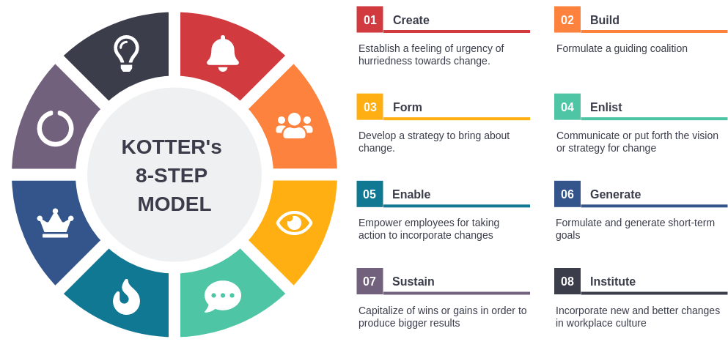
Figure 4: Change Management (Kotter’s Model) (Smith and Merritt, 2020)
Building a Guiding Coalition
The people on the guiding coalition at British Airways consist mainly of the groups of senior leaders under the extensive network of the International Airlines Group. This alliance comprises the executive, sustainability, operational managers, and strategic planners whose responsibility is to tie in corporate performance with environmental objectives. On top of this, BA is involved in broader industry partnerships which help in decarbonisation, especially in Sustainable Aviation Fuel development. However, to a certain extent, this coalition is constrained by the fact that it has external dependencies towards suppliers, regulators and technological partners, and the overall sustainability performance cannot be controlled.
Developing a Vision and Strategy
British Airways has a clear vision of sustainability on the framework of net-zero carbon emissions by 2050, with liberalising goals on fleet modernisation and an increase in utilisation of the Sustainable Aviation Fuel (Al Aina and Atan, 2020). This vision incorporates long-term brand positioning and corporate responsibility aspirations of sustainability as an effective means of optimising the identity of BA as a positive and high-end global carrier. This strategic vision, insofar as marketing is concerned, will embrace environmental responsibility regarding the value proposition of the organisation. Limitations inherent in the process of realising the vision, in turn, are limited by external factors like the impossibility of purchasing SAF and the high costs of decarbonisation technologies.
Sharing the Change Vision
Communication of sustainability goals is in different forms, e.g. corporate ESG reporting, investor message, and external marketing message. British Airways introduces its sustainability as one of its strategic priorities to support the concept of transparency and responsibility towards its stakeholders. However, the requirement to be regular when communicating promises and the organisation's suggested effect on the environment are among the most crucial ones (Ruel, 2025). Increased doubts about the honesty of any of the sustainability claims may be the outcome of the apparent lack of alignment of progress with the messaging, which may create problems of credibility and raise suspicions in consumers and other interested parties.
Empowering Broad-Based Action
British Airways has implemented several measures to do away with barriers to the sustainability revolution, including investing in fuel-efficient cars, efficiency in operations and using digital solutions to allow customers to engage with carbon-saving opportunities. These actions aid in behaviour congruence among internal and external stakeholders. Another way the involvement of employees strengthens the values of sustainability in service delivery is through employee participation. The constraint (costs of operation and the impossibility of obtaining scalable Sustainable Aviation Fuel) of the structures remains to make the full empowerment of the action at the organisational level.
Generating Short-Term Wins
Some short-term wins that the organisation has realised depict deep-seated appearances on the sustainability agenda. These include renewal projects of its fleet, a slow adoption of Sustainable Aviation Fuel partnerships, and customer-ugly carbon offset programs (Hossain, Fernando and Akter, 2025). This kind of development has an influence on the perception of the stakeholders since it translates to commitment and growth. However, the environmental effects of these efforts are incremental in the sense that, though these efforts are symbolic, they have yet to cause systemic change on a large scale within the aviation industry.
Making Gains, Consolidation, and Churning More Change
By incorporating environmental goals into both its operational and strategic decision-making areas, British Airways keeps on enhancing the sustainability efforts it has made in its initial stages. This entails more spending on efficiency, more reporting of sustainability, and more communications between marketing and sustainability goals. Momentum is, however, difficult to sustain due to the financial pressure and technology limitations, since they can slow the speed of translating the initial gains to more structural change on a large scale.
Changes towards New Ways of Doing Things in Organisational Culture
The last phase of the Kotter model is concentrated on enculturing change in organisational culture to enable it to be long-term. In British Airways, the principle of sustainability is increasingly being implemented in the governance platforms, strategy implementation and corporate reporting mechanisms (Landi et al., 2022). Yet, complete cultural integration has not happened due to operational priorities such as cost efficiency and service delivery still playing off with environmental purposes. This implies that sustainability is a new issue that has gained strategic importance, but has not yet been implemented fully at all levels of the organisations.

Task 2: Conclusions (Shortcomings of Strategy)
This report has been a critical consideration of sustainability as one of the major determinants of an effective marketing change in the airline industry, particularly British Airways. The analysis reveals that sustainability is no longer a high-end issue of corporate responsibility, but it is now a strategic core component, determining marketing strategy, competitive positioning, and customer perception. The context in which British Airways does business is highly regulated, with factors of greater environmental and consumer questioning and a shifting policy of consumerism (Awewomom et al., 2024). The use of both the PESTLE and Porter's five forces models clearly resolves the fact that sustainability is integrated in the macro-environmental forces it operates in, as well as the competitive forces it is operating within the industry. All these pressures influence the strategic direction of the organisation and have to be constantly adapted to.
Overall, sustainability cannot be considered as a temporary marketing trend but as the restructuring of the aviation industry. In the case of British Airways, this means that environmental responsibility is gradually turning into a requirement to become competitive and not some area of differentiation in its own right. The ability of the organisation to integrate sustainability further in both the organisation's strategy and operations, and also in the marketing performance execution, will hence determine whether the organisation will be successful in the long run.
To sum up, British Airways is credibly responding to the change in sustainability-oriented marketing. However, the limits and difficulties in execution in the industry temper its effectiveness in strategies (Kobrin, 2022). Long-term competitive advantage will be based on the ability of the organisation to reduce the existing gap between sustainability ambition and quantifiable environmental performance, and to be able to ensure consistency in the responses of customers, organisational capabilities in terms of operations and strategic investment priorities.

Task 3: Recommendations
Growing and Scoring Aviation Fuel (SAF)
Better strategic working relationships with fuel producers, governments and industry consortia can be important in ensuring that British Airways is keen on scaling Sustainable Aviation Fuel in the long-run. Since SAF is currently restrained by the unavailability and a very high price, its early growth into developing the supply chain can result in being more resilient over time and having a reduced dependence on traditional jet fuel. Marketing-wise, this would also help BA to be a pioneer of aviation sustainability, instead of a victim of industry trends (Andersen, Grude and Haug, 2025).
Improving ESG Credibility and Transparency
Among the strategic alterations, one of which would be suitable, would be to enhance the transparency of the sustainability reporting. British Airways should take its next steps on general ESG activities and focus on freely independent indicators of environmental performance which escape measurement. This would decrease greenwashing perceptions and enhance trust among stakeholders. The reduction of emissions, increasing fuel efficiency, and a move towards net-zero should be made comprehensible to establish more credibility and establish brand authority.
Incorporation of Customer Visible Sustainability Programs
British Airways should also include sustainability in the customer journey through the addition of more interactive and value-added tools of engagement. This can include improved carbon footprint tracing upon reservation, more open opt-in offsets and loyalty schemes for sustainable kinds of travel (Smith and Merritt, 2020). Such initiatives would effectively increase the interaction with the customer, not just that, this would provide the brand with the sustainability reinforcement as part and parcel of the brand experience rather than a peripheral message.
Operations and Sustainability of Marketing Strategy
To be effective in the long term, the British Airways activities related to marketing communications should be brought closer to the reality of the operations. Sustainability messaging has to be tied directly to the measurable operational changes to be consistent in the delivery and promise of the brand.

Conclusion
Overall, it is possible to say that British Airways can be described as partially loyal to the 8-Step Model designed by Kotter, that is, the establishment of a sense of urgency, the establishment of a vision, and early adoption. It is, however, revealed in the analysis that sustainability transformation is at a transitional level and not an entirely embedded organisational change. Exogenous influences, such as technological and supply-side constraints, also play an important role in the speed and extent of change. Consequently, even as BA continues to make the right move in the sustainability agenda, structural industry obstacles, and augmented congruity between strategic ambition and operational ability will still come as a prerequisite to total transformation.

References
Aaker, D. (2015) ‘Brand personalities are like snowflakes’, Marketing News, 49(7), pp. 20–21. Available at: EBSCOhost Business Source Complete.
Aaker, D.A. and Moorman, C. (2023) Strategic market management. Hoboken: John Wiley & Sons.
Aaker, D.A. and Moorman, C. (2023) Strategic market management. Hoboken: John Wiley & Sons. (duplicate removed if using full list — keep only once)
Al Aina, R. and Atan, T. (2020) ‘The impact of implementing talent management practices on sustainable organisational performance’, Sustainability, 12(20), p. 8372. Available at: https://doi.org/10.3390/su12208372
Andersen, E.S., Grude, K.V. and Haug, T. (2025) Goal-directed project management: effective techniques and strategies. London: Taylor & Francis.
Awewomom, J., Dzeble, F., Takyi, Y.D., Ashie, W.B., Ettey, E.N.Y.O., Afua, P.E., Sackey, L.N., Opoku, F. and Akoto, O. (2024) Addressing global environmental pollution using environmental control techniques: a focus on environmental policy and preventive environmental management. Discover Environment, 2(1), p.8. Available at: https://doi.org/10.1007/s44274-024-00033-5
Bieling, G., Stock, R.M. and Dorozalla, F. (2015) ‘Coping with demographic change in job markets: how age diversity management contributes to organisational performance’, Zeitschrift für Personalforschung, 29(1), pp. 5–30. Available at: EBSCOhost Business Source Complete.
Buchanan, D.A. and Badham, R.J. (2008) Power, politics and organisational change. 2nd edn. London: Sage Publications.
Burnes, B. (2014) Managing change. 6th edn. Harlow: Pearson.
Cameron, E. and Green, M. (2015) Making sense of change management: A complete guide to the models, tools and techniques of organisational change. 4th edn. London: Kogan Page.
Chernev, A. (2020) The marketing plan handbook. Chicago: Cerebellum Press.
Danciu, V. (2013) ‘The future of marketing: an appropriate response to the environment changes’, Theoretical and Applied Economics, 20(5), pp. 33–52. Available at: EBSCOhost Business Source Complete.
Foreman, J., Donthu, N., Henson, S. and Poddar, A. (2014) ‘The performance implications of planning, implementation, and evolution of firms’ customer and competitor orientations’, Journal of Marketing Theory and Practice, 22(4), pp. 349–366. Available at: EBSCOhost Business Source Complete.
Hansen, D.R., Mowen, M.M. and Heitger, D.L. (2025) Cost management: Accounting and control. Boston: Cengage Learning.
Hayes, J. (2014) The theory and practice of change management. 4th edn. Basingstoke: Palgrave Macmillan.
Horner, S. and Swarbrooke, J. (2020) Consumer behaviour in tourism. London: Routledge.
Hossain, S., Fernando, M. and Akter, S. (2025) ‘The influence of artificial intelligence-driven capabilities on responsible leadership: A future research agenda’, Journal of Management & Organisation, 31(5), pp. 2360–2384. Available at: https://doi.org/10.1017/jmo.2025.10010
Kaufman, I., Horton, C. and Soltanifar, M. (2023) Digital marketing: Integrating strategy, sustainability, and purpose. London: Routledge.
Kim, W.C. and Mauborgne, R. (2004) ‘Blue ocean strategy’, Harvard Business Review, 82(10), pp. 76–84. Available at: EBSCOhost Business Source Complete.
Kim, W.C. and Mauborgne, R. (2014) ‘Blue ocean leadership’, Harvard Business Review, 92(5), pp. 60–72. Available at: EBSCOhost Business Source Complete.
Kobrin, S.J. (2022) Managing political risk assessment: Strategic response to environmental change. Oakland: University of California Press.
Kotabe, M. and Helsen, K. (2022) Global marketing management. Hoboken: John Wiley & Sons.
Kotler, P. and Armstrong, G. (2023) Marketing: An introduction. Bookman Editora. (Note: “Princípios de marketing” is a regional edition title; corrected to standard citation format)
Kotler, P., Keller, K.L. and Chernev, A. (2022) Marketing management. Global edn. Harlow: Pearson.
Kotter, J.P. (2009) Leading change. Boston: Harvard Business Press.
Landi, G.C., Iandolo, F., Renzi, A. and Rey, A. (2022) ‘Embedding sustainability in risk management: The impact of environmental, social, and governance ratings on corporate financial risk’, Corporate Social Responsibility and Environmental Management, 29(4), pp. 1096–1107. Available at: https://doi.org/10.1002/csr.2256
Malhotra, N.K., Nunan, D. and Birks, D.F. (2020) Marketing research: An applied approach. Harlow: Pearson.
Nagle, T.T., Müller, G. and Gruyaert, E. (2023) The strategy and tactics of pricing: A guide to growing more profitably. London: Routledge.
Ruel, S. (2025) ‘The “mythologies” of women at work, interrupted: feminist origins antenarratives from Harvard Business Review and Western University’s The Quarterly’, Journal of Management History, 31(3), pp. 511–542. Available at: https://doi.org/10.1108/JMH-04-2023-0034
Smith, P.G. and Merritt, G.M. (2020) Proactive risk management: Controlling uncertainty in product development. New York: Productivity Press.

