ASSESSMENT OF PRACTICAL TASKS (MENU ENGINEERING)
Student ID: 2017768
Name: Rothna Begum
Tutor Name: Kathryn Roberts
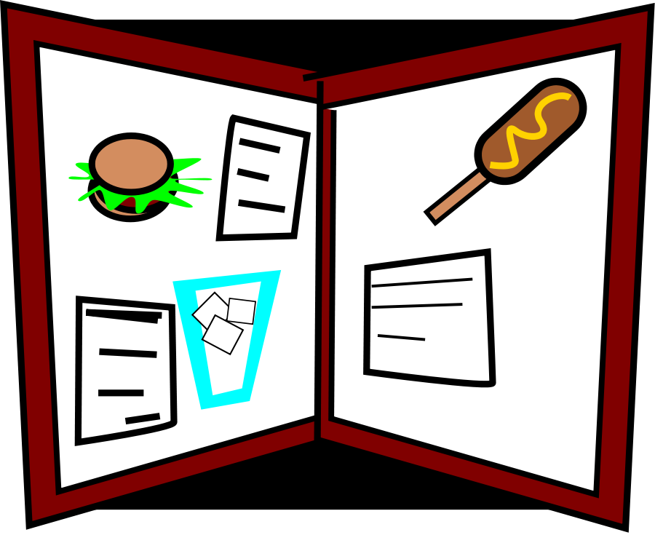
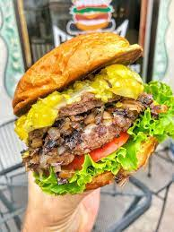
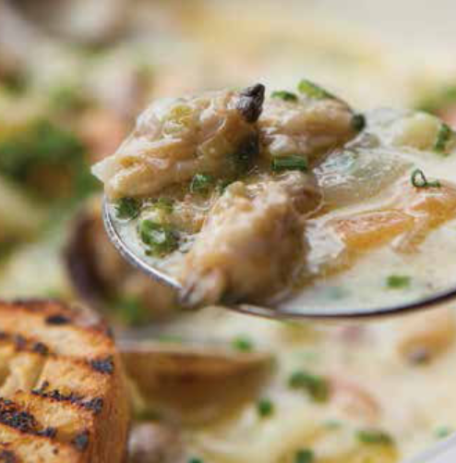
Entrée menu
- Tavern’s burger (comes with your choice of grilled chicken or beef patty along with melted Cheddar, grilled bacon streak, also it includes sticky BBQ sauce. Garnishes with grilled sliced tomato, onion rings, ice lettuce topped with coleslaw)
      - £26.50
- Mushroom pasta in a white creamy sauce (butter tossed button mushrooms and penne pasta cooked in a creamy smoked cheese and garlic sauce, also served with chilli garlic toasted bread)
      - £25.50
- Mash and Glamorgan sausage (served as the traditional trio that comes with cheese sausages and leek, comes along with vegetarian gravy, caramelized onion sauce and mashed potatoes with butter tossed green peas)
      - £29.00
- Pork sausage and butter tossed mash (served grilled pork sausage with butter tossed potato mash, including boiled green peas tossed in olive oil, rich Rev James gravy and caramelized onion sauce)
      - £29.20

Starters
- Steaky bacon with traditional cockles (cooked in a creamy and rich sauce and served with toasted loaf bread) £16.25
- Katsu chicken (it is a Japanese style crispy fried chicken thigh pieces and served with katsu sauce as well as baby lettuce) £22.35
- Chicken pate liver (this dish is mainly served with Welsh butter and toasted sourdough, also our special beer brain sauce is served with it) £23.50
- Shrimp or prawn cocktail (served with chef’s special seafood sauce, Welsh butter and loaf bread, also it served on baby lettuce) £27.60
- Soup of the day (the soup comes with Welsh butter and tin loaf bread, ask our waitress or waiter for today’s speciality) £21.60

HOTEL TRINITY BAR AND FOOD MENU

Desserts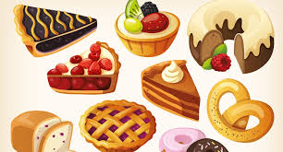
- Brain beer chocolate brownie (brain beer-infused freshly baked chocolate brownie served with single scooped Mario's ice cream and crunchy caramelized walnut)
                - £21.45
- Mario's ice cream (comes with three scoops of your customized favourite flavour among peach, cherry sorbet, vanilla, strawberry cream and Brecon honey)
                - £17.60

Beverage menu
WINE
White wine [France, Wales & England, Italy] (30 ml) £12.00
Sparkline wine (30 ml) £12.10
Rose wine (30 ml) £13.50
COCKTAILS
Rum punch in coast style (rum 30 ml, cranberry juice, Kombucha and orange juice)
£17.00
Sweet liquid almond (Jim beam 30 ml, sliced passion fruit, melted hazelnut and honey)
£18.00
Chilli boat (Vodka 30 ml, coconut water, sliced chilli and lime cordial)
£12.00
CIDER & BEER
Largo lager(contains 5.1% alcohol) 330 ml£9.50
Hallet’s cider (contains 6% alcohol) 600 ml£10.50
Beck’s blue (contains 0.5% alcohol) 275 ml£10.00
SOFT DRINKS
Fever tree (contains lemonade, a Mediterranean tonic, elderflower tonic and coconut water) 200 ml £7
Coca cola (classic and diet) 330 ml £6
Folkington’s juice (pink lemonade, tomato juice, pineapple juice, apple juice and orange juice) 250 ml £8
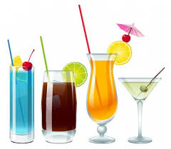
EAT & DRINK (valid Monday to Friday 12-4 pm and on weekends 11-3 pm)
- 2 Mash and Glamorgan sausage and any 1 White wine [France, Wales & England, Italy] (30 ml) £36
- 2 Tavern’s burger and 1 Rose wine (30 ml) £32


Special note: if you have any food allergies and a preference for vegetarian dishes, please speak to our floor staff about your meal ingredients before placing the order.
DUE TO COVID SITUATION, IF THE SEATING ARRANGEMENT WOULD FULL, YOU CAN TAKE AWAY YOUR ORDER.

