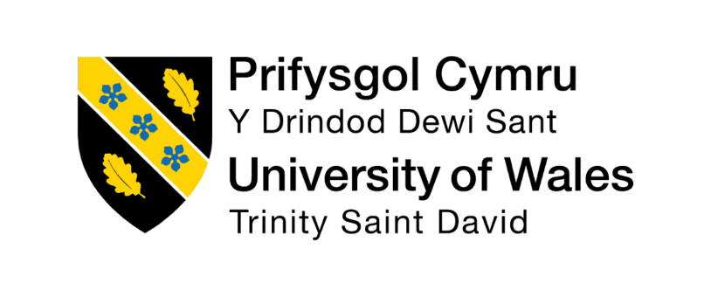

Programme: Master of Business Administration (MBA)
Module Name: International Marketing : Principles and Practices
Module Code: LCMB7026
Assignment Title: Toyota
Lecturer's Name: Dian Mayasari

Student Name: Arjun Sanjaybhai Parmar
Student ID: 2411725

Executive Summary

This report attempts to critically analyse the international marketing strategy of Toyota using a comparison between the Japanese and the Indian market. It also analyses the differences in Toyota's marketing strategies in both markets, which are different in terms of economic, cultural, political and technological conditions. The PESTLE analysis reveals key variations in regulations, consumer age groups, tech advancements, and sustainability agendas. Hofstede's cultural dimensions are set to illustrate the differences in the values and behaviour that customers use to make their decisions, which impact Toyota's positioning and the marketing and promotion it uses. In context to the STP analysis, it is found that as Toyota's vehicles are available in the market in almost every country, it is able to customise its products, pricing, distribution and communication strategies by keeping demands and needs of its customers in mind. This report has, therefore, focused on examining Toyota's joint venture route in India as well as its effectiveness in supporting long-term growth and competitiveness.
Table of Contents

Section 1: International Marketing Report 4
1. Introduction 4
1.1 Company Overview 4
1.2 Purpose of the Report 5
2. Comparative Market Analysis -PESTLE Analysis 6
3. Comparative Cultural Analysis Using Hofstede Framework 8
3.1 Hofstede Dimensions Comparison 8
3.2 Implications for Toyota's Marketing Strategy 9
4. Comparative STP Analysis 10
5. Comparative Marketing Mix Analysis (7Ps) 12
6. Market Entry Strategy Analysis 13
6.1 Entry Mode 13
6.2 Evaluation 14
6.3 Effectiveness Assessment 14
7. Ethical Issues in Toyota's Marketing Mix 15
8. Recommendations 17
9. Conclusion 17
Section 2: Reflective Account 19
References 23

Section 1: International Marketing Report

1. Introduction
The global automobile sector is competitive where it has become indispensable for operating brands to make marketing adjustments based on economic, cultural, and regulatory requirements of individual countries. Innovation, quality and customer solutions are being introduced in various markets in order to build a strong presence on the international market. This highlights the basic distinction between the mature market that Toyota deals in Japan and India. The automotive sector is firing and is a big strength of India's economy and demographics. Therefore, an in-depth analysis of the market in these two countries provides solid tracking indications to the modifications Toyota may make in its international marketing strategy.

1.1 Company Overview
Toyota Motor Corporation is a Japanese multinational automotive manufacturer, established in 1937 and headquartered in Toyota City in Japan (Toyota, 2026). More than 170 of these countries and regions are served by the company and it is one of the world's largest carmakers. As shown in figure 1, Toyota's market cap in 2019 ranged from $191 billion, and as of 2025 expired to $338 billion (Statista, 2025). Like Toyota and Lexus, its brands have made it known for its quality, reliability and technology advancement (Toyota, 2026). Sustainable mobility, carbon neutrality and constant innovation are a long-term strategy of this automotive manufacturer. The company's international activities are supported by substantial investments in research and development efforts that enable it to remain competitive in rapidly-changing vehicle markets. The auto industry has been hit by technological changes and shifting consumer demands and environmental laws, making strategic planning more and more pivotal to success. Zahan et al. (2025) added that effective global strategic planning, automotive companies can respond swiftly to market uncertainties and simultaneously stay competitive on the market.
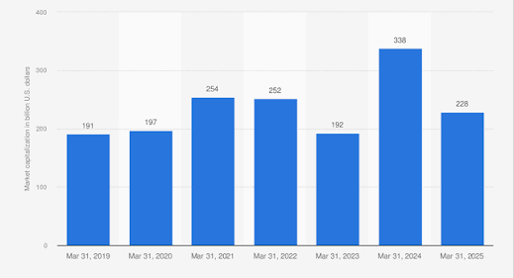
Figure 1: Toyota Motor Corporation Market Capitalization
(Source: Statista, 2025)
Japan is Toyota's home market and one of the world's most technologically advanced automotive environments (Toyota, 2026). Contrarily, India is one of the world's most rapidly emerging markets, boasting high economic growth (3.4% in 2023), high urbanisation rates, and high demand for personal mobility solutions (World Bank, 2025). Tokyo's consumer behaviour and its purchasing habits and traditions also differ from India, which offers and poses its own opportunities and pitfalls for Toyota to encounter. Ashta et al. (2025) pointed out that the further dynamics of culture, as a value, are still impacting Japanese - Indian organisations through business relationships, communication approach, and market engagement strategies. These cultural differences render localisation an integral part of successful international marketing.

1.2 Purpose of the Report
The main purpose of this report is to critically analyse the international marketing strategies followed by Toyota and draw comparisons from the global market, with a particular comparison between Japan and India. This comparison is perfect because the two countries differ in many aspects of market and culture, purchasing attitudes of consumers, structure of the market, and overall economic development/contribution. This comparative analysis is especially relevant because doing business in the international arena demands that international firms take into account the differences in customer expectations and conditions of competition from country to country. Additionally, the report specifically examines how Toyota approaches the different market situations. It gets into the PESTLE analysis of the macro-environment, Hofstede's culture dimensions analysis, the segmentation, targeting and positioning analysis, and the marketing mix comparison of the company between both countries.

2. Comparative Market Analysis -PESTLE Analysis
PESTLE Factor | Japan | India | Implications for Toyota
Political | Long-term government with an eye on automotive innovation and carbon-neutral mobility projects | “Make in India” and FAME schemes are government incentives to promote manufacture of vehicles in the country. | Opportunity to build up local production capacity and EV investments
Economic | Mature automotive market with high purchasing power of consumers and high-income economy (Nasuno, 2022) | These drivers are expected to include a population of over 1.4 billion, with significant automotive demand, and rapid economic growth, supported by this population (GB, 2025) | Outlook for more market demand for low-cost and medium class cars
Social | A strong preference for safety and reliability, coupled with advanced car technologies, is characterising the ageing population | Younger population with growing demand for SUVs and family cars | Demand for diverse product strategies in both markets
Technological | European automotive innovation hub and excellent infrastructure for EV's and Hybrid vehicles.  Toyota allocated around US$8.7 billion for R&D activities in 2025, which contributed to the technological leadership (IBISW, 2025) | The expansion of the EV ecosystem using Toyota's worldwide lineup of 30 electrified models (CA, 2026) | Raising investment in innovation, digitalisation and smart mobility solutions
Legal | Compliance with strict emission and safety/environmental regulations | The formulation of car safety requirements and the new environmental regulations | Ongoing compliance and product improvements must be made
Environmental | High awareness of carbon neutrality and of sustainability and air quality in road transport.  To showcase Japan as an international reputation in the field with use of energy carbon-neutral fuels, the Japan Automobile Manufacturers Association (JAMA) has commissioned the Institute of Energy Economics (Toyota, 2025) | Increasing environmental consciousness and government incentives for EVs | Growth in the market as a result of new models and electric car sales to fulfil sustainability requirements
Table 1: Comparative PESTLE Analysis of Toyota in Japan and India
Political conditions are similar between the two countries of Japan and India, and are conducive to Toyota in its actions. However, both governments have different priorities when it comes to strategic decision making. The political and regulatory landscape in Japan is very stable, promoting innovation and development of technology and sustainable mobility modes. On the contrary, India shows keenness in fostering the development of the industry through Make in India initiative, a Production Linked Incentive (PLI) policy, Faster Toyota sold approximately 2.4 million hybrid vehicles globally in 2025, strengthening its electrification strategy (CA, 2026). However, stark differences exist with regard to economic conditions. The Japanese market is a mature market, with high income, good buying power and reasonably stable purchase trends. This country, however, is also one of the biggest and fastest growing markets with more than 1.4 billion citizens (GB, 2025). Therefore, Japan has an increasing pool of consumers with money to spend and a growing middle class. It stated Toyota's worldwide revenues were approximately £241 billion with employment of more than 380,000 people, enjoying its success in both developed and emerging markets (GB, 2025).
The demand for safe, reliable and more technologically advanced products is growing in Japan as part of the global ageing trends, whereas India's growing young population is encouraging demand for sport utility vehicles (SUVs), family vehicles and affordable mobility options. The distribution of technological conditions is also quite varied. Japan continues to lead the world in terms of auto products, EV infrastructure and robotics, and private industry (Tomoshige, 2025). Contrarily, the government in India is now closing the gap on the back of the pack by prioritizing digital and EV functions. Both countries are influenced by legal and environmental considerations, which continue to impact the automotive industry. Japan has been relying on different options toward achieving carbon neutrality by 2050, with the promotion of BEVs (Battery Electric Vehicle) (Toyota, 2025) In May this year, Toyota's overall sales dropped by 7.4%, showcasing that it will continue making adjustments in the various market conditions and preferences (YF, 2026).

3. Comparative Cultural Analysis Using Hofstede Framework

3.1 Hofstede Dimensions Comparison
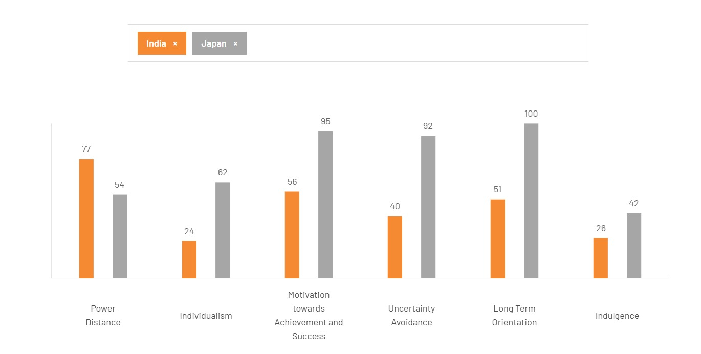
Figure 2: Hofstede Dimensions Comparison
(Source: TCF, 2026)
The Hofstede-McSweeney cultural differences between India and Japan point to several key disparities that are relevant to India's consumer behaviour and marketing strategy in the automotive industry. Figure 2 reveals that Indian consumers are mostly accepting hierarchical organisation and authority, as the country scores a higher Power Distance (PD) Index of 77, whereas Japan scored 54 (TCF, 2026). Japan also scored 62 points for Individualism, which signifies that Japanese purchasing behaviour is not strongly affected by others or by family. In context to Individualism, India scores 24 which indicates that purchasing activity is more likely to be guided by others and influenced by family. Kumar (2025) highlighted how important it is for businesses to grasp these value systems when formulating their market strategies for cultural and economic cooperation between India and Japan.
Japan scores 92 for the Uncertainty Avoidance dimension and 100 for Long-Term Orientation, whereas India scores 40 for Uncertainty Avoidance and 51 for LTO. Europeans, for instance, are more interested in planning, reliability, quality assurance and future investment than are the Japanese with these scores. Kobayashi and Weese (2026) pointed out that long-term relationships and a trust-based interaction are still crucial for decisions in the Japanese automotive sector and the expectation of consumers towards high quality and reliability remained intact. The difference is also found in the greater want of achievement and success in Japan (95) than in India (56). These are some of the facts that spark a technology performance car market. Continued and anticipated digital and green transitions influence consumer expectations in advanced Asian automotive markets, thereby reinforcing the critical role of innovation and sustainability (Dzienis and McCaleb, 2025).

3.2 Implications for Toyota's Marketing Strategy
Key cultural differences between Japan and India impact business aspects of Toyota's marketing, particularly in terms of promotion and product positioning and customer involvement. Toyota's focus on advanced technologies, safety features and sustainable mobility solutions is driven by consumer preference in Japan (Toyota, 2026b). This gives paramount importance to quality, reliability and long-term value. Uncertainty avoidance and long-term orientation are also high and drive demand for hybrid and eco-friendly cars, which correspond to future mobility needs. Tinwala et al. (2025) showed that these functional characteristics play a significant role in consumer assessments of vehicles, emphasising the need for conveying a product's functional benefits in the Indian context. Toyota, therefore, advocates fuel efficiency, durability and cost-efficiency to bolster its standing in the competition with the middle-class customers. The same also applies to other aspects of organisational adaptability, where adapting to shifting market conditions and consumer expectations is just as critical. According to James and Zeidan (2026), companies should constantly check their managerial practices and strategic approaches to remain relevant in a changing environment. Additionally, the increasing focus on sustainability has made it an important consideration for consumers and stakeholders' decisions. Paudel (2025) emphasised how sustainability reporting and the incorporation of environmental responsibility are now at the core of competitive advantage in the automotive industry in Asia.

4. Comparative STP Analysis
STP Element | Japan | India
Segmentation | Target customers who are concerned about age, the environment and those who look for the best vehicles. Total sales revenue of Toyota in 2025 amounted to ¥48.037 billion, where segments focused on quality were particularly appealing (Toyota, 2025b) | Target young workers, middle-income families and the rising number of SUV buyers in a population where youth is prevalent.
Targeting | Serves the customer's wants and expectations of hybrid technology, advanced safety features and long-term reliability. In 2025, Toyota sold more than 10.8 million cars worldwide, showcasing its leadership in the communication market for technologically-demanding consumer segments (RG, 2026). | Toyota has moved around 337,000 cars in India in FY2025 (SO, 2026).
Positioning | Positioned as an innovative, sustainable and technologically advanced automotive brand emphasising quality and environmental responsibility. | An automotive brand that reliable, durable and affordable mobility for emerging consumers.
Table 2: Comparative STP Analysis of Toyota in Japan and India
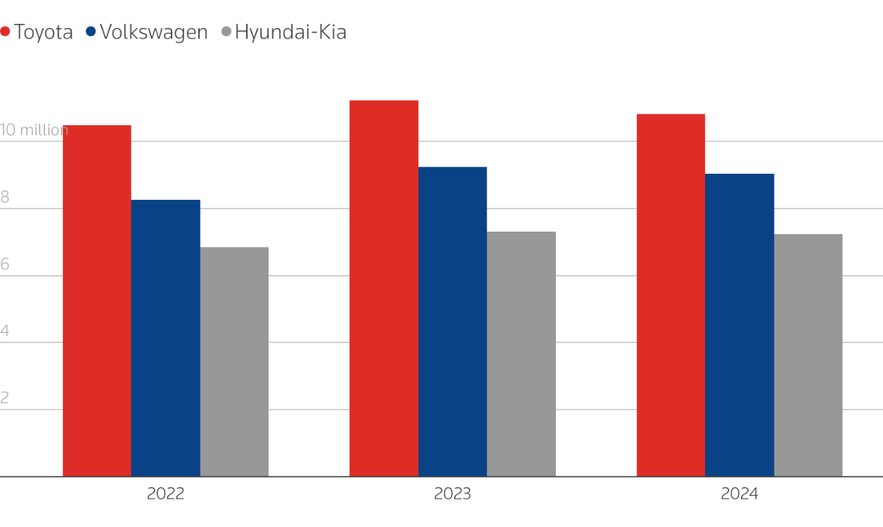
Figure 3: Global Vehicle Sales Comparison of Toyota, Volkswagen and Hyundai-Kia
(Source: Reuters, 2025)
Toyota remains the sales leader on a global basis with sales over 10 million annually for years 2022 through 2024 (Reuters, 2025). The STP analysis points out the various aspects of the Japanese as well as Indian consumers and how Toyota will shift its market strategy. Toyota has over 50 manufacturing plants around the world, which optimises its production and enhances market responsiveness (NTE, 2025). The focus on hybrid and advanced mobility solutions is in line with the digital transformation of the automotive industry. Yun et al. (2025) pointed out how digital innovation and technological advancements have emerged as major competitiveness factors among automotive industries, strengthening Toyota's position strategy in saturated markets like Japan.
Toyota's targeting gap in India is, however, due to the demographic and economic factors (Tinwala et al., 2025). Its main market is the young professional, the middle-income family and the emerging SUV segment where its products are relevant due to their low price, reliability and fuel economy. Consuming markets for automobiles are changing, with emerging economies progressively impacting the worldwide boom and development of demand. Pardi (2025) stated that the market in developing countries, where the demand of consumers and the economic situation were being improved, exerted greater influence on the direction of the cars industry. Those are reflected in the positioning in the market that Toyota has signified.

5. Comparative Marketing Mix Analysis (7Ps)
Marketing Mix Element | Japan | India
Product | Focuses on hybrid, electric and technologically advanced vehicles. Toyota offers more than 70 vehicle models globally, supporting extensive product differentiation (RB, 2025) | Focuses on affordable sedans, SUVs and hybrid vehicles tailored to local consumer preferences
Price | Premium pricing strategy reflecting advanced technology and quality standards | Competitive pricing strategy aimed at middle-income and value-conscious consumers
Place | Extensive dealership and digital distribution network across developed urban markets | Broad dealership coverage in urban and semi-urban regions to improve accessibility
Promotion | Emphasises innovation, sustainability and safety in marketing communications | Highlights affordability, reliability and family-oriented benefits through localised campaigns
People | Highly trained sales and customer service personnel supporting premium customer experiences | Customer-focused sales teams providing personalised assistance and after-sales services
Process | Digital purchasing processes and integrated after-sales support systems | Simplified purchase and service processes designed for diverse consumer segments
Physical Evidence | Modern showrooms and technologically advanced service centres reflecting brand quality. The May 2026 sales drop worldwide was 7.4% for Toyota, underlining the significance of providing high quality service and adapting to the market (TET, 2026) | Expanding dealership infrastructure and service centres to strengthen brand visibility and trust
Table 3: Comparative Marketing Mix (7Ps) Analysis of Toyota in Japan and India
The comparative analysis of Toyota's marketing mix indicates that Toyota could make some operational changes to fit the marketing mix characteristics amongst consumers in both Japan and India. The two markets are quite different when it comes to product strategies. The emphasis in Japan is on hybrid, electric and technologically advanced solutions, which consumers have come to value as a major trend toward sustainability and innovation (Tomoshige, 2025). Toyota's dedication to sustainable mobility and continued technological progress positions it as a strong contender in the hybrid car market (Putri et al. 2025). This way, Toyota positioned itself closer to the top segment in Japan. Prices also vary depending on socio-economic circumstances and buying power. While Japan has a mature market with high prices, the Indian market needs more competitive pricing structures to attract middle-income consumers. Car performance, price sensitivity and perceived value of the vehicle are some of the factors that play an active role in consumer purchasing decisions in India (KV et al., 2022). Simamora et al. (2025) claimed that many economic and product-related factors indeed play a significant role in a consumer decision within automobile markets, consistent with different markets requiring different pricing and promotion strategies.
Toyota's place and promotion strategies are also an indication of the local market. The expansion of production, sales and export activities is reinforcing the possibilities in the Indian automotive industry. The integration between production performance and sales performance has helped in expanding the Indian automobile industry (Yadav and Kumari, 2026). Overall, the distinctive 7Ps approach adopted by Toyota boosts the competitiveness and customer engagement within the market for both countries.

6. Market Entry Strategy Analysis

6.1 Entry Mode
Toyota's first venture in the Indian market was via a tie-up with the Kirloskar Group (KTD), which formed Toyota Kirloskar Motor (TKM) in 2002 (Toyota, 2002). This entry mode, Toyota was able to utilise local knowledge, manufacturing facilities and distribution channels and, at the same time, reduce the risk generally associated with entering an emerging economy. This joint venture specifically enabled Toyota to integrate its international experience with India's local markets and tastes, ensuring its supremacy in the Indian car market. Strategic adaptation can be a key ingredient in successful international expansion. Abdelsalam Mohamed Mostafa (2025) found the basis for the assertion that firms entering foreign markets obtain better performance by using strategies to adapt to local economic, institutional and cultural settings. This is evident in Toyota's entry strategy approach of doing business through partnerships, striking a balance between standardisation globally and responsiveness in the local environment. In addition, technologically-integrated production systems have gained even more relevance in international automotive operations with the help of the technologies of Industry 4.0. All automotive value chains across the world are now undergoing digital manufacturing and automation transformation. This has compelled MNCs to invest in technologically-advanced automotive manufacturing plants, considering the target markets (Krzywdzinski and Lechowski, 2025).

6.2 Evaluation
As analysed, Toyota has established local partnerships in India to gain insight into the local regulatory landscape, develop manufacturing capacity, and foster deeper engagements with various stakeholders across the automotive value chain (Toyota, 2002). These benefits are even more critical in emerging markets where institutional settings and market preferences may vary greatly from the home market. Toyota's entry strategy is also due to operational efficiency and supply chain management. Fortuna et al. (2025) reiterated the fact that good logistics management contributes to improving the functioning of the organisation by improving the coordination of logistics, utilisation of logistics resources and the responsiveness of logistics operators. Toyota's commitment to the principles of lean production also enhances the efficiency and sustainability of its operations. Toyota's production system still serves as a guide for the adoption of lean practices and the sustainability goals of automotive companies (Figueiredo et al. 2025). However, joint ventures may create problems in the areas of decision-making authority, strategic direction or profit sharing. Over time, there can be organisational differences in priority, making it challenging for the partners. Besides, other market uncertainties can impact the automotive sector's performance. Akorsu et al. (2025) noted that the automotive industry's performance and investment decisions remain prone to the impacts of crude oil price volatility and overall economic uncertainties.

6.3 Effectiveness Assessment
Toyota's India entry approach has been effective because of its market growth, stability and competitiveness. By being among the first to develop manufacturing plants on the ground, the joint venture established an additional way to increase supply chain integration and responsiveness of the products to shifting consumer demand. Such results have helped Toyota remain competitive in a fast-changing, tough car market. The resilience of the supply chain has been crucial in assessing the success of Toyota's global operations. Toyota's adaptive supply chain approaches during times of disruption and crises contribute to improving overall operational continuity and organisational resilience (Toyota, 2016). Toyota's lessons in previous crises have strengthened the company's understanding of how to deal with uncertainty while continuing the efficient production process in the international market.
The success of Toyota’s approach to the market is further confirmed by financial and market performance indicators. Koroma et al. (2025) added that financial management practices are important in enhancing the relationship between financial management practices and profitability among Japanese automobile companies based on their market share. Toyota's market presence in India is crucial not just for sales but also for strategic manoeuvring. Furthermore, market structure transformation in the global motor industry has remained to provide chances for emerging economies to become more entrenched in motor sector development. Likewise, it is evident from the findings of Pardi (2025) that emerging markets are playing a higher role in future pathways of automotive development. The market entry approach used is found successful with Toyota's successful venture in India, which could help sustainable international expansion. Besides, Toyota's effectiveness can also be judged based on the localisation of its products and meeting changing Indian consumer tastes. These benefits have contributed to increasing the trust of its customers while providing the brand with effective publicity and competitiveness in the fierce competition from home and abroad automobile manufacturers.

7. Ethical Issues in Toyota's Marketing Mix
Ethical Issue | Evidence and Numerical Data | Implications for Toyota
Product Safety and Reliability | Toyota has been classified as one of the most reliable car brands, with a rating of 62 on a scale of 100 on Consumer Reports' 2025 model line (CR, 2025). | High reliability improves customer confidence and trust, and may have devastating effects when reliability becomes an issue.
Environmental Responsibility | There is a growing demand for stakeholders to understand the emissions and sustainability performance of vehicles. | An ongoing hybrid and electric vehicle investment strategy is essential to retain ethical and environmental integrity.
Marketing Transparency | An ethical question might arise if promotional items about safety, fuel usage or sustainability do not dovetail fully with the actual vehicle performance. | A big key in ensuring that the consumer stays informed and in check with regulation is the reduction of mistakes and miscommunication.
Corporate Social Responsibility (CSR) | Toyota is renowned for its quality and reliability; its reputation has raised expectations for responsible business behaviour and operations. | A successful CSR programme can benefit the company in terms of its brand and maintaining long term relations with its stakeholders.
Table 4: Ethical Issues in Toyota's Marketing Mix
The above analysis highlights a number of ethical issues that affect Toyota's marketing and reputation of the company. One of the most important ethical aspects is also product safety and reliability which is related to the quality and performance of the vehicle, which the customer has to rely on. In the automotive industry, Toyota is known for its reliability, scoring an overall reliability of 62 on 100 (CR, 2025). Environmental responsibility has become increasingly relevant by the day and governments, investors and consumers just demand greater transparency with regards to emissions and sustainability. In response, Toyota has increased its investments in hybrid and electric vehicle technologies and incorporated sustainability into its business strategy. Kumar et al. (2025) suggests that open innovation is transforming the essence of industrial capabilities, which is driving a more sustainable and technologically oriented development of new capabilities.
The other key marketing transparency question is one of ethics. Promotional claims and statements about safety, efficiency and sustainability of vehicles should not mislead consumers and fairly and accurately depict its performance (Şenyapar, 2024). Transparent communication builds up consumer trust and enhances regulatory conformance. Another important aspect of the TWOW is corporate social responsibility. Socio-environmental aspects of business must continually be balanced with profitability, as expectations of stakeholders bring in the need to do so. Additionally, the corporate conduct and decision making in numerous of the Asian markets is primarily motivated by competition. Scholars noted that industrial cooperation and competition have now become a major factor to shape a region's industrial strategies, which are subjecting the companies to growing ethical and responsible needs (Ohashi, 2025).

8. Recommendations
Toyota needs to put more emphasis on market promotion by creating more low-cost hybrid/electric vehicles exclusively for emerging markets, such as India and offer better marketing plans abroad. Together with the worldwide transition to sustainable mobility and the increasing awareness of the advantages of emission-free mobility, the demand for e-mobility solutions continues to rise (Buechler, 2023). The greater the rate of penetration into the sought-after group looking for hybrid cars (with even lower prices), the greater Toyota would benefit in securing access without reducing competitiveness. It should also boost digital marketing and customer engagement strategies. This further includes increasing customer engagement and building customer loyalty with customisable online messaging, virtual showrooms and data driven marketing, amongst others, in key verticals. Segmentation plays a more important role in the international business environment. Ting (2025) posited that in the era of changing market structures and segmentations, the patterns of international trade and competitive positioning are significantly affected by these.
Another suggestion is to improve the resilience of the supply chain by diversifying suppliers, stock flexibility and sophisticated risk management systems. The automotive supply chain's exposure to global uncertainties and economic and geopolitical shocks has been highlighted by the global disruptions. According to Min and Sheriff (2025), resilient supply chains play a significant role in the continuity of operations and in gaining a competitive edge in the automotive industry. Further investments in digital technologies of the supply chain could bring better responsiveness and effectiveness. Lastly, Toyota should continue to improve its transparency around sustainability performance, emissions reduction and its corporate social responsibility work.

9. Conclusion
This report comparatively analysed Toyota's international marketing strategy with the countries of Japan and India. The results showed that there were huge differences with respect to the economy, culture and consumer preferences, and hence Toyota needs to use market-specific strategies. PESTLE, Hofstede, STP and 7Ps identified the successful relationship Toyota maintains between its global brand and producing adaptations for operating in the local markets. The evaluation of the company's market entry strategy revealed that the company's joint venture has facilitated the sustainability of growth and competitiveness in India. Toyota seems to be in a great position to secure its international stature in the face of the epidemiological and ethical obstacles by focusing on innovation, resilience and people-centric communication.

Section 2: Reflective Account
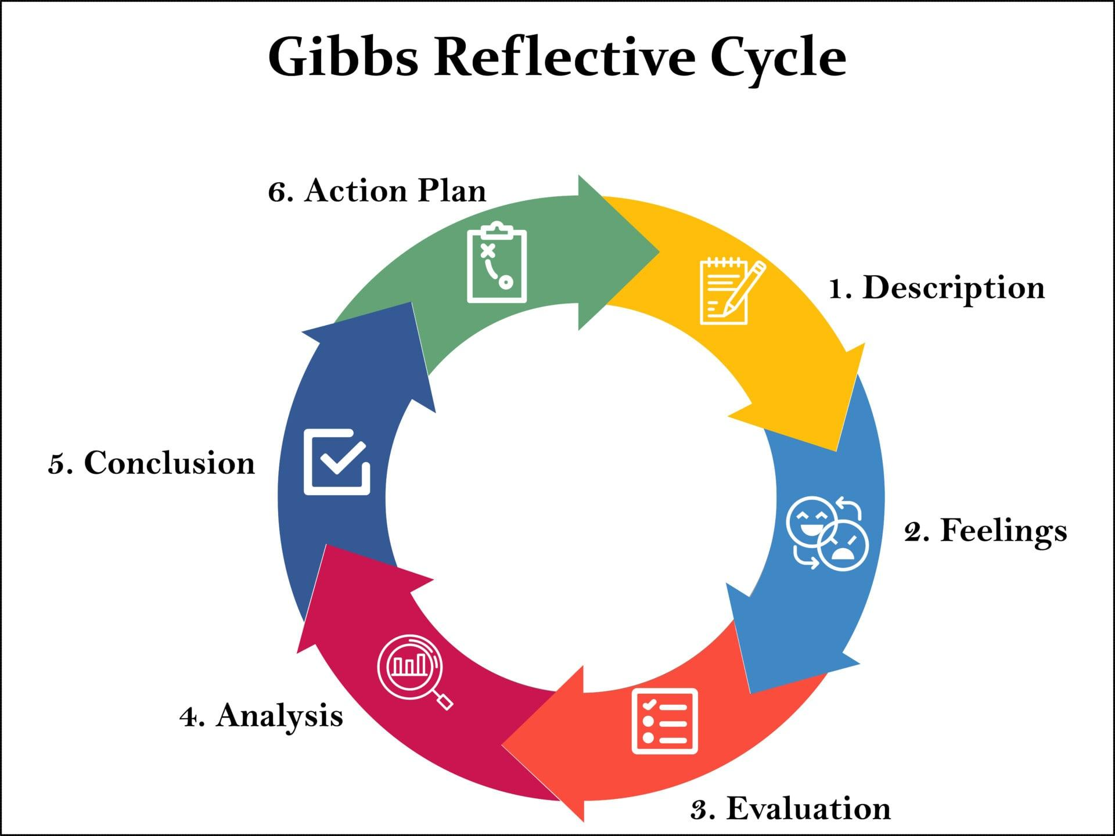
Figure 4: Gibbs Reflective Cycle
(Source: SP, 2025)
Description
In this evaluation, I critically contrasted the international marketing strategy of Toyota by analysing its operation in Japan and India. The PESTLE, Hofstede's cultural dimension, STP and 7 Ps marketing mix were used in the analysis of the report. I assessed and analysed Toyota's market entry and also considered and identified the ethical factors, and presented practical suggestions for future expansion. While working through it, I read academic papers, industry reports and company information to gain insight into the different approaches of the MNC in the automotive industry. Having this Japanese and Indian interaction helped me to understand the effect of the differences in economics, culture, and regulations on marketing decisions. Furthermore, I explored the automotive industry's subject of the influence of global megatrends on sustainability, digitalisation, and electric vehicles. Fadhil and Shen (2025) emphasised the fast growth of global markets for EVs and the relevance of sustainable mobility in the automotive industry.
Feelings
I was confident at the start of this assignment analysing Toyota, as it is one of the best-known automotive companies in the world. I also discovered that to analyse international marketing strategies, much more needs to be understood with regard to cultural aspects, politics and economics than what I had initially thought. I was more interested in how the behaviour of consumers is so different in different countries, the more I went through the report. Hofstede's insight and the cultural differences found thereof and implications for marketing adaptation were of particular interest. As a result, I became more aware of the intricacies of the automotive business in several countries and learned more about how strategic choices are made in multi-national corporations. A challenge that I went through that also disturbed my consistency was integrating numerous analysis schemes.
Evaluation
One positive aspect of the assignment, which is worth highlighting is that we actually had to practice the theoretical concept of marketing that we had learnt, to a real Emirates airline. Learning about the transfer of Toyota's operations in Japan and India provided me an opportunity to connect the academic world of operations with the business world. I gained profound understanding of the importance of localisation in international marketing, and how cultural adjustment could be a factor in influencing food preferences. Comparative analyses have been applied in order to improve the ability to analyse business strategy rather than simply describing it. A key strength was the learning and development of research skills as a result of access to a range of academic and industry resources. Economic cooperation between India and Japan continues to grow in resilient and diversified value chains, as these markets play an important role in global business networks (Prakash, 2025). This detail was helpful for me to be able to better understand the long-term strategy of Toyota. One problem was, however, the vast amount of data available on Toyota and within the automotive industry. Identifying the most relevant evidence, particularly in relation to balanced analysis, was a significant amount of work.
Analysis
This assignment did a great deal for my knowledge around international marketing strategy and, as a whole, the auto market. In PESTLE analysis, I realised the impact of political policies, economic factors and environmental laws in the process of decision-making at the strategic level. That is, there are no standardised solutions that can be applied across the globe in international companies by default, but it is important that this kind of company continually moves with changing market environments. Further, differences in usage behaviour and values of consumers were identified as key aspects to consider in the cultural analysis. I came to understand that what works in Japan won't necessarily work in India because of societal, buying and cultural attitudes. As Khan (2026) pointed out, operational efficiency and responsiveness to the market are essential aspects of Toyota's strategic achievement, reflecting the critical importance of adaptation in international business.
Increased insight into how geopolitical and economic factors influence the global automotive industry. Mendez Parra et al. (2025) outlined the growing importance of geopolitics in trade trends and global competitiveness of industries. That was what helped me to realise that the importance of resilient supply chains and flexible business models is becoming a must for a multinational organisation. Moreover, the assignment helped me to realise and see the level of sustainability and technological innovation within the motor industry. Jha et al. (2025) discussed the evolution of automotive industries in the emerging economies in the context of changing market conditions and technology.
Conclusion
This assignment allowed me to gain a better understanding of international marketing strategy in the global automotive industry as a whole. In the comparative study of Toyota's business in Japan and India, I was able to reinforce my capability to analyse the business environment using marketing frameworks, critically analyse business environment choices, and evaluate strategic decisions. The study has highlighted the influence of cultural, economic, political and technological factors on marketing strategies in international markets. It also enhanced my research, analytical and academic writing abilities since it involved using an integration of academic and industry literature. I received some wonderful insight into the challenges of and opportunities for multinational companies to fit their business definition into varying markets while keeping their global competitiveness and achieving sustainable growth.
Action Plan
In future study and work projects, I aim to build up my critical knowledge skills to implement more complex critical analysis of materials, using more up-to-date academic references. I'm also looking to enhance my grasp of international trade, supply chain management and sustainability due to the rising significance of these subjects in the eyes of global corporations. I will study international marketing frameworks and their application in international marketing across various industries to further sharpen my strategic thinking capabilities. Also, I would love to acquire more skills in the field of new technologies, with a focus on e-mobility, data-based marketing and digital transformation. Fadhil and Shen (2025) illustrated the significance of electric mobility in the world's markets and why it is important for professionals to get ready for the future. As I continue to grow, I know my knowledge and analytical skills will become robust and will help me to be better equipped to assess complex international business challenges and add value to strategic decisions in an international context.

References
Abdelsalam Mohamed Mostafa, M., 2025. Beyond Borders: How Strategic Adaptations Shape Global Market Entry Success. Available at SSRN 5118307. https://papers.ssrn.com/sol3/papers.cfm?abstract_id=5118307
Akorsu, P.K., Kumordzie, M., Agyei, S.K., Woode, J.K. and Adjei, A.F., 2025. Dynamic interdependence between crude oil and the automobile equities amid uncertainties. Future Business Journal, 11(1), p.112. https://link.springer.com/article/10.1186/s43093-025-00526-6
Ashta, A., Stokes, P., Hughes, P. and Visser, M., 2025. Japanese cross-cultural management in Indian business-to-business marketing situations: A study of evolving intra-Asian differences in cultural values. Journal of Business-to-Business Marketing, 32(3), pp.307-326. https://www.tandfonline.com/doi/abs/10.1080/1051712X.2024.2399780
Buechler, A.M., (2023). Acceptance of E-mobility in India. https://pearl.plymouth.ac.uk/cgi/viewcontent.cgi?article=1270&context=pbs-theses
CA. (2026). Toyota statistics 2026. Available at: https://www.consumeraffairs.com/automotive/toyota-statistics.html [Accessed: 30 June 2026]
CR. (2025). Who Makes the Most Reliable New Cars? Available at: https://www.consumerreports.org/cars/car-reliability-owner-satisfaction/who-makes-the-most-reliable-cars-a7824554938/ [Accessed: 02 July 2026]
Dzienis, A.M. and McCaleb, A., 2025. Digital and green transitions and automotive industry reconfiguration: evidence from Japan and China. Journal of Contemporary Asia, 55(4), pp.618-644. https://www.tandfonline.com/doi/abs/10.1080/00472336.2024.2384704
Fadhil, I. and Shen, C., 2025. Global electric vehicle market monitor for light-duty vehicles in key markets, 2024. https://theicct.org/wp-content/uploads/2025/06/ID-366-%E2%80%93-Global-monitor-cars_brief_final.pdf
Figueiredo, O.C.D., Oliveira, U.R.D., Aprigliano Fernandes, V., França, S.L.B. and Lemos, W.D.M., 2025. Lean and sustainability in automotive organizations: a comparative analysis with Toyota. Gestão & Produção, 32, p.e11424. https://www.scielo.br/j/gp/a/vkLdBQq9VGbB44X8PGMVHqm/?lang=en
Fortuna, F.A., Jayanti, A.C., Purba, T. and Ichsan, M., 2025. Identification of Key Success Factors in Performing Effective Logistic Management: A Case Study of XYZ Ltd. Manufacturing Company. Global Business & Finance Review, 30(1), p.58. https://www.researchgate.net/profile/Mohammad-Ichsan-5/publication/388735497_Identification_of_Key_Success_Factors_in_Performing_Effective_Logistic_Management_A_Case_Study_of_XYZ_Ltd_Manufacturing_Company/links/68137af060241d514021353d/Identification-of-Key-Success-Factors-in-Performing-Effective-Logistic-Management-A-Case-Study-of-XYZ-Ltd-Manufacturing-Company.pdf
GB. (2025). Toyota Motor Corp: Overview. Available at: https://www.globaldata.com/company-profile/toyota-motor-corp/ [Accessed: 27 June 2026]
IBISW. (2025). Toyota Motor Corp - Company Profile. Available at: https://www.ibisworld.com/united-states/company/toyota-motor-corp/10379/ [Accessed: 28 June 2026]
James, R. and Zeidan, S., 2026. Validating the core tenets of deinstitutionalization–a process model of managerial practice abandonment. International Journal of Organizational Analysis, pp.1-29. https://www.emerald.com/ijoa/article/doi/10.1108/IJOA-09-2025-5984/1359341
Jha, P., Herr, H., De Conti, B., Teipen, C. and Gräf, H., 2025. Industrial Trajectories in the Brazilian and Indian Auto Sectors. In Global Shifts in the Automotive Sector: Markets, Firms and Technologies in the Age of Geopolitical Disruption (pp. 229-256). Cham: Springer Nature Switzerland. https://link.springer.com/chapter/10.1007/978-3-031-80641-4_10
Khan, N.I., 2026. Strategic & Operational Analysis of Toyota Motor Corporation. I made this just out of hobby in my leisure time. https://papers.ssrn.com/sol3/Delivery.cfm?abstractid=6208539
Kobayashi, M. and Weese, E., 2026. Examining supplier switching behavior: an empirical analysis of the Japanese automotive industry. Production & Manufacturing Research, 14(1), p.2604351. https://www.tandfonline.com/doi/abs/10.1080/21693277.2025.2604351
Koroma, S., Kabia, A.U., Kamason, A.A. and Fofanah, A.C., 2025. The Relationship between Working Capital Management and Profitability of Listed Automobile Companies in Japan Stock Exchange Market: Moderating Effect of Market Share. Research Journal in Business and Economics, 3(3), pp.01-22. https://bluemarkpublisher.org/index.php/RJBE/article/view/453
Krzywdzinski, M. and Lechowski, G., 2025. Industry 4.0 and its implications for the international division of labor in the automotive industry. In Global Shifts in the Automotive Sector: Markets, Firms and Technologies in the Age of Geopolitical Disruption (pp. 67-88). Cham: Springer Nature Switzerland. https://link.springer.com/chapter/10.1007/978-3-031-80641-4_4
Kumar, N., 2025. Harnessing India–Japan Economic Partnership for Supply Chain Resilience in the Context of Global Trade Policy Uncertainties. India–ASEAN–Japan Cooperation for Diversified and Resilient Supply Chains, p.62. https://isid.org.in/wp-content/uploads/2025/09/WP301.pdf
Kumar, R., Sinha, K., Fernandes, M. and Kumar, A., 2025. Open Innovation: Reshaping Industrial Capabilities. Available at SSRN 5671911. https://papers.ssrn.com/sol3/papers.cfm?abstract_id=5671911
KV, S., Michael, L.K., Hungund, S.S. and Fernandes, M., 2022. Factors influencing adoption of electric vehicles–A case in India. Cogent Engineering, 9(1), p.2085375. https://www.tandfonline.com/doi/pdf/10.1080/23311916.2022.2085375
Macrotrends. (2025). Toyota Revenue 2012-2025 | TM. Available at: https://www.macrotrends.net/stocks/charts/TM/toyota/revenue [Accessed: 28 June 2026]
Mendez Parra, M., Agarwal, P., Luke, D., Vutula, N., Magooa, A., El-Aidi, I., Parshotam, A., Iacovou, E. and Chapman, F., 2025. Impact of geopolitical dynamics on global trade: the case of the African automotives sector. ODI Global Report. https://www.econstor.eu/handle/10419/319286
Min, H. and Sheriff, K.M., 2025. Enhancing resilience in the global automotive supply chain: Lessons learned from the systematic literature review. International Journal of Logistics Systems and Management, 51(3), pp.339-375. https://www.inderscienceonline.com/doi/abs/10.1504/IJLSM.2025.147540
Nasuno, K., 2022. Progress of electric vehicles and transformation of supply chain in the Japanese automobile industry. In Frameworks and Cases on Evolutional Supply Chain (pp. 46-67). IGI Global Scientific Publishing. https://www.igi-global.com/chapter/progress-of-electric-vehicles-and-transformation-of-supply-chain-in-the-japanese-automobile-industry/302797
NTE. (2025). Facts & Figures. Available at: https://newsroom.toyota.eu/facts--figures/ [Accessed: 02 July 2026]
Ohashi, H., 2025. BRI and Japan in the Regional Context: Sino-Japanese Economic Cooperation and Competition. Hong Kong Review of Belt and Road Studies, 3(4 (9)), pp.5-19. https://oborjournal.org/index.php/journal/article/view/45
Pardi, T., 2025. Car markets in transition: Can emerging countries take the lead?. In Global shifts in the automotive sector: Markets, firms and technologies in the age of geopolitical disruption (pp. 15-40). Cham: Springer Nature Switzerland. https://link.springer.com/chapter/10.1007/978-3-031-80641-4_2
Paudel, D., 2025. Corporate Sustainablity Implementation in the Asian Automotive Industry: An Analysis of Sustainability Reports. https://www.preprints.org/manuscript/202506.1445/v1?utm_source=Twitter&utm_medium=social_organic&utm_campaign=research&utm_term=preprintsharing&utm_content=image
Prakash, A., 2025. ERIA-CII-ISID Study on India–Japan Economic Partnership for Resilient and Diversified Value Chains. Books. https://www.eria.org/uploads/India-Japan-Economic-Partnership-for-Resilient-Diversified-Supply-Chains-rev_.pdf
Putri, K.A., Nasukha, K.S., Febriyanti, M.Y. and Rasyid, S., 2025. A Comparative Study of Honda and Toyota Brands in Hybrid Vehicle Sustainability Using the Competitive Profile Matrix (CPM) Framework. In EPJ Web of Conferences (Vol. 328, p. 01037). EDP Sciences. https://www.epj-conferences.org/articles/epjconf/abs/2025/13/epjconf_icetsf2025_01037/epjconf_icetsf2025_01037.html
RB. (2025). Ultimate List Of Toyota Stats. Available at: https://www.ronbrooks.co.uk/ultimate-list-of-toyota-stats/ [Accessed: 02 July 2026]
Reuters. (2025). Toyota sells 10.8 million vehicles in 2024 to remain world's top-selling automaker. Available at: https://www.reuters.com/business/autos-transportation/toyota-sells-108-million-vehicles-2024-remain-worlds-top-selling-automaker-2025-01-30/ [Accessed: 30 June 2026]
RG. (2026). Toyota Car Sales Statistics. Available at: https://roadgenius.com/cars/statistics/sales-by-manufacturer/toyota/ [Accessed: 30 June 2026]
Şenyapar, H.N.D., 2024. Unveiling greenwashing strategies: A comprehensive analysis of impacts on consumer trust and environmental sustainability. Journal of Energy Systems, 8(3), pp.164-181. https://dergipark.org.tr/en/download/article-file/3728264
Simamora, S.J., Ulkhaq, M. and Handayani, N.U., 2025. Consumer decision-making in car purchases: insights from a logistic regression analysis. LogicLink, pp.70-77. https://e-journal.uingusdur.ac.id/logiclink/article/view/10934
SO. (2026). Toyota’s global vehicle output and sales declined during the January–May 2026. Available at: https://www.steelorbis.com/steel-news/latest-news/toyotas-global-vehicle-output-and-sales-fall-in-jan-may-2026-1461403.htm [Accessed: 28 June 2026]
SP. (2025). Gibbs Reflective Cycle. Available at: https://www.simplypsychology.org/gibbs-reflective-cycle.html [Accessed: 02 July 2026]
Statista. (2025). Toyota Motor Corporation's market capitalization between March 31, 2019 and 2025. Available at: https://www.statista.com/statistics/279650/market-capitalization-of-toyota/?srsltid=AfmBOooH3lxCWoZrFyxxbiCYmj-PvKqw9BHJpZONT2eN4NOqvJi_5anG [Accessed: 30 June 2026]
TCF. (2026). Country Comparison tool. Available at: https://www.theculturefactor.com/country-comparison-tool?countries=india%2Cjapan [Accessed: 28 June 2026]
TET. (2026). Toyota sales fall for fourth month in May as declines in China, US and Middle East weigh. Available at: https://economictimes.indiatimes.com/news/international/business/toyota-sales-fall-for-fourth-month-in-may-as-declines-in-china-us-and-middle-east-weigh/articleshow/132063078.cms?from=mdrhttps://economictimes.indiatimes.com/news/international/business/toyota-sales-fall-for-fourth-month-in-may-as-declines-in-china-us-and-middle-east-weigh/articleshow/132063078.cms?from=mdr [Accessed: 30 June 2026]
Ting, C.C., 2025. A New Theory of International Trade: Capital Deepening and Market Segment Determines the Pattern of International Trade. International Journal of Economics and Finance, 17(11). https://scholar.archive.org/work/n77mnrw7jnd43ocxpfaa3fqoui/access/wayback/https://ccsenet.org/journal/index.php/ijef/article/download/0/0/52450/57123
Tinwala, M., Singh, V. and Vidani, J., 2025. A Comparative Study on Urban Cruiser of Toyota V/S Harrier of Tata Engine, Mileage and Safety Among Consumers in Ahmedabad City. https://www.academia.edu/download/122959698/283.pdf
Tinwala, M., Singh, V. and Vidani, J., 2025. A Comparative Study on Urban Cruiser of Toyota V/S Harrier of Tata Engine, Mileage and Safety Among Consumers in Ahmedabad City. https://www.academia.edu/download/122959698/283.pdf
Tomoshige, Y. (2025). Japan's Automotive Electrification Trends (2025 H1). Available at: https://www.jato.com/resources/news-and-insights/japans-automotive-electrification-trends-2025-h1 [Accessed: 29 June 2026]
Toyota (2025). Toyota’s Views on Climate Public Policies 2025. Available at: https://global.toyota/pages/global_toyota/sustainability/esg/environmental/climate_public_policies_2025_en.pdf [Accessed: 27 June 2026]
Toyota, (2025b). FINANCIAL SUMMARY FY2025. Available at: https://global.toyota/pages/global_toyota/ir/financial-results/2025_4q_summary_en.pdf [Accessed: 28 June 2026]
Toyota. (2002). Toyota Establishes Transmission Joint Venture in India. Available at: https://global.toyota/en/detail/211673 [Accessed: 29 June 2026]
Toyota. (2016). Five Years on: Toyota's Efforts to Build a Disaster Resilient Future. Available at: https://global.toyota/en/detail/11373994 [Accessed: 30June 2026]
Toyota. (2026). About us. Available at: https://global.toyota/en/company/profile/overview/ [Accessed: 24 June 2026]
Toyota. (2026b). Carbon Neutrality Efforts in Tohoku. Available at: https://global.toyota/en/mobility/beyond-zero/tohoku.html [Accessed: 28 June 2026]
World Bank. (2025). India. Available at: https://www.worldbank.org/ext/en/country/india [Accessed: 27 June 2026]
Yadav, J. and Kumari, C., 2026. An Analysis of the Relationship Between Production, Sales, and Export in the Indian Automobile Industry: Using Time Series. Modern Journal of Statistics, 2(2), pp.1-13. https://sphinxsp.org/journal/index.php/mjs/article/view/59
YF. (2026). Toyota global sales drop 7.4% in May. Available at: https://finance.yahoo.com/markets/stocks/articles/toyota-global-sales-drop-7-075735268.html [Accessed: 26 June 2026]
Yun, J.J., Zhao, X., Koo, I., Sadoi, Y. and Pyka, A., 2025. Open innovation and digital transformation in the automotive industry: a comparative analysis of South Korea, Japan and Germany. European Journal of Innovation Management, 28(9), pp.4284-4304. https://www.emerald.com/ejim/article/doi/10.1108/EJIM-08-2024-0948/1251962
Zahan, M., Thasin, T. and Zahan, S.K., 2025. Global Strategic Planning: Feedback from the Automobile Industry. The Business & Management Review, 16(1), pp.110-122. https://cberuk.com/cdn/publications/2025-05-29-00-16-46-AM.pdf#page=108

