

Changemakers: Creativity and Value Creation
Professions (BMHP5014)

Component 1: Online portfolio of set exercises

Student name:Samantha Martin Jukisz
Student number:2416089
Lecturer’s name:Laila Surani

Table of contents

Task 1 3
Task 2: 4
Task 3- Reflection Using Gibbs’ Reflective Cycle 5
Feelings 5
Evaluation 5
Analysis 5
Conclusion 5
Action Plan 6
Task 4-UK Innovation in Health and Social Care 6
Task 5 – The Importance of Research in Health and Social Care 6
Task 6 – Digital Innovation in Health and Social Care 7
What is digital innovation in health and social care? 7
What are the benefits and challenges of digital innovation? 7
How could digital innovation influence your future professional practice? 7
Task 7 – NHS Healthcare Leadership Model 8
Task 8 – Final Reflection 8
References 9
Evidence of forum submissions: 10

Task 1
Innovation, Creativity, Value Creation and change.
Innovation, creativity, value creation and change are four important concepts that help health and social care organisations improve services and respond to the changing needs of patients and service users. Although these concepts are linked, they each have a different purpose and contribute to improving care in different ways.
Creativity is the ability to develop original ideas or new ways of solving problems (Amabile, 1996). In health and social care, creativity can involve finding new ways to communicate with patients, developing activities that improve wellbeing, or creating solutions that make services more accessible. Creativity is important because it encourages professionals to think differently and identify opportunities for improvement.
Innovation is the process of turning creative ideas into practical improvements that benefit individuals or organisations (Rogers, 2003). Unlike creativity, which focuses on generating ideas, innovation involves putting those ideas into practice. An example within the NHS is the introduction of virtual GP appointments, which have increased access to healthcare for many patients while reducing unnecessary travel and waiting times. This demonstrates how innovation can improve efficiency and patient experience.
Value creation refers to producing positive outcomes for patients, staff and organisations. In health and social care, value is created when services improve people’s health, wellbeing and quality of life while making effective use of available resources (Porter, 2010). For example, introducing digital technologies that reduce hospital admissions or improve communication between professionals can create value by improving both patient outcomes and service efficiency.
Change is the process of moving from existing ways of working to improved practices. Lewin’s (1947) Change Management Model suggests that successful change involves preparing people for change, implementing new approaches and embedding them into everyday practice. In health and social care, effective change requires strong leadership, communication and staff engagement to ensure improvements are successfully adopted.
These four concepts are closely connected. Creativity generates ideas, innovation turns those ideas into action, change enables organisations to implement improvements, and value creation measures the benefits these improvements bring. Understanding how these concepts work together is essential for health and social care professionals because continuous improvement is needed to meet increasing demand, improve patient outcomes and deliver high-quality, person-centred care.

Task 2:
CREATIVITY
│
┌───────────────────────┼────────────────────────┐
│ │ │
Innovation Change Value Creation
│ │ │
Implement new ideas Improve services Better patient outcomes
│ │ │
Digital technology Staff engagement Higher quality care
│ │ │
Better efficiency Strong leadership Patient satisfaction
│
Health and Social Care
The mind map shows how creativity, innovation, change and value creation are connected within health and social care. Creativity is the starting point because it involves generating new ideas to solve problems. These ideas can then become innovations when they are successfully introduced into practice. Implementing innovation often requires change, which involves adapting existing ways of working and encouraging staff to embrace new approaches. When change is managed effectively, it creates value by improving patient outcomes, increasing efficiency and enhancing the quality of care. An example is the introduction of digital healthcare technologies, which have improved communication between healthcare professionals and increased access to services. Overall, the four concepts work together to support continuous improvement and help health and social care organisations respond to the changing needs of patients and communities.

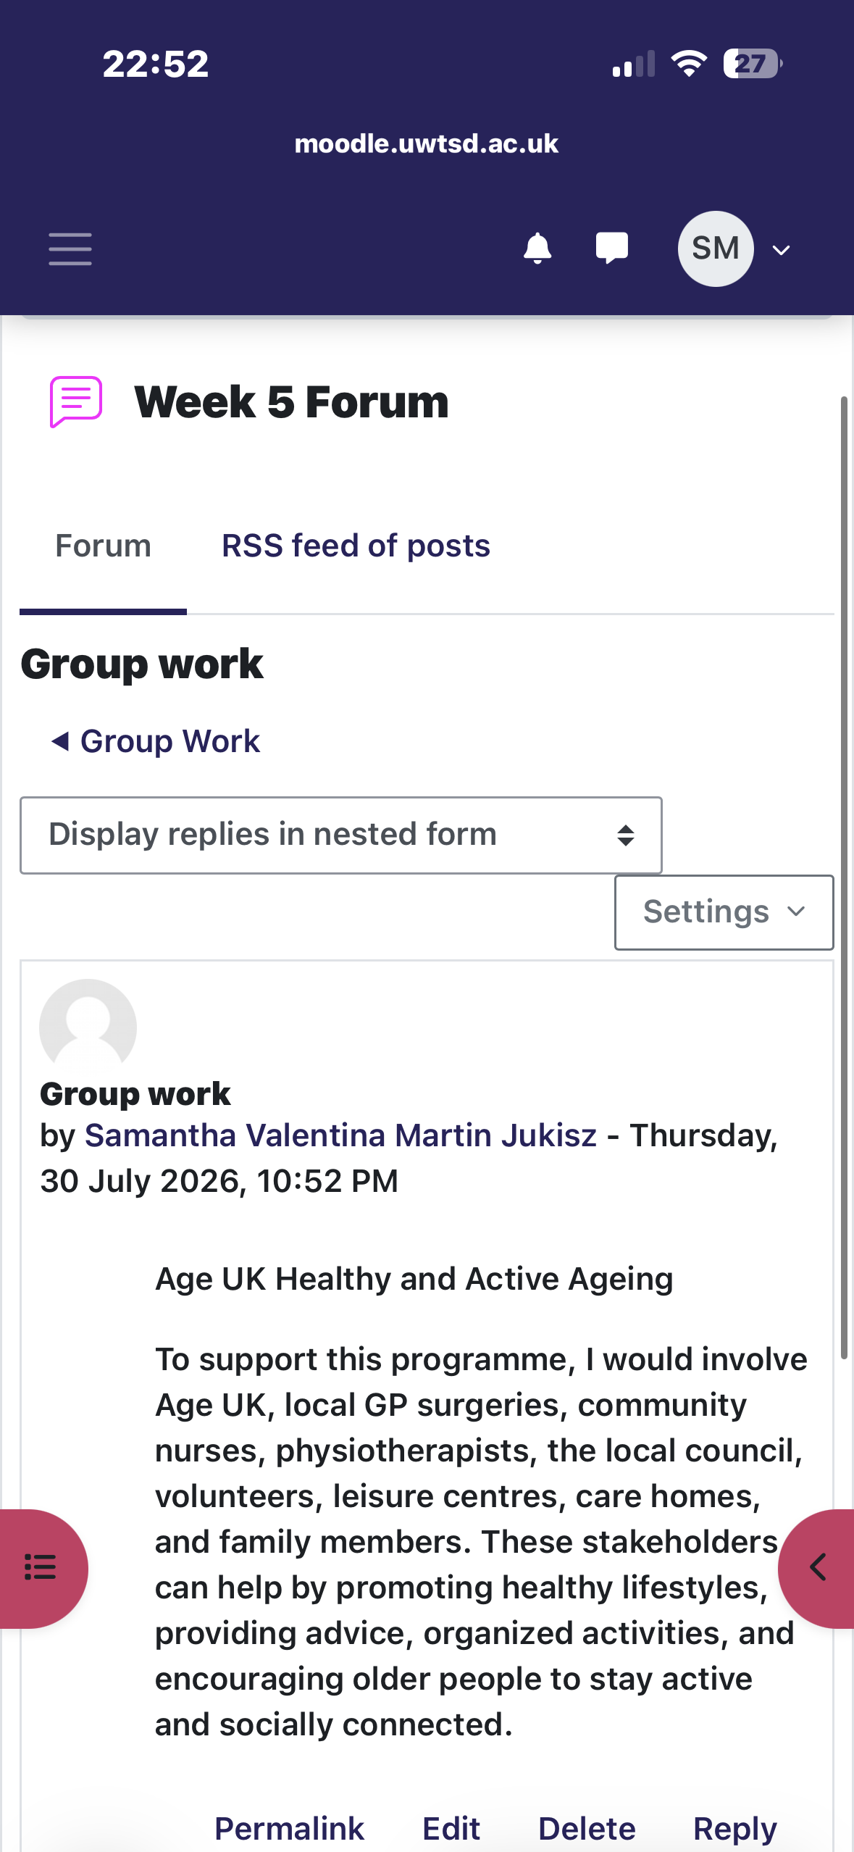
Task 3- Reflection Using Gibbs’ Reflective Cycle
Evidence.

During one of the group activities, my classmates and I discussed the different stakeholders involved in Age UK’s Healthy and Active Ageing programme. We worked together to identify who the key stakeholders were, including older adults, healthcare professionals, local authorities, volunteers and community organisations. We then discussed how each stakeholder contributes to supporting older people to live healthier and more independent lives. Throughout the activity, I shared my ideas, listened to the opinions of others and contributed to the group discussion.

Feelings
At the beginning of the activity, I felt slightly nervous about sharing my opinions because I wanted to make sure my ideas were relevant. However, as the discussion developed, I became more confident because everyone was encouraged to contribute. Working with my group made me feel more comfortable and helped me appreciate the value of teamwork.

Evaluation
Overall, the activity was successful because everyone participated and respected each other’s opinions. Listening to different perspectives helped us identify stakeholders that I had not initially considered, such as carers and community volunteers. One challenge was that some members had different opinions about the importance of certain stakeholders, but we overcame this by discussing our ideas and supporting them with evidence.

Analysis
This experience showed me that effective communication and teamwork are essential in health and social care. Every professional brings different knowledge and experience, which helps improve decision-making and achieve better outcomes for service users. It also reinforced the importance of collaboration between different organisations when planning and delivering care.

Conclusion
Looking back, I believe I contributed positively to the group discussion by sharing ideas and listening respectfully to others. The activity increased my confidence in working collaboratively and helped me understand how different stakeholders contribute to improving health and social care services.

Action Plan
In future group activities, I would like to contribute even more by taking on a leadership role when appropriate and encouraging quieter members of the group to share their opinions. I will also continue developing my communication and teamwork skills, as these are essential for my future career in health and social care.

Task 4-UK Innovation in Health and Social Care
One example of innovation in UK health and social care is the NHS App, which has transformed the way patients access healthcare services. The app allows users to book GP appointments, order repeat prescriptions, view parts of their medical records and access NHS services using a smartphone or computer. This digital innovation has improved accessibility and made healthcare more convenient for many people, particularly those who find it difficult to attend appointments in person.
The introduction of the NHS App demonstrates Rogers’ (2003) Diffusion of Innovation Theory, as it shows how new technology can be adopted to improve healthcare delivery. The app has encouraged more efficient communication between patients and healthcare professionals while reducing administrative workload for GP practices. It has also supported patients to become more involved in managing their own health by providing easy access to personal health information.
Overall, the NHS App has created value by improving patient experience, increasing efficiency and supporting person-centred care. Although some individuals, particularly older adults or those with limited digital skills, may face challenges using the technology, it remains an important innovation that continues to modernise healthcare services across the UK. As digital healthcare continues to develop, innovations such as the NHS App are likely to play an increasingly significant role in improving health outcomes and service delivery.

Task 5 – The Importance of Research in Health and Social Care
Research plays an important role in improving health and social care because it provides evidence that helps professionals make informed decisions and improve patient outcomes. Evidence-based practice ensures that treatments, policies and interventions are supported by reliable research rather than personal opinion or tradition (NICE, 2022). This helps healthcare organisations provide safe, effective and high-quality care.
An example of research leading to innovation is the increasing use of digital health technologies within the NHS. Research has shown that online consultations, electronic patient records and digital monitoring can improve communication between healthcare professionals, reduce waiting times and increase access to healthcare services. These findings have encouraged healthcare organisations to adopt new technologies that improve efficiency while maintaining patient-centred care.
Research also supports continuous improvement by identifying problems within healthcare services and evaluating possible solutions. For example, studies on patient satisfaction and service delivery help organisations understand where improvements are needed and how resources can be used more effectively. As a future health and social care professional, I recognise that using evidence-based research will help me provide safe, effective and person-centred care while contributing to the ongoing development of healthcare services.

Task 6 – Digital Innovation in Health and Social Care

What is digital innovation in health and social care?
Digital innovation refers to the use of technology to improve the way health and social care services are delivered. Examples include electronic patient records, online GP consultations, wearable health devices and the NHS App. These technologies help healthcare professionals communicate more effectively, reduce paperwork and improve access to services. Digital innovation also supports person-centred care by allowing patients to access health information and manage appointments more easily. As healthcare continues to evolve, digital innovation is becoming increasingly important because it improves efficiency while helping organisations meet the changing needs of patients and communities.

What are the benefits and challenges of digital innovation?
Digital innovation offers many benefits, including faster access to healthcare, improved communication between professionals and better management of patient information. It can reduce waiting times, improve patient safety and increase efficiency across health services. However, there are also challenges. Some people, particularly older adults or those with limited digital skills, may struggle to use digital services. Data security and patient confidentiality are also important concerns, meaning organisations must ensure personal information is stored securely. Providing training and support can help reduce these barriers and encourage more people to benefit from digital healthcare services.

How could digital innovation influence your future professional practice?
As a future health and social care professional, I believe digital innovation will become an essential part of everyday practice. Electronic patient records and digital communication systems can improve teamwork by allowing healthcare professionals to share information quickly and accurately. Digital technology can also support better decision-making by providing immediate access to patient information and evidence-based guidance. To provide safe and effective care, I will need to develop my digital skills and remain open to learning about new technologies. Embracing innovation will help me deliver high-quality, person-centred care while adapting to the changing needs of the healthcare sector.

Task 7 – NHS Healthcare Leadership Model
Effective leadership is essential in health and social care because it helps organisations adapt to change, improve services and deliver high-quality patient care. The NHS Healthcare Leadership Model identifies behaviours that support positive leadership and encourage continuous improvement across healthcare organisations. One of the most important behaviours is Leading with Care, which focuses on treating others with compassion, respect and understanding while creating a positive working environment (NHS Leadership Academy, 2013).
Leading with Care is important because healthcare professionals often work in demanding environments where teamwork and communication are essential. Leaders who support and encourage their staff can improve motivation, job satisfaction and staff wellbeing. This can lead to better patient care because employees are more likely to feel valued and confident in their roles. Strong leadership also encourages staff to share ideas, contribute to service improvements and embrace innovation rather than being afraid of change.
During this module, I have learned that leadership is not only about managing people but also about inspiring others to work towards a shared goal. For example, introducing digital innovations such as electronic patient records or the NHS App requires leaders to communicate the benefits of change, provide appropriate training and support staff throughout the implementation process. This reflects Lewin’s (1947) Change Management Model, which highlights the importance of preparing people for change before introducing new ways of working.
Reflecting on my own development, I believe I have improved my communication, teamwork and problem-solving skills throughout this module. Completing the weekly activities helped me understand that good leaders listen to different perspectives, encourage collaboration and make evidence-based decisions. In my future career in health and social care, I hope to demonstrate these leadership qualities by supporting colleagues, embracing innovation and always putting the needs of patients first. Developing effective leadership skills will help me contribute to positive change and improve the quality of care delivered within health and social care services.

Task 8 – Final Reflection
Completing this portfolio has increased my understanding of creativity, innovation, leadership and value creation within health and social care. Before studying this module, I mainly associated innovation with new technology. However, I have learned that innovation also involves developing new ideas, improving existing services and finding creative solutions to challenges that improve outcomes for patients and service users. The activities completed throughout the module have strengthened my research, communication, critical thinking and reflective skills, helping me understand how these contribute to professional practice.
I have also recognised the importance of leadership and teamwork in successfully implementing change. Effective leaders create a positive environment where staff feel supported to share ideas and adapt to new ways of working. Reflecting on my own learning, I believe I have become more confident in analysing problems, evaluating evidence and considering different perspectives before making decisions. In the future, I will continue to develop these skills so that I can contribute to high-quality, person-centred care and support positive change within health and social care organisations.

References
Amabile, T.M. (1996) Creativity in Context. Boulder, CO: Westview Press.
Gibbs, G. (1988) Learning by Doing: A Guide to Teaching and Learning Methods. Oxford: Oxford Polytechnic.
Lewin, K. (1947) ‘Frontiers in Group Dynamics’, Human Relations, 1(2), pp. 143–153.
National Institute for Health and Care Excellence (NICE) (2022) Evidence standards framework for digital health technologies. Available at: https://www.nice.org.uk/corporate/ecd7
NHS (2025) NHS App. Available at: https://www.nhs.uk/nhs-app/
NHS Leadership Academy (2013) Healthcare Leadership Model. Available at: https://www.leadershipacademy.nhs.uk/resources/healthcare-leadership-model/
Porter, M.E. (2010) ‘What is Value in Health Care?’, New England Journal of Medicine, 363(26), pp. 2477–2481.
Rogers, E.M. (2003) Diffusion of Innovations. 5th edn. New York
The King’s Fund (2022) Digital technology and health care. Available at: https://www.kingsfund.org.uk/insight-and-analysis/long-reads/digital-technology-and-health-care
Age UK (2024) Healthy Ageing. Available at: https://www.ageuk.org.uk/our-impact/policy-research/healthy-ageing/

Evidence of forum submissions:
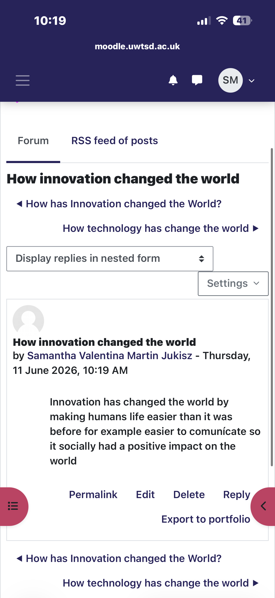
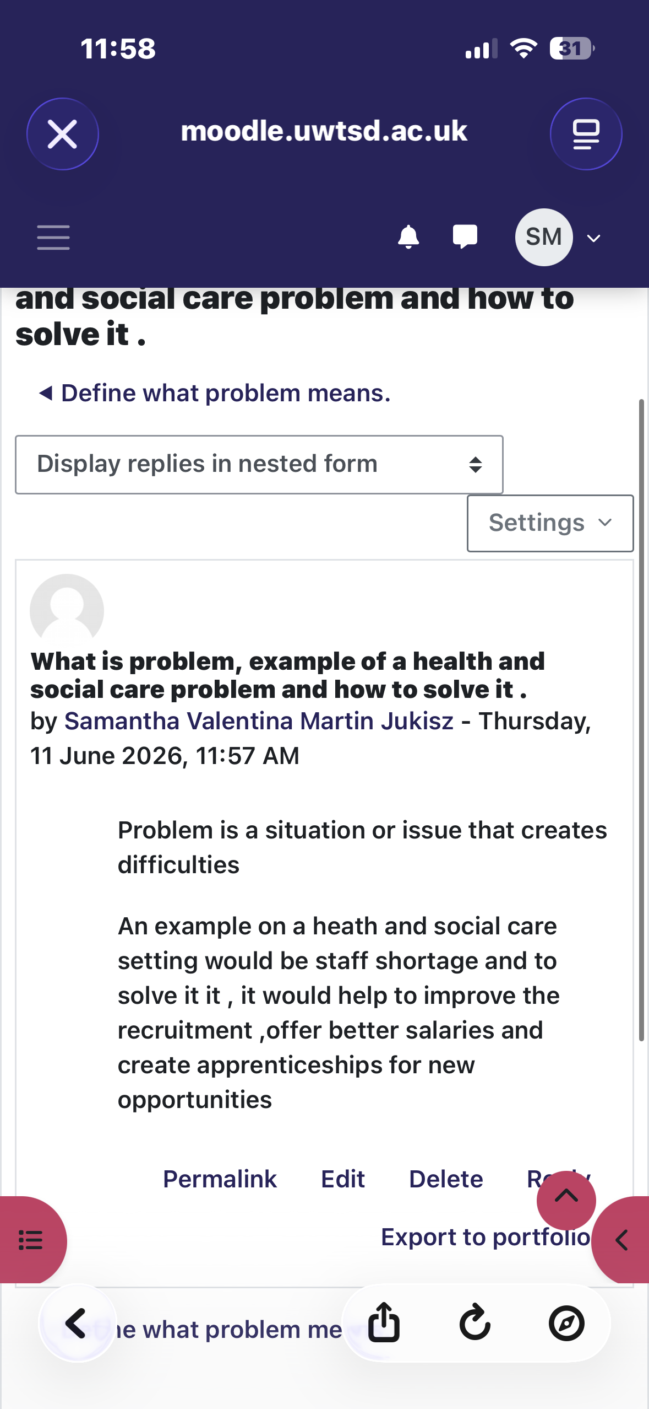
Week 1:
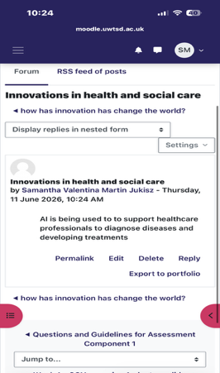
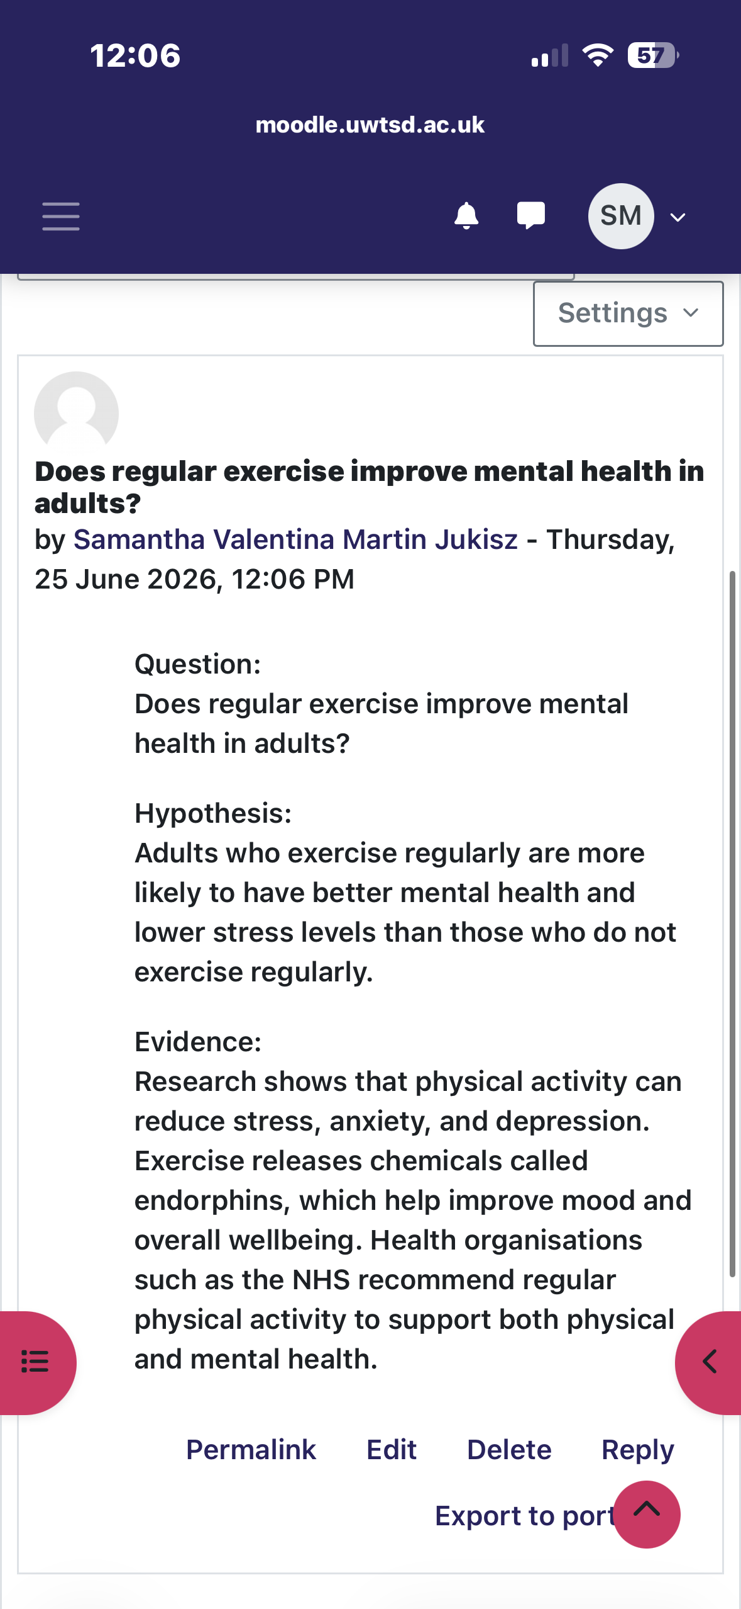
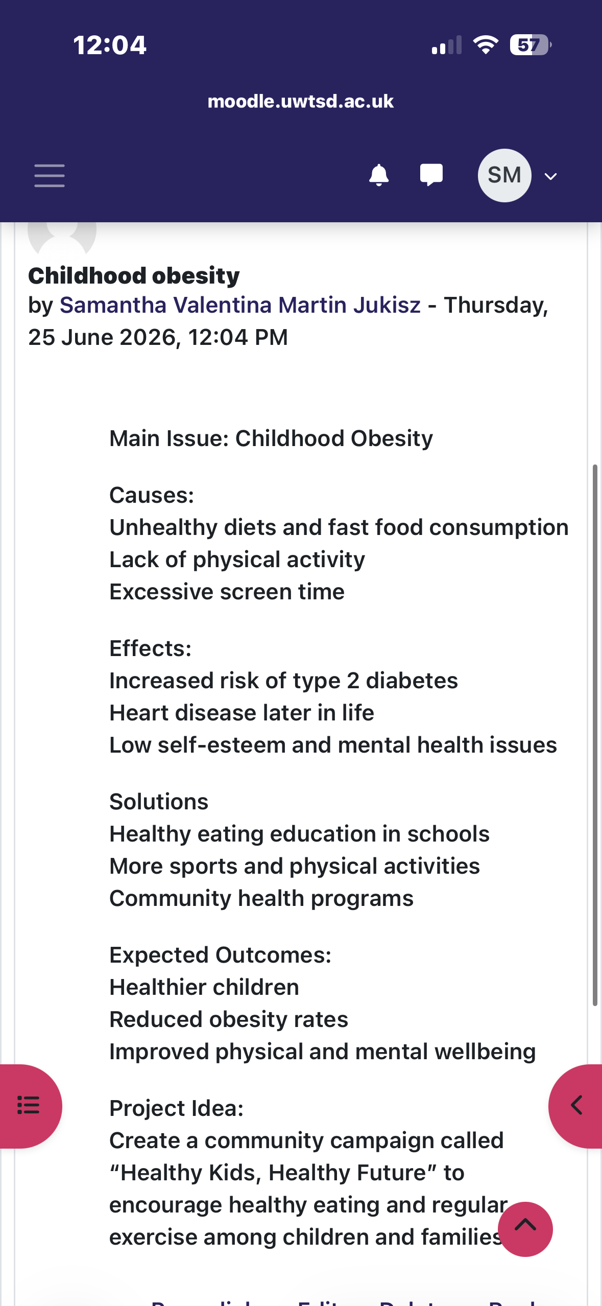
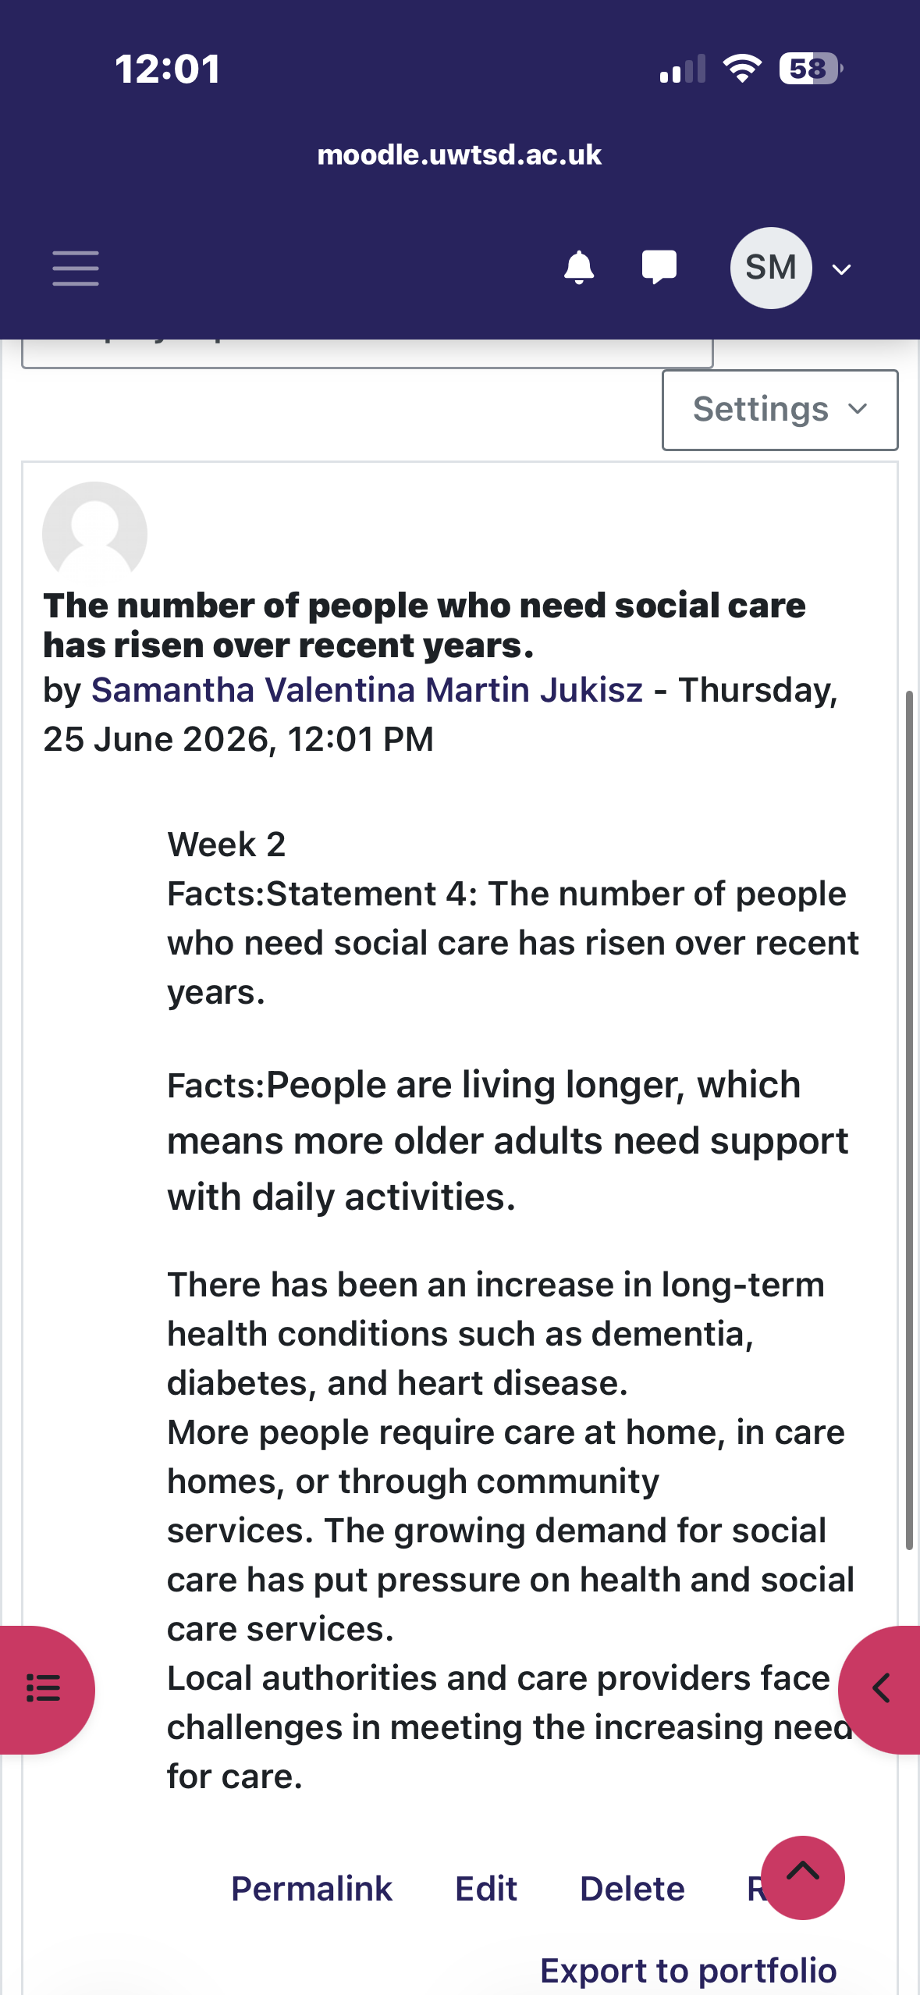
Week 2

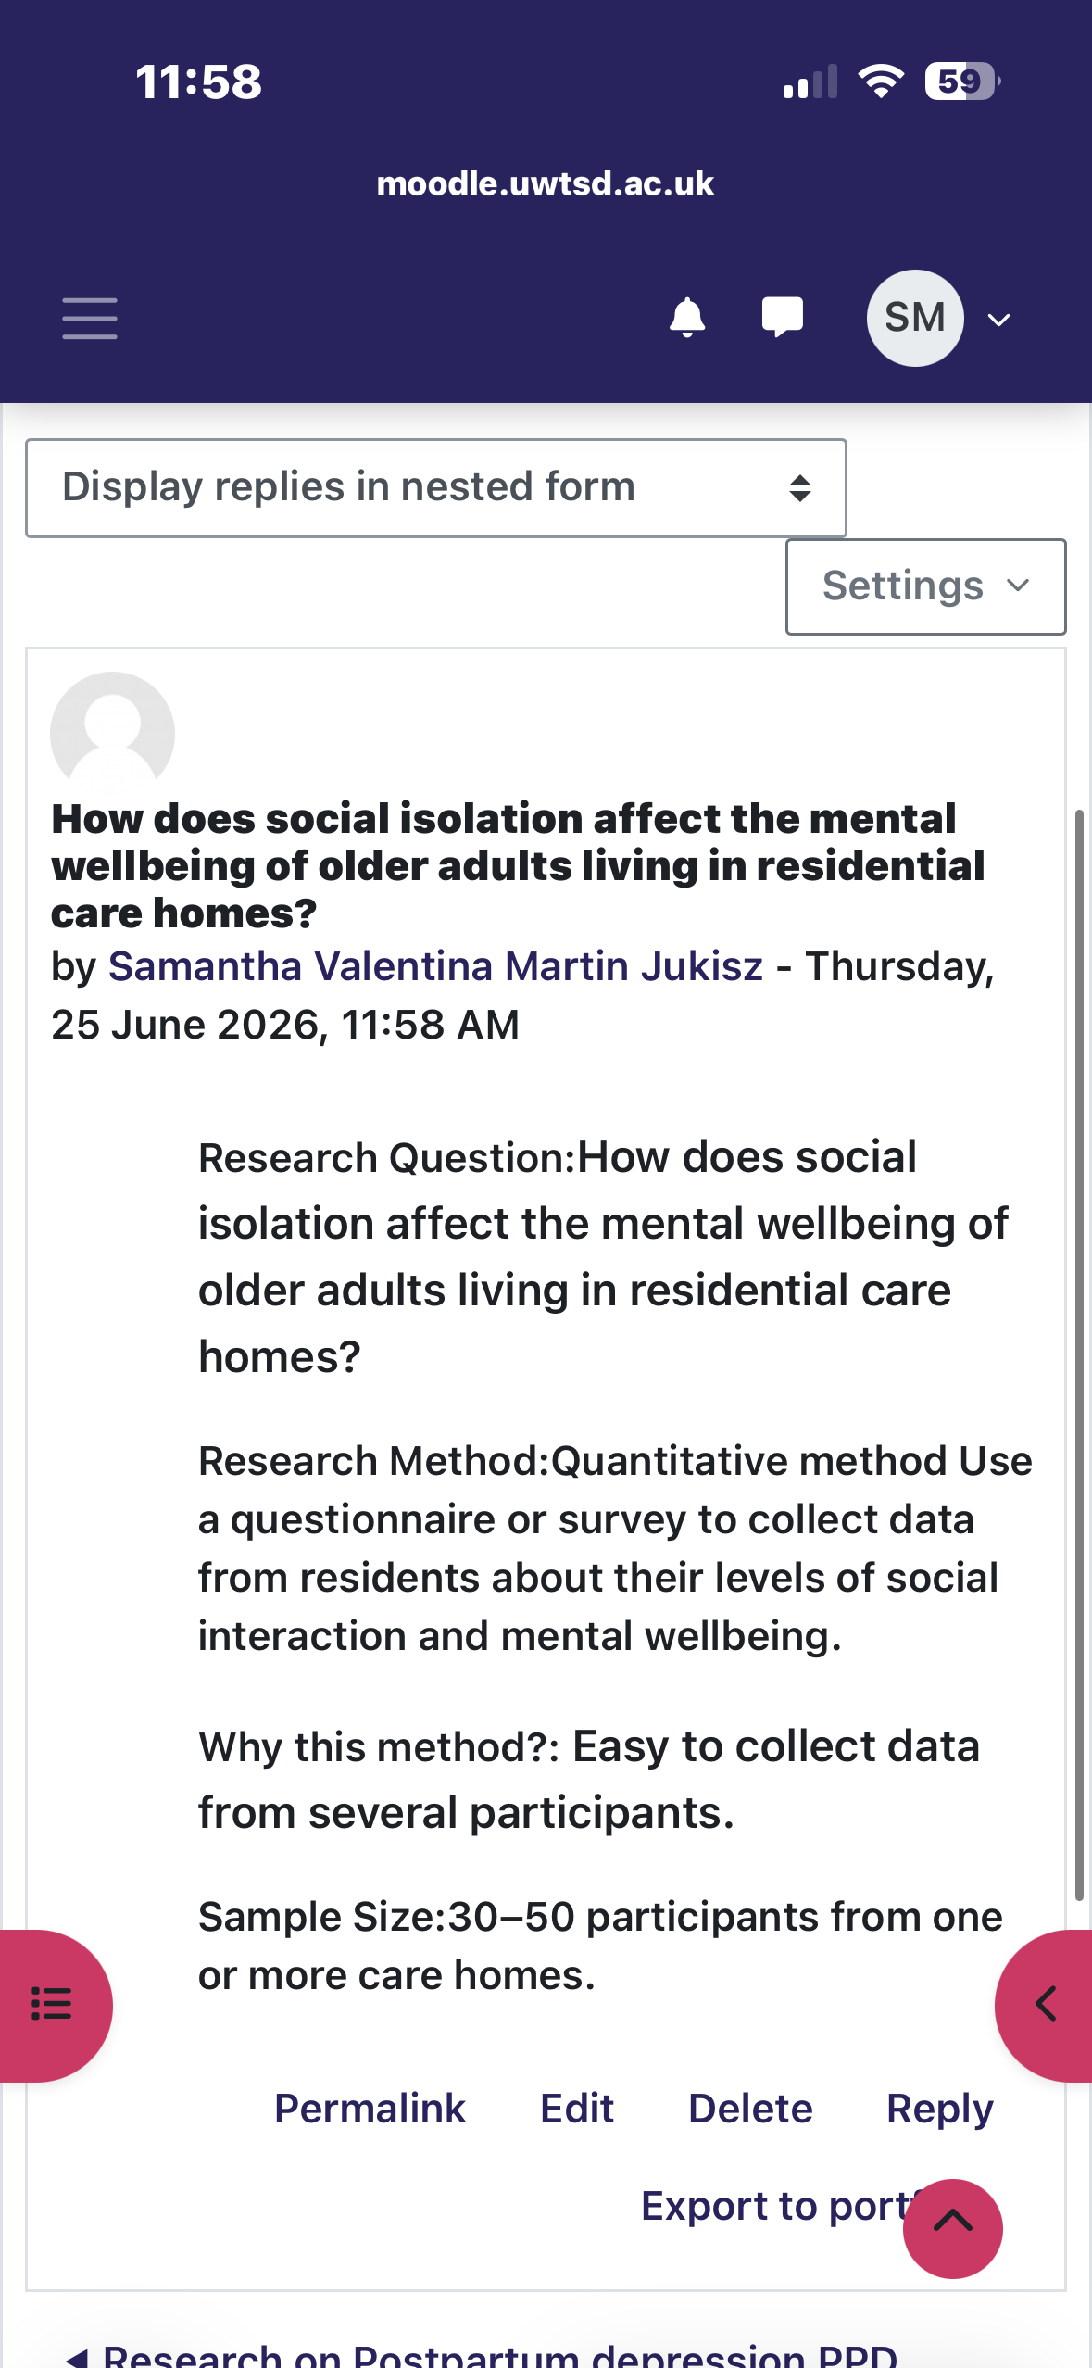
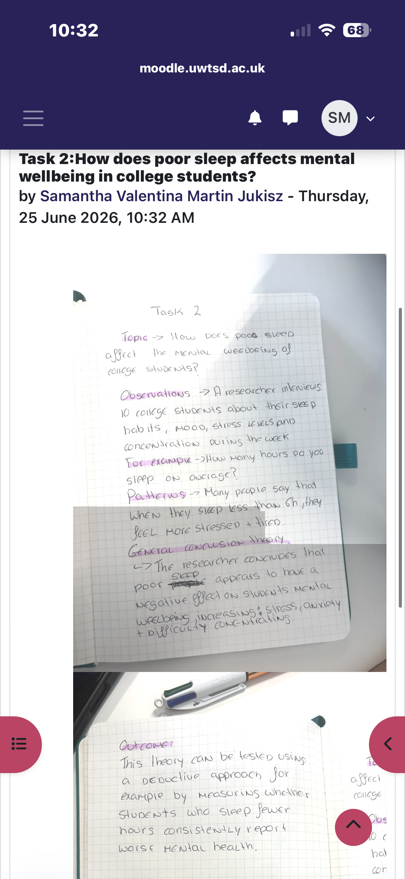
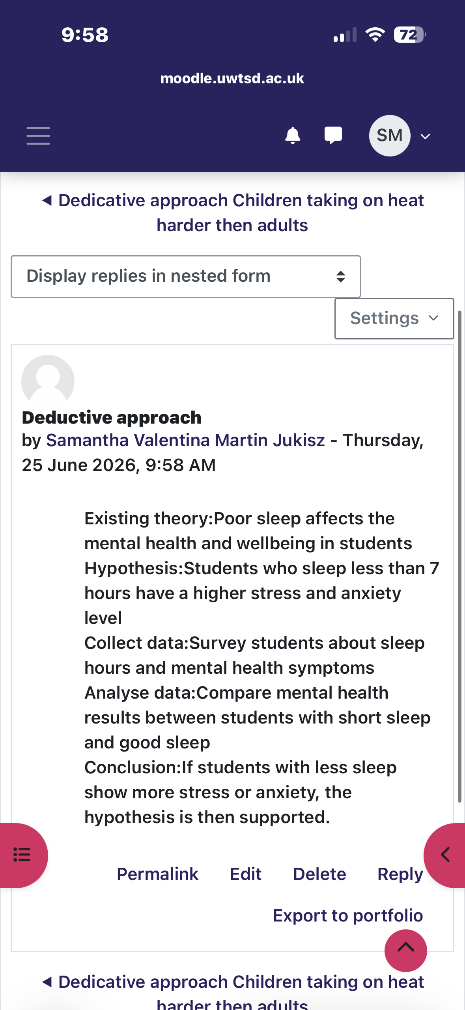
Week 3

Week 4:
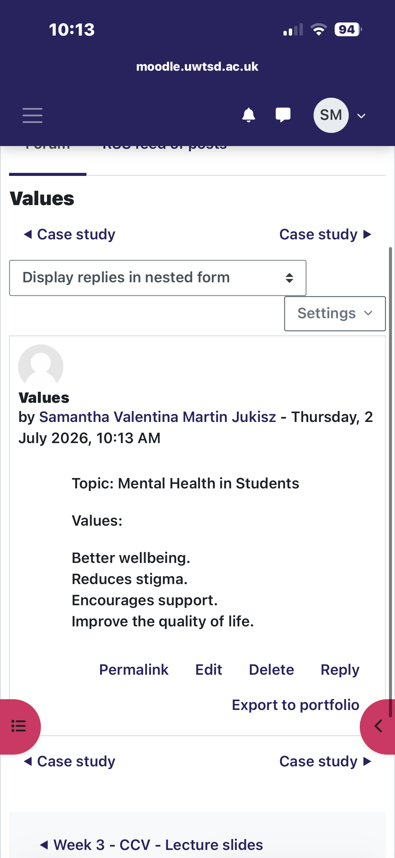
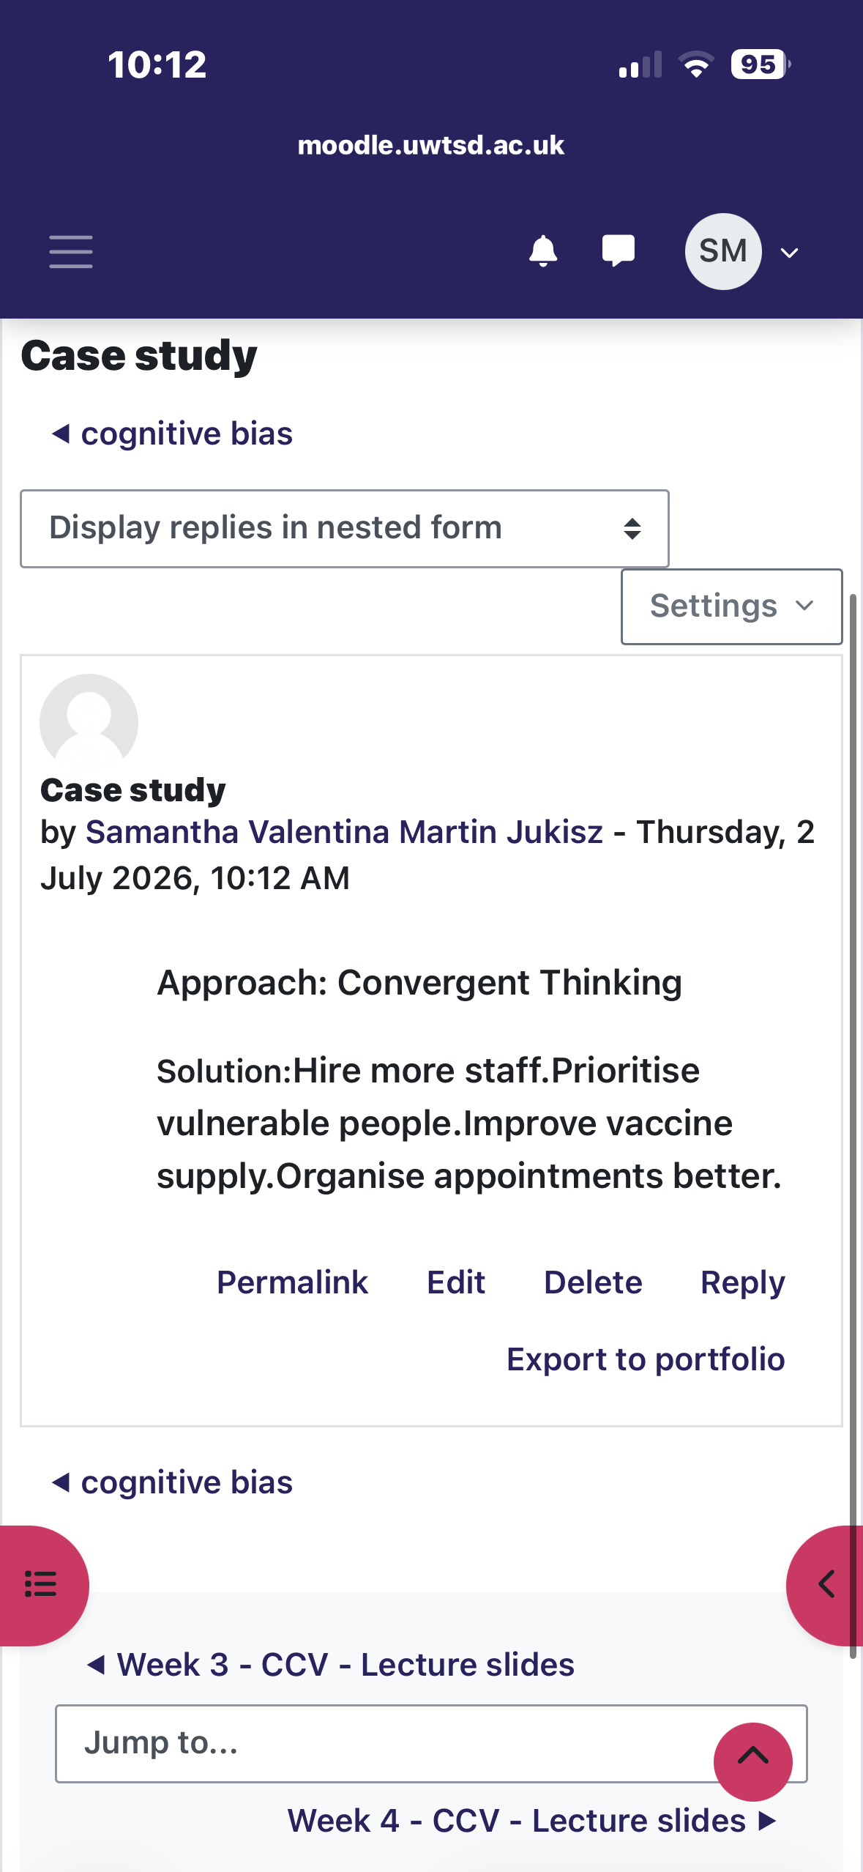
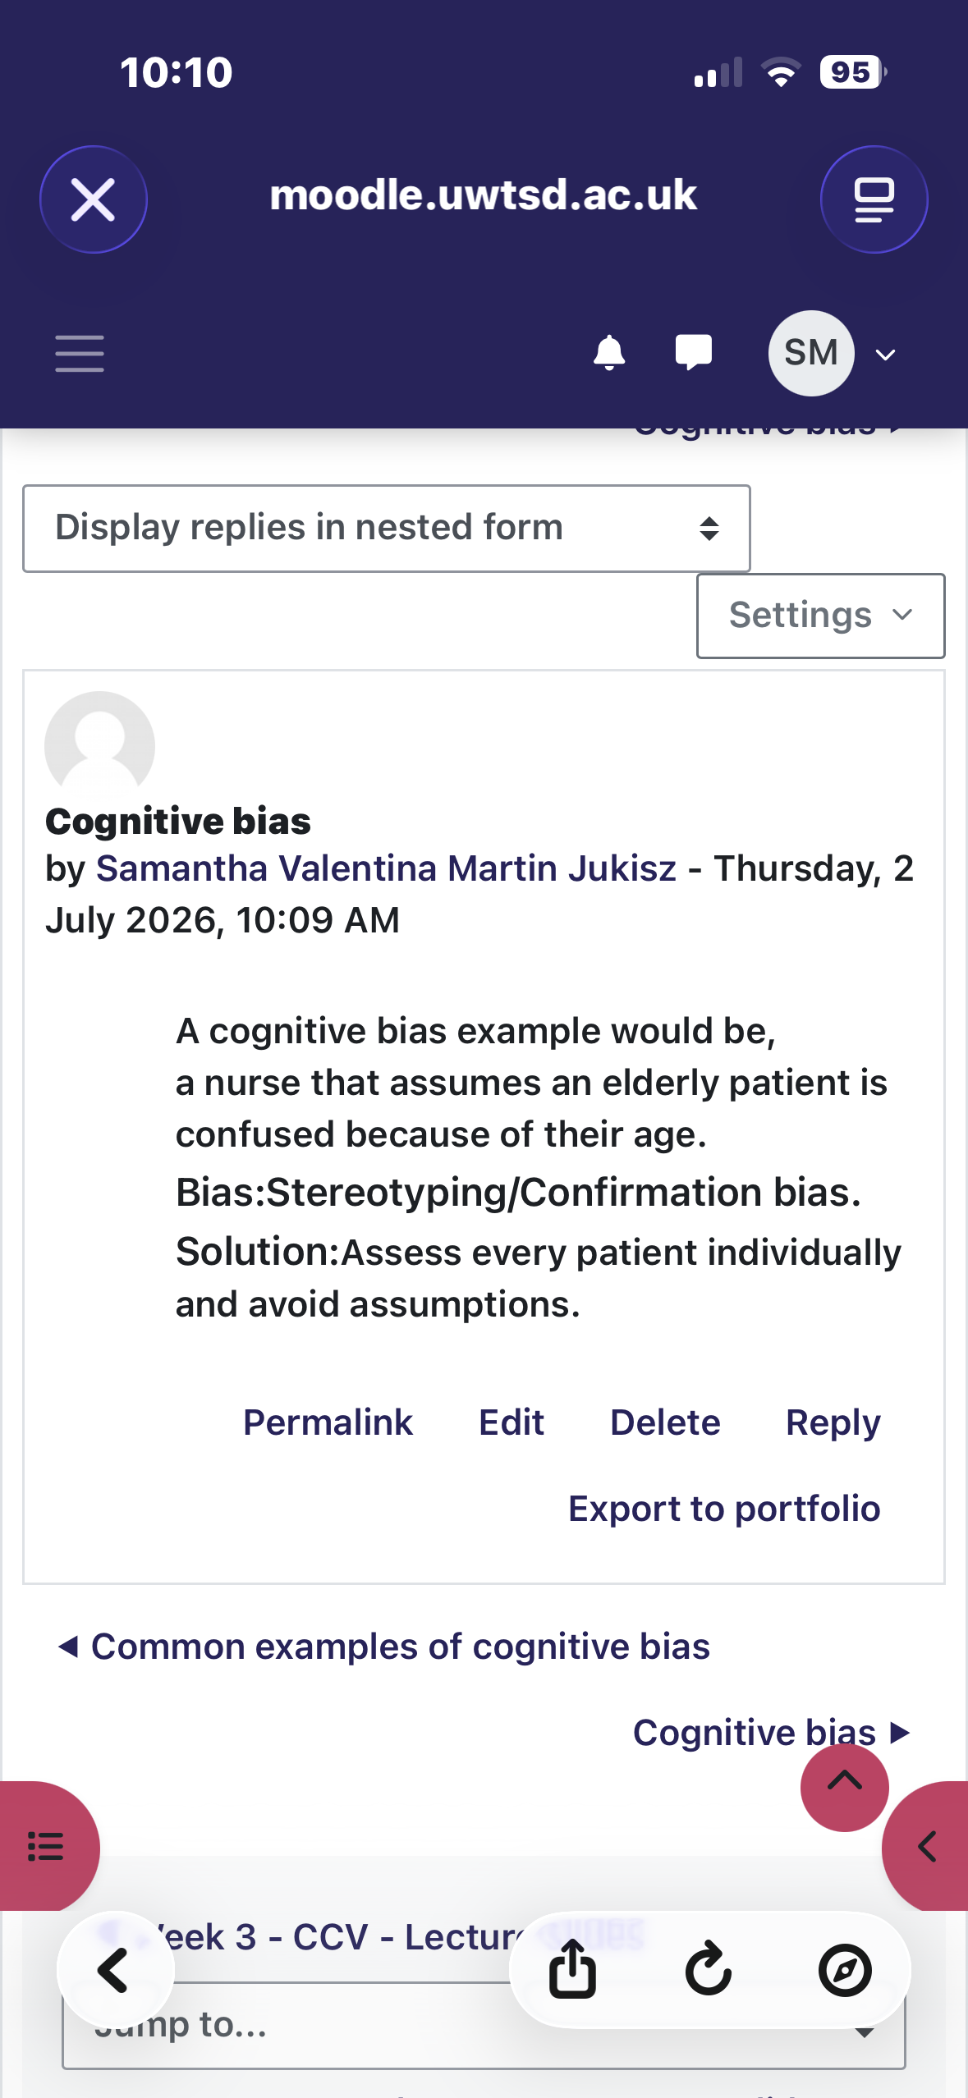

Week 5:

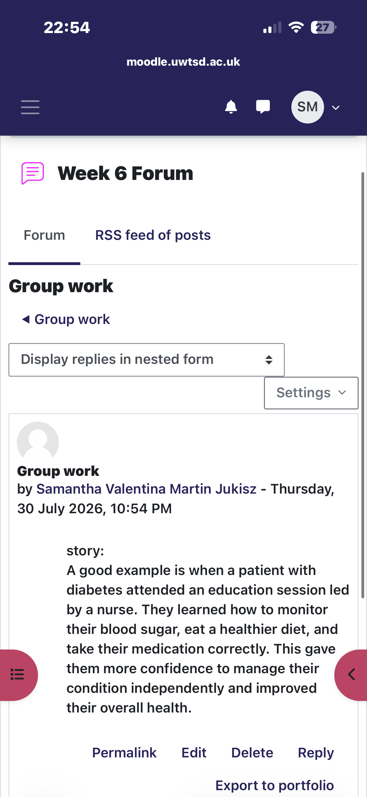
Week 6:

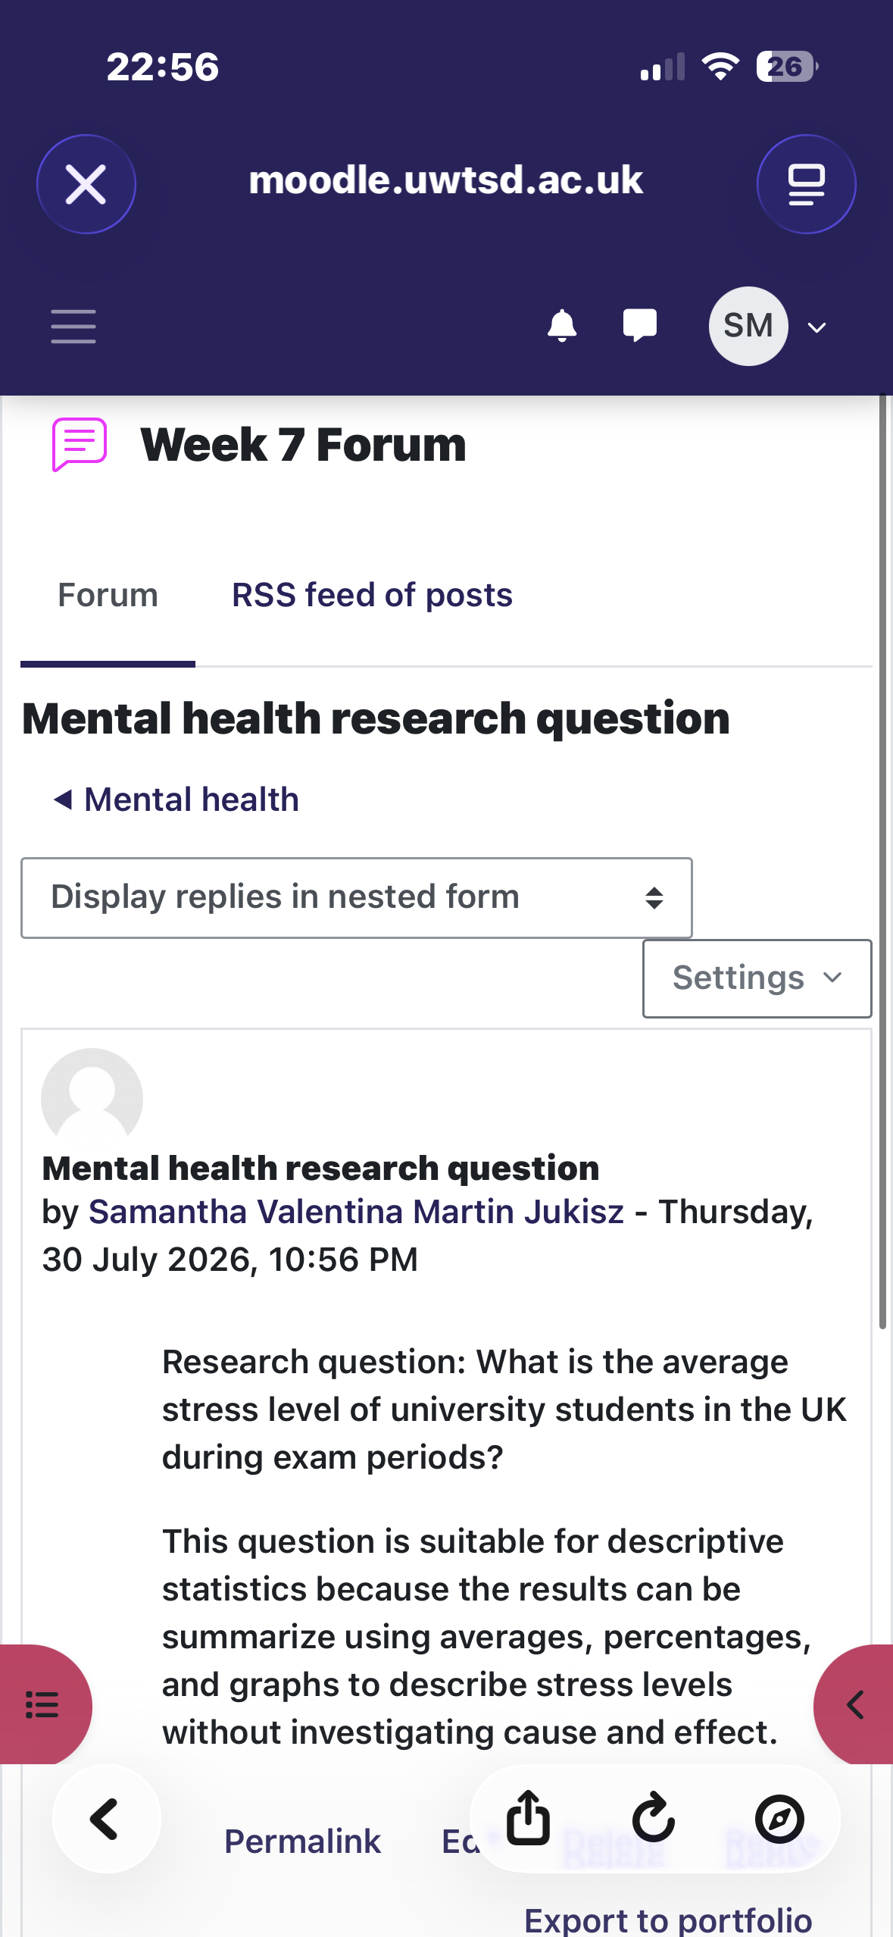
Week 7:

Week 8:


