Assignment 1
Wing Yan Yuen_1813127
University of Wales Trinity Saint David

Abstract
This assignment is aimed to create the database for the estate agency company who are gaining increasing the customer base with friendly and fast services. Here are two parts: one is an Entity Relationship Diagram, another is a user-friendly database.
- Assignment 1

1.a) The Requirements & Assumption of the Entity Relationship Diagram

- There are five main parties: the estate agency company (Home from Home), Vendors, the property hunters, individual buyers from market and potential investors from hunters.
- The estate agency company has many branches in towns and cities in South Wales
- The estate agency company receives the property’s details such as location, sizes and prices etc from variety of vendors, and they associated to vendors and property hunters.
- The estate agency company will make appointments for house viewing from individual buyers and property hunters once they received any instructions from buyers and hunters.
- A viewing of a property is open to many buyers viewing.
- Once the buyer makes the offer to the property which he/she is interested in, the property would stop to allow appointments made from buyers and hunters even though the vendor accepted it or not.
- One vendor can list many properties to the estate agency
- Appointment forms have been created manually and those are used to inform agencies the forthcoming appointments. They could be from calls, emails or walk-in.
- vendors would be required to provide their own details as well, such as their name or company name if listing from organization property, contact details etc.
- With regarding the location of branches far away from others branches and the size of south wales, I assume the agency only work for one branch and the properties near the branch.
- Each buyer or hunter only has one agency to follow the whole procedure.
- Each buyer or hunter could have more than once viewing at the same property at different time.

1.b) Entity Relationship Diagram
Here is the briefly explanation for my ERD. My diagram includes seven entities, such as Agency, Sales properties listing form, Vendors, Agency branches, Appointment form, Property hunters and Individual buyers. Each of entities includes a unique ID (An attribute) for identifying in the table. The relationships between entities are one to one or one to many.
For example, the relationship between Agency and Agency Branches is many to one. The reason why is that many agencies belongs to one branch due to distances being far away between each branch. Agencies only work near their home branch.

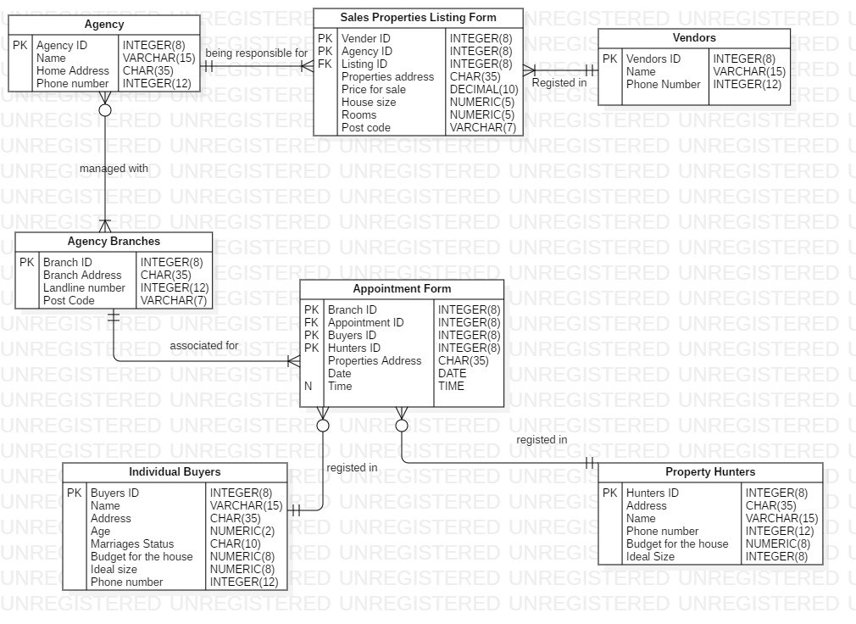

1.c) Normalization table (1NF to 3NF)

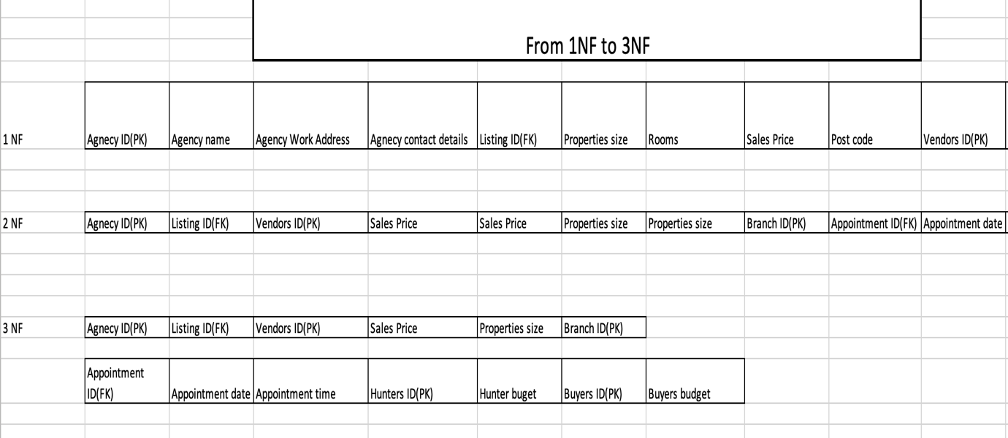
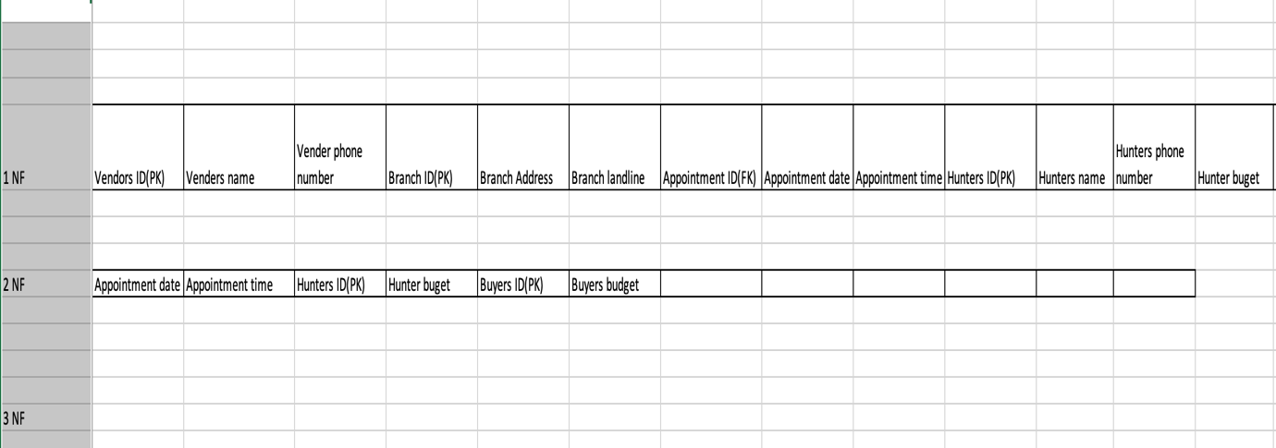
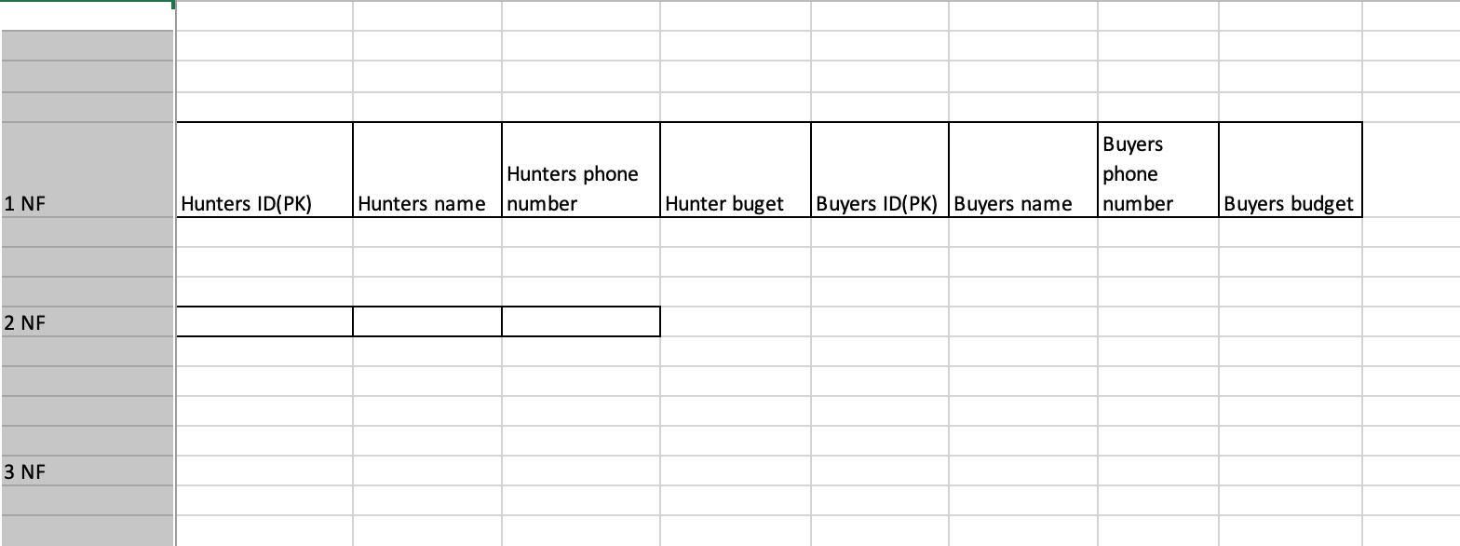

As the table shown, the dependent FD has been reduced to 2NF. And then, it reduced to transitive dependency table.

2) The Database Report

As improving the database and easily finding the information for clients and properties hunters. Here is a database.

The relationship report as below.
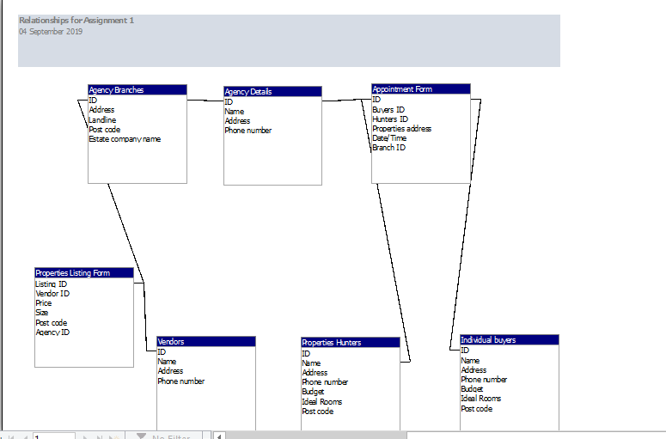
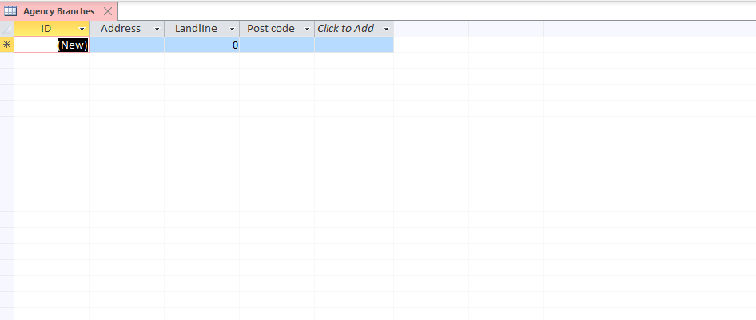
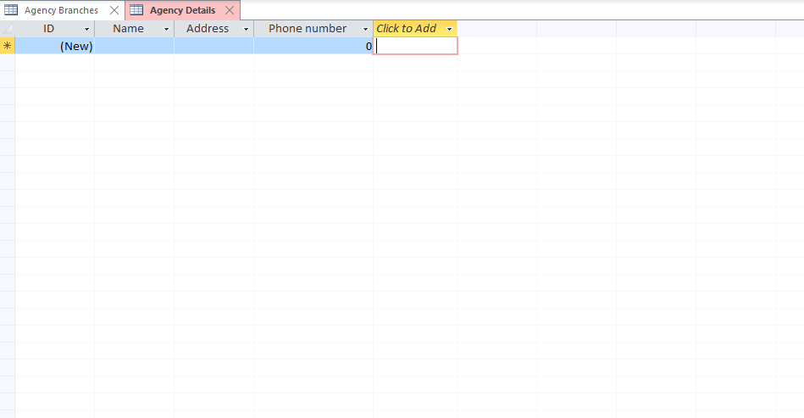
Here are parts of forms from the database. As you can see, there are seven entities are related to.

References
1.https://www.expatica.com/uk/housing/buying/buying-a-house-in-the-uk-103191/#Finding-property
2. https://www.zoopla.co.uk/find-agents/estate-agents/directory/a (find agency list)

