Process Improvement Methodologies

Introduction
Six Sigma is a methodology for tracking constant improvement in profit and customer satisfaction. It’s also a systematic process that helps us concentrate on services and developing and delivering near-perfect products.

Features of Six Sigma
The objective of Six Sigma is to remove waste and inefficiency, thus improving customer satisfaction by delivering what the customer is hoping for.
Six Sigma has clear roles for partakers and follows a designed methodology.
Six Sigma demands precise data collection for the processes being analysed.
Six Sigma is about setting results on Financial Statements.
Six Sigma is an intricately designed and business-driven method for –
- Improving Processes
- Lowering Defects
- Reducing process variability
- Reducing costs
- Increasing customer satisfaction
- Increased profits
The word Sigma is an analytical expression that measures how far a given process differs from perfection.
The concept of Six Sigma: “If you can measure how many "defects" you have in a process, you can systematically figure out how to eliminate them and get as close to "zero defects" as possible and specifically it means a failure rate of 3.4 parts per million or 99.9997% perfect.”

Key Concepts of Six Sigma
Six Sigma focuses on a handful of key concepts.
- Critical to Quality − Attributes most important to the customer.
- Defect − Failing to deliver what the customer wants.
- Process Capability − What your process can deliver.
- Variation − What the customer sees and feels.
- Stable Operations − Improving what the customer sees and feels by ensuring a consistent and predictable processes.
- Design for Six Sigma − Designing to meet customer needs and process capability.
Six Sigma concentrates initially on decreasing process variation and then on enhancing the process capability. “Our Customers Feel the Variance, Not the Mean.”

Benefits of Six Sigma
Six major benefits are provided by Six Sigma that interest companies –
- Generates sustained success
- Sets a performance goal for everyone
- Enhances value to customers
- Accelerates the rate of improvement
- Promotes learning and cross-pollination
- Executes strategic change

Methodology
Six Sigma has two main methodologies –
- DMAIC − This methodology is used to enhance an existing business process. It concerns a data-driven quality approach for improving processes.
- DMADV − This methodology is used to build new product designs or process designs that results in a more predictable, mature and defect free performance. It concerns a data-driven quality approach for designing products & processes.
There’s another methodology named DFSS – Design for Six Sigma. DFSS is a data-driven quality approach for designing or redesigning a product or service from the ground up.
On occasion, a DMAIC project may lead into a DFSS project because the process demands complete redesign to accomplish the required measure of improvement.

DMAIC Methodology
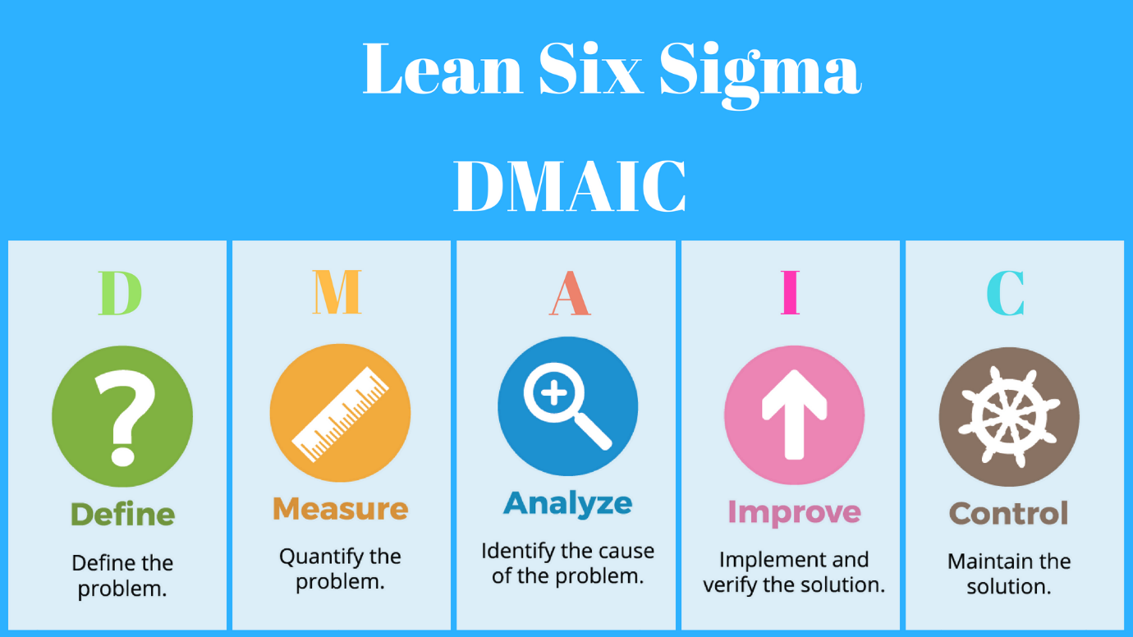
Fig. 1 – DMAIC Approach in Lean Six Sigma

This methodology comprises of the consecutive 5 measures –
Define --> Measure --> Analyse --> Improve --> Control
- Define − Define the problem or project goal that needs to be addressed.
- Measure − Measure the problem and process from which it was produced.
- Analyse − Analyse data and process to determine root causes of defects and opportunities.
- Improve − Improve the process by finding solutions to fix, diminish, and prevent future problems.
- Control − Implement, control, and sustain the improvements solutions to keep the process on the new course.

DMAIV Methodology
The methodology comprises of 5 measures –
Define --> Measure --> Analyse --> Design --> Verify
- Define − Define the Problem or Project Goal that needs to be addressed.
- Measure − Measure and determine customers’ needs and specifications.
- Analyse − Analyse the process to meet the customer needs.
- Design − Design a process that will meet customer’s needs.
- Verify − Verify the design performance and ability to meet customer needs.

DFSS Methodology
DFSS is a separate and emerging discipline related to Six Sigma quality processes. This is a systematic methodology utilizing tools, training, and measurements to enable us to design products and processes that meet customer expectations and can be produced at Six Sigma Quality levels.
This methodology comprises of the 5 consecutive measures –
Define --> Identify --> Design --> Optimize --> Verify
- Define − Define what the customers want, or what they do not want.
- Identify − Identify the customer and the project.
- Design − Design a process that meets customer’s needs.
- Optimize − Determine process capability and optimize the design.
- Verify − Test, verify, and validate the design.

Define Phase
Six Sigma is constructed of five high-level measures to enhance the quality of output. Define is the first measure. Four major tasks are tackled during this phase.

Project Team is Formation
Perform two activities –
- Decide who your team will be
- Who will perform what roles
Selecting who is right for your team can be a challenging task, especially if a project incorporates a vast number of departments. In such dilemmas, the tactical approach would be to dissect the project into lesser sections and work towards completion of a series of phased projects.

Document Customers Core Business Processes
Customers are part of every project. A customer is a beneficiary of the product or service of the process, chosen for improvement. Every supplier receives needs from their customers. There are requirements for each need provided. Whether the customer is happy with the product or service provided depends on the requirements of the need. Therefore, customer needs and related requirements is documented.
An assortment of business processes is documented. To settle their Critical to Quality issues, these processes will be achieved to meet customer's requirements.

Develop a Project Charter
This document titles the project, clarifies the business case in a brief statement by summarising the project, and records the project scope and goals. A project charter has the following elements –
- Project name
- Business case
- Project scope
- Project goals
- Milestones
- Special requirements
- Special assumptions
- Roles and responsibilities of the project team

Develop the SIPOC process map
A process is defined as a series of steps and activities that take inputs, add value, and produce an output.
SIPOC is a process map that recognises all the following components of a project –
- Suppliers
- Input
- Process
- Output
- Customers

Conclusion
You should know who the customer or end-user is, their resistance issues, and requirements, at the end of the design phase. You should also have a clear understanding of goals and the scope of the project including budget, time constraints, and deadlines.

Measure Phase
The overall performance of the Core Business Process is considered, during the Measure Phase.
The Measure Phase comprises of three fundamental pieces.

Data Collection Plan and Data Collection
To gather the data needed, a data collection plan is assembled. This plan contains what type of data needs to be collected, what are the sources of data, etc. To recognise areas where current processes need to be improved, is why data is collected.
Input, process, and output are the three main sources where you gather your data.
- The process is produced from the input source
- Process data refers to tests of efficiency: the time requirements, cost, value, defects or errors, and labour spent on the process.
- Output is a measurement of efficiency.

Data Evaluation
Sigma is calculated from the gathered data, at this point. It offers an estimate number of defects.
- A Six Sigma defect is defined as anything outside of customer specifications.
- A Six Sigma opportunity is the total quantity of opportunities for a defect.
Defects Per Million Opportunities (DPMO) is calculated first, a Sigma is determined from a predefined table based on that –
$$DPMO= \frac{Number of defects}{Number of units x Number of opportunities} x 1,000,000$$
From the equation above, the total number of defects found is Number of defects, number of units given is Number of units, and the number of ways to create defects is Number of opportunities.
For example, the Concast tundish and mould powder ordering delivery project team examines 50 deliveries and discovers the following –
- Delivery is not on time (13)
- Ordered powder is not according to order (3)
- Powder is past expiry date (0)
DPMO will be as follows –
$$DPMO= \frac{13+3}{50 x 3} x 1,000,000=106,666.7$$
Under 106,666.7 defects per million opportunities is approximate to a sigma performance of between 2.7 and 2.8. In relation to the Yield to Sigma Conversion Table displayed below.
Yield % | Sigma | Defects Per Million Opportunities
99.9997 | 6.00 | 3.4
99.9995 | 5.92 | 5
99.9992 | 5.81 | 8
99.9990 | 5.76 | 10
99.9980 | 5.61 | 20
99.9970 | 5.51 | 30
99.9960 | 5.44 | 40
99.9930 | 5.31 | 70
99.9900 | 5.22 | 100
99.9850 | 5.12 | 150
99.9770 | 5.00 | 230
99.9670 | 4.91 | 330
99.9520 | 4.80 | 480
99.9320 | 4.70 | 680
99.9040 | 4.60 | 960
99.8650 | 4.50 | 1350
99.8140 | 4.40 | 1860
99.7450 | 4.30 | 2550
99.6540 | 4.20 | 3460
99.5340 | 4.10 | 4660
99.3790 | 4.00 | 6210
99.1810 | 3.90 | 8190
98.9300 | 3.80 | 10700
98.6100 | 3.70 | 13900
98.2200 | 3.60 | 17800
97.7300 | 3.50 | 22700
97.1300 | 3.40 | 28700
96.4100 | 3.30 | 35900
95.5400 | 3.20 | 44600
94.5200 | 3.10 | 54800
93.3200 | 3.00 | 66800
91.9200 | 2.90 | 80800
90.3200 | 2.80 | 96800
88.5000 | 2.70 | 115000
86.5000 | 2.60 | 135000
84.2000 | 2.50 | 158000
81.6000 | 2.40 | 184000
78.8000 | 2.30 | 212000
75.8000 | 2.20 | 242000
72.6000 | 2.10 | 274000
69.2000 | 2.00 | 308000
65.6000 | 1.90 | 344000
61.8000 | 1.80 | 382000
58.0000 | 1.70 | 420000
54.0000 | 1.60 | 460000
50.0000 | 1.50 | 500000
46.0000 | 1.40 | 540000
43.0000 | 1.32 | 570000
39.0000 | 1.22 | 610000
35.0000 | 1.11 | 650000
31.0000 | 1.00 | 690000
28.0000 | 0.92 | 720000
25.0000 | 0.83 | 750000
22.0000 | 0.73 | 780000
19.0000 | 0.62 | 810000
16.0000 | 0.51 | 840000
14.0000 | 0.42 | 860000
12.0000 | 0.33 | 880000
10.0000 | 0.22 | 900000
8.0000 | 0.09 | 920000
Fig. 2 – Yield to Sigma Conversion Table
As we progress through a project, this is the approach used for measuring results. This starting point allows us to discover the cause and effect of those processes and to seek defect point so that the procedure can be improved.

Failure Mode and Effects Analysis – FMEA
FMEA is the concluding element of the measure phase. It refers to preventing defects before they happen. The FMEA process often involves rating potential defects, or failures, in three ways –
- The probability that something might go wrong.
- The ability to identify a defect.
- The level of severity of the defect.
A rating scale may be used. For example, rate each of these three sections from 1 to 10, with 1 being the lowest FMEA level and 10 being the highest. The more severe the rating, the higher the level. Therefore, a high FMEA suggests the need to devise and implement improved measuring steps within the overall process. This would have the effect of avoiding defects. if the probability of a defect is low, there is no need to spend a lot of time on this procedure.

Analyse Phase
The objective of Six Sigma is to explain the causes of defect, measure those defects, and analyse them so that they can be lowered. To aid to promote the goals of the project, we deem there to be five distinct kinds of analyses. These are source, process, data, resource, and communication analysis.

Source Analysis
This is also known as root cause analysis. It aims to locate defects that are obtained from the sources of information or work generation. Aims are made to rectify the problem before we anticipate removing defects from the product.

Three Steps to Root Cause Analysis
- The open step − The project team brainstorms all the potential reasons for current sigma performance, during this phase
- The narrow step – The project team reduces the list of potential reasons for current sigma performance, during this phase
- The close step − The project team validates the reduced list of reasons that explain sigma performance, during this phase.

Process Analysis
Analyse the findings to determine how well or poorly the processes are working, compared to what's possible and what the competition is achieving.
Process analysis involves producing a more detailed process map, and analysing the more detailed map, where the utmost inefficiencies exist.
The source analysis is generally difficult to distinguish from process analysis. The process refers to the exact movement of materials, information, or requests from one place to another.

Data Analysis
Use of measures and data (those already collected or new data gathered in the analyse phase) to discern patterns, tendencies or other factors about the problem that either indicate or prove/disprove potential cause of the problem.
The data itself may have defect. There may be an instance when products or deliverables do not offer all the needed information. Therefore, data is analysed to discover defects and attempts are made to rectify the problem before we expect to remove defects from the product.

Resource Analysis
Employees in all department that influence the process need to be adequately trained. If training is inadequate, you want to recognise that as a cause of defects.
Other resources include raw materials needed to manufacture, process, and deliver the goods. For example, if the Accounting Department is not paying vendor bills on time and, consequently, the vendor holds up a shipment of shipping supplies, it becomes a resource problem.

Communication Analysis
Most processes high in defects is poor communication is one common problem. The classic interaction between a customer and a retail store is worth examining because many of the common communication problems are evident in this case.
The same kinds of problems happen with internal customers as well, even though we may not identify the sequence of events as a customer service problem.
The exercise of observing issues from both points of view is instructive. A vendor wants payment according to agreed-upon terms, but the Accounting Department wants to make its batch processing uniform and efficient. Between these kinds of groups, such disconnects demonstrates the importance of communication analysis.

Conclusion
Analysis can take many forms. Some Six Sigma programs lean towards the use a lot of diagrams and worksheets, and others prefer discussion and list making. There are several tools that can be used to execute analysis like Box Plot, Cause and Effect Diagram, Progressive Analysis, Ranking, Pareto Analysis, Prioritization Matrix, Value Analysis, etc. Presuming that the result is successful, the appropriate procedure is the one that works best for your team.

Improve Phase
The improve phase of DMAIC can be quick, easy, and satisfying work, If the project team does an attentive job in the root causation phase of analysis.
The aim of improve phase is to identify improvement breakthroughs, identify high gain alternatives, select preferred approach, design the future state, determine the new Sigma level, perform cost/benefit analysis, design dashboards/ scorecards, and create a preliminary implementation plan.
- Identify Improvement Breakthroughs –
- Apply idea-generating tools and techniques to recognise possible solutions that remove root causes.
- Identify/Select High Gain Alternatives −
- Apply idea-generating tools and techniques to recognise possible solutions that remove root causes.
- Develop criteria to evaluate candidate improvement solutions.
- Think systematically and holistically.
- Prioritize and evaluate the candidate solutions against the solution evaluation criteria.
- Conduct a feasibility assessment for the highest value solutions
- Develop preliminary solution timelines and cost-benefit analysis to aid in recommendation presentation and future implementation planning.
Improvement can include a simple fix once we learn the causes of defects. However, in some cases, we may need to employ additional tools as well. These include −
- Solution alternatives
- Experiments with solution alternatives
- Planning for future change

Control Phase
The final phase of DMAIC is control, which is the phase where we guarantee that the processes continues to work well, produce desired output results, and maintain quality levels. You will be involved with four distinct aspects of control, which are as follows.

Quality Control
The goal in control is the overall guarantee that a high standard of quality is met. Customer's expectations depend on this, so control is naturally linked with quality.
Improvement of the overall process by lowering defects is the aim of Six Sigma. For keeping the whole process on track, quality control is the required method; for allowing us to spot trouble and repair it; and for deeming how effectively the project was achieved and performed.
Six Sigma’s philosophy is quality. Lowering defects has all to do with striving for perfection. The effort expresses our approach towards quality itself.

Standardisation
Standardisation allows processes to run as effortlessly as possible. The benefit of standardisation has been proven time and time again in a manufacturing environment.
So that most work is controlled in a standardized manner, we need to construct a control feature to processes.

Control Methods and Alternatives
To control work flow, the development of a new process of any change to an existing process demands the development of procedures.
There need to be alternatives, short of forcing compliance to the standardised method, when a process cannot be handled in the normal fashion.

Responding when Defects Occur
Once a defect is uncovered, knowing how to act is the last step in a control process. The weak links in the procedure, where defects are most likely to happen, can and should be monitored meticulously so that defects can be detected and repaired before the process continues.
The reaction to a defect may be to prevent a detected flaw from becoming a defect at all. In the best designed systems, defects can be lowered to near zero, so that we may accept that Six Sigma can be achieved.

Conclusion
The project team influences how to technically control the newly improved process and produces a response plan to guarantee the new process and continues the improved sigma performance.

References
https://www.tutorialspoint.com/six_sigma/index.htm

