University of Wales Trinity Saint David
Wales Institute of Science and Art



Kinetic Energy Recovery
ACHA5010

Jack Purnell
2205053
January 2024

Contents
1 Introduction 3
2 Research 4
2.1 Test Vehicle Reasoning 4
2.2 Vehicle Dynamic Characteristics 4
3 Test Procedure 6
3.1 Worldwide harmonised Light vehicle Test Procedure (WLTP) 6
3.2 Deceleration 6
3.3 Calculations 7
3.4 Graphs 8
4 Kinetic Energy Recovery System 10
5 Conclusion 11
6 Reference List 12

Figure 1 - 2017 Ford Fiesta Ecoboost 4
Figure 2 - WLTP Class 3b Test 6
Figure 3 - First 100 seconds of WLTP Class 3b Test 6
Figure 4 - WLTP Class 3b with 'coast down' line 7
Figure 5 - WLTP Resistance Plot 8
Figure 6 - WLTP Velocity Plot 8
Figure 7 - WLTP Power Plot 9

Table 1 - Drag Coefficient vs Type of Objects (The Engineering Toolbox, 2004) 5
Table 1 - Drag Coefficient vs Type of Objects (The Engineering Toolbox, 2004) 5
Table 2 - Rolling Resistance Coefficients (The Engineering Toolbox, 2008) 5

Equation 1 - Estimated Frontal Area 4
Equation 2 - Force 7
Equation 3 - Rolling Resistance (Sandford, 2023a) 7
Equation 4 - Vertical Force 7
Equation 5 - Aerodynamic Resistance (Sandford, 2023a) 7
Equation 6 – Power (Sandford, 2023a) 8

Introduction
This report will include all of my research and findings of an investigation carried out to identify the most suitable Kinetic Energy Recovery System (KERS) for a vehicle of my choice in order to improve the fuel economy. I will explain in detail why my choice of vehicle is a valid one for the investigation. I will explain my reasoning behind, and justify why I have selected specific components and I will discuss the real-word viability and practicality of these choices.

Research

Test Vehicle Reasoning
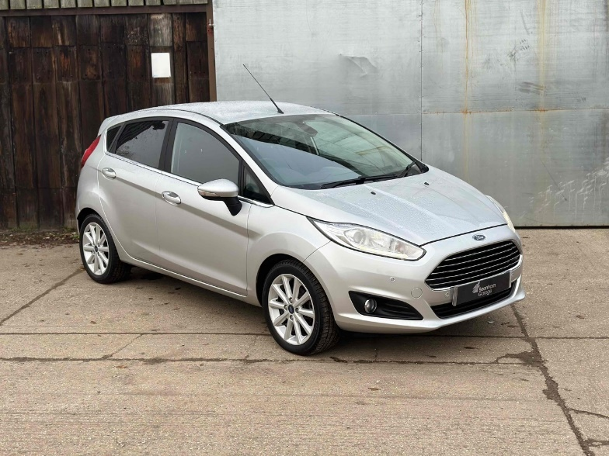
The vehicle I have chosen for this investigation is a 2017 Ford Fiesta EcoBoost (Figure 1). The reason as to why I have chosen this vehicle is because I personally own one, therefore I should easily be able to access as much information as possible about the vehicle. This vehicle is also a good choice as it is a very common vehicle on UK roads, therefore there should be a very large dataset available to me to support my reasoning for all choices I make for the KERS.
Figure 1 - 2017 Ford Fiesta Ecoboost

Vehicle Dynamic Characteristics
For this project I am required to research and find the following characteristics of my vehicle:
- Test Mass
- Frontal Area
- Rolling Friction Coefficient
- Coefficient of Aerodynamic Drag

I first researched and found the test mass of a 1.0l mk7.5 Ford Fiesta. I found this figure to be 1041kg (Clarke, 2023).
I then scoured the internet to find the frontal area of the vehicle. I struggled to find the exact frontal area of the vehicle, so I estimated using the width and height dimensions of 1,978mm (width with mirrors) x 1,468mm (Ingram, 2014). This would create a box around the vehicle from the maximum height and width. I then made a general assumption that 85% of that box would be filled in by the car. This resulted in Equation 1 (below) which shows how I achieved the frontal area of 2,468,148.4mm² or 2.47m² (2 d.p).
Equation 1 - Estimated Frontal Area
$Frontal Area=0.85(Width ×Height)$

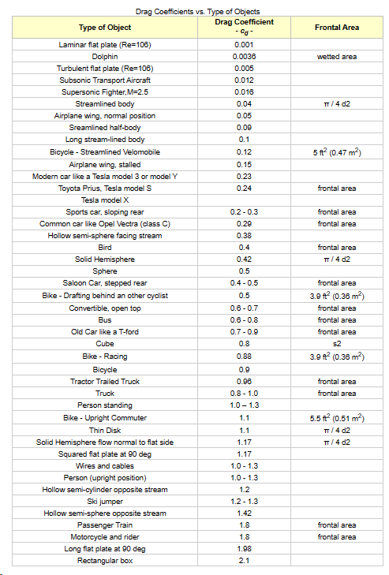
As with the frontal area, I could not find any conclusive results for the coefficient of drag for my vehicle, therefore using Table 1 I estimated my drag value at 0.24, due to my car being similar to a Toyota Prius in dimensions (The Engineering Toolbox, 2004).
Table 1 - Drag Coefficient vs Type of Objects (The Engineering Toolbox, 2004)

Table 1 - Drag Coefficient vs Type of Objects (The Engineering Toolbox, 2004)

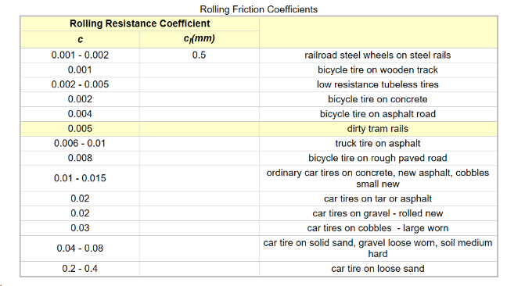
Similarly, I used the same process to find the rolling resistance coefficient for my vehicle. I estimated this to be 0.0125 using Table 2 (The Engineering Toolbox, 2008).
Table 2 - Rolling Resistance Coefficients (The Engineering Toolbox, 2008)

Test Procedure

Worldwide harmonised Light vehicle Test Procedure (WLTP)
Following my initial research, I was to select an appropriate Worldwide harmonised Light vehicle Test Procedure (WLTP) for my vehicle of choice. The WLTP class that a Ford Fiesta would be categorised into would be the WLTP 3b class. The test for the 3b class of vehicles is shown below.

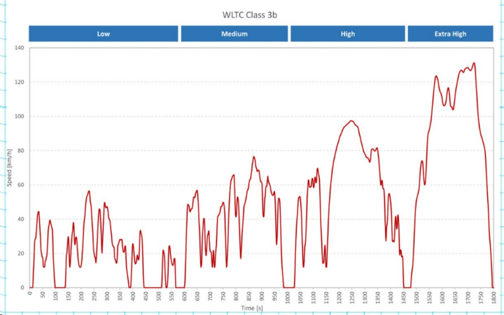
As shown in Figure 2, the WLTP tests a range of speeds and scenarios that a vehicle could encounter. In comparison to the old New European Driving Cycle (NEDC), the WLTP is a more accurate representation of what a modern vehicle experiences (Autocar, 2022).
Figure 2 - WLTP Class 3b Test

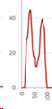
Deceleration
Taking a closer look at the WLTP Test, analysing the first 100 seconds of the test, as shown in Figure 3, we can draw estimated values for when the car needs to brake. Figure 4 shows the same timescale of graph, but I have drawn a line to show where I estimate the ‘coast down’ deceleration. The graph is stretched in order to more accurately represent the coast-down line.
Figure 3 - First 100 seconds of WLTP Class 3b Test
Figure 4 - WLTP Class 3b with 'coast down' line

Any deceleration below this line means that a negative tractive force is being applied, via the brakes. The area below the line therefore indicates any energy that is used in the braking process, energy which can be harnessed and used for other reasons. This is why a hybrid system for this vehicle seems like a viable choice.

Calculations
Using a pre-made spreadsheet, provided as part of my alternate propulsion systems lectures presented by Mark Sandford (Sandford, 2023b), I used Equation 2 (below) to calculate the acceleration force in Newtons for every second of the test.
Equation 2 - Force
$Force=Mass ×Acceleration$

Following that, I then used Equation 3 to calculate the rolling resistance force. As the test takes place with no gradients, the vertical force can be assumed as Equation 4.
Equation 3 - Rolling Resistance (Sandford, 2023a)
$Rolling Resistance=Vertical Force ×Coefficient of Rolling Resistance$
Equation 4 - Vertical Force
$Vertical Force=Mass ×Gravity$

I then calculated the aerodynamic friction of the vehicle using Equation 5.
Equation 5 - Aerodynamic Resistance (Sandford, 2023a)
$Aerodynamic Resistance= \frac{1}{2} ×Area ×Cd × ρ ×{Velocity}^{2}$

I then combined all three resistive forces to calculate a total resistive force, which I then plugged into Equation 6 to work out power.
Equation 6 – Power (Sandford, 2023a)
$Power=Force ×Velocity$

Graphs
From the spreadsheet that I constructed using the equations above, I created a series of plots to show my results.
Figure 5, below, shows all my resistance values plotted on a single graph.
Figure 5 - WLTP Resistance Plot

Following that, I then plotted velocity for the test. This is shown in Figure 6.

Figure 6 - WLTP Velocity Plot
The next graph that I plotted was the power values that I calculated in the spreadsheet. This is displayed in Figure 7.
Figure 7 - WLTP Power Plot

From Figure 7, we know that when Power < 0, we have a negative tractive force, therefore there is potential to recover energy.
To find out the energy wasted on deceleration, I took the cumulative energy from when the car came to rest.

Kinetic Energy Recovery System
Due to struggles with calculating cumulative energy, the rest of this report is purely theoretical, using my research to justify my choices.
A large part of my research that I have conducted is into a mild hybrid system for a turbocharged vehicle. From my own knowledge I know that there is a system that uses a small battery and a small electric motor that is attached to the turbine of the turbocharger. The battery stores energy saved during the braking process and then feeds it into the turbo to achieve a faster throttle response and better efficiency, especially at low RPM, which is commonly seen in city driving.
This system would be suitable for my vehicle of choice as it is a very compact system and does not require a lot of internal reworking of the engine bay. The Ford Fiesta is known as a compact car and is very commonly seen driving in cities due to their size.
This system is also cheaper than a conventional hybrid system as it requires less components and less reworking of the vehicle. This means that there are less costs in research and development. When compared to other hybrid systems, Ford’s mild-hybrid Fiesta model is significantly cheaper than competitors’ models.

Conclusion
To conclude this report, I have decided that a mild hybrid-turbo would be my best option. This is due to costs as well as the relative simplicity of the system (RAC, 2021). The hybrid-turbo option is perfect for a car like the Fiesta as it is not expected to be an expensive luxury hybrid, comparable to the likes of Lexus or Volvo. The compact nature of the system is also perfect as it allows the car to keep its original bodywork and styling without adding extreme amounts of weight. As well as this, the Fiesta is seen as a ‘low-cost’ car, and being able to make it even more efficient whilst keeping the initial buying price as low as possible is a good option for the customer base. My options can be justified as this is the route that Ford took, and ignoring the discontinuation of the Fiesta, the model sold very well and had very positive reviews (Kew, 2020; RAC, 2021).

Reference List
Autocar. (2022, March 1). The Autocar guide to WLTP emissions testing | Autocar. Autocar. https://www.autocar.co.uk/car-news/features/autocar-guide-wltp-emissions-testing
Clarke, P. (2023). Ford Fiesta EcoBoost Review (1.0-litre) | Green Car Guide. Green Car Guide. https://www.greencarguide.co.uk/car-reviews-and-road-tests/ford-fiesta-1-0-litre-ecoboost/
Ingram, A. (2014, June 3). Ford Fiesta - UK Exterior &amp; Interior Dimensions | carwow. Carwow. https://www.carwow.co.uk/blog/ford-fiesta-dimensions-919
Kew, O. (2020, October 30). Ford Fiesta Ecoboost Hybrid review: the best small car money can buy Reviews 2024 | Top Gear. Top Gear. https://www.topgear.com/car-reviews/ford/fiesta/10-ecoboost-hybrid-mhev-125-st-line-x-edition-5dr/first-drive
RAC. (2021, October 29). Ford Fiesta EcoBoost mHEV review | Car review | RAC Drive. RAC. https://www.rac.co.uk/drive/car-reviews/ford/fiesta/fiesta-ecoboost-mhev/
Sandford, M. (2023a). ACHA5010 Alternate Propulsion Technology Equations.
Sandford, M. (2023b). Alternate Propulsion Systems Lectures. In University of Wales Trinity Saint David.
The Engineering Toolbox. (2004). Drag Coefficient. The Engineering Toolbox. https://www.engineeringtoolbox.com/drag-coefficient-d_627.html
The Engineering Toolbox. (2008). Rolling Resistance. The Engineering Toolbox. https://www.engineeringtoolbox.com/rolling-friction-resistance-d_1303.html

