

Programme: MSc Public Health and Social Care in Practice
Module: Community Care and Management of Longer-term Conditions LCHS7003 (BIRMINGHAM)
Assignment Title: Component 1
Information Booklet of Long-term Condition Management
Lecturer: Dr Aishat Bakre
Student’s name and ID: Maryam Al-Shameri 2311625
Final word count: 3,239 Words
submission date 23/10/2026

INFORMATION BOOKLET
Diabetes
Understanding and managing a long-term condition
A guide for health and care professionals in the UK

Assignment title
Information Booklet Presentation on Long-term Condition (Diabetes) Management
In this booklet
1 What is diabetes? Definition, prevalence and risk factors
2 How diabetes affects people and families, and NHS treatments
3 Models for better outcomes: international and UK
4 National and local policy
5 Recommendations for person-centred care, including end of life

About this booklet
This booklet is for UK health and care professionals, such as nurses, GPs, healthcare assistants, pharmacists and social care staff, who support adults with diabetes. It helps people and families understand what diabetes is and why it happens, how it affects them, which NHS treatments work, which care models work better and how, how policy influences services and how to make care more person-centred. According to NHS England (2023), it says “people living with diabetes”, not “diabetics”.
1 What is diabetes?
Diabetes is a long-term (chronic) condition in which the pancreas does not make enough insulin, or the body cannot use the insulin it makes effectively. Insulin regulates blood glucose, and when it is not available, excess glucose builds up in the blood (hyperglycaemia). Over time, this negatively affects blood vessels and nerves (World Health Organisation (WHO), 2024).
Types of diabetes
- Type 2 (about 90% of people diagnosed in the UK): the body resists insulin or does not make enough. It progresses slowly and can be prevented or brought into remission (Diabetes UK, no date; NHS, 2025).
- Type 1 (about 8%): Insulin-producing beta cells are destroyed by the immune system. The cause is unknown; it cannot be prevented, and people need insulin every day (WHO, 2024; Azimi et al., 2024).
- Other types (about 2%), plus gestational diabetes, which develops in pregnancy and raises the later risk of type 2 (Diabetes UK, no date; WHO, 2024).
- Prediabetes (non-diabetic hyperglycaemia): HbA1c 42–47 mmol/mol, above normal but below the diabetes level (Valabhji et al., 2020).
Spot the signs
Symptoms include extreme fatigue, increased urination, constant thirst, and weight loss. Other symptoms are slow-healing cuts, repeated thrush, and blurred vision. For many people with type 2, there are no signs or symptoms, which is why it is important to test people who are at risk (NHS, 2025).

How common is diabetes worldwide?
- In 2024, 589 million adults aged 20–79 (1 in 9) had diabetes, projected to reach 853 million by 2050. Of these, 43% are undiagnosed, 3.4 million people die annually due to diabetes and health spending has exceeded US$1 trillion (International Diabetes Federation (IDF), 2025).
- If a broadened definition is used, NCD Risk Factor Collaboration (2024) estimates that in 2022, 828 million adults received no treatment for any of the NCDs, of which 445 million were aged 30 or above (59%).
- Type 2 accounts for 96% of cases and is projected to affect more than 1.31 billion people by 2050 (GBD 2021 Diabetes Collaborators, 2023).
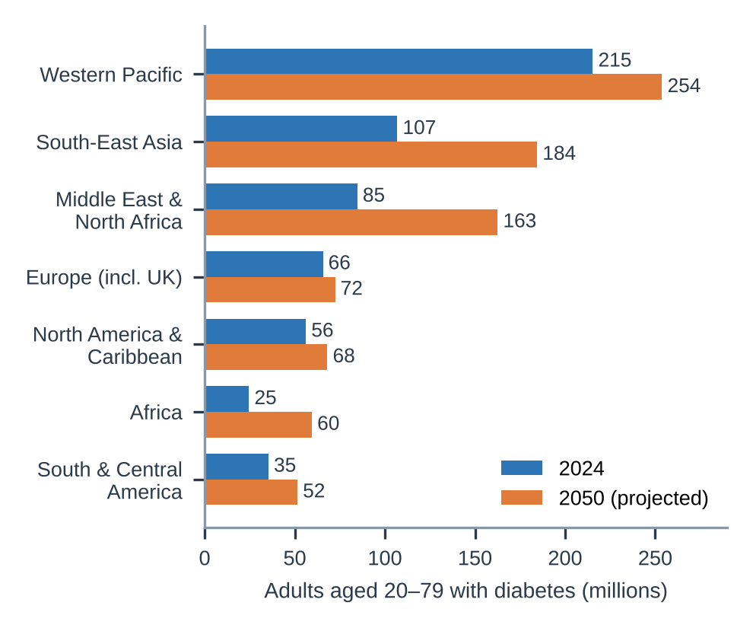
Figure 1. Adults with diabetes by world region, 2024 and 2050. Europe, including the UK, has the smallest rise (10%), and Africa the largest (142%) (data: IDF, 2025).
Critical note: these estimates differ because studies use different ages and definitions. According to the IDF, the 828 million figure could be inflated, as HbA1c may occasionally be falsely high in individuals with iron deficiency (IDF, 2025).
How common is diabetes in the UK?
- Almost 6 million people live with diabetes, an all-time high: over 4.7 million diagnosed (up 155,803 in one year) and almost 1.3 million undiagnosed. A further 6.9 million people are at risk, making a total of more than 12 million adults with diabetes or prediabetes (Diabetes UK, no date a).
- In England in 2024–25, 284,010 people were registered with type 1 and 3,713,155 with type 2 (NHS England, 2026).
- Diabetes currently costs the NHS £10.7 billion per year, around 6% of the health budget, and £3.3 billion in lost productivity. Complications are responsible for around 60% of NHS expenditure, with the majority avoidable (Hex et al, 2024).
Risk factors and causes
Type 2 diabetes results from several factors (Diabetes UK, no date b):
- Age and ethnicity: risk rises over 40 for White people and over 25 for South Asian, Chinese, African-Caribbean and Black African people, who are 2–4 times more likely to develop type 2, often at a lower weight.
- Family history: a parent, sibling or child with type 2 raises the risk 2–6 times.
- Weight: Overweight, obesity and a large waist. High body mass index causes 52.2% of the global type 2 burden (GBD 2021 Diabetes Collaborators, 2023).
- Health history: High blood pressure, heart attack or stroke, gestational diabetes, polycystic ovary syndrome, and severe mental illness or antipsychotic medicines.
- Lifestyle: Long sitting, smoking, consuming over 14 units of alcohol per week and sleeping less.
- Deprivation: 24% of those diagnosed with type 2 live in the most deprived fifth of areas, compared to 15% in the least deprived (Diabetes UK, 2023).
Evaluation: type 2 is “largely preventable” (GBD 2021 Diabetes Collaborators, 2023) and lifestyle programmes can reduce risk by approximately 50% (Diabetes UK, no date a). However, income, housing and access to healthy food strongly shape risk, so treating type 2 as a simple “lifestyle choice” is inaccurate and fuels blame (Speight et al., 2024).
2 How diabetes affects people and families
Physical impact
High glucose damages blood vessels in the heart, eyes, kidneys and nerves. In the UK, diabetes is responsible for 184 amputations, more than 1,010 strokes, more than 700 heart attacks and more than 3,340 incidents of heart failure each week (Diabetes UK, no date a). Worldwide, high blood glucose causes about 11% of cardiovascular deaths (WHO, 2024), and diabetes is linked to dementia, some cancers and severe infections (NCD Risk Factor Collaboration, 2024). The immediate risks are hypo- or diabetic ketoacidosis (DKA).
Psychological impact
Diabetes needs managing “24/7, 365 days a year”. Diabetes UK (2019) found that:
- 7 out of 10 feel overwhelmed by its demands, and 3 out of 4 feel that it is detrimental to their self-management;
- people with diabetes are twice as likely to experience depression;
- 2 in 5 people with type 1 and 1 in 4 with type 2 have had disordered eating, including skipping insulin to lose weight (“diabulimia”);
- Three-quarters of those who required expert psychological assistance were unable to receive it.
This is a bi-directional relationship: distress increases HbA1c; high HbA1c increases risk of complications (Diabetes UK, 2019).
Social impact
Stigma affects about 4 in 5 adults with diabetes, and 1 in 5 adults with diabetes faces discrimination in health care, education, or employment (Speight et al., 2024). Money matters: 66% of people with or at risk of diabetes have reduced their food or energy intake, and those in the most deprived areas are over twice as likely to cite cost of living as a barrier to managing their diabetes (41%, compared to 17%) (Diabetes UK, 2023).
Impact on families and carers
Two-thirds of parents and carers feel overwhelmed, and 4 in 10 report that their diabetes team has not supported them to discuss how caring impacts them (Diabetes UK, 2019). A review of 18 studies of parents of children with type 1 found chronic sorrow, guilt about glucose highs and lows, broken sleep from night-time checks, lost work and income, and isolation because trusted respite care is rare. Caring brings “a constant sense of vigilance” (Azimi et al., 2024).
Evaluation: Most of this evidence concerns parents of children with type 1. The partners and adult children of the 90% experiencing type 2 are under-researched, and services should be mindful of this.
Evidence-based NHS treatments
- Structured education: free courses should be provided within 12 months of diagnosis (NHS, 2025). Self-management education reduces HbA1c by 0.45 to 0.57% and has no side effects (Powers et al., 2020).
- Medicines: NICE guideline NG28 (February 2026) recommends that most adults first receive a combination of modified-release metformin and an SGLT-2 inhibitor (also good for the heart and kidneys). People with cardiovascular disease also get semaglutide, a GLP-1 agonist. Treatment changes are shared decisions (National Institute for Health and Care Excellence (NICE), 2026). If other medications are not effective, insulin is used (NHS, 2025).
- Annual checks: NICE recommends eight routine checks: HbA1c, blood pressure, cholesterol, kidney function, urine albumin, foot check, BMI and smoking status (Diabetes UK, 2023). Eye screening is provided every 1–2 years (NHS, 2025).
- Remission: in the Direct trial, a total diet replacement of 825–853 kcal a day for 3–5 months put 46% of people into remission at one year, against 4% on usual care (Lean et al., 2018). Since April 2024, the NHS Path to Remission programme has been available across England and has achieved a 32% remission rate among those who completed it (Valabhji et al., 2024).
- Prevention: The Healthier You NHS Diabetes Prevention Programme provides 13 or more sessions in a 9-month period to those with prediabetes in groups. Participants lost an average of 2.3 kg (Valabhji et al., 2020).
- Technology: Hybrid closed-loop systems (also called an “artificial pancreas”) connect an insulin pump to a glucose monitor. NICE recommends them for children under 19, people who are pregnant and adults with HbA1c of 58 mmol/mol or more. NHS England began a five-year rollout in April 2024 (NHS England, 2024). Despite NICE guidance since 2022 recommending glucose monitors for all people with type 1 diabetes, only 5% of people with type 1 diabetes surveyed in Diabetes UK 2023 use a closed-loop system.
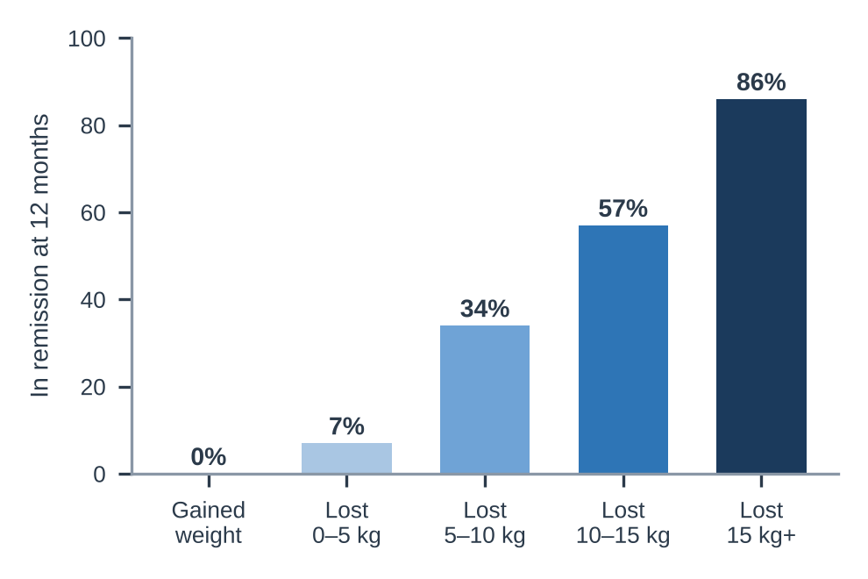
Figure 2. Remission at 12 months by weight lost in the DiRECT trial: 86% of people who lost 15 kg or more were in remission (data: Lean et al., 2018).
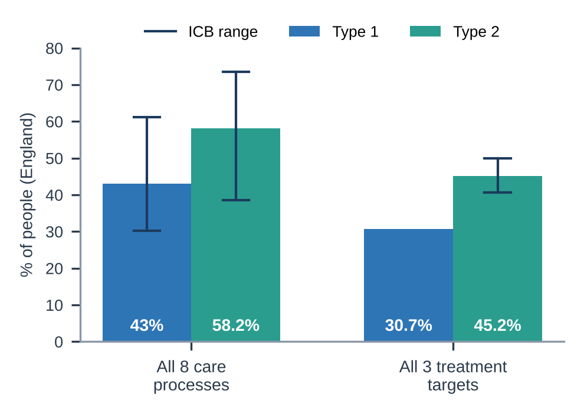
Figure 3. People receiving all eight checks and all three treatment targets in England, 2024-25. Lines show the range across Integrated Care Boards (ICBs) (data: NHS England, 2026).
Critical view: effective but unequal
Only 43% of people with type 1 and 58.2% with type 2 had all eight checks; most omissions were foot and urine checks. While 87.6% of people with type 2 are offered education (NHS England, 2026), only 8% of those referred in the UK attend (Powers et al., 2020).
Of those who were referred, just 19% finished the prevention programme and deprived Black participants lost less weight (Valabhji et al., 2020). However, real-world remission rates are worse than in the trial (32% vs. 46%) (Valabhji et al., 2024).

3 Models for better outcomes
International model: Chronic Care Model and WHO ICCC
The Chronic Care Model, developed by Wagner and colleagues in the USA, creates a partnership between health systems and communities and empowers patients to self-manage. It consists of six elements: health system organisation, self-management support, decision support, delivery system design, clinical information systems, and community resources and policies (Stellefson, Dipnarine and Stopka, 2013). In the UK, diabetes care aligns with structured education, NICE guidance, and the National Diabetes Audit registers.
A review of 16 U.S. studies, including nine randomised trials, identified benefits of the model in diabetes primary care, with one study showing a reduction in HbA1c from 7.6% to 7.0%. All studies, however, took place in the US insurance-based system; outcomes were mixed, and only 7 of 16 included community resources and policies (Stellefson, Dipnarine and Stopka, 2013).
The World Health Organisation (2002) enlarged the model to incorporate the Innovative Care for Chronic Conditions (ICCC) framework. It works at three levels: micro (patient and family), meso (health care organisation and community) and macro (policy) (Epping-Jordan et al., 2004). Its “triad” of patients and families, health care teams, and community supporters clearly involves families, and it explicitly frames poor adherence as a failure of the health care system rather than a failure of patients (WHO, 2002). Its weakness is that it has less direct trial evidence.
UK model: the House of Care
The House of Care evolved from the Year of Care diabetes programme, delivered by Diabetes UK and the Department of Health in 2007. At the centre is personalised care and support planning, where patients and clinicians share goals, actions, and review dates. Figure 4 illustrates the walls, roof and foundations. Each person has one care plan, regardless of how many conditions they have, and tackling inequalities is a central aim (Coulter, Roberts and Dixon, 2013).
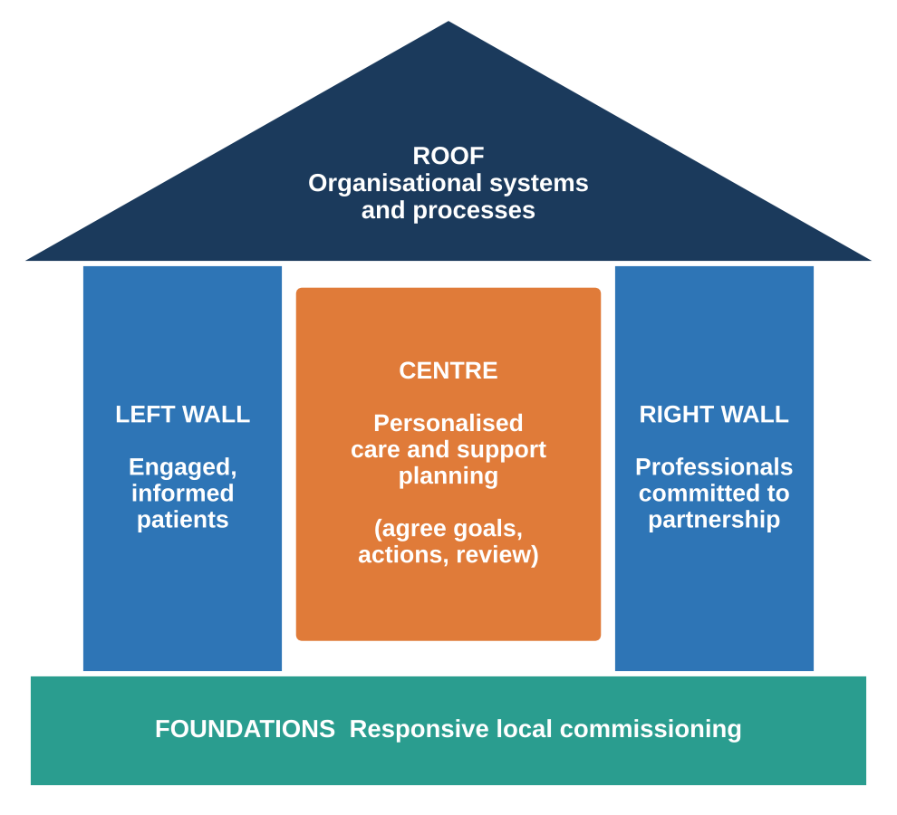
Figure 4. The House of Care (adapted from Coulter, Roberts and Dixon, 2013).
The evidence is satisfactory. A Cochrane review of 19 trials (12 diabetes, 10,856 people) found that care planning reduced HbA1c by 0.24%, systolic blood pressure by 2.64 mmHg, depression scores, and increased self-efficacy, with no identifiable harms. When care planning was intensive and incorporated into routine care, the effects were modest but larger (Coulter et al., 2015). NHS England promotes this approach via the Comprehensive Model of Personalised Care, which includes six elements: shared decision-making, care and support planning, choice, social prescribing, supported self-management and personal health budgets (NHS England, 2019).
Table 1. Comparing the two models
 | Chronic Care Model / ICCC | House of Care
Origin | USA; WHO global version | UK, built on diabetes
Focus | Redesigning the whole system | The care-planning conversation
Strength | Includes family, community and policy | Strong UK and Cochrane evidence
Limitation | US evidence; mixed results | Needs time, training and funding

4 National and local policy
National agendas
NHS Long Term Plan (2019). The plan pledged to double the Diabetes Prevention Programme with a digital version, pilot low-calorie diets for type 2 diabetes from April 2019 and provide continuous glucose monitoring for pregnant women with type 1 diabetes by 2020/21. It also guaranteed foot care teams in each hospital and reduced differences across areas, including the NHS (NHS, 2019). The prevention and remission programmes are now rolling out across the country, with variation between ICBs, with 25% to 62% of people receiving all eight checks in 2021-22, and between primary care networks (with 10% to 86% of people receiving all eight checks in 2021-22) (Diabetes UK, 2023).
10 Year Health Plan (2025). The plan sets three shifts: hospital to community, analogue to digital, and sickness to prevention. It pledges a Neighbourhood Health Centre in every community, care plans in the NHS App by 2028, increased access to weight-loss medicines and an obesity ‘moonshot ', and its target is to reduce the difference in healthy life expectancy between rich and poor areas by half (Department of Health and Social Care, 2025). However, diabetes is barely mentioned, and digital-first care risks excluding older and poorer people.
Core20PLUS5. The NHS England approach seeks to address the most deprived 20% of people, plus local groups (such as ethnic minority and inclusion health groups) in five clinical areas (NHS England, no date). Diabetes is not one of the five adult areas, though it is closely related to the hypertension area, and it occurs 2-4 times more often in some ethnic groups (Diabetes UK, no date b).
Soft Drinks Industry Levy. Since April 2018, manufacturers have paid 24p per litre on drinks with 8 g or more of sugar per 100 ml. Drinks with over 5 g of sugar per 100 ml fell from 49% to 15% of the market, and obesity in girls aged 10–11 fell by 8%, preventing about 5,234 cases a year, mostly in deprived areas. Boys and younger children showed no change (Rogers et al., 2023).
Local agendas
The Health and Care Act 2022 created 42 integrated care systems (ICSs). Each has an Integrated Care Board (ICB) that plans and funds NHS services, alongside an Integrated Care Partnership with local councils that drafts a strategy for the local area. Addressing inequalities in outcomes, experience and access is one of their four goals. Care is organised in neighbourhoods (30,000–50,000 people), places (250,000–500,000) and systems (Charles, 2022).
Social care. Diabetes care can link to housing, social care, and community support, with local councils, social care providers, and voluntary groups sitting on Integrated Care Partnerships and place partnerships (Charles, 2022). Personalised care brings together health and social care through social prescribing link workers and personal budgets, giving people more choice and control (NHS England, 2019). This matters because about a quarter of care home residents have diabetes, so care home staff need clear diabetes and end-of-life plans (James, Hicks and Sinclair, 2024).
Local example: South Yorkshire
South Yorkshire ICS has 4 places (Barnsley, Doncaster, Rotherham and Sheffield) and approximately 30 neighbourhoods (Charles, 2022). In 2021–22, NHS South Yorkshire ICB gave all eight checks to 46.6% of people with diabetes, 11.9 points fewer than before the pandemic, with a 50-point gap between its best and worst primary care networks (Diabetes UK, 2023). Plans need to reach all neighbourhoods.

Evaluation: local systems can link together GP, hospital, council and voluntary services. However, “it is not possible to legislate for collaboration”, and partnerships may lack power because the ICB controls the money (Charles, 2022). In 2022, there were more than 7,000 excess deaths caused by diabetes in England, and Diabetes UK (2023) has urged each ICB to reduce the backlog, prioritise patients who have not attended for more than a year, and channel prevention efforts to deprived communities.
5 Recommendations for person-centred care
- Make every review a care planning conversation. Send results before the appointment, ask “what matters to you?” and agree on goals and one care plan (Coulter, Roberts and Dixon, 2013; Coulter et al., 2015).
- Utilise language that avoids blame. Avoid saying the words “non-compliant” or “control” and use the word “should”. NHS England (2023) also suggests saying "person living with diabetes" rather than "diabetic" and "you're not the sum of your diabetes numbers".
- Ask about feelings every time. Screen early for distress, depression, and disordered eating, and refer. For every £1 spent on psychotherapy, a service in Bath saved £29 (Diabetes UK, 2019).
- Support self-management at four key times: at diagnosis, every year, when complications develop and at life changes such as moving to adult services. Ensure people attend (Powers et al., 2020).
- Offer remission early. Refer eligible individuals diagnosed in the last 6 years to Path to Remission; the majority of people who lose 15kg will achieve remission (Lean et al, 2018; Valabhji et al, 2024).
- Close the gaps. Focus on foot, urine checks, people not seen for a year, and Core20PLUS groups and provide technology fairly (NHS England, 2026; NHS England, 2024).
- Include carers. Ask carers how they are doing, offer to include them in consultations if they agree, and signpost peer support and respite (Azimi et al., 2024; NHS England, 2019).
End-of-life care
The goal at the end of life is not to prevent future complications, but to provide comfort (James, Hicks and Sinclair, 2024):
- Maintain blood glucose levels 6-15 mmol/L and prevent hypos;
- Review and discontinue medicines that are no longer beneficial, with the person and family;
- Never stop insulin in type 1 diabetes, because of the risk of DKA, but simplify it;
- Begin advance care planning early and incorporate ReSPECT forms.
Staff should recognise those in their final year of life and agree a personalised plan to help people die where they wish (NHS England, 2019).
Useful websites
- Diabetes UK: www.diabetes.org.uk (information, helpline, and Know Your Risk tool)
- NHS: www.nhs.uk/conditions/type-2-diabetes
- NICE guideline NG28: www.nice.org.uk/guidance/ng28
- Language Matters: www.england.nhs.uk/long-read/language-matters-language-and-diabetes
- End of life guidance: www.diabetes.org.uk (search “end of life care”)

References List
Azimi, T., Johnson, J., Campbell, S.M. and Montesanti, S. (2024) ‘Caregiver burden among parents of children with type 1 diabetes: a qualitative scoping review’, Heliyon, 10(6), e27539. Available at: https://doi.org/10.1016/j.heliyon.2024.e27539 (Accessed: 13 October 2026).
Charles, A. (2022) Integrated care systems explained: making sense of systems, places and neighbourhoods. London: The King’s Fund. Available at: https://www.kingsfund.org.uk/insight-and-analysis/long-reads/integrated-care-systems-explained (Accessed: 13 October 2026).
Coulter, A., Entwistle, V.A., Eccles, A., Ryan, S., Shepperd, S. and Perera, R. (2015) ‘Personalised care planning for adults with chronic or long-term health conditions’, Cochrane Database of Systematic Reviews, 2015(3), CD010523. Available at: https://doi.org/10.1002/14651858.CD010523.pub2 (Accessed: 13 October 2026).
Coulter, A., Roberts, S. and Dixon, A. (2013) Delivering better services for people with long-term conditions: building the house of care. London: The King’s Fund. Available at: https://www.kingsfund.org.uk/insight-and-analysis/reports/better-services-people-long-term-conditions (Accessed: 13 October 2026).
Department of Health and Social Care (2025) Fit for the future: 10 Year Health Plan for England (CP 1350). London: DHSC. Available at: https://www.gov.uk/government/publications/10-year-health-plan-for-england-fit-for-the-future (Accessed: 13 October 2026).
Diabetes UK (2019) Too often missing: making emotional and psychological support routine in diabetes care. London: Diabetes UK. Available at: https://www.diabetes.org.uk/sites/default/files/2019-05/Full%20Report_Too%20Often%20Missing_Diabetes%20UK_May%202019.pdf (Accessed: 13 October 2026).
Diabetes UK (2023) Diabetes care: is it fair enough? London: Diabetes UK. Available at: https://www.diabetes.org.uk/sites/default/files/2023-05/DUK_Diabetes%20is%20Serious%20Report%202023_Digital.pdf (Accessed: 13 October 2026).
Diabetes UK (no date a) Diabetes statistics. Available at: https://www.diabetes.org.uk/about-us/about-the-charity/our-strategy/statistics (Accessed: 13 October 2026).
Diabetes UK (no date b) Diabetes risk factors. Available at: https://www.diabetes.org.uk/about-diabetes/type-2-diabetes/diabetes-risk-factors (Accessed: 13 October 2026).
Epping-Jordan, J.E., Pruitt, S.D., Bengoa, R. and Wagner, E.H. (2004) ‘Improving the quality of health care for chronic conditions’, Quality and Safety in Health Care, 13(4), pp. 299–305. Available at: https://doi.org/10.1136/qshc.2004.010744 (Accessed: 13 October 2026).
GBD 2021 Diabetes Collaborators (2023) ‘Global, regional, and national burden of diabetes from 1990 to 2021, with projections of prevalence to 2050: a systematic analysis for the Global Burden of Disease Study 2021’, The Lancet, 402(10397), pp. 203–234. Available at: https://doi.org/10.1016/S0140-6736(23)01301-6 (Accessed: 13 October 2026).
Hex, N., MacDonald, R., Pocock, J., Uzdzinska, B., Taylor, M., Atkin, M., Wild, S.H., Beba, H. and Jones, R. (2024) ‘Estimation of the direct health and indirect societal costs of diabetes in the UK using a cost of illness model’, Diabetic Medicine, 41(9), e15326. Available at: https://doi.org/10.1111/dme.15326 (Accessed: 13 October 2026).
International Diabetes Federation (2025) IDF Diabetes Atlas. 11th edn. Brussels: International Diabetes Federation. Available at: https://diabetesatlas.org/resources/idf-diabetes-atlas-2025/ (Accessed: 13 October 2026).
James, J., Hicks, D. and Sinclair, A. (2024) End of life guidance for diabetes care. 5th edn. Trend Diabetes. Available at: https://www.diabetes.org.uk/sites/default/files/2025-03/EoL_TREND_2024_v11-1.pdf (Accessed: 13 October 2026).
Lean, M.E.J., Leslie, W.S., Barnes, A.C., Brosnahan, N., Thom, G., McCombie, L. et al. (2018) ‘Primary care-led weight management for remission of type 2 diabetes (DiRECT): an open-label, cluster-randomised trial’, The Lancet, 391(10120), pp. 541–551. Available at: https://doi.org/10.1016/S0140-6736(17)33102-1 (Accessed: 13 October 2026).
National Institute for Health and Care Excellence (NICE) (2026) Type 2 diabetes in adults: management (NICE guideline NG28). First published 2015, last updated 18 February 2026. Available at: https://www.nice.org.uk/guidance/ng28 (Accessed: 13 October 2026).
NCD Risk Factor Collaboration (NCD-RisC) (2024) ‘Worldwide trends in diabetes prevalence and treatment from 1990 to 2022: a pooled analysis of 1108 population-representative studies with 141 million participants’, The Lancet, 404(10467), pp. 2077–2093. Available at: https://doi.org/10.1016/S0140-6736(24)02317-1 (Accessed: 13 October 2026).
NHS (2019) The NHS Long Term Plan. London: NHS England. Available at: https://www.longtermplan.nhs.uk/online-version/chapter-3-further-progress-on-care-quality-and-outcomes/better-care-for-major-health-conditions/diabetes/ (Accessed: 13 October 2026).
NHS (2025) Type 2 diabetes. Available at: https://www.nhs.uk/conditions/type-2-diabetes/ (Accessed: 13 October 2026).
NHS England (2019) Universal personalised care: implementing the comprehensive model. London: NHS England. Available at: https://www.england.nhs.uk/personalisedcare/comprehensive-model-of-personalised-care/ (Accessed: 13 October 2026).
NHS England (2023) Language matters: language and diabetes. 2nd edn. Available at: https://www.england.nhs.uk/long-read/language-matters-language-and-diabetes/ (Accessed: 13 October 2026).
NHS England (2024) Implementation of hybrid closed loop technologies in England: information for people living with type 1 diabetes and their carers. Available at: https://www.england.nhs.uk/diabetes/digital-innovations-to-support-diabetes-outcomes/hybrid-closed-loop-technology/implementation-of-hybrid-closed-loop-technologies-in-england-information-for-people-living-with-type-1-diabetes-and-their-carers/ (Accessed: 13 October 2026).
NHS England (2026) National Diabetes Audit Core Report 1: Care Processes and Treatment Targets 2024–25. Available at: https://digital.nhs.uk/data-and-information/publications/statistical/national-diabetes-audit/report-1-cp-and-tt-data-release-2024-25/nda-report-1-cp-and-tt-data-release-2024-25 (Accessed: 13 October 2026).
NHS England (no date) Core20PLUS5 (adults): an approach to reducing healthcare inequalities. Available at: https://www.england.nhs.uk/about/equality/equality-hub/national-healthcare-inequalities-improvement-programme/core20plus5/ (Accessed: 13 October 2026).
Powers, M.A., Bardsley, J.K., Cypress, M., Funnell, M.M., Harms, D., Hess-Fischl, A. et al. (2020) ‘Diabetes self-management education and support in adults with type 2 diabetes: a consensus report’, Diabetes Care, 43(7), pp. 1636–1649. Available at: https://doi.org/10.2337/dci20-0023 (Accessed: 13 October 2026).
Rogers, N.T., Cummins, S., Forde, H., Jones, C.P., Mytton, O., Rutter, H., Sharp, S.J., Theis, D., White, M. and Adams, J. (2023) ‘Associations between trajectories of obesity prevalence in English primary school children and the UK soft drinks industry levy: an interrupted time series analysis of surveillance data’, PLOS Medicine, 20(1), e1004160. Available at: https://doi.org/10.1371/journal.pmed.1004160 (Accessed: 13 October 2026).
Speight, J., Holmes-Truscott, E., Garza, M. et al. (2024) ‘Bringing an end to diabetes stigma and discrimination: an international consensus statement on evidence and recommendations’, The Lancet Diabetes & Endocrinology, 12(1), pp. 61–82. Available at: https://doi.org/10.1016/S2213-8587(23)00347-9 (Accessed: 13 October 2026).
Stellefson, M., Dipnarine, K. and Stopka, C. (2013) ‘The Chronic Care Model and diabetes management in US primary care settings: a systematic review’, Preventing Chronic Disease, 10, 120180. Available at: https://doi.org/10.5888/pcd10.120180 (Accessed: 13 October 2026).
Valabhji, J., Barron, E., Bradley, D., Bakhai, C., Fagg, J., O’Neill, S., Young, B., Wareham, N., Khunti, K., Jebb, S. and Smith, J. (2020) ‘Early outcomes from the English National Health Service Diabetes Prevention Programme’, Diabetes Care, 43(1), pp. 152–160. Available at: https://doi.org/10.2337/dc19-1425 (Accessed: 13 October 2026).
Valabhji, J., Gorton, T., Barron, E., Safazadeh, S., Earnshaw, F., Helm, C. et al. (2024) ‘Early findings from the NHS Type 2 Diabetes Path to Remission Programme: a prospective evaluation of real-world implementation’, The Lancet Diabetes & Endocrinology, 12(9), pp. 653–663. Available at: https://doi.org/10.1016/S2213-8587(24)00194-3 (Accessed: 13 October 2026).
World Health Organisation (2002). Innovative care for chronic conditions: building blocks for action. Geneva: WHO. Available at: https://www.who.int/publications/i/item/innovative-care-for-chronic-conditions-building-blocks-for-actions (Accessed: 13 October 2026).
World Health Organisation (2024) Diabetes. Available at: https://www.who.int/news-room/fact-sheets/detail/diabetes (Accessed: 13 October 2026).

