Using a Research Approach in Human Resources

Report Title: Using a Research Approach in HR (5CIHR)
Using a Research Approach in HR – Activity 2
Undertake research into an area of HR and write a business report for identified stakeholders. Within your report you should:
1. Assess a range of primary and secondary data sources suitable for the area investigated;
2. Explain how you collected and analysed the data, justifying the methodology adopted;
3. Draw conclusions and make recommendations based on the data.

Name: Rebekah Thomas

CIPD Membership Number:

Date: Wednesday 7th July 2021

Word count: 2490

By signing below, I confirm that the work/evidence presented is my own, unaided work. I understand the regulations pertaining to candidate malpractice and the action that may be taken as a result.

Signed: R A THOMAS
Date: 07/07/2021

Executive Summary
This research report has been completed for key stakeholders within Capita including line managers, the Recruiting Operations Manager and other senior executives. It has produced to analyse and explore working from home and whether the coronavirus pandemic has changed the world of work within the organisation.
The literature review was completed parallel to the report’s objectives to stay on track and relevant. A wide range of reliable research was collected and considered from various sources such as the CIPD, People Management and the Guardian online in order to further understand the topic and to identify any key trends and behaviours. The primary research collected consists of a quantitative questionnaire and qualitative discussion notes gathered via email. A mixed method approach to the research was chosen in order to allow room to explore the advantages of both quantitative and qualitative data. Primary research was needed in order to focus on the organisation, to comprehend the situation for colleagues and what will happen post pandemic. It was discovered that colleagues at Capita have had to work from home as a result of COVID-19 and performance along with productivity levels have either excelled or stayed the same. The majority of staff would like to continue to work from home as well as returning to the office by adopting a hybrid approach, which means the ability and option to do both. The report has found that the coronavirus pandemic is still a phenomenon, so organisations are still strategically planning how and when to return to the office. Capita have implemented a hybrid approach for now with the intention of returning to the office full time when able to do so.
The following recommendations have been proposed:
- Discoveries have shown the majority of colleagues want to follow a hybrid approach, but this may not be the case for everyone so it may be beneficial to conduct further research into this.
- Assuming that everyone is willing to go back to the office would be unrealistic. Capita may lose colleagues, which would have detrimental effect to the business. This is something the organisation needs to appreciate.
- In order to work from home successfully, employees must be provided with the correct equipment. Appendix D gives an estimated cost to deliver equipment from the office, but this is a rough quote and will be dependent on the office location.
There were a few obstacles to overcome while conducting the research report. Time limits and working from home were the two biggest concerns. Working from home in the sense that it was more difficult to contact colleagues and conduct research in a timely manner. If more time was given, the qualitative discussion notes could have been a lot more detailed, or a focus group could have been arranged in order to collect more valuable input. The response rate to the quantitative questionnaire was a lot lower than expected and the success of this research depended on both the responses and authenticity of responses. However, lessons have been learnt for future research reports.
Contents
Executive Summary………………………………………………………………………………….2
1. Introduction…………………………………………………………………………………………4
2. Literature Review…………………………………………………………………………………..4
- 2.1 To investigate if working from home always been possible…………………………….4
- 2.2 Has performance been affected by working from home and COVID-19?.……………4
- 2.3 Working from home - momentary or here to stay?......................................................5
- 2.4 Where do we go from here?........................................................................................5
3. Methodology………………………………………………………………………………………..6
4. Findings…………….……………………………………………………………………………….7
5. Conclusion………………………………………………………………………………………...11
6. Recommendations…………………………………………………………………………….…11
7. Limitations…………………………………………………………………………………………12
References…………………………………………………………………………………………..13
Appendices………………………………………………………………………………………..…17
- Appendix A Copy of email sent to staff regarding taking part in research……………….17
- Appendix B Further results from the quantitative questionnaire…………………………....18
- Appendix C Further qualitative discussion notes……………………………………………19
- Appendix D Estimated cost implications for organisation………………………………….20
- Appendix E UWTSD Ethics approval form…………………………………………………..21

1. Introduction
The aim of this research report is to explore working from home and whether COVID-19 has changed the world of work, specifically within Capita. This will be investigated through objectives set below. This research report has focused exclusively on the organisation, Capita and how they have adapted to COVID-19 restrictions. Concentrating on performance levels and productivity as a result of the pandemic while working from home rather than other factors of COVID-19 such as wellbeing. The reason for the chosen topic and why it is exclusive to Capita is to inform key stakeholders within the organisation such as management and headquarters that working practices have transformed due to COVID-19 for the better.
Aim: To determine whether COVID-19 has altered the working practices at Capita forever?
Objectives:
1. Look into the history of working from home through Capita, was it an option prior to COVID-19 or has it only now been introduced due to the pandemic?
2. Find out how working from home has affected performance at Capita by comparing the advantages and disadvantages.
3. Establish if this is something that will be continue post COVID-19 for staff at Capita, such as the option to work from home or flexible working.
4. To make recommendations exclusively for Capita: Determine whether we are more productive working from home and whether working from home will continue post pandemic.
2. Literature Review
Literature has been collected and analysed from reliable sources such as the CIPD, People Management and the Guardian online. I have assessed key themes and focused on particular areas in order to cover the set objectives. The focus on the report has been the pandemic therefore not all literature reviewed has been included in order to stay relevant.
1. To investigate if working from home always been possible.
A report by the CIPD (2019) found that flexible working has always been available, and flexitime is the most popular form used in the UK compared to the rest of the EU. Another CIPD (2020) report confirmed that 5% of people generally worked from home prior to the pandemic to which Brown and Serle (2020) state rocketed to over 60% during lockdown. This implies that even though some employees had the opportunity to work remotely before COVID-19 they have chosen not to. It is important to understand that working remotely and working from home as a result of COVID-19 are very different. April and Dasgupta (2020) verify that Finland are pioneers with their approach to flexible working, but it’s impossible to establish whether the UK will follow suit. According to Brown and Serle (2020) organisations were forced into a new way of working practically overnight and even though we have adapted well considering the circumstances, there are still outstanding factors.
2. Has performance been affected by working from home and COVID-19?
It is difficult to assess productivity levels of those working from home according to the CIPD (2020) as there are many various kinds of work, where some roles are suited to remote settings better than others. Data available from Office for National Statistics (2020a) indicates that home working opportunities are often only available to those in roles where qualifications and salary are high-ranking in comparison to manual roles. April and Dasgupta (2020) argue that a detriment of working from home is reduced productivity levels and low performance. Osborne (2021) suggests there is evidence that those working from home clock more hours too, whether it is powering through a lunch break and staying online for longer in order to get the task done. The CIPD (2020) echo this by referring to work intensification as a regular side effect by working from home. According to Bloom, Nicholas, et al (2021) one of the reasons why working from home will be utilised more often post COVID-19 is because performance levels have generally risen. When corroborating whether we are more productive working from home, roles need to be taken into consideration as data collected from the Office for National Statistics (2020b) advises not all jobs can be done remotely.
3. Working from home - momentary or here to stay?
There will be the option to continue to work from home after pandemic according to a report from the CIPD (2020). Their survey suggests more than three quarters of people working from home currently and expect to be able to continue working from home after the pandemic. Bloom, Nicholas, et al (2021) agrees with this report as their data discloses people working from home in the UK want to preserve this arrangement for at least two days a week. Free (2020) deliberates if people are to continue to work from home, then organisations need to make reasonable amendments such as advertising flexible roles and ensuring the company has fully adapted to this new way of working. Cosslett, R L. (2020) adds that working from home has shown some people positive benefits such as a better work life balance. There is plenty of evidence that people working from home want to continue doing so but there are also people who cannot wait to get back to the office. “It's been said of the pandemic that while we're all in the same storm, we are not all in the same boat. (Free, C. 2020, https://www.capita.com/our-thinking/are-we-at-risk-of-missing-the-point)”
4. Where do we go from here?
A report from the CIPD in September (2020) suggests a hybrid approach may be the best option for organisations. Sweney (2021) discloses Nationwide Building Society’s plans for their staff post pandemic which reveals the ability to work wherever they want. Some would disagree with this and find it unfair, as not all organisations are in the position to offer this. Another report from the CIPD (2020) suggests that although people are relatively happy to be working from home, some are not. The UK went homebased overnight and for some, working from home also means home schooling, childcare and caring duties. The hybrid approach will give employers and employees the best of both worlds, however Rambhai (2021) has found that only 20% of employees are happy with hybrid working. So, can we continue to work from home post pandemic? Ultimately, this question is still open as there are a lot of factors to consider and it is not a simple yes or no.
Literature Review Summary
The option to work from home has always been available. Flexible working is common in the UK but how flexible depends on the organisation and profession specifically. Whether performance levels have been affected by the pandemic remains unanswered because research shows a clear divide between employees and employers. A survey from Bloom, Nicholas, et al (2021) discovered that people do tend to be more efficient while working from home. However, research also indicated some organisations found performance lower than usual. Evidence suggests working from home will stay put post pandemic. Many organisations have demonstrated that working from home is possible. A survey from the BBC (2020) revealed that many companies do not plan to return to the office because it is cost saving but also has improved work-life balance.
The literature review has provided a wealth of information which is general to the UK working from home and COVID-19. In order to attempt to meet the set objectives, there now needs to be a focus solely on Capita.
3. Methodology
A cross-section approach has been followed in order to be effective. The primary research collected consists of a quantitative questionnaire and qualitative discussion notes gathered via email. A mixed method research route was chosen to allow room to explore the benefits of quantitative and qualitative data, to which Anderson (2013) mentions the triangulation process that allows the use of verifying results.
An email was sent to staff who would be later contacted to take part in the following research activities in accordance with ethical standards (Appendix A). A questionnaire was created via Google Forms and sent electronically in order to collect results swiftly and was sent to a total of 22 members of staff within the Region. It was sent regionally instead of nationally in order to remain pertinent. Staff were able to remain anonymous and were given the option to take part. It was hoped that by remaining anonymous, more would respond but out of 22, only 31% responded. The limited number of responses meant the results may be inadequate. Opie (2002) specifies questionnaire answers need to be measurable and closed question types should be avoided. The qualitative discussion started with a question sent to direct members of the team, it was unstructured, and the purpose was to uncover a greater understanding into how the team felt. Perkins and Woodhams (in Taylor and Woodhams 2016a) imply this is an advantageous way to identify any precise issues.
Investigation results have been analysed in order to identify trends, discover any areas for development and later to make recommendations. Other methods were considered. If there were no limitations and timescales on this project, it may have been advantageous to interview colleagues rather than sent a questionnaire. Denscombe (2017) suggests in comparison to a questionnaire, an interview provides more detail and flexibility.
4. Findings
Results from the quantitative questionnaire can be found at Appendix B and the qualitative discussion notes at Appendix C. These findings have been cross-referenced and organised by the initial literature review;
1. To investigate if working from home always been possible.
Findings from the questionnaire indicate that colleagues are aware of flexible working and the capability to request it. Colleagues worked from home during the pandemic and 71.4% of them worked from home previously as indicated in Figure 1. The CIPD (2020) proclaim that more people are working from home. The Office for National Statistics (2020a) also confirms that 86% of people working from home are because of the pandemic.
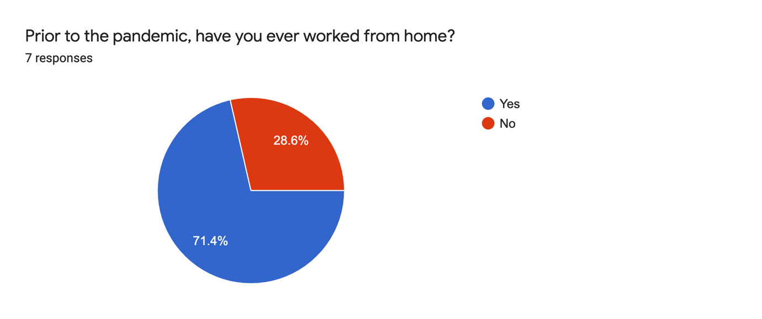
Figure 1
Haar (2020) suggests working from home is common and believes the normal 9-5 pattern will soon be a thing of the past. For Capita, working from home has always been a possibility so working from home will continue.
2. Has performance been affected by working from home and COVID-19?
The CIPD (2020) suggest performance levels of those working from home have risen. Although Bloom, Nicholas, et al (2021) believe many have noticed no change in their performance. It is clearly different for all organisations. According to Figure 2, colleagues believe they are more productive while working from home. Almost a third neither agree nor disagree, so there has been no change on performance due to the pandemic.
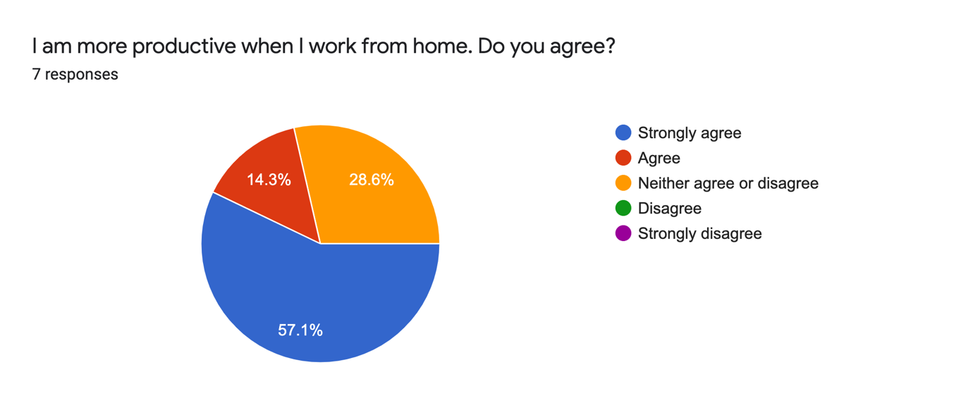
Figure 2
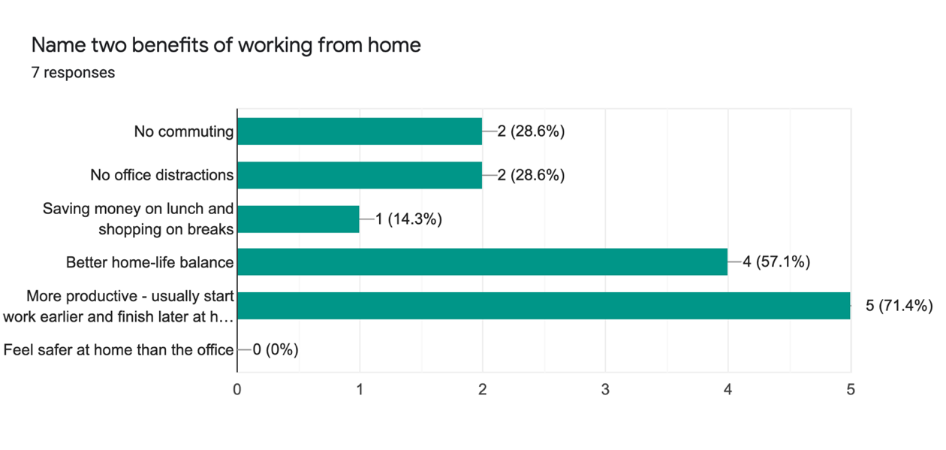
Figure 3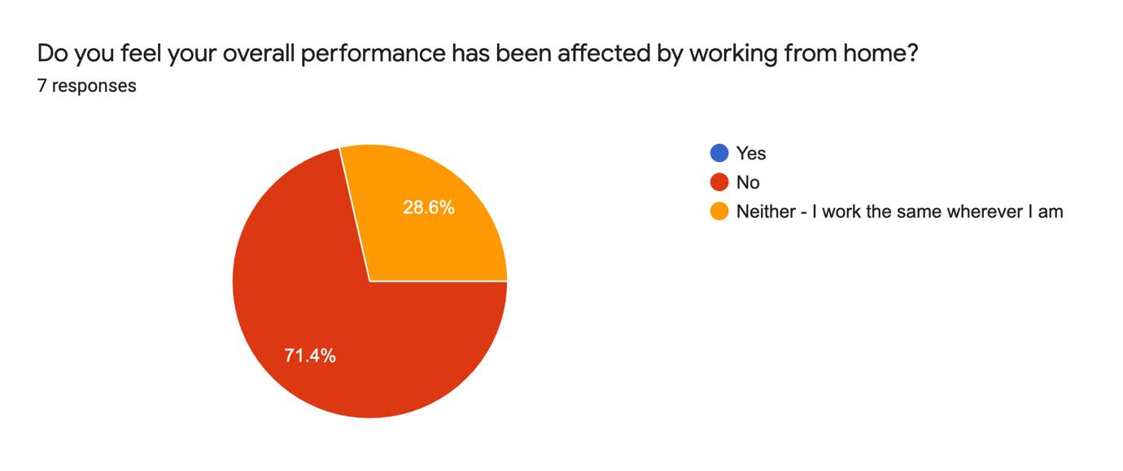Figure 4
Figure 3 indicates colleagues believe one of the benefits of working from home has been productivity, by starting work earlier or finishing later. Calnan (2017) implies that people working from home tend to put more effort in and Osborne (2021) adds that employees are spending more time at their desk at home. This amplifies the findings match the initial research. It shows that performance has been affected by the pandemic but in a positive way as shown in Figure 4.
3. Working from home - momentary or here to stay?
Colleagues within Capita want the flexibility to do both as revealed in Figure 5. This contradicts Churchill’s (2020b) impression that the majority of people want to continue working from home post lockdown. Staff want the best of both which Owen (2020b) reiterates.
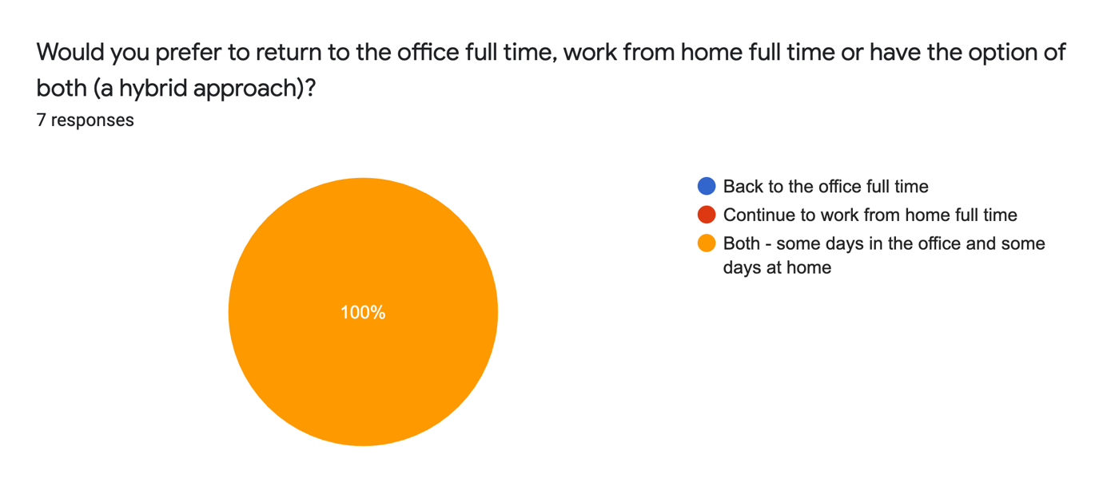
Figure 5
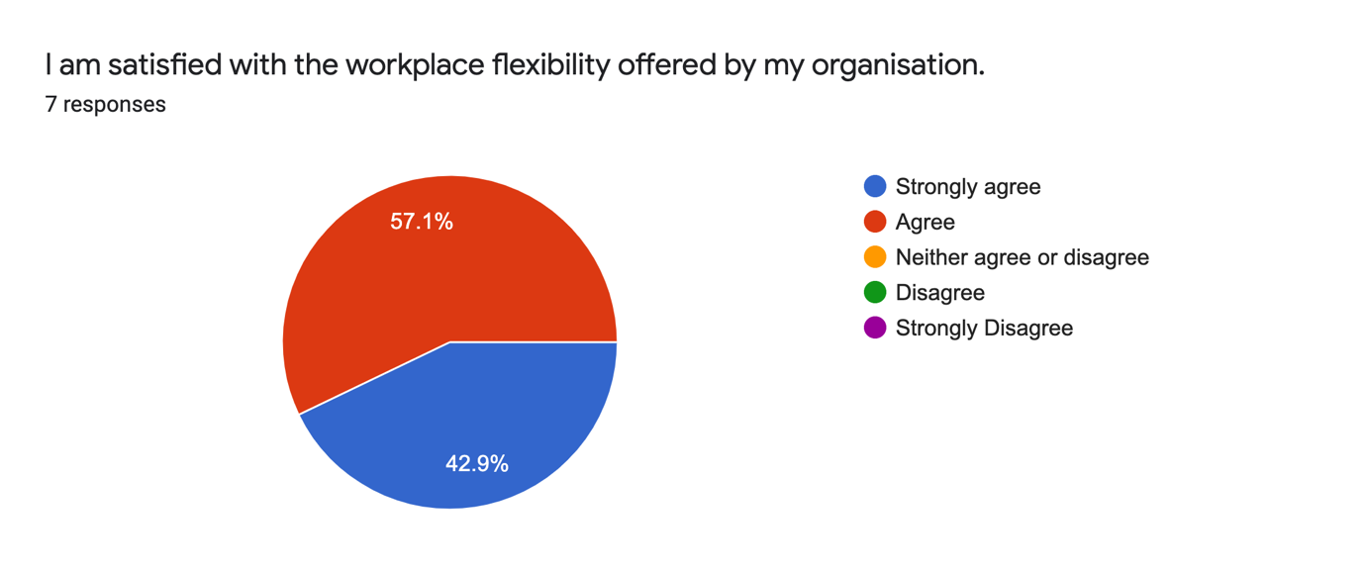
Figure 6
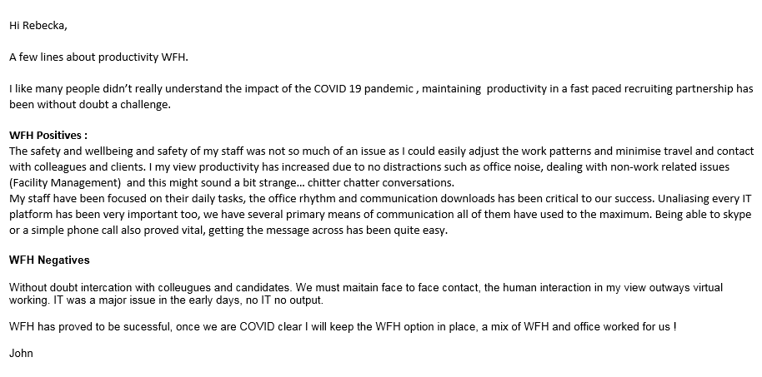
Figure 7
In Figure 6, colleagues are satisfised with the flexibility that is available as over 50% strongly agree. It compares well to Nationwide’s approach to flexible working, where Sweney (2021) discloses the organisation have listened to their staff’s needs. Figure 7 demonstrates working from home is here to stay.
4. Where do we go from here?
Figure 5 reveals colleagues want a hybrid approach to working. Rambhai (2021) declares more than half of those working from home because of COVID-19 will expect to continue in the future. However, one in seven wouldn’t request to work from home in future as shown in Figure 8. Although this could be for a number of reasons unrelated to COVID-19. 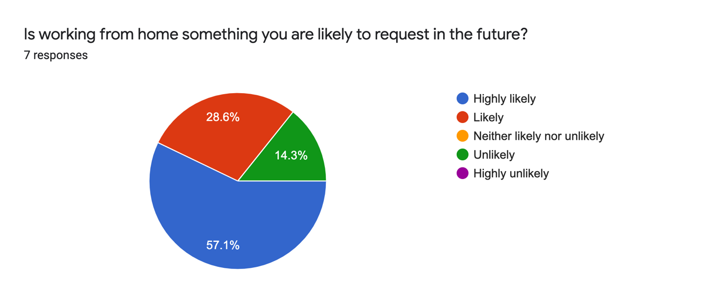
Figure 8
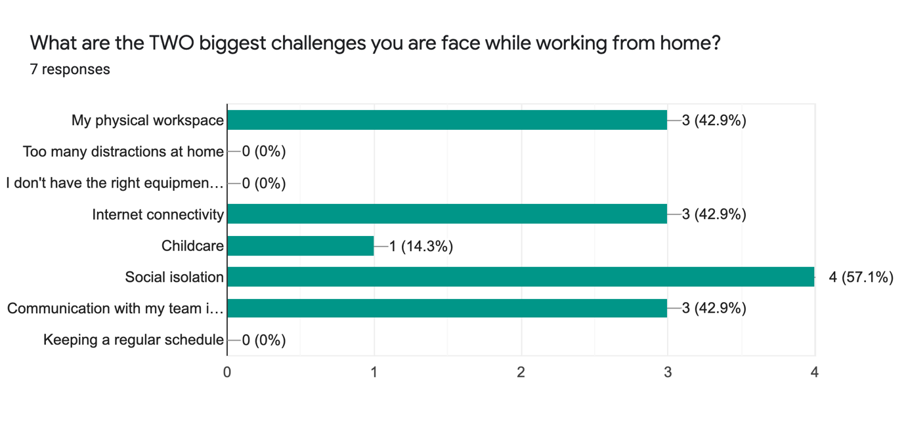
Figure 9
Challenges colleagues faced while working from home have been identified in Figure 9. These findings have been magnified by the CIPD’s (2020) predictions of social isolation and communication issues problems. Colleagues either agreed or strongly agreed that the COVID-19 has changed the future of the world of work. Views from the team collected through qualitative discussion notes attached to Appendix B show they believe are more productive at home and want the hybrid work method. They also identified risk factors, which only strengthens the findings from the questionnaire.
5. Conclusion
Working practices have transformed due to COVID-19 for the better with Capita. Staff working from home want to maintain the flexibility post pandemic by working both in the office and at home using a hybrid approach.
Performance has not been affected, staff either work the same or put more effort in. Senior managers are aware, and this may be why the option to continue working from home been planned. There are difficulties for staff as a result of working from home, but the majority are still content with ability to continue doing so.
COVID-19 has unquestionably altered the world of work. As lockdowns lift, it’s only a matter of time before organisations will ask staff to return to the office. Senior managers at Capita have proposed a timeline to return to the office in a staggered formation. This doesn’t mean returning to the office full-time, so where do we go from here?
6. Recommendations
Based on the findings from both the literature review and primary research, the following recommendations have been made:
- Discoveries have shown the majority of colleagues want to follow a hybrid approach, but this may not be the case for everyone so it may be beneficial to conduct further research into this.
- Assuming that everyone is willing to go back to the office would be unrealistic. Capita may lose colleagues, which would have detrimental effect to the business. This is something the organisation needs to appreciate.
- In order to work from home successfully, employees must be provided with the correct equipment. Appendix D shows the estimated cost to deliver equipment from the office.
7. Limitations
Time restraints and working from home were the two biggest concerns. Responses to the quantitative questionnaire was a lot lower than expected and the success of this research depended on both the responses and authenticity of responses according to Denscombe (2017). After distributing the quantitative questionnaire, the realisation that a lot of the questions were not worded correctly and types of questions such as open or closed were not fully thought through so findings were scarce. If more time was given, the qualitative discussion notes would be more detailed, or a focus group could have been arranged. Anderson (2013) points out the better the qualitative the easier to evaluate. This is something to consider in future research projects.

References & Bibliography List
Anderson, Val. (2013) Research Methods in Human Resource Management. 3rd Ed. London: CIPD.
April, M. & Dasgupta, P. (2020) Could the UK introduce the legal right to work from home? People Management. [Article] 20 May 2020. Available at: https://www.peoplemanagement.co.uk/experts/legal/could-the-uk-introduce-the-legal-right-to-work-from-home (Accessed 3 March 2021)
BBC (2020) Capita to close over a third of offices permanently. [Article] 30 August 2020. Available at: https://www.bbc.co.uk/news/business-53968213 (Accessed 3 March 2021)
Bell, J., & Opie, C. (2002) Learning from research: getting more from your data. 1st Ed. Buckingham. Open University Press.
Bloom, Nicholas, et al (2021) “How Has Working from Home Impacted Productivity? This UK Survey Has Answers.” [Article] 21 March 2021. World Economic Forum. Available at: www.weforum.org/agenda/2021/03/survey-what-are-uk-attitudes-to-working-from-home-in-the-new-normal?utm_source=facebook&utm_medium=social_scheduler&utm_term=Education (Accessed 6 April 2021)
Brown, J. & Serle, W. (2020) Overnight we went home – what will work look like after the crisis? Capita – our thinking. [Article] 15 June 2020. Available at: https://www.capita.com/our-thinking/what-will-work-look-like-after-crisis (Accessed 3 March 2021)
Calnan, M. (2017) Almost three-quarters of employees “put in more effort” when working from home. [Article] People Management. 5 October 2017. Available at: https://www.peoplemanagement.co.uk/news/articles/employees-more-effort-working-from-home (Accessed 30 March 2021)
‌Churchill, F. (2020a) Half working from home during lockdown are unhappy with work-life balance, survey finds. [Article] People Management. 7 April 2020. Available at: https://www.peoplemanagement.co.uk/news/articles/half-working-from-home-during-lockdown-unhappy-with-work-life-balance (Accessed 30 March 2021)
Churchill, F. (2020b) Majority of public in favour of continued working from home, poll finds. [Article] People Management. 28 August 2020. Available at: https://www.peoplemanagement.co.uk/news/articles/majority-public-favour-continued-working-from-home-poll-finds (Accessed 30 March 2021)
CIPD (2019) Flexible working in the UK. [Report] 12 June 2019. Available at: https://www.cipd.co.uk/knowledge/work/trends/flexible-working (Accessed 4 March 2021)
CIPD (2021) Flexible working practices. [Factsheet] 1 February 2021. Available at: https://www.cipd.co.uk/knowledge/fundamentals/relations/flexible-working/factsheet#gref (Accessed 28 March 2021)
CIPD (2020) Coronavirus (COVID-19): Flexible working during the pandemic and beyond. [Guide] 4 November 2020. Available at: https://www.cipd.co.uk/knowledge/fundamentals/relations/flexible-working/during-COVID-19-and-beyond (Accessed 4 March 2021)
CIPD (2020) Working from home: assessing the research evidence. [Report] 26 November 2020. Available at: https://www.cipd.co.uk/knowledge/fundamentals/relations/flexible-working/working-from-home-evidence-after-lockdown (Accessed 3 March 2021)
CIPD (2020) Coronavirus and the workforce: working from home in the ‘new normal’. [Thought Piece] 2 July 2020. Available at: https://www.cipd.co.uk/news-views/changing-work-views/future-work/thought-pieces/coronavirus-working-home (Accessed 3 March 2021)
CIPD (2020) Megatrends: Working from home – what’s driving the rise in remote working? [Report] 2 April 2020. Available at: https://www.cipd.co.uk/knowledge/work/trends/megatrends/working-home-rise (Accessed 3 March 2021)
CIPD (2020) Home working set to more than double compared to pre-pandemic levels once crises is over. [Survey] 16 July 2020. Available at: https://www.cipd.co.uk/about/media/press/home-working-increases (Accessed 3 March 2021)
CIPD (2020) Embedding new ways of working post-pandemic. [Report] 16 September 2020. Available at: https://www.cipd.co.uk/knowledge/work/trends/working-post-pandemic (Accessed 3 March 2021)
CIPD (2021) Planning for hybrid working. [Guide] 10 March 2021. Available at: https://www.cipd.co.uk/knowledge/fundamentals/relations/flexible-working/planning-hybrid-working (Accessed 4 May 2021)
Cosslett, R L. (2020) Working from home has offered people a glimpse of how things could be different. [Article] The Guardian Online. Wednesday 18 November 2020. Available at: https://www.theguardian.com/commentisfree/2020/nov/18/working-from-home-living-coronavirus-remote (Accessed 2 April 2021)
Denscombe, M. (2017) The Good Research Guide : for Small-Scale Social Research Projects. London: Open University Press
Haar, A. ter (2020) Making flexibility work in the “new normal.” [Article] People Management. 16 June 2020. Available at: https://www.peoplemanagement.co.uk/voices/comment/making-flexibility-work-in-the-new-normal (Accessed 30 March 2021)
Free, C. (2020) Are we at risk of missing the point? Capita – our thinking. [Article] 15 December 2020. Available at: https://www.capita.com/our-thinking/are-we-at-risk-of-missing-the-point (Accessed 3 March 2021)
GOV.UK (2012) Flexible working. [online] GOV.UK. Available at: https://www.gov.uk/flexible-working (Accessed 28 March 2021)
Legislation.gov.uk (1996). Employment Rights Act 1996. (Amended) [online] Legislation.gov.uk. Available at: https://www.legislation.gov.uk/ukpga/1996/18/contents (Accessed 28 March 2021)
Legislation.gov.uk (2014). The Flexible Working Regulations 2014. [online] www.legislation.gov.uk. Available at: https://www.legislation.gov.uk/uksi/2014/1398/made (Accessed 28 March 2021)
Marchington, M. & Wilkinson, A. (2012) Human resource management at work. 5th ed. London. CIPD
Office for National Statistics (2020a) Coronavirus and homeworking in the UK: April 2020 [Statistics] 8 July 2020. Available at: https://www.ons.gov.uk/employmentandlabourmarket/peopleinwork/employmentandemployeetypes/bulletins/coronavirusandhomeworkingintheuk/april2020 (Accessed 3 March 2021)
Office for National Statistics (2020b) Which jobs can be done from home? [Report] 21 July 2020. Available at: https://www.ons.gov.uk/employmentandlabourmarket/peopleinwork/employmentandemployeetypes/articles/whichjobscanbedonefromhome/2020-07-21 (Accessed 3 March 2021)
Osborne, H. (2021) Home works putting in more hours since Covid, research shows. [Article] Thursday 4 February 2021. The Guardian Online. Available at: https://www.theguardian.com/business/2021/feb/04/home-workers-putting-in-more-hours-since-covid-research (Accessed 2 April 2021)
Owen, J. (2020a) Home working boosts work-life balance, collaboration and focus, report finds. [Article] People Management. 17 September 2020. Available at: https://www.peoplemanagement.co.uk/news/articles/home-working-boosts-work-life-balance-collaboration-focus-report-finds (Accessed 30 March 2021)
Owen, J. (2020b) Majority of employees want to work from home for most of the week, research finds. [Article] People Management. 11 September 2020. Available at: https://www.peoplemanagement.co.uk/news/articles/majority-employees-want-work-home-most-week-research-finds (Accessed 30 March 2021)
Pakes, A. (2021) Staff must have a say in flexible working policies. [Article] Wednesday 31 March 2021. The Guardian Online. Available at: https://www.theguardian.com/money/2021/mar/31/staff-must-have-a-say-in-flexible-working-policies (Accessed 2 April 2021)
Partridge, J. (2021) Capita to close more offices as working from home options increase. [Article] Wednesday 17 March 2021. The Guardian Online. Available at: https://www.theguardian.com/business/2021/mar/17/capita-to-close-more-offices-as-working-from-home-options-increase-covid (Accessed 2 April 2021)
Rambhai, J. (2021) Many employers unprepared for hybrid working. [Research] 9 April 2021. Available at: https://www.peoplemanagement.co.uk/experts/research/many-employers-unprepared-for-hybrid-working (Accessed 4 May 2021)
Roper, J. (2020) Your new working normal questions – answered. [Article] People Management. 22 October 2020. Available at: https://www.peoplemanagement.co.uk/long-reads/articles/your-new-working-normal-questions-answered (Accessed 30 March 2021)
‌Sharman, J. (2020) Coronavirus: ‘Millions’ in Britain want permanent flexible working after lockdown, survey suggests – The Independent Online. [Article] 20 May 2020. Available at: https://www.independent.co.uk/independentpremium/uk-news/coronavirus-lockdown-flexible-working-uk-remote-wfh-home-office-a9524921.html (Accessed 4 March 2021)
Sweney, M. (2021) Nationwide office staff can work anywhere in the UK when lockdown ends. [Article] Thursday 25 March 2021. The Guardian Online. Available at: https://www.theguardian.com/business/2021/mar/25/nationwide-office-staff-can-work-anywhere-in-uk-when-lockdown-ends (Accessed 2 April 2021)
The Work Foundation. (2016) Working anywhere: a winning formula for good work. London: The Work Foundation.
Taylor, S. and Woodhams, C. (2016a) Studying Human Resource Management. 2nd Ed. London. CIPD
Taylor, S. and Woodhams, C. (2016b) Human Resource Management: People and Organisations. 2nd Ed. London. CIPD

Appendices
Appendix A
Copy of email sent to colleagues in accordance with ethical standards asking them to take part in the quantitative research questionnaire:
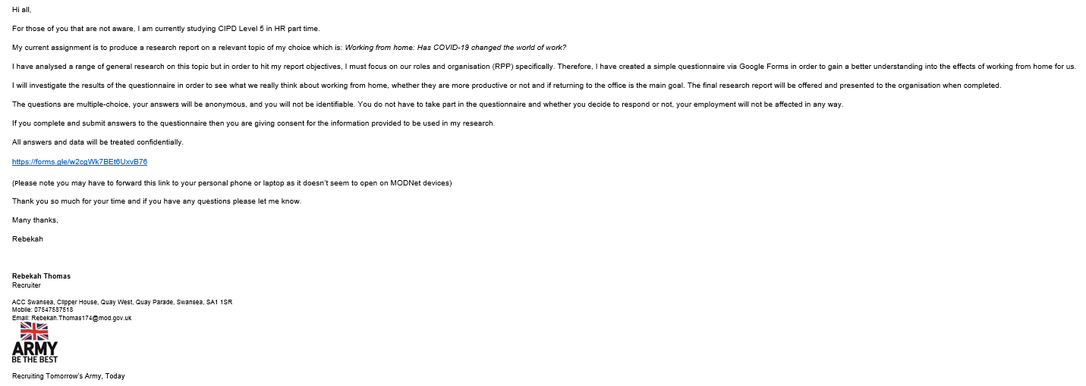

Appendix B
Results from the quantitative questionnaire which were not utilised in the main body of the report:
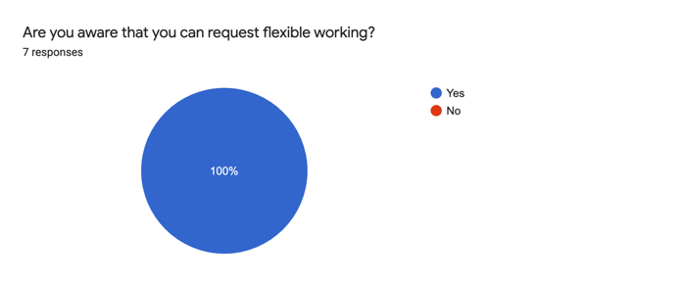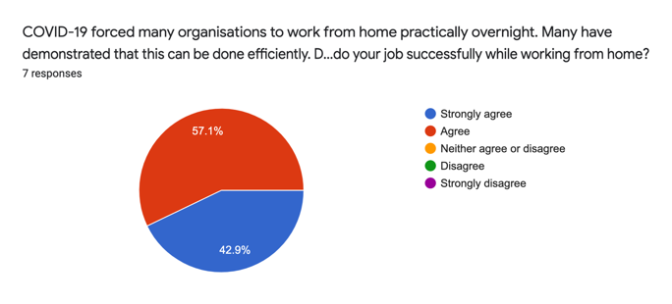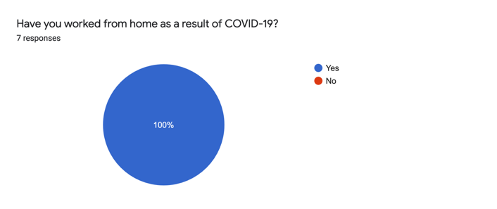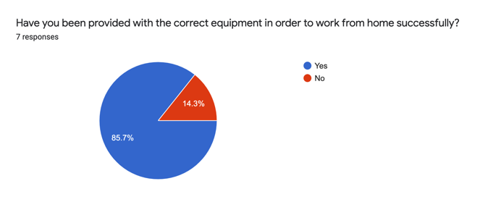
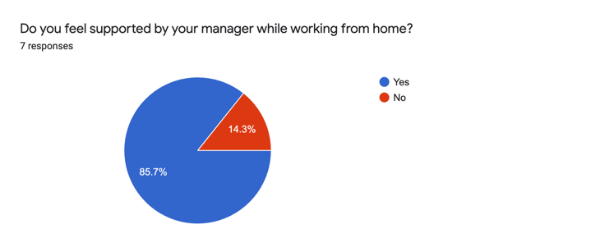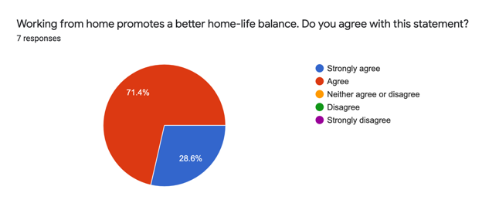

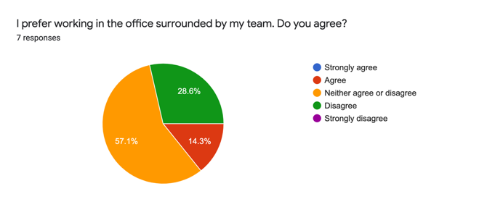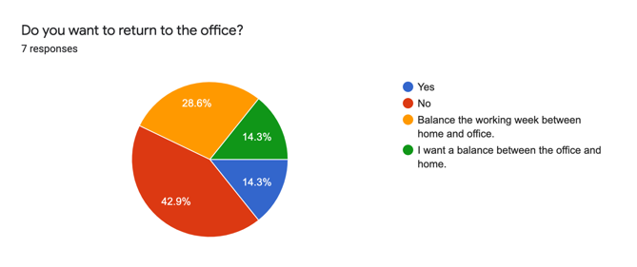

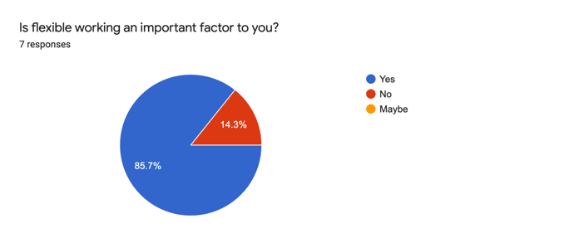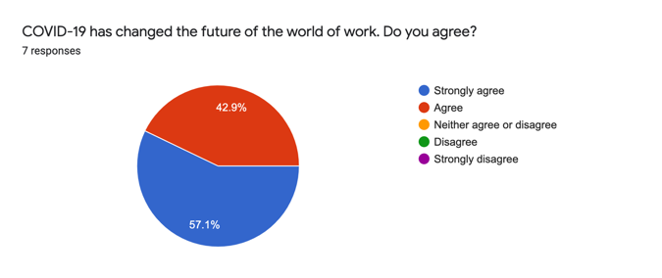
Appendix C
Further qualitative discussion notes which were not used in the main body of the report:
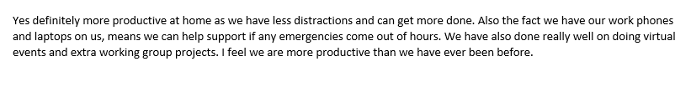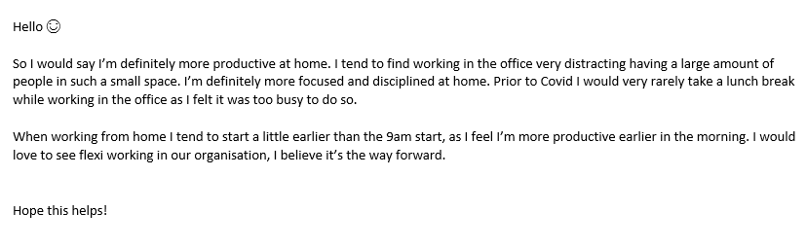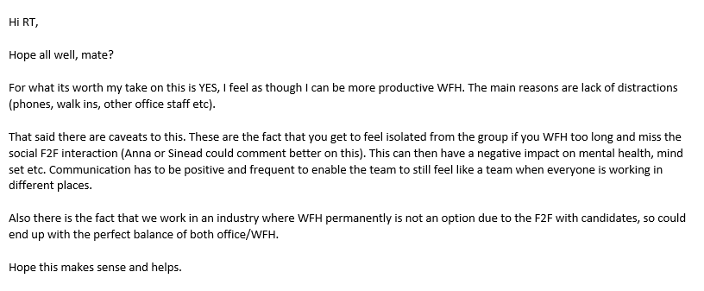
Appendix D
Estimated cost implications for organisation:
Research into the cost of moving office equipment such as a desk, computer chair and a filing cabinet from the office to home. Bearing in mind. This is a rough estimate of the cost. This would fluctuate across the region depending on location and what supplies are needed specifically from each individual. As an estimate, to move basic office supplies from the Swansea office to a home in Neath, it would £73.00. It may cost considerably more for those working in the Cardiff or Birmingham office.
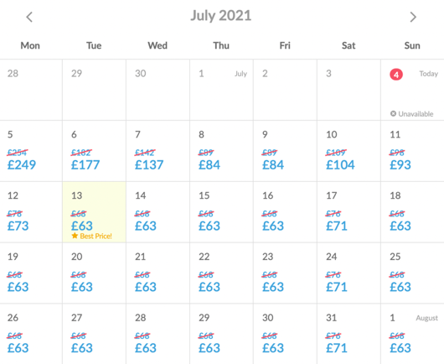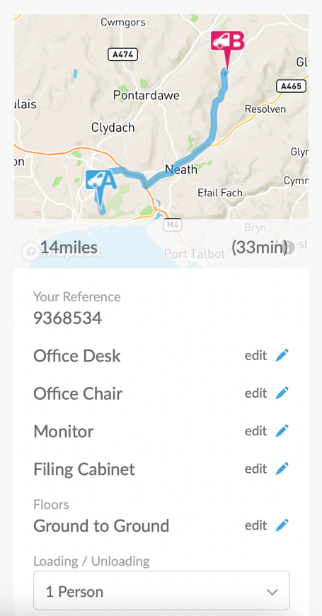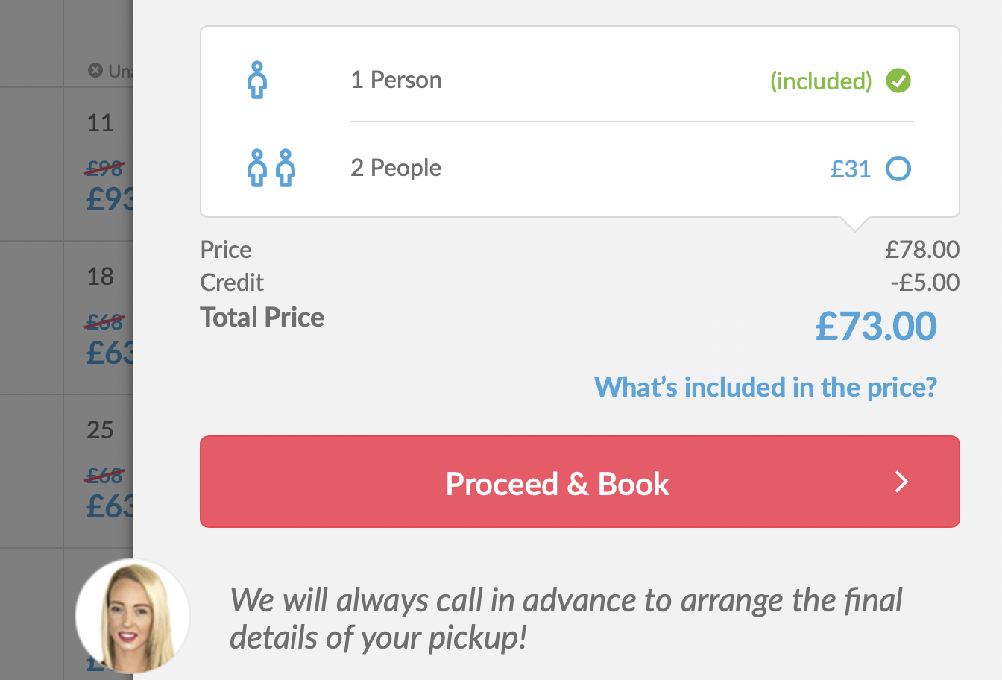
Appendix E
A UWTSD Ethical Approval Form has been completed, submitted and approved before commencing any research. Below is a snippet of the declaration signed by myself and my lecturer:


