ASSIGNMENT 1

STUDENT NAME: Reemabahen Patel

LECTURER NAME: Jaya Gopalkrishnan

SUBJECT: Entrepreneurship

Executive summary
The study mainly focused on the main values and beliefs of entrepreneurship methods within such organisations in the UK to understand its key benefits and traits. Entrepreneurship refers to the ability of all organisations to generate and run any business. To make huge profits within the organisations. For-profit and non-profit values can be measured through the attributes and values of entrepreneurship methods in small enterprises. It can be very helpful and easy to understand the ways of entrepreneurs in the business method to utilise the valuable ways of working by making money or managing financial stability in the market.

Table of Contents
Introduction 4
Traits and Characteristics of Entrepreneurship 4
Traits 4
Characteristics 5
Motivation and Attributes 6
Motivation 6
Attributes 7
Differentiation among for-profit and non-profit 8
Entrepreneur's Values and Beliefs 10
Values 10
Beliefs 10
Conclusion 11
Reference list 13

Introduction
Entrepreneurship refers to the ability of all organisations to generate and run any business. To make huge profits within organisations, the process of entrepreneurship can be very helpful to execute the business process. Development and organising the organisational business method can be generated by the ability method of entrepreneurship. Organisational risk can be mitigated or reduced through the profits of entrepreneurship. Entrepreneurship plays a key role to generate organisational products when the organisation takes any kind of issues such as financial or other business-related risks. The major aim of the study is to focus on the values and benefits of entrepreneurship in organisations to generate business.

Traits and Characteristics of Entrepreneurship

Traits
Major traits of the method of entrepreneurship engaged the main values of strong and effective leadership qualities of the organisational leaders to execute the business accurately. According to Anwar et al. (2021), Theory of Innovation, entrepreneurship can be engaged within organisations to make creativity and take creative decisions among all the employees and leaders of the workplace. It can be very helpful for organisations to utilise leadership values and their benefits to achieve business goals. The workplaces such as small organisations can take the strategies of highly motivated employees and other staff through the entrepreneurship method of the leaders. The theory of innovation entrepreneurship can be helpful to take the traits such as strong and valuable ways of basic integrity and ethics. As stated by İspir et al. (2019), the theory of physiological entrepreneurship helps to track the organisational competitor’s spirit and its benefits within the workplace. Innovation entrepreneurship theory plays a key part to make organisational innovation in Sainsbury through engaging the values of serial innovators.
The theory of innovation entrepreneurship can be very valuable to make knowledge about the organisational leaders and team members to engage them in the workplace and gain knowledge about what they do not know. Hence, it can be determined that the values of entrepreneurship through innovation entrepreneurship theory can be used to spread knowledge about unknown things in the workplace (Frese and Gielnik, 2023). Innovation in business organisations can achieve successful milestones through entrepreneurship values in the organisation. In the organisation, Tesco Plc, utilised the values of entrepreneurship of jack Kohen in the leadership process to make active business management values through making accurate interaction and communication among all the team members of the company (Ahmed et al., 2022). The competitive spirit of the organisation, Tesco Plc focused on entrepreneurship to make engagements of social values in business. Understanding the working process of any organisation, mainly of the small organisations, can be managed through a strong peer network, it can be very valuable for the organisational employees to increase the organisational network in the business market.

Characteristics
Appropriate discipline, vision, mission, management ability, adaptability, leadership, and more are the major characteristics of entrepreneurs. As stated by Fleck et al. (2020), they are referred to as organisational leaders as they contain the ways of active listening and accurate interaction values among all the team members in the workplace. Motivation plays a key part in the characteristics of the entrepreneurs, small type business organisations such as Fourex, applied the entrepreneurship method in their work to motivate the organisational team member in the values of business work to also motivate them towards achieving successful goals. Through the theory of resource-based entrepreneurship, it can be stated that entrepreneurs carry out the main characteristics of creativity and confidence (Dai et al., 2019). Entrepreneurs can also help employees by providing confidence to them to work appropriately within the workplace to achieve the organisational successful goals. Organizations can face the values and major benefits through the ways of entrepreneurship.
Innovation in business organisations can achieve successful milestones through entrepreneurship values in the organisation. It can be very helpful for companies to activate leadership values through the entrepreneurship method by utilising the theory of opportunity-based entrepreneurship in the workplace. As stated by Altinay et al. (2022), the confidential skills of entrepreneurs can be helpful for organisations and their workers to innovate such creative ways and ideas to achieve milestones. The risk-taking process can be determined as one of the crucial parts for the entrepreneurs to help the companies such as Tesco plc and Tesla Motors to mitigate the issues and major risks in the business method of the organisations.
It can be very helpful for the companies to access these valuable characteristics of the entrepreneurs to generate the business successfully. From the figure below, it can be determined that a maximum number of private companies utilised the values of entrepreneurs to increase their sales. Around 1 lakh employees registered through the values of entrepreneurship and also around 2,833,340 employees claimed as unregistered in the organisations (Statista.com.uk, 2023). In recent years, the number of registered employees through entrepreneurship values is engaged in organisations with both registered and unregistered employees.
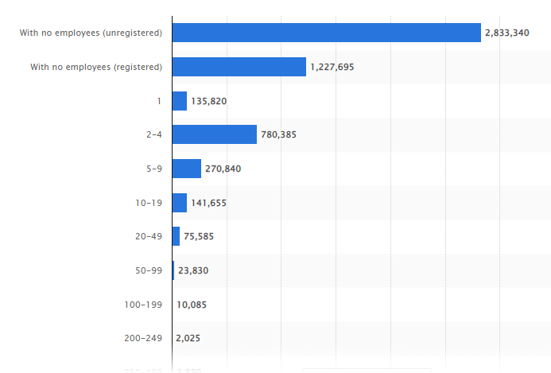
Figure 1: Number of businesses by enterprise size in the UK in 2022
(Source: Statista.com, 2023)

Motivation and attributes

Motivation
Motivational ways of entrepreneurs engaged the values of creative control, authority, more freedom, and financial stability within business organisations. More freedom for the organisational employees can be very helpful for the companies to maintain economic stability. While organisations have to face economic downfall, entrepreneurs can take the strategies of economic values (Hassan et al., 2020). Economic entrepreneurship theory can be very useful for the value proposition method to utilise the factors of financial stability and apply them in the business method of the companies. The theory of economic leadership can help the team members and other employees of any organisation and also the organisational managers to make monetary stability through aching the goals and managing the business outcomes. It can be very helpful for organisations to motivate all the workers to work according to the business values of the companies to reduce economic downfall. The motivation of the entrepreneurs also helps to lead the values of more freedom to the employees.
The employees of the organisations can get the freedom of work as they can interact with the entrepreneurs accurately through work according to the company's rules. Creativity and more authority can be managed by the entrepreneurship method and its values in the business market. The authority and management method of the entrepreneurs can be helpful for the values of entrepreneurship and their motivational ways (Wang et al., 2019). The desire to do something creative and new is the most significant for organisations to help the organisation get positive feedback and reviews from the entrepreneurs such as business managers. Becoming independent can be the major way for organisational employees to work independently without any issues and risks. It can also be a major way for the employees of the organisation of Tesco Plc to resolve any queries and issues in the workplace.

Attributes
Key attributes of the entrepreneurship method include the values of innovation and technological ways in the working method of the companies. The entrepreneurs can engage the values of taking any risks and issues of the organisational work. Taking organisational risks can be the major problem-solving method and resolving the value of the organisational employees. Entrepreneurs mainly focus on the attributes of managing monetary stability and making money for the company by making enterprises. Entrepreneurs can also help employees by providing confidence to them to work appropriately within the workplace to achieve the organisational successful goals (Prayetno and Ali, 2020). From the figure, it can be determined that small organisations utilise around 27% of the entrepreneurship values in SME enterprises. In the values of entrepreneurship management in SME enterprises, around 27-29% of management methods through entrepreneurship management in the small type organisations in the country, the United Kingdom (Statista.com.uk, 2023). Entrepreneurs are most passionate about the values of managing the organisational money and creating monetary stability.
The employees of the organisations can get the freedom of work as they can interact with the entrepreneurs accurately through work according to the company's rules. Adaptability can be counted as a wide range of values for entrepreneurs to adopt the values of the SME to locate their monetary management and stability method in the workplace. It can be determined by the adoption values of the entrepreneurs and the entrepreneurship management within the small enterprises. Economic entrepreneurship theory can be very useful for the value proposition method to utilise the factors of financial stability (Tiwari et al., 2022). It can be stated that the attributes of adoption and values of making money among the small enterprises in the country the UK and also in the entire world.
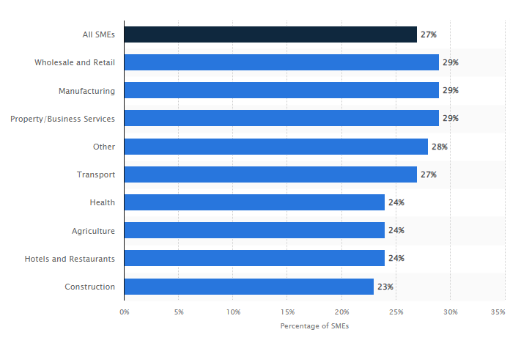
Figure 2: Percentage of SMEs that grew in the last year UK 2022, by sector
(Source: Statista.com, 2023)

Differentiation between profit and non-profit
The organisation utilises the factors of entrepreneurship mainly focused on the process of making profits through the values of profits. Through the partnership method, the entrepreneurs can be helpful for the profits. Mainly the profit business strategies focus on the business managers and the business owners. On the other hand, non-profit business organisations have to find out the largest based society and its social values (Webb et al., 2020). The organisation of Shell, Hugo Loudon mainly focussed on the business style of for-profit as they included the values of retail strategies and partnership methods. The organisation, Rio Tinto Group utilised the entrepreneurship style through the non-profit style. Social entrepreneurs mainly focused on creating sociological entrepreneurship methods by developing social conditions. In Shell, the entrepreneurs developed the values of economic growth in the business market. Moreover, the values of non-profit entrepreneurship utilise only the values of sociological vision and creating accurate missions for the employees to make social conditions, it mainly depends on creating and developing a new venture in the business market.
Both for-profit and non-profit entrepreneurs mainly focused on developing new and creative ideas and business tactics to make and maintain the organisational reputation. For-profit business organisations mainly take the value of making money by creating a vision of developing the growth of economic stability of the business (Dana, 2021). Entrepreneurs mainly focus on the attributes of managing monetary stability and making money for the company by making profits. For non-profit business enterprises, the entrepreneurship method tackles ways of improving the social conditions to provide equal opportunity to every employee and it can be also very helpful to provide proper services to the consumers. Entrepreneurship of non-profit organisations can be engaged in the values of trust and committee. On the other hand, for-profit organisations take the beliefs of partnership and bravery in their business style (Lubberink et al., 2019). Entrepreneurs are most passionate about the values of managing the organisational money and creating monetary stability.
The values of trust and committee of the entrepreneurs can be very useful for the organisations to increase their sales and maintain monetary stability. Value innovation is a major part of non-profit as an innovative way to engage every worker in the organisational business and it helped them to work with more freedom. The non-profit entrepreneurs take the values of honesty without focusing on making huge money from the business to gain every worker's trust and risk mitigation issues. As stated by Farny et al. (2019), the team members of the non-profit enterprises in the UK have taken the values of honesty and trust through the entrepreneurs. Similarly, in the organisation Rio Tinto group, Hugh Matheson takes the strategy of building trust among the committee to create business values in the business market. Hence, it can be determined that the values of passion and determination of the entrepreneurs make stability in the organisational business. The values and beliefs of entrepreneurship can be handled within these organisations to help the employees and also business managers achieve successful goals and values in business.

Entrepreneur’s values and beliefs

Values
Values of entrepreneurship engage the values of bravery and honesty of the entrepreneurs. Among all the enterprises, the entrepreneurs contain proper values of honesty towards the values of the entrepreneurship of the money-making policy throughout the business market. In the organisation of Tesla Motors, the entrepreneur mainly focused on the values of trust and fortitude towards the employees (Kruse et al., 2019). Honesty and fortitude of the entrepreneurs in small enterprises to achieve the milestones of entrepreneurship management in the business market. It can be determined by the adoption values of the entrepreneurs and the entrepreneurship management within the small enterprises. It can be very helpful for companies to activate leadership values through entrepreneurship methods.
A clear vision of the entrepreneurs can be very helpful for creating all the ways towards making money and also making independent working processes of the business market. Sociological entrepreneurship theory can be very helpful for organisations to expand their business values in the foreign business market. Taking organisational risks can be the major problem-solving method and resolving the value of the organisational employees (Hassan et al., 2020). Entrepreneurs mainly focus on the attributes of managing monetary stability and making money for the company by making profits. The theory of sociological entrepreneurship can be most effective in anthropologically accessing values to improve and expand the market values of small enterprises. The organisation of Tesla Motors mainly utilised the values of entrepreneurship such as making respect for self and others to give priority to every employee's work.

Beliefs
The main beliefs of entrepreneurship include the values of making possible anything with own work and mitigating the risks by identifying the risk issues within the enterprises. The entrepreneurs believed that risks are necessary for making planning about the risks to reduce or mitigate the issues to create a developed business plan. The small enterprises of Davison Canners utilised the beliefs of smart work rather than creating hard work (Khalilov and Yi, 2021). It helped mostly the organisation to make more money by providing all employees more freedom in their work. The competitive spirit of the organisation focused on entrepreneurship to make engagements of social values in business in the business market.
It can be very helpful for the company to access ways to convince the worker everything can be possible in the workplace to manage the business methods. It can be very helpful for companies to activate leadership values through entrepreneurship methods. Risks can be necessary for the business organisation to activate more ways to learn such as technological advancements and their implications in the global business market. It can be determined that the beliefs of entrepreneurship in the business market through the values of making confidential information about anything or everything can be possible (Rehan et al., 2019). Experience matters of the organisation in the business market can be helpful to utilise perfect management methods through the perspectives of the business process. It helped them to make money and also profit from their work. Hence, it can be stated that the values of leadership entrepreneurship theory and anthropological theory can be utilised to increase ten values and beliefs.
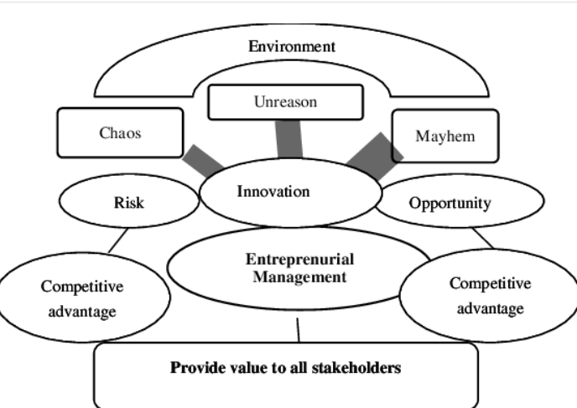
Figure 2: Values and Beliefs of entrepreneurship
(Source: research.net, 2023)

Conclusion
The study has reflected on the values of entrepreneurship management methods in small enterprises in the business market. The study has shown the major values and beliefs and also the main characteristics and attitudes of the entrepreneurs that can be helpful for SMEs to locate organisational profits. The entrepreneurs mainly focused on the values of profits and non-profits in the organisations to help the organisational values in the workplace and it also helped to engage unregistered employees as non-profit business marketing. It can be determined that the motivational skills of the entrepreneurs helped the small organisations to develop their business in the business market.

Reference list
Ahmed, M.A., Khattak, M.S. and Anwar, M., 2022. Personality traits and entrepreneurial intention: The mediating role of risk aversion. Journal of Public Affairs, 22(1), p.e2275.
Altinay, L., Kromidha, E., Nurmagambetova, A., Alrawadieh, Z. and Madanoglu, G.K., 2022. A social cognition perspective on entrepreneurial personality traits and intentions to start a business: Does creativity matter? Management Decision, 60(6), pp.1606-1625.
Anwar, I., Jamal, M.T., Saleem, I. and Thoudam, P., 2021. Traits and entrepreneurial intention: testing the mediating role of entrepreneurial attitude and self-efficacy. Journal for International Business and Entrepreneurship Development, 13(1), pp.40-60.
Dai, S., Li, Y. and Zhang, W., 2019. Personality traits of entrepreneurial top management team members and new venture performance. Social Behavior and Personality: an international journal, 47(7), pp.1-15.
Dana, L.P., 2021. Religion as an explanatory variable for entrepreneurship. In World Encyclopedia of Entrepreneurship (pp. 535-552). Edward Elgar Publishing.
Farny, S., Frederiksen, S.H., Hannibal, M. and Jones, S., 2019. A CULTure of entrepreneurship education. In Institutionalization of Entrepreneurship Research (pp. 38-59). Routledge.
Fleck, E., Kakouris, A. and Winkel, D., 2020. Cultural traits of entrepreneurship education: a cross-national study. Journal of Entrepreneurship in Emerging Economies, 13(5), pp.838-863.
Frese, M. and Gielnik, M.M., 2023. The psychology of entrepreneurship: action and process. Annual Review of Organizational Psychology and Organizational Behavior, 10, pp.137-164.
Hassan, A., Anwar, I., Saleem, I., Islam, K.B. and Hussain, S.A., 2021. Individual entrepreneurial orientation, entrepreneurship education, and entrepreneurial intention: The mediating role of entrepreneurial motivations. Industry and Higher Education, 35(4), pp.403-418.
Hassan, A., Saleem, I., Anwar, I. and Hussain, S.A., 2020. The entrepreneurial intention of Indian university students: the role of opportunity recognition and entrepreneurship education. Education+ Training, 62(7/8), pp.843-861.
İspir, Ö., Elibol, E. and Sönmez, B., 2019. The relationship of personality traits and entrepreneurship tendencies with career adaptability of nursing students. Nurse education today, 79, pp.41-47.
Khalilov, L. and Yi, C.D., 2021. Institutions and entrepreneurship: Empirical evidence for OECD countries. Entrepreneurial Business and Economics Review, 9(2), pp.119-134.
Kruse, P., Wach, D., Costa, S. and Moriano, J.A., 2019. Values matter, Don't They?–combining the theory of planned behavior and personal values as predictors of social entrepreneurial intention. Journal of Social Entrepreneurship, 10(1), pp.55-83.
Lubberink, R., Blok, V., van Ophem, J. and Omta, O., 2019. Responsible innovation by social entrepreneurs: an exploratory study of values integration in innovations. Journal of Responsible Innovation, 6(2), pp.179-210.
Prayetno, S. and Ali, H., 2020. Entrepreneurial supply chain management competence: Predictors of work motivation advocate. International Journal of Supply Chain Management, 9(3), pp.444-454.
Rehan, F., Block, J. and Fisch, C., 2019. Entrepreneurship in Islamic communities: How do Islamic values and Islamic practices influence entrepreneurship intentions? Journal of Enterprising Communities: People and Places in the Global Economy, 13(5), pp.557-583.
Tiwari, P., Bhat, A.K. and Tikoria, J., 2022. The mediating role of prosocial motivation in predicting social entrepreneurial intentions. Journal of Social Entrepreneurship, 13(1), pp.118-141.
Wang, S., Hung, K. and Huang, W.J., 2019. Motivations for entrepreneurship in the tourism and hospitality sector: A social cognitive theory perspective. International Journal of Hospitality Management, 78, pp.78-88.
Webb, J.W., Khoury, T.A. and Hitt, M.A., 2020. The influence of formal and informal institutional voids on entrepreneurship. Entrepreneurship Theory and Practice, 44(3), pp.504-526.
Website
Statista (2023), Number of businesses by enterprise size in the UK 2022. Available at: https://www.statista.com/statistics/675750/number-of-businesses-by-number-of-employees-in-the-united-kingdom/ [Accessed on 7th April, 2023]
Statista (2023), Percentage of SMEs that grew in the last year UK 2022, by sector. Available at: https://www.statista.com/statistics/291488/uk-sme-growth-by-sector/ [Accessed on 7th April, 2023]
The value of Entrepreneurial Management Note: Adapted from Henry. (2023). Available at: https://www.researchgate.net/figure/The-value-of-entrepreneurial-management-Note-adapted-from-Henry-2006-and-Burns-2008_fig1_272727756 (Accessed: April 7, 2023).

