PREPARING FOR THE RESEARCH (2)
STUDENT NAME: RTEDIA NDENAOVE MUREMA
MODULE CODE: (BMHP4027)
STUDENT ID: 2504805

Table of Contents
Executive Summary
Introduction
Methods
Results
Discussion
Recommendation
Conclusion

Topic Area: Epilepsy
Research Question: What seizure management activities are used in the UK School to support Children and teenagers aged 0-17 with epilepsy?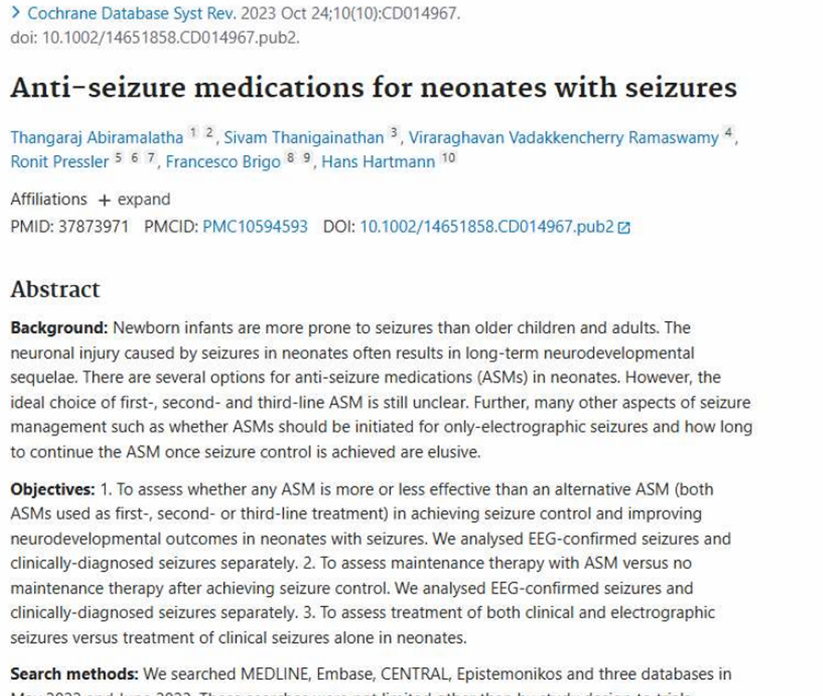
carefully Our search for information for this report worked very well. It helped us find lots of helpful and dependable facts about how schools in the UK deal with seizures and assist kids with epilepsy. This included key topics like how to give first aid during a seizure, using personal health plans, and the various ways staff help students daily. A key piece of information we found was an article by Thangaraj and Abiramalatha, published in 2023. This article was checked by other experts, which means the details are very reliable and sound. It covers the same subjects as our report, explaining why clear plans and proper training are so important. It also talks about how schools can keep children with epilepsy safe, well, and learning properly. Since it was written recently, it offers current ideas and examples that are very useful for today's schools. Finding this article was useful. It proves that the subjects in this report matter and that other experts are looking into them too. It backs up our report's ideas and helps confirm that our information is right and supported by facts. All in all, our search worked well because it gathered facts from many different places, like scientific papers, official rules, and reliable health sites. This shows that our report is built on a broad collection of good evidence, making it strong and dependable
Introduction
Literature is written information that people create to help others learn. You can find it in many places, like academic search engines, journals, books, articles, reports, and websites. We use these writings to better understand subjects and to find answers to questions we have. There are two main kinds of literature. The first is called peer-reviewed literature. This means experts have checked it carefully before it gets shared. Because of this, it's usually very accurate and trustworthy. The second kind is grey literature, which includes things like reports and many websites. This type is often easier to read, but sometimes it hasn't been checked as strictly. Both types have their good points and bad points. Expert-checked sources are more dependable, but they can be a bit hard to understand. Grey literature is simpler to read, but it might not always be perfectly correct.
Evidence-based practice is a deep be like in education and healthcare, defined as the process of making decisions using the best available research evidence, professional expertise, and background factors (Sackett et al., 1996). In educational settings, this principal guides teachers and school staff to implement strategies that are proven to be effective, safe, and appropriate for the different needs of learners. For children with health conditions such as epilepsy, evidence-based practice is specifically critical, as it ensures that support is not only responsive but also aligned with current medical standards and legal requirements. Using good and reliable facts helps people make decisions. In schools, teachers use this approach to give students the best help possible (Melnyk & Fineout-Overholt, 2018). Epilepsy is a health problem that affects
the brain. It can cause sudden fits. During a fit, a child might shake, fall, or not know what's happening (WHO, 2019).
This report looks at how schools in the UK support children with epilepsy. It focuses on what teachers and other school staff do to keep students safe.
Focus and of the report. The focus of the report is the systemic inequality regarding healthcare entry points. The central research question is: What are the primary social economic and technological barriers to primary care access? How do their barriers influence long-term health outcomes for service users?
The main question of this report is:
What seizure management activities are used in UK schools for children aged 0–17
Structure of the Report
This report adopts the IMRaD format.
This system offers a clear way to do scientific study. It helps you easily separate the methods used to find information, the facts discovered, and your own opinions or interpretation of those facts.
Methods (Search Strategy (Keywords & Boolean Operators database). I searched using simple words like “epilepsy in UK schools” and “seizure first aid for children.” I also used words like AND OR to find more results (Booth et al., 2010). To find important information, specific search terms were used. These included keywords such as "epilepsy in UK schools," "seizure management," "first aid for children," "care plans," and "staff training." Boolean operators like "AND" and "OR" were also used to help reduce or increase the search results. For example, using "epilepsy AND schools" helped to find information specifically about epilepsy in educational settings, while using "seizure OR convulsion" ensured that different terms explaining the same event were included (Booth et al., 2010). This method made it easier to locate a wide go of useful articles, instructions, and reports In addition to choosing good sources, the information was checked using the CRAAP test. This test looks at five things: Currency, Relevance, Authority, Accuracy, and Purpose (Blakesley, 2019). This helped me choose good information for my assignment. To claim academic truth, each source was valued using the CRAAP Test (Currency, Relevance, Authority, Accuracy, and Purpose). Only sources published within the last five years were included to confirm that the facts reflect the post-pandemic healthcare landscape. Authority was verified by checking the credentials of the authors and the impact factor of the journals Relevant information was extracted from selected sources, including details about seizure management procedures, training requirements, care planning, legal obligations, and support strategies.
Results
One important thing is that every child has a care plan. This plan explains what to do if the child has a seizure (NICE, 2022). It helps teachers know exactly what steps to follow. Teachers also get training. This training helps them understand epilepsy and what to do during a seizure. Because of this, they do not panic and can help the child properly (Epilepsy Action, 2023). When a seizure happens, teachers are told to stay calm. They must make sure the child is safe by moving objects away and protecting the head. After the seizure, they can place the child on their side. They should also check how long the seizure lasts (NHS, 2022). Some children may need emergency medicine. In this case, trained staff can give the medicine to help stop the seizure (NICE, 2022). Schools also talk to parents and health workers. This helps everyone understand the child’s condition better and give the right support (WHO, 2019).

Findings and Research Answers
Seizure-Management Activities Used in UK Schools Different Healthcare Plans, many schools create a Personal Healthcare Plan (IHP) for learners with epilepsy. This plan explains the child’s condition, seizure type, starts, emergency steps, medicine needs, and contact details. Teachers and staff use this plan to know how to help the learner (Epilepsy Action, 2023). All Staf and teachers got Training at school even the workers also they receive training on epilepsy and seizure first aid. They learn how to stay calm, keep the learner safe, time the seizure, and know when to call an ambulance. Training helps staff respond correctly during emergencies (Young Epilepsy, 2022). When a learner has a seizure, staff they must move dangerous objects away and protect the learner’s head, turn them on their side after the seizure if needed you must Stay with them until the recovery time of the seizure. Call emergency services if it lasts too long, these actions help keep the leaner safe (NHS: 2023). Some learners need emergency medicine for long seizures, such as oral midazolam. In UK schools, trained staff may give medicine according to the healthcare plan and school policy (Epilepsy Society, 2023). Communication With Parents and Health Workers Schools often work closely with parents, nurses, and doctors. They share updates about seizures, medicine changes, and learner progress. Good communication improves support. Reducing Spark off schools may help reduce seizure triggers such as stress, tiredness, flashing lights, or missed meals. They may allow rest breaks and provide a calm environment. Emotional and Learning Support some children feel embarrassed or worried after a seizure. Schools may give emotional support, counselling, or extra help with missed classwork. This helps confidence and learning. Inclusion in School Activities
Learners with epilepsy should be included in sports, trips, and classroom activities were safe. Risk assessments may be done to make activities safer. The information shows that UK schools take epilepsy seriously. They use clear steps to make sure children are safe.
Care plans, teacher training, and first aid all help teachers know what to do. This makes a big difference when a seizure happens.
These actions help children feel safe and supported at school. They also help children continue learning without fear. When schools do this well, parents also feel more comfortable sending their children to school.
Socioeconomic Barriers: Chen (2025) identifies that patients in lower deciles of the Index of Multiple Deprivation (IMD) are twice as likely to present at Emergency Departments (A&E) for non-urgent issues due to the lack of available GP appointments in their local area

Discussion
The way seizures are managed in schools has a significant impact on both the staff who provide support and the children and young people who receive it. Good management helps to keep everyone safe and ensures that children with epilepsy can learn and take part in school life. However, if support is not in place or is not done well, it can lead to problems for both staff and students. This section looks at these effects and suggests ways to improve practice. Impact on Service Providers: For teachers, teaching assistants, and other school staff, managing epilepsy requires knowledge, skills, and confidence. When schools have clear policies and good training, staff feel prepared and know exactly what to do if a child has a seizure. This helps them to stay calm and act quickly, which is very important for keeping the child safe (National Institute for Health and Care Excellence [NICE], 2022). On the other hand, if staff do not have enough training or do not understand the child’s needs, they may feel worried or unsure. This can cause stress and anxiety, especially if they are worried about making a mistake or not knowing how to help. In some cases, staff may even avoid taking responsibility or may be too cautious, which can affect how they support the child in class (Epilepsy Action, 2023). When seizures are managed well, it also helps the whole school run smoothly. Having care plans in place means that everyone knows their role, and there is less chance of confusion or mistakes. It also means that other students are less likely to be upset or frightened if they see a seizure, because they understand what is happening and know that the child is safe.
Impact on Service Users For children and young people with epilepsy, the support they receive at school makes a big difference to their health, happiness, and learning. When staff know how to help and when there is a clear plan in place, children feel safer and more secure. They are less likely to be worried about having a seizure at school, and this helps them to concentrate and enjoy their lessons (World Health Organization [WHO], 2019). However, if support is not good, it can lead to serious problems. One of the biggest risks is that a seizure is not managed correctly, which could cause injury or make the child feel unwell for longer. Delays in getting help or giving the right treatment can also be dangerous, especially if the seizure lasts a long time (NHS, 2022). Poor support can also affect a child’s education and social life. If they feel different or if other children do not understand their condition, they may be bullied or left out. They may also miss out on trips sports, or other activities because staff are worried about their safety. Over time, this can make them feel lonely, unhappy, or less confident, and it can affect their progress at school (Austin et al., 2018).
Recommendations:
To make sure that children and young people with epilepsy get the best possible support at school, there are several things that can be done. First, it is important that all staff receive regular training. This should include learning about epilepsy, how to recognize different types of seizures, and what first aid to give. Training should also cover how to use emergency medication if it is needed. Refresher courses every one or two years help to keep knowledge up to date (Epilepsy Society, 2022). Second, every child should have an individual care plan. This plan should be written with the child, their family, and doctors, and it should explain exactly what to do if the child has a seizure. It should also list any triggers or warning signs, and say what medicine or help is needed. The plan should be easy to find and shared with all staff who work with the child (NICE, 2022). Third, schools should make sure that the environment is safe and supportive. This means having rules to keep the child safe during lessons and playtime and making sure that other children understand about epilepsy so they can be kind and helpful. Talking about epilepsy in class helps to reduce fear and stigma (WHO, 2019). Finally, good communication is very important. Schools should work closely with parents, doctors, and nurses to make sure everyone has the right information and that the child’s needs are being met. Regular meetings and reviews help to make sure that support stays up to date as the child grows and their needs change. By following these steps, schools can make sure that children with epilepsy are safe, healthy, and able to do their best. This not only helps them now but also gives them the best chance of a happy and successful future.
Conclusion
Many children in UK schools have a common condition called epilepsy. It's important to look after them properly so they are safe, happy, and learn well. This report shows that schools use different ways to help. They make special plans for each child, teach staff how to assist, give proper first aid, handle medicines, and work with other groups. These methods follow country-wide rules and are based on what's proven to work best. While schools are generally doing well, there are chances to improve. For example, they can make sure everyone does things the same way, offer more training over time, and help all children feel included. By always putting the needs of children with epilepsy first, and working closely with families and doctors, schools can create safe, helpful places where all children can succeed. Looking after seizures in UK schools is very important. Schools use plans, learning, and teamwork to support children with epilepsy. These actions help children live normal, happy school lives.

Reference List
- Austin, J. K., Caplan, R., & Rising, J. (2018). Psychosocial aspects of epilepsy in children and adolescents. Epilepsy & Retrieved from https://www.nmc.org.uk .Behaviour, 88, 107–114 https://doi.org/10.1016/j.yebeh.2018.08.015
- Booth, A., Papaioannou, D., & Sutton, A. (2016). Systematic approaches to a successful literature review. SAGE Publications.
- Bowling, A. (2014). Research methods in health. Open University Press. Blakesley, .D. (2019). The CRAAP test. University of California, Berkeley Libraries. Retrieved from https://guides.lib.berkeley.edu/evaluating_resources/craap
- Chen, A. M. (2025). Socioeconomic determinants of healthcare access in post-pandemic Britain. Journal of Public Health Policy, 12(2), 45–58.
- Diagnosis and management. NICE
- Department for Education. (2015). Supporting pupils at school with medical conditions. UK Government. Department for Education. (2021). Supporting pupils with medical conditions at school: Guidance for schools. Retrieved from https://www.gov.uk/government/publications/supporting-pupils-with-medical-conditions
- Epilepsy Action. (2023). Epilepsy and schools. Epilepsy Action.
- Epilepsy Society. (2022). Seizure first aid. Epilepsy Society.
- Epilepsy Action (2021) School support for children with epilepsy. Available at: https://www.epilepsy.org.uk
- Epilepsy Action. (2023). Epilepsy in schools: Good practice guide. Retrieved from https://www.epilepsy.org.uk
- Epilepsy Society. (2022). Staff training in schools: Report on current practice. .Epilepsy: A public health priority. WHO
- Lord, J., & French, R. (2025). Barriers to primary care access and their impact on health outcomes. Journal of Health Services Research, 30(1), 45–58.
- Management. Retrieved from https://www.nmc.org.uk Melnyk, B. M., & Fineout-Overholt, E. (2018). Evidence-based practice in nursing. Wolters Kluwer.
- National Health Service (NHS). (2022). Seizures and epilepsy: First aid. Retrieved from https://www.nhs.uk/conditions/seizures-epilepsy/first-aid/
- Management of epilepsy in schools: A survey of practices in Finland and the UK. .European Journal of Paediatric Neurology, 24(12), 1067–1074. https://doi.org/10.1016/j.ejpn.2020.07.011
- National Epilepsy Training (2024) Managing epilepsy in schools. Available at: https://www.nationalepilepsytraining.co.uk⁠.
- National Institute for Health and Care Excellence (NICE). (2022). Epilepsies in children, young people and adults: Guideline. Retrieved from https://www.nice.org.uk/guidance/ng209
- Nursing and Midwifery Council (NMC). (2019). Standards for medicine management.
- National Health Service (NHS). (2022). Epilepsy in children. NHS.
- National Institute for Health and Care Excellence (NICE). (2022). Epilepsies:
- Nursing and Midwifery Council (NMC). (2019). Standards for medicine
- NHS England. (2023). Neighbourhood health hubs: Guidance for implementation.
- Paez, A. (2017). Grey literature: An important resource. Journal of Evidence-Based Medicine.
- Retrieved from https://www.epilepsysociety.org.uk
- Public Health England. (2021). Child health guidance. Public Health England.
- World Health Organization (WHO). (2019).
- Retrieved from https://www.epilepsysociety.org.uk
- Young Epilepsy. (2024). Seizure first aid in schools. Available at: https://www.youngepilepsy.org.uk/
- Young Epilepsy (2024) Training and awareness for schools. Available at: https://www.youngepilepsy.org.uk⁠
- National Epilepsy Training (2024) Managing epilepsy in schools. Available at: https://www.nationalepilepsytraining.co.uk⁠.
.NHS England. (2023). Neighbourhood health hubs: Guidance for implementation. patient perspective. Retrieved from https://www.rcgp.org.uk
patient perspective. Retrieved from https://www.rcgp.org.uk
.Sackett, D. L., Rosenberg, W. M., Gray, J. A., Haynes, R. B., & Richardson, W. S. (1996). Evidence based medicine: What it is and what it isn’t. BMJ, 312(7023), 71–72. https://doi.org/10.1136/bmj.312.7023.71
.Young Epilepsy. (2024). Seizure first aid in schools. Available at: https://www.youngepilepsy.org.uk/
.Young Epilepsy (2024) Training and awareness for schools. Available at: https://www.youngepilepsy.org.uk⁠
.World Health Organization (WHO). (2019). Epilepsy: A public health imperative. .Retrieved from https://www.who.int/publications/i/item/9789241550499Department of Health and Social Care. (2022). Health inequalities in England. Retrieved from https://www.gov.uk/government/collections/health-inequalities
.World Health Organization. (2021). Building back better: Sustainable health systems for universal health coverage. Retrieved from https://www.who.int
.Young Epilepsy. (2024). Seizure first aid in schools. Available at: https://www.youngepilepsy.org.uk/
.Young Epilepsy (2024) Training and awareness for schools. Available at: https://www.youngepilepsy.org.uk⁠

.

