Stakeholder V Stockholder Approaches to CSR (support doc for 05 January 2021)

- Draw stakeholder maps for your cases:
A government hospital- eg Singleton Hospital Swansea https://sbuhb.nhs.wales/recovery-wellbeing/about-recovery-wellbeing/

A private hospital- eg Private Harley Street Clinic https://privateharleystreetclinic.com/?gclid=Cj0KCQiA_c-OBhDFARIsAIFg3eyD24BCmcCWxdJEQA5HzX90cmvlFL1KSsOyHcPRF2yRa_OkBg2z-WUaAo6rEALw_wcB

A Not for Profit (NFP) health provider- eg Sancta Maria Hospital, Swansea. Is a charitable trust. https://hmtsanctamaria.org/about-us/

The more you read the more complex it gets!!!
- Government hospitals have private sector activity and work with charities.
- Private hospitals are often charitable trusts like Sancta Maria.
- NFP are governed by many of the same regulations which apply to public and private hospitals.

- Compare the maps to see similarities and differences. Do you agree with the lists of the other groups

- Using a case, what evidence is there of their CSR policy and implementation? How much CSR takes place if it does not “pay back”?

Can you use the ethical v profit diagram?
Figure 1: Ethics-Profits Matrix. Source: Tom Cannon (1996) Corporate Responsibilty, London, Pearson)

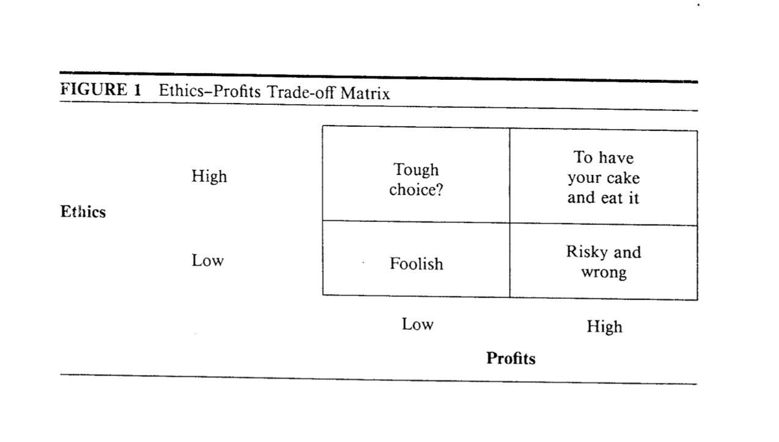

- How do Greenfield (2004), Sternberg (2005), Crane and Matten (2010) and Porter (2011) fit the CSR approach?
Get a simple stockholder map or diagram to compare with a stakeholder map. A basic stakeholder map will be similar for all. Are internal stakeholders more important than external?

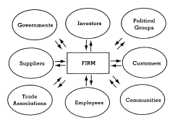
Figure 2; the Stakeholder Model (Donaldson et al., 1995)

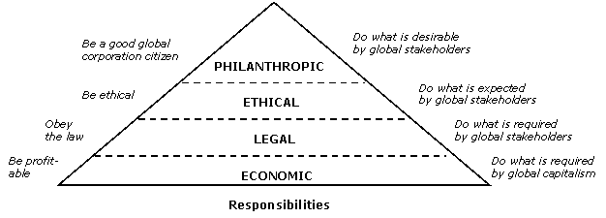
Figure 3; Responsibility and Performance (Carroll, 2004)

- Are all stakeholders equal?

Important- the ones you ought to consider? Just looking at ethical reasons.

or

Important- the ones who you respond to because they have power, influence or can hurt you if you don’t???

Use this diagram to identify the most important stakeholders.

The original article that I would quote in your assignment:

Mendelow, A. L. (1991) ‘Environmental Scanning: The Impact of the Stakeholder Concept’. Proceedings From the Second International Conference on Information Systems 407-418. Cambridge, MA.

There are many worked examples available and sites offering the tools to make your own.

Figure 4. Mendelow’s Power/interest matrix (Source https://blog.oxfordcollegeofmarketing.com/2018/04/23/what-is-mendelows-matrix-and-how-is-it-useful/ Accessed 11-11-21).

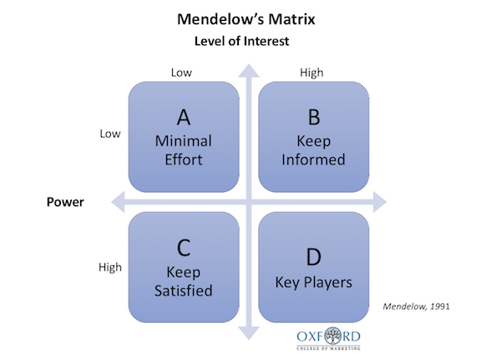

Mendelow Matrix is an essential tool that is used to understand the behaviour of stakeholders and come up with a productive corporate strategy. Every organization is governed by its stakeholders. It doesn't matter if you own a start-up, or if you are a founder of a reputed firm, but you can't progress without knowing the interest of your stakeholders in mind. It is known to be the best way of achieving stakeholder mapping, which can further be used to come up with a productive plan of action.
In every organization, there are different kinds of stakeholders - from the ones who have less power and have the least interest to the ones who are the most powerful and are interested in every business move. In order to make sure that you satisfy the need of every one of them, you need a way to map them into various categories. Mendelow Matrix will help you achieve your requirements by providing you just the right way to distinguish the nature of a stakeholder based on their power and interest so that you could create your plan of action accordingly.
More on stakeholders. https://www.open.edu/openlearn/money-business/leadership-management/discovering-management/content-section-1.4.3
A 5-minute video on using Mendelow https://www.youtube.com/watch?v=5n1vf4pcmfw
Worked example by Imperial College London https://www.imperial.ac.uk/media/imperial-college/administration-and-support-services/staff-development/public/impex/Stakeholder-management-21jun17.pdf
Create your own https://conceptboard.com/blog/stakeholder-analysis-mendelow-matrix/

