Title

Name: Nicusor Mihai
Surname: Enache
Affiliation: Student at University of Wales Trinity Saint David
Course: Cloud Computing
Module: Academic and Employability Skills

Table of Content
1. Title
2. Table of Content
3-5. Personal Overview
6-8. Skills Evaluation
9. Action Plans
10-11. Application
12. Conclusion
13. References

Personal Overview
This assignment will give the reader an overall idea of my skills and weaknesses, personality type, long-term and short-term goals and how I am going to achieve them

My name is Nicusor Mihai Enache, I am 30 years old and I am a student at the University of Wales Trinity Saint David. I am studying Cloud Computing because I want to become a successful network engineer. One of the skills I learned after I joined the University of Wales Trinity Saint David was delivering successful PowerPoint presentations. I consider this is important as it makes it easier to share my ideas and concepts to other people

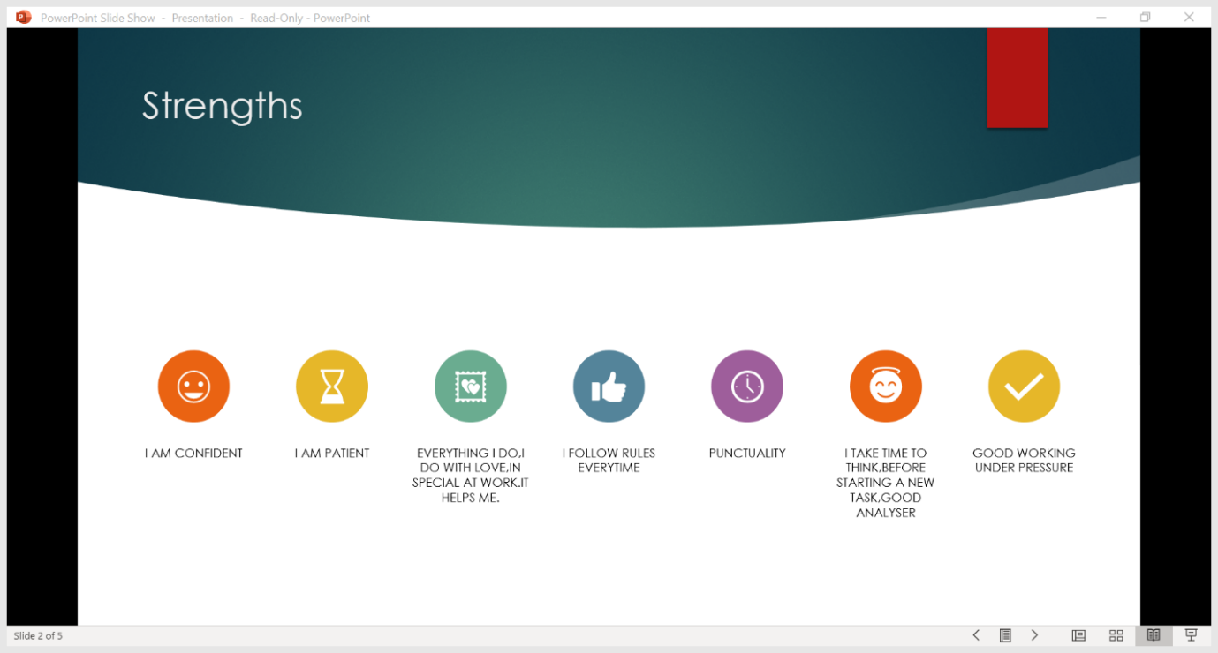
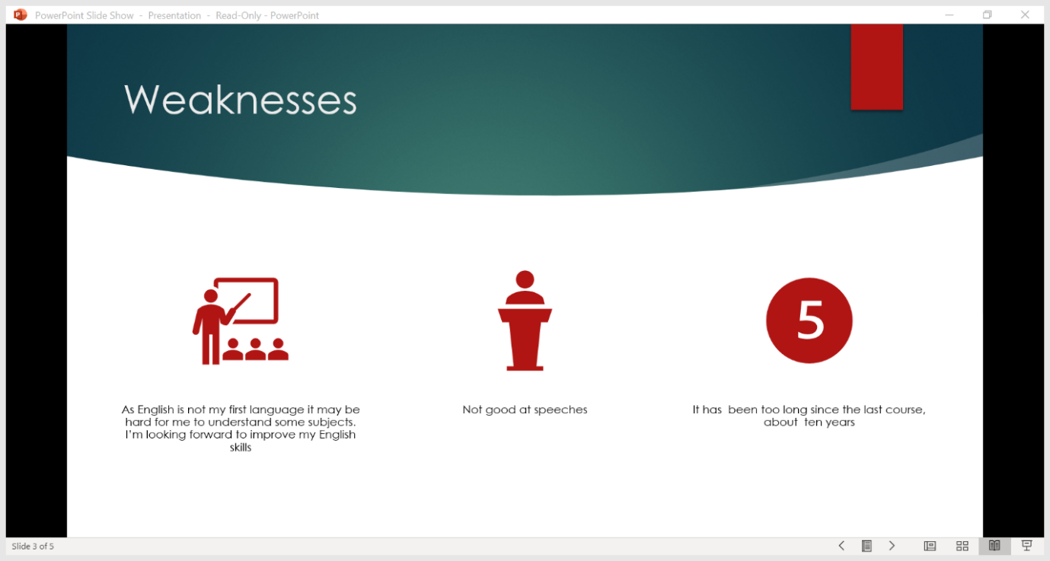
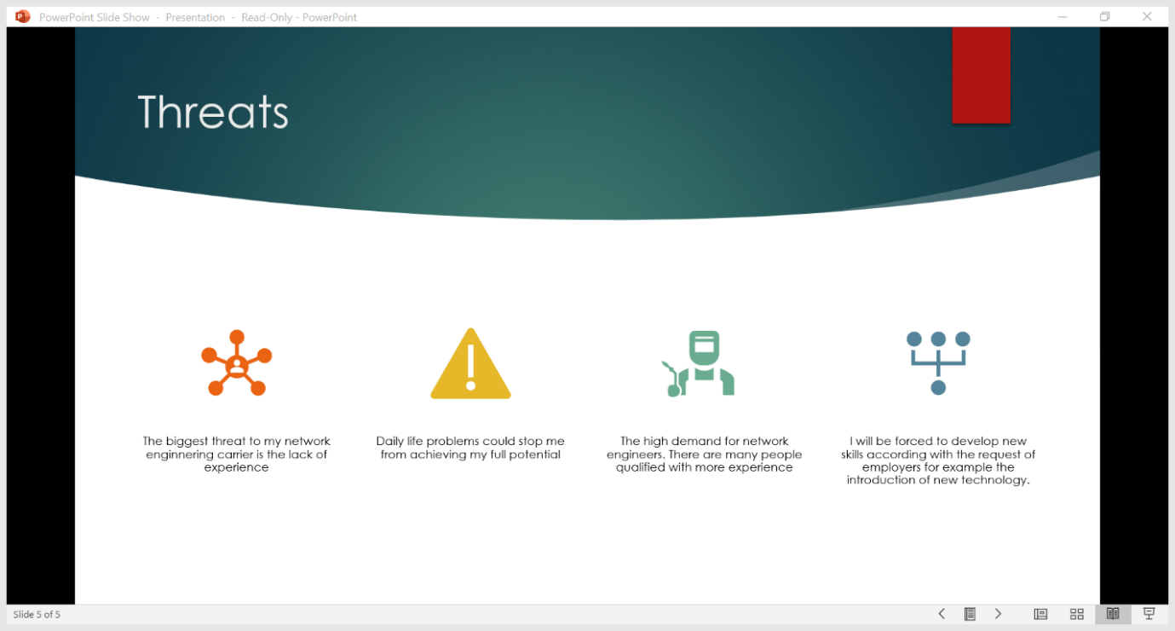

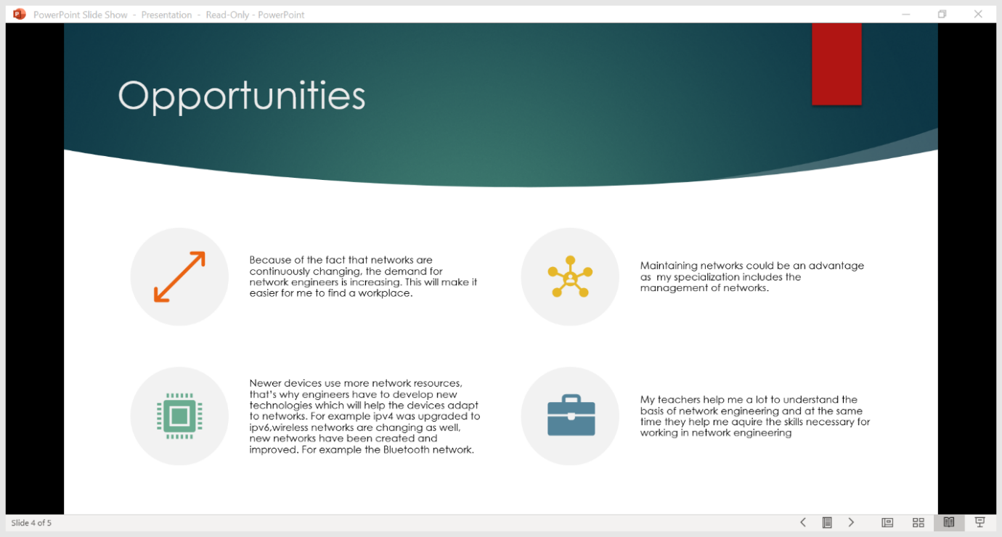

Skills Evaluation

“There are four categories of skills that are substantial to HE education and employment. The first category of skills that I consider every student must have is the basic skills. These are the skills which are easier to acquire and without them HE would not be possible. The five basic skills are: Reading, Writing, Mathematics, Speaking, and Listening”. (https://www.careerkey.org/identify-your-skills/basic-skills.html, accessed on 01/05/2020)

(1) “Reading involves being able to identify relevant information, facts and specification from books, graphs, and texts. It also involves finding the meaning of unknown words and comparing information and selecting the one with the best quality”. “Writing requires a person to write ideas and concepts with proper grammar and punctuation and recheck their work for mistakes and correct them”. (https://www.careerkey.org/identify-your-skills/basic-skills.html, accessed on 01/05/2020)
(2) “Mathematics Skills is the ability to use numbers, fractions, and percentages to solve problems and represent data”. (https://www.careerkey.org/identify-your-skills/basic-skills.html, accessed on 01/05/2020)
(3) “Speaking demands a person to organize their ideas and transmit them in a clear way with select language and suitable tone of voice”. (https://www.careerkey.org/identify-your-skills/basic-skills.html, accessed on 01/05/2020)
(4) “Listening is the ability to listen carefully to what a person says, his/her tone of voice and other body language showing that you understood what they said”. (https://www.careerkey.org/identify-your-skills/basic-skills.html, accessed on 01/05/2020)
“The second category of skills that is important for HE learning is Thinking Skills. As the name suggests, this category of skills focuses more on the ability to think. The four Thinking skills are: Creative thinking, Problem-Solving Skills, Decision Making Skills and Visualization”. (https://www.careerkey.org/identify-your-skills/thinking-skills.html (https://www.careerkey.org/identify-your-skills/thinking-skills.html, accessed on 01/05/2020)
(5) “Creative Thinking involves using imagination freely, without limiting it, combining ideas and information in new ways”. (https://www.careerkey.org/identify-your-skills/thinking-skills.html, accessed on 01/05/2020)
(6) “Problem Solving Skills involve identifying problems and finding an adequate solution. It also involves verifying if the solution has worked and finding a new one if it did not”. (https://www.careerkey.org/identify-your-skills/thinking-skills.html, accessed on 01/05/2020)
(7) “Decision making skills involve deciding which solution is the best, weighing pros and cons and finding an alternative. This type of skills is more important in big businesses or companies”. (https://www.careerkey.org/identify-your-skills/thinking-skills.html, accessed on 01/05/2020)
(8) “Visualization involves being able to see a building or object just by looking at a photo or drawing. It also involves being able to imagine how a system works by looking at a schematic or blueprint.” (https://www.careerkey.org/identify-your-skills/thinking-skills.html, accessed on 01/05/2020)
“The third category of skills needed for HE and employment is People Skills. This type of skills is related to a person’s behavior among other people. The five People Skills are: Social, Negotiation, Leadership, Teamwork and Cultural Diversity”. (https://www.careerkey.org/identify-your-skills/people-skills.html, accessed on 01/05/2020)
(9) “The Social skill is the ability to show understanding, friendliness, and respect to other people; Taking an interest in what other people say and do”. (https://www.careerkey.org/identify-your-skills/people-skills.html, accessed on 01/05/2020)
(10) “Negotiation skills consists in identifying common goals among different parties in conflict. Presenting the facts and arguments of your position and listening to the other party’s arguments and understanding them. Trying to find possible ways of solving the conflict. Making compromises”. (https://www.careerkey.org/identify-your-skills/people-skills.html, accessed on 01/05/2020)

(11) “Leadership involves communicating thoughts and feelings to justify a position. Encourage and convince others to do the right thing. Make others believe in your ideas and concepts and make them trust you because of your abilities”. (https://www.careerkey.org/identify-your-skills/people-skills.html, accessed on 01/05/2020)
(12) “Teamwork requires the ability to cooperate with other people. Contribute with ideas and effort. Do your part of the job and encourage other team members. Solve problems for the benefit of the team”. (https://www.careerkey.org/identify-your-skills/people-skills.html, accessed on 01/05/2020)
(13) “Cultural Diversity means working well with people with different ethnic, social, or educational backgrounds. Understand the problems of members of other ethnic and gender groups. Judge a person by his/her behavior, not by his/her social, ethnic, or educational backgrounds. Understand a person’s culture and help them make cultural adjustments when needed”. (https://www.careerkey.org/identify-your-skills/people-skills.html, accessed on 01/05/2020)
(14) “The fourth and last category of skills needed for HE and employment are personal qualities. The three personal qualities are: Self-Esteem, Self-Management, and Responsibility”. (https://www.careerkey.org/identify-your-skills/personal-qualities.html, accessed on 01/05/2020)
(15) “Self-Esteem is characterized as an individual’s subjective evaluation of their own worth. Self-Esteem encompasses beliefs about oneself as well as emotional states such as: Triumph, despair, pride, and shame”. (https://en.wikipedia.org/wiki/Self-esteem, accessed on 01/05/2020)
(16) “Self-Management is the ability to assess your knowledge and skills accurately. Set specific, realistic, and personal goals and display a high standard of attendance, honesty, energy, and optimism”. (https://www.careerkey.org/identify-your-skills/personal-qualities.html, accessed on 01/05/2020) (17) “Responsibility is characterized by working hard to reach a goal even though the task may seem unpleasant. Do quality work and display high standard of attendance, honesty, energy, and optimism”. (https://www.careerkey.org/identify-your-skills/personal-qualities.html, accessed on 01/05/2020)

I consider myself a persistent person who never gives up despite any situation. The fact that English is not my first language only encourages me to learn more and achieve my full potential. Furthermore, the strengths that represent me are my: confidence, patience, punctuality and finally but not least, my teamwork. However, despite my strengths I still have weaknesses. One of the reasons I wanted to join university was my wish to improve my weaknesses and turn them into strengths as I thought it is an important step in achieving a successful career. Some of the weaknesses I am planning on improving are: My lack of knowledge about networks, my English language skills, and my communication skills. It will be a long way to go, but my determination will help me walk on the path to my success. As of my personality, I am a calm person, friendly with the people around me. I am willing to help others whenever I can, and I do not mind other people helping me if they are willing to. Considering my personality, I believe a network engineering career would suit me the best.
I am also planning on acquiring all the skills I have listed above that I do not have yet because without them HE would not be possible.

Action Plans

Short term goals:
My first short term goal is gaining more knowledge and experience. I am planning to do this by finishing university, attending job fairs, informational meetings, and training sessions to meet professionals in network engineering.
My second short term goal is to graduate university and gain my bachelor’s degree in Computer Science as only by doing this I can become a network engineer.
My third short term goal is to find a job which will allow me to attend courses more frequently. I consider this very important as it will make it easier for me to reach success.
Long term goals:
My first long term goal and the most important one is becoming a successful network engineer. I believe a network engineering career suits me the best because of my skills and personality.
My second, long term goal is finding a stable job in network engineering that will help me support both me and my family.
My third and last long-term goal is living a happy and calm life “as true success is measured by how happy you are” (Richard Branson, founder of the Virgin group. https://www.businessinsider.com/how-successful-people-define-success-2017-3?r=UK#billionaire-richard-branson-believes-success-is-about-happiness-1)
The skills that I must acquire to progress in HE and life are: Creative thinking, Problem solving, Decision making, Visualization.
Creative thinking will help me find new innovations that will change networks. Network engineers also need Creative thinking as they need to adapt to the development of new technologies and develop new innovations to match them. For example, Ipv6 is an innovation of Ipv4 that was created because of the exhaustion of the Ipv4 address type.
Problem Solving will help me identify problems and solve them as fast as possible. Decision making is part of problem solving because I must decide which solution is better for the situation, find the pros and cons and find an alternative solution. Visualization will allow me to visualize the solution to the problem and how I should apply it.

Application

My backup strategy is related to the “in the three different places” rule that we were taught about in class. My strategy involves storing two copies of data in two password protected folders on my computer and a third copy on a cloud server. By doing this I am ensuring my data is safe and I can recover it in case any problem occurs.
Many problems could affect my data and my system. I will try listing all the possible problems and explain them
Hardware problems. This type of problems involves technical problems of my system resulting in loss of data and other problems.
The first component that could stop working correctly and affect my system and its data is the SSD. If this happens, I will lose all the data stored on my computer. To solve this problem, I could use data recovery software to recover my lost data but there is no certitude it will work. This would not affect me a lot as I stored the most important data on the cloud server. The best solution to this problem would be to buy a new SSD drive and use the cloud to restore the important data.
The second component that could stop working correctly is the Random-access memory (RAM). This could result in many problems like Blue Screens of Death or declining performance of my computer, but the most important problem is the corruption of my files. This could result in loss of important data especially because RAM stores frequently used data and as a student It is more likely I will access important data more often. However, this is not a problem because I use a cloud server. This problem could be solved by buying new RAM drives.
The third component that might stop working correctly is the motherboard. If this happens my computer will fail to boot, the computer might display numerous errors and BSODs (Blue Screens of Death), hardware will stop working and the computer will freeze. If the computer will fail to boot It will be impossible to access my data. The only solution would be to buy a new motherboard.
The fourth component that may stop working correctly is the Power Supply Unit. This would result into random crashes of a computer and complete failure of the system. Again, if this happens, it will be impossible to access my files. To solve the problem, I will have to buy a new power supply unit.
The fifth component that can stop working correctly is the monitor. If the monitor fails, the screen will start blinking, the screen will become black or the colors may not be displayed correctly. If the monitor dies completely It will be impossible to use the computer. The only solution to this problem is to buy a new monitor.

Software problems. This type of problems involves the failure of different application on my system or the systems itself. Software problems might not necessarily mean that my data will be lost but it can slow my progress and make it harder for me to work.
The first application that might stop me from progress can be Microsoft Word. A range of errors and problems can slow me down, but the biggest problem related to Microsoft Word could be the app’s saving feature might not work correctly. As this has happened to me before the solution I found as most efficient was to make a copy of my work and save it on an external storage drive and update Microsoft Word.
Corrupted windows files can also endanger my work as the operating system might have problems booting up making it hard for me to access my work when I need it. The best solution to this problem is to do incremental backups of your work and reinstall the operating system.
Human Error is an act that could cause data loss. This is done by deleting files accidentally, forgetting to save my work, turning off my system during the saving process of my work resulting in corrupted files. This can also be done by accidentally damaging your computer.
Viruses. Viruses are malicious software that stop a computer from working correctly. A virus might be the reason of slower performance and damaged files. To prevent it you can use a good antivirus software, frequently backup the important data and download files only from safe sources.
Black-Hat Hackers. A black hat might use malicious software to access a computer and its data. They might also lock the data and ask for money to unlock the system and its files. To prevent this use Firewalls, Antiviruses and Antimalware and only access and download files from safe sources.
Computer Theft. There are always the chance burglars might try to steal your belongings. If this happens the best way to restore your data is using a cloud server or storing your files on an external storage drive. A burglar may also be paid by a company to infiltrate another company and make copies of their important data without being detected. This is called Data theft.
Housefires. A house fire may damage my computer and the files stored on it at the same time. To restore my important files, I will have to buy a new computer and restore the files stored on the cloud server.
Power Failures. Power failures could happen anytime I am writing a piece of schoolwork resulting in any unsaved work being lost. The only solution I found to this problem was to save my work once a. hundred words

An example of a serious threat to my data is the Crypto wall Virus. The crypto wall is a Trojan Horse that spreads itself by disguising as another program and encrypts the files on an endangered computer and then asks the user to pay money to decrypt the files. The Crypto wall virus is especially dangerous to me as it targets Microsoft office documents and other files that may be related to my work. To protect my system from the Crypto wall Virus I am using the latest Bitdefender antivirus, I keep my firewall on and I only enter trusted sites.
To increase my productivity and reduce my stress levels I am planning on finding a new job with a more flexible schedule. For me, time is a very valuable resource and managing time according to your tasks is very important.

Conclusion

In conclusion, my path towards success will not be easy and I still have many important things to learn, but I believe that my determination will help me reach success and complete my goals. I am hoping that during my time in university I will be able to learn other important subjects like politics and sociology

References

Basic Skills: https://www.careerkey.org/identify-your-skills/basic-skills.html
Thinking Skills: https://www.careerkey.org/identify-your-skills/thinking-skills.html
People Skills: https://www.careerkey.org/identify-your-skills/people-skills.html
Personal Qualities: https://www.careerkey.org/identify-your-skills/personal-qualities.html
Self-Esteem definition: https://en.wikipedia.org/wiki/Self-esteem
My point of view regarding success, the same as Richard Branson’s: https://www.businessinsider.com/how-successful-people-define-success-2017-3?r=UK#billionaire-richard-branson-believes-success-is-about-happiness-1

