HTML Basics

Basic structure for a HTML page

<html>

</html>

There are two main parts to a html document, the head and the body. These should be structured as shown below:

<html>
<head>

</head>
<body>

</body>
</html>

Note: Most of the HTML that we write will be placed in the <body> section.
Title

All web pages should be given a title.

Title tags are always placed within the <head> of the page:

<html>

<head>
<title>My first web page</title>

</head>
<body>

</body>
</html>

Title appears here

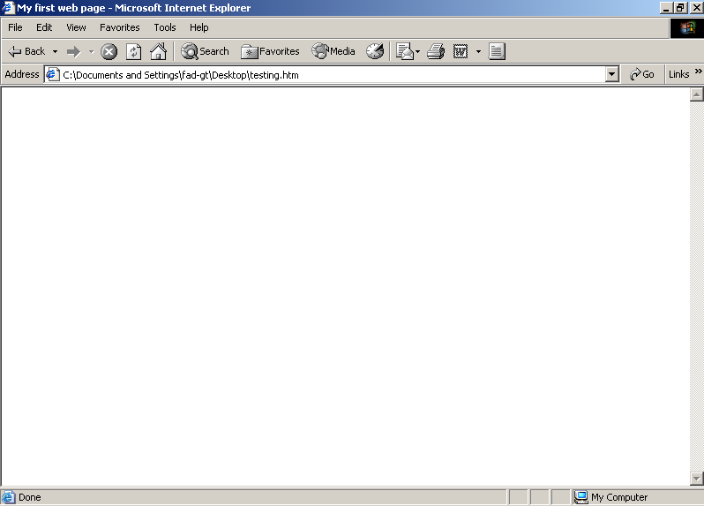

The title of the page is also important when it is added to Favourites/Bookmarks:

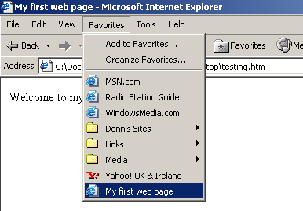
Simple text

Simple text can be added by typing it into the body tag. By default, this text appears in black and in Times New Roman font.

<html>
<head>
<title>My first web page</title>
</head>

<body>

Welcome to my page

</body>
</html>

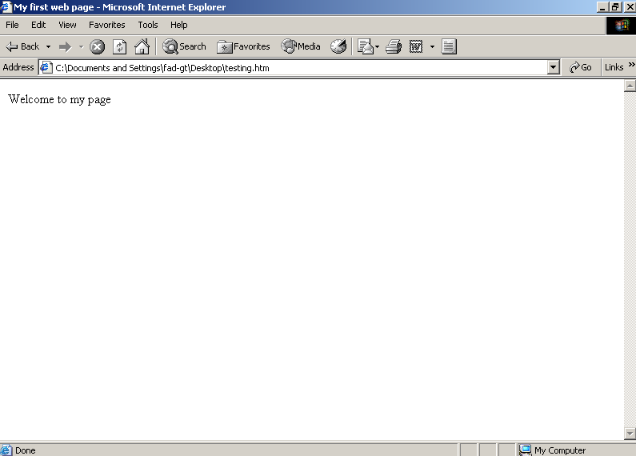

Breaks

Text can be spaced down the page by the use of the <br> tag. If you want to space down more than one line, you can use more than one <br> tag:

<html>
<head>
<title>My first web page</title>
</head>

<body>

Welcome to my page<br>

How are you?<br><br>

</body>
</html>

Change font face

By default, the font used is Times New Roman. If you want to change this font, you can do so by using the <font> tag with “face=…”

<html>
<head>
<title>My first web page</title>
</head>
<body>

<font face="Arial">Welcome to my page</font>

</body>
</html>

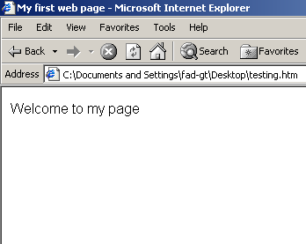

You should choose a popular font that most users have on their computer. There is no point in choosing an obscure font – if the user doesn’t have that font on their machine, the page will simply default to Times New Roman.
Change font size

Text can be made larger by using the <font> font tag with “size=…” Sizes range from 1 to 7.

<html>

<head>

<title>My first web page</title>

</head>

<body>

Welcome to my page<br><br>

<font face="Arial" size="7">This is size 7</font><br>

<font size="6">This is size 6</font><br>

<font size="5">This is size 5</font><br>

<font size="4">This is size 4</font><br>

<font size="3">This is size 3</font><br>

<font size="2">This is size 2</font><br>

<font size="1">This is size 1</font>

</body>

</html>

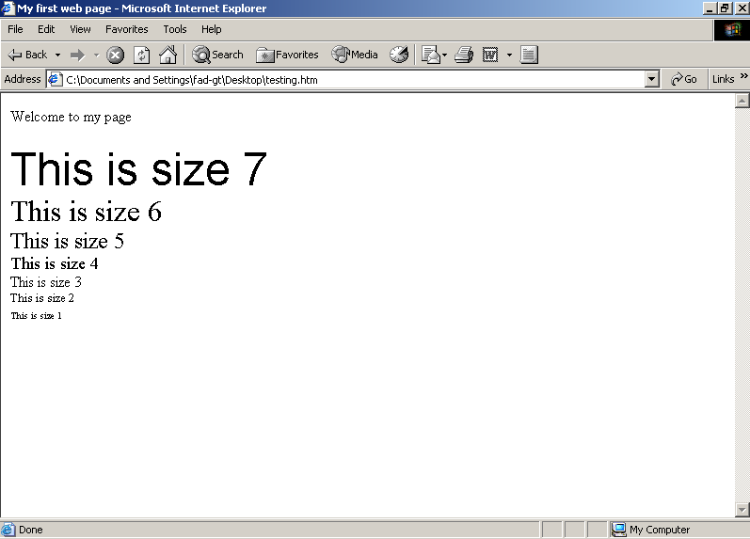
Change font colour

The colour of text is black by default. However, we can change the colour of the text by using the <font> tag with “color=…”

For example:

<font color=”blue”>Welcome to my page</font>

Note that “color” must be spelt the American way!

Change background colour

The background colour for the page is white by default. If you want to change it to another colour, this can be done by adding “bgcolor=…” to the <body> tag.

For example:

<body bgcolor=”red”>

Hex values

Until now we have specified the colour we want to use by name (e.g. red, green etc. ) However, only 16 basic colours are supported by all browsers:

The 16 supported colours are:
Red, Green, Blue, Black, White, Gray, Silver, Maroon, Lime, Navy, Purple, Magenta, Olive, Yellow, Teal, Cyan

All other colours should be specified by hex codes to guarantee support in all browsers.

The hex value for a colour is made up of 3 values, which are the amounts of red, green and blue which make up the colour.

For example, the hex value for Red is #FF0000

#FF 00 00

Red Green Blue

(all red, no green, no blue)

Other examples:

#00FF00 – green

#0000FF - blue
Positioning text

To centre text on the page, we can use the <center> </center> tags.

<html>
<head>
<title>My first web page</title>
</head>
<body>

<center>Welcome to my page</center>

</body>
</html>

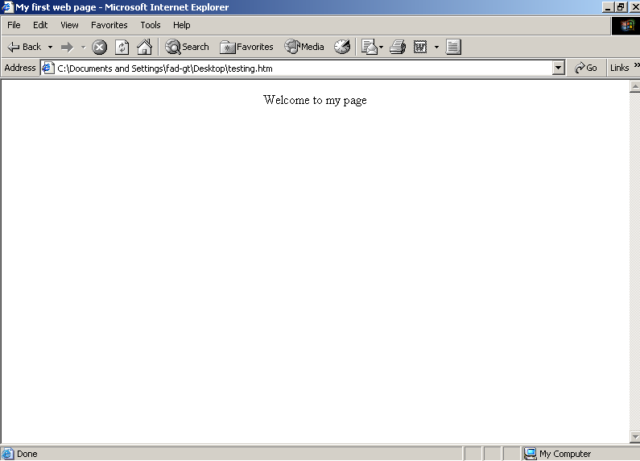
Headings

There are a number of headings available in HTML. They are using to make text a standard size, according to the heading used.

H1 is the largest, H6 is the smallest.

<html>
<head>
<title>My first web page</title>
</head>
<body>
<font face="Arial">
<center>Welcome to my page</center>

<h1>This is a h1 heading</h1>
<h2>This is a h2 heading</h2>
<h3>This is a h3 heading</h3>
<h4>This is a h4 heading</h4>
<h5>This is a h5 heading</h5>
<h6>This is a h6 heading</h6>

</body>
</html>

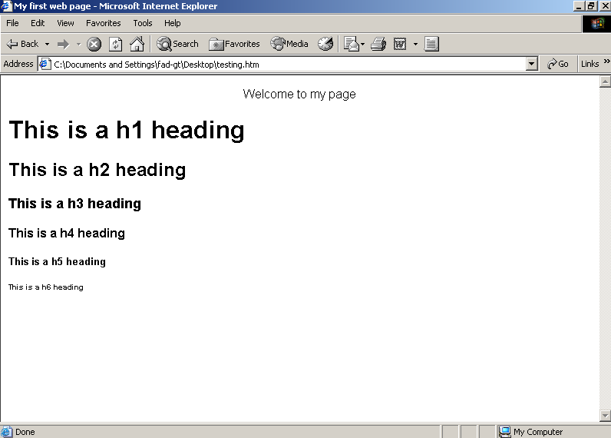
Headings can be aligned to the left, right or centre (left by default)

<html>
<head>
<title>My first web page</title>
</head>
<body>
<font face="Arial">
<center>Welcome to my page</center>

<h1 align="center">This is a h1 heading</h1>
<h2 align="right">This is a h2 heading</h2>
<h3 align=”left”>This is a h3 heading</h3>
<h4 align="right">This is a h4 heading</h4>
<h5 align="center">This is a h5 heading</h5>
<h6 align=”left”>This is a h6 heading</h6>

</body>
</html>

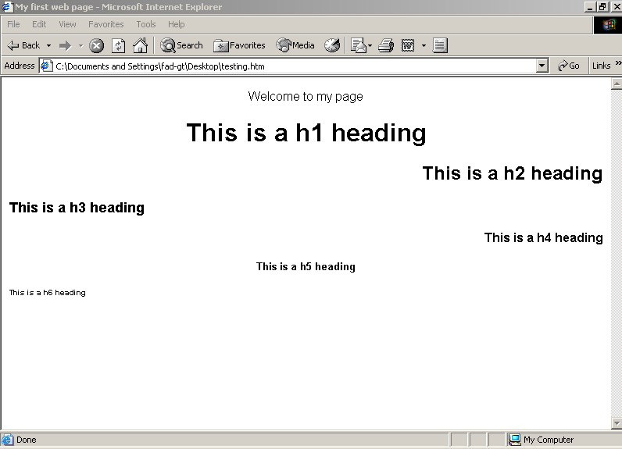

Images

There are 3 possible image formats which can be used for webpages:

.gif
.jpg
.png.

Of these, .gif and .jpg are used the most. .png is less popular.

An image is put into a page using the <img> tag as shown below:

<html>
<head>
<title>My first web page</title>
</head>
<body>
Welcome to my page
<br><br>

<img src="sihelogo.gif">

</body>
</html>

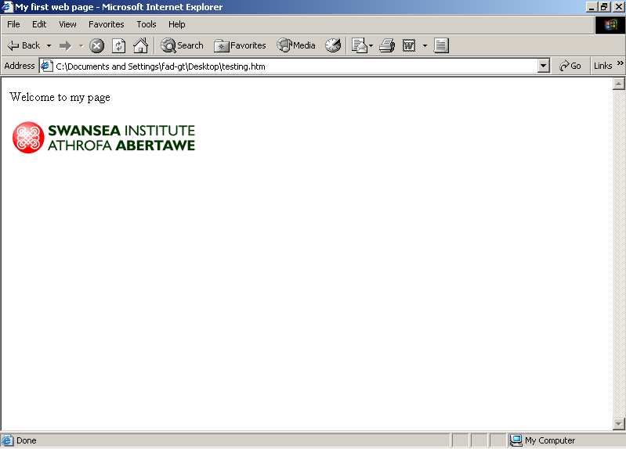

Image borders

Set to a value (0=no border)

An image can be given a border by setting a border attribute.

<html>
<head>
<title>My first web page</title>
</head>
<body>

<img src="sihelogo.gif" border="0" alt="SIHE logo with no border">
<br>
<img src="sihelogo.gif" border="1" alt="SIHE logo with thin border">
<br>
<img src="sihelogo.gif" border="5" alt="SIHE logo with thick border">

</body>
</html>

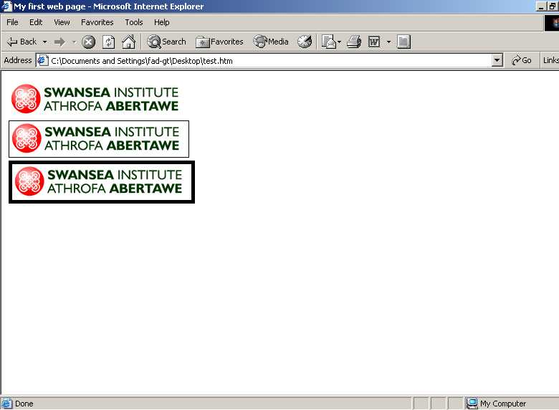
Alt attribute for images

You should always put a brief description of the image in an alt attribute. This is because if the image cannot be displayed for any reason, the contents of the alt is displayed on the screen. This at least gives the user some idea of what they are missing!

For example:

<img src="sihelogo.gif" alt="Swansea Institute Logo">

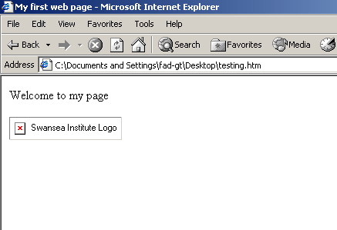

Image not found, alt attribute’s contents displayed.
Background Images

We can define an image to cover the entire background of the page. If the image is not big enough to fill the screen the browser will automatically “tile” the image.

<html>
<head>
<title>My first web page</title>
</head>
<body background="sihelogo.gif">

<h1 align="center"><font face="Arial">Welcome to my page</font></h1>

</body>
</html>



Note that background images can obscure the writing on the page, as has happened in the example above. You should use background images with care!
Links

Links to other pages are created using the <a> tag. By default, links appear in blue and are underlined.

An example of a link is shown below:

<html>
<head>
<title>My first web page</title>
</head>
<body>
Welcome to my page

<br><br>

<a href="page2.htm">Click here to go to Page 2</a>

</body>
</html>

destination of link what you want to
appear on the screen
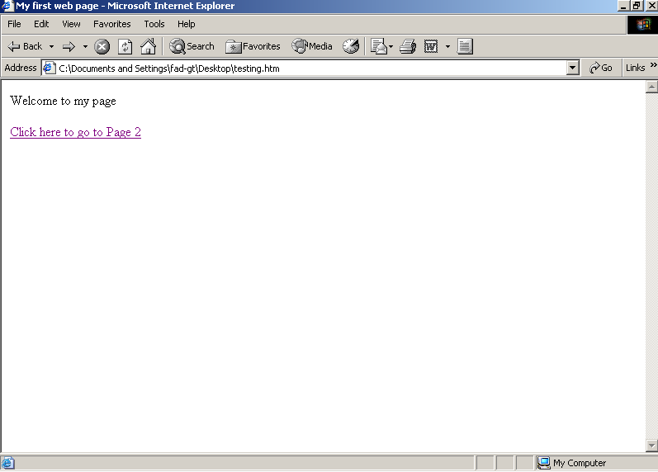

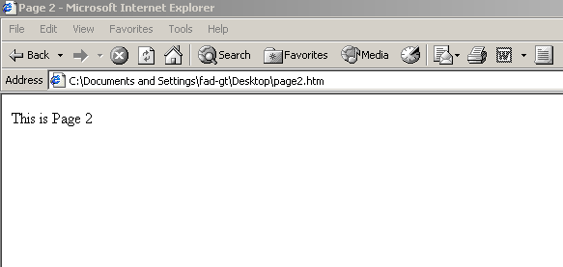

Images as Links

As well as using text for links, you can use images for links. This is done by putting the image inside the <a> tags.

For example:

<a href="page2.htm">
<img src="sihe2.jpg" alt="Picture of University - Click for page 2">
</a>



link

