1.Jamaican Jill’s restaurant and cocktail Bar
Christelle Senga Fundi
2nd May 2018
P142103
Classification : Confidentiel
Jamaican Jill’s Manager : Bernadette Davies
Bernadette Davies phone : 07384250113
Bernadette Davies Telephone: 011792476222
Email: berniedavies@jamaicanjills.com

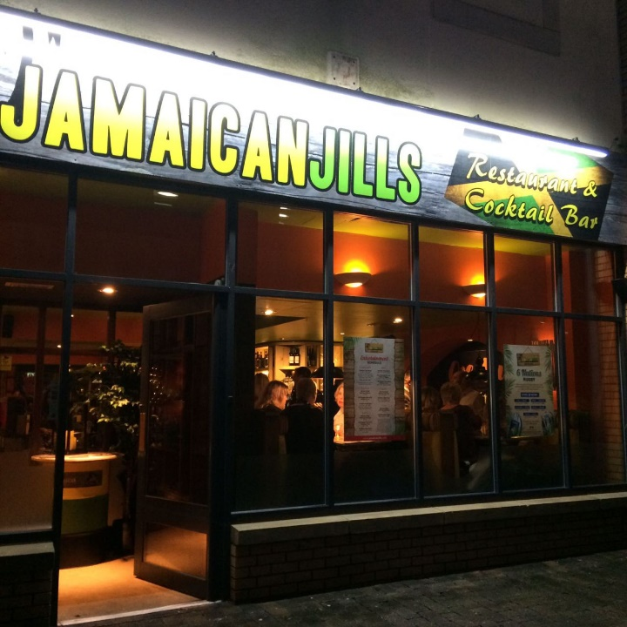
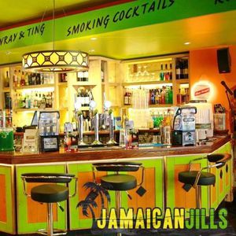



2.Acknowledgements
The consultant would like to thank Bernadette Davies who is Jamaican Jill’s manager for accepting the consultant to do the consultancy project to help the restaurant to increase student customers via social media marketing .
Mike is the lecture for the consultancy project module has been teaching each stage from the consultancy project from the bid presentation, PID and final project and checking through the work and checking each stages of the project to see how the work is improving and gives feedback to improve the work before is submitted.

3. Excusive summary

This report will discuss about Jamaican Jill’ restaurant, Bar and cocktail. The aim is to solve the issue for Jamaican Jill’s to increase student customers via social media. The object for this project The researcher will evaluate social media marketing to increase student customers for Jamaican Jill’s. The consultant will also look at marketing strategy that best fits the project aim to discover what the students want Jamaican Jill to do to attract them to go there. The consultant will deliver a marketing plan with recommendations on what Jamaican Jill’s could follow to increase the student customer. The consultant used three different methodology for the project to get the answers for objectives .The first methodology used was Interview The consultant interviewed students at University of Wales Trinity Saint David the aim for the interview was to find out if the student were aware of Jamaican Jill’s in Swansea. The second methodology was survey which was made on survey monkey and it was aimed to students to find out what do the student want Jamaican Jill’s to do that would attract them to go the restaurant. The third methodology that was used is observation the consultant had been going to Jamaican Jill’s for around six hours and spending up to two hours in different occasion in the restaurant observing the restaurant to see how if it get busy and how many student customers they get in the restaurant regularly. The consultant has included division from PID and discussed what has changed from the PID to the final project it mentions Jamaican Jill’s has got a new location in Upland but the Jamaican Jill’s in Wind street it still operating as usual. The finding shows the information gathered from interview of what the student said in the responses asked from the interview questions, the consultant used graph to show students answers from the survey for three different questions the first pie chart finding is from question seven from the survey asking students, Jamaican Jill’s has cocktail bar , how can they use this to attract more customers? Question eight asked the student what social media website can Jamaican Jill advertise the restaurant to increase more student customers? Question nine asked student to answer what deals can Jamaican Jill’s offer to student customers ? the third finding was observation the consultant used bullet points to show the issues that stood out from the restaurant. Discuss and analysis section shows all three methodology interview, survey and observation are analysed and discussed in depth from the student results the interview shows what the student what the student answers. The graph shows the findings from the survey showing the answer gathered from the student on what they want Jamaican Jill’s to do to increase student customers. The observation shows the consultants thought on the restaurant of what they have experience when visiting Jamaican Jill’s the consultant has also included swot analysis of the funding’s from the survey, interview and observation. The conclusion discuss the decision how Jamaican Jill’s can increase student customers with a marketing strategy . From the conclusion the consultant drew out the key strategy for Jamaican Jill’s on to the recommendation that they can follow to reach the target on how to increase student customers. The appendixes shows all the question from the interview and survey that was asked to the students. In the appendixes includes the costed the project and shows the time of meet meeting that the consultant has been meeting the Jamaican Jill’s manager through the whole project to show the improvement of the final project each step.

4 Contest page

Title page ………………………………………………………….……………………………. 1
Acknowledgement……………………………………………..………………………….….2
Excusive summary …………………………………………………………….…………..….3
Contents page ……………………………………………………….…………………………..4
List of tables and figures…..……………………………………………………………..…..5
Project aim ……………………………………………………………….………………………….6
Project objective………………………………………………………..………………………….6
Research methods ………………………………………………………….……..……….…..6.5
Deviation from PID………………………………………………………….………..…..……..6.5
Finding ……………………………………………………………………………………..………….. 7, 8 , 9
Discuss and analysis……………………………………………………………………..………… 9.5, 10
Swot analysis …………………………………………………………………………………………. 11
Conclusion……………………………………………………………………………………………….. 11.5
Recommendation……………………………………………………………………………………..12
Appendices………………………………………………………………………………………..……. 12.5 13, 14, 15, 16,17,18,19, 20
Bibliography…………………………………………………………………………………………..… 21, 22

List of tables and figures

Title page ………………………………………………………….……………………………. 1
Acknowledgement……………………………………………..………………………….….2
Excusive summary …………………………………………………………….…………..….3
Contents page ……………………………………………………….…………………………..4
List of tables and figures…..……………………………………………………………..…..5
Project aim ……………………………………………………………….………………………….6
Project objective………………………………………………………..………………………….6
Research methods ………………………………………………………….……..……….…..6.5
Deviation from PID………………………………………………………….………..…..……..6.5
Finding ……………………………………………………………………………………..………….. 7, 8 , 9
Discuss and analysis……………………………………………………………………..………… 9.5, 10
Swot analysis …………………………………………………………………………………………. 11
Conclusion……………………………………………………………………………………………….. 11.5
Recommendation……………………………………………………………………………………..12
Appendices………………………………………………………………………………………..……. 12.5 13, 14, 15, 16,17,18,19,20
Bibliography…………………………………………………………………………………………..… 21, 22

6.Project aims
To increase the number of student customer via social media marketing.
6.Project objectives
- The researcher will evaluate social media marketing to increase student customers for Jamaican Jill’s.

- The researcher di will use marketing strategy that best fits the project aim to discover what the students want Jamaican Jill to do to attract them to go there.

- The researcher will deliver a marketing plan with recommendations on what Jamaican Jill’s could follow to increase the student customer.

6.5Research methods
The research methods that the consultant will be using are both qualitative and Quantitative data. The researcher used question air, interview and observation method. The consultant used books and website for secondary research.
The consultant created interview questions and interviewed University student at University of Wales Trinity Saint David most of the student lived in Swansea and was familiar with Wind street is where all the restaurant clubs and pubs are in Swansea including Jamaican Jill’s. The interview was aiming to find out are they aware of Jamaican Jill’s. The consultant interview 10 students in the university and collected all the respondent
The consultant created a questions air on survey monkey the questionnaire was aiming to find out what do the student want Jamaican Jill’s to do for the student to go to the restaurant. The consultant collected 30 students responses from the survey monkey . The consultant needed to find out what is something Jamaican Jill’s can do or change about their restaurant that would encourage them to visit Jamaican Jill’s.
The targeted age for the consultancy project interview and survey is 18 to 50 years of age. The age range has been targeted because Jamaican Jill’s aim is to increase student customers to the restaurant. Technology plays a huge role in society and with technology comes social media therefore the aim is to grab the target audience’s for the survey attention via social media e.g. Facebook, Instagram and twitter. Looking for over 30 respondent.

6.5 Deviation from PID
On the PID the consultant stated they will use Interviews and Surveys but the consultant has added Observation on the final project. Jamaican Jill’s was closed for a week because the was opening a second restaurant in Uplands. There for I had to meet the manager Bernadette Davies to show her my work in uplands. The first Jamaican Jill’s is still open in Wind street. The project aim still hasn’t changed to increase student customer via social media for Jamaican Jill’s.

7 Findings

Q7 ) Jamaican Jill’s has cocktail bar , how can they use this to attract more customers?
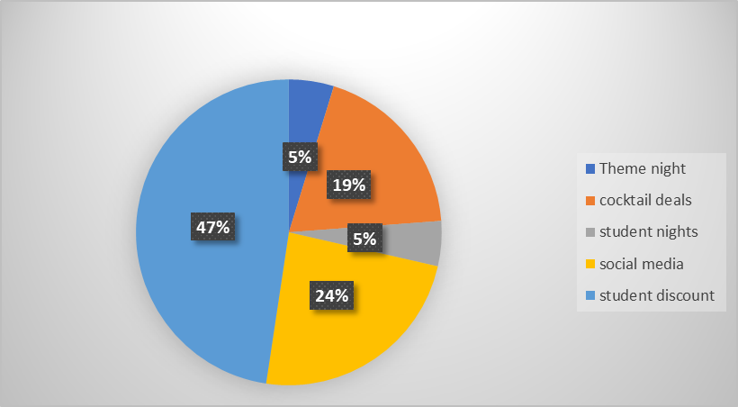
The pie chart shows the student responses for question seven from the survey that Jamaican Jill’s can attract student customers by advertising more of the cocktail bar with different student discount.
- Theme night
- Cocktail deals
- Student night
- Social media
- Student discount

Q8 What social media website can Jamaican Jill advertise the restaurant to increase more student customers?
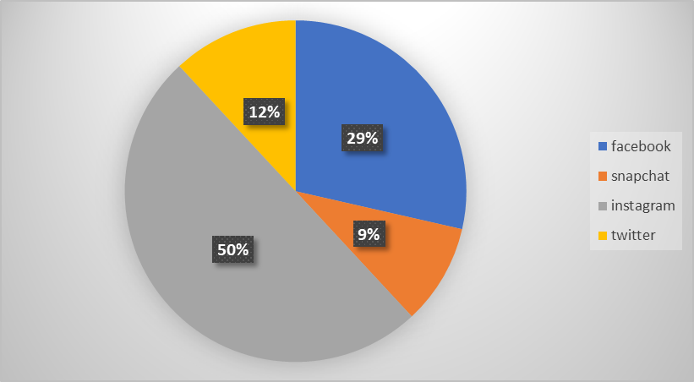

The pie chart is showing the student responses from survey question eight The student said Jamaican Jill’s can use social media to advertise the restaurant , food and drink such as.
- Facebook
- Snapchat
- Instagram
- twitter
Q9 What deals can Jamaican Jill’s offer to student customers ?
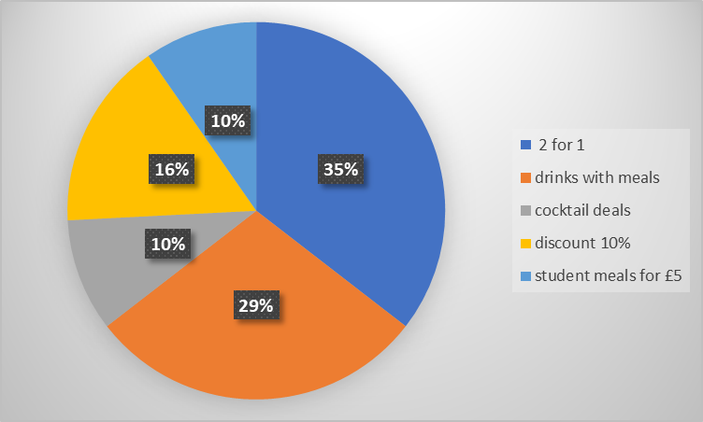
The pie chart show the student answers from question nine what can Jamaican Jill’s offer to student customers and the student said.
- Two for one deal
- Drinks with meals
- Cocktail deals
- Ten percent discounts
- Student meals for £5

The consultant gathered the main responses from the Interview from the student the consultant interview . The student are aware of Jamaican Jill’s and the location in Wind street. Allot of student wasn’t aware of the student discount. The consultant asked on the interview what can Jamaican Jill’s do to increase more student customers. The student said “ Jamaican Jill’s could do a leaflet drop on campus on the university tables, showing the menus that would encourage them to go because they haven’t got any idea what the menu is like”. Another student said “ Jamaican Jill’s can increase student customers by having student nights example on Wednesday at the restaurant and offer deals and would go as it would be cheaper for them”. “other student said Jamaican Jill’s can increase student customers by going to student fairs and give out the student discount leaflets, they should also advertise on social media by joining student groups. They should also adverting the bar more than just the restaurant”. “The student said they Jamaican Jill’s can advertise them self on social media like Facebook”

The consultant has also been observing Jamaican Jill’s for six hours on different occasion during the day and night.
- Not allot of student customers
- The restaurant is not busy during the week at peak times during lunch time 1:30 pm to 2 pm dinner time 6pm to 9pm
- Jamaican Jill’s doesn’t know when the students enter the restaurant or how many student they get at the restaurant

9.5 Discuss and analysis
The consultant created ten questions for the interview the consultant collected the response and it shows all the ten students who participated in the interview are aware of Jamaican Jill’s location in Swansea. but five of ten students have been to Jamaican Jill’s the other half haven’t been to Jamaican Jill’s in Swansea or Neath. Allot of students are not aware of the student discount that Jamaican Jill’s offer to students. This could be the main reason why allot of student don’t choose to go to Jamaican Jill’s because they are not aware of the student discount. The student are aware of the food they provide which is Jamaican food such as jerk chicken , rice and Pease , BBQ wings etc. The student who have visited Jamaican Jill’s enjoyed the cocktails and the Jamaican food cuisine. This shows if the student are aware of Jamaican food it should be easier for Jamaican Jill’s to attract the student customers to Jamaican Jill’s restaurant. on the interview question seven asked what can Jamaican increase more student customers student one said “ Jamaican Jill’s they can do a leaflet drop on campus on the UWTSD university tables in the canteen , showing the menus that would encourage them to go because they haven’t got any idea what the menu looks like”. By putting menu of the food or cocktail in university campus it will attract more student to go in to the restaurant to try the food and drinks. The student said “Jamaican Jill’s can increase student customers by going to student fairs and give out the student discount leaflets , they can also advertise on social media such as Facebook and they should consider of joining student groups. The student said Jamaican Jill’s can increase more student customers by adverting the bar more than just the restaurant” By advertising the bar the student would be more encouraged to go in to Jamaican Jill’s and buy the cocktail even if they don’t buy the food Jamaican Jill’s will increase student customers if they did advertise the bar more. “Jamaican Jill’s can increase student customers by posting poser in university halls , they can go to freshers weak they can take samples at student union for student to try it. They could also post leaflets of the menu in the university “by handing out samples for people to try it will attract more student customers. “The student said Jamaican Jill’s can advertise the student discount more she has been there but wasn’t aware of the student” As the aim is to increase student customers and if they are not aware of the student discount Jamaican Jill should make more effort in advertising student discount more clearly so student see it when they go to the restaurant. The student answered they would go to Jamaican Jill with friends and family this shows Jamaican Jill have got customers as student would go to the restaurant they just need to work harder in advertising the student discount , the cocktail bar much more.
The consultant created ten questions for the survey foe student to participate the aim for the survey is what can Jamaican Jill’s to increase student customers . First question asked what gender are you and 22 female participated and 8 male. The student participant of the survey were from the age group of eighteen to twenty four, and twenty five to thirty four. Third question asked if the student knew what Jamaican food was nineteen student said yes and eleven student said no this shows the majority of the student know what Jamaican cuisine is in Swansea the is a positive answer from the student it shows the is a market for Jamaican Jill’s that student are interested in. Question for from the survey asked if they have you tried Jamaican food and eleven said yes they have tried Jamaican food and 19 said no they haven’t which is a very big number but by advertising more Jamaican Jill could attract the student to go to the restaurant to the Jamaican food from the menu. Question five sked if the student like Jamaican food twelve student said yes and fifteen said no this is a negative result , it could be one of the reasons why student don’t go to Jamaican Jill’s to eat the food. Question six asked if the student had been to Jamaican Jill’s in Swansea or Neath only five student have been to Jamaican Jill’s in Swansea and one student has been to Neath and twenty one student said they haven’t been either one. That bad results considering allot of the student know the location of Jamaican Jill’s in Swansea. Question seven asked how can Jamaican Jill’s use the cocktail bar to attract more student customers the student responded with different deals Jamaican Jills can consider theme nights for theme student nights , cocktail deals , student events, and student discount which seems to be the most student mention that would attract them to go to Jamaican Jill’s cocktail and bar. Question eight asked what social media website can Jamaican Jills advertise the restaurant to increase more student customers? the most popular answer was Instagram with twenty one suggestions , the second most popular social media sit they can advertise on was Facebook with twelve student percipient mentioning it five student said twitter and four student said they can advertise on snap chat.

The consultant observed Jamaican Jill’s for over six hours on different days at different times. The consultant asked Jamaican Jill’s manager how many student customers they get and she replied with two maybe three student customers come in to the restaurant. Jamaican Jill’s are not aware of the student customers they are going to the restaurant because the student are not aware of the student discount they offer as the students would make them self-known as student to be able to get student discount on the food. Jamaican Jill said they student don’t say they are student until they about to leave the restaurant there for Jamaican Jill’s need to advertise more. Jamaican Jill’s are not busy when is peak times from 1:30 pm to 2 pm for lunch and dinner time from 6 pm to 9pm it is very quiet. By advertising student discount more clearly to make all student are aware of it by posting a poster on the window so when the student entering the restaurant they can see it. By posting a big enough poster student also going pass the restaurant when they see the poster it will encourage them to go there next time
11 Swot analysis
Strength: Jamaican Jill’s strength from the survey and interviews shows most all the student know where the location of Jamaican Jill’s restaurant is in Wind street. Jamaican Jill’s offer student discount that means they can attract more student customers. Another strength for Jamaican Jill’s is they are close to Swansea University and University of Trinity Saint David.
Weakness : Jamaican Jill’s weakness is they don’t have allot of student customers. As it shows on the survey and the Interview response not allot of the students have been to Jamaican Jill’s. Jamaican Jill’s are located close to Swansea university and UWTSD but they don’t advertise the restaurant and the bar in the universities as the student in the interview has said Jamaican Jill’s could advertise with cocktail menu in the university canteen there for when the student see the leaflets it would encourage them to go to Jamaican Jill’s and try the cocktail drinks.
Opportunity: Jamaican Jill’s opportunity from respondent gathered from the survey and the interviews everyone is aware of the location in the city centre in wind street there for everyone this shows most students are aware of Jamaican Jills.
Threats: Jamaican Jill’s is located in Wind Street with other restaurants, bars and clubs there for they have to be in competition with chain brands such as Turtle Bay they have a Jamaican theme as well. ( Pyke 2017,) Turtle Bay , Turtle Bay already has restaurant more than 30 others in the UK cities, including Cardiff’s St Marry Street It was founded in 2010 by Ajith Jayawickrema and Stepen Entwistel Turtle Bay was the first high street Caribbean branded restaurant. The restaurant at night transform in to a bar serving beer and cocktail. Turtle Bay has more of advantage to get more customers than Jamaican Jill’s because it is already a familiar brand there for customers would chose to go to Turtle Bay because they already know the type service they will be expecting.

11Conclusion
The consultant has come to a conclusion to solve the issue for Jamaican Jill’s to increase student customers. Jamaican Jill’s have bar and student s discount that they offer this should be enough to pull customers but as they are not getting student customer . They should follow what the student has been saying from the interview and survey. The students said Jamaican Jill’s need to advertise the cocktail bar more than the restaurant that would attract more student customers. Jamaican Jill’s should also consider discount right know Jamaican Jill’s discount is only on the food by introducing new deals such as theme nights, cocktail deals , student event night they will gain more student customers as student would choose to go Jamaican Jill’s bar and cocktail for cheap prices on the drinks. The biggest way Jamaican Jill’s can increase more student customers is by advertising on social media such as Facebook, Snap chat , Instagram and twitter that way they can reach to a bigger audience. The way they can get to the audience Jamaican Jill’s ned to ask university like Swansea university and UWTSD if they can let them advertise the menus of the cocktail drinks and food when they student see it in there canteens it will encourage them to go to Jamaican Jills.
Marketing strategies

12 Recommendation
The recommendations the consultant gather from the survey on the question asked Jamaican Jill’s has cocktail bar, how can they use this to attract more student customers?. The recommended Jamaican Jill’s to make offer like two for one discount , happy hours, meal deal discount student nights where cocktail are under £5 as most people will try Jamaican Jill’s food if they do cocktail deals this student deals would increase student customers to go to Jamaican Jill’s. Jamaican Jill’s should promote on social media such as Facebook and emphasise more on the fact that they got a cocktail bar. Jamaican Jill’s should advertise opening hours much better and open until late hours to compete with other bars.
The recommendations the consultant gather from the survey from the question what social media website can Jamaican Jill’s advertise the restaurant to increase more student customers? The student recommend that Jamaican Jill’s should advertise on social media sites such as Instagram, Twitter, Facebook, Snapchat would be the best to reach students. Allot of student recommended Instagram because they can show the types of cuisine and drinks by posting pictures. Instagram has new boomerangs it will attract more student customer to the page because young people like to see new cool thing on Instagram. Jamaican Jill’s can also advertise on group app , Uni days they student discount apps for students.

Appendices

Survey questions
1) What gender are you
2) What age group are you
3) Do you know what Jamaican Food is
4) Have you tried Jamaican food /Yes or no if yes what have you tried
5) Do you like Jamaican food ?
6) Have you been to Jamaican Jill’s in Swansea or Neath /Yes or no
7) Jamaican Jill’s has got a cocktail bar how can they use that to attract more student customer
8) What’s social media website can Jamaican Jill’s advertise the restaurant on to increase more student customers
9) What deals can Jamaican Jill’s offer to students
10) What can be change about the restaurant that would encourage you to visit

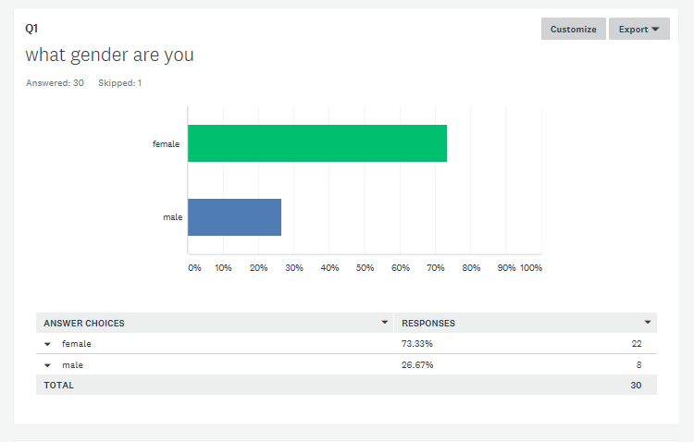

This graph shows the gender of the students 22 female and 8 male participated to answer the survey

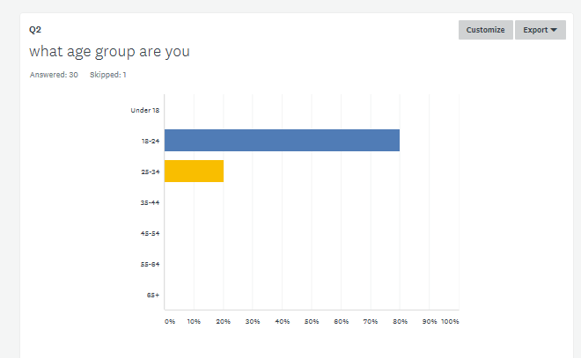

This graph shows the age group of the student who participated on the survey from 18 to 24 and 25 to thirty four.

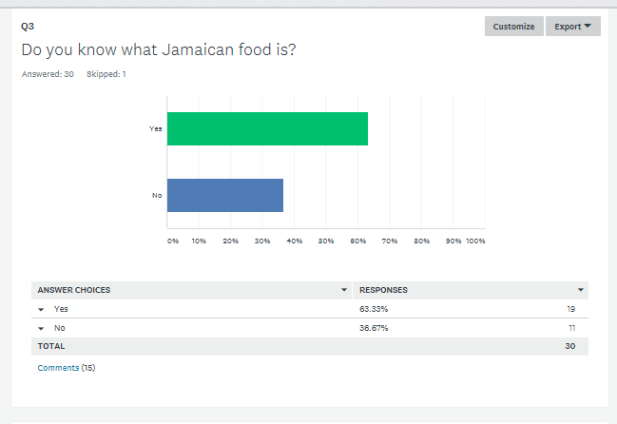

This graph shows 19 student know what Jamaican food is and 11 doesn’t know what it is.

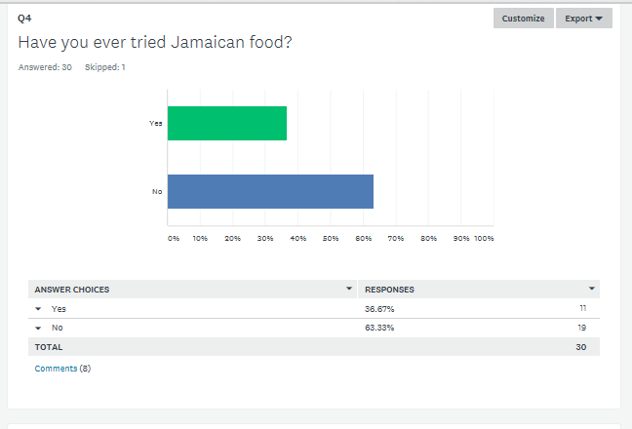

This graph shows 11 student have tried Jamaican food and 19 student hasn’t tried Jamaican food before

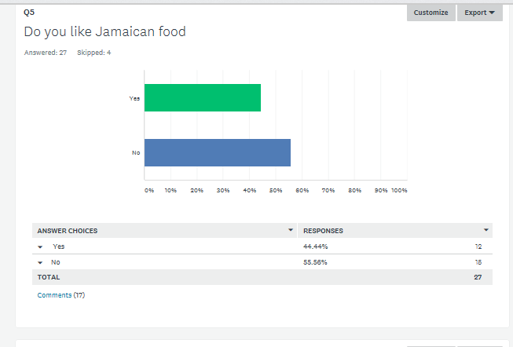

This graph shows 12 student said they like Jamaican Food and 16 said they don’t like Jamaican food.

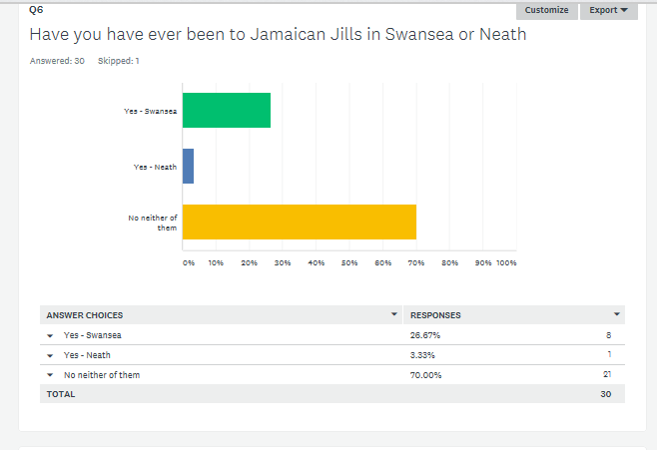

This graph shows how many students have been to Jamaican Jill’s and 8 student have been to Jamaican Jill’s in Swansea 1 in Neath and 21 haven’t been either of them.

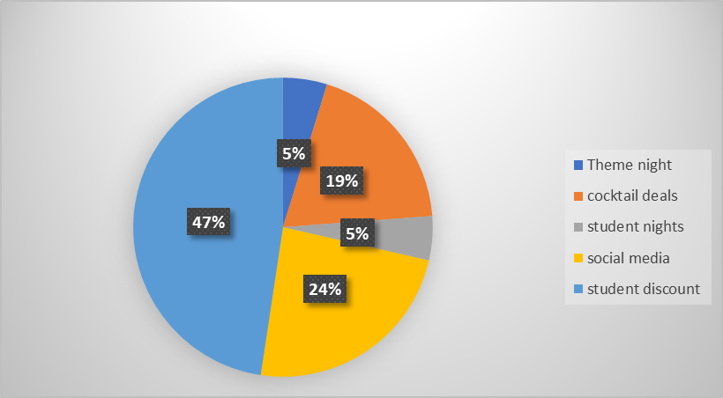
7

This pie chart answer was collected from question 7 Jamaican Jills has cocktail bar, how can they use this to attract more customers and the student said by hosting theme night, offering cocktail deals, student nights, advertising on social media and student discount.
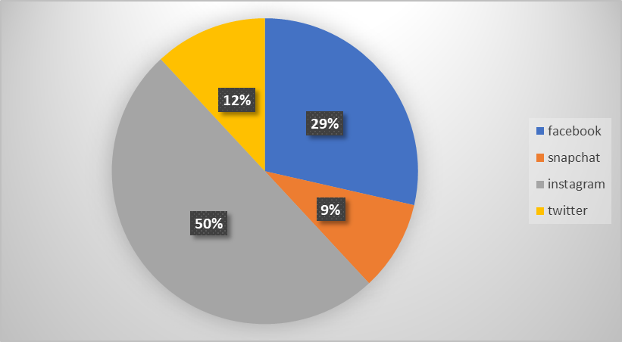

9)

This graph shows the answer from question 8 from the survey it asked student what social media
Website can Jamaican Jill’s advertise the restaurant to increase more student and the student said Instagram Facebook snap chat and twitter,
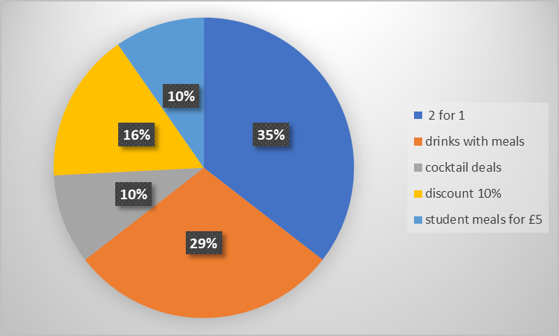

This pie chart from the survey answer collected on question nine it asked student what deals can Jamaican Jill’s offer to student customers. And the student said 2 for 1, drinks with meals , ten percent discount and student meals under five pound.
Jamaican Jill’s interview questions
I have Interview student from UWTSD to find out if they were aware of Jill’s and to find out if they have been to Jamaican Jill’s

- Have you heard of Jamaican Jill’s / if not what come in your mind when you hear Jamaican Jill’s
- Do you know Jamaican Jill’s restaurant location in Swansea
- Have you been to Jamaican Jill’s in Swansea or Neath
- Are you aware of Jamaican Jill’s student discount
- what comes in to you mind when you hear of Jamaican Jill’s food
- what was your favourite meal or drink when you visited Jamaican Jill’s/what would you like to eat from the menu or try from the Bar
- what can Jamaican Jill’s do to increase student customers
- would you go to Jamaican Jill’s with a friends or refer to others if not why

student 1
- Yes the student have heard of Jamaican Jill’s
- Yes they were familiar with Jamaican Jill’s location in Swansea in wind street
- No they have not been to Jamaican Jill’s in Swansea or Neath
- They were not aware of Jamaican Jill’s student discount
- They were aware of Jamaican Jill’s food and drink the student said they sell Jerk chicken authentic cuisine.
- The student hasn’t been to Jamaican Jill’s but they would like the alcoholic drinks and wings
- The student recommend for Jamaican Jill’s to do a leaflet drop on campus on the university tables, showing the menus that would encourage them to go because they haven’t got any idea what the menu is like.
- Yes the student would go to Jamaican Jill’s because they would like to taste Jamaican food
Student 2
- Yes the student was aware of Jamaican Jill’s
- Yes the student was aware of Jamaican Jill’s location in Swansea in Wind street
- No the student hasn’t been to Jamaican Jill’s in Swansea or Neath
- No the student wasn’t aware of student discount
- The student was aware of Jamaican food like rice and Pease, chicken wings
- The student would like to eat the wings and try the cocktail
- The student said Jamaican Jill’s can increase student customers by advertising on social media such as Uni days as easier to see student discount , Jamaican Jill’s can advertise with poster in the university
- The student would go to Jamaican Jill’s with the friends
Student 3
- Yes the student has heard of Jamaican Jill’s
- Yes the student was aware of Jamaican Jill’s location in Swansea in Wind Street
- No they student hasn’t been to Jamaican Jill’s in Swansea or Neath
- The student wasn’t aware of Jamaican Jill’s student discount
- No they student wasn’t aware of the type of food Jamaican Jill’s sell
- The student would go to Jamaican Jill’s because they like the cocktail menu
- The student said Jamaican Jill’s can increase student discount by advertising on the own social media app
- The student would go to Jamaican Jill’s with the friends to try the food

Student 4
- Yes the student has heard of Jamaican Jill’s
- Yes the student know the location of Jamaican Jill’s in Swansea in Wind Street
- Yes she has been to Jamaican Jill’s in Swansea
- Yes the student is aware of Jamaican Jill’s student discount
- The student knew about the type of food Jamaican Jill’s sell
- The student enjoyed Jamaican Jill’s Jerk chicken strips
- The student said Jamaican Jill’s can increase more student customers on Uni days app
- The student would recommend her student friends to go to Jamaican Jill’s and they would go there again

student 5
- Yes the student has heard of Jamaican Jill’s
- Yes the student is aware of Jamaican Jill’s location in Swansea
- No the student hasn’t been to Jamaican Jill’s in Swansea or Neath
- The student wasn’t aware of Jamaican Jill’s student discount
- No the student wasn’t aware of the food Jamaican Jill’s provide
- The student would like to try Jamaican Jill’s famous curried goat
- The student said Jamaican Jill’s can increase more student customers by having a student night on Thursday at the restaurant and offer deals and student would go as its cheaper . Jamaican Jill’s can advertise with the leaflets in university
- The student would go to Jamaican Jill’s

Student 6
- Yes the student has heard of Jamaican Jill’s
- Yes the student Is aware of Jamaican Jill’s location In Swansea but they didn’t know the was another Jamaican Jill’s in Neath
- No she hasn’t been to Jamaican Jill’s in Swansea or Neath
- Yes the student knows about the student discount
- The student knows they sell Jamaican food
- The student would like to taste Jamaican Jill’s food
- The student said Jamaican Jill’s can increase student customers by going to student fairs and give out the student discount leaflets, the student said they can also advertise on social media by joining student groups. The student said Jamaican Jill’s can increase more student customers by adverting the bar more than just the restaurant
- The student would go to Jamaican Jill’s with her boyfriend

Student 7
- Yes the student has heard of Jamaican Jill’s
- Yes the student is aware of Jamaican Jill’s location in Swansea but not in Neath
- The student has been to Jamaican Jill’s in Swansea
- Yes the student know about the student discount
- The student enjoyed the cocktail drinks
- The student enjoyed rice and peace
- The student said Jamaican Jill’s can increase student customers by adverting on Uni days, they can also advertise on the coupon app and offer two for one meal to student that would increase more student customers as they can bring the friends with them.
- The student would go back again and recommend it to her friends and family
Student 8
- No the student hasn’t heard of Jamaican Jill’s
- No the student doesn’t know the location of Jamaican Jill’s
- Not the student hasn’t been in Jamaican Jill’s in Swansea
- No the student is not aware of the student discount
- The student said when she hears Jamaican Jill’s she already got the idea is Jamaican cuisine
- student would be interested in the bar to drink cocktail
- The student said Jamaican Jill’s can increase student customers by posting poser in university halls , go to freshers weak they Jamaican Jill’s can take samples for people to try it. They could also post leaflets of the menu is the university
- The student if she go there she would go with a friend
Student 9
- Yes the student has heard of Jamaican Jill’s
- The student know the location of Jamaican Jill’s in Swansea
- The has been to Jamaican Jill’s three times in Swansea but not in Neath
- No the student didn’t know about the student discount
- The student knew the was Jamaican cuisine that why he went there
- He enjoyed the drinks and chicken
- The student said they Jamaican Jill’s can advertise them self on social media like Facebook
- No he wouldn’t recommend it his friends

Student
- Yes the student has heard of Jamaican Jill’s
- The student know the location of Jamaican Jill’s in Swansea
- The student has been to Jamaican Jill’s
- No the student was not aware of Jamaican Jill’s student discount
- The student know it is Jamaican food that they provide
- The student enjoyed cocktail called ruby Tuesday
- The student said Jamaican Jill’s can advertise the student discount more she has been there but wasn’t aware of the student
- Yes the student would recommend the friends to go there again
Cost
Social media is cost effective as to register for social media page is free and Jamaican Jill’s have already the own site and they are on Facebook and Instagram. Twitter Instagram if they consider to think of snap chat is free.

Minuets of meeting
The consultant communicates with Barnie Davies who is Jamaican Jill’s manager on the mobile phone by calling her or by text and email to book an appointment to see her for face to face to show her the progression of the final project and to get feedback. I have been meeting with Jamaican Jills through the whole project for over twelve hours at different occasions.

Bibliography

Barker, A. (2016). Improve your communication skills . London: Kogan Page Publishers.

Bylthe, J. (2012). Essential of Marketing. England: Pearson Education Limited.
Corbin, J. (2008). Basic Qualitative research. California: Sage pubication Inc.
Dave Chaffey and Fiona Ellis Chadwich. (2012). Digital Marketing. England: Pearson Education Limited.
Davies, B. (2018, Apiril 17). Jamaican Jills manager. (C. S. Fundi, Interviewer)
eight, s. (2018, March 22). student . (C. S. Fudni, Interviewer)
five, s. (2018, March 22). student. (C. S. Fundi, Interviewer)
four, s. (2018, March 22). student. (C. S. Fundi, Interviewer)

Harold Kerzner and Harold R. Kerzner. (2017). Project Management: A systems Aproach to planing, scheduling and controllising. Canada: John Wiley & Sons.
Jamaican Jilss Swansea. (2018, March 16). Retrieved from Jamaican Jills: http://jamaicanjills.com/events/
Jon Curwin and Rogers Slater. (2004). Quantitaive methods: A short course. Bedford: Thomson Learning.
Judith Bell and Stephen Waters. (2014). Doing your research project . Maidenhead: Open University Press.

Lawrence, B. B. (1989). Qualitative research methods fir the social science. America: Allyn & bacon.

nine, s. (2018, March 22). student. (C. S. Fundi, Interviewer)
Oakland, J. S. (2004). Quality Management . New York: Routledge. .
one, s. (2018, March 22). student. (C. s. Fundi, Interviewer)
research methodlogy. (2018, March 15). Retrieved from Business Dictionary : http://www.businessdictionary.com/definition/research-methodology.html
Robert D. Cecil and William J. Rothwell. (2007). next generation management development . San Francisco: pfeiffer.

seven, s. (2018, April 12). student . (C. S. Fundi, Interviewer)

six, s. (2018, March 22). student. (C. S. Fundi, Interviewer)
survey monkey. (2018, May 02). Retrieved from How can Jamaican Jills increase student customers via social media: https://www.surveymonkey.com/analyze/v_2F4MpNF_2B4GgwQzt9lH7zMpRTzjnxkCq_2B9hhy4QjDOmLV5ABTxXT6DnnM34W2iBjt
ten, s. (2018, March 22). student. (C. S. Fundi, Interviewer)

three, s. (2018, March 22). student. (C. S. Fundi, Interviewer)

two, s. (2018, March 22). student. (C. S. Fundi, Interviewer)

