Monica Pusey

Reflective
Portfolio

Student Number: 1817260 Module Number: BMSW4005 Lectures Name: Damina Pokubo Module: Professional and Career development Assignment Title: Reflective Portfolio

Content

Introduction pg 3

Self-awareness pg 3
Reflection on mock interview pg 6
Professional development plan pg 8

Introduction
Though self-reflection and self-awareness exercises, you can determine what your skills are, where you want to be in life, what you enjoy doing and what is important to you. Being self-aware of your strength and weaknesses can significantly advance your career while reflection is associated with looking back at past events, to examine and learn from mistakes in order not to make the same mistakes again, Williams, N, E., Fauth, J., (2005).
Self-awareness is the capacity for introspection, and to recognize yourself as an individual separate from the environment and others. According to the book written by Zahavi., D, (1999), self-awareness is very important as it empowers you to make changes in your behaviour. Being self-aware helps you see how your feelings affects the way you act on things. It also helps you to build on your areas of strength as well as identifying areas you would like to make improvements on your knowledge and skills.
This Reflective portfolio assignment will show the tools l have used to help me on my own journey to become more self-aware. l know what I’ve learnt can help my future professional career development, work life plans and skills in the workplace.

1.It’s important for one to know oneself, Munoz, D., (2020), who am l, what’s your likes and dislikes, what do l want to do, how well do I work with others and what’s your strengths and weaknesses. To self-reflect l have used a tool readily available to anyone that can connect to the internet. It’s called meditation there are different types of meditation. I use a mindfulness meditation videos, this helps me to calm my nerves with breathing techniques and focus on the here and now by using all five senses, (sight, smell, taste, touch and sound), also remain aware and present in the moment. Mindfulness meditation can be done by anyone and mostly anywhere, while waiting in an office for an interview for instance according to, Bohcun, P., (2011). Using your senses to be aware of the things you see, the smells you smell and sounds you hear and so on. Mindfulness contributes to nearly all forms of meditation; it encourages you to be aware of your breathing and be in the moment and the here and now. This helps you to relax and focus on what’s going on inside of you, whether it be work stress, a pain in your leg or just feeling low. Mindfulness can reduce negative emotions, improves memory and focus, lessen impulsive behaviours and improve relationships with others according to Dyer, N.L., Borden, S., Dusek, J.A. and Khalsa, S.B.S., (2020). Evidence suggest that mindfulness can improve your health.
Another tool l use to help my awareness is to write down my plans, goals and priorities, Locke, E, A., (1996). This has helped me become more conscious and organised. I’ve learnt everything in life has a process you cannot go from A to Z. When l set my goals, l want them to be effective, so everything is broken down into smaller steps then l take things one step at a time enjoying each step of the way.
During my time as a student my peers and l have be asked to take part in a couple of, (PT), Psych tests, personality test and used the Johari window which is also a self-awareness tool. Developed in 1955, the Johari’s Window Model
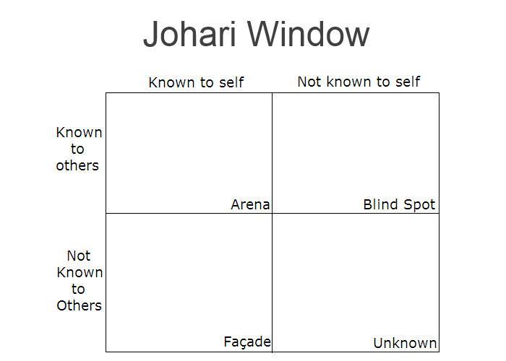 Johari window
Though using the Johari window model, Luft, J., Ingham, H., 1961.
Blind spot, which is not known to me but seen by other, the way we treat others and the way which we speak or act toward others could be perceived as negative by others. It’s important to reflect on all you do, get feedback from peers or work colleges and make changes when needed in order to shrink your blinded spot. Some of my peers, in their feedback saw me confident but quiet, a kind woman with a lot to give but holds back and l should believe in myself more.
Arena, (open area), the better the communication with others and the more transparent you are with your behaviour, views, beliefs, feeling and skills the open area will develop and grow this area. When starting University l was very friendly and open with my peers, l told them things about myself my life and my family. As time has gone by my peers and l have had many conversations on many topics and sometimes, we don’t agree with each other’s opinions but always respects each other’s views.
During an activity in class we were asked to make a list of all the patients that could be affected if doctors couldn’t do their jobs. My peer took up the marker and said she would do it, l thought that was not fair as one of our team sat back all the time, didn’t get involved much and agreed to everything, so l asked her if she would like a go and she said she would love to. I then asked my peer if someone who has not had a go have a turn this activity. Everything went well and we were all happy and work well together in our team. Later my peer approached me and told me because some students talk a lot and are louder, she found it easier to sit quiet and agree. She then thanked me and said I gave her a chance. Though this class activity our relationship has grown.
Façade the hidden area, the ego within us, which is unknown to others but not to yourself. Things that I have done, feeling and fears I have. Once this information is shared and known, (if relevant to work or interaction), it makes the hidden area smaller and the open area more known.
Unknown, which is unknown by all and yourself, in a higher learning setting or employment setting this area tends to get smaller over time as both you and your colleges get to know each other more. Though childhood trauma or fear, lack of self-confidence, your attitude, could make the unknown area a negative aspect of your personality
The Johari Window has helped me improve my awareness, awareness of myself and others, in the way l talk and work with others. As a mature student in a higher learning setting, l have learnt to be more self-aware as every action has a reaction, if l don’t plan my time then l will not get my work done. Or when taking public transport to university if l don’t leave out at the correct time, I would miss the bus and be waiting a further 22 minutes for the next one and be late for class. Through working on my time keeping, writing to-do lists and reflection l am improving in all areas of my life and my confidence is growing. I enjoy working within a team and l am better at problem solving, decision making and working more effectively. Which has helped my employability skill and helped me be ready to go back into the workplace.
I took a Career Motivation Test, which the summary of my test resembled my own thoughts. In its results it said financial reward is my motivation. I work well in a team but do prefer to work alone. I feel what l do motivates me, especially when l like it, l really enjoy learning new skills. The summary also said I like to invest in what I am doing because l do not want short-term goal, I do prefer looking at long term goals, rewards and achievements, knowing the work l put into my goal is more rewarding than money. Also, as a student of higher learning we are expected to write a reflective review. I have made many mistakes along the way and used them as a steppingstone to do better.
2.During the term all students are expected to participate with the in class activity a mock interview exercise, Hansen, K., Oliphant, G. C., Oliphant, B. J. and Hansen, R. S., (2009), for a job of my choice, this is to prepare us for the workplace and enhance our employability skills. Feedback will be given to each participant, feedback is looked at and evaluated, it is up to each student to use this feedback positively to make necessary changes if needed and improve our employability skills. This is to help me to prepare myself for future employment and to use the best practices. My CV a cover letter and the job advertisement/ person specification was needed for this mock interview. As part of my assignment the interview was formal as if it was a real job opportunity. I knew l loved waitressing as l had worked this position before, for ten years. I found a few jobs for waitressing on, indeed the job web site, to narrow down the search l looked at the distances I needed to travel, funds needed of travel, start times, wages and adult care for my disable son. After taking these things into consideration Birmingham City Football Club, (BCFC), was the best option for me as it was the nearest to get to. The start times was 10am so l did not need to worry about my disable son as he would have left for day care and the wages was very reasonable, with a chance to become team leader. In preparation for the interview as a potential employee l read over the job advertisement paying attention to job specification so l could explain how I understood what my role would be if it was asked of me. I googled job role to see what had changed since it had been a while since l had last waitressed.
STAR interview technique, used at many universities to help prepare graduates for employment, STAR is an acronym for Situation, Task, Action and Result, (Lackner, C., and Martini, T., 2017). The STAR interview technique is used by interviewer, potential employers, to gather information to see if l have the relevant skills required for the job role to set out. Using the same technique l tried to deliver my answers to the questions which could be asked. Most employer ask behaviour-based questions by discussing a specific situation, task the action taken and the result of the situation. This shows a potential employer if l would be capable to fulfil the skills needed for the job.
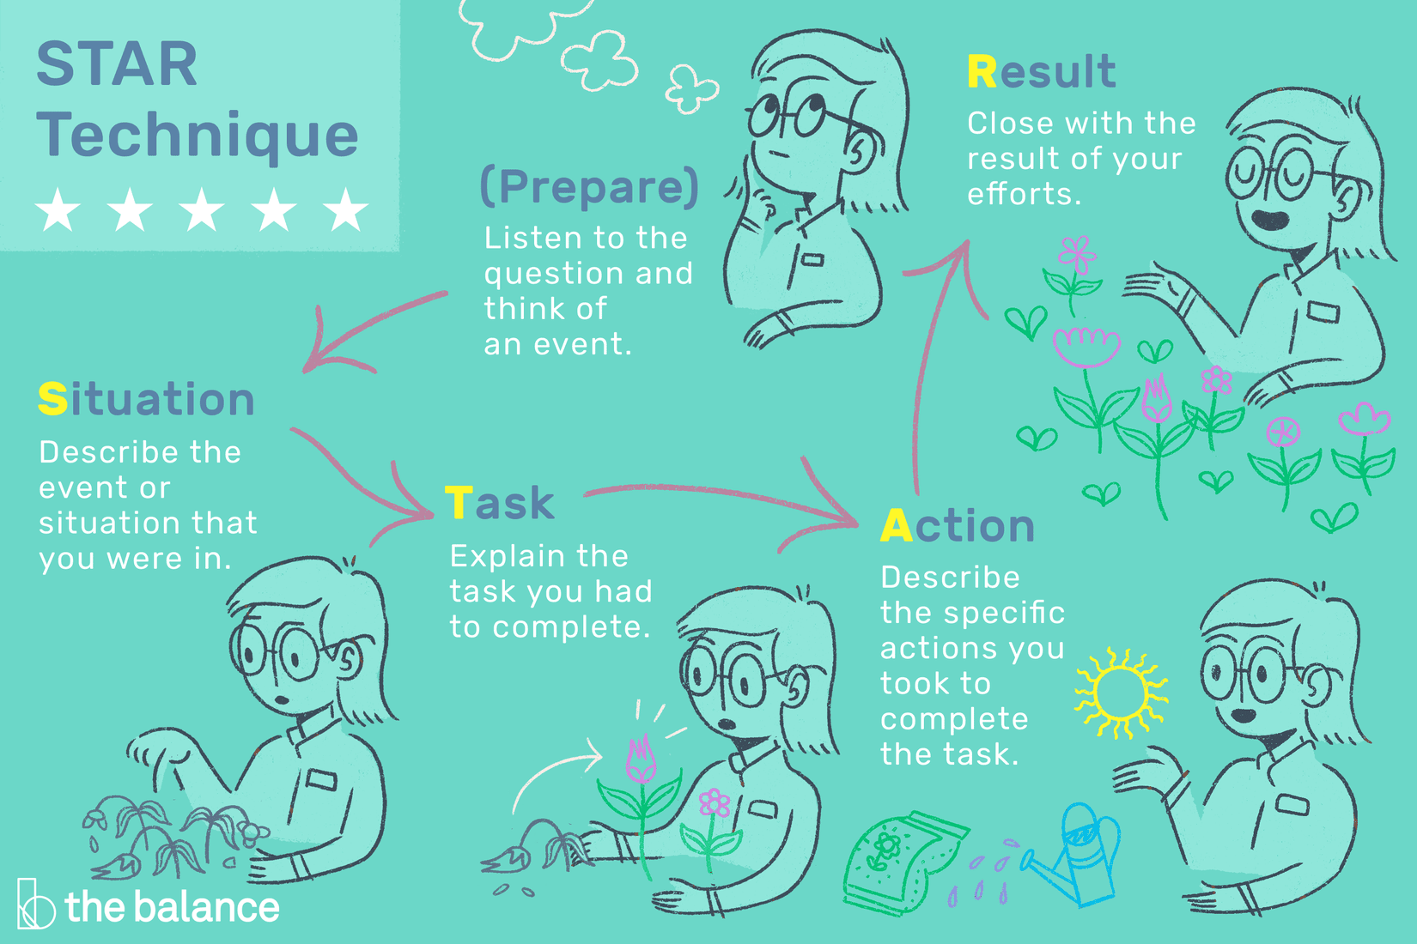
On the day of the interview, l made sure l was up early, clothes set out and bag packed. I arrived for the interview early got a drink and read over the job spec. I was called in for my interview, the interview was given by two of the university tutors, l felt the interview went reasonably well even though l felt a nervous the moment l sat down so l took a couple of breaths. I was asked questions about myself and the job l was applying for, why l wanted this job and what l knew about the company l was applying to work for, BCFC, they also wanted to know how l handled specific situations. After the interview l was given feedback from the two tutor who interviewed me l was graded 70% overall. This meant l would not of be employed by BCFC because l was not ready, (prepare), enough. This result has shown me l have improved a lot since my first term as l always hid in the back when there was a group presentation. l still have room for improvement
l should of rang BCFC beforehand to find out more information about the company, how long they’ve going, do they help or work with the local community. Knowing information shows you have research and are more emphatic this could have helped me during my interview.
Improvement of my posture is very important in an interview, because of crossing my legs l came across closed off and inappropriate. This was not intended and was down to nerves.
I also should have asked questions about my future progress within the company, how long could it take and what it entailed. More mistakes were made than l anticipated yet l have not failed l just have more to learn.
Professional Career Development plan
Professional career development plan, this can help me organise and prioritize activities to help me turn all weaknesses into strengths and build on them, Planning, C., (2018).
After looking at feedback given during the mock interview, l have taken each weakness mentioned by the interviews, to help me work out a professional career development action plan to eliminate all weaknesses and improve my potential as an employer. Documenting an action plan to improve on my skills and knowledge is important, when assessing and evaluating my progress l will know if my personal development plan was effective enough and if more action is needed to be taken. Here is my development and action plan to improve my communication skills within twelve months.
SMART | Career development plan with SMART objectives  and future action plan
Specific:  Improve communication skills when talking. | Continue my journey at UWTSD, Birmingham learning centre to complete level 5/6 in B A Business Management. Talking more during class activities, group work, presentations and assignments, reading this would help improve my vocabulary and my confidence when speaking.
Measurable:  Tools which will be used to measure improvement. | Tutor, peers’ feedback and self-evaluation using Swot analysis. Accessing the university careers services.
Achievable:  Over how much time will it take. | I will be monitoring my own progress throughout each term, (ten weeks). Using self-assessment on development weekly.
Realistic/Relevant:  Is this relevant to my future goals and objectives. | To have a well-established business within 5year is my goal, communication is of key importance to this, having excellent communication will help me develop my interaction skills, gain knowledge and improve my vocabulary.
Time based:  All my goals will have a specific timeframe in which to be completed. | One academic year, after this time l will see if all the changes implement have been effective in growing myself confidence.
Each goal, (self-development, reading, work on weaknesses, challenge myself, improve my work life balance, get organised and communicate better), will be given an action plan. Using a SMART action plan to help me plan my future works with any goal I want to achieve, one by one goals can be broken down into smaller segment for effectiveness and long-term effects. Career planning is essential for my success, giving myself milestones to reach within a set time, by doing this it will give me a clear sense of direction and progression and if l have achieved milestones set by myself.

References
Bohcun, P., 2011. Mindfulness and Creativity. Canadian Teacher Magazine. Pp8-9. Available at: www.sterlinghall.com/uploaded/The_Institute/News/Mindfulness_and_Creativity.pdf
Accessed on 23rd/March/2020
Dyer, N.L., Borden, S., Dusek, J.A. and Khalsa, S.B.S., 2020. Long-Term Improvements in Psychological Health Following a Yoga-Based Program for Professionals. The Journal of Alternative and Complementary Medicine. Available at: http://doi.org/10.1089/acm.2019.0340 Accessed on: 21st/January/2020
Hansen, k., Oliphant, G. C., Oliphant, B. J. and Hansen, R. S., 2009. Best practices in preparing students for mock interviews. Business Communication Quarterly, 72(3), pp. 318-327. Available at: https://journals.sagepub.com/doi/abs/10.1177/1080569909336951 Accessed on 23rd/March/2020
Lackner, C., and Martini, T., 2017. Helping University Students Succeed at Employment Interviews. The Role of Self-Reflection in E-Portfolio, Teaching and learning Inquiry, 5(2), pp 3-15. Available at: https://eric.ed.gov/?id=EJ1156279 Accessed on 24th/March/2020
Locke, E, A., 1996. Motivation through conscious goal setting. Applied and Prevented psychology, 5(2), pp 117-124. Available at: https://scholar.google.co.uk/scholar. Accessed on 4th/March/2020
Luft, J., Ingham, H., 1961. The Johari Window. Human relations training new. 5(1), pp 6-7. Available at: http://www.richerexperiences.com/wp-content/uploads/2014/02/Johari-Window.pdf. Accessed on 5th/March/2020
Munoz, D., 2020. The Paradox of Duties to Oneself. Australasian Journal of Philosophy, pp 1-12. Available at: https://www.tandfonline.com/doi/full/10.1080/00048402.2019.1697711. Accessed on 4th/March/2020
Planning, C., 2018. Personal Development Plan. Available at: http://www.christensoncommunities.com/img/content/PDPGuideforCareerCoaches.pdf Accessed on 27th/March/2020
William, N, E., Fauth, J., 2005. A psychotherapy process study of therapist in session self-awareness. Psychotherapy Research, 15 (4). Pp374,381. Available at: https://www.tandfonline.com/doi/abs/10.1080/10503300500091355. Accessed on 4th/March/2020
Zahavi, D., 1999. Self-awareness and alterity: A phenomenological Investigation. Northwestern University Press. Available at: books.google.com. Accessed on 4th/March/2020

