Assignment 2
-
Usability Engineering

James Craddock-Jones
256515
19/05/2022

Contents
Machine Interface Review 3
Good Design 3
Interfaces 3
Usability Heuristics Review 6
Bad Design 8
Interface 8
Usability Heuristics Review 9
Interface Evaluation 11
Visibility of system status 11
Match between system and the natural world 11
User control and freedom 11
Consistency and standards 11
Error prevention 11
Recognition rather than recall 12
Flexibility and efficiency of use 12
Aesthetic and minimalist design 12
Help users recognise, diagnose, and recover from errors 12
Help and documentation 12
Guidelines and Accessibility 12
Strive for Consistency 12
Enable Frequent Users to Use Shortcuts 12
Offer Informative Feedback 13
Design Dialog to Yield Closure 13
Offer Simple Error Handling 13
Permit Easy Reversal of Actions 13
Support Internal Locus of Control 13
Reduce Short-Term Memory Load 13
Summary of Recommendations 14
User Interfaces and Web Standards 14
References 14

Machine Interface Review
Below will go over two designs, one being a good design and one being a bad user interface design. An explanation of each will be given, a heuristics evaluation using the same format from the last assignment that was provided to Aaron to give feedback on my design, and a few recommendations on how they could be improved.

Good Design
The first design reviewed is a ticket machine created for Transport for London. This new iteration of the system was redesigned to be modernised and improved. This was created by MT Design. (1)
The previous design used older computer graphics that had since become outdated and no longer served their purpose. When doing this, MT Design conducted a significant amount of research to find the requirements of the current system and the user. They also had access to previous research conducted by Transport for London (1)

Interfaces
The below image is one of the interfaces the users are greeted with when trying to buy a ticket to use the London underground. The menu provides the user with options to purchase tickets on a destination base, buy a day ticket, or buy a group or family tick. In addition, it provides the users to switch languages and buy a new Oyster card.
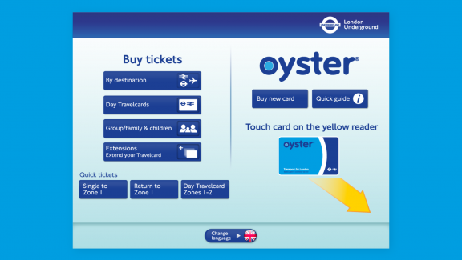
(1)
The below interface shows the options when selecting the Oyster card. These options include a top-up system for the card with eight predefined options with the ability to choose a custom amount. The interface also allows users to renew old passes and check their journey history.
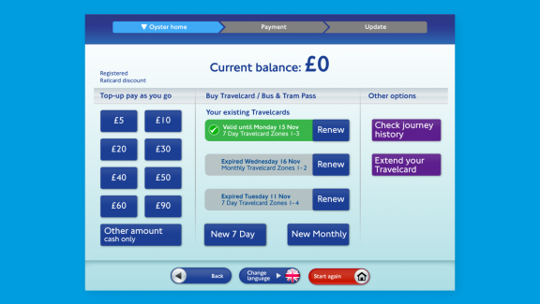
(2)
The following image shows the menu where the user can select their payment preferences using the external buttons at the side of the screen with points pointing to the right buttons to press. This menu also allows the user to print off a receipt, return to the previous menu, and start again. The menu also clearly shows the amount of money that will be placed onto the Oyster card and the amount the user must pay.
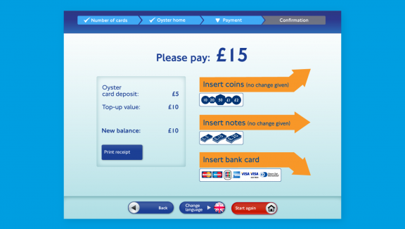
(2)
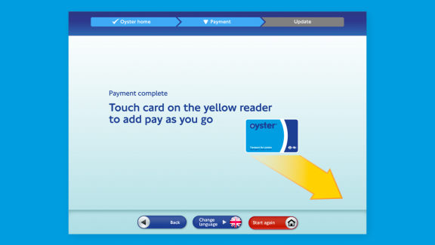
(2)
The below is now the design in action. One issue that could come up with the design being implemented is that not all of the machines are the same, with interface input placements all being different, which may hinder usability in that, for example, the user would not be able to use recall on the physical side of the system making it a steeper learning curve.
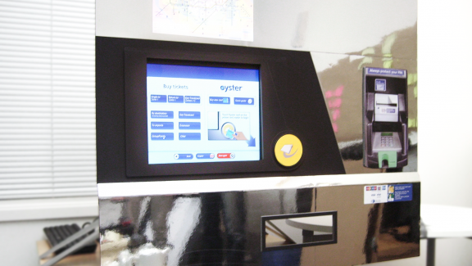
(2)
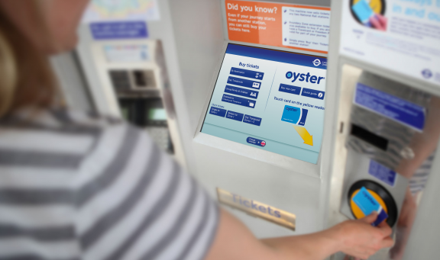
(3)

Usability Heuristics Review

Visibility of system status
Severity score out of 5:
1 | 2 | 3 | 4 | 5
Reasons why:
The design shows the system’s status when booking a ticket or topping up their Oyster allowing them to know where they are in the process. No loading screens could be found throughout the final design or mock-up designs, so that no comment can be made on that.

Match between system and real world
Severity score out of 5:
1 | 2 | 3 | 4 | 5
Reasons why:
The design uses rounded buttons, which match how a button would somewhat look in the real world.

User control and freedom
Severity score out of 5:
1 | 2 | 3 | 4 | 5
Reasons why:
The user can go back to the previous menu or start all over again easily throughout the many processes within the system. In addition, the user can change the interface’s language to their prefered option.

Consistency and standards
Severity score out of 5:
1 | 2 | 3 | 4 | 5
Reasons why:
The system design is consistent throughout all the menus aiding in the users’ ability to recall from memory how the interface should work.

Error prevention
Severity score out of 5:
1 | 2 | 3 | 4 | 5
Reasons why:
The user can go back to the previous menu or start all over again quickly throughout the many processes within the system.

Recognition rather than recall
Severity score out of 5:
1 | 2 | 3 | 4 | 5
Reasons why:
As said previously, the design is constant throughout, aiding the user in recalling from memory. The design also uses buttons in a style that makes them look similar to buttons in the real world.

Flexibility and efficiency of use
Severity score out of 5:
1 | 2 | 3 | 4 | 5
Reasons why:
The system provides shortcuts to the user by renewing previous purchases to avoid going through the whole process again.

Aesthetic and minimalist design
Severity score out of 5:
1 | 2 | 3 | 4 | 5
Reasons why:
In some cases, it could be argued that more options are provided at one time than what is required. An example of this is the eight amount options when you also have an opportunity to select a custom amount.

Help users recognise, diagnose, and recover from errors
Severity score out of 5:
1 | 2 | 3 | 4 | 5
Reasons why:
No error message screens are shown within the final design or the mock-ups, so it has to be assumed that there are only a few or none.

Help and documentation
Severity score out of 5:
1 | 2 | 3 | 4 | 5
Reasons why:
Documentation and help are limited, if not wholly absent from the design. The only provided documentation is a quick guide to the Oyster card.

Recommendations:
Even though the design is mainly good, many recommendations could be made. The first recommendation would be to add more help options for inexperienced users who may have never used the London underground before.
Another would be unifying the physical interface of the digital vending machine, so there is a relatively small learning curve needed to use any of the devices across the whole London underground.

Bad Design
The next vending machine is a pay and display ticket machine in Buxton, Derbyshire. Many elements are generally wrong with the design of this interface. For example, one would be the vertical keyboard which hinders recall as keyboards are laid out horizontally on computers.

Interface
There is only one interface for this electronic vending machine. As you can see, the interface consists of a tiny display, a slot to insert coins, a keyboard to enter car details, and a slot where the parking ticket is dispensed.
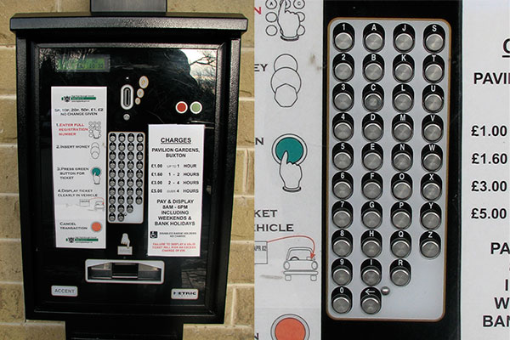(3)

Usability Heuristics Review

Visibility of system status
Severity score out of 5:
1 | 2 | 3 | 4 | 5
Reasons why:
The display is too small with no backlight, making it hard to read.

Match between system and real world
Severity score out of 5:
1 | 2 | 3 | 4 | 5
Reasons why:
The interface uses a keyboard but does not use a traditional keyboard layout which entails a learning curve for the user.

User control and freedom
Severity score out of 5:
1 | 2 | 3 | 4 | 5
Reasons why:
There is no way to move backwards in steps which limit control.

Consistency and standards
Severity score out of 5:
1 | 2 | 3 | 4 | 5
Reasons why:
Even though the design is terrible, it is consistent with using the keyboard as a form of input.

Error prevention
Severity score out of 5:
1 | 2 | 3 | 4 | 5
Reasons why:
There’s very little error prevention due to the nature of the design. Once the car’s registration number has been entered, the user cannot go back to change it if the user entered it wrong.

Recognition rather than recall
Severity score out of 5:
1 | 2 | 3 | 4 | 5
Reasons why:
Using a keyboard helps with recall, but the keyboard’s design hinders this as it uses a vertical design rather than the traditional horizontal design used with computers.

Flexibility and efficiency of use
Severity score out of 5:
1 | 2 | 3 | 4 | 5
Reasons why:
The interface is not flexible, nor is it efficient in handling user input with a big keyboard.

Aesthetic and minimalist design
Severity score out of 5:
1 | 2 | 3 | 4 | 5
Reasons why:
The keyboard can cause more confusion when the user enters details into the system.

Help users recognise, diagnose, and recover from errors
Severity score out of 5:
1 | 2 | 3 | 4 | 5
Reasons why:
No help is provided to help the user recover from an error.

Help and documentation
Severity score out of 5:
1 | 2 | 3 | 4 | 5
Reasons why:
There is documentation on how to use the system, but it does not show the user what they need to do in the event errors occur.

Recommendations:
Many recommendations could be made. The general guidance would be to fully digitalise the system to like what is used by Transport for London. This would include using a large display with a digital interface that could be interacted with either by touch or simple external buttons.
This design would allow the process to be much more allowing for error prevention as the user would be able to go back to the previous steps and alter what they have been inputted.
In addition, a system could be implemented where the system could recall previous parking tickets for a car’s registration number it remembers to speed the process up for the user. This may be hard to do given GDPR, but an alternative would be to use a system like Oyster cards.

Interface Evaluation

Visibility of system status
When designing a user interface, the design should always keep the user up to date on what is occurring within the system quickly and appropriately. Whenever the users are aware of the present state, they might understand the outcomes of prior activities and anticipate their future steps. Predictable interactions aid in the development of trust. (4)
An example of this is setting up a new device such as a smartphone. You are always shown where you currently are within the set-up procedures, whether selecting a language, WiFi network, signing into your Apple or Google account, or setting up security features such as a Touch ID or a passcode. You are also allowed to go back or skip the menu.
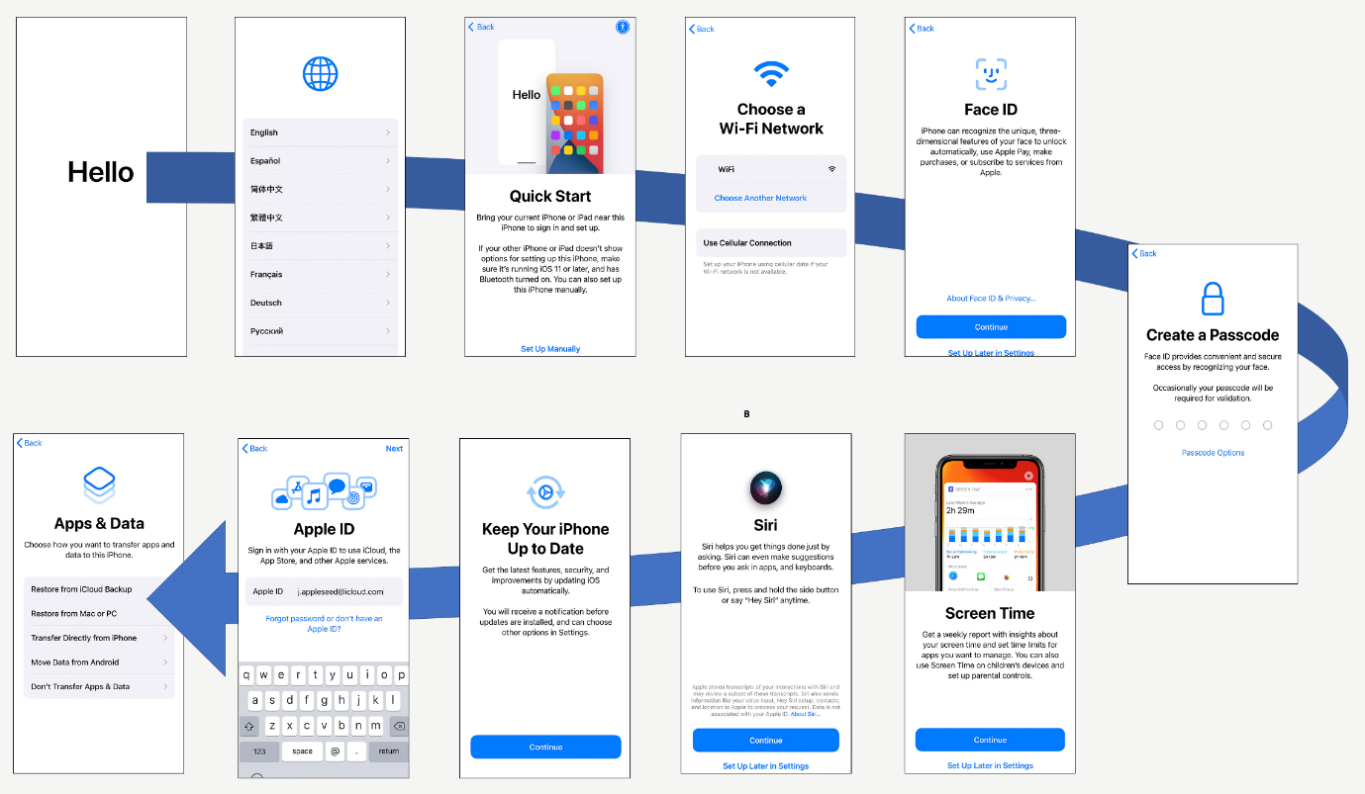
(7)

Match between system and the natural world
When creating a new user interface design, the design should communicate with the users. Instead of using jargon known internally or by experts, utilise language and ideas that the user is acquainted with. To display facts in a typical and easy sequence that follows real-world conventions. (4)
The way an interface is designed is highly dependent on who you are trying to reach. Language, thoughts, signs, and pictures that appear entirely prominent inside could be unfamiliar to or confusing to others. (4)
An example of this would be to use buttons that look like real-life buttons. This allows the user to understand that the element is clickable.
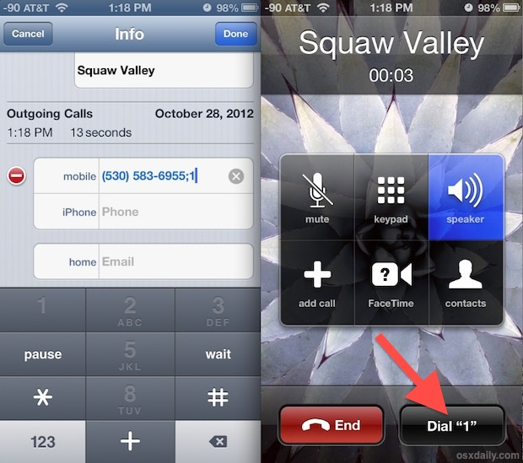 (6)

User control and freedom
When performing tasks, the user might regularly make errors. They demand an indicated method of exiting the uncomfortable task without going into a long-drawn-out process. People can back out from a function or delete an action. They feel more independent and secure. Exits allow users to maintain control over their encounters and prevent being trapped and frustrated. (4)
An example of this is shown below with the old iOS 6 contact list menu. It allows the user to completely remove the phone number, edit the number, and edit the contact’s name, among other tasks such as adding or deleting associated emails.

Consistency and standards
It should never be necessary for the user to assume whatever new phrases, conditions, or actions mean. More contemporary designs must adhere to platform and industry standards. The user’s expectations are based on their previous encounters with various services. Failing to keep consistency could increase the overall mental workload of users by forcing them to learn new knowledge. (4)

Error prevention
Although excellent error indicators are essential, the best designs undertake precautions to minimise problems in the first place. It is best to either delete any error-prone situations or inspect them and offer users a verification option once they engage in an activity. (4)

Recognition rather than recall
Reducing the user’s cognitive load by making actions and selections apparent. While designing an interface, remember that users must and should come first. While creating an interface, it is essential to remember that users should not have to recollect facts from one section to the next. We humans have limited short-term memory. Using interfaces that improve recognition reduces the user’s cognitive workload. (4)

Flexibility and efficiency of use
Shortcuts concealed from newer users may enable more knowledgeable users to engage faster, enabling the user interface to suit new and experienced users. (4)

Aesthetic and minimalist design
When designing user interface design, it should be kept in mind that it should not include information that is either worthless or rarely utilised. Each extra data element in a user interface might clash with the relevant pieces of data, reducing relative visibility. (4)

Help users recognise, diagnose, and recover from errors
Error warnings presented to a user must be written in plain English. This means that it identifies the problem and provides a helpful solution. (4)

Help and documentation
When creating an interface, it is best if the process does not require any further clarification. However, it is not always possible. Thus, documentation may well be necessary to help the user understand how to complete activities. (4)

Guidelines and Accessibility
For this section, I will be using Schneiderman’s interface guidelines to form the bases of my recommendation.

Strive for Consistency
It is critical to maintain consistency through the graphical interface design, whether it uses the same layout, button style, or colours. This uniformity will help establish the brand and prevent people from leaving your service. (5)

This applies to the interfaces that have been researched at the beginning. These machines must use a uniform design throughout the many processes required to reach the end goal. The parking ticket machine falls here as it does not use a standardised keyboard format. It would be recommended to use a standardised computer keyboard layout to reduce the users’ cognitive needs regarding short term memory.

Enable Frequent Users to Use Shortcuts
When designing a user interface, allow the user to navigate the entire interface with only a few clicks. (5)
This principle does not apply to the parking ticket machine because the user has to input their car registration number, which would require many clicks to input it to continue navigating to the next stage.
However, this is appliable to the London Underground ticket machine. I believe it does an excellent job by allowing the user to reorder a previous ticket to save going through the whole process again.

Offer Informative Feedback
Suppose the user has finished or is presently doing activities while using the interface. In that case, it is essential to offer quick feedback to know exactly when in the processes they are and how far they need to go to the finish. (5)

Design Dialog to Yield Closure
It is important to remember that every user interaction should be closed based on the interactions made by the user. For example, displaying a message of gratitude, a notice of validation, or a message sent throughout the buying process. (5)
It is also important to remember that the user must see the route of their actions throughout the interface. This can be done by providing feedback after an activity. You minimise the user’s mental burden and improve their interface UX experience. (5)
This applies to both vending machines as a thank you message could be displayed when making a purchase or when an issue occurs with the data they have inputted.

Offer Simple Error Handling
When creating exemplary user interfaces, keep in mind that you want to remove as many errors as possible. If something goes wrong, the UI should enable easy identification to correct the problem. (5)
This also applies to both, as any interface should provide the user with the necessary information to solve issues if any were to crop up while trying to buy a train or parking ticket. This may be hard to do on interfaces with a small display like the parking ticket machine, but it is still necessary.

Permit Easy Reversal of Actions
In addition, when designing an interface, it is an excellent option to allow the user to easily pick “Reset” or “Cancel” after making errors. This allows the user to be less worried and eager to investigate choices, provided they understand there is a simple solution to address an issue. (5)
Both systems allow for this easily. It is always recommended that the user reverse any decision they have made within the system, especially those requiring the user to pay.

Support Internal Locus of Control
When designing an interface, it is crucial to provide the user power and control so that the user feels like they are overseeing the system. This can assist in comforting them. (5)
The parking ticket system does allow for this as it is all set out for the user in a strict manner. It would be recommended to design a system like the London underground ticket system, which provides the users with many options that can be altered to their needs.

Reduce Short-Term Memory Load
Due to human’s poor short-term memory limitations, graphical interfaces must be simple and easy to use. If a design uses multiple-page displays, they must be unified, so users rely less on their short-term memory. It is essential to avoid flooding interfaces with similar quantity content. (5)
This also applies to both designs. The London underground system works well by using a consistent design throughout and taking design cues from the real world with objects such as buttons. On the other hand, the parking ticket system does not do an excellent job because the keyboard uses an unorthodox layout.

Summary of Recommendations
- Keep the user interfaces as consistent and straightforward as possible.
- Provide the user with enough information to perform a task.
- Do not use unorthodox designs or layouts. Use standard layouts to help the users.
- Take design cues from popular and commonly used designs to aid users learning curve.
- Provide simple and effective error handling.
- Allow for shortcuts to speed the process up for more experienced users.
- Allow decisions to be easily reversible.

User Interfaces and Web Standards
Going forward, designers must look at web standards for accessibility. This is due to our ever-growing reliance on using the internet for day-to-day tasks such as working, using search engines to find new information, online shopping, and many more like entertainment such as Netflix and YouTube.
The more we use these interface designs, the more we learn and understand them, which is vital to consider when designing new user interfaces by looking into what is commonly used by users. This keeps the interface’s design close to the user’s expectations and allows for a more lenient learning curve.

References
- MT Design, TICKET MACHINE REDESIGN – LONDON UNDERGROUND, https://mt.design/portfolio/ticket-machine-redesign-london-underground/ Date Accessed: 12/04/2022
- Fool Proof, Improving the daily lives of millions of people with TfL, https://www.foolproof.co.uk/services/case-studies/tfl/ Date Accessed: 11/04/2022
- D. Travis, What car park payment machines can teach us about usability, What car park payment machines can teach us about usability (userfocus.co.uk) Date Accessed: 12/04/2022
- J. Nielsen, 10 Usability Heuristics for User Interface Design, https://www.nngroup.com/articles/ten-usability-heuristics/ Date Accessed: 16/04/2022
- Capian, Shneiderman’s Eight Golden Rules of Interface Design, https://capian.co/shneiderman-eight-golden-rules-interface-design Date Accessed: 18/04/2022
- OSX Daily, Add a “Dial Extension” Button to Contacts on iPhone, https://osxdaily.com/2012/10/28/add-dial-extension-button-to-contacts-iphone/ Date Accessed: 23/04/2022
- A. Robertson, Set Up iPhone and iPad For Your Family, Set Up iPhone and iPad For Your Family (askaboutgames.com) Date Accessed: 25/04/2022

