MODULE: DIGITAL SKILLS
MODULE CODE: LCLM4002
TASK 3- WEBSITE EVALUATION REPORT

Table of Contents
Introduction 3
Company Overview 3
Website Usability and Navigation 4
Website Content and Clarity 5
Visual Design and Branding 5
Mobile-Friendliness and Responsiveness 6
Accessibility and Inclusivity 6
Online Booking and Contact Options 6
SEO and Social Media Integration 6
Recommendations for Improvement 7
Conclusion 7
Reference 8

Introduction
Eden Spa Harborne is a wellness company that specialises in massage therapy, skin care, and relaxation treatments (edenspaharborne.wixsite.com, 2014). The website of a business is also essential in attracting potential customers to the spa's services since first impressions are the basis of most spa decisions. The report at hand evaluates Eden Spa Harborne's website in terms of usability, content, design, mobile responsiveness, and visibility to search engines.

Company Overview
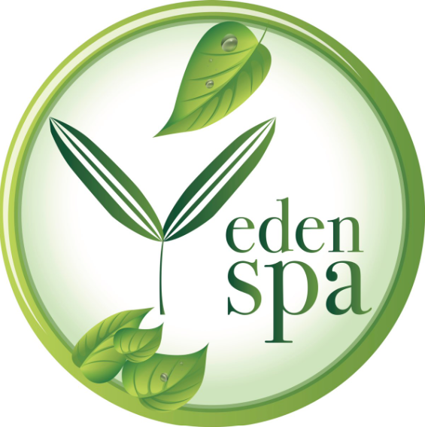
Figure 1: Eden Spa Harborne
(Source: edenspaharborne.wixsite.com, 2014)
The Eden Spa Harborne, located in Harborne, Birmingham, offers services such as massages, facials, and bespoke spa treatments (edenspaharborne.wixsite.com, 2014). Its clients are mainly women aged 25-50 seeking beauty and wellness services. The business uses the website to list their services, price them, and provide contact information. The site is built on Wix and has a visually heavy layout filled with calming imagery to reflect the relaxing experience delivered at the spa. Due to the specialised nature of the business and the local competition, the website serves as a vital channel of customer acquisition, especially for first-time clients, who may have found the spa through a search or social media. For service-based businesses, a good, attractive website that works intuitively fosters trust and clientele booking.

Website Usability and Navigation
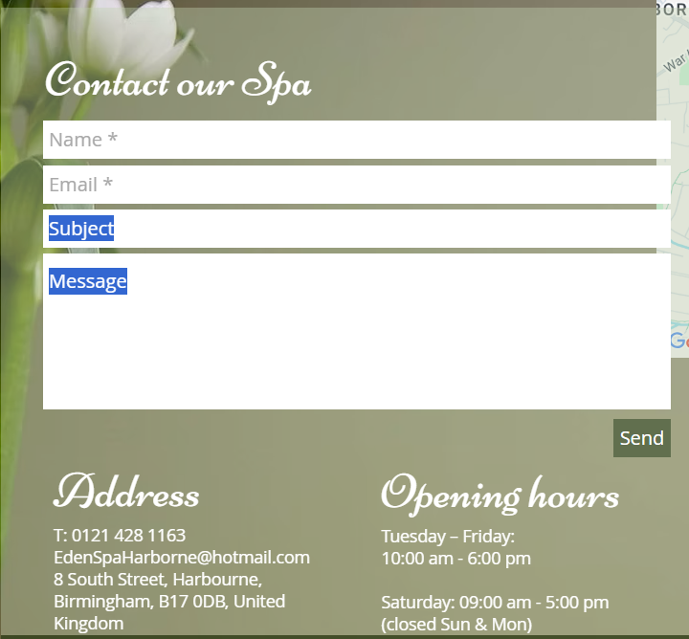
Figure 2: Contact Us Page
(Source: edenspaharborne.wixsite.com, 2014)
The structure of the website is quite a simple one, with the top section navigation bar stating such links as "Home," "Services," and "Contact Us." It does well in welcoming the visitor through a calm background image, together with a straightforward service category layout on its homepage; indeed, quite fitting for a spa firm (Korhonen, 2024). There are some sections that require long scrolling of a page, while actions such as making an appointment are not at first obvious. The "Services" tab illustrates services available, but not the "Book Now" button, indicating that booking can be made right next to the services; such would better streamline user flow. Internal links link well, but there are pages where the navigation may get confusing; for example, the return to homepage calls for either scrolling down manually or using the menu, but not clicking on the logo. Some menu headings are not sticky, which means you have to scroll up to find them. Overall, navigation is OK, but could be significantly improved through persistent menus, call-to-action buttons, and the booking journey being clearer. Simplicity in accessing key services and reduction of clicks for users would enhance the total usability.

Website Content and Clarity
The site content is short, reliable, and free from grammatical errors or spelling mistakes. Service descriptions are brief but descriptive, offering a basic understanding of treatments such as facials, waxing, and body massages (edenspaharborne.wixsite.com, 2014). More detailed explanations—such as duration, ingredients, or benefits—would serve to align user understanding better. Pricing is included, but it is not consistent: some services indicate the costs, while others require users to inquire further to find out. This discrepancy lowers the trust factor or could impede users' decisions. The tone is overall appropriate for the brand: calm, friendly, and professional; however, some headings are somewhat obscure in meaning (e.g., "About Me" could be replaced by "Our Therapist" or "Meet Your Therapist").

Visual Design and Branding
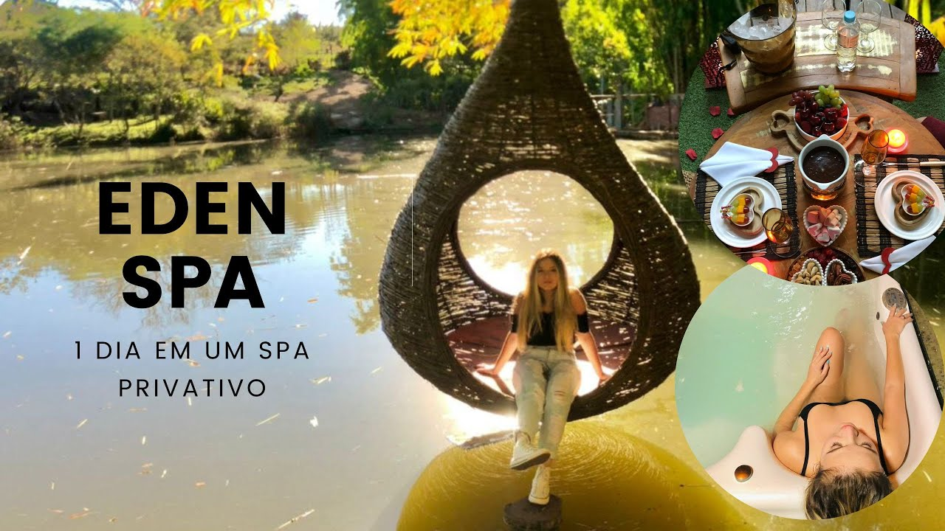
Figure 3: Eden Spa
(Source: edenspaharborne.wixsite.com, 2014)
An offline booking approach lacks some momentum for a client to respond quickly; instead, Eden Spa has clients emailing or calling (Cheng and Yu, 2024). A live calendar would be suitable for marketing purposes, combined with a chatbot and a contact form. Integration with any online booking tool, Fresha or SimplyBook.me, and Google Maps would add to the appearance of professionalism and make the appointment simple.

Mobile-Friendliness and Responsiveness
The Eden Spa Harborne website is considered responsive for mobile phones, but it can still be improved further. The images resize well, and the text is readable, but the pages take a bit long to load, and are slow on pages with photos. The navigation bar opens with a hamburger menu, a standard option, but some drop-down links are not easy to tap. Some clickable buttons are either too small in size or too close together, which can cause usability issues on smaller screens. There is also extra scrolling needed for the "Contact" and "Services" pages on mobile, with no quick-scroll option to the top(Nguyen, 2024).

Accessibility and Inclusivity
The site would meet all of the basic accessibility qualifications, font size is readable to some extent, and alt text is included on some images. It did need improvements for inclusivity, however. Also, the contrast between the text colour and background is sometimes too low, especially on image overlays. No accessibility toolbar or the ability to enlarge text size, or have high-contrast mode. Navigation by keyboard is minimal (Poolsawas, 2024). Also, the screen-reading compatibility may not be that great. Important links are not always clearly labelled for assistive technologies. Quite a friendly and welcoming language. More accessible design features would make Eden Spa better able to cater to a varied audience, including those with vision or physical impairment, and would demonstrate a commitment to inclusive practice.

Online Booking and Contact Options
Online booking is not an integrated system within the web page, leaving users to contact the business via either email or phone to schedule their appointments. This could be a drawback, since clients today expect their booking to be done on-demand and in a minute. The "Contact" page provides the company's email address, phone number, and social media links. A contact form for immediate queries would have been even better, along with a chatbot. Appointment confirmation or an appointment-scheduling mechanism is absent, a feature standard with service websites today (Kothiya, 2025). A live calendar would give an air of professionalism. At the same time, the integration of Fresha or SimplyBook.me would allow for an enjoyable user experience.

SEO and Social Media Integration

SEO for the website needs to be developed; generic page titles, no meta descriptions, few headings or alt tags, with emphasis on keywords. These weaknesses have kept the site from being visible to search engines. Also, social media icons for Instagram and Facebook are present on the homepage, but they open in the same tab, thus disrupting user flow, and the Facebook link appears to be dead. The fact that social media is updated regularly is a positive note. Relevant metadata, images optimised with descriptive alt text, structured content, and an assurance that all external links are functioning by opening in a new browser tab will go a long way in boosting the SEO performance.

Recommendations for Improvement
Integrate the online booking system, improve service descriptions, and standardise pricing. Improve site navigation through clear marketing call-to-action buttons and sticky menus. Optimise the website for mobile access, as well as for accessibility. Strengthen the SEO portion of the site with the addition of meta tags, alt text, and structured content. Repair broken links, and open social media in a new tab.

Conclusion
Eden Spa Harborne's website mirrors its brand nature but possesses certain requisite ameliorations centred on usability, booking functionality, and search engine optimisation improvements. The ways to enhance navigation, accessibility, and content clarity for the user experience elevate the usability of the site and provide a stronger platform for recruitment and aid business growth for the spa-going clients.

Reference
Cheng, A., and Yu, Y. (2024). Recent advances in data collection for Cryo-EM methods. Current Opinion in Structural Biology, 86, 102795.
edenspaharborne 2014. Treatments [Online] Available at: https://edenspaharborne.wixsite.com/eden-spa/treatments [Accessed on 01.07.2025]
edenspaharborne.wixsite.com 2014. The Spa [Online] Available at: The Spa | eden-spa [Accessed on 01.07.2025]
Korhonen, E., 2024. Customer Expectations Created through a Hotel Website.
Kothiya, B., 2025. Market analysis of an appointment booking system: understanding market demand and innovation in appointment scheduling systems.
Nguyen, H., 2024. Enhancing Accessibility in Web Applications: A Comprehensive Study on Common Accessibility Issues and Implementing Solutions in React Application.
Poolsawas, B., 2024. A Comparative Study of 3D Navigation Techniques Using Trackpads in Desktop VR. JOURNAL OF INFORMATION SCIENCE AND TECHNOLOGY, 14(2), pp.28-35.

